Supplementary Information

A liquid-phase-synthesized cathode composite with a three-dimensional ion/electron-conducting structure for all-solid-state lithium–sulfur batteries
Peilu Jiang¹, Huangkai Zhou¹, Subin Song¹, Kota Suzuki^{1, 2}, Kenta Watanabe¹, Yumi Yamaguchi², Naoki Matsui², Satoshi Hori², Ryoji Kanno² and Masaaki Hirayama^{1, 2}*
¹Department of Chemical Science and Engineering, School of Materials and Chemical Technology, Tokyo Institute of Technology, 4259 Nagatsuta, Midori-ku, Yokohama 226- 8502, Japan.
²Research Center for All-Solid-State Battery, Institute of Innovative Research, Tokyo Institute of Technology, 4259 Nagatsuta, Midori-ku, Yokohama 226-8502, Japan.

*Corresponding author. E-mail: hirayama@mac.titech.ac.jp

Supplementary Methods
Preparation of carbon replica 10 (CR10). The CR10 synthesis protocol has been described in our previous report¹. Essentially, monodisperse 10-nm-diameter silica nanosphere (SNS) colloidal crystals were synthesized using a hydrothermal method as a template for CR². To synthesize CR10 (0.2 g), L-arginine (0.35 g; ≥98.0%, Kanto Chemicals) was selected as a base catalyst, mixed in distilled water (348 g), and then stirred at 1000 rpm for ~5 min at room temperature until dissolution. A silicic acid source – tetraethyl orthosilicate (TEOS; 20.9 g, ≥96.0%, Tokyo Kasei Kogyo) – was subsequently added, and the resulting mixture was stirred at 1000 rpm at 70 °C for 24 h in a bath stirrer (EWS-100RD, AS One). The obtained solution was transferred to a ceramic baking dish and then dried in a thermostatic oven (SU241, ESPEC) at 100 °C for 10 h, yielding a white powder of 10-nm-sized SNS particles. Subsequently, furfuryl alcohol (10 g; 97.0%; Wako Pure Chemical Industries) was selected as a carbon source and then mixed with oxalic acid (0.05 g, 98.0%; Wako Pure Chemical Industries), which was used as an acid catalyst. The stirred furfuryl alcohol solution was added dropwise onto the SNS powder, which was subsequently placed in a perfluoroalkoxy fluoropolymer jar until the SNSs became lumpy. The furfuryl alcohol was then polymerized by heating the sample in a muffle furnace at 100 °C for 48 h. The specimen obtained after natural cooling was pulverized in an alumina mortar to obtain a brown powder. The resulting sample was carbonized at 120 °C for 1 h and at 800 °C for 5 h under argon flow in a tube furnace (TF-1300, R-DEC). This yielded a black CR10 powder, which was treated with a 29 wt% aqueous hydrofluoric acid solution to remove the silica template.

Preparation of Li₆PS₅Br SE by ball milling (SE-bm). For the ball-milling synthesis, Li₂S (99.9%, Mitsuwa Chemicals), P₂S₅ (99%, Sigma-Aldrich), and LiBr (99.9%, Sigma-Aldrich) were mixed in a molar ratio of 5:1:2 by hand for ~15 min in a glove box under an argon atmosphere. Mechanical ball-milling was performed at 600 rpm for 48 h using a planetary ball mill (Pulverisette 7, Fritsch Japan). The sample and eighteen 10-mm-diameter zirconia balls were sealed in a zirconia (ZrO₂) grinding vessel in a glove box to prevent contact with air. The obtained powder was pressed in a pellet compactor, and the obtained pellet was sealed in a quartz tube under vacuum. The sample was sintered at 550 °C for 6 h in an argon atmosphere and then cooled to room temperature naturally. This synthesis process has been reported previously³.

Preparation of Li_{3.45}Ge_{0.45}P_{0.55}S₄ SE by vibration milling. The Li_{3.45}Ge_{0.45}P_{0.55}S₄ SE (denoted herein as LGPS0.55) was used as the separating layer of the ASSLSBs. The LGPS synthesis protocol adopted in our previous study⁴ was used. Li₂S, P₂S₅, and GeS₂ (99.9%, Kojundo Chemical Lab) were hand-mixed in a molar ratio of 69:11:18 for 15 min in an agate mortar in a glove box under an argon atmosphere. The mixture was transferred into a cylindrical container and subjected to vibration milling (VM) in a high-speed vibratory mill (TI-100, CMT) for 30 min to obtain the precursor powder. The resulting sample was sintered at 550 °C for 8 h in an argon atmosphere and then cooled to room temperature naturally.

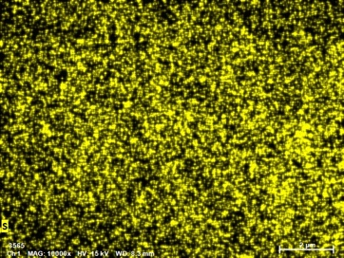
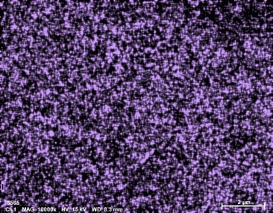
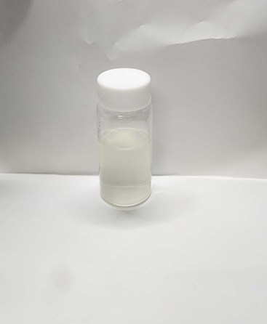
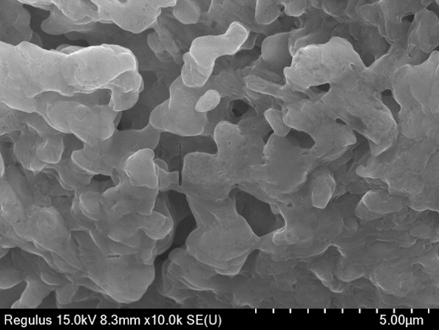
(c) S
(a) 3Li₂S-LiI in EtOH
(b) 3Li₂S-LiI (AM)
~1 μm

(d) I

Supplementary Fig. 1 (a) Photograph of 3Li₂S–LiI in EtOH. (b) FE-SEM image and (c), (d) elemental maps of the 3Li₂S–LiI active material.

(b)
(a)

(d)
(c)

(e)

Supplementary Fig. 2 Rietveld refinement of liquid-phase-synthesized xLi₂S–LiI (x = 1, 3, 5), Li₂S, and LiI based on their XRD patterns shown in Fig. 2a. The acquired datapoints are indicated by red cross marks (+), and the data obtained via Rietveld refinement are shown as green lines overlaying the datapoints. Vertical markers indicate the positions of possible Bragg reflections of the Li₂S and LiI phases (green and orange, respectively). Differences between the experimental and calculated data are shown as blue profiles at the bottom.

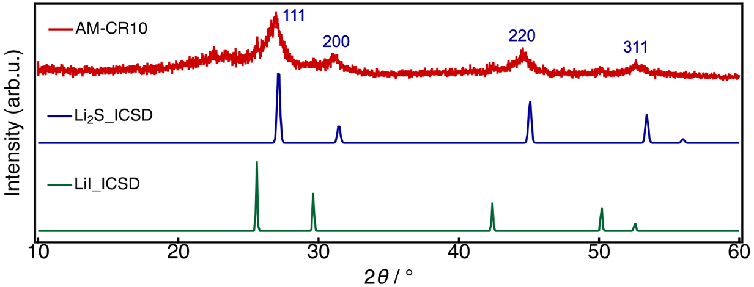

Supplementary Fig. 3 XRD patterns of the AM–CR10 composite prepared using a liquid-phase process.

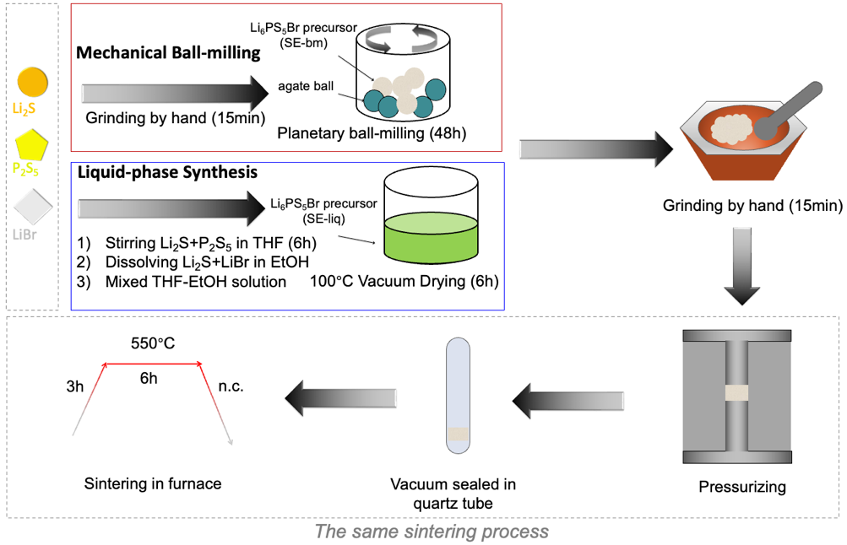

Supplementary Fig. 4 Schematics illustrating the preparation of the Li₆PS₅Br SE (SE-liq) obtained by liquid-phase synthesis and the Li₆PS₅Br SE (SE-bm) obtained by ball milling.

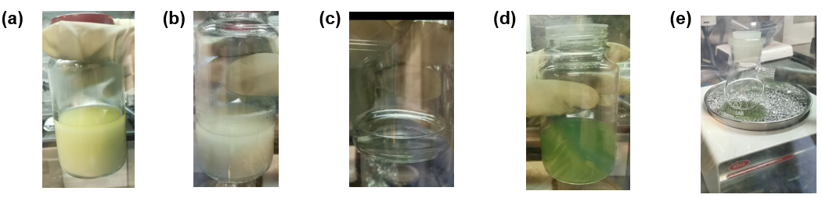

Supplementary Fig. 5 Photographs of (a) THF suspension prior to stirring, (b) THF suspension after 6 h of stirring, (c) LiBr and Li₂S in EtOH, (d) Li₆PS₅Br precursor in THF-EtOH, (e) and vacuum drying with an Al-bead heater at 100 °C for 6 h.

(a)

(b)

Supplementary Fig. 6 Synchrotron X-ray Rietveld refinement patterns of (a) Li₆PS₅Br (SE-liq) obtained via liquid-phase synthesis and (b) Li₆PS₅Br (SE-bm) acquired by ball milling. Red cross marks (+) represent the obtained datapoints, and green lines overlaying the datapoints denote the data obtained via Rietveld refinement. Vertical markers indicate the positions of possible Bragg reflections of the main argyrodite-type Li₆PS₅Br phase (green) and the minor LiBr and Li₂S phases (orange and pink, respectively). Differences between the experimental and calculated data are shown as blue profiles at the bottom.

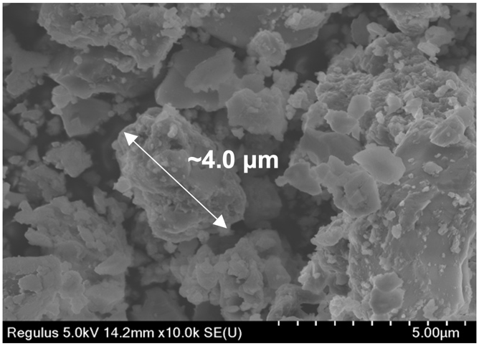
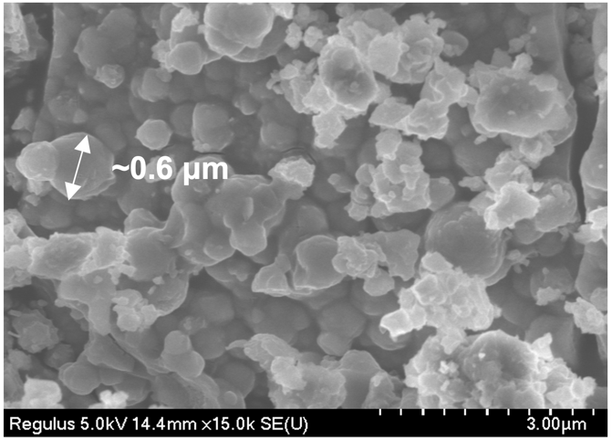
(b)
(a)

Supplementary Fig. 7 FE-SEM images of (a) Li₆PS₅Br (SE-liq) obtained via liquid-phase synthesis and (b) Li₆PS₅Br (SE-bm) prepared by ball milling.

(a)
(b)

Supplementary Fig. 8 Charge–discharge profiles of all-solid-state Li–S cells with the (a) Li₂S+SE-liq+VGCF or (b) Li₂S+SE-bm+VGCF cathode composites.

Supplementary Fig. 9 XRD patterns of ACSV and AM–CR10 composites.

(c)
(b)
(a)

(f)
(e)
(d)

Supplementary Fig. 10 (a)–(c) Nyquist plots constructed using EIS data, and (d)–(f) I–V curves acquired by potential step chronoamperometry for AM, AM–CR10, and ACSV.

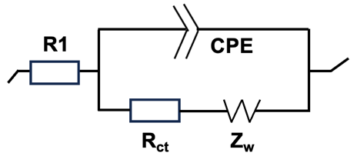
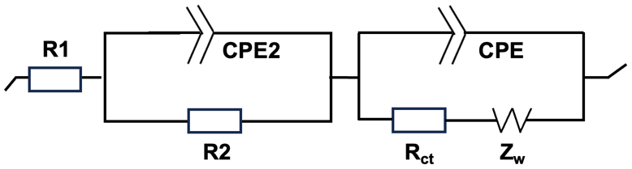
(b)
(a)

Supplementary Fig. 11 Proposed Randles equivalent circuits for the ACSV, CR10-free, and LiI/CR10-free cathodes in ASSLSBs (a) before and (b) after 50 cycles. R1 represents the ohmic resistance of the SE and cell components. R_{ct} is the charge-transfer resistance. R2 denotes the interfacial contact resistance of the electrode bulk. CPE is the constant-phase element corresponding to the double-layer capacitance. Z_{w} represents the Warburg impedance.

Supplementary Table 1 Rietveld refinement of synchrotron XRD data for the liquid-phase-synthesized Li₆PS₅Br (SE-liq) at 298 K.

Atom | Site | g | x | y | z | B / Å²
Li(1) | 48h | 0.4 | 0.3044 | 0.0253 | =1-x(Li(1)) | 4.93
Li(2) | 24g | 0.2 | 0.25 | 0.009 | =1-x(Li(2)) | 3.95
P(1) | 4b | 1 | 1 | 0.5 | 1 | 1.39
S(1) | 16e | 1 | 0.1196(1) | =-x(S(1)) | =0.5+x(S(1)) | 2.25
Br(1) | 4a | 0.551 | 1 | 1 | 1 | 2.0
Br(2) | 4d | =1-g(Br(1)) | 0.75 | 0.75 | 0.75 | 3.7
S(2) | 4a | =1-g(Br(1)) | 1 | 1 | 1 | 2.0
S(3) | 4d | =g(Br(1)) | 0.75 | 0.75 | 0.75 | 2.38
Note: space group F-43m (216), a = b = c =9.960198(7) Å, Rwp = 16.63%, S = Rwp/Re = 9.02, Rp = 11.39%, Rb = 5.91%, Rf = 4.42%. (Impurities: LiBr, 1.57 wt%; Li₂S, 3.46 wt%)

Supplementary Table 2 Rietveld refinement of synchrotron XRD data for the ball-milling-synthesized Li₆PS₅Br (SE-bm) at 298 K.

Atom | Site | g | x | y | z | B / Å²
Li(1) | 48h | 0.4 | 0.3044 | 0.0253 | =1-x(Li(1)) | 1.88
Li(2) | 24g | 0.2 | 0.25 | 0.009 | =1-x(Li(2)) | 3.95
P(1) | 4b | 1 | 1 | 0.5 | 1 | 2.39
S(1) | 16e | 1 | 0.12400(1) | =-x(S(1)) | =0.5+x(S(1)) | 3.15
Br(1) | 4a | 0.551 | 1 | 1 | 1 | 1.4
Br(2) | 4d | =1-g(Br(1)) | 0.75 | 0.75 | 0.75 | 8.67
S(2) | 4a | =1-g(Br(1)) | 1 | 1 | 1 | 1.1
S(3) | 4d | =g(Br(1)) | 0.75 | 0.75 | 0.75 | 0.08
Note: space group F-43m (216), a = b = c =9.985318(5) Å, Rwp = 8.92%, S = Rwp/Re = 5.15, Rp = 6.36%, Rb = 4.58%, Rf = 9.64%. (Impurities: LiBr, 0.64 wt%)

Supplementary Table 3 Performance comparison of the Li₂S-based cathode prepared in this study with several previously reported state-of-the-art cathodes.

Active material (Remark) | Li₂S  content  (%) | Loading  (mg cm⁻²) | Discharge capacity  (mAh g⁻¹) | Capacity after cycling  (mAh g⁻¹) | Cut-off  voltage  vs Li (V) | Ref.
Li₂S (ACSV) | 30 | 2 | 1009  (0.05C) | 650  (100th, 0.1C) | 1.2–3.1 | Present study
Li₂S (without CR10) | 30 | 2 | 651  (0.05C) | 144  (50th, 0.1C) | 1.2–3.1 | Present study
Li₂S (without LiI) | 40 | 2.7 | 298  (0.05C) | 266  (50th, 0.1C) | 1.2–3.1 | Present study
Li₂S (without LiI and CR10) | 40 | 2.7 | 203  (0.05C) | 75  (50th, 0.1C) | 1.2–3.1 | Present study
Li₂S | 40 | 1.4 | 590  (0.06C) | 764  (15th, 0.06C) | 1.5–3.5 | ⁵
Li₂S | 29 | 2.2 | 469  (0.02C) | 600  (20th, 0.02C) | 1.0–5.0 | ⁶
Li₂S | 36 | 3.6 | 407  (0.08C) | 830  (60th, 0.04C) | 1.0–3.6 | ⁷
Li₂S | 43 | 2.5 | 950  (0.05C) | 424  (100th, 0.2C) | 1.2–3.0 | ⁸
Li₂S | 30 | 2 | 828  (0.14C) | 536  (100th, 0.14C) | 1.0–3.6 | ⁹
Li₂S | 25 | 3.2 | 800  (0.03C) | 700  (10th, 0.03C) | 0.6–3.6 | ¹⁰
Li₂S (60 °C) | 65 | 0.2 | 848  (0.1C) | 594  (100th, 0.1C) | 1.5–2.8 | ¹¹

References

- Nagao, M. et al. All-solid-state lithium–sulfur batteries with three-dimensional mesoporous electrode structures. J. Power Sources 330, 120–126 (2016).
- Watanabe, R. et al. Extension of size of monodisperse silica nanospheres and their well-ordered assembly. J. Colloid Interface Sci. 360, 1–7 (2011).
- Yu, C. et al. Tailoring Li₆PS₅Br ionic conductivity and understanding of its role in cathode mixtures for high performance all-solid-state Li–S batteries. J. Mater. Chem. A 7, 10412–10421 (2019).
- Kamaya, N. et al. A lithium superionic conductor. Nat. Mater. 10, 682–686 (2011).
- Yan, H. et al. In situ generated Li₂S–C nanocomposite for high-capacity and long-life all-solid-state lithium sulfur batteries with ultrahigh areal mass loading. Nano Lett. 19, 3280–3287 (2019).
- Eom, M. et al. High performance all-solid-state lithium-sulfur battery using a Li₂S-VGCF nanocomposite. Electrochim. Acta 230, 279–284 (2017).
- Han, F. et al. High-performance all-solid-state lithium–sulfur battery enabled by a mixed-conductive Li₂S nanocomposite. Nano Lett. 16, 4521–4527 (2016).
- Xu, R. et al. Cathode-supported all-solid-state lithium–sulfur batteries with high cell-level energy density. ACS Energy Lett. 4, 1073–1079 (2019).
- Wei, C. et al. Tuning ionic conductivity to enable all-climate solid-state Li–S batteries with superior performances. Mate. Adv. 3, 1047–1054 (2022).
- Nagao, M., Hayashi, A. & Tatsumisago, M. High-capacity Li₂S–nanocarbon composite electrode for all-solid-state rechargeable lithium batteries. J. Mater. Chem. 22, 10015–10020 (2012).
- Lin, Z., Liu, Z., Dudney, N. J. & Liang, C. Lithium superionic sulfide cathode for all-solid lithium–sulfur batteries. ACS Nano 7, 2829–2833 (2013).

