Extended Data
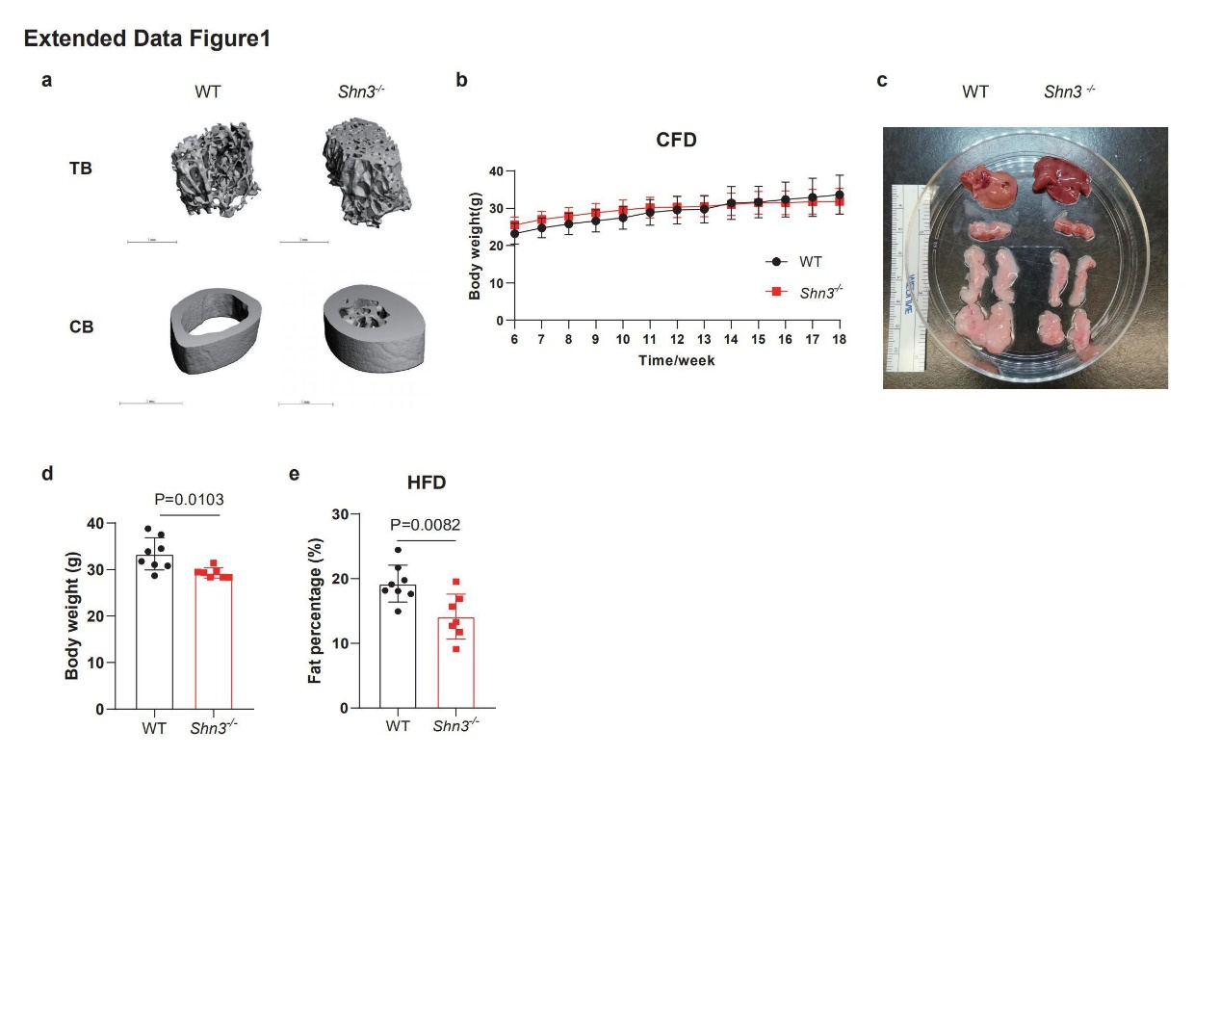
Extended Data Figure 1 Shn3^{-/-} mice are resistant to DIO with dysfunctional glucose homeostasis
(a) μCT representative images of trabecular (TB) and cortical bone (CB) of WT and Shn3^{-/-} mice. (b) Body weight curve of control-fat-diet fed WT and Shn3^{-/-} mice (n=5). (c) General view of liver, BAT, iWAT and eWAT of WT and Shn3^{-/-} Balb/c background mice after 12-week HFD feeding. (d) End point body weight of 12-week HFD-fed WT and Shn3^{-/-} Balb/c mice. (e) Body composition of WT and Shn3^{-/-} Balb/c background mice through echo-MRI. Results were presented as mean ± s.d., analyzed by unpaired, two-tailed Student’s t test (d, e) or two-way ANOVA with Bonferroni’s multiple comparisons test (b).

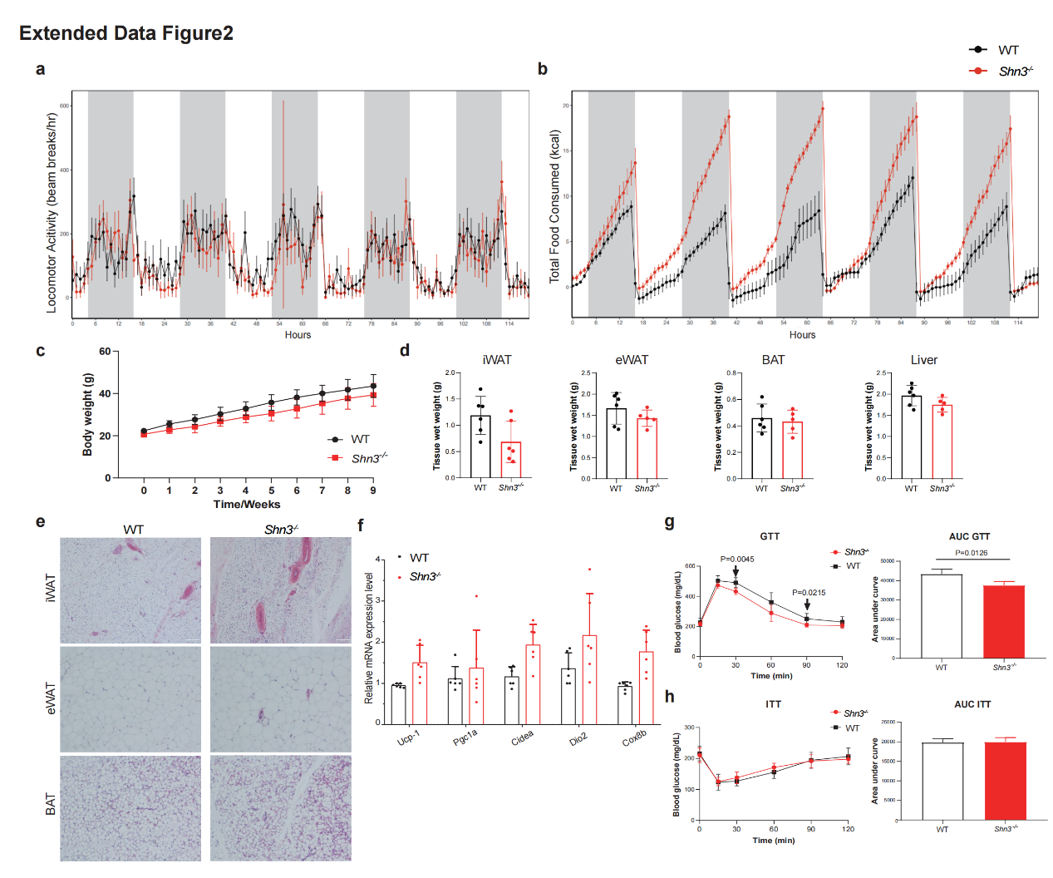
Extended Data Figure 2 Increased energy expenditure and WAT browning in Shn3^{-/-} mice
(a) Locomotor activity and (b) total food consumption of HFD-fed WT and Shn3^{-/-} mice.
For thermoneutral housing experiments, data and samples were collected from C57BL6/J background littermate male WT (n=6) and Shn3^{-/-} mice (n=6) after HFD feeding under thermoneutral condition (housing temperature 30ºC) for 10 weeks. (c) Body weight curve obtained during 10 weeks HFD feeding started from 6-week-old age. (d) Tissue wet weight of liver, BAT, iWAT and eWAT of WT and Shn3^{-/-} mice. (e) Representative histological sections of iWAT, eWAT, BAT and liver. Scale bar=200um. (f) Expression level of thermogenic genes in iWAT from WT and Shn3^{-/-} mice measured by qPCR. (g) Representative H&E staining of pancreas islet. (h) IGTT and ITT results of HFD-fed WT and Shn3^{-/-} mice. Results were collected from 6 repeated experiments. Results were presented as mean ± s.d., analyzed by unpaired, two-tailed Student’s t test (d and right of g-h) or two-way ANOVA with Bonferroni’s multiple comparisons test (a-c and left of g-h).

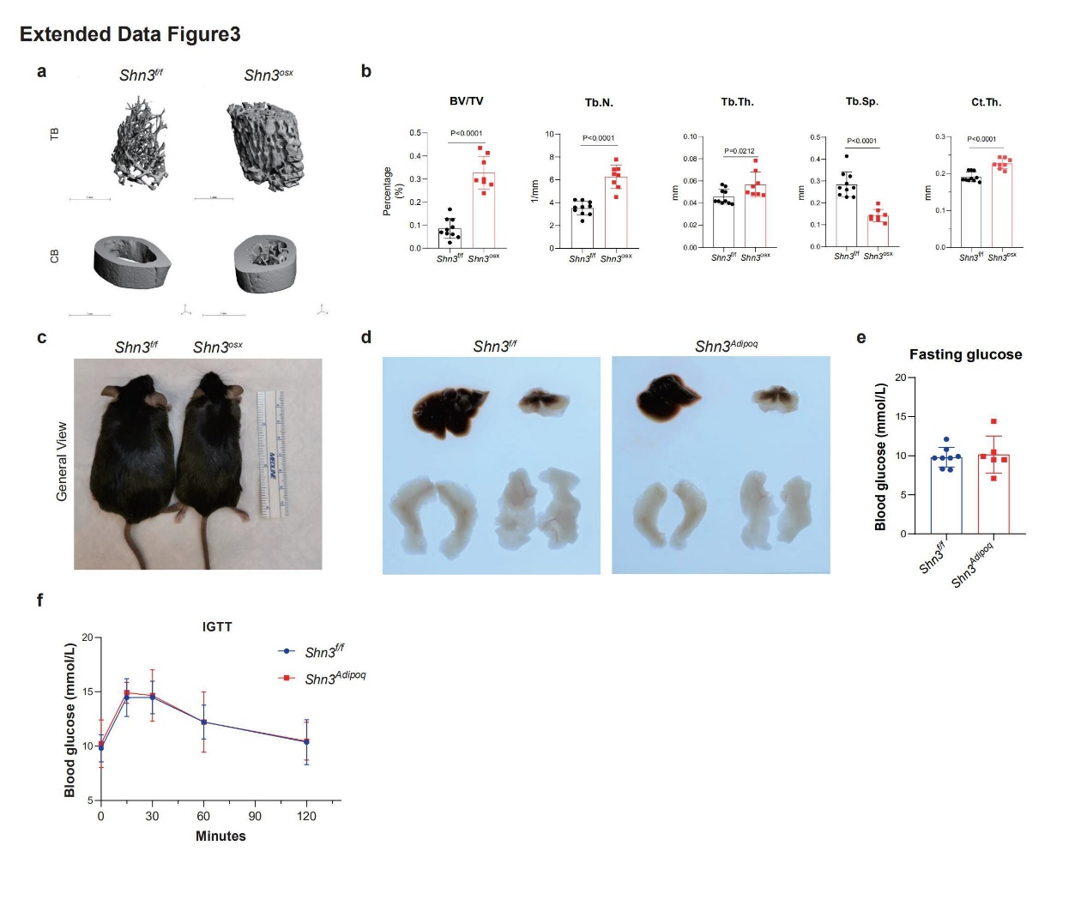

Extended Data Figure 3 Deletion of Shn3 in osteoblasts but not adipocytes recapitulates resistance to DIO
(a) μCT representative images of trabecular (TB) and cortical bone (CB) of Shn3^{Osx} and Shn3^{f/f} mice. (b) μCT analysis of bone volume/total volume (BV/TV), trabecular number (Tb.N.), trabecular thickness (Tb.Th.), trabecular spacing (Tb.Sp.) and cortical thickness (Ct.Th.) from Shn3^{Osx} and Shn3^{f/f} mice femurs. (c) Gross observation of Shn3^{Osx} and Shn3^{f/f} mice after 12-week HFD feeding. (d) Gross view of Liver (upper left), BAT (upper right), iWAT (lower left) and eWAT (lower right) from Shn3^{Adipoq} and Shn3^{f/f} mice after 12-week HFD exposure. (e) Fasting glucose levels and (f) IGTT results of HFD-fed Shn3^{Adipoq} and Shn3^{f/f} mice. Results were presented as mean ± s.d., analyzed by unpaired, two-tailed Student’s t test (b, e) or two-way ANOVA with Bonferroni’s multiple comparisons test (f).

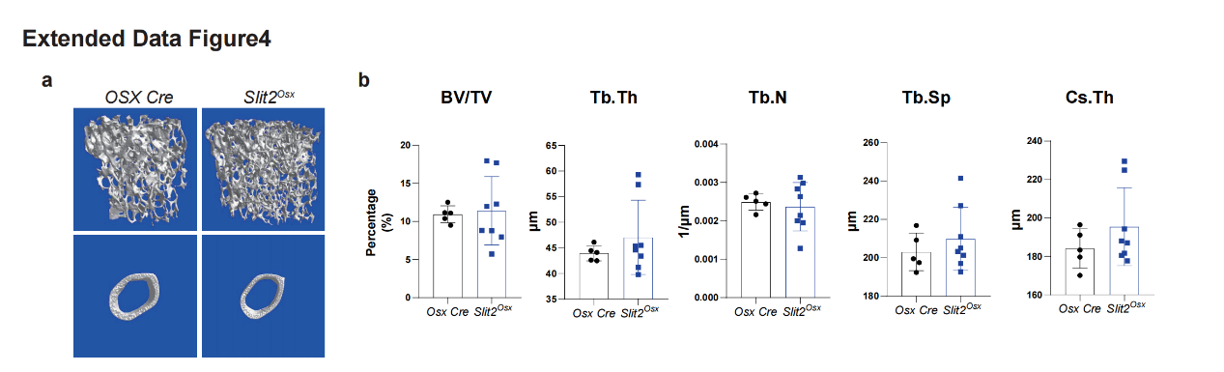

Extended Data Figure 4 SLIT2 is an osteokine secreted by osteoblasts that protects mice from DIO
(a) μCT reconstruction of trabecular (TB) and cortical bone (CB) of HFD-fed Slit2^{Osx} and Osx Cre mice. (b) Bone μCT analysis of HFD-fed Slit2^{Osx} and Osx Cre mice. Results were presented as mean ± s.d., analyzed by unpaired, two-tailed Student’s t test (B).

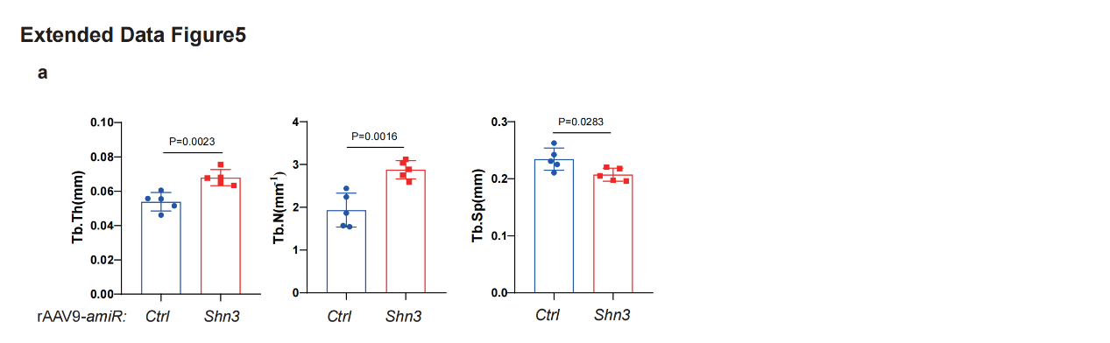
Extended Data Figure 5 AAV-mediated skeletal SHN3 depletion reduced development of DIO and metabolic syndrome
(a) Analysis of μCT reconstruction results showing trabecular number (Tb. N), trabecular thickness (Tb. Th) and trabecular separation (Tb. Sp) of rAAV9-amiR-Shn3 and rAAV9-amiR-Ctrl injected mice. Results were presented as mean ± s.d., analyzed by unpaired, two-tailed Student’s t test (A).

Gene symbols | Forward sequence | Reverse sequence
Gapdh | CATCACTGCCACCCAGAAGACTG | ATGCCAGTGAGCTTCCCGTTCAG
Ucp1 | GCTTTGCCTCACTCAGGATTGG | CCAATGAACACTGCCACACCTC
Pgc1a | TATGGAGTGACATAGAGTGTGCT | CCACTTCAATCCACCCAGAAAG
Cidea | GGTGGACACAGAGGAGTTCTTTC | CGAAGGTGACTCTGGCTATTCC
Dio2 | GGTGGTCAACTTTGGTTCAGCC | AAGTCAGCCACCGAGGAGAACT
Cox8b | GCGAAGTTCACAGTGGTTCC | GGAACCATGAAGCCAACGAC
Acads | GACTGGCGACGGTTACACA | GGCAAAGTCACGGCATGTC
Acadm | AGGATGACGGAGCAGCCAATGA | GCCGTTGATAACATACTCGTCAC
Acadl | GGCGATTTCTGCCTGTGAGTTC | GCTGTCCACAAAAGCTCTGGTG
Acadvl | GAGAAGGTGGAGGACGACACTT | CACAATCTCTGCCAAGCGAGCA
Cpt1a | GGCATAAACGCAGAGCATTCCTG | CAGTGTCCATCCTCTGAGTAGC
Hadha | GTTTGAGGACCTCGGTGTAAAGC | GAGAGCAGATGTGTTGCTGGCA
CD36 | GGACATTGAGATTCTTTTCCTCTG | GCAAAGGCATTGGCTGGAAGAAC

Extended Data Table 1 Primer list for qPCR analysis

