Appendix

Appendix Figure 1. Power at interim analysis of Scenario A by methods (Pocock).
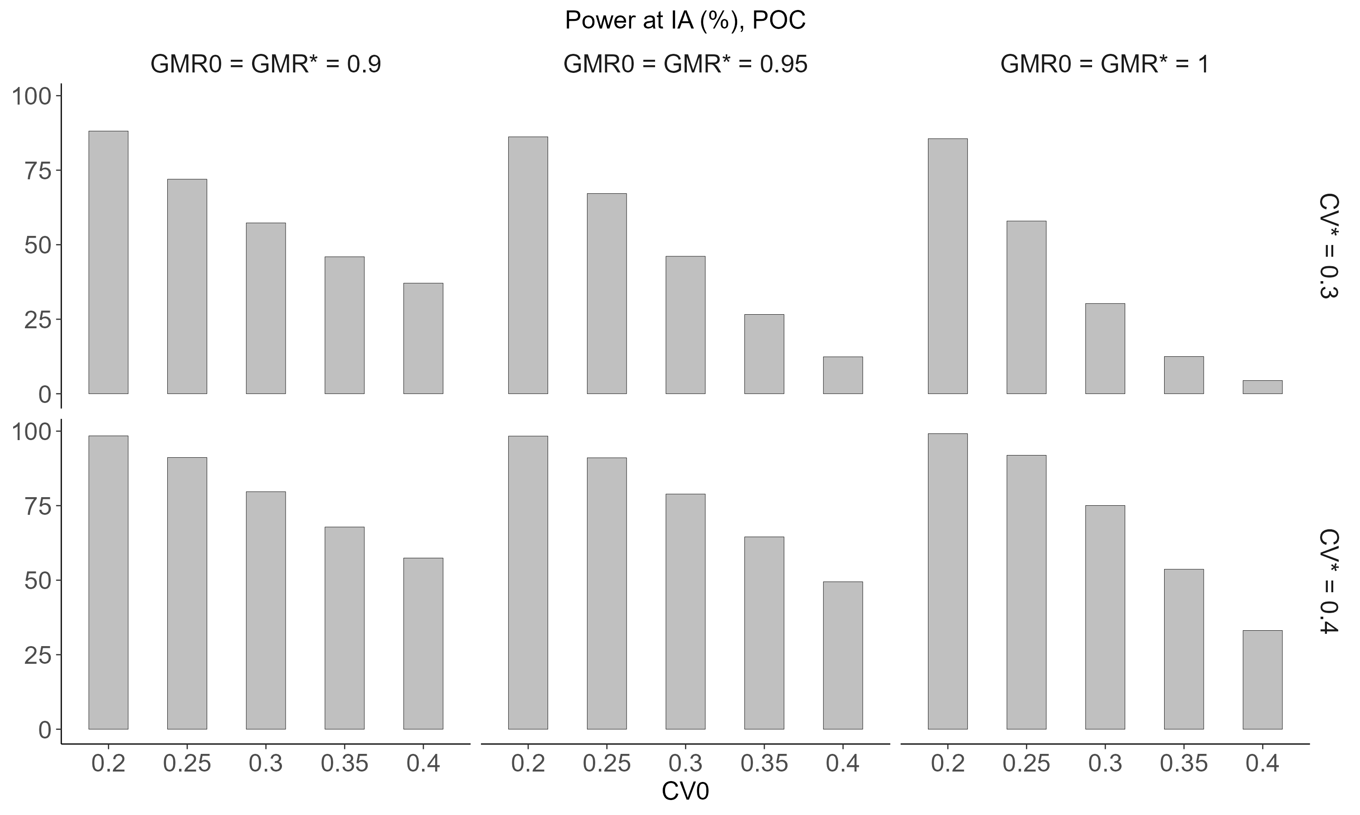
Appendix Figure 2. Power at interim analysis of Scenario B by methods (Pocock).
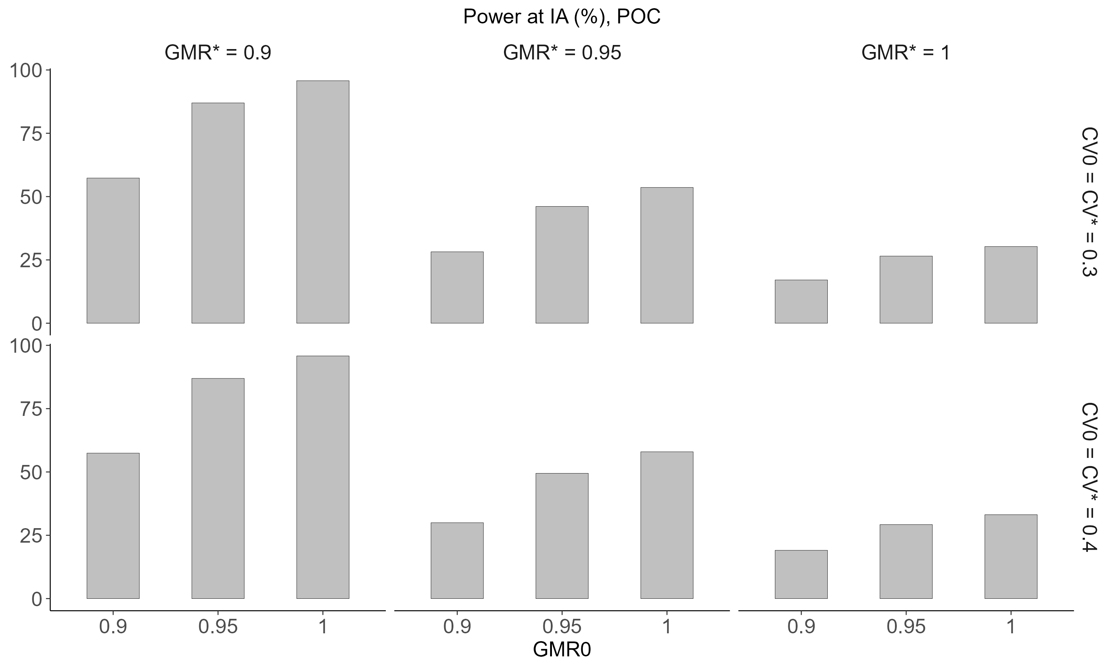

Appendix Figure 3. Power at interim analysis of Scenario C by methods (Pocock).
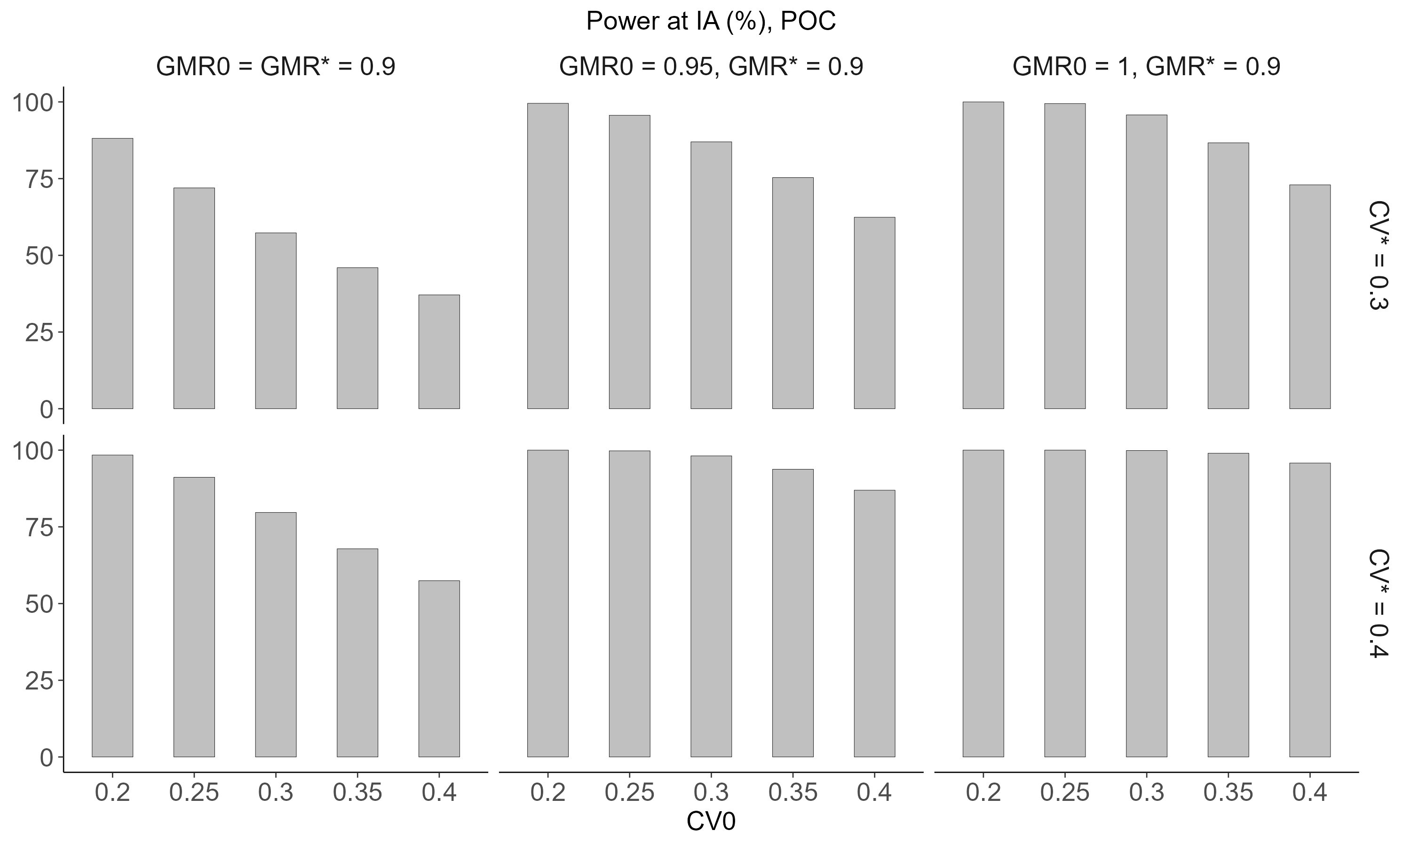
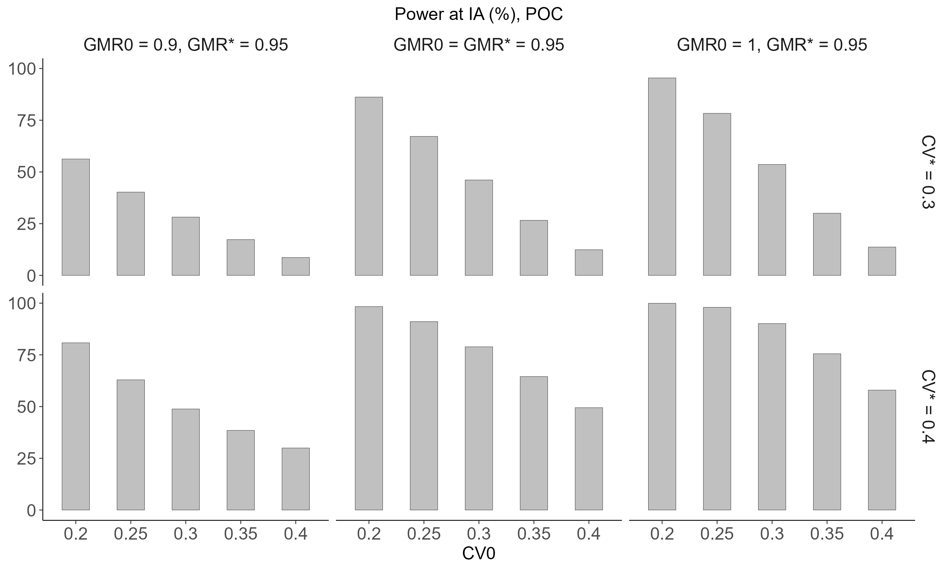
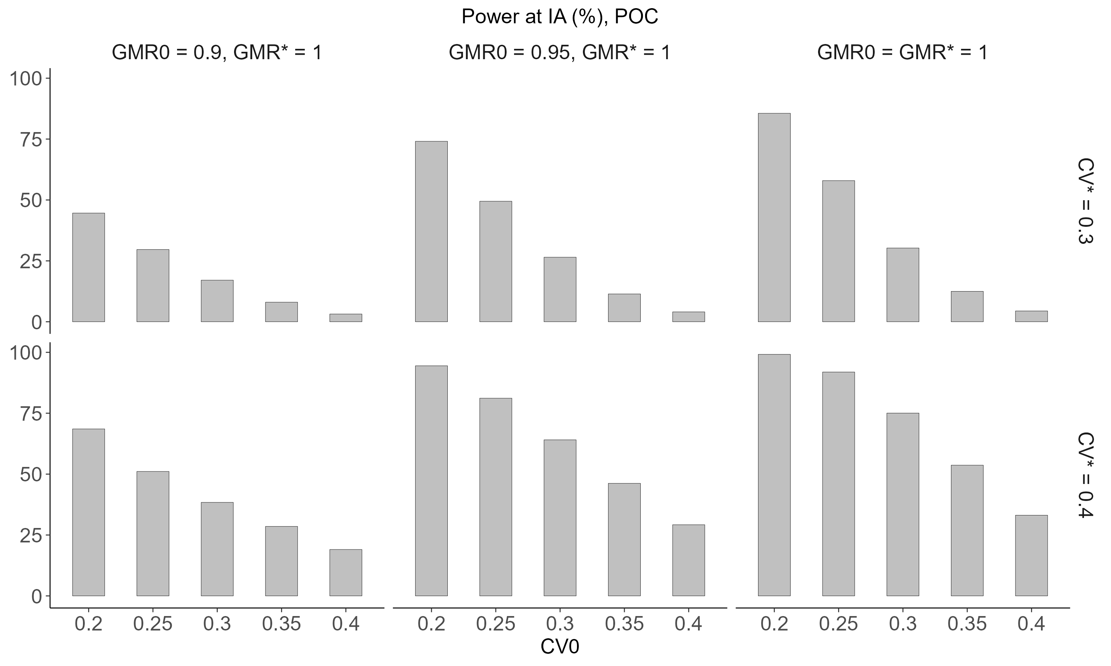
Appendix Figure 4. Power at interim analysis of Scenario A by methods (O’Brien-Fleming).
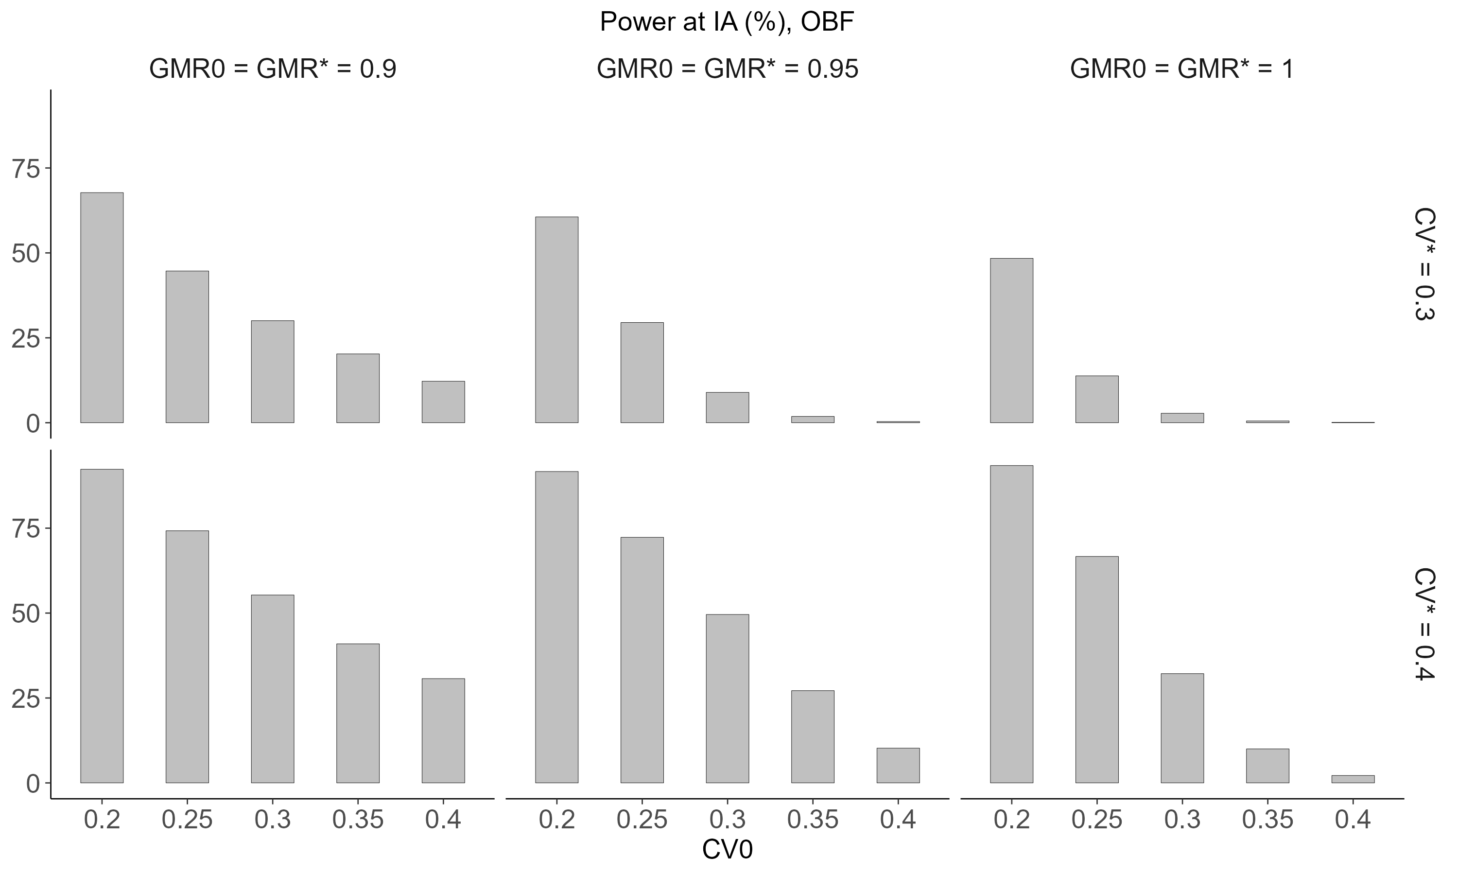

Appendix Figure 5. Power at interim analysis of Scenario B by methods (O’Brien-Fleming).
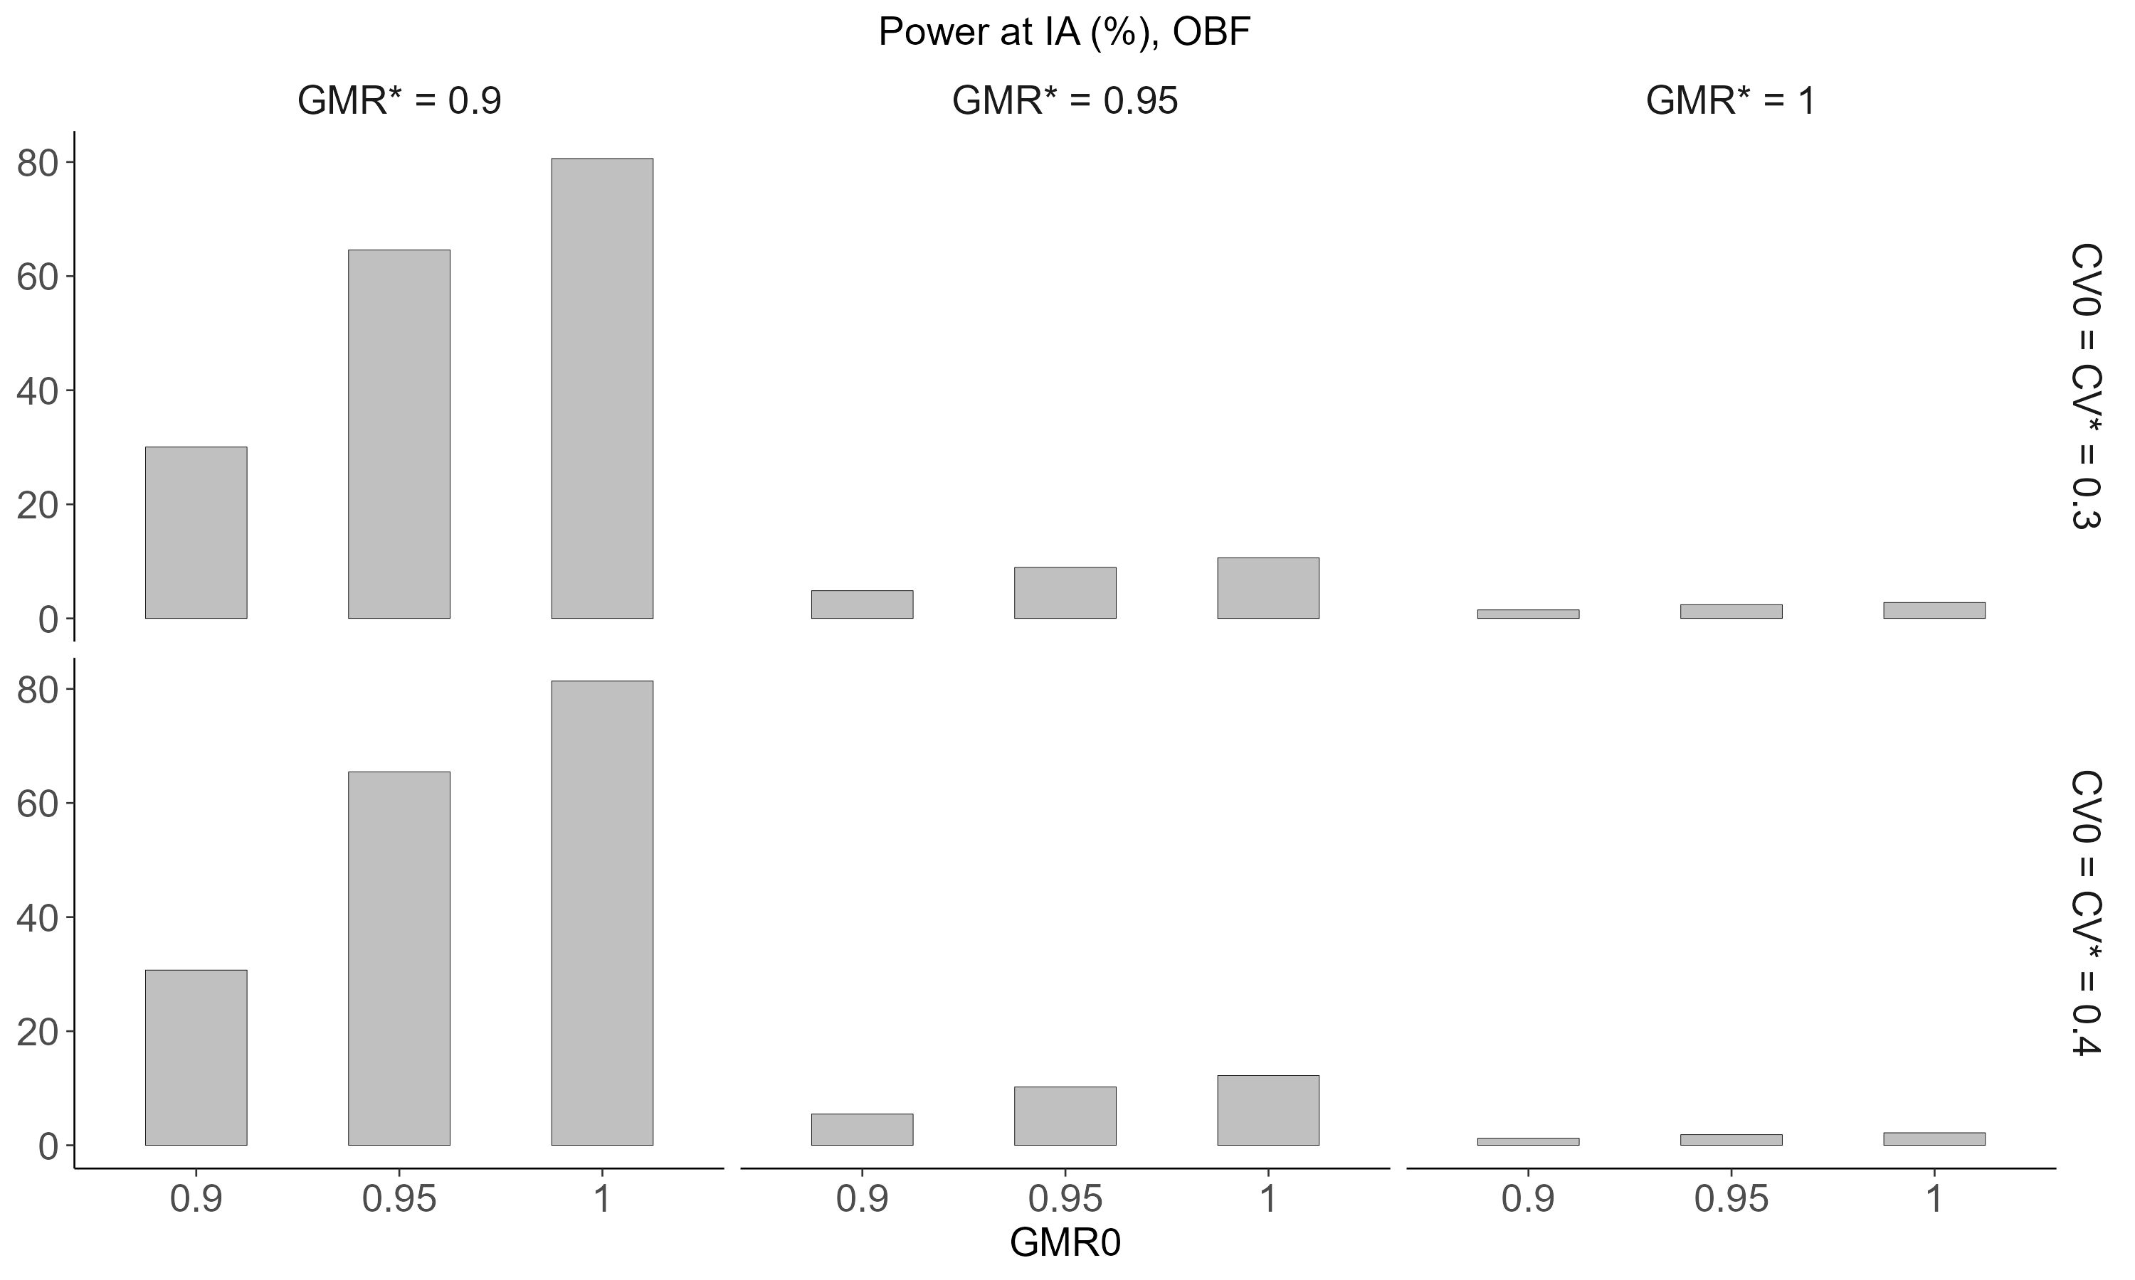
Appendix Figure 6. Power at interim analysis of Scenario C by methods (O’Brien-Fleming).
