Supplementary Information
for
Electrolyte Depletion Triggers Vicious Circles in Fast-Charging Batteries

Dechao Meng,¹ Zhichen Xue,² Guokang Chen,¹ Dengke Zhou,¹ Yu-Shi He,¹ Yijin Liu,^{2, *} Zi-Feng Ma,¹ Linsen Li^{1,} *

¹ Department of Chemical Engineering, Shanghai Electrochemical Energy Devices Research Center, School of Chemistry and Chemical Engineering, Shanghai Jiao Tong University, Shanghai 200240, China
² Walker Department of Mechanical Engineering, The University of Texas at Austin, Austin, Texas 78712, USA

Corresponding author’s email: yijin.liu@austin.utexas.edu (Y. Liu), linsenli@sjtu.edu.cn (L. Li)

Supplementary Methods
Electrochemistry tests:
Commercial 2 Ah cylindrical 18650-type cells from a reputable battery manufacturer was chosen for this studies. The fast charging (2 C) rate and slow charging rate (0.5 C) were selected for comparison during the electrochemical experiments, with 2.5-4.2 V charging and discharging voltage range, and 0.05 C current rate cut-off, 15 min rest to reduce the heat effect, using a Neware 5 V/6 A Battery Test System.

Micro-CT characterizations:
Three fast-charged batteries at different cycles (200th, 400th, and 500th) were chosen for the Micro-CT tests. These batteries were stopped at the discharged state at 2.5 V. The 3D Micro-CT tomography profiling was performed on a lab-based system (Zeiss Xradia 520, Carl Zeiss). The X-ray beam parameters comprised an emission energy set at 140 keV and a power of 10 mW. Subsequently, fine-tuning was carried out, which involved manipulating the distance between the emission source, detector, and the battery to obtain a voxel resolution of 20 μm and a field of view of 2 mm × 2 mm. A total of 3601 consecutive slices were acquired over 180° rotations, with each slice exposed to the X-ray beam for 1.5 s. Different components in the slice were recognized using Matlab (codes available upon reasonable request) based on the X-ray intensity. The electrode center for each circle was exported by fitting the electrode curve via Gaussian function, then the layer spacing between electrode was calculated. The curvature of cathodes was measured using the curvature analysis function in ImageJ.

Disassembly and SEM-EDX characterization:
After the micro-CT tests, the cathode, anode, and separator of each cycled battery were obtained by disassembling in an Ar-filled glovebox (H₂O < 0.1 ppm; O₂ < 0.1 ppm). Optical photos of the three key components were taken immediately. Some region of interest from the anode was cut off using scissors and washed carefully by dimethyl carbonate to remove the electrolyte and LiPF₆. Finally, surface composition analysis of anode electrode was conducted on field-emission SEM (RISE MAGNA, Tescan). A vacuum transfer holder was used, which was open under 1000 Pa in the SEM chamber and could help maintained the plating lithium on the anode surface unchanged. Both SE and BSE SEM images of surface tomography were acquired, using SE mode to take clear SEM images of graphite and surface deposits, and using the BSE mode to recognize the depositions contain metal elements. EDX elements analysis of the depositions were taken by 20 kV accelerating voltage.

Cross-sectional multimodal characterizations:
All samples were washed several times by dimethyl carbonate in argon-filled glovebox. Then the samples were polished by three Ar⁺ ion beams on the EM TIC 3X (Leica) ion-milling instrument to get the smooth and flat cross-sections. The multi-modal studies were conducted on Tescan SEMs (RISE MAGNA and GAIA instruments), in order to gain the particle tomography, crystal structure, and Li element concentration for the same region of interest. Firstly, a SEM image of 8 k resolution was captured on RISE MAGNA, using 5 kV electron accelerating voltage and under In-Chamber BSE imaging mode. Then, the same sample was moved coaxially under the Raman 100X objective lens, keeping the same interested area directly shown as optical image. Optimized test conditions were selected to conduct single point Raman scanning for cross-sectional particle, with the parameters of 532 nm laser, 1.25 mW laser power, total 60 s integration time, 600 g/mm grating, which ensured that the particles were un-damaged and high-quality Raman spectra. Typically, ~100 particles were chosen to do single point scanning for each cross-section. Statistical analysis of the multi-particles was done after background removal, data-smoothing, and normalization. The distance of particle to electrode surface were measured using the line profile function in ImageJ. Another FIB-SEM-ToF/SIMS SEM (TESCAN GAIA) was used to acquire the relative lithium concentration from the cross-sections of the particles from the same region of interest. Focused Ga⁺ was used as sputtering ion beam to sputter the sample and to produce the secondary Li⁺ ions. The same cross-sectional interested area was located under the SEM mode and then tilted 45°-perpendicular to the ion beam to perform the ToF/SIMS mapping experiments. To obtain data that can be analyzed statistically, consistent and rigorous testing parameters and operations were followed. After the optimization, the parameters were as follows: positive test mode was chosen to detect the secondary Li⁺ ion, 30 kV-500 pA ion beam was adjusted to gain high yield of secondary Li⁺ ion at 70 nm spatial resolution. A typical scanning area of 100 × 100 μm² was set to reduce shadow effect and to obtain 50-100 particles Li distribution for statistics analysis. 20 sputtering frames was controlled to get stable secondary Li⁺ ion yield. For further statistical analysis of the data, Matlab codes (available upon request) were written to remove background and signal noise caused by the edge effect, and extract lithium concentration from the region of interest.

Surface characterizations:
Time-of-flight secondary-ion mass spectrometry (ToF-SIMS) depth-profiling was performed on ToF-SIMS 5-100 spectrometer (ION-TOF GmbH, Germany), utilizing Bi³⁺ analysis ion-beam, and Cs⁺ sputtering ion beam as detection enhancement for negative or positive secondary-ion fragments. All samples were washed multiple times using dimethyl carbonate to remove electrolytes and surface impurities. Then, the samples were dried at 80℃ for 12 h under argon, and subsequently moved to the ToF-SIMS chamber via a transfer holder. The ToF-SIMS depth profiling experiments were conducted in an ultra-high vacuum environment with a pressure of 2 × 10⁻⁹ mbar, in order to acquire data suitable for semi-quantitative analysis. Negative mode was selected, with a typical scanning area of 100 × 100 μm² using a 30 keV Bi³⁺ ion beam at a 45° injection angle, and the sputtered area was 300 × 300 μm² using a 2 keV Cs⁺ ion beam injected at 45°. The integrated yields of secondary-ion fragments of interest were determined by calculating the full-width-half-maximum (FWHM) area under the depth curve of the fragment profiles.

Characteristics of the thermal runaway:
The thermal-safety behaviors of the cycled batteries were characterized by an ARC (Extended Volume Plus Accelerating Rate Calorimetry, Thermal Hazard Technology). The cycled batteries were charged to 4.2 V before the ARC tests. The thermocouple was placed on the battery to obtain an accurate temperature. The curves of heat rate were examined by the ARC in the exothermal mode. The thermal runaway tests were proceeded in heating (with the heating step of 5 °C, waiting and seeking mode to search the specific temperature of self-heating). Once the heat rate of the cells increased to 0.02 °C·min⁻¹, the apparatus switched to the adiabatic mode.

Supplementary Figures

Supplementary Figure 1 The direct current internal resistance (DCIR) as a function of cycle number between the fast-charge (2 C-2 C) and the slow-charge (0.5 C-0.5 C) cells.

Supplementary Figure 2. Cathode-layer spacing distances in directions vertical to (a) and in parallel with (b) the aluminum tab for the 200th and 400th cycled batteries. (c), (d) and (e) are xy-slice X-ray CT images at different cycles. L1 and L2 are the two directions we calculated the cathode-layer spacing distance and local curvature.

Supplementary Figure 3. SEM image of non-metal compounds depositions on the surface of graphite cathode.
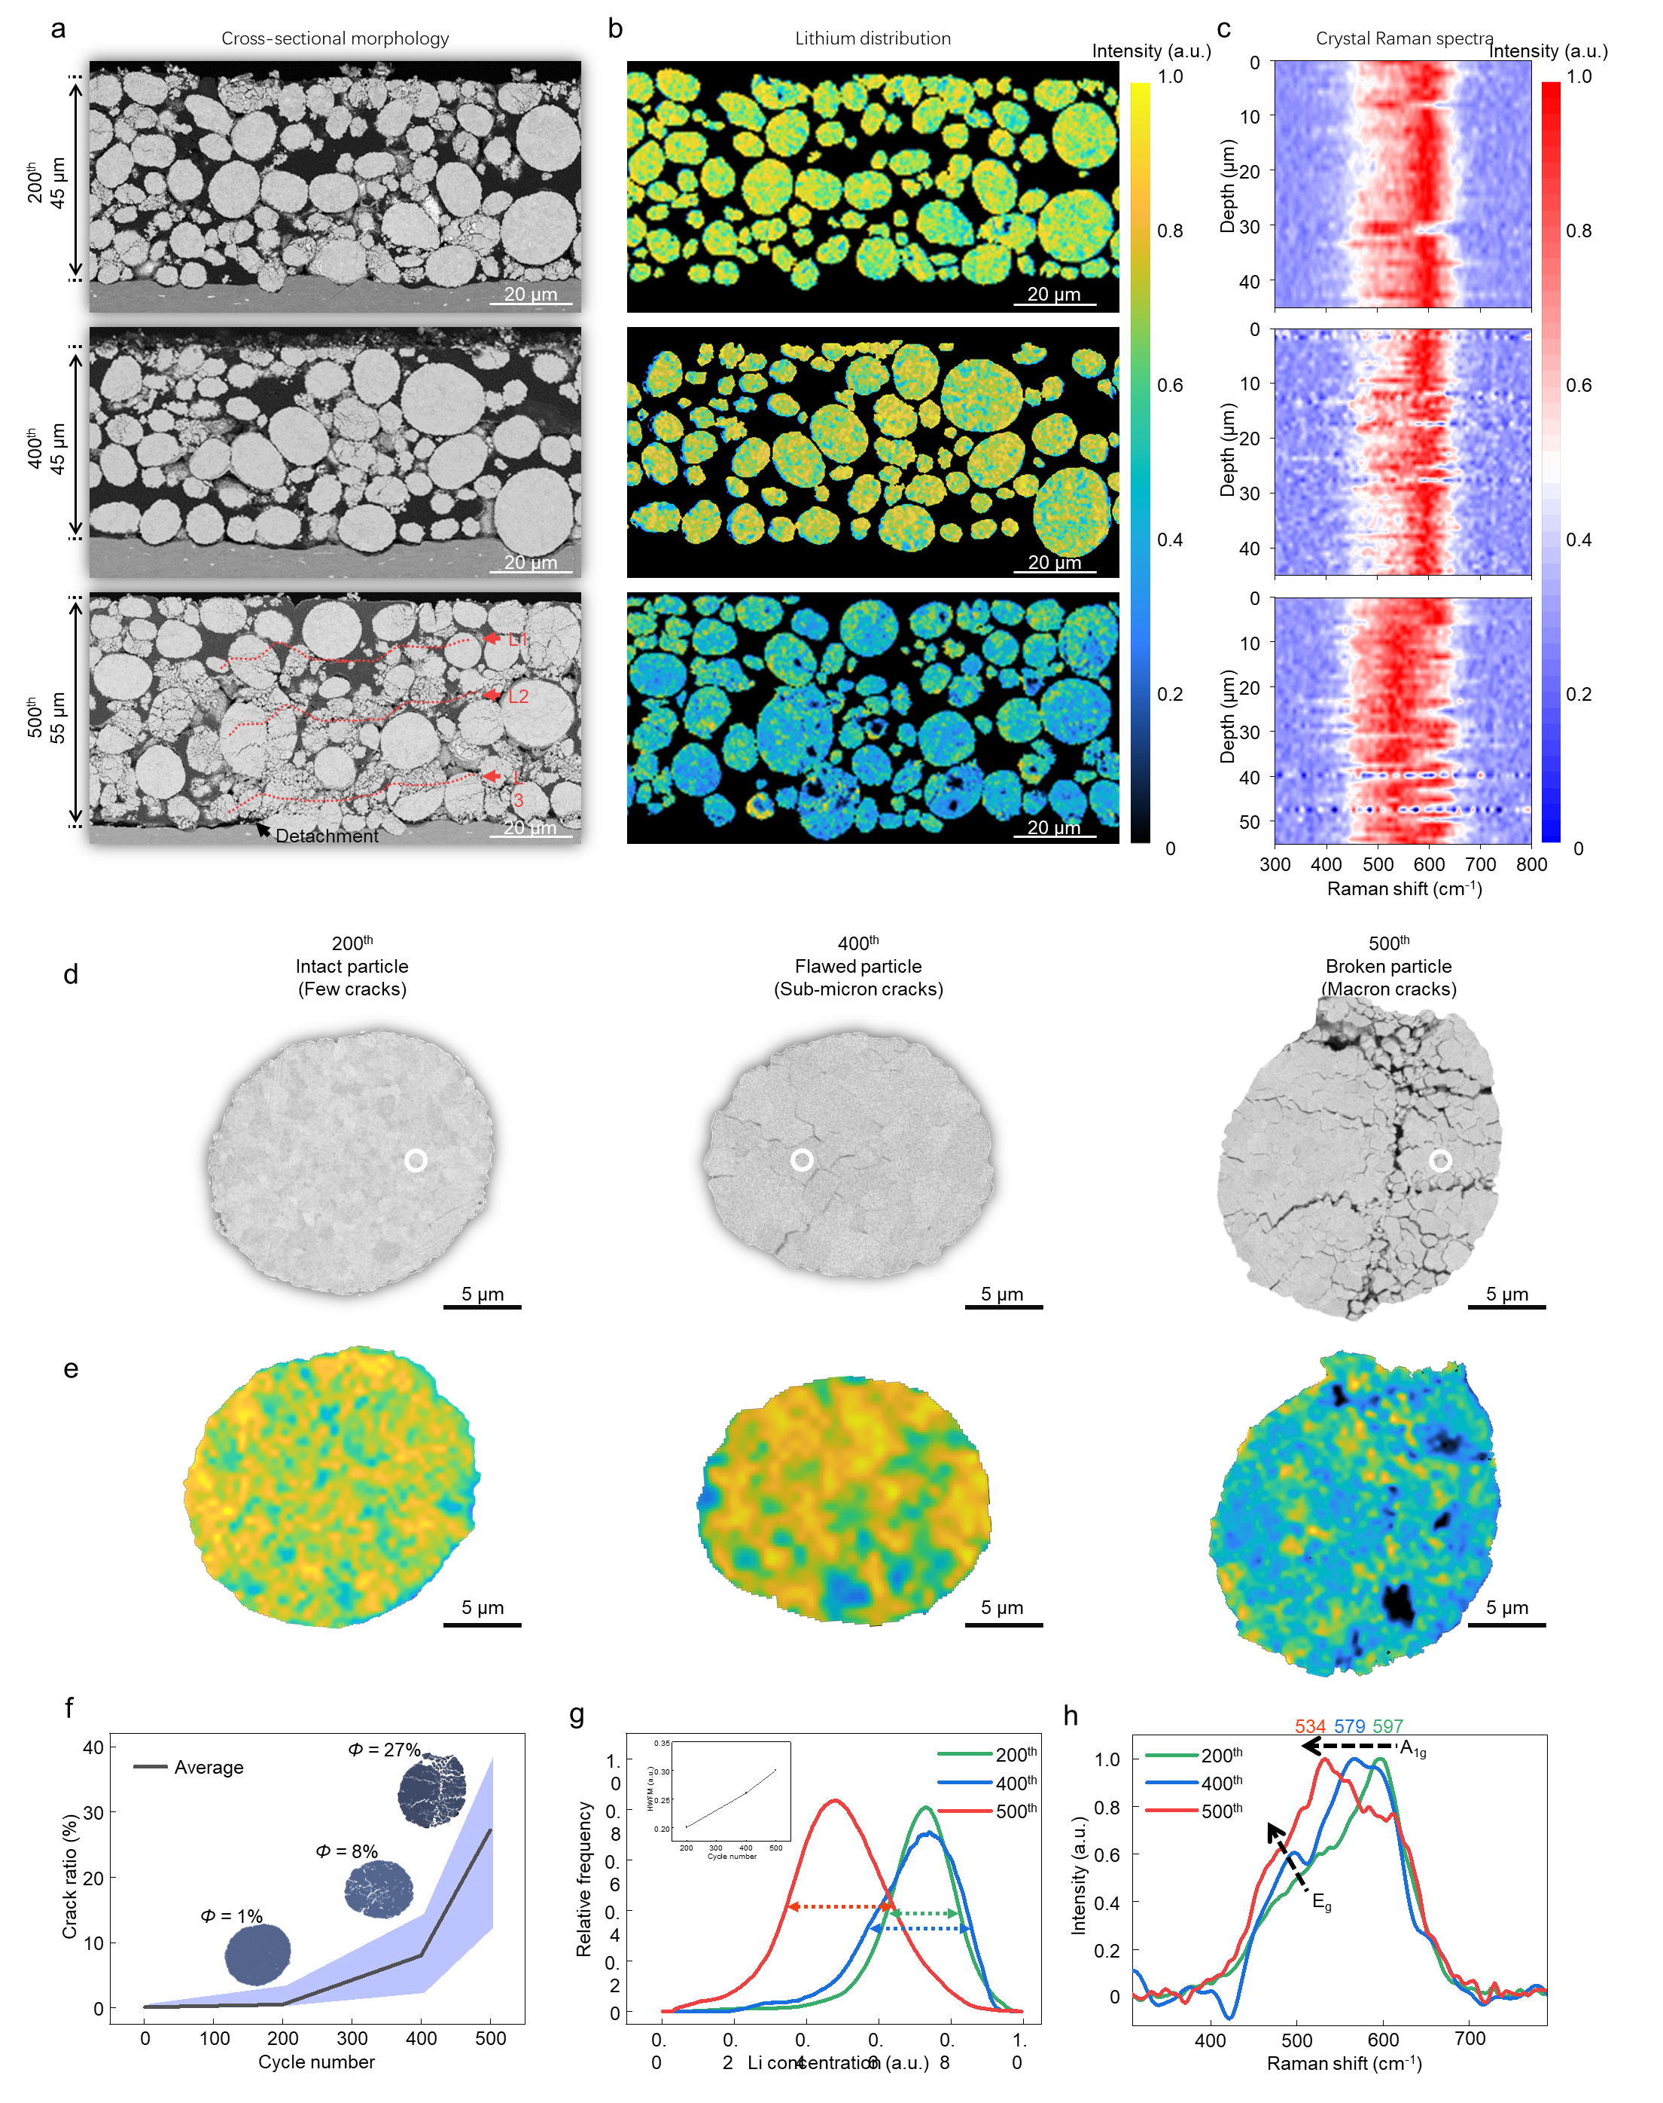
Supplementary Figure 4. a) Cross-sectional SEM morphologies of the cathodes. b) NanoSIMs images of Li distribution of the same area in (a). (c) Raman spectra along the depth direction, which were obtained from the same area in (a). (d) Cross-sectional SEM images of typical NCM particles for the 200th, 400th, and 500th cathodes. (e) Li distribution maps of typical NCM particles. (f) NCM particle crack ratio as a function of cycle number, using the three particles in panel (d) as explanatory examples. (g) The distribution of lithium concentrations in the three NCM particles shown in panel (e). (h) Raman spectra collected from the region shown in panel (d), marked by the white circles.
Supplementary Figure 5. (a) ARC test results from slow (0.5 C-0.5 C cycling) and fast-charge (2C-2C cycling) batteries. The ARC tests were done at the charged states. (b) Tempetature increasing rate versus battery temperature during the ARC tests. (c) Three characteristic temperatures (T1, T2, and T3) for the slow-charge and fast-charge batteries. T1 is the onset temperature for the detectable self-heat generation. T2 is the trigger temperature for thermal-runaway (dT/dt > 1°C/min). T3 is the maximum temperature that the battery can reach during a thermal-runaway. It can be seen that the fast-charge battery started self-heating at 52 °C and reached a much higher temperature during the thermal runaway (501 °C). The safety of the battery was likely compromised by the severe electrode distortion observed in Figure 2c and 2h.

Supplementary Tables

Supplementary Table 1. The specifications of the 18650-type batteries used in this study.
No. | Item | Specification
1 | Nominal Discharge Capacity | 2000mAh
1 | Nominal Discharge Capacity | Charge: 1A, 4.20V, CCCV 100mA cut-off
1 | Nominal Discharge Capacity | Discharge: 0.4A, 2.50V DC cut-off
2 | Nominal Voltage | 3.60V
3 | Standard Charge | CCCV, 1A, 4.20±0.05V, 100mA cut-off
4 | Rapid Charge | CCCV, 4A, 4.20±0.05V, 100mA cut-off
5 | Standard Discharge | DC, 0.4A, 2.50V cut-off
6 | Max. Continuous Discharge | DC, 30A, 2.50V cut-off (cut-off temperature 80°C)
7 | Charge/Discharge Voltage Range | 4.20~2.50V
8 | Initial Internal Impedance | ≤ 18mΩ
9 | Cell Weight | 45.0g Max (~42-43 g)
10 | Cell Dimension | Height: 65.00±0.15mm
10 | Cell Dimension | Diameter: 18.35±0.10mm
11 | Operation Temperature | Ambient Temperature：
11 | Operation Temperature | Charge: 0 to 45°C
11 | Operation Temperature | Discharge: -20 to 60°C

Supplementary Table 2. Comparison of key parameters of the normal cell and the cell with additional electrolyte.
No. | Items | Normal Cells | Cells with additional electrolyte
1 | total mass/g | 42.59 | 43.08
2 | cathode mass/g | 15.86 | 15.83
3 | anode mass/g | 13.08 | 13.10
4 | electrolyte mass/g | 3.90 | 4.72
5 | cathode thickness/μm | 107 | 100
6 | anode thickness/μm | 108 | 110

