Photoformation of EPFRs during phototransformation of polycyclic aromatic hydrocarbons (PAHs) on particles in an aqueous solution: The hydrogenation of PAHs and effect of co-existing water matrix factors

Xintong Li †, Baocheng Qu§, ††, Jingyao Wang†, Hongxia Zhao *, †

† Key Laboratory of Industrial Ecology and Environmental Engineering (Ministry of Education), School of Environmental Science and Technology, Dalian University of Technology, Linggong Road 2, Dalian 116024, China
§Dalian Ocean University, Dalian 116023, China
††Key Laboratory of Environment Controlled Aquaculture, Ministry of Education, Dalian 116023, China

#Corresponding author phone: +86-411-84706552; Fax: +86-411-84706552
Email: hxzhao@dlut.edu.cn
Supplemental Information
Text S1
Target standards including 15 PHA congeners, including acenaphthylene (ACY), acenaphthene (ACE), fluorene (FLU), phenanthrene (PHE), anthracene (Ant), fluoranthene (FLA), pyrene (PYR), benzo[a]anthracene (BaA), chrysene (CHR), benzo[b]fluoranthene (BbF), benzo[k]fluoranthene (BkF), benzo[a]pyrene (BaP), dibenz[a,h]anthracene (DahA), indeno[1,2,3-c,d]pyrene (IcdP) and Benzo[g,h,i]perylene (BghiP), and surrogate standard ACE-d10, and 2,2-Diphenyl-1-picrylhydrazyl (DPPH) standard were all purchased from Aladdin Co. Ltd. (Shanghai, China). Purities of all the standards were higher than 95%. Also, Analytical grade chemicals, including anhydrous sodium sulfate, (Na₂SO₄) (60 mesh), were purchased from Sigma-Aldrich (St. Louis, MO, USA). Neutral silica gel (70–230 mesh) was purchased from Thermo Fisher Scientifc Co.

Text S2
Fe(III)-montmorillonite simulated samples were prepared mainly followed the methodology of Jia et al.(Jia et al., 2019b; Jia et al., 2018). Montmorillonite was cleaned in ultrapure water at a ratio of 1:20 (w/w) (solid/liquid) and stirred for 8 hours. After centrifugation for 6 minutes at a 100g speed, 0.5 mol/L sodium acetate buffer was dropwise added until the pH of the suspension maintained below 6.8 for 2 hours. Then 0.1 mol/L NaCl solution was added after centrifugation at 3300g speed for cation exchange on montmorillonite. Samples were centrifuged again before freeze-dried at -4°C for 48 hours. The treated montmorillonite was passed through a 200-mesh sieve and 0.05 mol/L FeCl₃ solution was mixed with the montmorillonite and stirred for 8 hours to prepare the Fe(III)-montmorillonite simulated samples. The samples were immediately freeze-dried and stored in polyethylene bottles. The pH of the actual samples was around 8.80-8.83 and the Fe(III)-montmorillonite samples was around 4.65-4.68. Other relevant characterization results were reported in our previous manuscript(Li, X. et al., 2022).

Text S3
A Bruker A200 electron paramagnetic resonance spectrometer (Karlsruhe, Germany) equipped with an ER075 magnet (65 mm pole cap distance) and an ER 4102ST cavity were used for X-band EPR spectroscopic measurements. All the EPR determinations were undertaken at ambient temperature. Instrument parameters were set as following: center field at 3361 G, X-band microwave frequency of 9.43 GHz, microwave power of 0.20 mW, spectral window of 200 G, modulation amplitude of 3.00 G, modulation frequency of 100 kHz, time constant of 163.84 ms, conversion time 40.00 ms, sweep time 40.96 s, the resolution in the X axes of 1024 points and 5 times of X-scans. The quantification of EPFRs was calculated with the help of DPPH. By comparing the DI/N, as calculated from double integration of the first derivative signal divided by normalized constant, the concentrations of EPFRs were normalized to the weight (shown in spins/g). The spin number is calculated based on these equations:
$S_{EPFRs}=S_{DPPH}×\frac{{(DI/N)}_{EPFRs}}{{(DI/N)}_{DPPH}}$ (1)
Or $S_{EPFRs}=S_{DPPH}×{H_{EPFRs}{({∆H}_{EPFRs})}^{2}}/{H_{DPPH}{({∆H}_{DPPH})}^{2}}$ (2)
Here S_{DPPH} is the total spin number of DPPH spin. (DI/N)_{EPFRs} and (DI/N)_{DPPH} were obtained by double integration of the first derivative signal divided by normalized constant. H_{EPFRs}, ΔH_{EPFRs} and H_{DPPH}, ΔH_{DPPH} were the height and width of the EPR signal peaks obtained from the particle samples and DPPH. All the parameters were estimated using Bruker’s WINEPR software.

Text S4
We extracted the actual samples (1 g) spiked with surrogate standards in a total of 10 ml of solvent mixture (1:1 (v/v), acetone and dichloromethane) for 30 min in the presence of ultrasound and then centrifuged at 8000 g speed for 5 min to separate the supernatant. The extracts were collected and repeated three times to ensure the organic compounds were fully extracted. All the extracts were concentrated to 2mL by N₂ stream and the solvent was exchanged for n-hexane before cleanup. A silica gel column containing silica gel (3% deactivated) and anhydrous sodium sulfate was used to clean the extracts. The eluent was 10 mL of n-hexane and 25 mL of n-hexane/dichloromethane (1:1, v/v) sequentially. Then the fractions were concentrated near dryness under a gentle flow of N₂ stream, and the final residue was redissolved in 1 ml hexane. The internal standard hexamethylbenzene was spiked in the final extract for GC-MS analysis. As for the simulated samples, the illuminated sample was centrifuged and 5 ml of solvent mixture of acetone and dichloromethane (1:1, v/v) was added for ultrasonic extraction. The suspension was collected and repeated three times. After concentrated to near dryness and redissolved in 1 mL hexane, the eluates were filtered using a 0.22 μm organic membrane syringe filter (Jin Teng) before analysis. Control experiments were conducted using the same method mentioned above and the extraction efficiency of the samples were around 88.57%±2.34% and 82.44%±6.49%, respectively.

Text S5
The photoconversion byproducts were identified by a Q Exactive GC Orbitrap GC-MS/MS (Thermo Fisher Scientific, 2021AAEE, America) operated on a full scan mode (30-500 amu). The oven temperature was programmed starting at 80 °C for 3 minutes, increased to 290 °C at 10 °C/min and held for 5 minutes.

Table S1 Concentrations of typical PAHs (μg/g dw) in sampling sites
PAHs | Ring number | Concentration range  (μg/g) | Standard deviation  (μg/g) | Proportion
Nap | 2 | — | — | —
ACY | 2 | 5.45~41.42 | 25.43 | 1.15%
FLU | 2 | 30.00~42.64 | 8.94 | 1.79%
Ant | 3 | 8.06~9.91 | 1.30 | 0.44%
FLA | 3 | 80.49~104.91 | 17.27 | 4.57%
PYR | 4 | 135.57~137.87 | 1.63 | 6.74%
BaA | 4 | 388.99~480.13 | 64.44 | 21.41%
BbF | 4 | 265.08~612.86 | 245.92 | 21.63%
BkF | 4 | 23.42~83.41 | 42.42 | 2.63%
BaP | 5 | 371.71~521.24 | 105.73 | 22.00%
IcdP | 5 | 38.07~153.59 | 81.69 | 4.72%
DahA | 5 | 62.12~93.61 | 22.27 | 3.84%
BghiP | 6 | 111.42~257.65 | 103.41 | 9.09%

Table S2 EPFRs detected on soil particles and atmospheric particulate matters with different concentrations of PAHs
Particle Sources | Contaminants | Concentrations | EPFR intensities | References
soil particles | ∑PAHs | 1058.1 mg/kg | 1.25~3.58×10¹⁶ spin/g | (Ni et al., 2023)
soil particles | ∑PAHs | 4.755-17.422 mg/kg | ~3×10¹⁷ spin/g | (Jia et al., 2017)
soil particles | ∑PAHs | hundreds to thousands of mg/kg | 10¹⁷~10¹⁸ spin/g | (Jia et al., 2019a)
soot | ∑PAHs | 169.6 ± 2.1 mg/kg | 3.20 × 10¹⁷ ~ 3.10 × 10¹⁹ spin/g | (Wang et al., 2018)
Soil particles  (montmorillonite) | Ant | 0.386~0.703 mg/g | 10¹⁷~10¹⁸ spin/g | (Wang et al., 2018)
Soil particles  (montmorillonite) | PYR | 1.130-~2.441 mg/g | 10¹⁷~10¹⁸ spin/g | (Wang et al., 2018)
PM_{2.5} | ∑PAHs | 1.09~76.24 ng/m³ | 1.13~8.97×10¹⁵ spin/m³ | (Li, Z. et al., 2022)
PM_{2.5} | ∑PAHs | 74.94 ng/m³ | 2.31×10¹³ spin/m³ | (Sun et al., 2022)

Table S3 Structures, relevant numberings and substitution sites based on the predictive approaches of the PAHs(Chen et al., 2022)
PAHs |  | Structures | HOMO | pp-π | FF | DD
FLU |  |  | C3,Cb4 | Cb1,C3 | C3,Cb4 | Cb4,C8
PYR |  |  | C1,C4 | C1,C4 | C1,C4 | C1,C4
BaA |  |  | C7,C12 | C7,C12 | C7,C12 | C7,C6
BbF |  |  | C4,C1 | C4,C2 | C4,C1 | C4,Cil
BghiP |  |  | C5,C4 | C7,C5 | C7,C5 | C5,C1

Table S4 The g value and line width (ΔH_{pp}) of EPFRs detected on samples in different co-existing water matrix solutions
 | g factor | △Hp-p (Gauss)
Blank | 2.00224±0.0000794 | 10.2151±0.4334
0.02 mol/L NO₂⁻ | 2.00250±0.000362 | 9.8730±0.3386
0.02 mol/L Cl⁻ | 2.00207±0.0000685 | 10.70378±0.7205
0.02 mol/L Cl⁻ | 2.00264±0.000235 | 9.9707±0.8522
0.25 g/L SDS | 2.00198±0.0000479 | 10.8015±0.5837
2.5 g/L SDS | 2.00253±0.000206 | 13.9297±1.099

Fig S1. EPR signals of actual samples under irradiation

Fig S2. EPR signals of Fe(III)-montmorillonite sample with Nap and FLU and lab-prepared aging particles at different concentrations of PAHs (5 mg/kg, 25 mg/kg and 100 mg/kg) under irradiation for 4 hours.

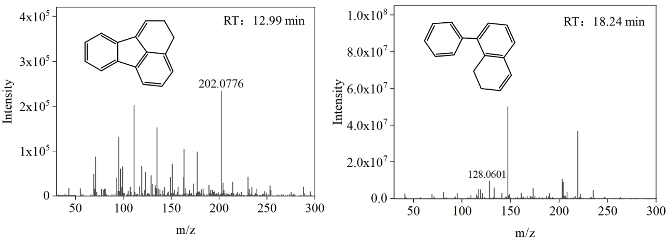
Fig.S3 Mass spectrum of 8-Phenyl-1,2-dihydro-naphthalene and 2,3-Dihydro-fluoranthene

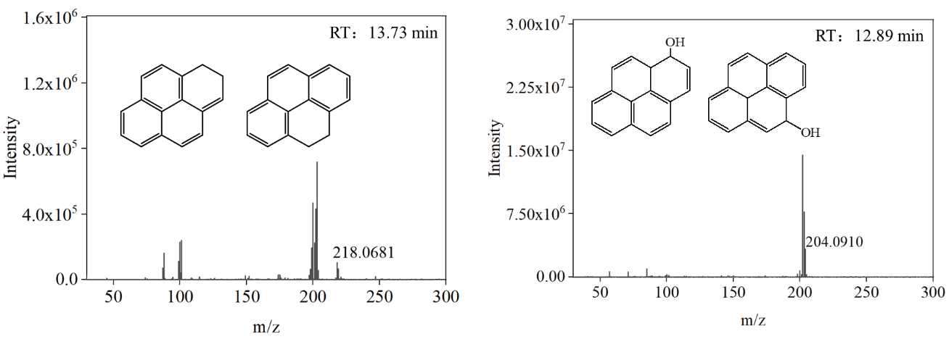
Fig.S4 Mass spectrum of 1,2-Dihydro-pyrene or 4,5-Dihydro-pyrene and 1,10a-Dihydro-pyren-1-ol or 4,10c-Dihydro-pyren-4-ol

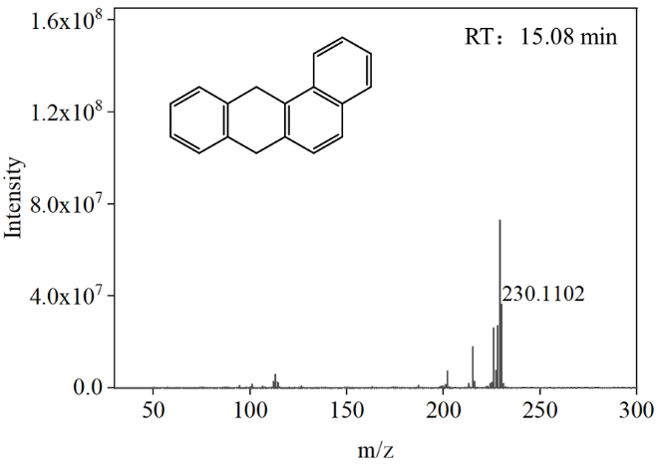
Fig.S5 Mass spectrum of 7,12-Dihydro-benzo[a]anthracene

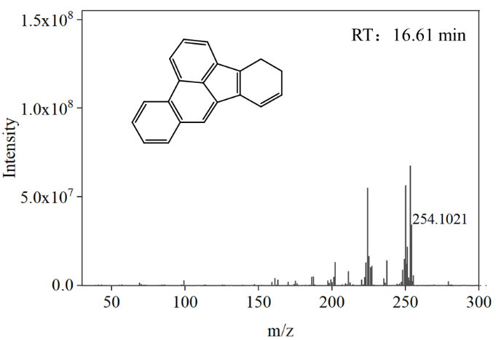
Fig.S6 Mass spectrum of 4,5-Dihydro-benzo[e]acephenanthrylene
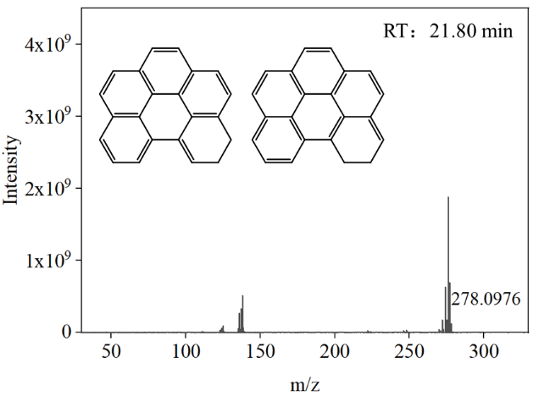
Fig.S7 Mass spectrum of 5,6-Dihydro-benzo[ghi]perylene or 6,7-Dihydro-benzo[ghi]perylene

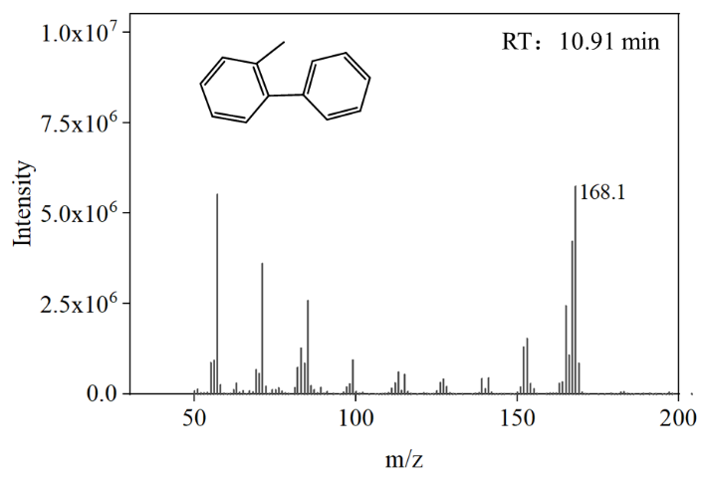
Fig.S8 Mass spectrum of 2-Methyl-biphenyl

References
Chen, X.M., Li, H.R., Feng, L., Wang, H.T., Sun, X.H., 2022. Prediction of ·OH⁻Initiated and ·NO₃⁻Initiated Transformation Products of Polycyclic Aromatic Hydrocarbons by Electronic Structure Approaches. Acs Omega 7(29), 24942-24950. https://doi.org/10.1021/acsomega.1c06447.
Jia, H., Zhao, S., Nulaji, G., Tao, K., Wang, F., Sharma, V.K., Wang, C., 2017. Environmentally Persistent Free Radicals in Soils of Past Coking Sites: Distribution and Stabilization. Environ. Sci. Technol. 51(11), 6000-6008. https://doi.org/10.1021/acs.est.7b00599.
Jia, H., Zhao, S., Shi, Y., Fan, X., Wang, T., 2019a. Formation of environmentally persistent free radicals during the transformation of anthracene in different soils: Roles of soil characteristics and ambient conditions. J. Hazard. Mater.362, 214-223. https://doi.org/10.1016/j.jhazmat.2018.08.056.
Jia, H., Zhao, S., Shi, Y., Zhu, K., Gao, P., Zhu, L., 2019b. Mechanisms for light-driven evolution of environmentally persistent free radicals and photolytic degradation of PAHs on Fe(III)-montmorillonite surface. J. Hazard. Mater. 362, 92-98. https://doi.org/10.1016/j.jhazmat.2018.09.019.
Jia, H., Zhao, S., Shi, Y., Zhu, L., Wang, C., Sharma, V.K., 2018. Transformation of Polycyclic Aromatic Hydrocarbons and Formation of Environmentally Persistent Free Radicals on Modified Montmorillonite: The Role of Surface Metal Ions and Polycyclic Aromatic Hydrocarbon Molecular Properties. Environ. Sci. Technol. 52(10), 5725-5733. https://doi.org/10.1021/acs.est.8b00425.
Li, X., Zhao, H., Qu, B., Tian, Y., 2022. Photoformation of environmentally persistent free radicals on particulate organic matter in aqueous solution: Role of anthracene and formation mechanism. Chemosphere 291. https://doi.org/10.1016/j.chemosphere.2021.132815.
Li, Z., Zhao, H., Li, X., Bekele, T.G., 2022. Characteristics and sources of environmentally persistent free radicals in PM2.5 in Dalian, Northeast China: correlation with polycyclic aromatic hydrocarbons. Environ. Sci. Pollut. Res. 29(17), 24612-24622. https://doi.org/10.1007/s11356-021-17688-9.
Ni, Z., Gao, N., Chen, N., Zhang, C., Liu, Z., Zhu, K., Sharma, V.K., Jia, H., 2023. Particle-size distributions of environmentally persistent free radicals and oxidative potential of soils from a former gasworks site. Sci. Total Environ. 869. https://doi.org/10.1016/j.scitotenv.2023.161747.
Sun, Y., Chen, J., Qin, W., Yu, Q., Xin, K., Ai, J., Huang, H., Liu, X., 2022. Gas-PM2.5 partitioning, health risks, and sources of atmospheric PAHs in a northern China city: Impact of domestic heating. Environ. Pollut. 313. https://doi.org/10.1016/j.envpol.2022.120156.
Wang, P., Pan, B., Li, H., Huang, Y., Dong, X., Ai, F., Liu, L., Wu, M., Xing, B., 2018. The Overlooked Occurrence of Environmentally Persistent Free Radicals in an Area with Low-Rank Coal Burning, Xuanwei, China. Environ. Sci. Technol. 52(3), 1054-1061. https://doi.org/10.1021/acs.est.7b05453.

