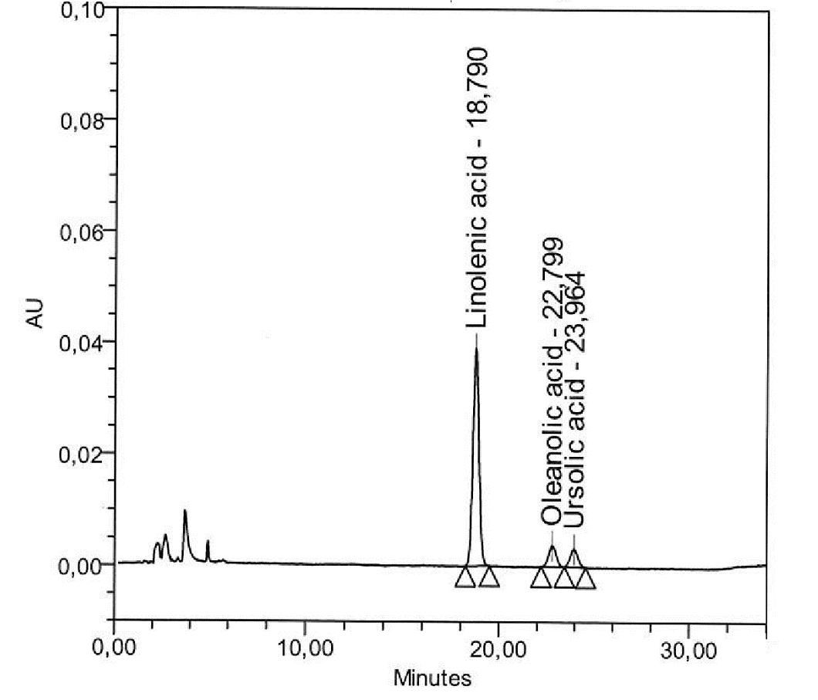
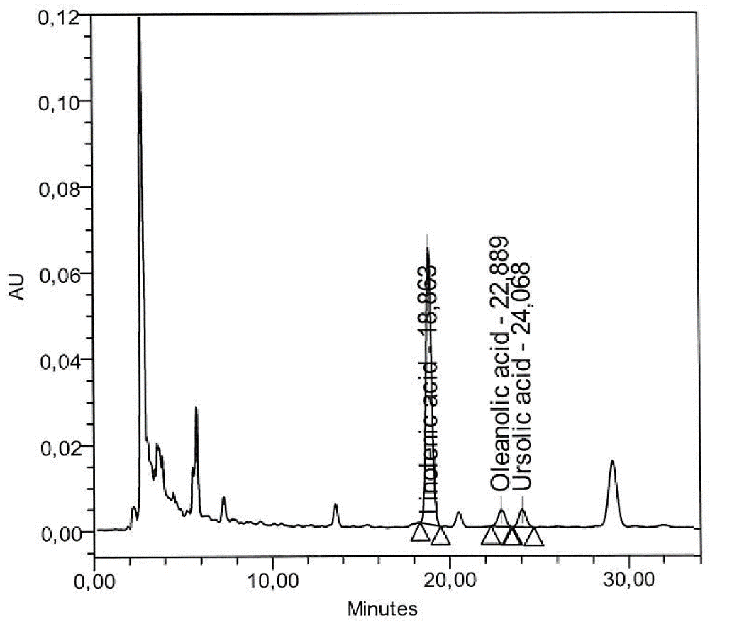
Figure S1. HPLC Chromatogram of the standard mixture of the major components in Hitrechol (upper) and Hitrechol®️ capsules (bottom).

Table S1: Certificate of Analysis of Hitrechol®️ (Batch number: 25003)
Parameters | Specification | Results of  batch No. 25003
Characteristics
Description | Soft capsules with filling of yellow-green oily material, odour slightly fragrant | complies
Filling variation | 200 mg (not more than 2 out of 20: ±10%,  none out of 20: ± 20%) | complies
Disintegration time | complies with the requirement for capsules | complies
Identity
TLC fingerprint of active ingredient | TLC fingerprint has to comply | complies
Purity
Appearance of filling mass | yellow-green, oily | complies
Microbial limit test | Bacteria count: not more than 1000 cfu per g  Fungi and yeasts count: not more than 100 cfu per g  E. coli: absence in 1 g  Salmonella: absence in 10 g | complies  complies  complies  complies
Assay
Sum of Ursolic acid and Oleanolic acid | 40 – 150 µg per capsule | complies
Linolenic acid | 70 – 350 µg per capsule | complies

