Supplemental Materials
Key resources table
REAGENT or RESOURCE | SOURCE | IDENTIFIER
Antibodies
Rabbit polyclonal anti-SQLE | Proteintech | Cat#12544-1-AP
Rabbit polyclonal anti-KRAS | Proteintech | Cat#12063-1-AP
Rabbit monoclonal anti-GAPDH | Cell Signaling Technology | Cat#85925SF
Rabbit monoclonal anti-PGC1$α+β$ | Abcam | Cat#ab188102
Total OXPHOS Rodent WB Antibody Cocktail | Abcam | Cat#ab110413
Rabbit polyclonal anti-TFAP2E | Proteintech | Cat#25829-1-AP
Biological samples
The patient tissue microarray | Outdo Biotech | HPanA150CS03
Chemicals, peptides, and recombinant proteins
Squalene | Topscience | Cat#T4749
Terbinafine | Topscience | Cat#T6702
Critical commercial assays
Lipofectamine RNAiMax | ThermoFisher | Cat#13778150
RNA-Quick Purification Kit | EZbioscience | Cat#B0004D
Color Reverse Transcription Kit (with gDNA Remover) | EZbioscience | Cat#A0010CGQ
2× Color SYBR Green qPCR Master Mix (ROX2 plus) kit | EZbioscience | Cat#A0001-R2
MitoTracker Green FM | Invitrogen | Cat#M7514
Pierce Magnetic ChIP Kit | ThermoFisher | Cat#26157
Dual-Luciferase® Reporter Assay System | Promega | Cat#E1910
The Dynabeads™ MyOne™ Streptavidin C1 beads | Invitrogen | Cat#65001
ECL detection kit | Tanon | Cat#180-5001
Experimental models: Cell lines
AsPC-1 | ATCC | CRL-1682
PANC-1 | ATCC | CRL-1469
BxPC-3 | ATCC | CRL-1687
The doxycycline inducible hTERT-immortalized human pancreatic cells (HPNE)/K-ras^{G12D} | Huang’s lab | N/A
The doxycycline inducible T-Rex/K-ras^{G12V} | Huang’s lab | N/A
Experimental models: Organisms/strains
BALB/c Nude
Oligonucleotides
siRNA targeting sequence: Human ERK1: CCUUAAGAUUUGUGAUUUCTT and  GGGAGGUGGAGAUGGUGAATT | Huang’s lab | N/A
siRNA targeting sequence: Human ERK2: GUACAGGGCUCCAGAAAUUT and ACACAAGAGGAUUGAAGUATT | Huang’s lab | N/A
siRNA targeting sequence: Human DBP: CGAAGACAUCGCUUCUCAGAA | Huang’s lab | N/A
siRNA targeting sequence: Human ELF3: CCGAAAGCUGAGCAAAGAGUA and GCCAUGAGGUACUACUACAAA | Huang’s lab | N/A
siRNA targeting sequence: Human Sp1: UGGUGGUGAUGGAAUACAUTT and GAGUCACCCAAUGAGAACATT | Huang’s lab | N/A
siRNA targeting sequence: Human TFAP2E: CCUAGACCAGUCCGUGAUCAATT and CUUGACACACUUUAGCCUCAUTT | Huang’s lab | N/A
Primers , see Table 1 | Huang’s lab | N/A
Recombinant DNA
Predicted Sp1 and TFAP2E promoter sequence binding sites: TCCATGCCTCACCCCTCCCCTGAAAATGGGGA, TGCTTGTCAGGAGGGGAGGGTTGGGTT, GTGCCCGTCCGTCCTGCCTCCATGGACCCGC | Huang’s lab | N/A
Overexpression plasmid pLVX-Puro-SQLE | Public Protein/Plasmid Library | N/A
Software and algorithms
GraphPad Prism software | San Diego | https://www.graphpad.com/ GraphPad

Table 1
SQLE | TGACAATTCTCATCTGAGGTCCA | CAGGGATACCCTTTAGCAGTTTT
PGC1A | GCTTTCTGGGTGGACTCAAGT | GAGGGCAATCCGTCTTCATCC
DBP | CTGATCTTGCCCTATCAAGCATT | CGATGTCTTCGAGGGTCAAAG
ELF3 | GGCCGATGACTTGGTACTGAC | GCTTGCGTCGTACTTGTTCTTC
TFAP2E | GCCTCCTAGACCAGTCCGT | CTCACCAGGATTTGTGATGCC
ATF3 | CCTCTGCGCTGGAATCAGTC | TTCTTTCTCGTCGCCTCTTTTT
JUN | CCCAGTGTTGTTTGTAAATAAGAGA | CAGAAAAGAGGTTAGGGGAGTA
Sp1 | ACGCTTCACACGTTCGGATGAG | TGACAGGTGGTCACTCCTCATG
VEGFA | AGGGCAGAATCATCACGAAGT | AGGGTCTCGATTGGATGGCA
CyclinD1 | GCTGCGAAGTGGAAACCATC | CCTCCTTCTGCACACATTTGAA

Resource availability
The information and resources that support the findings of this study are available from the corresponding authors upon request. The TCGA database used in this study are available through the following websites:
https://www.genome.gov/Funded-Programs-Projects/Cancer-Genome-Atlas
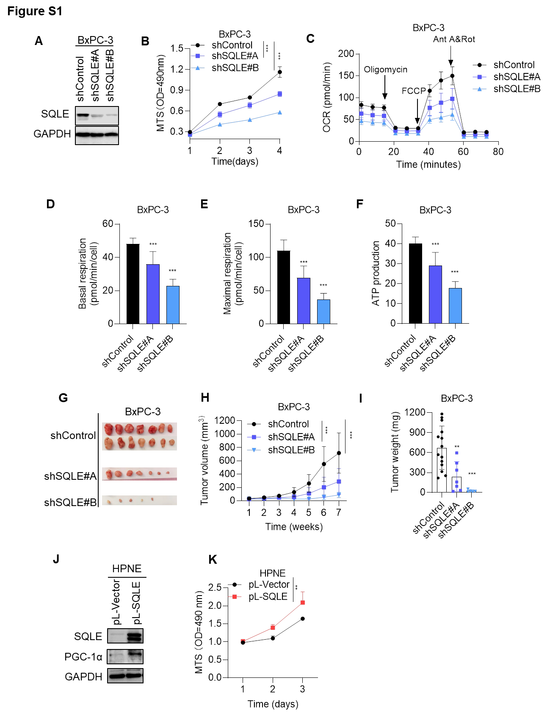
Fig. S1 SQLE plays an important role in pancreatic cancer cell proliferation and tumor growth both in vitro and in vivo.
A Western blot analysis of SQLE expression in BxPC-3 cells with shControl or with shRNA knockdown of SQLE (shSQLE#A, shSQLE#B).
B Cell proliferation in BxPC-3 cells with shControl or shRNA knockdown of SQLE (shSQLE#A, shSQLE#B), analyzed by MTS.
C Real-time measurement of OCR for BxPC-3 cells with shControl or with shRNA knockdown of SQLE (shSQLE#A, shSQLE#B) using Seahorse XF96 analyzer.
D-F Basal respiration (D), maximal respiration (E) and ATP production (F) were analyzed.
G-I In vivo effects of SQLE knockdown on BALB/c nude mice inoculated with BxPC-3 cells (2×10⁶ cells per injection; n=7 for each group). Images of tumors isolated from the mice (G), Tumor volume (H) and weight (I) were measured. The mice were sacrificed at week 7 after tumor inoculation.
J SQLE promoted PGC-1α expression in HPNE cells. Western blot analysis of PGC-1α expression in HPNE cells without or with SQLE overexpression (using control vector pL-Vector or lentiviral vector pL-SQLE), determined by immunoblotting.
K MTS assay in HPNE cells without or with SQLE overexpression (using control vector pL-Vector or lentiviral vector pL-SQLE).
*p < 0.05; **p < 0.01; ***p < 0.001. (D-F, I) One-way ANOVA; (B, H, K) Two-way ANOVA. Data are mean ± S.D. of three independent experiments.
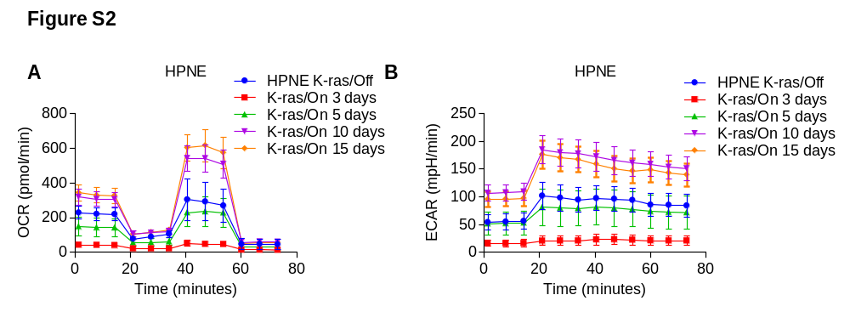

Fig. S2 Expression of SQLE was correlated with mitochondrial respiration activity in K-ras inducible cell lines.
A, B Real-time measurement of OCR (A) and ECAR (B) for HPNE cells incubated with 100 ng/ml doxycycline to induce K-ras^{G12D} expression for indicated time periods, analyzed by Seahorse XF96 analyzer.
Data are mean ± S.D. of three independent experiments.
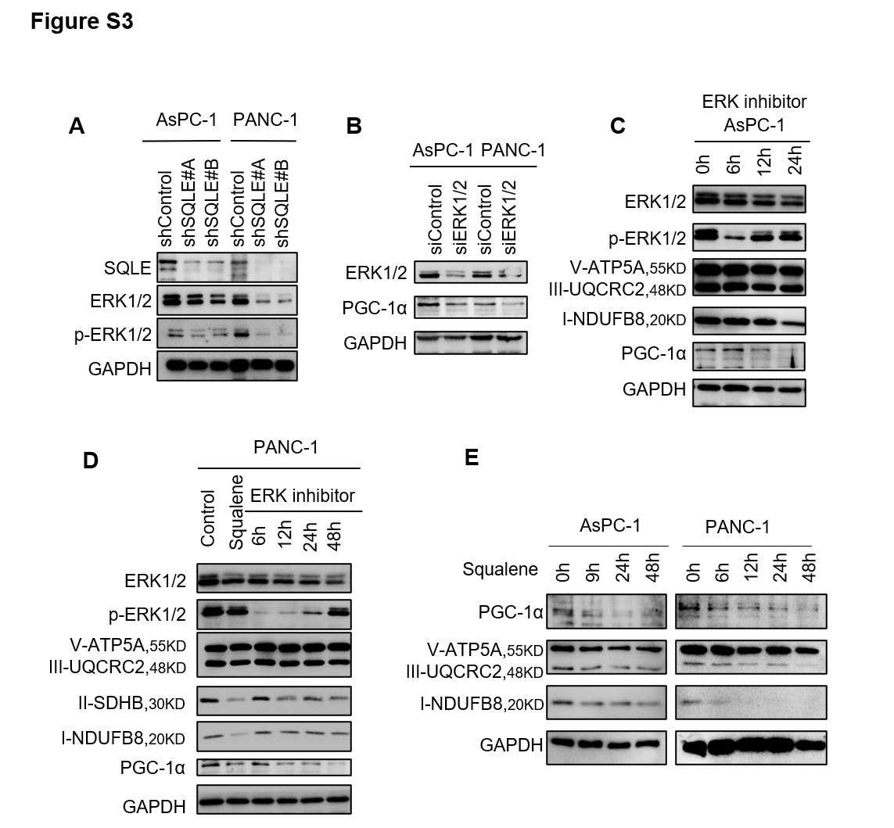
Fig. S3 SQLE silencing decreased PGC-1α expression independent of ERK-activation.
A Protein expression level of ERK, p-ERK and PGC-1α in AsPC-1 and PANc-1 cells with shControl or with shRNA knockdown of SQLE (shSQLE#A, shSQLE#B), analyzed by western blotting.
B Western blot analysis of PGC-1α protein expression level in AsPC-1 and PANC-1 cells after siRNA knockdown of ERK1/2.
C, D Protein expression levels of ERK, p-ERK, ATP5A, UQCRC2, SDHB, NDUFB8 and PGC-1α in AsPC-1 (C) and PANC-1 (D) cells treated with ERK inhibitor SCH772984 (12 μM) for indicated hours or 200 μM squalene for 24 h, analyzed by western blotting.
E Western blot analysis of PGC-1α, ATP5A, UQCRC2 and NDUFB8 expression in AsPC-1 and PANC-1 cells treated with 200uM squalene at indicated time.
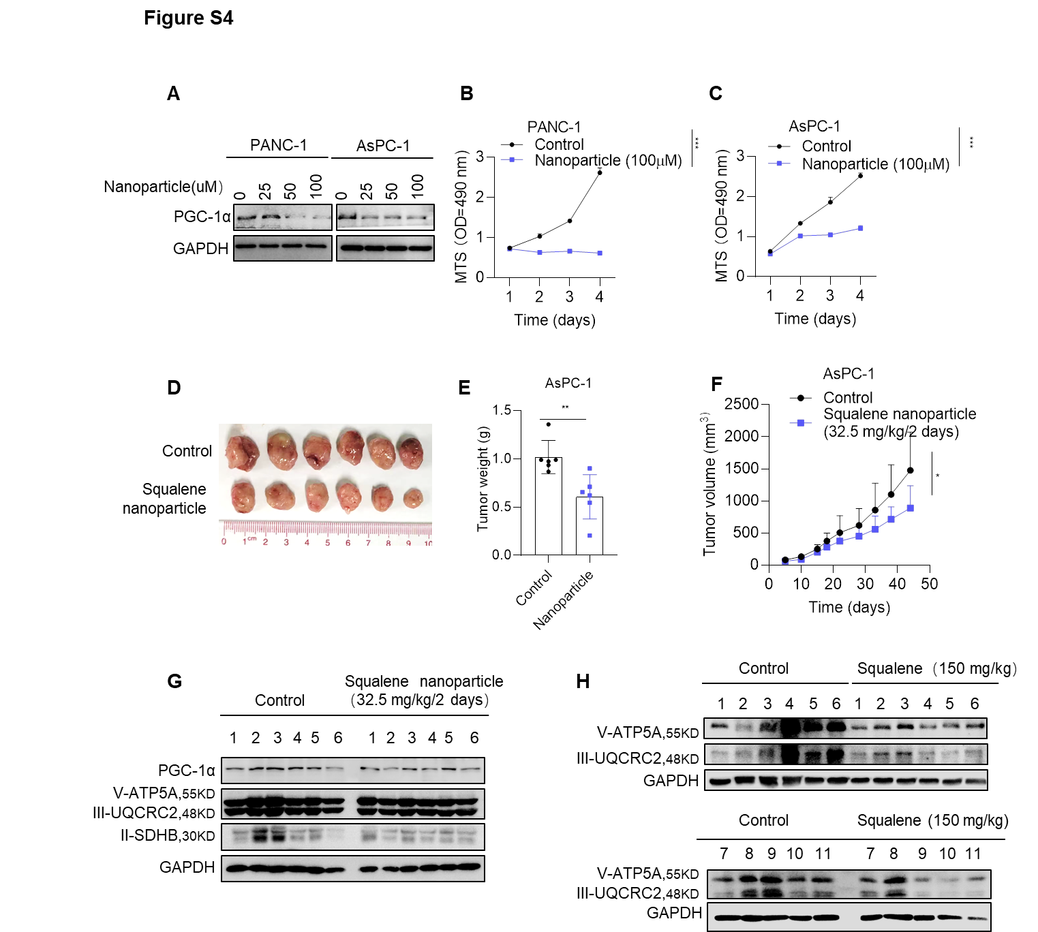
Fig. S4 Squalene nanoparticles efficiently suppressed tumor growth and mitochondrial biogenesis/function in vivo in pancreatic cancer.
A Western blot analysis of PGC-1α expression in PANC-1 and AsPC-1 cells treated with squalene nanoparticle at indicated concentrations for 24 h.
B, C Cell proliferation in PANC-1 cells (B) and AsPC-1 cells (C) treated with 100 μM squalene nanoparticle, analyzed by MTS.
D-F In vivo effects of squalene nanoparticle treatment on BALB/c nude mice inoculated with AsPC-1 cells (2×10⁶ cells per injection; n=6 for each group). (D) Images of isolated tumors from subcutaneous AsPC-1 xenografts treated with squalene for 45 days (32.5 mg/kg/2 days). Tumor weight (E) and volume (F) were measured in the mice.
G, H Protein expression levels of mitochondria complexes in tumor cells isolated from control or squalene nanoparticle (G) or squalene-treated (H) PDAC xenografts (control group: n=6 or 11; squalene-treated group: n=6 or 11) harboring AsPC-1 cells, measured by western blot analysis.
*p < 0.05; ** p < 0.01. (E) Unpaired Student’s t test; (B, C, F) Two-way ANOVA. Data are mean ± S.D. of three independent experiments.

