Supplementary Information

Exploratory Studies on Amide Bond Replacement of a SARS-CoV-2 Main Protease Inhibitor Utilizing a Chloroalkene Dipeptide Isostere

Takuya Kobayakawa,ª Chika Azuma,ª Nobuyo Higashi-Kuwata,^{b} Kohei Tsuji,ª Takahiro Ishii,ª Kouki Shinohara,ª Peter Bolah,ª Hiroaki Mitsuya,^{b,c,d} and Hirokazu Tamamura^{*,a}

ªDepartment of Medicinal Chemistry, Institute of Biomaterials and Bioengineering, Tokyo Medical and Dental University (TMDU), Chiyoda-ku, Tokyo 101-0062, Japan, ^{b}Department of Refractory Viral Infections, National Center for Global Health and Medicine Research Institute, Shinjuku-ku, Tokyo 162-8655, Japan, ^{c}Experimental Retrovirology Section, HIV and AIDS Malignancy Branch, National Cancer Institute, National Institutes of Health, Bethesda, Maryland 20892, United States, ^{d}Department of Clinical Sciences, Kumamoto University Hospital, Chuo-ku, Kumamoto 860-8556, Japan.

*To whom correspondence should be addressed; phone: +81-3-5280-8036, fax: +81-3-5280-8039,
e-mail address: tamamura.mr@tmd.ac.jp

Table of contents
I. General information S2
I-I. General methods S2
I-II. Compound characterization S2
II. Experimental procedures S3
III. ¹H NMR and ¹³C NMR charts (5, TKB0130) S6
IV. High Resolution Mass Spectrometry (HRMS) charts (5, TKB0130) S7
V. HPLC charts (5, TKB0130) S8

I. General information

I-I. General methods
All reactions were performed using commercially supplied reagents and solvents in dried glassware under an atmosphere of nitrogen unless otherwise noted. Thin-layer chromatography (TLC) was performed on Merck 60F₂₅₄ precoated silica gel plates and was visualized by fluorescence quenching under UV light and by staining with phosphomolybdic acid, p-anisaldehyde, or ninhydrin, respectively. Flash column chromatography was carried out with silica gel 60 N (Kanto Chemical Co., Inc.) or automatic silica gel flash column chromatography system (Isolera One (Biotage, Sweden). Preparative RP-HPLC was performed using a Cosmosil 5C₁₈-ARII column (20 × 250 mm, Nacalai Tesque, Inc., Japan) on a JASCO PU-2089 plus (JASCO Corporation, Ltd., Japan) in a linear gradient of CH₃CN containing 0.1% TFA (Solvent B) in H₂O containing 0.1% (v/v) TFA (Solvent A) at a flow rate of 10 cm³ min^{–1}, and eluting products were detected by UV at 254 nm.

I-II. Compound characterization
¹H NMR (500 MHz) and ¹³C NMR (125 MHz) spectra were recorded using a Bruker AVANCE 500 spectrometer (Bruker, USA). Coupling constants are reported in Hertz, and peak shifts are reported in d (ppm) relative to CDCl₃ (¹H 7.26 ppm, ¹³C 77.16 ppm). Low- and high-resolution mass spectra were recorded on a Bruker Daltonics micrOTOF focus in the positive and negative detection mode. For analytical RP-HPLC, a Cosmosil 5C₁₈-ARII column (4.6 × 250 mm, Nacalai Tesque, Inc.) was employed with a linear gradient of CH₃CN containing 0.1% (v/v) trifluoroacetic acid (TFA) (Solvent B) in H₂O containing 0.1% (v/v) TFA (Solvent A) at a flow rate of 1.0 cm³ min^{–1} on a PU-2089 plus (JASCO Corporation, Ltd.), and eluting products were detected by UV at 254 nm.

II. Experimental procedures
Ethyl (2R,5S,Z)-5-(((benzyloxy)carbonyl)amino)-4-chloro-2-isobutyl-6-methylhept-3-enoate (15): To a solution of Bus-Val-ψ[(Z)-CCl=CH]-Leu-OEt (14) (257 mg, 650 μmol) in CH₂Cl₂ (6.50 ml) was added anisole (212 μL, 1.95 mmol) and aluminum chloride (391 mg, 2.93 mmol) under nitrogen. After stirring for 1.5 h at room temperature, the reaction mixture was quenched with NH₃ aqueous, saturated Rochelle salt aqueous and extracted with CH₂Cl₂. The extract was washed with brine and dried over MgSO₄. The reaction mixture was concentration under reduced pressure to give amine S1, which was used immediately in next step without purification. To the solution of amine S1 in CH₂Cl₂ (6.50 mL) was added benzyl chloroformate (100 μL, 720 μmol) and DIPEA (126 μL, 750 μmol). After stirring for 1.5 h at room temperature. The reaction mixture was quenched by saturated aqueous NH₄Cl and extracted with CH₂Cl₂. The extract was washed with brine and dried over MgSO₄. Concentration under reduced pressure followed by flash chromatography over silica gel with n-hexane-EtOAc (10:1) to give Cbz-Val-ψ[(Z)-CCl=CH]-Leu-OEt (15) as a clear oil (141 mg, 53% in 2 steps); ¹H NMR (500 MHz, CDCl₃) δ 0.866-0.912 (9H, m), 0.973 (3H, d, J = 6.7 Hz), 1.23 (3H, t, J = 7.1 Hz), 1.43-1.54 (2H, m), 1.62-1.67 (1H, m), 1.84-1.90 (1H, m), 3.55-3.60 (1H, m), 3.99 (1H, t, J = 9.45 Hz), 4.10-4.15 (2H, m), 5.00 (1H, d, J = 9.4 Hz), 5.10 (2H, s), 5.75 (1H, d, J = 9.4 Hz), 7.30-7.38 (5H, m); ¹³C{¹H} NMR (125 MHz, CDCl₃) δ 14.3, 18.9, 19.7, 22.4, 22.8, 25.9, 30.8, 41.2, 43.6, 60.9, 63.7, 67.0, 127.0, 128.2, 128.3 (2C), 128.7 (2C), 135.5, 136.5, 155.7, 173.5; HRMS (ESI), m/z calcd for C₂₂H₃₃ClNO₄ [M+H]⁺ 410.2093, found 410.2092.

(2R,5S,Z)-5-(((Benzyloxy)carbonyl)amino)-4-chloro-2-isobutyl-6-methylhept-3-enoic acid (6): To a solution of Cbz-Val-ψ[(Z)-CCl=CH]-Leu-OEt (15) (123 mg, 300 μmol) in Et₂O (3.00 mL) was added dropwise a solution of LiBH₄ in THF (2.0 M, 450 µL, 900 μmol) at 0 ºC under nitrogen, and the mixture was stirred at room temperature for 2.0 h. MeOH was added slowly to quench and the solvent was then removed under reduced pressure. After brine was added, the solution was extracted with CH₂Cl₂. The combined organic extracts were dried over MgSO₄. Concentration under reduced pressure gave alcohol S2, which was used in next step without purification. To a solution of alcohol S2 in MeCN (3.00 mL) were added TEMPO (23.4 mg, 150 µmol), NaClO₂ (67.8 mg, 750 µmol) and NaClO (81.0 µL, 60.0 µmol) at 0 ºC. This solution was allowed to stir at room temperature for 2.0 h. The reaction mixture was washed with saturated Na₂S₂O₃, and extracted by EtOAc, and the extract was washed with brine and dried over MgSO₄. Concentration under reduced pressure followed by flash chromatography over silica gel with n-hexane-EtOAc (3:1) gave Cbz-Val-ψ[(Z)- CCl=CH]-Leu-OH (6) as a clear oil (91.8 mg, 80%); ¹H NMR (500 MHz, CDCl₃) δ 0.88-0.93 (9H, m), 0.97 (3H, d, J = 6.7), 1.47-1.70 (3H, m), 1.84-1.90 (1H, m), 3.59-3.64 (1H, m), 4.00 (1H, t, J = 9.4 Hz), 5.00 (1H, d, J = 9.4 Hz), 5.10 (2H, s), 5.76 (1H, d, J = 9.4 Hz), 7.31-7.38 (6H, m); ¹³C{¹H} NMR (125 MHz, CDCl₃) δ 18.9, 19.7, 22.3, 22.8, 25.9, 30.7, 41.2, 43.2, 63.6, 67.1, 126.3, 128.2, 128.3 (2C), 128.7 (2C), 136.2, 136.5, 155.8, 178.2; HRMS (ESI), m/z calcd for C₂₀H₂₉ClNO₄ [M+H]⁺ 382.1780, found 382.1781.

Benzyl ((3S,6R,Z)-6-(((S)-1-(benzo[d]thiazol-2-yl)-1-oxo-3-((S)-2-oxopyrrolidin-3-yl)propan-2-yl)carbamoyl)-4-chloro-2,8-dimethylnon-4-en-3-yl)carbamate (TKB0130, 5) : To a solution of Boc protected amine 7 (75.9 mg, 195 μmol) in CH₂Cl₂ (1.95 mL) was added dropwise a solution of HBF₄·OEt₂ (93.8 μL, 684 μmol) at 0 ºC under nitrogen, and the mixture was stirred at room temperature for 1 h. The reaction mixture was concentration under reduced pressure, and the crude solid was washed by Et₂O in 2% MeOH. The crude amine HBF₄ salt 8 was used immediately in next step without purification. To a solution of crude amine HBF₄ salt 8 in MeCN (1.95 mL) was added acid 6 (74.5 mg, 195 μmol), COMU (83.5 mg, 195 μmol) and DIPEA (66 μL, 391 μL) at 0 ºC under nitrogen for 3 h. The reaction mixture was quenched by saturated aqueous NH₄Cl and extracted with EtOAc. The extract was washed with brine and dried over MgSO₄. The crude compound was roughly purified using automatic flash column chromatography system (Isolera One, CHCl₃/MeOH = 100:0 to 94:6) to obtain the title compound 5 (TKB0130). Further purification was performed by preparative RP-HPLC to obtain the title compound 5 as pale yellow powder (6.55 mg, 5.1% in 2 steps):; ¹H NMR (500 MHz, CDCl₃) δ 0.855 (3H, d, J = 6.6 Hz), 0.901-0.964 (9H, m), 1.25 (1H, s), 1.42-1.60 (2H, m), 1.69-1.73 (1H, m), 1.90-2.02 (2H, m), 2.13-2.16 (2H, m), 2.52-.2.58 (2H, m), 3.33-3.35 (2H, m), 3.50-3.55 (1H, m), 4.04 (1H, t, J = 9.05 Hz), 5.10 (2H, s), 5.16 (1H, d, J = 9.25 Hz), 5.71-5.76 (1H, m), 5.80-5.81 (1H, m), 7.29-7.38 (5H, m), 7.52-7.59 (2H, m), 7.64 (1H, d, J = 6.6 Hz), 7.97-7.99 (1H, m), 8.17 (1H, d, J = 7.8 Hz); ¹³C{¹H} NMR (125 MHz, CDCl₃) δ 18.6, 19.8, 22.4, 22.9, 25.8, 28.8, 29.4, 30.7, 33.7, 39.0, 40.6, 41.1, 44.9, 54.9, 63.5, 67.0, 122.6, 125.8, 127.2, 127.6, 128.1, 128.2, 128.3, 128.7 (2C), 135.7, 136.5, 137.4, 153.6, 155.8, 164.1, 173.0, 179.7, 192.5; HRMS (ESI), m/z calcd for C₃₄H₄₂ClN₄O₅S [M+H]⁺ 653.2559, found 653.2563.

III. ¹H NMR and ¹³C NMR charts (5, TKB0130)
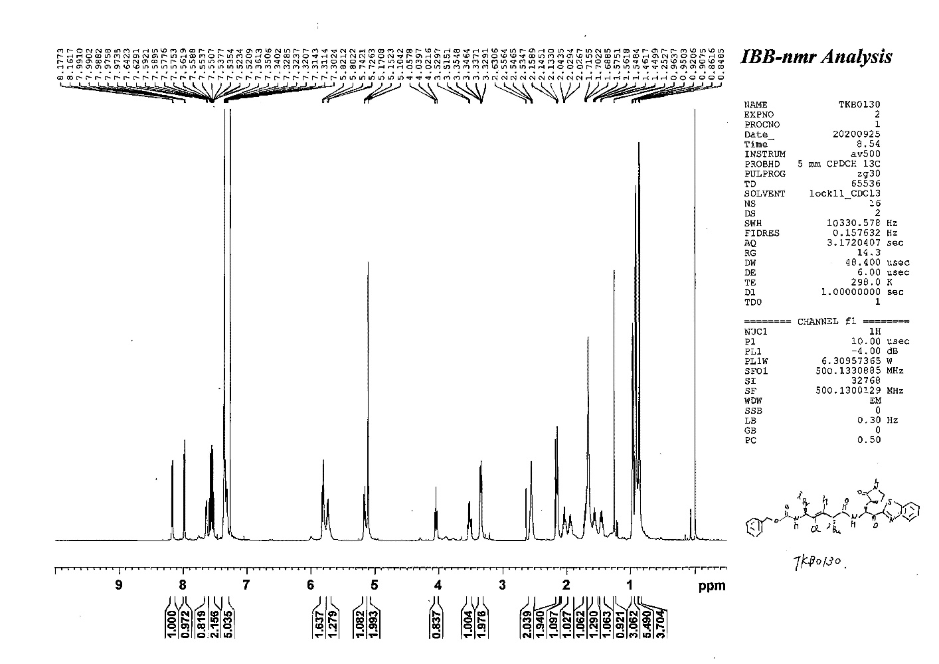
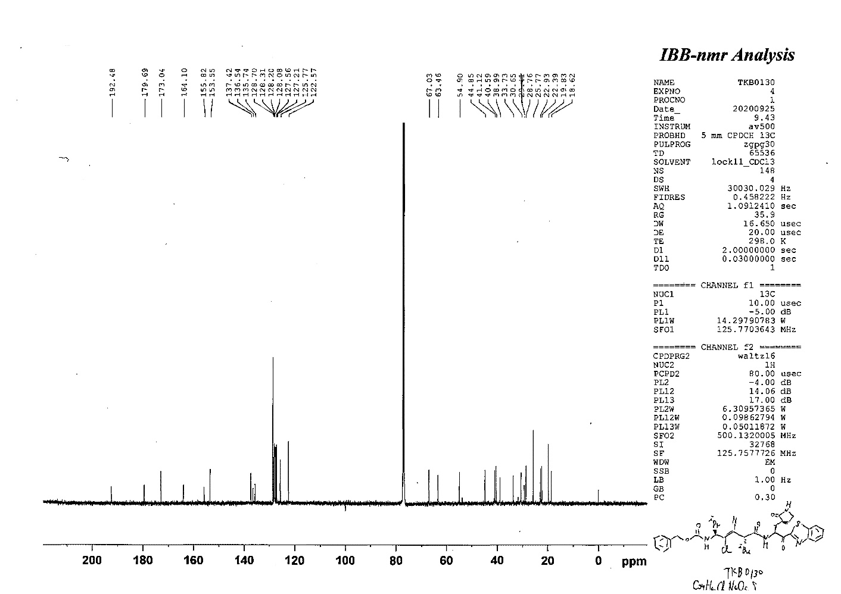

IV. High Resolution Mass Spectrometry (HRMS) charts (5, TKB0130)
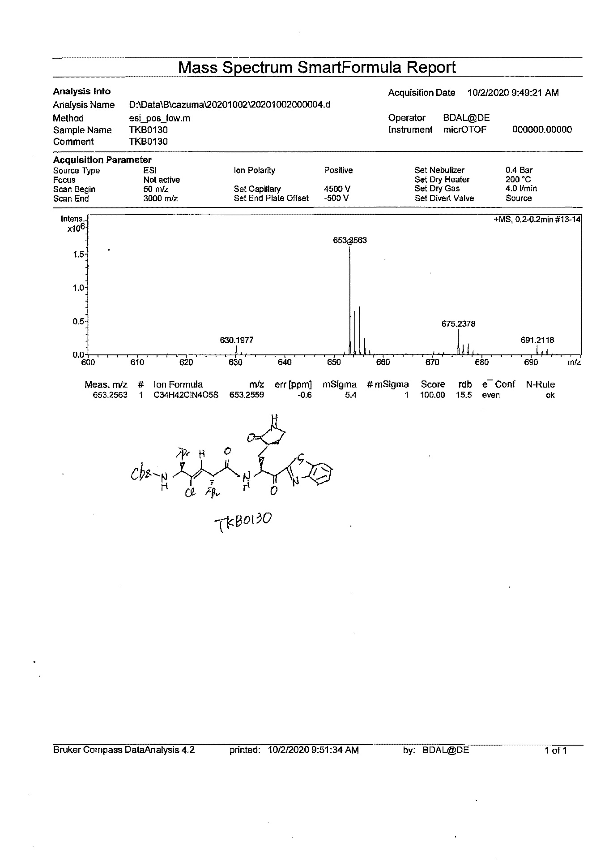

V. HPLC charts (5, TKB0130)

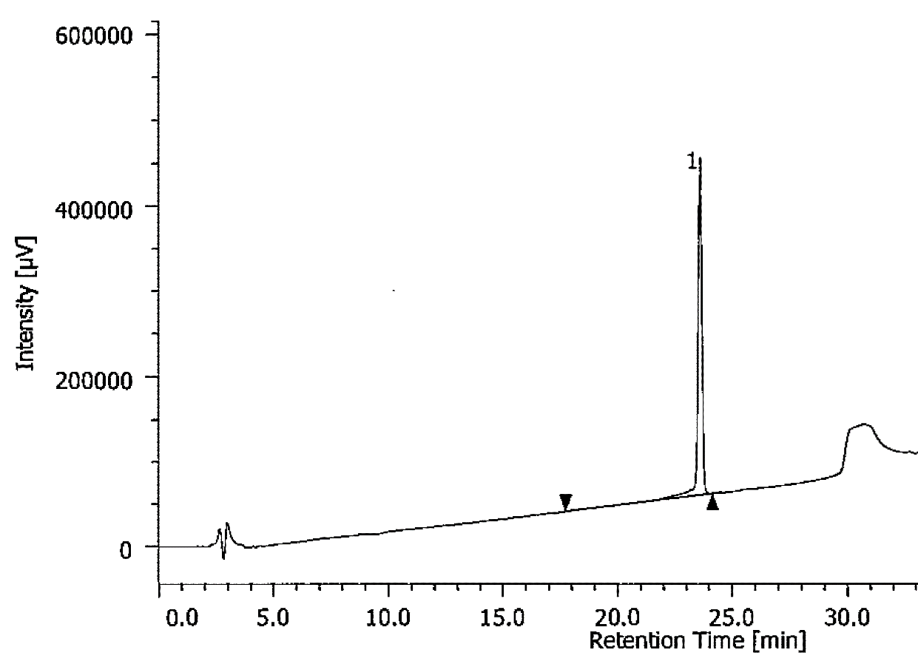
[HPLC condition]
45-75% B, (30 min)
A: H₂O in 0.1% TFA
B: MeCN in 0.1% TFA
Flow: 1.0 mL/min
Detected at 254 nm

