Supplementary Information
Supplementary Table 1: COVID-CNS inclusion and exclusion criteria
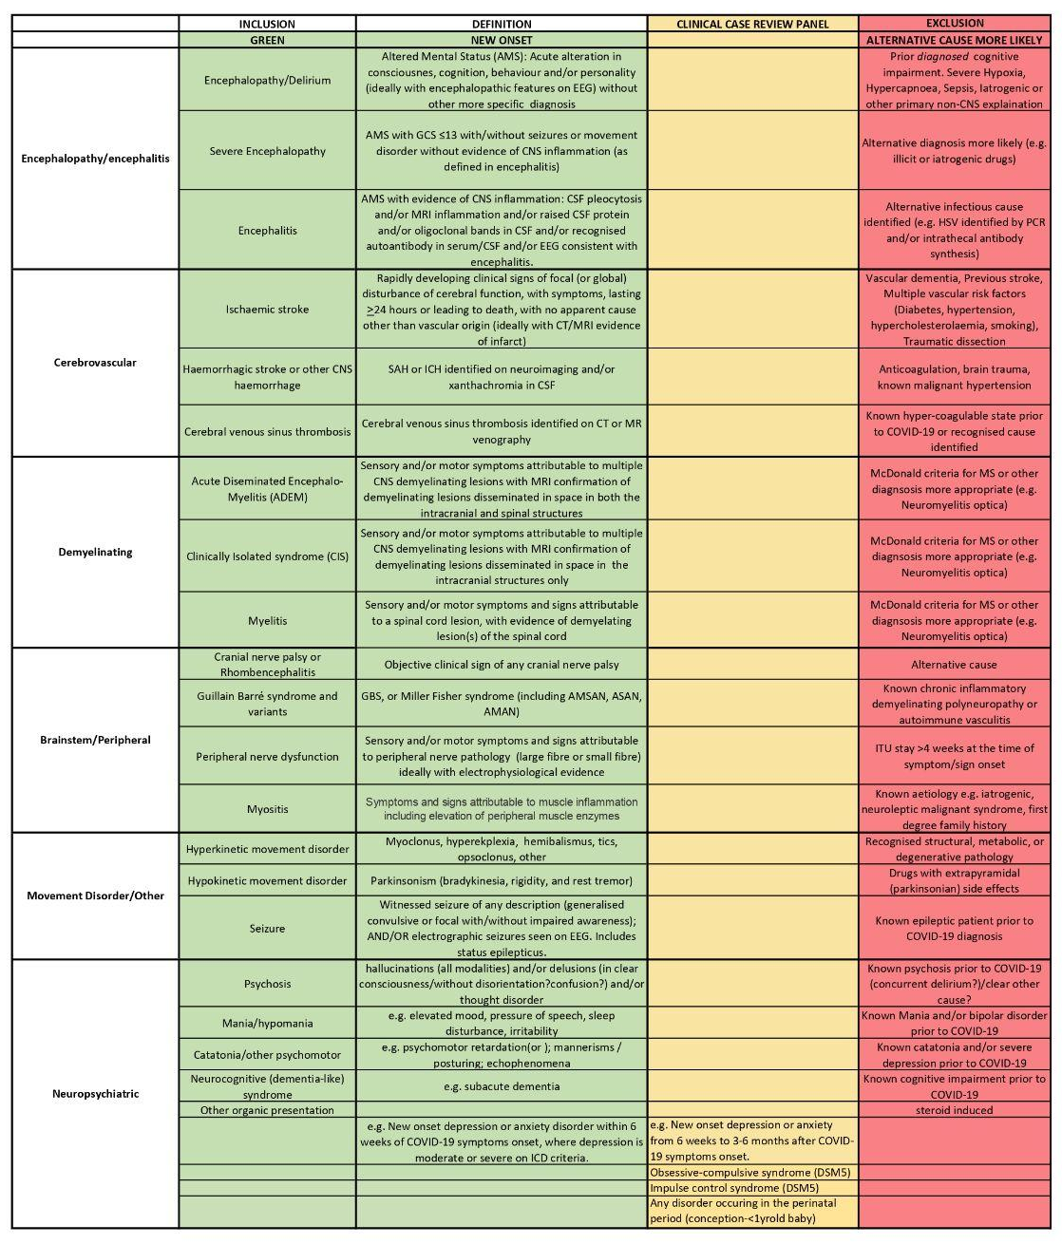

Supplementary Information 2: COVID-CNS: Cognitive tasks

Included tasks:
- Recognition memory (immediate)
- Spatial Span
- 2D Manipulations
- Verbal Analogies
- Recognition memory (delayed)
- Tower of London
- Motor control

Task 1 and 5: Recognition memory
Participants memorise a word list at the start of the battery. They are then tested on immediate recall and delayed recall. This type of task is the mainstay of neuropsychological assessment of memory function. The Cognitron version has been validated with data from ~100,000 members of the general public.
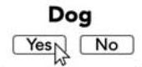

Task 2: Spatial span
The Spatial Span test measures spatial short-term memory capacity. It is a variant on the classic Corsi Block Tapping Test (Corsi, 1972). The participant is presented with a 4 x 4 grid, onto which is displayed a sequence of squares in different positions in the grid. The participant must then click the squares in the order that they were highlighted. The difficulty is incremented using a ratchet system, every time a sequence is recalled correctly, the length of the subsequent sequence is incremented by one. The test is terminated when three consecutive mistakes are made on a particular sequence length. The outcome measure is the maximum sequence length correctly recalled. Minimum level = 2, maximum level = 16, ISI = 0ms, encoding time = 1500ms. Population mean = 6.10, SD = 1.23.

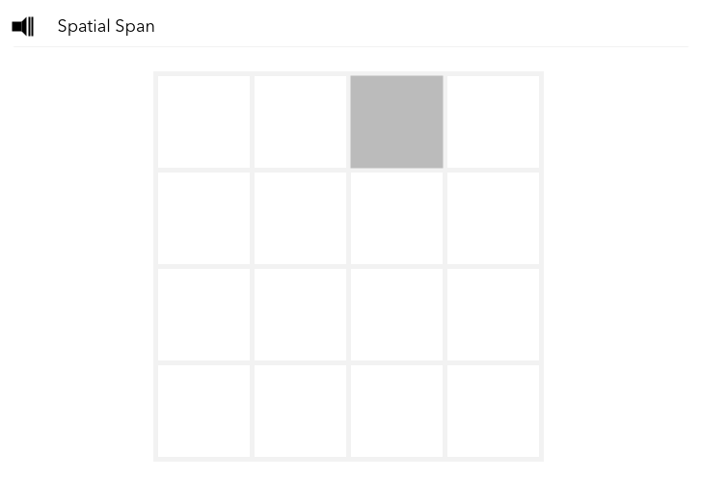

Task 3: 2D Manipulations
The 2D Mental rotation test measures the ability to spatially manipulate objects in mind (Silverman et al., 2000). In this version of the test, a grid with coloured squares is presented at the top of the screen, with a further four grids with coloured squares presented below (i.e. probe grids). One of the four grids is identical to the target grid above but is rotated by either 90, 180 or 270 degrees whilst the other grids differ by five squares. To obtain maximum points, the participant must indicate which of the four grids is identical to target, solving as many problems as possible within three minutes. For every correct response, the total score increases by one. The outcome measure is the total score. Population mean = 26.8, SD = 8.35.

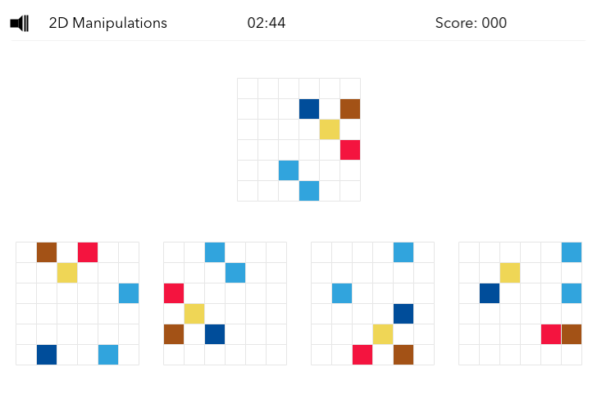

Task 4: Verbal Analogies
The Analogical Reasoning test measures semantic reasoning abilities. In this version of the test, participants are presented with two written relationships that they must decide have the same type of association or not (e.g. “Lion is to feline as cabbage is to vegetable”). Participants must indicate their decision by selecting the True or False buttons presented below the written analogies. Analogies are varied across semantic distance to modulate difficulty and associations types switch throughout the sequence of trials. To obtain maximum points, participants must solve as many problems as possible within three minutes. For every correct response, the total score increases by one. For every incorrect response, the total score decreases by one. The outcome measure is the total score. Population mean = 24.1, SD = 11.5.

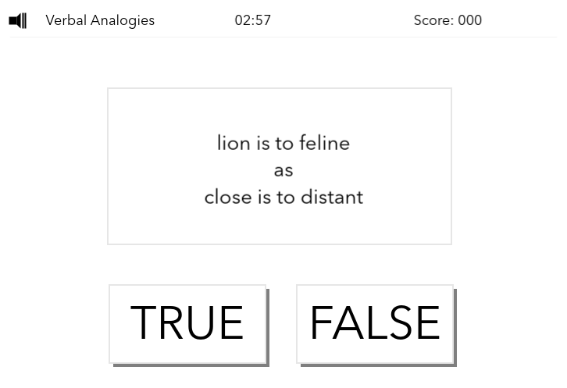

Task 6: Tower of London
The Tower of London test measures spatial planning. It is a variant on the original Tower of London Test (Shallice, 1982). The participant is shown two sets of three prongs with coloured beads on them. The first set is the initial state and the second set is the target state. The participant must work out the lowest number of moves it would take to transition from the initial state to the target state. They must then input this number using an on-screen number pad. This differs from the original test in that the participant is not allowed to move the beads, all calculation and planning must be done in their head. This is to prevent correct answers being reached through iterative error correction. The test consists of 10 trials of variable difficulty. The difficulty is scaled using the number of beads and the convolutedness, defined as the number of moves that must be made that do not place a bead in its final target position. The outcome measure is the total number of correct trials. Population mean = 6.57, SD = 2.62.

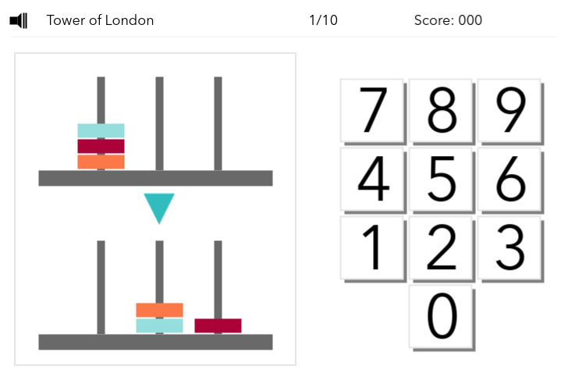
Task 7: Motor control
The motor control task assesses speed and therefore only response time is reported. Subsampled normative data were unavailable hence exclusion from Figure 2b.
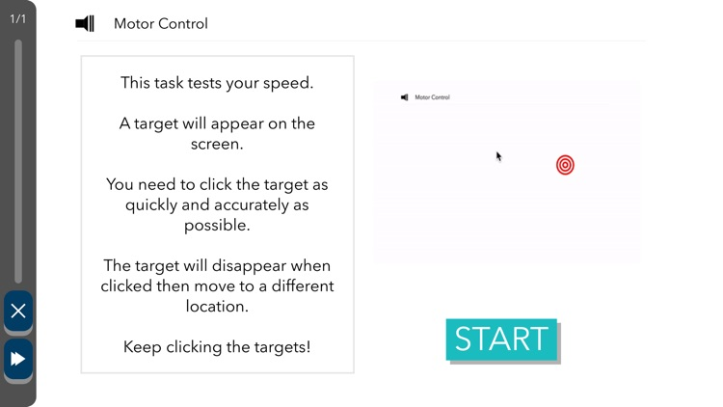

Supplementary Table 3: Image Derived Phenotypes (IDPs) considered for inclusion in analysis. All structural IDPs from Desikan-Killiany parcellation. Surface area IDPs were not used in final analysis due to collinearity (VIF >10) with volume IDPs.
Composite IDP
Anterior Cingulate Cortex Volume | aparcdesikanlhvolume_caudalanteriorcingulate | aparcdesikanlhvolume_rostralanteriorcingulate | aparcdesikanrhvolume_caudalanteriorcingulate | aparcdesikanrhvolume_rostralanteriorcingulate
Entorhinal Cortex Volume | aparcdesikanlhvolume_entorhinal | aparcdesikanrhvolume_entorhina
Orbitofrontal Cortex Volume | aparcdesikanlhvolume_lateralorbitofrontal | aparcdesikanlhvolume_medialorbitofrontal | aparcdesikanrhvolume_lateralorbitofrontal | aparcdesikanrhvolume_medialorbitofrontal
Parahippocampal Gyrus Volume | aparcdesikanlhvolume_parahippocampal | aparcdesikanrhvolume_parahippocampal
Superior Temporal Gyrus Volume | aparcdesikanlhvolume_superiortemporal | aparcdesikanrhvolume_superiortemporal
Insula Volume | aparcdesikanlhvolume_insula | aparcdesikanrhvolume_insula
Anterior Cingulate Cortex Thickness | aparcdesikanlhthickness_caudalanteriorcingulate | aparcdesikanlhthickness_rostralanteriorcingulate | aparcdesikanrhthickness_caudalanteriorcingulate | aparcdesikanrhthickness_rostralanteriorcingulate
Entorhinal Cortex Thickness | aparcdesikanlhthickness_entorhinal | aparcdesikanrhthickness_entorhinal
Orbitofrontal Cortex Thickness | aparcdesikanlhthickness_lateralorbitofrontal | aparcdesikanlhthickness_medialorbitofrontal | aparcdesikanrhthickness_lateralorbitofrontal | aparcdesikanrhthickness_medialorbitofrontal
Parahippocampal Gyrus Thickness | aparcdesikanlhthickness_parahippocampal | aparcdesikanrhthickness_parahippocampal
Superior Temporal Gyrus Thickness | aparcdesikanlhthickness_superiortemporal | aparcdesikanrhthickness_superiortemporal
Insula Thickness | aparcdesikanlhthickness_insula | aparcdesikanrhthickness_insula
Anterior Cingulate Cortex Surface Area | aparcdesikanlharea_caudalanteriorcingulate | aparcdesikanlharea_rostralanteriorcingulate | aparcdesikanrharea_caudalanteriorcingulate | aparcdesikanrharea_rostralanteriorcingulate
Entorhinal Cortex Surface Area | aparcdesikanlharea_entorhinal | aparcdesikanrharea_entorhinal
Orbitofrontal Cortex Surface Area | aparcdesikanlharea_lateralorbitofrontal | aparcdesikanlharea_medialorbitofrontal | aparcdesikanrharea_lateralorbitofrontal | aparcdesikanrharea_medialorbitofrontal
Parahippocampal Surface Area | aparcdesikanlharea_parahippocampal | aparcdesikanrharea_parahippocampal
Superior Temporal Gyrus Surface Area | aparcdesikanlharea_superiortemporal | aparcdesikanrharea_superiortemporal
Insula Surface Area | aparcdesikanlharea_insula | aparcdesikanrharea_insula
Additional (Included in Volume and/or overall composites) | aseglhvolume_cortex | aparcdesikanlhthickness_GlobalMeanThickness | idpt1sienax_greynormalisedvolume | idpt1sienax_peripheralgreynormalisedvolume
 | aseglhvolume_hippocampus | asegrhvolume_hippocampus

