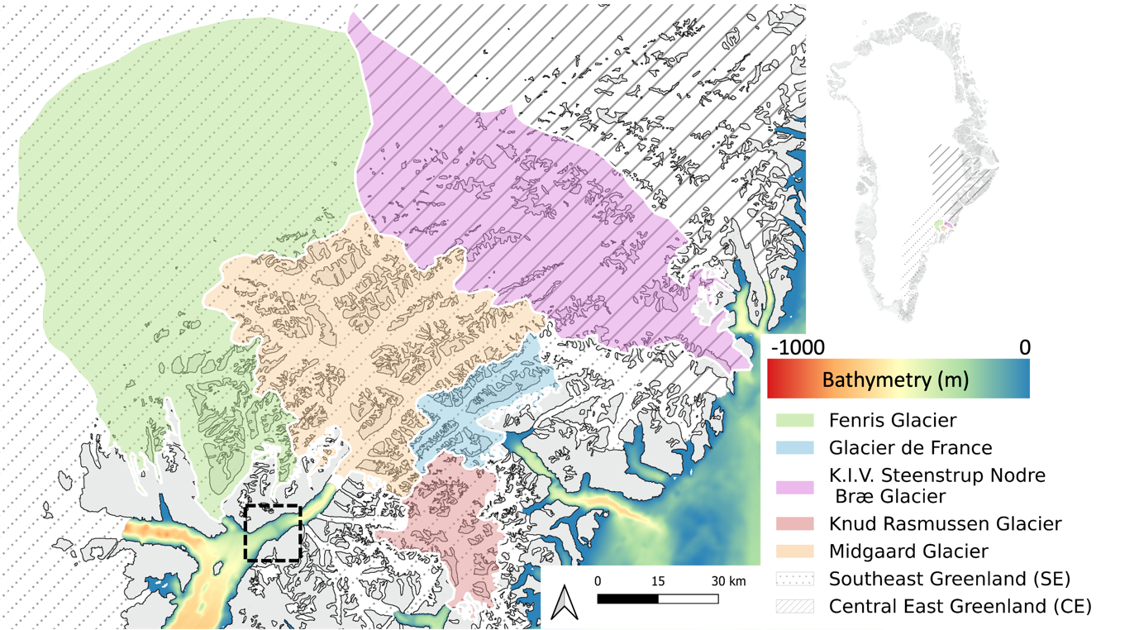
Fig.S1 – Catchment in the Ammassalik region
Maps of different catchments surrounding Midgaard Glacier from 2019⁴⁰. The sill location is highlighted by the black square.

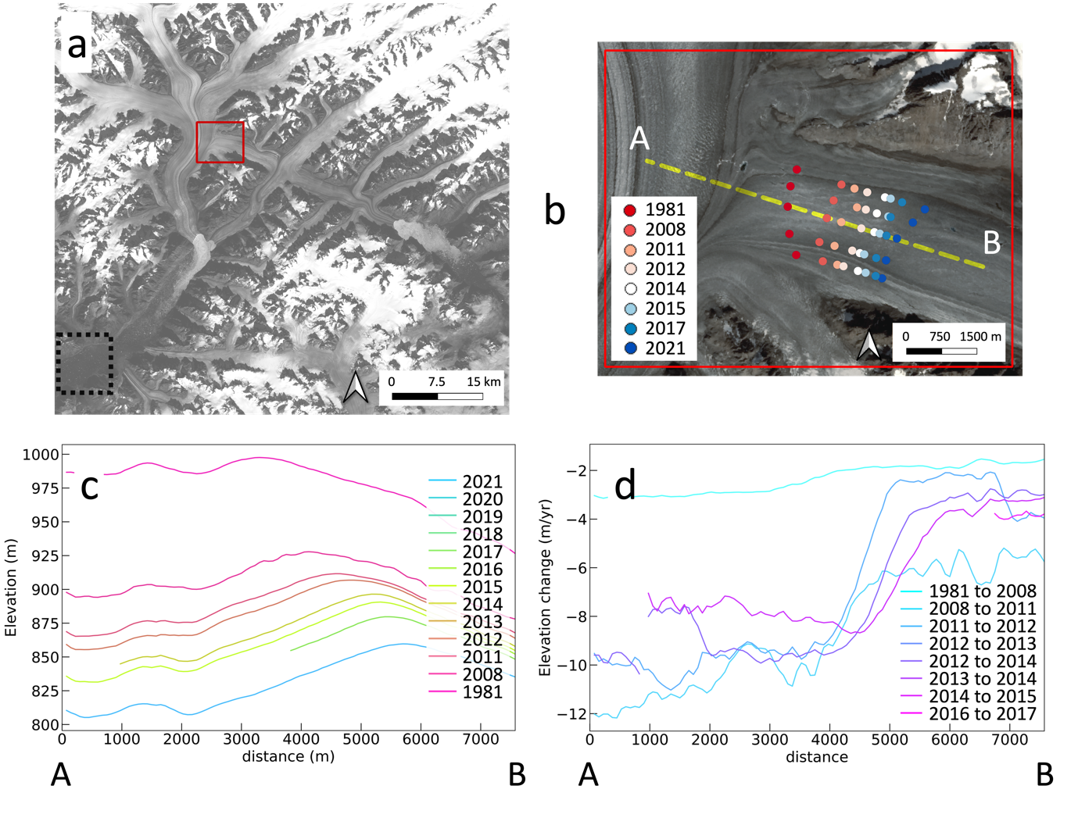
Fig.S2 – Migration of the ice divide between FCG and GDF
a, Map illustrating the location of the area. b, Visualisation of the flow reconfiguration and ice divide migration at the intersection between FCG and GDF. The points denote the manual tracking of the ice divide along five profiles to show the spatial retreat at different available years. The yellow dashed line corresponds to the location of the profile section of the figures to panels (c) and (d). (c) Elevation profile (m) and (f) yearly elevation change (m/yr) at the yellow dashed line in b.

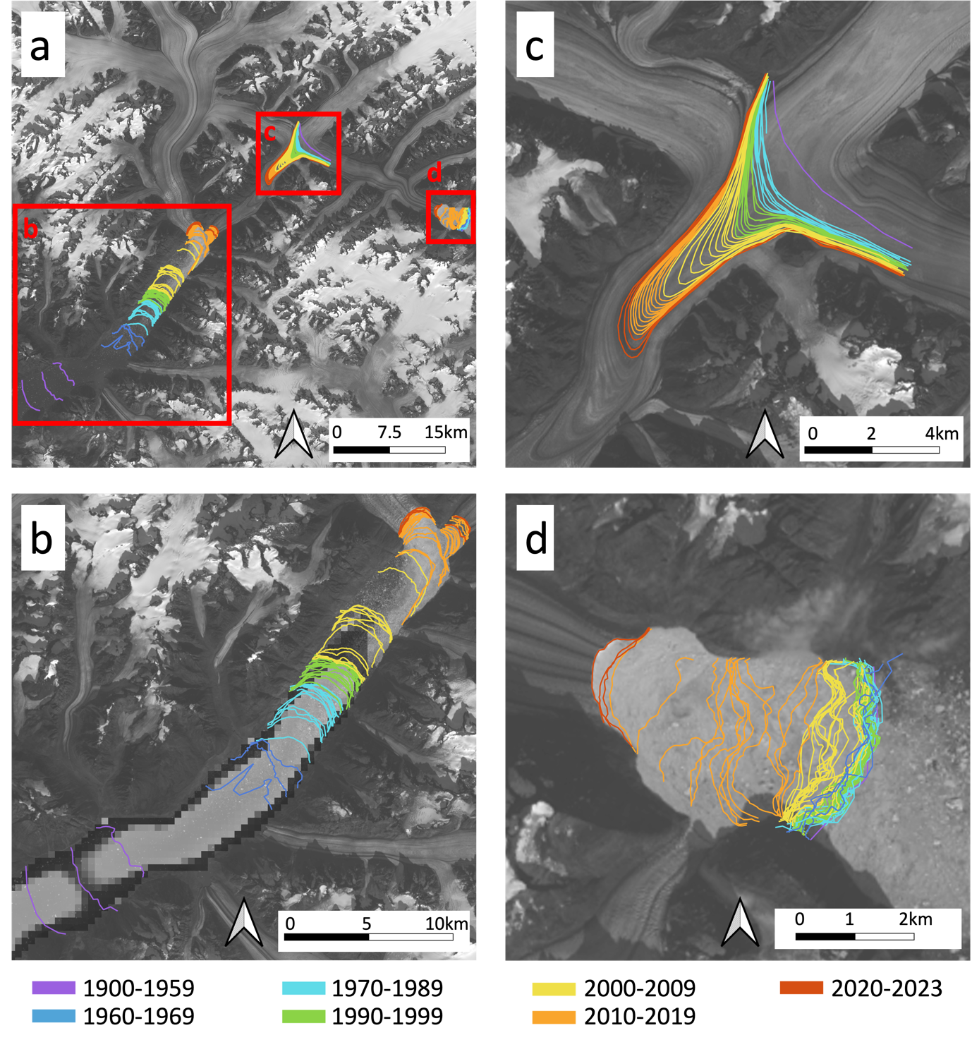
Fig.S3 – Terminus positions.
a, Overview of the study area, highlighting various positions. b, Evolution of the Midgaard Glacier terminus with a highlight on the position of the sill in dark, c, evolution of the medial moraine of Glacier de France, and d, evolution of Glacier de France terminus from 1900 to 2021, based on historical images and modern satellite imagery. (Background image: LANDSAT 9 2022)

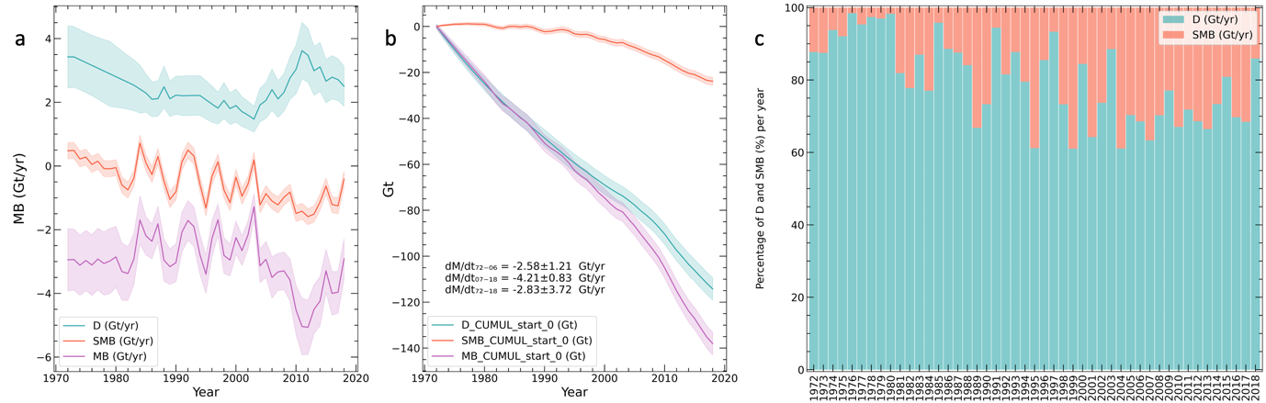
Fig.S4 – Mass budget of Midgaard Glacier catchment from 1972 to 2018¹ Partition D/SMB.
a, Ice discharge (D, blue), total surface mass balance (SMB, orange) and total mass balance (MB=SMB-D, purple) for Midgaard Glacier. b, Cumulative SMB (orange), D (blue), and MB (purple) for Midgaard Glacier. c, Percentage contribution of D compared to SMB.
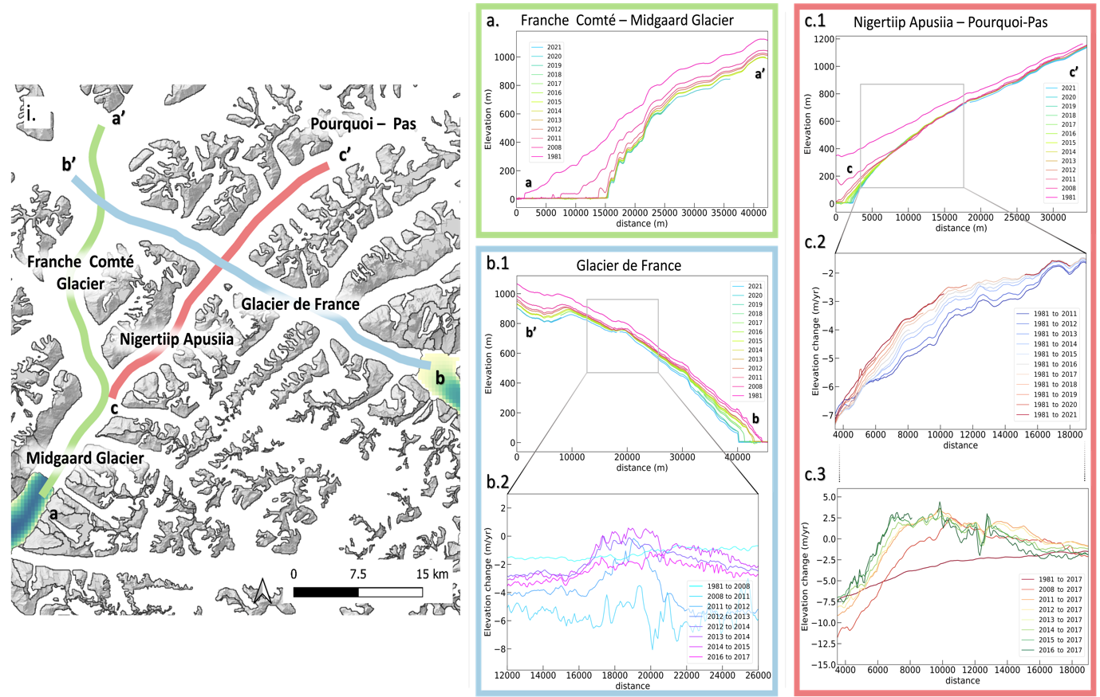
Fig.S5 – Elevation changes across Midgaard Glacier, Franche Comté, Nigertiip Apusia, Pourquoi-Pas and Glacier de France
i, Overview of the study area, highlighting the position of the profiles. (a,b.1,c.1) Elevation profile evolution of Franche Comté – Midgaard Glacier, Glacier de France and Pourquoi-Pas – Nigertiip Apusiia Glacier. (b.2) shows the yearly elevation change rates, (c.2) shows the long-term elevation change rates, (c.3) shows the short-term elevation change rate.

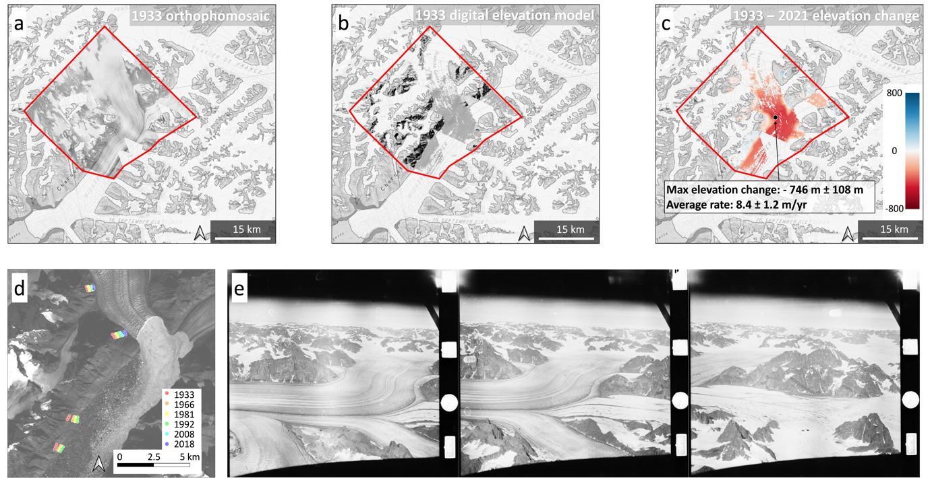

Fig.S6 – Oldest reconstructed Midgaard Glacier dataset
a, 1933 Orthophotomosaic at 10 m resolution, b, 1933 Digital Elevation Model (DEM) at 50 m resolution, and c, 1933-2021 Elevation Change (∆h) at 50 m resolution. d, Locations of the analysis of the historical trim lines using the Orthophotomosaic. e, High-oblique aerial images from the 1933 mapping expeditions²⁷
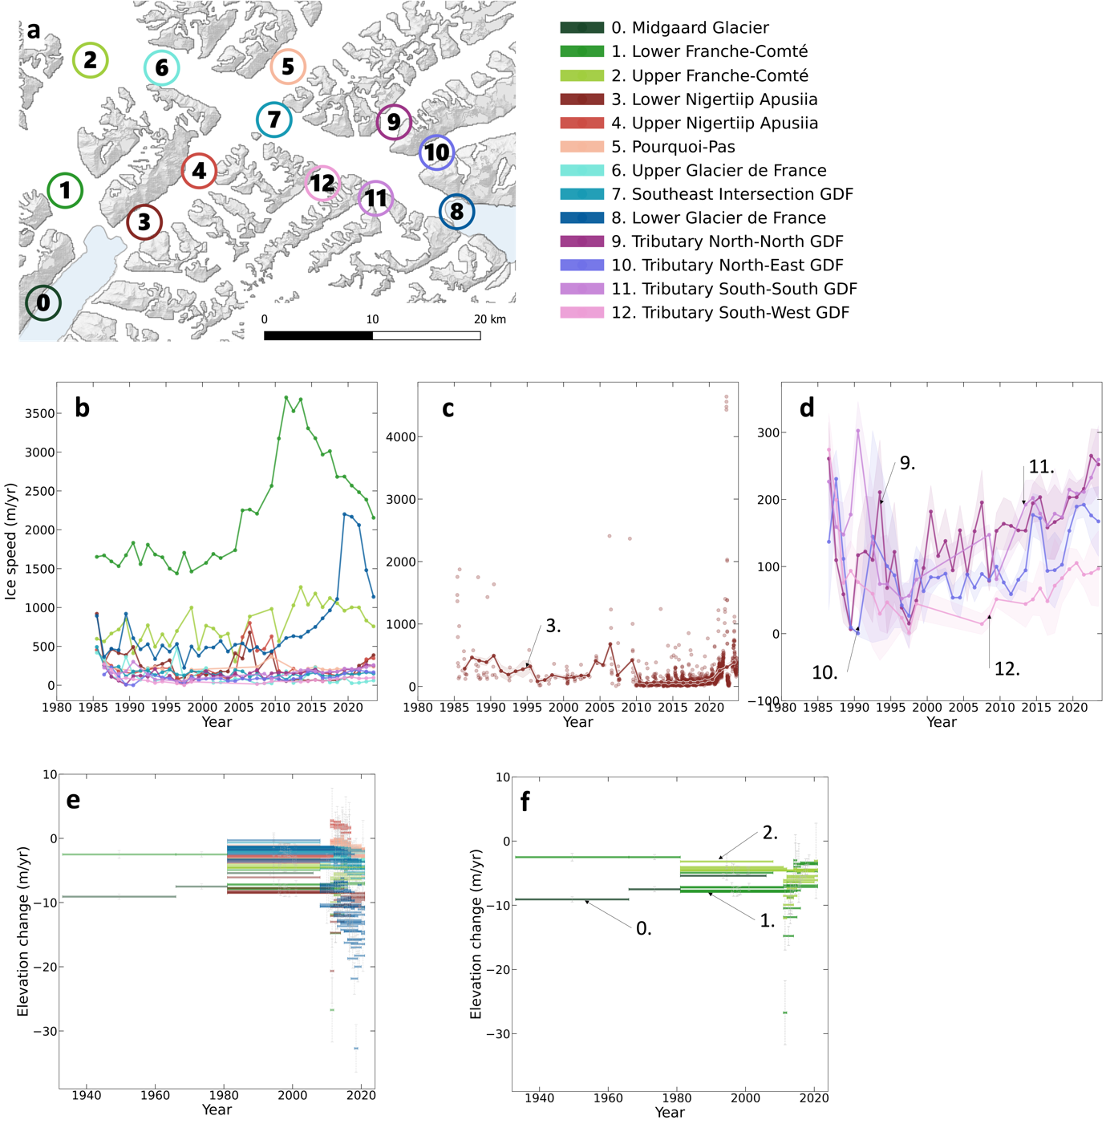
Fig.S7 – Supplementary velocity data and more than 80 years of thinning
a, Map illustrating the location of the different thinning values analysed starting from 1933 to 2021. b, All yearly velocity series stacked together in one figure to compare time series between each location. e, Zoom on velocity data at location 3 (all data for location 3 are represented with points, and yearly averaged data is represented with a line). d, Zoom on the yearly velocity data around the tributaries of GDF. e, All thinning data stacked together in one figure to compare time series between each location f, Times series of the thinning from Midgaard -Franche Comté Glacier.

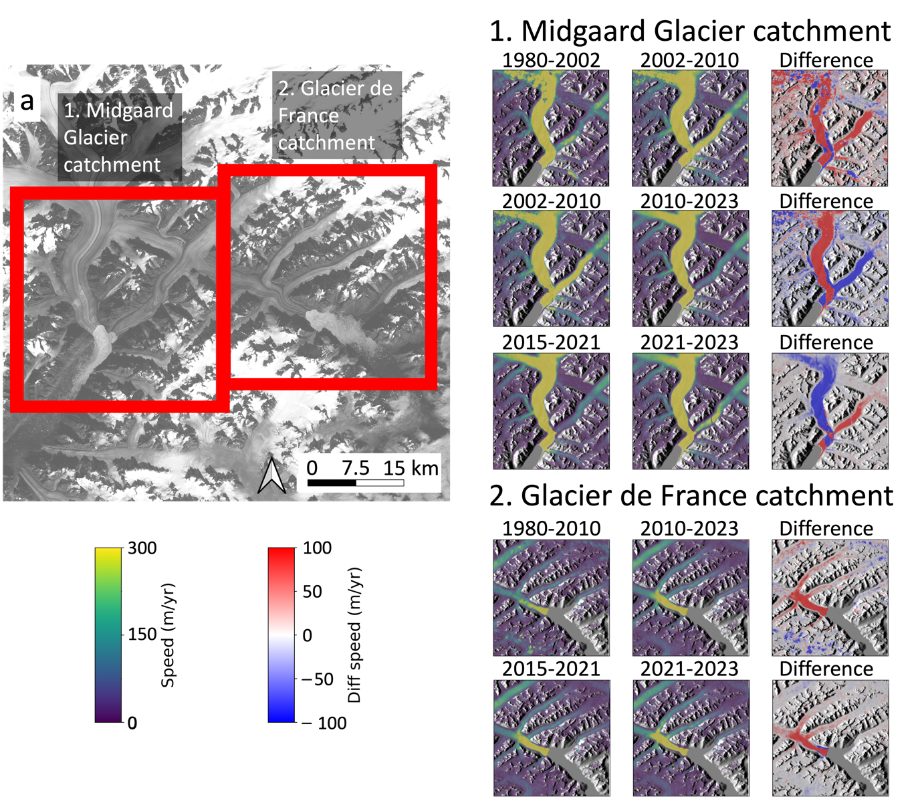

Fig.S8 – Velocity maps
a, Map illustrating the location of the two areas. (b,c,d,e) Velocity maps between four relevant periods for the area: 1980-2002, 2002-2010, 2015-2021 and 2010-2023 and (f,g,h) difference of velocity maps of the Midgaard Glacier catchment focusing on Franche Comté and Nigertiip Apusiia. (i,j,k) Velocity maps between three relevant periods for the area: 1980-2010, 2015-2021 and 2021-2023 and (l,m,n) difference of velocity maps of the Glacier de France catchment.

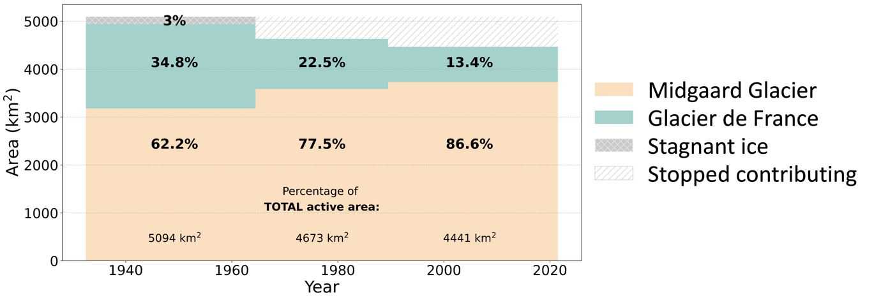
Fig.S9 – Evolution of the partitioning of Midgaard Glacier and Glacier de France catchments
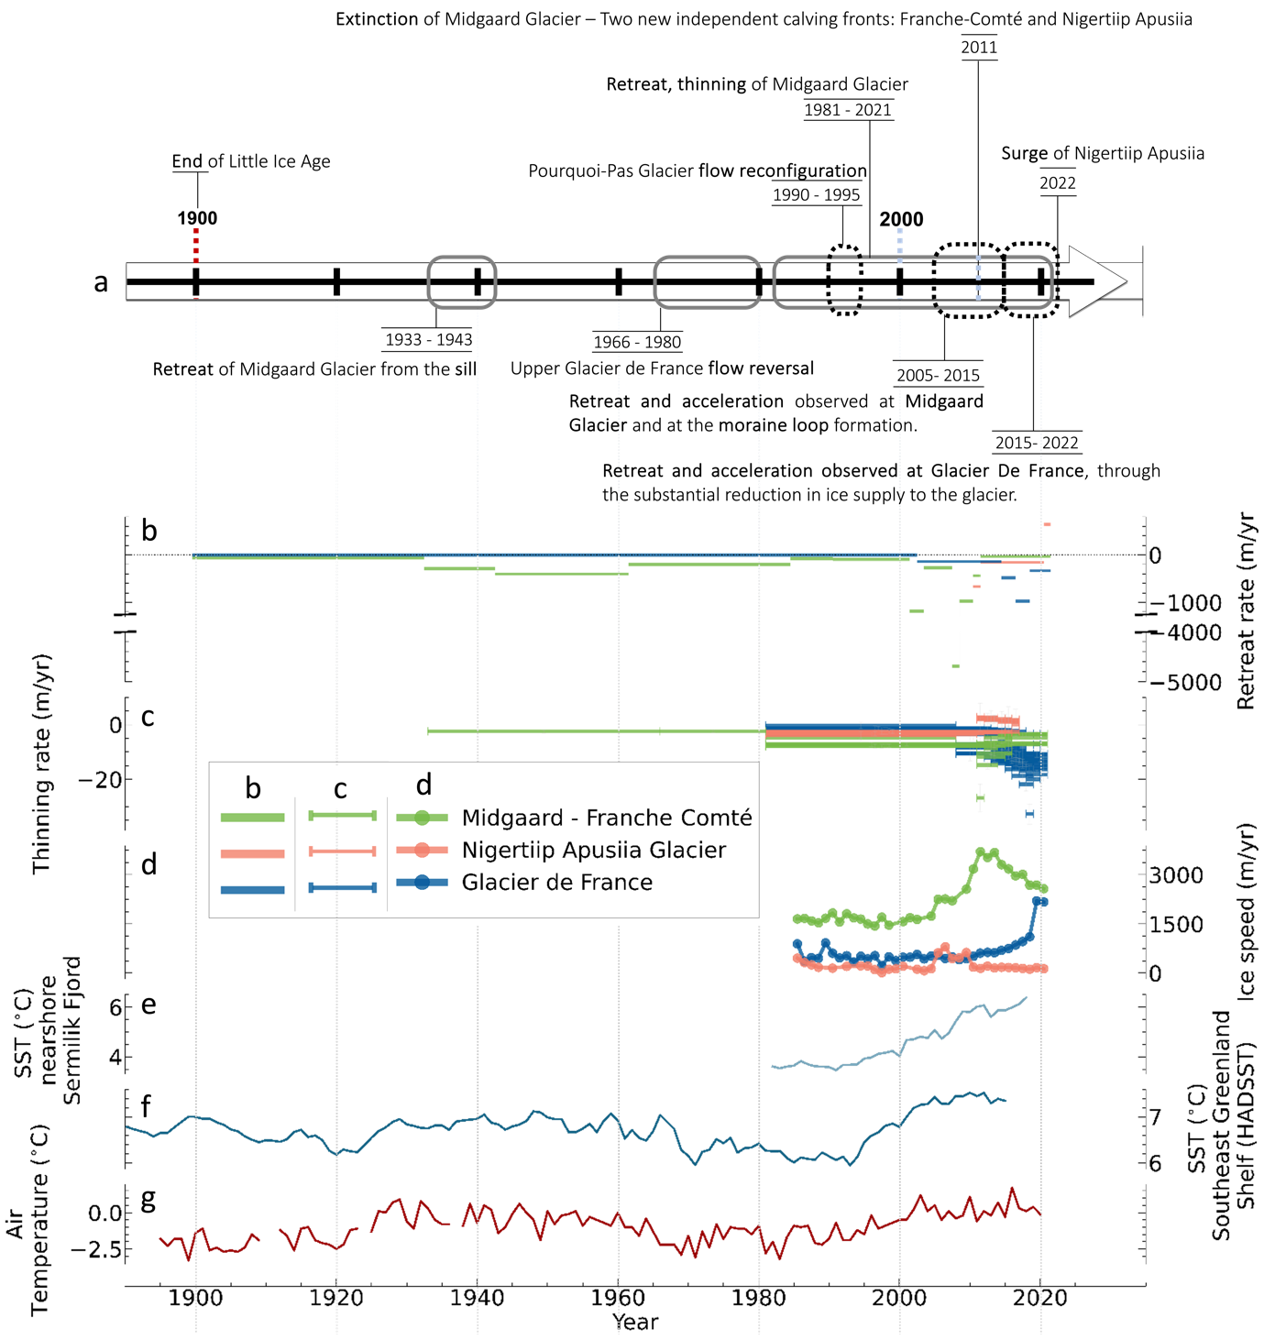
Fig.S10 – Climate History and Cascading Events
a, This timeline depicts the area's glacial history of the past century, showcasing periods of both warmer and colder conditions. It also illustrates the interconnected sequence of events unfolding across different catchments. b, Time series depicting the retreat rates of both the Midgaard Glacier (then Franche Comté and Nigertiip Apusia) and the calving front of Glacier de France. c, Times series of the thinning at different locations: Franche Comté Glacier, Nigertiip Apusiia and Glacier de France. d, Time series of velocity at: Franche Comté Glacier, Glacier de France and Nigertiip Apusiia. e, Summer SST (0-20 m) from the Southeast Greenland shelf (integrated over the area 64°-66°N and extending from the coast and 100 km offshore). f, HadSST observation-based modelled late summer Sea Surface Temperatures (SST) from the Southeast Greenland shelf. g, Air Temperature from the closest station located in Tasiilaq.

