Understanding the drivers of continued mpox transmission in the United States: a modeling study

Supplementary Data

Nodar Kipshidze, MS, MPH^{1,2}; Eili Klein, PhD^{2,3}; Wan Yang, PhD¹

- Department of Epidemiology, Mailman School of Public Health, Columbia University, New York, NY, USA
- One Health Trust, Washington, DC, USA
- Department of Emergency Medicine, Johns Hopkins University, Baltimore, MD, USA

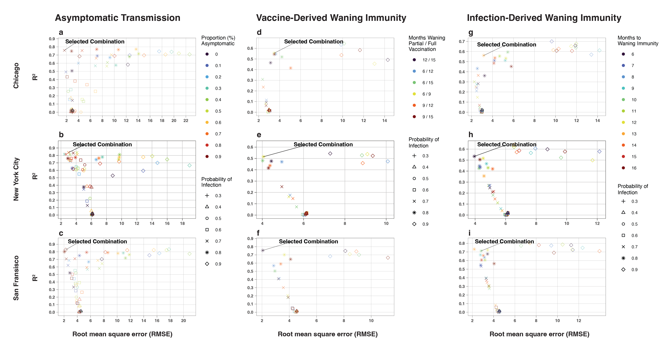
Figure S1. Evaluation of models based on the root mean square error (RMSE) and R². The figure is divided by modeled mechanisms and cities: asymptomatic transmission (a-c), vaccine-derived waning immunity (d-f), and infection-derived waning immunity (g-i). Each section consists of plots that compare the computed RMSE and R² values. Combinations that fall in the upper left quadrant, representing low RMSE and high R², are deemed the best performing. This quadrant signifies a balance between explained variance (high R²) and minimized error (low RMSE). The selected model combination for each section was chosen based on these metrics and a qualitative assessment comparing the simulated epidemic peak to the observed peak.

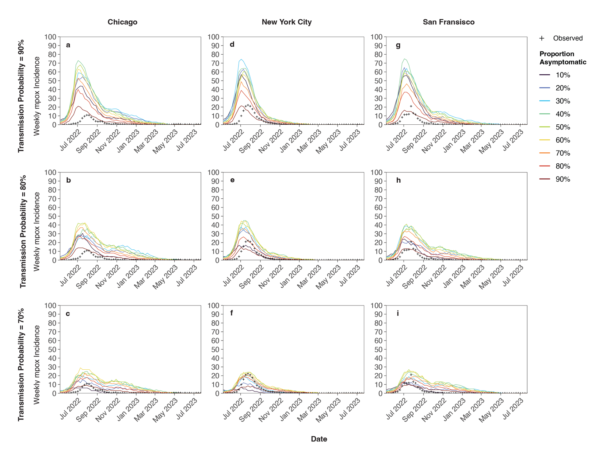
Figure S2. Comparing the peaks of the simulated mpox epidemics modeling asymptomatic transmission to the scaled observed data of each respective city for three highest probabilities of transmission (70-90%).

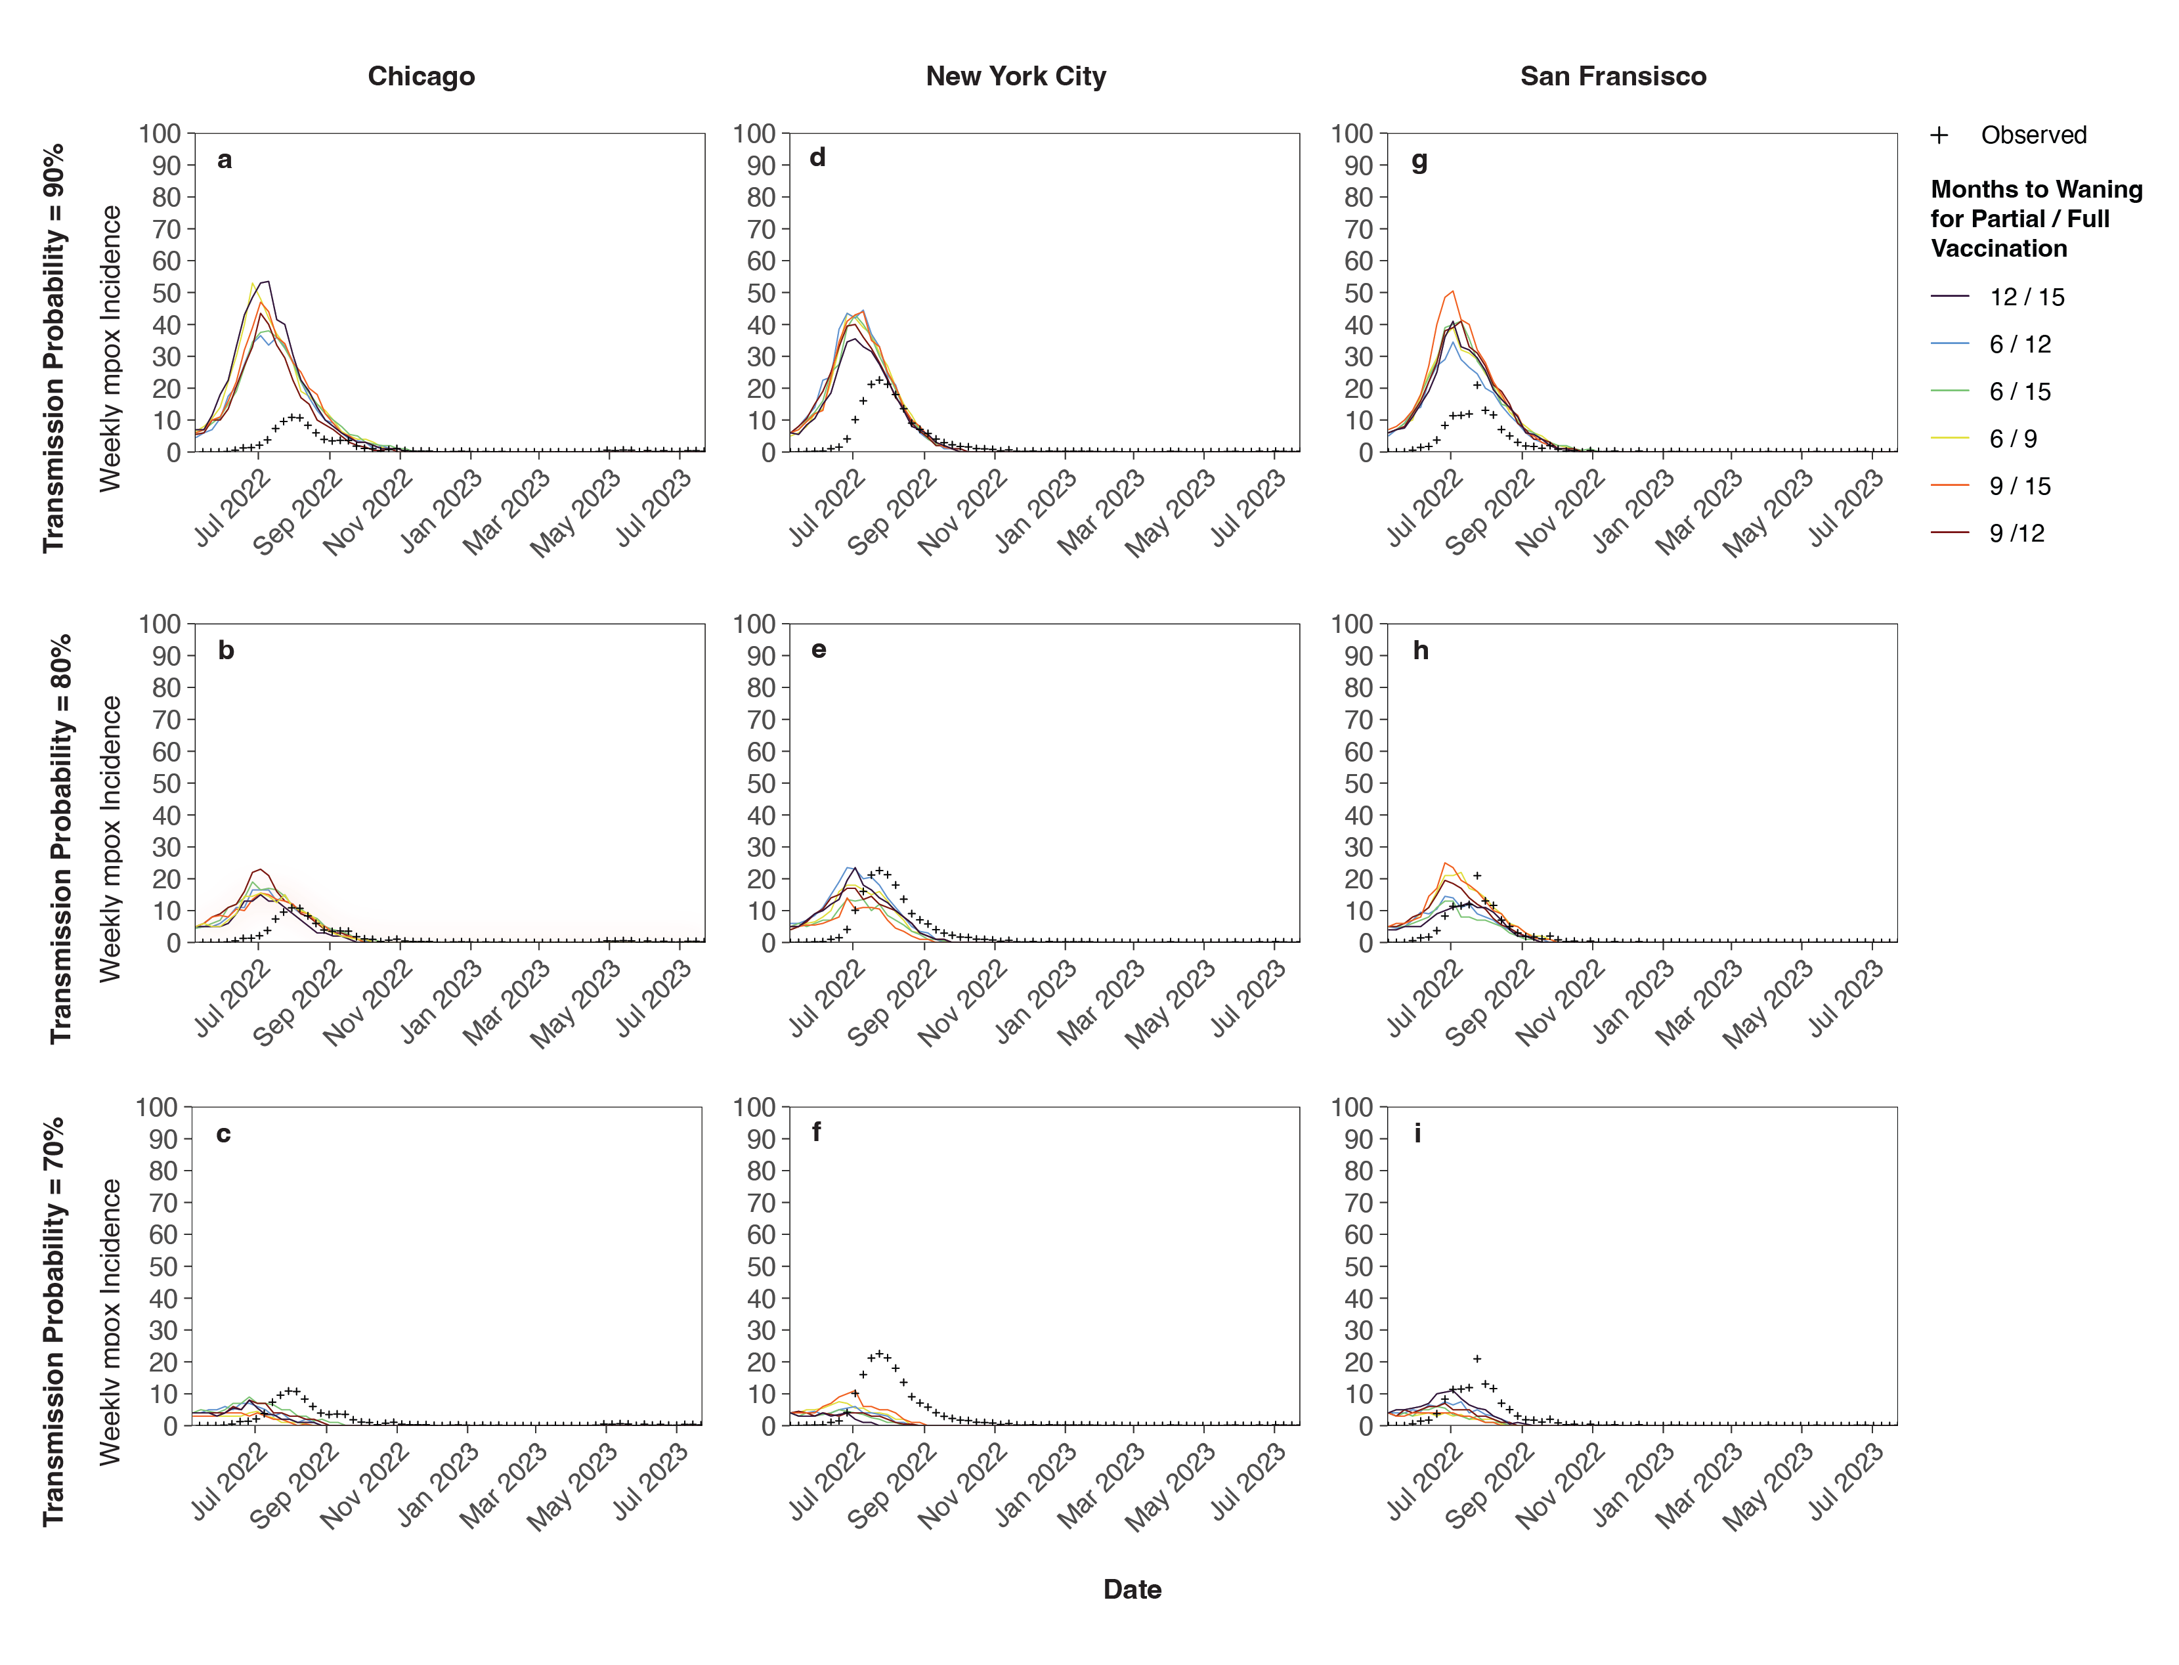
Figure S3. Comparing the peaks of the simulated mpox epidemics modeling vaccine-derived waning immunity transmission to the scaled observed data of each respective city for three highest probabilities of transmission (70-90%).

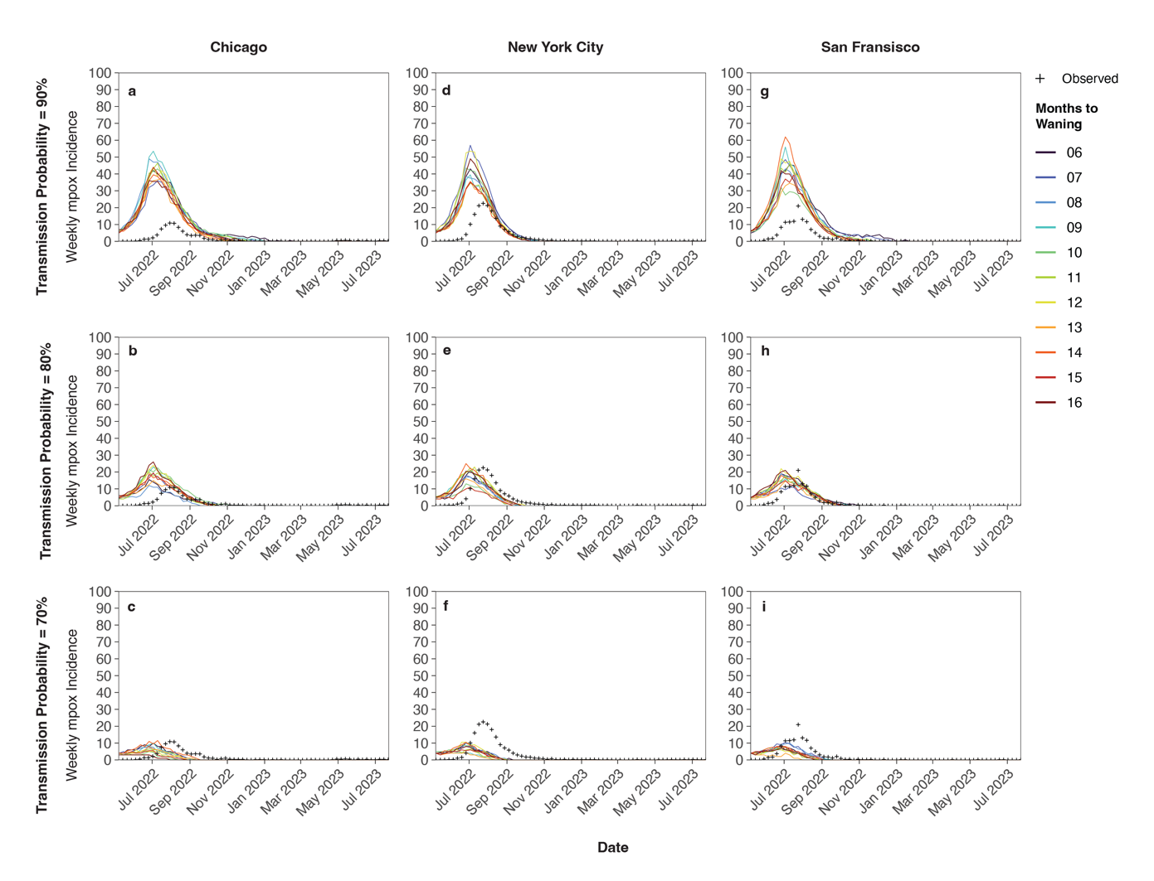
Figure S4. Comparing the peaks of the simulated mpox epidemics modeling infection-derived waning immunity transmission to the scaled observed data of each respective city for three highest probabilities of transmission (70-90%).

Table S1. Estimated basic reproductive number (R₀) for each city estimated as the average number of secondary infections among the first generation of infections, up to and including the second generation, and up to and including the third generation. The max recovery indicates the last day of infectiousness among a give generation.

City / Generation | Max Recovery | R₀ Estimates
City / Generation | Max Recovery | Median | Mean | Percentiles
 |  |  |  | 2.50% | 25% | 75% | 97.50%
Chicago
Generation 1 | 6-Jul-22 | 0.700 | 0.775 | 0.200 | 0.400 | 1.000 | 1.900
Generations 1-2 | 24-Dec-22 | 1.000 | 1.469 | 0.142 | 0.500 | 2.111 | 4.541
Generations 1-3 | 29-Jan-23 | 1.500 | 1.722 | 0.000 | 0.667 | 2.613 | 4.478
New York City
Generation 1 | 17-Jun-22 | 0.700 | 0.762 | 0.200 | 0.475 | 1.000 | 1.653
Generations 1-2 | 23-Dec-22 | 1.000 | 1.531 | 0.198 | 0.600 | 1.798 | 6.359
Generations 1-3 | 26-Dec-22 | 1.300 | 1.773 | 0.100 | 0.700 | 2.333 | 6.400
San Francisco
Generation 1 | 12-Jun-22 | 0.800 | 0.881 | 0.200 | 0.575 | 1.100 | 2.453
Generations 1-2 | 20-Dec-22 | 1.100 | 1.774 | 0.200 | 0.700 | 2.500 | 6.284
Generations 1-3 | 20-Jan-23 | 1.667 | 2.101 | 0.300 | 0.800 | 2.896 | 5.946

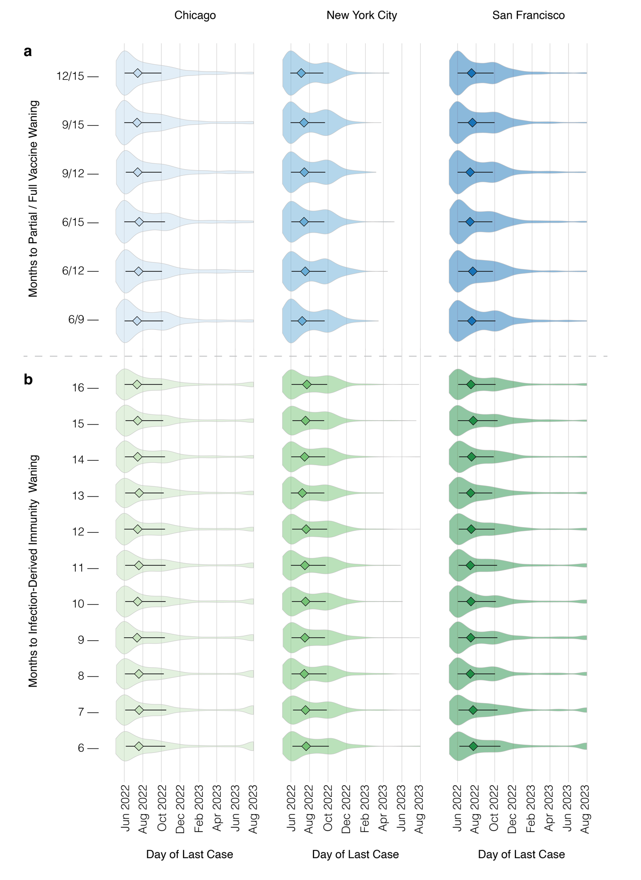
Figure S5. Outbreak duration sensitivity to the length of protection from vaccine-derived immunity (a) and infection-derived immunity (b).

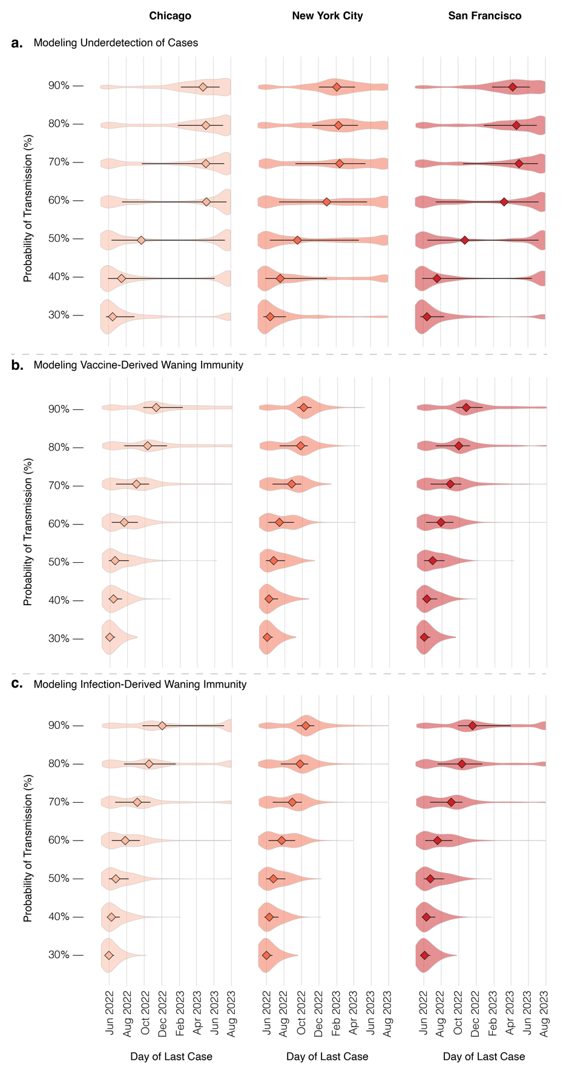
Figure S6. Violin and boxplots (diamond shape = median and bars = interquartile range) of the day of the last case observed of each modeled mechanism across the increments of infection probability for the three mechanisms: asymptomatic transmission (a), vaccine-derived immunity waning (b), and infection-derived immunity waning (c).

Table S2. Assessing the associations between fitted parameters and the day of the last case (i.e., length of the outbreak) using partial rank correlation analysis.
Scenario / Parameter | Partial Rank Correlation Coefficients
Scenario / Parameter | Chicago | New York City | San Francisco
Asymptomatic Transmission
Proportion asymptomatic ($θ$) | 0.3742 | 0.4489 | 0.3999
Probability of infection ($β)$ | 0.3584 | 0.4057 | 0.3704
Vaccine-derived Waning Immunity
Rate of partial vaccination waning immunity ($ω_{1}$) | -0.0094 | -0.0198 | -0.0131
Rate of full vaccination waning immunity ($ω_{2})$ | -0.0065 | -0.0010 | -0.0029
Probability of infection ($β)$ | 0.6100 | 0.5908 | 0.5817
Infection-derived Waning Immunity
Rate of infection-derived waning immunity (ξ) | 0.0287 | 0.0209 | 0.0214
Probability of infection ($β)$ | 0.6156 | 0.5992 | 0.5944

