Supplementary Information
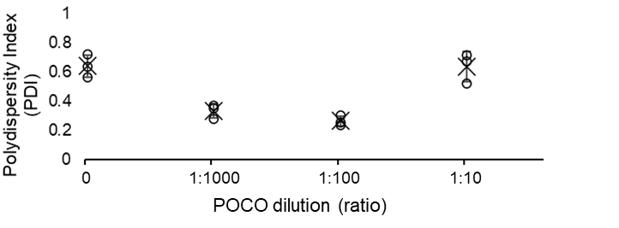
Supplementary Figure 1. PEDOT-POCO particle dispersity with varying POCO concentrations
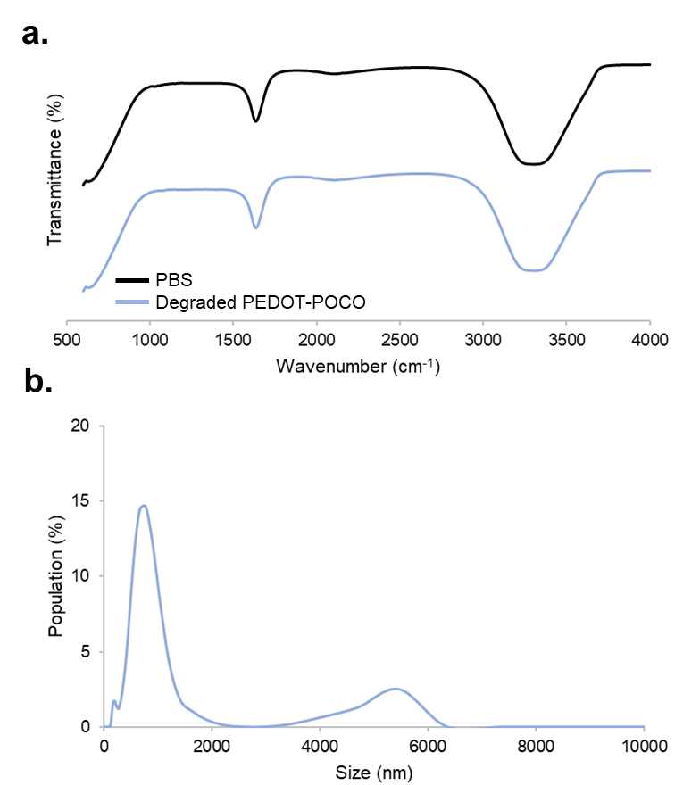
Supplementary Figure 2. Characterization of degraded PEDOT-POCO (a) FTIR of degraded PEDOT-POCO solution resembles that of PBS alone. (b) Particle analysis of degraded PEDOT-POCO films shows the primary distribution of particles being approximately 700 nm, which is consistent with PEDOT nanoparticle sizes.

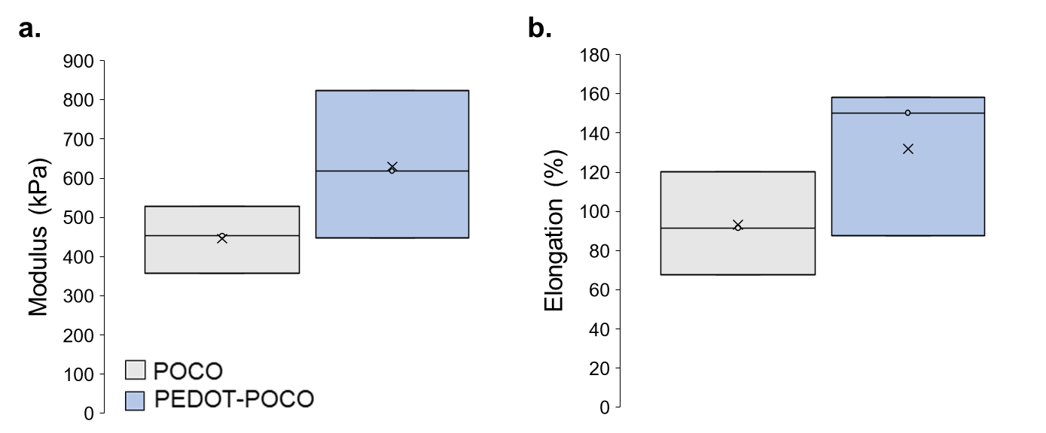
Supplementary Figure 3. Mechanical properties of POCO, PEDOT-POCO (a) Young’s modulus and (b) elongation at break were comparable for both POCO and PEDOT-POCO films.
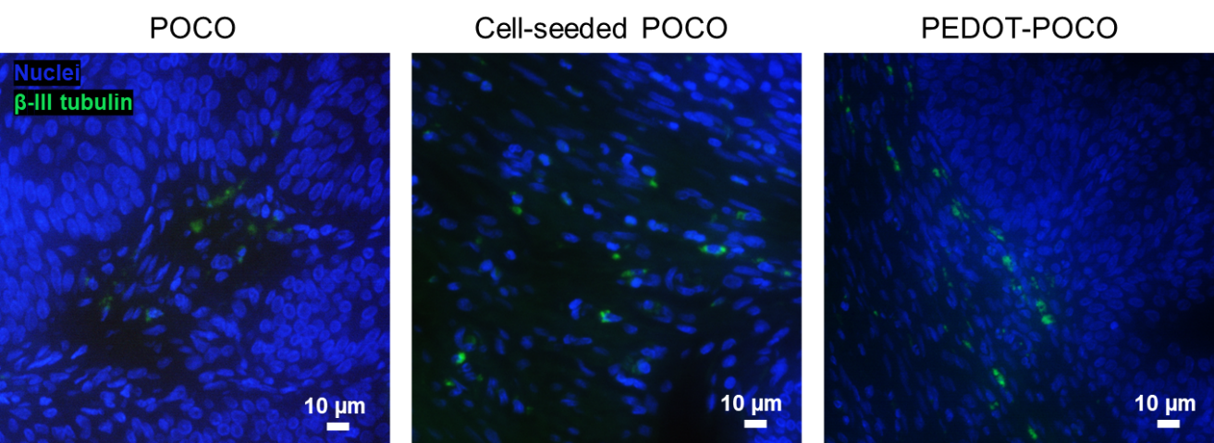
Supplementary Figure 4. Immunofluorescence staining of β-III tubulin for nerve quantification

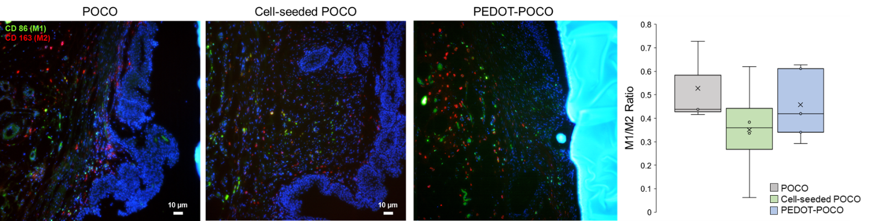
Supplementary Figure 5. M1:M2 cell analysis via immunofluorescence

