Supplementary Information for

• A pair of Chinese Shang oracle graphs Niu and Yang for certain livestock originate from the Neolithic Fertile Crescent

For author information see Title Page

This Supplementary Information file includes:

Supplementary Figs. S1 to S2
Supplementary Tables S1 to S4
Supplementary Reference List

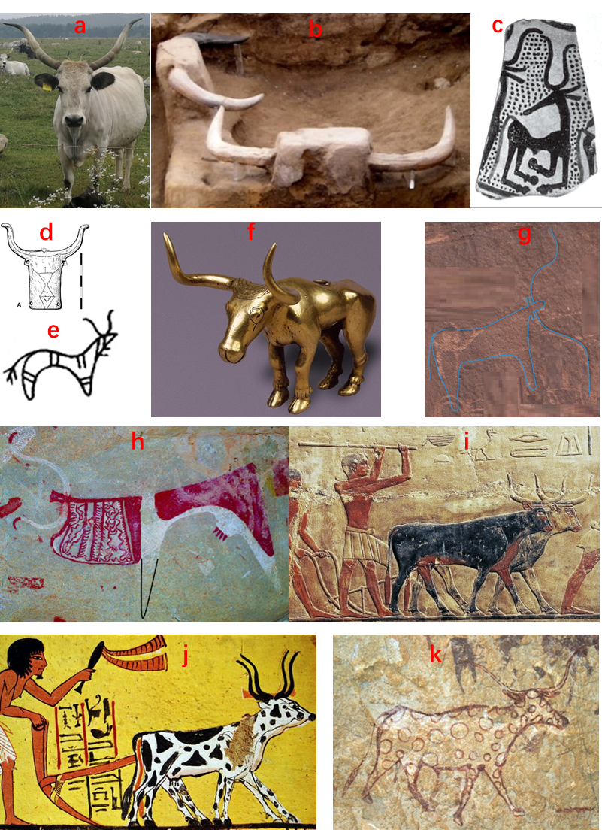

Fig. S1 The different period aurochs and taurine cattle with S-curved horns from different areas

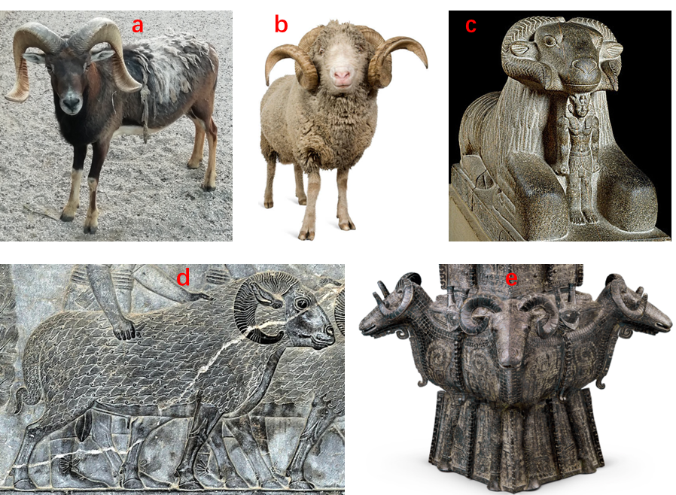

Fig. S2 The different period mouflons and sheep with spiral horns from different areas.

Table S1 The Halaf motifs discussed in this paper

Figs. | Sites | Fig. nos. in (Bahattİn, 2019) where applicable | Periods of Halaf culture | References
1.b | Chagar Bazar | - | Middle | (Mallowan, 1936)
1.c | Tell Arpachiyah | - | Early | (Mallowan & Rose, 1935)
1.d | Tell Arpachiyah | 34.2 | Early | (Mallowan & Rose, 1935; Bahattİn, 2019)
1.e | Chagar Bazar | 50.8 | Early | (Mallowan, 1936; Bahattİn, 2019)
1.f | Chagar Bazar | 50.13 | Early | (Mallowan, 1936; Bahattİn, 2019)
1.g | Chagar Bazar | 50.10 | Early | (Mallowan, 1936; Bahattİn, 2019)
1.h | Tell Yunus | 74.1 | Middle or late | (Dirvâna, 1944; Bahattİn, 2019)
1.i | Kerküşti Höyük | 61.17 | Middle | (Sarıaltun, 2008; Bahattİn, 2019)
2.1b | Tell Arpachiyah | 38.1 | Early | (Hijara, 1997a, 1997b; Bahattİn 2019)
2.1c | Tell Arpachiyah | - | Not available | (Dabbagh, 1966; Gong, 2009)
2.1d | Tell Yunus | - | Not available | (Dabbagh, 1966; Gong, 2009)
2.1e | Tell Arpachiyah | 34.5 | Early | (Mallowan & Rose, 1935; Bahattİn, 2019)
2.1f | Tell Arpachiyah | - | Not available | (Mallowan & Rose, 1935)
2.1g | Tell Arpachiyah | 34.4 | Early | (Becker, 2019; Bahattİn, 2019)
2.1i | Shams ed-Din Tannira | - | Middle or late | (Becker, 2019)
2.1j | Domuztepe | - | Not available | (Altuntaş, L. 2022; The History Blog, 2022)
2.2a | Tell Arpachiyah | - | Early | (Mallowan & Rose, 1935)
2.2b | Tell Yunus | 73.5 | Undated | (Woolley, 1934; Bahattİn, 2019)
2.2c | Tell Brak | 54.4 | Undated | (Mallowan, 1947; Bahattİn, 2019)
2.2d | Tell Arpachiyah | - | Early | (Mallowan, 1947)
2.2e | Tell Yunus | 73.8 | Middle or late | (Dirvâna, 1944; Bahattİn, 2019)
2.2f | Tell Yunus | 73.9 | Middle or late | (Dirvâna, 1944; Bahattİn, 2019)

To be continued.

Table S1 The Halaf motifs discussed in this paper (Continue)

Figs. | Sites | Fig. nos. in (Bahattİn, 2019) where applicable | Periods of Halaf culture | References
2.2g | Tell Kurdu | 83.3 | Early or middle | (Özbal et al., 2004; Bahattİn, 2019)
2.2h | Tell Damishliyya | 64.3 | Middle ? | (Akkermans 1988; Bahattİn, 2019)
2.2i | Khirbet esh-Shenef | 63.2 | Middle or late | (Akkermans &  Wittmann, 1993; Bahattİn, 2019)
2.2j | Khirbet esh-Shenef | 63.7 | Late | (Akkermans, 1993; Bahattİn, 2019)
2.2k | Tell Halula | 75.5 | Undated | (Cruells, 2013; Bahattİn, 2019)
2.2l | Tell Amarna | 72.3 & 72.9 | Middle or late | (Cruells, 2004; Bahattİn, 2019)
2.2m | Tell Arpachiyah | - | Not available | (Mallowan & Rose, 1935)
2.2n | Tell Arpachiyah | - | Not available | (Mallowan & Rose, 1935)
2.2o | Tell Yunus | 73.12 | Middle or late | (Dirvâna, 1944; Bahattİn, 2019)
2.2p | Tell Amarna | 72.5 | Middle or late | (Cruells, 2004; Bahattİn, 2019)
2.3a | Tell Kurdu | 83.2 | Early or middle | (Özbal & Gerritsen, 2003; Bahattİn 2019)
2.3b | Khirbet esh-Shenef | 63.3 | Middle or late | (Akkermans & Schwartz, 2003; Bahattİn, 2019)
2.3c | Tell Arpachiyah | 35.8 | Undated | (Hijara, 1997a, 1997b; Bahattİn 2019)
2.3d | Tell Arpachiyah | - | Early | (Mallowan & Rose, 1935)
2.3e | Yarim Tepe II | 40.12 | Undated | (Merpert & Munchaev, 1993a; Bahattİn, 2019)
2.3f | Tell Turlu | - | Late or Halaf-Ubaid | (Davidson, 1977)
2.3g | Tell Amarna | 72.4 | Middle | (Cruells, 1998, 2004; Bahattİn, 2019)
2.3h | Tell Sabi Abyad | - | Not available | (Grimbergen, 2016)
2.3i | Tell Arpachiyah | 35.2 | Undated | (Hijara, 1997a, 1997b; Bahattİn, 2019)

To be continued.

Table S1 The Halaf motifs discussed in this paper (Continue)

Figs. | Sites | Fig. nos. in (Bahattİn, 2019) where applicable | Periods of Halaf culture | References
2.4a | Tell Arpachiyah | 35.7 | Undated | (Hijara, 1997a, 1997b; Bahattİn, 2019)
2.4b | Tell Arpachiyah | 35.9 | Undated | (Hijara, 1997a, 1997b; Bahattİn, 2019)
2.4c | Tell Arpachiyah | 90.1 | Not available | (Hijara, 1997a, 1997b; Bahattİn, 2019)
2.4d | Tell Halaf | 56.15 | Undated | (Schmidt 1943; Bahattİn, 2019)
2.4e | Tell Halula | 75.2 | Early or middle | (Cruells, 2013; Bahattİn, 2019)
2.4f | Tell Turlu | 77.4 | Late or Halaf-Ubaid | (Breniquet, 1991; Bahattİn, 2019)
2.5a | Tell Arpachiyah | - | Not available | (Mallowan & Rose, 1935)
2.5b | Tell Amarna | - | Middle | (Cruells, 2004)
2.5c | Tell Yunus | 73.4 | Middle or late | (Woolley, 1934; Bahattİn, 2019)
2.5d | Tell Arpachiyah | - | Late | Mallowan & Rose, 1935
2.5e | Tell Arpachiyah | 35.6 | Undated | (Hijara, 1997a, 1997b; Bahattİn, 2019)
2.5f | Tell Arpachiyah | 35.10 | Undated | (Hijara, 1997a, 1997b; Bahattİn, 2019)
2.5g | Yarim Tepe II | 40.10 | Undated | (Merpert & Munchaev, 1987; Bahattİn, 2019)
2.5h | Chagar Bazar | - | Not available | [(Dabbagh, 1966; Gong et al., 2009)
2.5i | Tell Arpachiyah | - | Not available | (Dabbagh, 1966; Gong et al., 2009)
2.5j | Domuztepe | 84.4 | Early | Carter & Campbell, 2006; Bahattİn, 2019)
2.5k | Tell Arpachiyah | 35.4 | Undated | [21, 42, 43] (Hijara, 1997a, 1997b; Bahattİn, 2019)
2.5l | Tell Arpachiyah | 35.5 | Undated | [21, 42, 43] (Hijara, 1997a, 1997b; Bahattİn, 2019)
2.5m | Tell Halula | 75.3 | Early or middle | (Cruells, 2013; Bahattİn, 2019)
2.5n | Tell Arpachiyah | - | Not available | (Hijara, 1997a, 1997b; Bahattİn, 2019)

To be continued.

Table S1 The Halaf motifs discussed in this paper (Continue)

Figs. | Sites | Fig. nos. in (Bahattİn, 2019) where applicable | Periods of Halaf culture | References
2.6a | Tell Arpachiyah | - | Not available | (Mallowan & Rose, 1935)
2.6b | Tell Arpachiyah | - | Not available | (Mallowan & Rose, 1935)
2.6c | Tell Arpachiyah | - | Not available | (Mallowan & Rose, 1935)
2.6d | Tell Arpachiyah | - | Not available | (Mallowan & Rose, 1935)
2.6e | Tell Arpachiyah | 34.3 | Early | (Hijara, 1997a, 1997b; Bahattİn, 2019)
2.6f | Tell Arpachiyah | 35.1 | Undated | (Hijara, 1997a, 1997b; Bahattİn, 2019)
2.6g | Domuztepe | 84.6 | Late or Post Halaf | (Campbell et al., 1999; Bahattİn, 2019)
2.6h | Barhawi | - | Not available | (Hijara, 1997a, 1997b)
2.6i | Tell Arpachiyah | - | Not available | (Mallowan & Rose, 1935)
2.6j | Tell Arpachiyah | - | Not available | (Mallowan & Rose, 1935)
3.a | Chagar Bazar | 50.19 | Late | (Mallowan, 1936; Bahattİn, 2019)
3.b | Yarım Tepe III | 43.3 | Undated | (Merpert & Munchaev1993b; Bahattİn, 2019)
3.c | Chagar Bazar | 50.21 | Late | (Mallowan, 1936; Bahattİn, 2019)
3.d | Chagar Bazar | 50.23 | Late | (Mallowan, 1936; Bahattİn, 2019)
3.e | Tepe Gawra | 39 .1 | Late | (Tobler, 1950; Bahattİn, 2019)
3.f | Yarim Tepe II | 40.14 | Undated | (Merpert & Munchaev, 1987; Bahattİn, 2019)
3.g | Tell Halaf | 56.23 | Late | (Schmidt 1943; Bahattİn, 2019)
3.h | Kara Tepe | - | Not available | (Hijara, 1997a, 1997b)
4.1b | Chagar Bazar | 50.22 | Late | (Mallowan, 1936; Bahattİn, 2019)
4.1c | Khirbet esh-Shenef | 63.10 | Middle or late | (Akkermans & Wittmann, 1993; Grimbergen 2016; Bahattİn, 2019)
4.1d | Chagar Bazar | 50.24 | Late | (Mallowan, 1936; Bahattİn 2019)
4.1e | Chagar Bazar | 50.25 | Late | (Mallowan, 1936; Bahattİn, 2019)
4.1f | Tell Yunus | 73.22.15 | Middle or late | (Dirvâna, 1944; Bahattİn, 2019)
4.1h | Tell Damishliyya | 64.4 | Late | (Akkermans 1988; Bahattİn, 2019)
4.2a | Tell Yunus | 73.21 | Undated | (Dirvâna, 1944; Bahattİn, 2019)

To be continued.

Table S1 The Halaf motifs discussed in this paper (Continue)

Figs. | Sites | Fig. nos. in (Bahattİn, 2019) where applicable | Periods of Halaf culture | References
4.2b | Tell Arpachiyah | 34.18 | Early | (Hijara, 1997a, 1997b; Bahattİn, 2019)
4.2c | Tell Arpachiyah | 35.27 | Undated | (Hijara, 1997a, 1997b; Bahattİn, 2019)
4.2d | Tell Halaf | 56.18 | Late | (Schmidt, 1943)
4.2e | Tell Halaf | 56.24 | Undated | (Schmidt, 1943)
4.2f | Khirbet esh-Shenef | 63.11 | Late | (Akkermans, 1993; Bahattİn, 2019)
4.2g | Tell Yunus | 73.6 | Middle or late | (Dirvâna, 1944; Bahattİn, 2019)
4.2h | Domuztepe | 84.8 | Halaf-Ubaid | [(Tekin, 2016; Bahattİn, 2019)
4.3a | Tell Brak | 54.7 | Undated | (Mallowan, 1947; Bahattİn 2019)
4.3b | Ashiq | - | Not available | (Hijara, 1997a, 1997b)
4.3c | Chagar Bazar | 50.18 | Early | (Mallowan, 1936; Bahattİn, 2019)
4.3d | Tell Halaf | 56.19 | Late | (Schmidt 1943; Bahattİn, 2019)
4.3e | Tell Halaf | 56.21 | Undated | (Schmidt 1943; Bahattİn, 2019)
4.3f | Tell Halaf | 56.22 | Undated | (Schmidt 1943; Bahattİn, 2019)
4.3g | Tell Sabi Abyad | 68.6 | Early | (Akkermans, 1987; Bahattİn, 2019)
4.3h | Tell Sabi Abyad | - | Not available | (Grimbergen 2016)
4.3i | Kerküşti | 61.15 | Middle | (Sarıaltun, 2008; Bahattİn, 2019)
4.4a | Tell Arpachiyah | 34.13 | Early | (Hijara, 1997a, 1997b; Bahattİn, 2019)
4.4b | Tell Arpachiyah | 35.25 | Undated | (Hijara, 1997a, 1997b; Bahattİn, 2019)
4.4c | Tell Arpachiyah | 34.19 | Middle | (Mallowan & Rose, 1935; Bahattİn, 2019)
4.4d | Tell Arpachiyah | 35.24 | Undated | (Hijara, 1997a, 1997b; Bahattİn, 2019)
4.4e | Tell Arpachiyah | 35.26 | Undated | (Hijara, 1997a, 1997b; Bahattİn, 2019)
4.4f | Tell Arpachiyah | - | Not available | (Mallowan & Rose, 1935)
4.4g | Tell Arpachiyah | - | Not available | (Mallowan & Rose, 1935)
4.4h | Tell Arpachiyah | - | Not available | (Mallowan & Rose, 1935)
4.4i | Chagar Bazar | 50.20 | Middle | (Mallowan, 1936; Bahattİn, 2019)
4.4j | Sawwan | - | Not available | (Hijara, 1997a, 1997b; Bahattİn, 2019)

Table S2 The Shang oracle and bronze graphs, and characters discussed in this paper

Figs. | Descriptions | Character nos. | References
5.1a-b | The Shang oracle graph Niu | 8974, 32397 | (Guo & Hu 1978)
5.1c | The Shang oracle graph Niu | - | (Xu J., 2009: 72)
5.1d | The Shang bronze graph Niu | 4133 | (the Institute of  Archaeology CASS  1984)
5.1e | The Zhuanshu Form Niu | - | (Tao, 2020: 37)
5.1f | The Lishu Form Niu | - | (Xu J., 2009: 72)
5.1g | The Kaishu form Niu | - | (Xu J., 2009: 72)
5.2a-c | The Shang oracle graph Yang | 1072, 27321, 27330 | (Guo & Hu 1978)
5.2d | The Shang bronze graphs Yang | 2838 | (the Institute of  Archaeology CASS  1984)
5.2e | The Zhuanshu Form Yang | - | (Tao, 2020: 118)
5.2f | The Lishu Form Yang | - | (Xu J., 2009: 72)
5.2g | The Kaishu form Yang | - | (Xu J., 2009: 72)
5.3a-d | The Shang bronze graph Niu | 1103, 1104.1, 1104.2, 2973 | (the Institute of Archaeology CASS 1984)
5.4a-e | The Shang bronze graph Yang | 1105, 2410, 1289, 5267, 6315 | (the Institute of  Archaeology CASS  1984)
5.4f-g, i | The Shang bonze character Xiu | 8018, 1070, 4329 | (the Institute of  Archaeology CASS  1984)
5.4h | The Shang oracle graph Xiu | 1048 | (Guo & Hu 1978)
5.5a, 5.5d | The Shang oracle graph Si | - | (Lefeuvre 1982, 1990)
5.5b-c | The Kaishu Form Si | - | (Lefeuvre 1982, 1990)
5.5e | The Shang bronze graph Si | 1102 | (the Institute of  Archaeology CASS  1984)
5.6a-d | The Shang oracle graph Lu [deer] | 20752, 33368, 28334, 10287 | (Guo & Hu 1978)
5.6e | The Shang bronze graph Lu [deer] | 1110 | (the Institute of  Archaeology CASS  1984)

Table S3 The different period bovines with huge and S-curved horns from different areas

Fig. nos. | Descriptions | Sites and regions | Times (BCE) | References
1.a | Head view in outlines drawn after photos of Spanish-derived cattle Texas Longhorns | Texas | Modern | This paper, Mancini 2019, McTavish  et al., 2013
2.1a, 2.1h | The back view of a Hungarian Grey cattle | Hungary | Modern | Media, (2017).
2.1k | The back views of a group of Spanish cattle | Pamplona | Modern | EPA/Juan Pedro Urdíroz
S1a | Hungarian grey cattle | Orseg Hungary | Modern | (Secchi, 2019)
S1b | Aurochs with huge and  L-shaped horns very similar to  the Halaf bucranium horns. | Çatalhöyük, Anatolia | 7400–6000 | (Hodder 2012; Cridland, 2021)
S1c | A Halaf figural motif of male cattle | Tell Halaf Fertile Crescent | Halaf period | (Schmidt, 1943; Bahattİn 2019)
S1d | Bovid head shaped bone plate  of Trypillian culture | Veteba cave  Ukraine | 3900–2775 | (Nikitin et al.,  2010)
S1e | Bovid motif on pottery of  Trypillian culture | Veteba cave  Ukraine | 3450–3100 | (Nikitin et al.,  2010)
S1f | Bovine figurine of Maikop culture | Maikop  Caucasus | 3700–  3000/2900 | (Trifonov et al., 2022; James, 2021)
S1g | One of 104 Neolithic cattle rock art, most of which have huge and S-shaped horns | Shuwaymis  Saudi Arabia | 6800–6200 | Guagnin et al.  2015, 2016, 2018
S1h | One of many taurine cattle rock panting representations with huge and S-curved horns | Laas Geel  Somaliland | 3500–2500 | (Zboray 2017;  Gutherz &  Joussaume, 2018)
S1i | Two of many cattle painted bas-reliefs | Mastaba of Ty Egypt | 2400, the middle of the 5th dynasty | (Benderitter T., et al., no date)
S1j | Two cattle paintings in a plowing scene | tomb of  Sennedjem  Egypt | 1200, the 19th dynasty | (Mark, 2016)
S1k | Cattle rock art | Immidir in  Algeria | 4000 | (Dioli, 2018)

Table S4 The different period mouflons and sheep with spiral horns from different areas.

Fig. nos. | Descriptions | Sites and regions | Times (BCE) | References
4.1a 4.1g | Photo of European mouflon taken in Guangzhou city Zoological Garden | Europe | Modern | This paper
S2a | Photo of European mouflon taken in Guangzhou Zoological Garden | Guangzhou  city | Modern | This paper
S2b | Front view of sheep | Alpes and Corse France | Modern | (GlobalP. 2010)
S2c | An ancient Egypt Granite statue ram of Amun in Ashmolean Museum | Kawa in Nubia | 680, the 25th Dynasty | (Digital Karnak, 2018)
S2d | An Achaemenid Persian Empire Bas-relief of sheep with a thin and long tail | Persepolis, Iran | 500 | (Tafreshi, no date)
S2e | Shang bronze vessel Si Yang Fang Zun exhibited in the National Museum of China | Huangcai town  Middle  Changjiang  River | The Shang dynasty | (Si Yang Fang Zun, no date)

Supplementary References List

Akkermans, P. M. M. G. (1987). A Late Neolithic and Early Halaf Village at Sabi Abyad, Northern Syria. Paléorient, 13(1), 23-40.
Akkermans, P. M. M. G. (1988). The Soundings at Tell Damishliyya. In M.N. van Loon (Ed.), Hamam et-Turkman I: Report of the University of Amsterdam's 1981-84 Excavations in Syria (pp. 19-67). Nederlands Historisch-Archaeologisch Instituut te İstanbul.
Akkermans, P. M. M. G. (1993). Villages in the Steppe: Late Neolithic Settlement and Subsistence in the Balikh Valley, Northern Syria. International Monographs in Prehistory.
Akkermans P. M. M. G., & Wittmann, B. (1993). Khirbet esh-Shenef 1991: Eine späthalafzeitliche Siedlung im Balikhtal, Nordsyrien. Mitteilungen der Deutschen Orient-Gesellschaft, 125, 143-166.
Akkermans, P.M.M.G., & Schwartz, G.M. (2003). The Archaeology of Syria: From Complex Hunter-Gatherers to Early Urban Societies (ca.16,000-300 BC). Cambridge University Press.
Altuntaş, L. (2022, August 25). A Rare Late Neolithic Period Seal found in Domuztepe Mound. Arkeonews. Retrieved August 5, 2023, from https://arkeonews.net/a-rare-late-neolithic-period-seal-found-in-domuztepe-mound/
Bahattİn, İ. (2019). Figural motifs on Halaf pottery: An iconographical study of late Neolithic society in northern Mesopotamia. A Master’s Thesis, Bilkent University.
Becker, J., von Wickede, A., & Bachmann, F. (2019). A unique Halafian ceramic object from Shams ed-Din Tannira, Syria. Paléorient, 45(1): 19-32. https://doi.org/10.4000/paleorient.528
Benderitter, T., Treillet, M., Hirst, J. J., Mariais, C., Dispot, C., Blanc, S., Brualla, C., Bodsworth, J., Groesz, H., de Beler, A. G., & Brujic, T. (no date) The Mastaba of Ty. Osirisnet. https://www.osirisnet.net/mastabas/ty/e_ty_01.htm
Breniquet, C. (1991). Un site Halafien en Turquie meridionale: Tell Turlu. Akkadica, 71, 1-35.
Carter, E., & Campbell, S. (2006). Report on the 2004 Excavation Season at Domuztepe. Kazı Sonuçları Toplantısı, 27(1), 313-324.
Campbell, S. Carter, E., Healey, E., Anderson, S., Kennedy, A., & Whitcher, S. (1999). Emerging Complexity on the Kahramanmaraş Plain, Turkey: The Domuztepe Project, 1995-1997. American Journal of Archaeology, 103(3), 395-418.
Cridland, V. (2021, December 14). Bucrania, Ҫatalhöyük. World History Encyclopedia. Retrieved July 28, 2023 from https://www.worldhistory.org/image/14989/bucrania-atalhoyuk/
Cruells, W. (1998). The Halaf Levels of Tel Amarna (Syria). First Preliminary Report. Akkadica, 106, 1-21.
Cruells, W. (2004). The Pottery. In Ö. Tunca, M. Molist, & W. Cruells (Eds.), Tell Amarna (Syrie) I. La période de Halaf (pp. 41-200). Peeters Publishers.
Cruells, W. (2013). La cerámica Halaf en Tell Halula (VII y VI milenios cal BC). Orígenes y desarrollo. In M. Molist, & M. M. Montaña (Eds.), Tell Halula: un poblado de los primeros agricultores en el valle del Éufrates, Siria (pp. 59-211). TOMO II. Madrid: Ministerio de Educación, Cultura y Deporte.
Dabbagh, T. (1966). Halaf pottery. Sumer, 22, 23-43.
Davidson, T. E. (1977). Regional Variation within the Halaf Ceramic Tradition. Phd. Thesis, University of Edinburgh.
Digital Karnak (@digitalkarnak). (2018, May 11). Granite ram of Amun with King Taharqa. Tumblr. Retrieved August 6, 2023, from https://www.tumblr.com/digitalkarnak/173791800769/granite-ram-of-amun-with-king-taharqa
Dioli, M. (2018). Nomad aesthetic: Cattle modifications among the northern Turkana of north west Kenya. Pastoralism: Research Policy and Practice, 8, Article 6. https://doi.org/10.1186/s13570-017-0110-4
Dirvâna, S. Cerablus Civarında Yunusta Bulunan Tel Halef Keramikleri. Belleten 8(31), 403-420 (1944).
EPA/Juan Pedro Urdíroz. (2017). Pamplona 2017: San Fermin bull running festival, in pictures (Image 6 of 21). The Telegraph. Retrieved August 6, 2023, from https://www.telegraph.co.uk/news/2017/07/07/pamplona-2017-san-fermin-bull-running-festival-pictures/
GlobalP. (2010, April 20). Front view of Arles Merino sheep standing. Istock Photo. Retrieved July 27, 2023 from https://www.istockphoto.com/photo/front-view-of-arles-merino-sheep-standing-gm102716827-12555343
Gong, Y., Yan, H. & Ge, Y. (2009). Sumeier, Aiji ji Zhongguo guwenzi biijao yanjiu [The ancient writing systems from Sumer, Egypt and China: A comparative perspective] (pp. 64, 204-205, 283). Kexue chubanshe (Science Press (Chinese).
Grimbergen, L. (2016). The social uses of animals in the Halaf period: On the meanings of animal remains and animal representations. Thesis, University of Leiden, Heemstede.
Guagnin, M., Jennings, R. P., Clark-Balzan, L., Groucutt, H. S., Parton, A., & Petraglia, M. D. (2015). Hunters and herders: Exploring the Neolithic transition in the rock art of Shuwaymis, Saudi Arabia. Archaeological Research in Asia, 4, 3-16. http://dx.doi.org/10.1016/j.ara.2015.08.001

Guagnin, M., Jennings, R., Eager, H., Parton, A., Stimpson, C., Groucutt, H. S., Drake, N. A., Pfeiffer, M., Stepanek, C., Alsharekh, A., & Petraglia, M. D. (2016). Rock art imagery as a proxy for Holocene environmental change: A view from Shuwaymis, NW Saudi Arabia. The Holocene, 26(11), 1822–1834. https://doi.org/10.1177/0959683616645949
Guagnin, M., Perri A. R. & Petraglia, M. D. (2018). Pre-Neolithic evidence for dog-assisted hunting strategies in Arabia. Journal of Anthropological Archaeology, 49, 225-236. https://doi.org/10.1016/j.jaa.2017.10.003
Guo, M. & Hu, H. (Eds.) (1978-1982). Jiaguwen Heji (Collection of oracle bone inscriptions). Zhonghua Book Company (Chinese).
Gutherz, X., & Joussaume, R. (2018). The Laas Geel rock shelters and holocene rock art in Somaliland. International Newsletter on Rock Art, 80, 1-8.
Hijara, I. (1997a). The Halaf period in northern Mesopotamia, volume 2 (PL XLVIIIA.342A, PL LXXVIII-LXXIX, Fig. 24.22, Fig. 50.13, Fig. 22.6, Fig. 25.26, PL XIX, Fig. 64.67, Fig. 31.59, fig. 62.42, Fig. 62.47, Fig. 43.122, PL XXXVIII.257, Fig. 50.6, Fig. 42.119, Fig. 58.134, PL XII.76, Fig. 31.58, Fig. 41.114, PL XLV.318, Fig. 54.77-78, Fig. 61.19, Fig. 80.37). Nabu Publications.
Hijara, I. (1997b). The Halaf period in northern Mesopotamia, volume 1 (pp. 98-102). Nabu Publications.
Hodder, I. Season review. (2012). In B. Tung (Ed.), Çatalhöyük 2012 archive report. Catalhoyuk. Retrieved August 6, 2023, from https://www.catalhoyuk.com/archive_reports/2012
James, B. (2021). Maykop culture, 3800 BC-3000 BC. Comment Archive. Retrieved August 6, 2023, from https://commentarchive.quora.com/Maykop-culture-3800-BC-3000-BC-The-Maikop-Culture-in-the-northern-Caucasus-was-concurrent-with-the-Kura-Araxes-Cultu
Lefeuvre J. A. (1982). Rhinoceros and wild buffaloes north of the Yellow River at the end of the Shang Dynasty: Some remarks on the graph and the character. Paper presented at the Internationa1 Conference on Shang Civilization, Hawaii, 7–11 September 1982.
Lefeuvre J. A. (1990). Rhinoceros and wild buffaloes north of the Yellow River at the end of the Shang Dynasty: Some remarks on the graph and the character Monumenta Serica, 39(1), 131-157. https://doi.org/10.1080/02549948.1990.11731216
Mallowan, M. E. L., & Rose, J. C. (1935). Excavations at Tall Arpachiyah, 1933. Iraq, 2(1), I-XV, 1-178 (pp. 154-165).
Mallowan, M.E.L. (1936). The excavations at Tall Chagar Bazar and an archaeological survey of the Habur region, 1934-5 (pp. 47-48). Oxford University Press.
Mallowan, M. E. L. (1947). Excavations at Brak and Chagar Bazar. Iraq 9, 1-87, 89-259, i- iv.
Mancini, M. (2019, September 13). The Wild History of the Texas Longhorn. HowStuffWorks. Retrieved August 6, 2023, from https://animals.howstuffworks.com/mammals/texas-longhorn.htm
Mark, J. J. (2016, March 28). Egyptian afterlife - the field of reeds. World History Encyclopedia. Retrieved August 6, 2023, from https://www.worldhistory.org/article/877/egyptian-afterlife---the-field-of-reeds
McTavish, E. J., Decker, J. E., Schnabel, R. D., Taylor J. F., & Hillis, D. M. (2013). New World cattle show ancestry from multiple independent domestication events. Proceedings of the National Academy of Sciences, 110(15), Article 1398-1406. https://doi.org/10.1073/pnas.1303367110
Media. (2017). Hungarian Grey cattle 4K - Top Selling - Stock video. YouTube. Retrieved August 6, 2023, from https://www.youtube.com/watch?v=Vf7A_feuRto
Merpert, N.Y., & Munchaev, R. M. (1987). The Earliest Levels at Yarim Tepe I and Yarim Tepe II in Northern Iraq. Iraq, 49, 1-36.
Merpert, N.Y., & Munchaev, R. M. (1993a). Yarım Tepe II: The Halaf Levels. In N. Yoffee, & J.J. Clark (eds.), Early Stages in the Evolution of Mesopotamian Civilization: Soviet Excavations in Northern Iraq, (pp. 129-162). The University of Arizona Press.
Merpert, N.Y., & Munchaev, R. M. (1993b). Yarım Tepe III: The Halaf Levels. In N. Yoffee, & J.J. Clark (Eds.), Early Stages in the Evolution of Mesopotamian Civilization: Soviet Excavations in Northern Iraq, (pp. 163-205). The University of Arizona Press.

National Museum of China. (No date). Si yang qingtong fang zun (Shang dynasty bronze wine square vessel Si Yang Fang Zun). National Museum of China Network. Retrieved August 6, 2023, from http://www.chnmuseum.cn/zp/zpml/kgdjp/202108/t20210806_250991.shtml
Nikitin, A.G., Sokhatsky, M. P., Kovaliukh, M. M., & Videiko, M. Y. (2010). Comprehensive site chronology and ancient mitochondrial DNA analysis from Verteba cave – a Trypillian culture site of Eneolithic Ukraine. Interdisciplinaria Archaeologica, 1, 9–18. https://doi.org/10.24916/iansa.2010.1-2.1
Özbal, R., & Gerritsen, F. (2003). The 2002 Study Season. Tell Kurdu Project Newsletter, 2, 1-4.
Özbal, R., Gerritsen, F., Diebold, B., Healey, E., Aydın, N., Loyet, M., Nardulli, F., Reese, D., Ekstrom, H., Sholts, S., Mekel-Brobov, N., & Lahn, B. (2004). Tell Kurdu Excavations 2001. Anatolica, 30, 37-107. https://poj.peeters-leuven.be/content.php?url=issue&journal_code=ANA&issue=0&vol=30
Sarıaltun, S. ((2008). Kerküşti Höyük Halaf Dönemi Mimarisi ve Çanak Çömleği. thesis, Çanakkale Onsekiz Mart Üniversitesi.
Schmidt, H. (1943). Tell Halaf I: Die prahistorischen Funde. Walter de Gruyter.
Secchi M. (@marcosecchi). (2019, July 31). Hungarian Grey Cattle in Orseg Hungary. Twitter. https://twitter.com/marcosecchi/status/1156233591246008320

Tafreshi B. (no date). Bas-relief, Persepolis, Iran. Science Photo Library. Retrieved August 6, 2023, from https://www.sciencephoto.com/media/655210/view
Tao, S. (Ed.) (2020). Shuowen Jiezi (Xu Shen zhu, 121 CE) [The Dictionary of Shuowen Jiezi (by Xu Shen, 121 CE)] (pp. 37, 118). Zhonghua Book Company (Chinese).
Tekin, H. (2016). Domuztepe 2014 Yılı Kazılarının İlk Sonuçları. APAD (Anadolu Prehistorya Araştırmaları Dergisi/Journal of Anatolian Prehistoric Research), 2, 57-81.
The History Blog. (2022, August 26). Neolithic seal with bull heads found in Turkey. Retrieved August 5, 2023, from https://www.thehistoryblog.com/archives/64974
The Institute of Archaeology CASS (Ed.) (1984). Yin Zhou jinwen jicheng (Collection of Inscriptions of Yin and Zhou Dynasties). Zhonghua Book Company (Chinese).
Tobler. A. J. (1950). Excavations at Tepe Gawra Volume II. University of Pennsylvania Press.
Trifonov, V., Petrov, D., & Savelieva, L. (2022). Party like a Sumerian: reinterpreting the ‘sceptres’ from the Maikop kurgan. Antiquity, 96(385), 67-84. https://doi.org/10.15184/aqy.2021.22
Xu, J. (Ed.) 2009. Jianming Zhong Guo Wenzixue [Concise graphemics of Chinese characters] (pp. 28-37, 71-72, 265, 369). Xiuding ban (Revised version). Zhonghua Book Company (Chinese).
Woolley, C. L. (1934) The Prehistoric Pottery of Carchemish. Iraq 1(2), 146-162.
Zboray, A. (2017). Laas Geel, Somaliland – December 2017. Fliegel Jezerniczky Expeditions. Retrieved August 6, 2023, from https://www.fjexpeditions.com/frameset/laasgeel17.htm

