Supplemental Material
- The flowchart
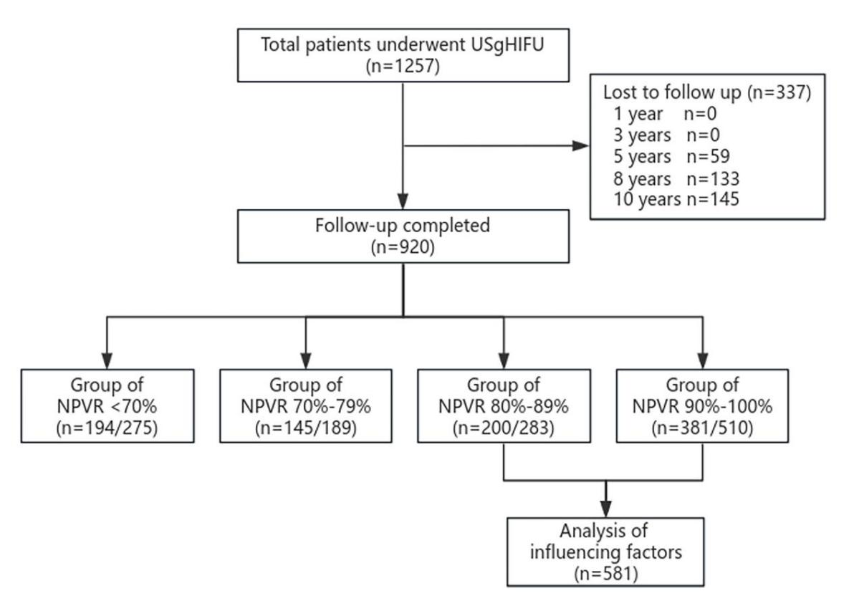

- The interpretation of the fibroid categorization (A1-A4: anterior fibroidsn; B1-B4: posterior fibroids)
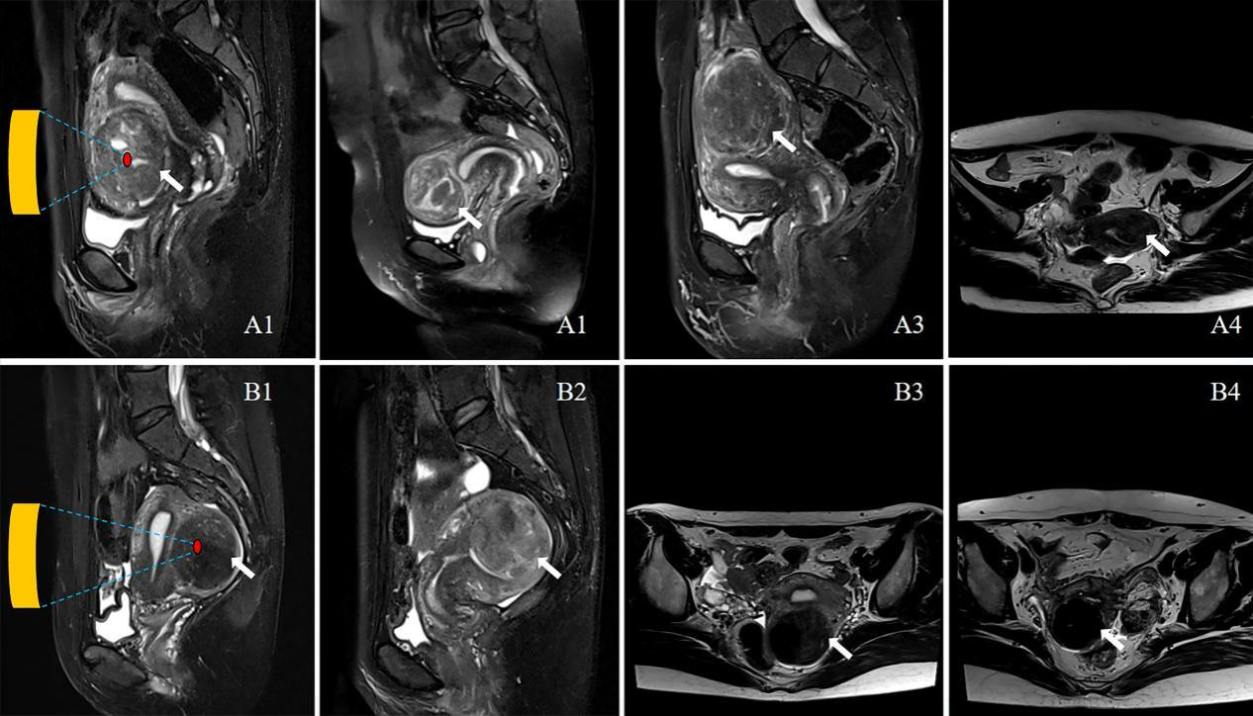

- The baseline characteristics and ablation results of patients in different NPVR
Variable | NPVR＜70%  (n=275) | NPVR 70%-79%  (n=189) | NPVR 80-89%  (n=283) | NPVR≥90%  (n=510) | P
Number of successful follow-up cases (n) | 194 | 145 | 200 | 381
General patient data
Age (years)* | 39.0 (34.0, 43.0) | 39.0 (33.0, 43.0) | 39.0 (33.0, 44.0) | 39.0 (33.0, 43.0) | .951
BMI (kg/m²) | 22.2 (20.5, 24.2) | 22.0 (20.5, 23.6) | 22.0 (20.2, 23.9) | 22.0 (20.4, 23.6) | .448
Family history of fibroids (yes/no) (n) | 12 (4.4) | 12 (6.3) | 21 (7.5) | 37 (7.2) | .402
History of smoking or drinking (yes/no) (n) | 17 (6.2) | 10 (5.3) | 22 (7.8) | 27 (5.3) | .533
History of lower abdominal surgery (yes/no) (n) | 112 (40.9) | 57 (30.5) | 88 (31.3) | 170 (33.5) | .052
History of childbirth (yes/no) (n) | 203 (74.1) | 135 (72.2) | 208 (74.0) | 374 (73.6) | .969
Fibroid data of MR imaging
Type (Ⅰ-Ⅱ/Ⅲ-Ⅳ/Ⅴ-Ⅵ) (n) | 30/55/190 | 21/33/135 | 28/50/205 | 64/98/348 | .878
Location (anterior/posterior) (n) | 165/110 | 128/61 | 202/81 | 365/145 | .006
Signal intensity on T₂WI (hypointense/isointense/hyperintense) (n) | 52/60/163 | 52/60/77 | 89/81/113 | 214/154/142 | ＜0.001
Enhancement type on T₁WI of primary fibroids  (mild / moderate / significant) (n) | 61/129/85 | 59/84/46 | 102/123/58 | 195/224/91 | ＜0.001
Maximum diameter (mm) | 56.0 (46.0, 70.0) | 58.0 (48.0, 67.5) | 56.0 (47.0, 69.0) | 56.0 (46.0, 67.0) | .330
Volume (cm³) | 65.1 (37.8, 130.7) | 73.5 (43.5, 124.8) | 69.2 (44.3, 128.6) | 72.0 (40.1, 119.8) | .598
Cumulative re-intervention rate (%) |  |  |  |  | ＜0.001
1 years | 8.4 | 5.3 | 1.4 | 1.2
3 years | 22.5 | 14.3 | 7.4 | 7.5
5 years | 30.1 | 19.6 | 13.4 | 10.7
8 years | 37.3 | 26.7 | 17.0 | 16.3
10 years | 37.3 | 31.0 | 18.2 | 17.8
Note: Data are median value; interquartile range in brackets.

