Supplemental Table 1. NRS 2002 scores and PG-SGA scores at baseline and 1 year after admission in the total sample
Time |  | N | NRS 2002 | PG-SGA
Baseline | FST+PRNS group | 204 | 3.98±0.71 | 9.33±3.41
 | PRNS group | 98 | 1.77±0.59 | 5.06±2.21
 | t |  | -26.814 | -13.058
 | P |  | <0.001 | <0.001
1 year after admission | FST+PRNS group | 204 | 2.51±1.44 | 5.22±3.24
 | PRNS group | 98 | 2.22±1.21 | 5.08±3.17
 | t |  | -1.804 | -0.355
 | P |  | 0.073 | 0.723

Supplemental Table 2. The changes of NRS 2002 and PG-SGA scores in the total sample¹
Project | FST+PRNS group （n=204） | PRNS group （n=98） | Z | P
Change in NRS 2002 | -2.00（-3.00，-0.35） | 0.00（-1.00，1.00） | -8.982 | ＜0.001
Change in PG-SGA | -2.00（-3.00，-0.00） | -4.00（-7.00，-1.25） | -7.180 | ＜0.001
¹Change in scores = scores at 1 year after admission - scores at baseline

Supplemental Table 3. Dietary energy, dietary protein, total energy and total protein at baseline, 1 month after admission, 2 months after admission, 4 months after admission and 1 year after admission in the total sample
Time |  | N | Dietary energy | Dietary protein | Total energy | Total protein
Baseline | FST+PRNS group | 204 | 631.82±314.47 | 28.49±13.90 | 861.30±362.71 | 38.67±18.44
 | PRNS group | 98 | 747.42±316.64 | 34.45±14.31 | 851.82±308.70 | 39.53±15.41
 | t |  | -2.984 | -3.456 | 0.223 | -0.401
 | P |  | 0.003 | 0.001 | 0.824 | 0.689
1 month after admission | FST+PRNS group | 204 | 849.79±329.55 | 39.89±14.68 | 973.64±310.17 | 50.04±21.33
 | PRNS group | 98 | 976.23±313.42 | 45.94±13.34 | 1075.92±330.86 | 47.70±20.80
 | t |  | 2.468 | 2.694 | 2.031 | 0.900
 | P |  | 0.015 | 0.008 | 0.044 | 0.369
2 months after admission | FST+PRNS group | 204 | 985.88±277.43 | 44.64±14.11 | 1092.36±323.38 | 54.87±21.09
 | PRNS group | 98 | 1057.05±295.06 | 46.12±13.64 | 1050.45±346.77 | 52.08±20.92
 | t |  | 1.582 | 0.672 | -1.030 | -1.079
 | P |  | 0.116 | 0.503 | 0.304 | 0.281
4 months after admission | FST+PRNS group | 204 | 1090.66±367.47 | 54.48±18.74 | 1227.35±382.27 | 66.21±23.72
 | PRNS group | 98 | 998.34±460.58 | 49.09±20.80 | 1123.52±455.41 | 59.52±27.02
 | t |  | -1.440 | -1.741 | -1.595 | -1.690
 | P |  | 0.152 | 0.083 | 0.113 | 0.093
1 year after admission | FST+PRNS group | 204 | 1140.08±402.20 | 53.47±21.20 | 1258.43±401.24 | 63.28±24.12
 | PRNS group | 98 | 1102.99±407.77 | 49.38±22.20 | 1187.23±412.96 | 57.78±21.76
 | t |  | -0.580 | -1.198 | -1.108 | -1.494
 | P |  | 0.563 | 0.233 | 0.270 | 0.137

Supplemental Table 4. Comparison of changes of dietary energy, dietary protein, total energy and total protein at different time points between FST+PRNS group and PRNS group in the total sample¹
Time |  | N | Dietary energy | Dietary protein | Total energy | Total protein
Change in 1 month | FST+PRNS group | 204 | 318.09  （-6.32，602.50） | 15.00  （0.00，29.45） | 207.99  （-111.87，638.69） | 15.43  （-2.75，37.80）
 | PRNS group | 98 | 93.73  （-124.50，513.80） | 9.92  （-6.48，23.83） | 1.24  （-240.16，491.26） | 10.64  （-1.77，25.71）
 | Z |  | 2.728 | 2.179 | 2.581 | 1.333
 | P |  | 0.099 | 0.140 | 0.108 | 0.248
Change in 2 months | FST+PRNS group | 204 | 387.00  （122.92，701.92） | 19.33  （7.77，32.59） | 339.00  （-3.25，701.92） | 15.80  （3.22，32.32）
 | PRNS group | 98 | 300.00  （-94.25，586.55） | 12.66  （-3.08，26.22） | 138.42  （-189.00，484.75） | 6.48  （-11.99，25.15）
 | Z |  | 5.754 | 6.725 | 6.339 | 4.592
 | P |  | 0.016 | 0.010 | 0.012 | 0.032
Change in 4 months | FST+PRNS group | 204 | 519.35  （189.50，863.94） | 28.92  （13.55，45.93） | 508.37  （65.25，898.50） | 30.12  （8.84，50.72）
 | PRNS group | 98 | 140.38  （-361.11，737.21） | 10.08  （-6.11，35.92） | 145.01  （-302.68，618.25） | 18.15  （-11.70，39.60）
 | Z |  | 13.361 | 14.233 | 9.743 | 7.544
 | P |  | <0.001 | <0.001 | 0.002 | 0.006
Change in 1 year | FST+PRNS group | 204 | 608.69  （191.37，1007.50） | 29.00  （10.14，48.83） | 540.00  （97.89，1017.68） | 32.23  （7.14，53.75）
 | PRNS group | 98 | 285.00  （-40.03，608.61） | 12.66  （-5.59，30.51） | 264.21  （-103.19，601.32） | 15.33  （1.71，32.44）
 | Z |  | 9.257 | 11.242 | 8.305 | 8.342
 | P |  | 0.002 | 0.001 | 0.004 | 0.004
¹Change of dietary energy in 1 month=Dietary energy _{1 month after admission}-Dietary energy _{baseline}
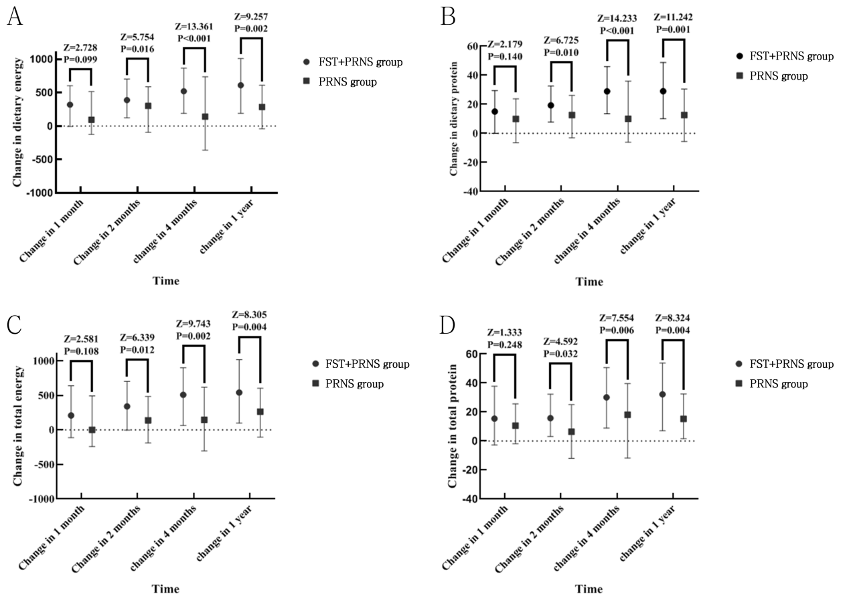
Supplemental Figure 1. Comparison of changes of dietary energy (A), dietary protein (B), total energy (C) and total protein (D) at different time points between FST+PRNS group and PRNS group in the total sample

Supplemental Table 5. PALB, ALB and HB at baseline, 7 days after admission, 1 month after admission, 2 months after admission, 4 months after admission and 1 year after admission in the total sample
Time |  | N | PALB | ALB | HB
Baseline | FST+PRNS group | 204 | 19.47±5.53 | 35.81±5.11 | 119.32±21.93
 | PRNS group | 98 | 21.23±5.73 | 37.55±5.81 | 121.59±21.44
 | t |  | 2.567 | 2.648 | 0.849
 | P |  | 0.011 | 0.009 | 0.396
7 days after admission | FST+PRNS group | 204 | 15.56±7.30 | 31.12±6.73 | 111.65±26.84
 | PRNS group | 98 | 17.04±5.66 | 33.01±6.59 | 114.11±22.01
 | t |  | 1.387 | 1.792 | 0.618
 | P |  | 0.167 | 0.075 | 0.537
1 month after admission | FST+PRNS group | 204 | 23.00±12.28 | 35.35±7.78 | 114.36±33.51
 | PRNS group | 98 | 24.67±9.46 | 40.33±7.88 | 116.27±19.33
 | t |  | 0.934 | 4.022 | 0.416
 | P |  | 0.351 | ＜0.001 | 0.678
2 months after admission | FST+PRNS group | 204 | 23.82±6.89 | 38.84±8.82 | 121.81±18.86
 | PRNS group | 98 | 25.55±10.60 | 40.40±8.53 | 118.22±19.75
 | t |  | 1.290 | 1.124 | 1.167
 | P |  | 0.199 | 0.263 | 0.245
4 months after admission | FST+PRNS group | 204 | 24.35±6.10 | 39.40±6.64 | 120.34±22.11
 | PRNS group | 98 | 24.49±6.72 | 40.50±7.72 | 123.72±22.51
 | t |  | 0.140 | 0.979 | 0.960
 | P |  | 0.889 | 0.329 | 0.338
1 year after admission | FST+PRNS group | 204 | 23.25±6.23 | 39.20±5.50 | 121.83±23.15
 | PRNS group | 98 | 23.58±6.89 | 39.79±6.57 | 122.72±22.64
 | t |  | 0.321 | 0.629 | 0.244
 | P |  | 0.749 | 0.530 | 0.530

Supplemental Table 6. Comparison of changes of PALB, ALB and HB at different time points between FST+PRNS group and PRNS group in the total sample¹
Time |  | N | PALB | ALB | HB
Change in 7 days | FST+PRNS group | 204 | -3.95  （-8.30，0.64） | -5.16  （-9.34，-0.78） | -7.43  （-18.00，6.25）
 | PRNS group | 98 | -6.00  （-9.18，0.53） | -3.92  （-7.28，0.12） | -7.17  （-17.91，11.29）
 | Z |  | 1.113 | 1.033 | 0.034
 | P |  | 0.291 | 0.309 | 0.855
Change in 1 month | FST+PRNS group | 204 | 2.55  （-3.63，9.93） | -0.30  （-5.20，5.65） | -6.00  （-18.00，10.25）
 | PRNS group | 98 | 2.25  （-1.80，6.15） | 2.77  （-1.20，8.30） | -4.90  （-12.75，4.00）
 | Z |  | 0.100 | 5.873 | 0.508
 | P |  | 0.751 | 0.015 | 0.476
Change in 2 months | FST+PRNS group | 204 | 5.80  （-0.78，10.44） | 3.54  （-3.23，8.40） | -1.00  （-12.25，14.00）
 | PRNS group | 98 | 2.50  （-1.95，7.65） | 4.60  （-1.08，7.93） | 0.00  （-11.75，17.00）
 | Z |  | 2.545 | 0.027 | 0.431
 | P |  | 0.111 | 0.868 | 0.512
Change in 4 months | FST+PRNS group | 204 | 4.49  （0.48，12.17） | 3.66  （-0.55，8.28） | -0.50  （-14.00，15.25）
 | PRNS group | 98 | 2.30  （-1.38，8.10） | 2.50  （-2.98，7.53） | -0.06  （-11.25，18.93）
 | Z |  | 4.021 | 0.581 | 0.168
 | P |  | 0.045 | 0.446 | 0.688
Change in 1 year | FST+PRNS group | 204 | 3.03  （-0.45，10.30） | 4.09  （-1.87，8.99） | 4.21  （-10.90，21.79）
 | PRNS group | 98 | 1.68  （-4.06，6.65） | 0.52  （-1.05，4.52） | 1.30  （-2.38，8.25）
 | Z |  | 3.106 | 1.086 | 0.000
 | P |  | 0.078 | 0.297 | 0.987
¹Change of PALB in 7 days=PALB _{7days after admission} - PALB _{baseline} ; ALB:Albumin ; HB: Hemoglobin ; PALB: Prealbumin.
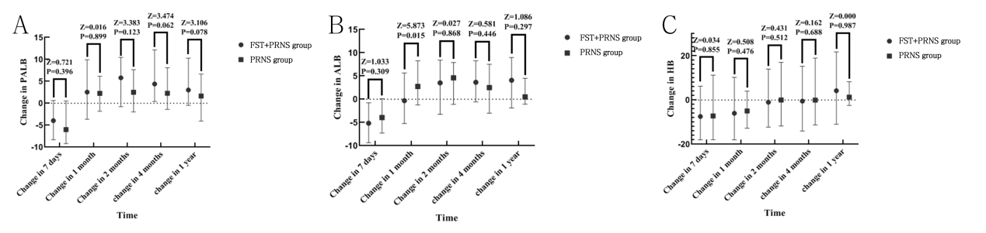
Supplemental Figure 2. Comparison of changes of PALB (A), ALB (B) and HB (C) at different time points between FST+PRNS group and PRNS group in the total sample

Supplemental Table 7. BMI, fat-free weight, walking time and grip strength at baseline, 7 days after admission, 1 month after admission, 2 months after admission, 4 months after admission and 1 year after admission in the total sample
Time |  | N | BMI | Fat-free weight | Walking time | Grip strength
Baseline | FST+PRNS group | 204 | 22.82±4.01 | 47.65±8.24 | 36.05±16.33 | 26.08±10.35
 | PRNS group | 98 | 23.50±4.43 | 46.86±7.45 | 38.42±15.05 | 27.32±12.99
 | t |  | 1.360 | -0.801 | 1.211 | -0.893
 | P |  | 0.178 | 0.423 | 0.227 | 0.373
7 days after admission | FST+PRNS group | 204 | 22.65±5.06 | 46.02±5.24 | 31.06±10.48 | 25.25±8.01
 | PRNS group | 98 | 23.97±5.54 | 46.47±4.38 | 29.49±10.03 | 26.42±7.79
 | t |  | 2.058 | 0.577 | -0.962 | 0.931
 | P |  | 0.040 | 0.565 | 0.338 | 0.353
1 month after admission | FST+PRNS group | 204 | 22.18±4.56 | 45.04±4.48 | 43.53±13.59 | 25.91±7.15
 | PRNS group | 98 | 22.40±4.63 | 44.69±6.57 | 43.42±12.66 | 25.40±7.01
 | t |  | 0.390 | -0.407 | -0.052 | -0.460
 | P |  | 0.697 | 0.684 | 0.958 | 0.646
2 months after admission | FST+PRNS group | 204 | 22.06±3.83 | 44.06±6.13 | 45.85±11.14 | 25.78±8.80
 | PRNS group | 98 | 22.74±4.93 | 44.82±7.11 | 45.97±13.03 | 26.30±7.89
 | t |  | 1.398 | 0.737 | 0.068 | 0.385
 | P |  | 0.192 | 0.462 | 0.946 | 0.701
4 months after admission | FST+PRNS group | 204 | 22.78±4.69 | 44.31±5.43 | 45.34±9.89 | 27.49±8.49
 | PRNS group | 98 | 22.35±4.77 | 44.98±4.77 | 48.34±10.37 | 27.46±7.27
 | t |  | -0.733 | 0.815 | 1.884 | -0.025
 | P |  | 0.464 | 0.416 | 0.061 | 0.980
1 year after admission | FST+PRNS group | 204 | 23.60±8.46 | 45.23±3.11 | 50.38±9.13 | 29.69±9.64
 | PRNS group | 98 | 22.34±6.13 | 44.67±2.99 | 50.70±9.23 | 31.23±8.89
 | t |  | -1.472 | -1.152 | 0.223 | 1.039
 | P |  | 0.142 | 0.251 | 0.824 | 0.300

Supplemental Table 8. Comparison of changes of BMI, fat-free weight,walking time and grip strength at different time points between FST+PRNS group and PRNS group in the total sample¹
Time |  | N | BMI | Fat-free weight | Walking time | Grip strength
Change in 7 days | FST+PRNS group | 204 | -0.16  （-1.21，0.42） | -0.31  （-4.51，3.69） | -3.07  （-17.51，5.00） | -0.89  （-8.97，2.62）
 | PRNS group | 98 | -0.33  （-1.88，0.37） | -0.06  （-4.85，5.88） | -7.47  （-16.25，0.00） | 0.70  （-2.88，5.43）
 | Z |  | 1.070 | 0.260 | 0.391 | 2.275
 | P |  | 0.301 | 0.610 | 0.532 | 0.131
Change in 1 month | FST+PRNS group | 204 | -0.85  （-2.15，0.10） | -1.20  （-4.32，1.10） | 0.00  （-4.55，20.00） | -0.55  （-5.83，4.22）
 | PRNS group | 98 | -0.45  （-1.64，0.18） | -0.41  （-4.33，1.98） | 0.13  （0.00，20.00） | -0.70  （-4.51，3.43）
 | Z |  | 0.503 | 0.324 | 0.034 | 0.071
 | P |  | 0.478 | 0.569 | 0.855 | 0.790
Change in 2 months | FST+PRNS group | 204 | -0.92  （-1.76，0.37） | -1.70  （-6.21，2.03） | 6.34  （0.00，20.00） | -0.35  （-6.93，5.41）
 | PRNS group | 98 | -0.50  （-1.27，0.34） | -0.55  （-6.87，2.52） | 10.00  （0.00，20.00） | -1.52  （-5.73，5.99）
 | Z |  | 0.894 | 0.467 | 0.014 | 0.006
 | P |  | 0.344 | 0.494 | 0.905 | 0.936
Change in 4 months | FST+PRNS group | 204 | -0.69  （-1.95，0.61） | -1.34  （-6.48，1.53） | 5.00  （-3.80，20.00） | 0.70  （-5.38，7.58）
 | PRNS group | 98 | -0.30  （-1.28，0.63） | -0.72  （-5.74，2.57） | 9.79  （0.00，20.00） | 1.40  （-4.70，8.51）
 | Z |  | 0.994 | 0.521 | 1.299 | 0.058
 | P |  | 0.319 | 0.470 | 0.254 | 0.809
Change in 1 year | FST+PRNS group | 204 | -0.35  （-2.08，1.40） | -1.97  （-6.09，4.30） | 11.22  （0.00，25.04） | 2.80  （-5.37，9.81）
 | PRNS group | 98 | -0.46  （-2.14，0.51） | -1.07  （-7.53，4.78） | 14.15  （0.85，24.94） | 5.48  （-4.00，13.02）
 | Z |  | 1.253 | 0.004 | 0.284 | 0.852
 | P |  | 0.263 | 0.951 | 0.594 | 0.356
¹Change of BMI in 7 days=BMI _{7days after admission} - BMI _{baseline} ; BMI: body mass index, the weight (in kg) divided by the square of the height (in m).
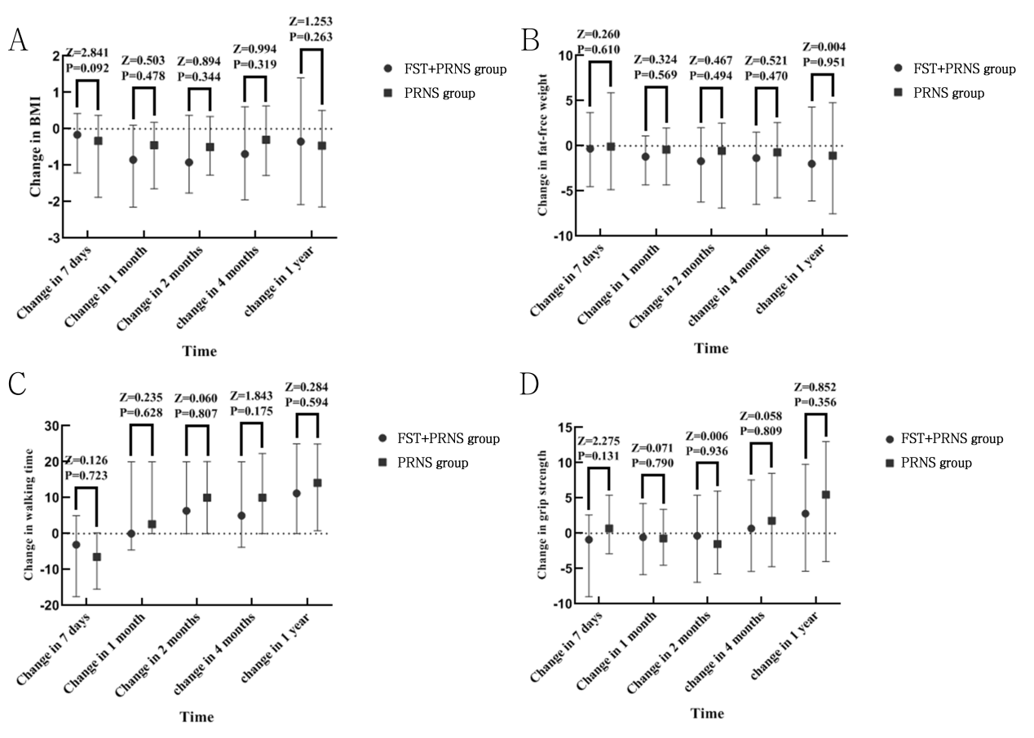
Supplemental Figure 3. Comparison of changes of BMI (A), fat-free weight (B),walking time (C) and grip strength (D) at different time points between FST+PRNS group and PRNS group in the total sample

Supplemental Table 9. NRS 2002 scores and PG-SGA scores at baseline and 1 year after admission in the sub-sample
Time |  | N | NRS 2002 | PG-SGA
Baseline | FST+PRNS group | 97 | 3.91±0.69 | 9.15±3.54
 | PRNS group | 97 | 1.76±0.59 | 5.06±2.22
 | t |  | -23.177 | -9.646
 | P |  | <0.001 | <0.001
1 year after admission | FST+PRNS group | 97 | 2.48±1.46 | 5.58±3.19
 | PRNS group | 97 | 2.23±1.21 | 5.08±2.97
 | t |  | -1.339 | -1.125
 | P |  | 0.182 | 0.262

Supplemental Table 10. The changes of NRS 2002 and PG-SGA scores in the sub-sample¹
Project | FST+PRNS group （n=97） | PRNS group （n=97） | Z | P
Change in NRS 2002 | -2.00（-2.00，-1.00） | 0.00（-1.00，1.00） | -7.412 | ＜0.001
Change in PG-SGA | -4.00（-7.00，-2.75） | -1.00（-2.00，1.00） | -5.311 | ＜0.001
¹Change in scores = scores at 1 year after admission - scores at baseline

Supplemental Table 11. Dietary energy, dietary protein, total energy and total protein at baseline, 1 month after admission, 2 months after admission, 4 months after admission and 1 year after admission in the sub-sample
Time |  | N | Dietary energy | Dietary protein | Total energy | Total protein
Baseline | FST+PRNS group | 97 | 551.35±347.07 | 23.98±14.70 | 868.64±357.44 | 39.74±17.33
 | PRNS group | 97 | 831.98±391.35 | 35.19±16.56 | 868.58±333.40 | 39.48±16.39
 | t |  | 4.224 | 3.988 | -0.001 | -0.111
 | P |  | ＜0.001 | ＜0.001 | 0.999 | 0.912
1 month after admission | FST+PRNS group | 97 | 853.36±338.12 | 39.55±13.52 | 971.11±325.46 | 50.04±19.03
 | PRNS group | 97 | 981.03±314.91 | 45.84±13.52 | 1082.45±332.74 | 52.00±21.90
 | t |  | 2.176 | 2.363 | 1.884 | 0.665
 | P |  | 0.032 | 0.020 | 0.062 | 0.507
2 months after admission | FST+PRNS group | 97 | 976.18±253.46 | 45.50±13.58 | 1077.47±299.50 | 55.90±18.45
 | PRNS group | 97 | 1058.86±297.47 | 46.11±13.58 | 1099.97±321.76 | 54.33±20.22
 | t |  | 1.666 | 0.249 | 0.403 | 0.564
 | P |  | 0.098 | 0.804 | 0.688 | 0.573
4 months after admission | FST+PRNS group | 97 | 1066.18±372.49 | 53.72±20.10 | 1228.84±397.02 | 65.14±24.42
 | PRNS group | 97 | 998.60±467.84 | 48.96±20.92 | 1127.12±462.24 | 57.65±33.76
 | t |  | -0.890 | -1.293 | -1.314 | 1.771
 | P |  | 0.375 | 0.198 | 0.191 | 0.078
1 year after admission | FST+PRNS group | 97 | 1168.28±380.10 | 54.43±19.49 | 1294.25±373.51 | 66.03±19.97
 | PRNS group | 97 | 1105.22±413.02 | 49.61±22.50 | 1188.45±417.38 | 62.20±18.42
 | t |  | -0.885 | -1.275 | -1.487 | 1.389
 | P |  | 0.378 | 0.205 | 0.140 | 0.167

Supplemental Table 12. Comparison of changes of dietary energy, dietary protein, total energy and total protein at different time points between FST+PRNS group and PRNS group in the sub-sample¹
Time |  | N | Dietary energy | Dietary protein | Total energy | Total protein
Change in 1 month | FST+PRNS group | 97 | 362.23  （-6.32，626.00） | 18.72  （1.16，33.46） | 280.45  （-148.26，721.94） | 20.82  （-0.65，40.46）
 | PRNS group | 97 | 93.73  （-121.50，489.93） | 9.93  （-6.44，22.90） | 1.24  （-206.72，518.51） | 10.64  （-2.33，26.28）
 | Z |  | 3.237 | 2.778 | 2.794 | 2.589
 | P |  | 0.072 | 0.096 | 0.095 | 0.108
Change in 2 months | FST+PRNS group | 97 | 523.87  （109.67，713.67） | 22.00  （7.72，36.49） | 370.50  （-2.31，745.56） | 21.59  （5.88，39.21）
 | PRNS group | 97 | 300.00  （-92.75，576.18） | 12.66  （-1.03，25.41） | 138.42  （-145.00，472.25） | 6.48  （-11.60，25.05）
 | Z |  | 5.289 | 8.092 | 6.941 | 6.719
 | P |  | 0.021 | 0.004 | 0.008 | 0.010
Change in 4 months | FST+PRNS group | 97 | 519.35  （179.81，882.00） | 29.42  （11.25，47.29） | 536.87  （64.50，947.06） | 34.72  （8.21，55.93）
 | PRNS group | 97 | 240.38  （-374.70，729.62） | 10.08  （-5.64，34.37） | 145.01  （-357.11，642.11） | 18.15  （-11.30，38.97）
 | Z |  | 10.617 | 11.787 | 8.474 | 7.555
 | P |  | 0.001 | 0.001 | 0.004 | 0.006
Change in 1 year | FST+PRNS group | 97 | 664.29  （373.53，955.17） | 31.73  （19.07，48.41） | 459.00  （138.85，1018.08） | 24.29  （8.21，50.93）
 | PRNS group | 97 | 396.39  （146.60，723.36） | 20.20  （5.40，34.46） | 268.00  （-89.33，716.33） | 20.20  （4.45，36.56）
 | Z |  | 11.806 | 12.646 | 8.325 | 8.398
 | P |  | <0.001 | <0.001 | 0.004 | 0.004
¹Change of dietary energy in 1 month=Dietary energy _{1 month after admission}-Dietary energy _{baseline}
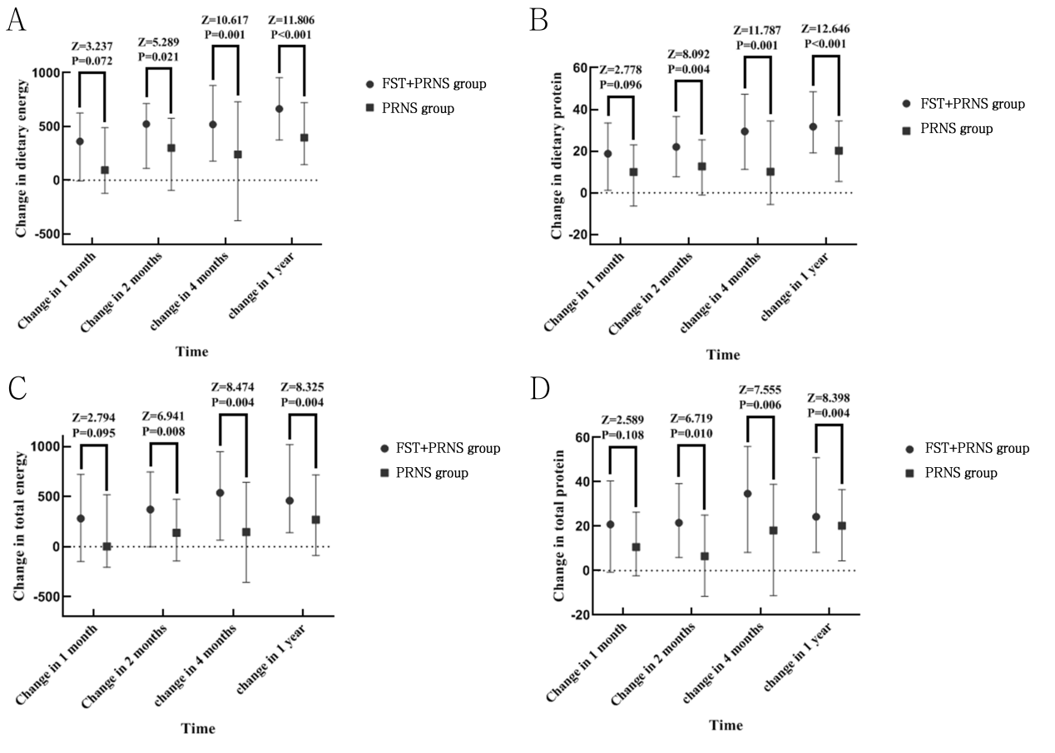
Supplemental Figure 4. Comparison of changes of dietary energy (A), dietary protein (B), total energy (C) and total protein (D) at different time points between FST+PRNS group and PRNS group in the sub-sample

Supplemental Table 13. PALB, ALB and HB at baseline, 7 days after admission, 1 month after admission, 2 months after admission, 4 months after admission and 1 year after admission in the sub-sample
Time |  | N | PALB | ALB | HB
Baseline | FST+PRNS group | 97 | 18.47±5.55 | 35.85±4.68 | 116.73±22.83
 | PRNS group | 97 | 21.19±5.62 | 37.53±5.84 | 119.72±19.73
 | t |  | 2.712 | 2.205 | 0.781
 | P |  | 0.008 | 0.029 | 0.436
7 days after admission | FST+PRNS group | 97 | 15.98±7.61 | 30.73±7.06 | 107.53±27.69
 | PRNS group | 97 | 17.22±5.65 | 33.36±6.27 | 114.47±22.26
 | t |  | 1.072 | 2.117 | 1.402
 | P |  | 0.306 | 0.036 | 0.164
1 month after admission | FST+PRNS group | 97 | 24.68±12.04 | 36.40±7.65 | 114.67±41.08
 | PRNS group | 97 | 24.70±9.61 | 40.38±8.00 | 116.36±19.63
 | t |  | 0.462 | 2.884 | 0.320
 | P |  | 0.497 | 0.005 | 0.749
2 months after admission | FST+PRNS group | 97 | 25.43±6.93 | 40.03±9.71 | 118.18±21.01
 | PRNS group | 97 | 25.57±10.75 | 40.44±8.66 | 121.76±19.13
 | t |  | 0.104 | 0.050 | 0.662
 | P |  | 0.917 | 0.960 | 0.509
4 months after admission | FST+PRNS group | 97 | 24.83±6.23 | 40.37±6.72 | 120.09±25.13
 | PRNS group | 97 | 24.60±6.79 | 40.69±7.75 | 134.88±100.08
 | t |  | 0.012 | 0.283 | 0.316
 | P |  | 0.991 | 0.778 | 0.753
1 year after admission | FST+PRNS group | 97 | 23.18±6.22 | 39.65±5.65 | 122.17±22.83
 | PRNS group | 97 | 23.63±6.99 | 39.81±6.67 | 122.76±22.69
 | t |  | 0.379 | 0.147 | 0.143
 | P |  | 0.705 | 0.884 | 0.887

Supplemental Table 14. Comparison of changes of PALB, ALB and HB at different time points between FST+PRNS group and PRNS group in the sub-sample¹
Time |  | N | PALB | ALB | HB
Change in 7 days | FST+PRNS group | 97 | -3.95  （-8.10，0.38） | -5.35  （-9.19，-1.60） | -10.50  （-21.45，5.06）
 | PRNS group | 97 | -5.25  （-9.13，0.85） | -3.84  （-7.08，0.32） | -5.50  （-18.00，11.79）
 | Z |  | 0.216 | 2.181 | 0.743
 | P |  | 0.642 | 0.140 | 0.389
Change in 1 month | FST+PRNS group | 97 | 3.00  （-1.73，9.97） | 0.14  （-3.33，6.23） | -7.50  （-18.75，11.00）
 | PRNS group | 97 | 2.40  （-1.90，6.25） | 2.95  （-1.23，8.42） | -4.90  （-13.75，5.00）
 | Z |  | 0.778 | 3.086 | 0.330
 | P |  | 0.378 | 0.079 | 0.565
Change in 2 months | FST+PRNS group | 97 | 7.10  （1.85，11.13） | 5.25  （-0.97，8.73） | 0.00  （-9.00，14.25）
 | PRNS group | 97 | 2.50  （-1.72，7.34） | 4.75  （-1.23，8.05） | -1.50  （-12.25，17.00）
 | Z |  | 5.790 | 0.465 | 0.016
 | P |  | 0.016 | 0.495 | 0.899
Change in 4 months | FST+PRNS group | 97 | 4.20  （0.24，12.83） | 4.33  （0.69，8.65） | 5.00  （-7.25，22.36）
 | PRNS group | 97 | 2.33  （-1.13，8.20） | 2.53  （-2.53，8.00） | -0.06  （-12.00，18.03）
 | Z |  | 2.470 | 1.433 | 0.823
 | P |  | 0.116 | 0.231 | 0.364
Change in 1 year | FST+PRNS group | 97 | 2.60  （-0.69，7.99） | 3.21  （-0.30，6.78） | 6.26  （-9.65，14.04）
 | PRNS group | 97 | 2.19  （-1.34，7.06） | 2.81  （-1.53，5.35） | -1.89  （-8.04，12.98）
 | Z |  | 0.790 | 0.893 | 0.472
 | P |  | 0.374 | 0.345 | 0.492
¹Change of PALB in 7 days=PALB _{7days after admission} - PALB _{baseline}; ALB : Albumin ; HB : Hemoglobin ; PALB : Prealbumin .
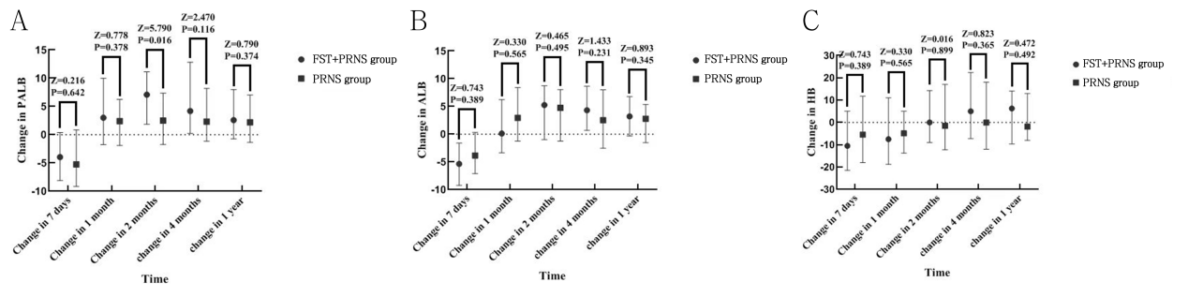
Supplemental Figure 5. Comparison of changes of PALB (A), ALB (B) and HB (C) at different time points between FST+PRNS group and PRNS group in the sub-sample

Supplemental Table 15. BMI, fat-free weight, walking time and grip strength at baseline, 7 days after admission, 1 month after admission, 2 months after admission, 4 months after admission and 1 year after admission in the sub-sample
Time |  | N | BMI | Fat-free weight | Walking time | Grip strength
Baseline | FST+PRNS group | 97 | 22.96±4.07 | 45.61±8.07 | 22.96±4.07 | 26.20±9.82
 | PRNS group | 97 | 23.66±4.84 | 46.02±8.14 | 23.66±4.84 | 27.35±13.60
 | t |  | 1.096 | 0.279 | 1.063 | 0.673
 | P |  | 0.289 | 0.781 | 0.289 | 0.501
7 days after admission | FST+PRNS group | 97 | 22.50±4.62 | 45.76±5.98 | 31.92±10.51 | 24.91±6.51
 | PRNS group | 97 | 23.48±5.28 | 46.44±4.44 | 29.63±10.16 | 26.64±8.60
 | t |  | 1.374 | 0.719 | -1.231 | 1.262
 | P |  | 0.171 | 0.474 | 0.221 | 0.209
1 month after admission | FST+PRNS group | 97 | 22.47±3.91 | 44.85±4.70 | 45.31±15.55 | 25.37±5.51
 | PRNS group | 97 | 22.84±4.72 | 44.73±6.58 | 43.70±12.75 | 26.32±5.09
 | t |  | 0.597 | -0.117 | -0.631 | 0.996
 | P |  | 0.551 | 0.907 | 0.529 | 0.321
2 months after admission | FST+PRNS group | 97 | 22.21±3.63 | 43.45±7.30 | 46.44±12.78 | 25.83±8.32
 | PRNS group | 97 | 22.86±5.00 | 44.80±7.21 | 46.46±12.84 | 26.53±6.27
 | t |  | 1.025 | 1.042 | 0.006 | 0.524
 | P |  | 0.307 | 0.300 | 0.995 | 0.602
4 months after admission | FST+PRNS group | 97 | 22.58±4.67 | 43.52±6.32 | 45.72±10.03 | 28.46±7.76
 | PRNS group | 97 | 22.49±4.83 | 44.98±4.84 | 48.51±10.48 | 26.49±5.01
 | t |  | -0.128 | 1.441 | 1.516 | -1.674
 | P |  | 0.899 | 0.152 | 0.132 | 0.097
1 year after admission | FST+PRNS group | 97 | 23.28±7.33 | 45.22±3.24 | 51.01±10.14 | 28.81±9.82
 | PRNS group | 97 | 22.69±6.21 | 44.58±2.99 | 50.86±9.28 | 30.91±8.27
 | t |  | -0.599 | -1.144 | -0.083 | 1.285
 | P |  | 0.550 | 0.255 | 0.934 | 0.201

Supplemental Table 16. Comparison of changes of BMI, fat-free weight, walking time and grip strength at different time points between FST+PRNS group and PRNS group in the sub-sample¹
Time |  | N | BMI | Fat-free weight | Walking time | Grip strength
Change in 7 days | FST+PRNS group | 97 | -0.18  （-1.38，0.42） | -0.05  （-4.55，3.79） | -3.53  （-18.70，2.68） | 1.20  （-4.76，5.75）
 | PRNS group | 97 | -0.34  （-1.94，0.28） | -0.06  （-5.29，5.84） | -6.49  （-15.82，0.06） | -0.37  （-1.73，0.19）
 | Z |  | 1.024 | 0.000 | 0.023 | 2.255
 | P |  | 0.311 | 0.984 | 0.880 | 0.133
Change in 1 month | FST+PRNS group | 97 | -0.67  （-2.25，0.21） | -0.70  （-4.32，3.66） | 4.52  （0.00，20.00） | -27.80  （-42.09，-9.84）
 | PRNS group | 97 | -0.37  （-1.72，0.19） | -0.41  （-4.60，1.93） | 2.63  （0.00，20.00） | -25.39  （-38.56，14.78）
 | Z |  | 0.339 | 0.060 | 0.000 | 0.041
 | P |  | 0.560 | 0.807 | 0.990 | 0.840
Change in 2 months | FST+PRNS group | 97 | -0.80  （-1.61，0.67） | -1.30  （-4.92，2.03） | 10.00  （0.00，20.28） | -1.40  （-7.98，1.01）
 | PRNS group | 97 | -0.50  （-1.36，0.37） | -0.65  （-7.00，1.97） | 10.00  （0.00，20.03） | -0.02  （-5.80，5.01）
 | Z |  | 0.073 | 0.033 | 0.036 | 0.747
 | P |  | 0.787 | 0.855 | 0.850 | 0.387
Change in 4 months | FST+PRNS group | 97 | -0.51  （-1.66，1.08） | -1.22  （-6.39，2.06） | 5.00  （-5.00，20.00） | 0.88  （-6.01，9.09）
 | PRNS group | 97 | -0.26  （-1.32，0.68） | -0.80  （-6.03，2.10） | 10.00  （0.00，20.78） | -0.14  （-5.42，5.41）
 | Z |  | 0.122 | 0.144 | 1.557 | 0.592
 | P |  | 0.720 | 0.704 | 0.212 | 0.442
Change in 1 year | FST+PRNS group | 97 | -0.22  （-1.53，1.33） | -2.55  （-8.40，3.32） | 12.17  （0.00，30.00） | 3.86  （-5.68，11.79）
 | PRNS group | 97 | -0.59  （-1.10，1.26） | -3.10  （-7.22，4.94） | 10.00  （0.00，20.00） | 4.17  （-6.02，12.57）
 | Z |  | 0.148 | 0.354 | 2.072 | 0.086
 | P |  | 0.712 | 0.552 | 0.150 | 0.770
¹Change of BMI in 7 days=BMI _{7days after admission} - BMI _{baseline} ; BMI: body mass index, the weight (in kg) divided by the square of the height (in m).
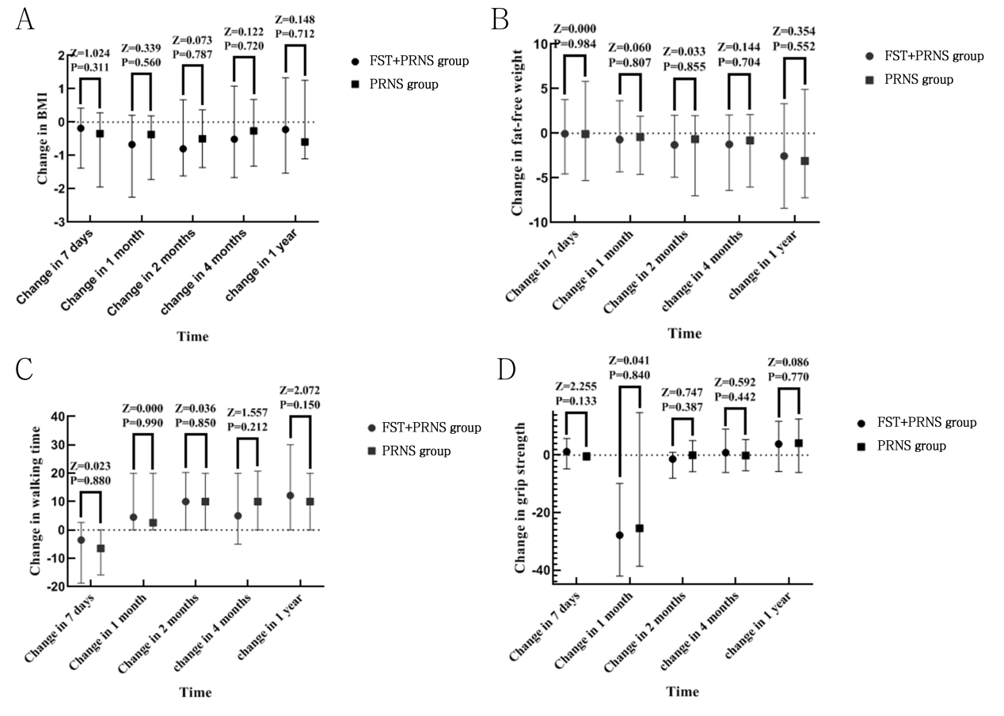
Supplemental Figure 6. Comparison of changes of BMI (A), fat-free weight (B),walking time (C) and grip strength (D) at different time points between FST+PRNS group and PRNS group in the sub-sample

Protocol
Approval Number: 2022HLL003
Board Name: The Shanxi Medical University Ethics Review Board
Board Affiliation: The Shanxi Medical University
Phone: 0351-3985076
Email: mufyzsb@163.com
Address: 56 Xinjian South Road, Yingze District, Taiyuan, Shanxi province, China
Contacts/Locations:
Central Contact Person: He Huang, doctor's degree
Telephone: 13734000596
Email: hh3003@163.com
Central Contact Backup: Yanli Wang
Telephone: 18535441257
Email: 3447114202@qq.com
Study Officials: He Huang, doctor's degree
Study Director
The First Affiliated Hospital of Shanxi Medical University
Locations: China, Shanxi
Huang He
Taiyuan, Shanxi, China, 045300
Contact: he huang, Learned scholar 13734000596

Study Design
Study Type: Interventional
Primary Purpose: Treatment
Study Phase: N/A
Interventional Study Model: Parallel Assignment
Number of Arms: 2
Masking: None (Open Label)
Allocation: Non-Randomized
Enrollment: 362

Title:
Effects of Different Nutritional Support Modes Based on Nutritional Risk Screening on Postoperative Nutritional Status of Patients with Gastrointestinal Cancer
Purpose:
The investigators conducted nutritional risk screening for patients with gastrointestinal tumors, gave different nutritional support methods to patients with different nutritional status, and analyzed the changes of various nutritional indexes of patients before and after nutritional intervention.
Sample:
Minimum Age: 18 Years
Maximum Age: NA
Sex: All Gender
Based: No
Accepts Healthy Volunteers: No
Criteria:
Inclusion Criteria:
- Age ≥ 18 years；
- The first pathological diagnosis was gastric or colorectal cancer and radical resection of malignant tumor was performed；
- Conscious, able to read, write and understand the study；
- Sign informed consent and participate in this study voluntarily.
Exclusion Criteria:
- Patients with malignant tumors at other sites；
- Patients undergoing neoadjuvant chemotherapy before surgery；
- Anastomotic fistula, anastomotic obstruction, gastroparesis and other serious complications occurred after operation；
- There are mental disorders, psychological disorders；
- Patients who did not cooperate to complete the full intervention or follow-up records were missing；
- Patients with missing baseline data and nutritional risk screening results.
Methods:
A total of 302 patients with gastrointestinal tumors admitted to the First Hospital of Shanxi Medical University from July 2021 to June 2023 were selected. All patients underwent nutritional risk screening after admission and were divided into intervention group (NRS2002≥3 and PG=SGA≥4, n=204) and control group (NRS2002 < 3 or PG=SGA < 4, n=98) according to the screening results. Different nutritional interventions were given to analyze the changes of NRS-2002 and PG-SGA scores between the two groups before and after propensity score matching, and compare the changes of dietary energy, dietary protein, total energy, total protein, body mass index (BMI), fat-free weight, walking time, grip strength and other nutritional indicators (hemoglobin, albumin, prealbumin) between the two groups. The effects of disease type and age on the results were compared by stratified analysis.
Prevention:
- Intervention Group
- Before operation： The patients' dietary intake was assessed by a 24-hour dietary review by a professional dietitian. According to the diet of the patients, the intervention was carried out by a professional nutritionist according to the five-step treatment mode of malnutrition. If the food intake cannot meet 60% of the daily requirement, the previous step of treatment is used, and it is adjusted at any time according to the situation of the patient.
- After operation: Routine nutrition support in department. Nutritionists will give patients routine parenteral nutrition support via peripheral or central vein 0-48 hours after surgery and then start enteral nutrition support 48-72 hours after surgery. Patients were initially given half of their enteral nutrition and the rest was supplemented with parenteral nutrition. After adaptation, the patient stopped parenteral nutrition and all nutrition came from enteral nutrition. After the patient's gastrointestinal function gradually recovered, the enteral nutrition could gradually decrease. At this time, nutritionists can let the patient eat some light liquid food, but pay attention to eating a small amount of multiple times. After adaptation, patients can gradually transition from liquid diet to semi-liquid diet. We will educate patients and their families about diet and encourage them to eat more high-quality protein-rich foods.
- Out-of-hospital: The patients' dietary intake was assessed by a 24-hour dietary review by a professional dietitian. According to the diet of the patients, the intervention was carried out by a professional nutritionist according to the five-step treatment mode of malnutrition. If the food intake cannot meet 60% of the daily requirement, the previous step of treatment is used, and it is adjusted at any time according to the situation of the patient.
- Strengthening Health Education and psychological intervention: Dietitians need to strengthen health education and communicate with patients during the implementation of nutrition intervention. For patients who actively cooperate with treatment, dietitians can give encouragement.
- Exercise Instruction: After the operation, according to the tolerance, the dietitian can instruct the patient to take a certain time walking every day.
- Control Group
Routine nutrition support in department. Nutritionists will give patients routine parenteral nutrition support via peripheral or central vein 0-48 hours after surgery and then start enteral nutrition support 48-72 hours after surgery. Patients were initially given half of their enteral nutrition and the rest was supplemented with parenteral nutrition. After adaptation, the patient stopped parenteral nutrition and all nutrition came from enteral nutrition. After the patient's gastrointestinal function gradually recovered, the enteral nutrition could gradually decrease. At this time, nutritionists can let the patient eat some light liquid food, but pay attention to eating a small amount of multiple times. After adaptation, patients can gradually transition from liquid diet to semi-liquid diet. We will educate patients and their families about diet and encourage them to eat more high-quality protein-rich foods.
Outcome Measures:
Primary Outcome Measure:
- Nutritional risk screening 2002: It is a nutritional risk screening scale. The maximum score of NRS2002 is 7 points and the minimum score is 0 points. A score of NRS2002≥3 indicates the presence of nutritional risk, and nutritional support programs should be developed in combination with clinical practice. A score of NRS2002 < 3 indicates no nutritional risk, and a review is performed 1 week later. Time Frame: baseline and through study completion, an average of 1 year.
- Patient-generated subjective nutrition assessment: It is a nutritional risk screening scale. 0-1 score, no intervention is required at this time, regular regular nutritional status score. 2 to 3 points, the nutritionist, nurse or clinician to educate the patient and family, and appropriate drug intervention for symptoms and laboratory tests. 4-8 points, requiring nutritional intervention and symptomatic treatment. A score of ≥9 indicates an urgent need for symptomatic treatment and appropriate nutrient support. Time Frame: baseline and through study completion, an average of 1 year.
Secondary Outcome Measures:
- Dietary energy intake: The 24-hour dietary review method was used to investigate the diet of the patients in the first 24 hours, and all the foods were converted into the energy value of the foods, and the dietary energy intake of the patients was calculated by adding. Time Frame: baseline、7 days after admission、1 month after admission、2 month after admission、4 month after admission and through study completion, an average of 1 year.
- Dietary protein intake： The 24-hour dietary review method was used to investigate the diet of the patients in the first 24 hours, and the protein amount provided by each food was recorded, and the dietary protein intake of the patients was calculated by adding. Time Frame: baseline、7 days after admission、1 month after admission、2 month after admission、4 month after admission and through study completion, an average of 1 year.
- Nutrient energy intake: The nutritional energy provided by oral nutrition, enteral nutrition and parenteral nutrition was recorded through inquiry and inquiry of nursing records. Time Frame: baseline、7 days after admission、1 month after admission、2 month after admission、4 month after admission and through study completion, an average of 1 year.
- Nutrient protein intake: The nutritional proteins provided by oral nutrition, enteral nutrition and parenteral nutrition were recorded through inquiry and inquiry of nursing records. Time Frame: baseline、7 days after admission、1 month after admission、2 month after admission、4 month after admission and through study completion, an average of 1 year.
- Prealbumin: Laboratory indicators on nutrition .Time Frame: baseline、7 days after admission、1 month after admission、2 month after admission、4 month after admission and through study completion, an average of 1 year.
- Albumin: Laboratory indicators on nutrition. Time Frame: baseline、7 days after admission、1 month after admission、2 month after admission、4 month after admission and through study completion, an average of 1 year.
- Hemoglobin: Laboratory indicators on nutrition. Time Frame: baseline、7 days after admission、1 month after admission、2 month after admission、4 month after admission and through study completion, an average of 1 year.
- BMI: Dietitians use a body fat scale to measure a patient's weight. When measuring the patient's weight, the body fat scale should be placed on a horizontal, firm floor. The patient takes off shoes and socks and wears light clothes. The patient then stood on the scale, keeping his body naturally upright. The patient's arms should be naturally drooped and relaxed at the sides of the body. Each weight measurement should be set at the same time. The dietitian uses a height meter to measure the patient's height. Weight and height will be combined to report BMI in kg/m^2. Time Frame: baseline、7 days after admission、1 month after admission、2 month after admission、4 month after admission and through study completion, an average of 1 year.
- Fat-free body weight: Dietitians use a body fat scale to measure a patient's fattened weight. When measuring the patient's weight without fat, the body fat scale should be placed on a level, firm floor. The patient takes off shoes and socks and wears light clothes. The patient then stood on the scale, keeping his body naturally upright. The patient's arms should be naturally drooped and relaxed at the sides of the body. The weight loss should be measured at the same time each time. Time Frame: baseline、7 days after admission、1 month after admission、2 month after admission、4 month after admission and through study completion, an average of 1 year.
- Grip strength: A dietitian uses a grip dynamometer to measure a patient's grip strength. When grip strength is measured, the patient's hands naturally droop and no other hand movements can be seen. Dietitians advise patients to measure their grip strength as best they can. The patient is tested on both hands, usually three times with each hand, and an average is taken. Time Frame: baseline、7 days after admission、1 month after admission、2 month after admission、4 month after admission and through study completion, an average of 1 year.
- Walking time: The patients were asked about their daily walking time. Time Frame: baseline、7 days after admission、1 month after admission、2 month after admission、4 month after admission and through study completion, an average of 1 year.
Other Pre-specified Outcome Measures:
Adverse reaction: After the clinician and dietitian judge the occurrence of adverse reactions, the types of adverse reactions are recorded. Time Frame: baseline、7 days after admission、1 month after admission、2 month after admission、4 month after admission and through study completion, an average of 1 year.

