2. Experimental procedures
2.1. Research design
This double-blind randomized controlled trial (evaluators, patients) was planned with a pre-posttest design. The statistical population included 60 men with CNSLBP who were recruited from a spine and nerve sub-specialist, Mr. Mehdi Arjipour in Hamedan province. In this clinical trial, patients were randomly assigned to two experimental groups (CKCE N=20 and OKCE N=20) and control groups (N=20). Ethical approval of the present study was obtained from the ethics committee of Bu-Ali Sina University (IR.BASU.REC.1402.011) and registered in the clinical trial center (IRCT20190129042534N1)
2.2. Sample size
We used G*Power software to determine the sample size. According to the previous study, the power was 0.8, alpha 0.5, and the effect size was 0.8. The software output reported 60 subjects for this clinical trial (16).
2.3. Participants
The statistical population of this clinical trial was men with CNSLBP. A total of 60 men were screened by nerve sub-specialist, Mr. Mehdi Arjipour (With 20 years of experience) and voluntarily participated in this study (Figure 1). The inclusion criteria were as follows: history of pain for more than 12 weeks, age range between 40 to 60 years, no history of spine surgery, and hip joint replacement. Exclusion criteria include pain in other segments, lower and upper limb deformity, consumption of painkillers in the past 6 months, physiotherapy in the past year, participation in sports, sciatica pain, spondylolysis, neuromuscular, neurological disorders, respiratory, muscle spasm, and fraction vertebrae. Patients signed an informed consent form before data collection(17).
2.4. Randomization and blinding

Random Allocation Software version 1.0 was used for randomization. Random codes were generated in blocks 4 and 6. We used sequentially numbered sealed envelopes to conceal allocation(18). A researcher who was not involved in data collection opened the sealed envelopes with consecutive numbers and delivered them to the patients(19). As a result, patients were randomly assigned to two experimental groups (CKCE N= 20 and OKCEN=20) and control (n=20) groups (20).
2.5. outcomes
2.5.1. Pain
Pain was assessed with a 10 cm visual analog scale. The VAS scale shows the pain sensation in people. The samples are asked to place their pain level by placing their hand in the numbers between these ranges. In the present study, people with a pain score higher than 4 were included in the study The reliability of this test is reported as 0.97. (21,22).

Randomized (n= 60)
Analysis
Allocation
Allocated to control (n= 20)
Did not receive allocated intervention (n=20)
Analysed (n= 20)
Excluded from analysis (give reasons) (n= 0 Outlier data)
Analysed (n= 40)
Excluded from analysis (did not return for
follow up treatment) (n = 0)
Assessed for eligibility (n= 86)
Enrollment

Excluded (n=26)
Not meeting inclusion criteria (n= 16)
Refused to participate (n= 6)
Other reasons (n= 6)

Allocated to intervetion CKCE (n= 20)
Allocated to intervetion OCE (n= 20)
Received allocated intervention (n= 40)

Figure 1. The CONSORT Flow Diagram of the randomized controlled tria
2.5.2. LumboPelvic Stability
The CORE STABILIZERS Pressure Bio-Feedback Unit device (REF PBU9296 Physiosupplies Europe, Inc, England) was used to evaluate lumbar-pelvic stability. The reliability coefficient of lumbar-pelvic control tests (0.86-0.90) has been reported (23). Moreover, a simple long-arm goniometer (Goniometer set, Gamatpoyan, Iran) with a 360 angle was used to control the starting positions of the hips and knees during KLAT,BKFO and ASLR(24).
1- Knee lift abdominal( KLAT) Test: The subject lies on his back, knees bent, and feet on the floor. The pressurized biofeedback bag was placed horizontally under the lumbar spine and the basic biofeedback pressure of this test was set to 40 mm Hg, then the subject was asked to lift one leg off the mat so that the hip and knee joint reach 90 degrees of flexion and keep it in this position for 4-6 seconds. (figure 1).

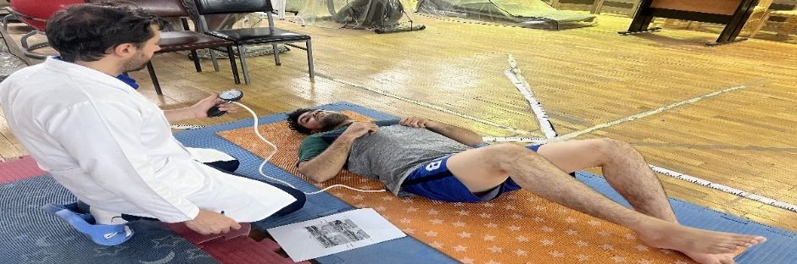

figure 1. Knee lift abdominal( KLAT) Test

2- Bent kneefall-out(BKFO) Test: The the subjects were supine position. Afterwards, one hip was flexed, and the knee was also flexed to 120°, with the foot resting on the surface of the examination couoch. The participants were asked to slowly bend their hip to approximately 45° of the abduction/lateral rotation while keeping their foot supported beside their straight knee and return to the starting position. The maximal pressure deviation was recorded and used for further analysis (Figure 2).
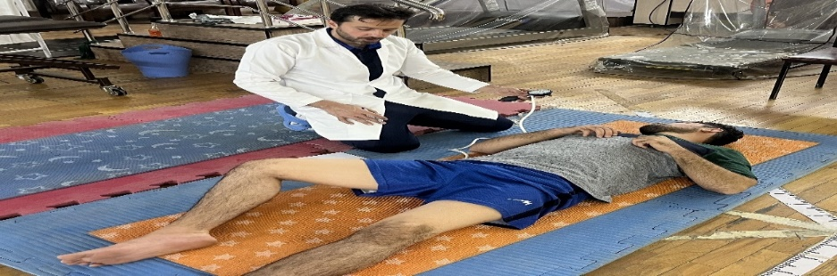

figure 2. Bent kneefall-out(BKFO) Test
3- Active Straight Leg Raising(ASLR) Test: The subject was lying on his back and the pressurized biofeedback device bag was placed horizontally under the lumbar spine and the lower edge of the device bag was placed at the level of the posterior upper lumbar spine. The base pressure of biofeedback was set to 40 mm Hg. Then the subject was asked to raise one leg straight up to 20 cm and hold it for 20 seconds. (Figure 3).
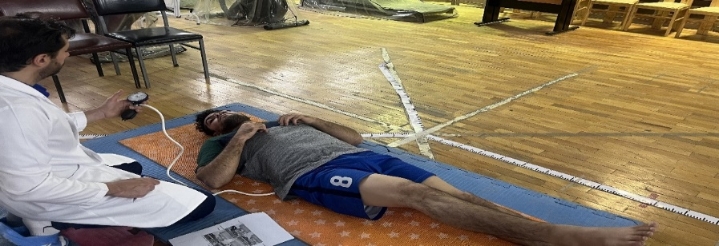

figure 3. Active Sraight Leg Raising(ASLR)

Prone Test: The subject is lying on his back and the high-pressure biofeedback bag is placed between the upper anterior sacral spine and the navel. Before the start of each contraction, the bag was adjusted to 70 mmHg and then the subject was asked to breathe through his abdominal wall. After two normal breaths and adjusting the airbag again to 70 mm Hg, the subject was asked to perform three contractions with verbal feedback. This contraction was done in such a way that without moving the spine of the back and pelvis, the stomach was pulled in and the navel was close to the spine and maintained in the same position for 10 seconds(Figure 4)(25,26,27,28).
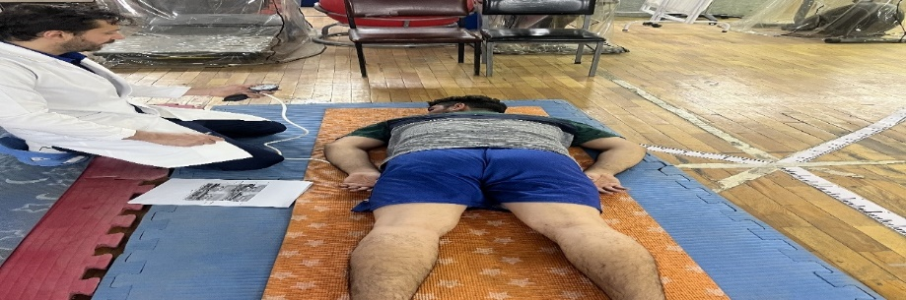

figure 4. Prone Test

2.6. Experimental protocol
After the evaluation of the mentioned variables, CKCE in water was performed in eight weeks, three sessions a week and each session was about 60 minutes under the supervision of the researcher for all three training groups in the same way. This part included about 5 minutes of general warm-up, about 50 minutes of motor chain exercises, and 5 minutes of cooling exercises in the form of stretching exercises. The primary goal of these exercises is to enable the patient to achieve control and coordination of the spine and pelvis using the principles of motor learning. The group of OKCE(in the deep part using noodles and under the care of four lifeguards) in the water for eight weeks, 3 sessions a week for 60 minutes in a group in the swimming pool of Buali Sina University, Hamedan, by a specialist in therapeutic exercises in water. became By previous studies(28,29,30,31,32), the training program for these groups increased in volume, intensity, duration, and repetition as an increase in the phasing of weeks (Table 1).
Time | Closed Chain Exercise group | Open Chain Exercise group
Warm up  Minutes(5) | - Walking back and forth with increasing speed in the shallow part of the pool  - Stretching exercises for the large muscles of the body (especially the hamstrings, piriformis, and quadratus lumborum). | - Walking back and forth with increasing speed in the shallow part of the pool  - Stretching exercises for the large muscles of the body (especially the hamstrings, piriformis, and quadratus lumborum).
The main exercise  (40) minutes  Every exercise  Minutes (4) | - Breathing exercises  - Exercises to activate transverse abdominal muscles and multifidus  - Walking forward with straight knees (parade walk)  - Walking backward with long steps  - Lateral walking with long steps  - Walking with trunk rotation  - Walking with consecutive stops on one leg  - Flexion and extension of the thigh in a single-leg position with a straight knee  - Shoulder flexion and extension in half squat position (12 x 3 repetitions)  - Shoulder abduction and horizontal adduction in the half squat position (12 x 3 repetitions)  - Performing thigh and knee extension simultaneously with ankle plantar flexion and then thigh and knee flexion with dorsiflexion (12 x 3 repetitions) | - Breathing exercises using noodles in the deep part  - Exercises to activate transverse abdominal muscles and multifidus using noodles in the deep part  - Bending and opening the thighs with straight knees (parade walking) using noodles in the deep part  - Pedaling (similar to riding a bicycle) backward using noodles in the deep part  - Bringing the legs closer and closer with a straight knee using noodles in the deep part  - Bringing the elbows to the knee of the opposite leg while rotating the trunk using noodles in the deep part  - One leg bicycle leg using noodles in the deep part  - Thigh flexion and extension in the floating position using noodles in the deep part  - Flexion and extension of the shoulders in a half squat position (12 x 3 repetitions) using noodles in the deep part.  - Shoulder abduction and horizontal adduction in half squat position (12 x 3 repetitions) using two noodles in the deep part  - Performing thigh and knee extension simultaneously with ankle plantar flexion and then thigh and knee flexion with dorsiflexion (12 x 3 repetitions) using noodles in the deep part
Cool down  Minutes(5) | - Walking at a reduced speed in the shallow part of the pool  - Stretching exercises for upper and lower body muscles | - Walking at a reduced speed in the shallow part of the pool  - Stretching exercises for upper and lower body muscles

2.8. Statistical Analysis
Statistical analysis was performed using SPSS version 26 software. The Shapiro-Wilk test was used to ensure the data's normal distribution (P > 0.05). A covariance test was used to compare results between groups. The effect size was classified using Cohen's index (small: 0.01, medium: 0.06, large 0.14) (33).

