Supplemental data table S1. Levels of 135 metabolites (μM) between normal and HTN groups
Metabolites |  | Mean (μM) ± SD
 |  | Controls (n=1011) | Cases  (n=511) | p-value
Amino acids | Alanine | 486.0 ± 116.0 | 523.5 ± 111.9 | $$2.08×{10}^{-9}$$
Amino acids | Aspartate | 41.36 ± 15.92 | 43.83 ± 16.64 | 0.00495
Amino acids | Citrulline | 35.67 ± 8.990 | 37.14 ± 10.07 | 0.00399
Amino acids | Glutamine | 560.3 ± 104.6 | 539.0 ± 115.0 | 0.00046
Amino acids | Glutamate | 162.5 ± 79.13 | 187.9 ± 86.86 | $$1.23×{10}^{-8}$$
Amino acids | Glycine | 344.3 ± 84.28 | 330.7 ± 80.01 | 0.00252
Amino acids | Isoleucine | 81.40 ± 18.72 | 85.21 ± 19.44 | 0.00022
Amino acids | Leucine | 172.8 ± 34.17 | 179.7 ± 36.85 | 0.00031
Amino acids | Ornithine | 93.32 ± 33.67 | 98.13 ± 31.64 | 0.00734
Amino acids | Phenylalanine | 100.1 ± 16.66 | 104.1 ± 17.46 | $$1.56×{10}^{-5}$$
Amino acids | Proline | 159.5 ± 46.38 | 173.8 ± 51.09 | $$5.57×{10}^{-8}$$
Amino acids | Tyrosine | 70.24 ± 14.61 | 73.14 ± 13.97 | 0.00022
Amino acids | Valine | 215.6 ± 39.91 | 226.1 ± 43.00 | $$4.79×{10}^{-6}$$
Acylcarnitines | Carnitine | 50.01 ± 10.25 | 51.22 ± 10.74 | 0.03245
Acylcarnitines | Tetradecenoylcarnitine | 0.117 ± .0419 | 0.126 ± .0454 | 0.00012
Acylcarnitines | Hexadecanoylcarnitine | 0.141 ± .0548 | 0.161 ± .0706 | $$2.82×{10}^{-9}$$
Acylcarnitines | Octadecenoylcarnitine (C18) | 0.043 ± .0127 | 0.046 ± .0150 | $$5.51×{10}^{-5}$$
Acylcarnitines | Octadecenoylcarnitine (C18_1) | 0.156 ± .0705 | 0.174 ± .0924 | $$5.97×{10}^{-5}$$
Acylcarnitines | Octadecadienylcarnitine | 0.101 ± .0586 | 0.110 ± .0691 | 0.01325
Acylcarnitines | Acetylcarnitine | 6.896 ± 2.471 | 7.199 ± 2.606 | 0.02693
Acylcarnitines | Propionylcarnitine | 0.448 ± .1476 | 0.474 ± .1734 | 0.00374
Acylcarnitines | Butyrylcarnitine | 0.197 ± .0748 | 0.210 ± .0911 | 0.00708
Acylcarnitines | Valerylcarnitine | 0.145 ± .0719 | 0.162 ± .1061 | 0.00027
Biogenic amines | Asymmetric dimethylarginine | 0.575 ± .1747 | 0.622 ± .1840 | $$1.43×{10}^{-6}$$
Biogenic amines | Kynurenine | 2.160 ± .6262 | 2.265 ± .7392 | 0.00366
Biogenic amines | Serotonin | 0.553 ± .2470 | 0.480 ± .2278 | $$1.29×{10}^{-8}$$
Biogenic amines | Taurine | 159.8 ± 44.06 | 170.8 ± 47.36 | $$8.20×{10}^{-6}$$
Glycerophospholipids | lysoPCaC16_0 | 256.8 ± 59.82 | 278.3 ± 69.71 | $$5.13×{10}^{-10}$$
Glycerophospholipids | lysoPCaC16_1 | 6.195 ± 1.986 | 6.815 ± 2.458 | $$9.10×{10}^{-7}$$
Glycerophospholipids | lysoPCaC17_0 | 3.600 ± 1.036 | 3.365 ± 1.029 | $$3.02×{10}^{-5}$$
Glycerophospholipids | lysoPCaC18_0 | 72.90 ± 18.36 | 77.36 ± 20.52 | $$1.89×{10}^{-5}$$
Glycerophospholipids | lysoPCaC18_1 | 28.86 ± 8.278 | 30.91 ± 10.64 | 0.00015
Glycerophospholipids | lysoPCaC20_3 | 2.463 ± .8800 | 2.740 ± 1.169 | $$3.00×{10}^{-6}$$
Glycerophospholipids | lysoPCaC20_4 | 7.698 ± 2.376 | 8.078 ± 2.513 | 0.00394
Glycerophospholipids | PCaaC32_0 | 13.40 ± 4.115 | 14.53 ± 3.920 | $$3.00×{10}^{-7}$$
Glycerophospholipids | PCaaC32_1 | 12.07 ± 7.75 | 15.28 ± 9.03 | $$1.32×{10}^{-11}$$
Glycerophospholipids | PCaaC34_1 | 162.6 ± 51.97 | 189.0 ± 66.18 | $$9.01×{10}^{-15}$$
Glycerophospholipids | PCaaC34_2 | 282.6 ± 71.17 | 301.3 ± 77.36 | $$5.64×{10}^{-6}$$
Glycerophospholipids | PCaaC34_3 | 14.46 ± 6.42 | 16.35 ± 7.413 | $$1.14×{10}^{-6}$$
Glycerophospholipids | PCaaC34_4 | 1.421 ± .4823 | 1.517 ± .4813 | 0.00023
Glycerophospholipids | PCaaC36_0 | 3.922 ± 1.259 | 3.732 ± 1.311 | 0.00619
Glycerophospholipids | PCaaC36_1 | 38.96 ± 12.10 | 45.60 ± 15.75 | $$2.65×{10}^{-16}$$
Glycerophospholipids | PCaaC36_2 | 163.5 ± 40.91 | 176.5 ± 45.70 | $$6.37×{10}^{-8}$$
Glycerophospholipids | PCaaC36_3 | 94.79 ± 25.17 | 103.8 ± 29.03 | $$3.37×{10}^{-9}$$
Glycerophospholipids | PCaaC36_4 | 136.8 ± 34.42 | 145.7 ± 38.51 | $$1.22×{10}^{-5}$$
Glycerophospholipids | PCaaC36_5 | 42.17 ± 21.36 | 46.55 ± 23.21 | 0.00037
Glycerophospholipids | PCaaC38_0 | 4.664 ± 1.599 | 4.359 ± 1.250 | 0.00016
Glycerophospholipids | PCaaC38_3 | 45.38 ± 12.28 | 49.71 ± 13.55 | $$4.56×{10}^{-10}$$
Glycerophospholipids | PCaaC38_4 | 85.41 ± 22.10 | 90.67 ± 24.27 | $$4.23×{10}^{-5}$$
Glycerophospholipids | PCaaC38_5 | 62.13 ± 19.58 | 69.02 ± 22.04 | $$3.35×{10}^{-9}$$
Glycerophospholipids | PCaaC40_1 | 0.577 ± .1668 | 0.552 ± .1893 | 0.00847
Glycerophospholipids | PCaaC40_4 | 3.460 ± 1.083 | 3.764 ± 1.242 | $$2.92×{10}^{-6}$$
Glycerophospholipids | PCaaC40_5 | 14.51 ± 5.74 | 17.00 ± 6.57 | $$6.96×{10}^{-13}$$
Glycerophospholipids | PCaaC40_6 | 62.30 ± 19.58 | 66.64 ± 23.02 | 0.000281177
Glycerophospholipids | PCaaC42_0 | 0.890 ± .2576 | 0.828 ± .2480 | $$6.12×{10}^{-6}$$
Glycerophospholipids | PCaaC42_1 | 0.525 ± .1463 | 0.480 ± .1337 | $$1.65×{10}^{-9}$$
Glycerophospholipids | PCaaC42_2 | 0.547 ± .1769 | 0.528 ± .1785 | 0.04325
Glycerophospholipids | PCaaC42_5 | 0.527 ± .1811 | 0.582 ± .2229 | $$2.02×{10}^{-6}$$
Glycerophospholipids | PCaaC42_6 | 0.902 ± .2678 | 0.938 ± .3157 | 0.02505
Glycerophospholipids | PCaeC30_0 | 0.272 ± .0744 | 0.255 ± .0681 | $$1.78×{10}^{-5}$$
Glycerophospholipids | PCaeC32_2 | 0.702 ± .2186 | 0.679 ± .1928 | 0.04038
Glycerophospholipids | PCaeC34_2 | 8.030 ± 2.448 | 7.596 ± 2.251 | 0.00058
Glycerophospholipids | PCaeC34_3 | 6.899 ± 2.117 | 6.548 ± 1.875 | 0.00099
Glycerophospholipids | PCaeC36_0 | 1.254 ± .4616 | 1.203 ± .4844 | 0.04381
Glycerophospholipids | PCaeC36_2 | 8.148 ± 2.241 | 7.731 ± 2.051 | 0.00030
Glycerophospholipids | PCaeC36_3 | 5.795 ± 1.585 | 5.539 ± 1.491 | 0.00246
Glycerophospholipids | PCaeC38_4 | 8.314 ± 2.013 | 8.027 ± 1.956 | 0.00828
Glycerophospholipids | PCaeC38_6 | 9.993 ± 2.958 | 9.657 ± 2.845 | 0.03412
Glycerophospholipids | PCaeC40_1 | 1.665 ± .4291 | 1.608 ± .4409 | 0.01477
Glycerophospholipids | PCaeC40_2 | 1.715 ± .4177 | 1.632 ± .4195 | 0.00027
Glycerophospholipids | PCaeC40_3 | 0.974 ± .2071 | 0.938 ± .2102 | 0.00122
Glycerophospholipids | PCaeC40_4 | 2.076 ± .4883 | 1.974 ± .4714 | 0.00010
Glycerophospholipids | PCaeC40_6 | 6.279 ± 1.747 | 5.818 ± 1.604 | $$6.68×{10}^{-7}$$
Glycerophospholipids | PCaeC42_0 | 0.745 ± .1676 | 0.726 ± .1885 | 0.03920
Glycerophospholipids | PCaeC42_3 | 0.940 ± .2120 | 0.906 ± .2150 | 0.00328
Glycerophospholipids | PCaeC42_4 | 0.813 ± .2110 | 0.769 ± .2026 | $$9.85×{10}^{-5}$$
Glycerophospholipids | PCaeC42_5 | 1.889 ± .3931 | 1.841 ± .4199 | 0.02726
Glycerophospholipids | PCaeC44_4 | 0.384 ± .0959 | 0.368 ± .1038 | 0.00278
Glycerophospholipids | PCaeC44_6 | 1.639 ± .4678 | 1.530 ± .4419 | $$9.31×{10}^{-6}$$
Sphingomyelins | SM_OH_C14_1 | 4.444 ± 1.102 | 4.140 ± 1.195 | $$8.63×{10}^{-7}$$
Sphingomyelins | SM_OH_C16_1 | 2.637 ± .6655 | 2.410 ± .7082 | $$8.96×{10}^{-10}$$
Sphingomyelins | SM_OH_C22_1 | 10.75 ± 2.650 | 10.44 ± 2.856 | 0.03716
Sphingomyelins | SM_OH_C22_2 | 9.103 ± 2.391 | 8.422 ± 2.418 | $$1.98×{10}^{-7}$$
Sphingomyelins | SM_OH_C24_1 | 1.108 ± .2925 | 1.068 ± .3015 | 0.01483
Sphingomyelins | SMC16_0 | 118.7 ± 22.21 | 115.2 ± 23.42 | 0.00511
Sphingomyelins | SMC24_1 | 52.18 ± 11.21 | 50.72 ± 11.79 | 0.01798
Sphingomyelins | SMC26_1 | 0.511 ± .170 | 0.489 ± .1821 | 0.01747
Monosaccharides | Hexoses | 5014. ± 1271. | 5422. ± 1749. | $$3.34×{10}^{-6}$$
LysoPC a: lyso phosphatidylcholine acyl; PC aa: phosphatidylcholine diacyl; PC ae: phosphatidylcholine acyl-alkyl; SM(OH): hydroxysphingomyelin; SM: sphingomyelin.

(A)
(B)
(C)
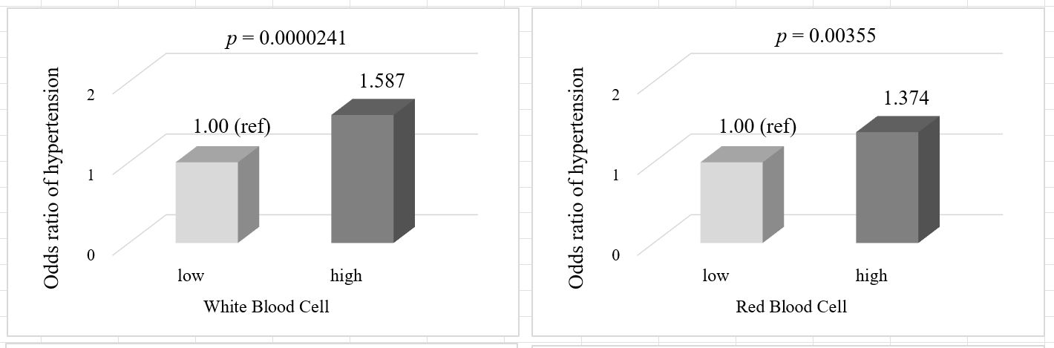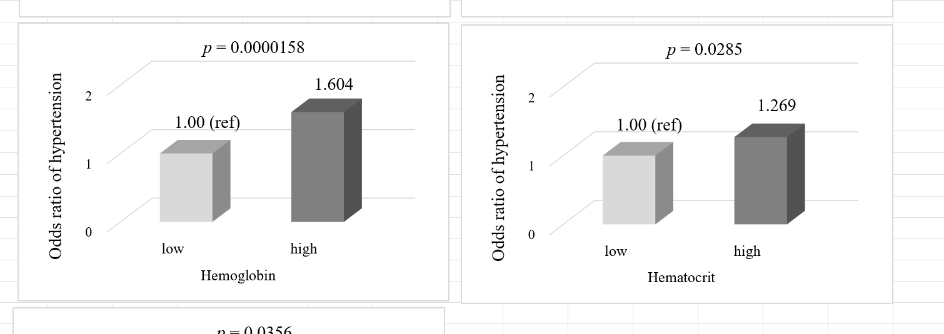
(D)

(E)
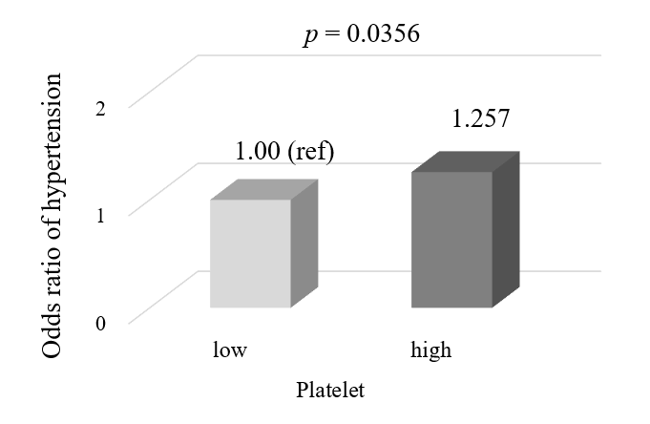
Supplemental data figure S2. HTN risk according to blood component levels
Supplemental data table S3. Results of association analysis of the SNPs in the HECTD4 with HTN (n=8840)
Gene | No. | SNP | Minor Allele | HTN
 |  |  |  | MAF |  | OR (95% CI) | P-value
 |  |  |  | Case (n = 2466) | Control (n = 2639) | OR (95% CI) | P-value
HECTD4 | 1 | rs3519 | T | 0.227 | 0.217 | 1.05 (0.94-1.17) | 0.32
HECTD4 | 2 | rs10850008 | C | 0.404 | 0.386 | 1.06 (0.97-1.16) | 0.18
HECTD4 | 3 | rs2074356 | T | 0.131 | 0.158 | 0.76 (0.67-0.86) | 2.54 × 10⁻³
HECTD4 | 4 | rs11066194 | A | 0.403 | 0.385 | 1.06 (0.97-1.16) | 0.16
HECTD4 | 5 | rs1005902 | T | 0.112 | 0.108 | 1.04 (0.90-1.20) | 0.52
HECTD4 | 6 | rs2106970 | G | 0.405 | 0.386 | 1.06 (0.97-1.16) | 0.16
HECTD4 | 7 | rs11066208 | C | 0.405 | 0.386 | 1.06 (0.97-1.17) | 0.15
HECTD4 | 8 | rs11066209 | T | 0.405 | 0.386 | 1.07 (0.97-1.17) | 0.14
HECTD4 | 9 | rs11066211 | T | 0.471 | 0.495 | 0.91 (0.83-0.99) | 0.04
HECTD4 | 10 | rs11066225 | C | 0.405 | 0.386 | 1.07 (0.97-1.17) | 0.14
HECTD4 | 11 | rs2285809 | G | 0.230 | 0.218 | 1.06 (0.95-1.18) | 0.26
HECTD4 | 12 | rs4766865 | T | 0.404 | 0.385 | 1.06 (0.97-1.17) | 0.16
HECTD4 | 13 | rs11066230 | G | 0.406 | 0.386 | 1.07 (0.97-1.17) | 0.13
HECTD4 | 14 | rs1468251 | T | 0.174 | 0.165 | 1.03 (0.92-1.17) | 0.52
HECTD4 | 15 | rs41425848 | A | 0.049 | 0.044 | 1.11 (0.90-1.37) | 0.30
HECTD4 | 16 | rs7954620 | T | 0.405 | 0.386 | 1.06 (0.97-1.16) | 0.17
HECTD4 | 17 | rs11066280 | T | 0.155 | 0.182 | 0.78 (0.69-0.88) | 4.15× 10⁻⁵
Abbreviations: No, number; SNP, single nucleotide polymorphism; HTN, hypertension; MAF, minor allele frequency; OR, odds ratio; CI, confdence interval.

