Supplemental figures
Supplement figure 1
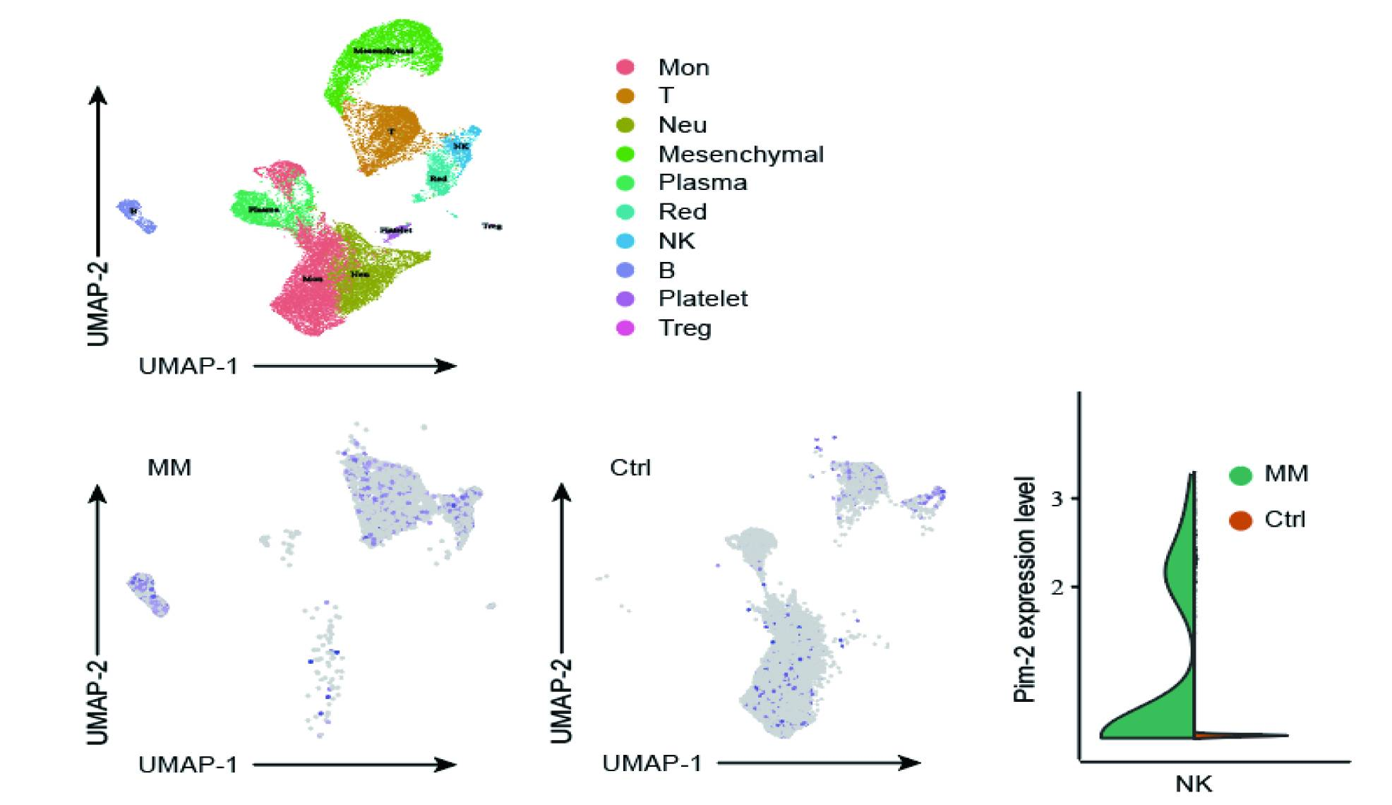

Supplement figure 2
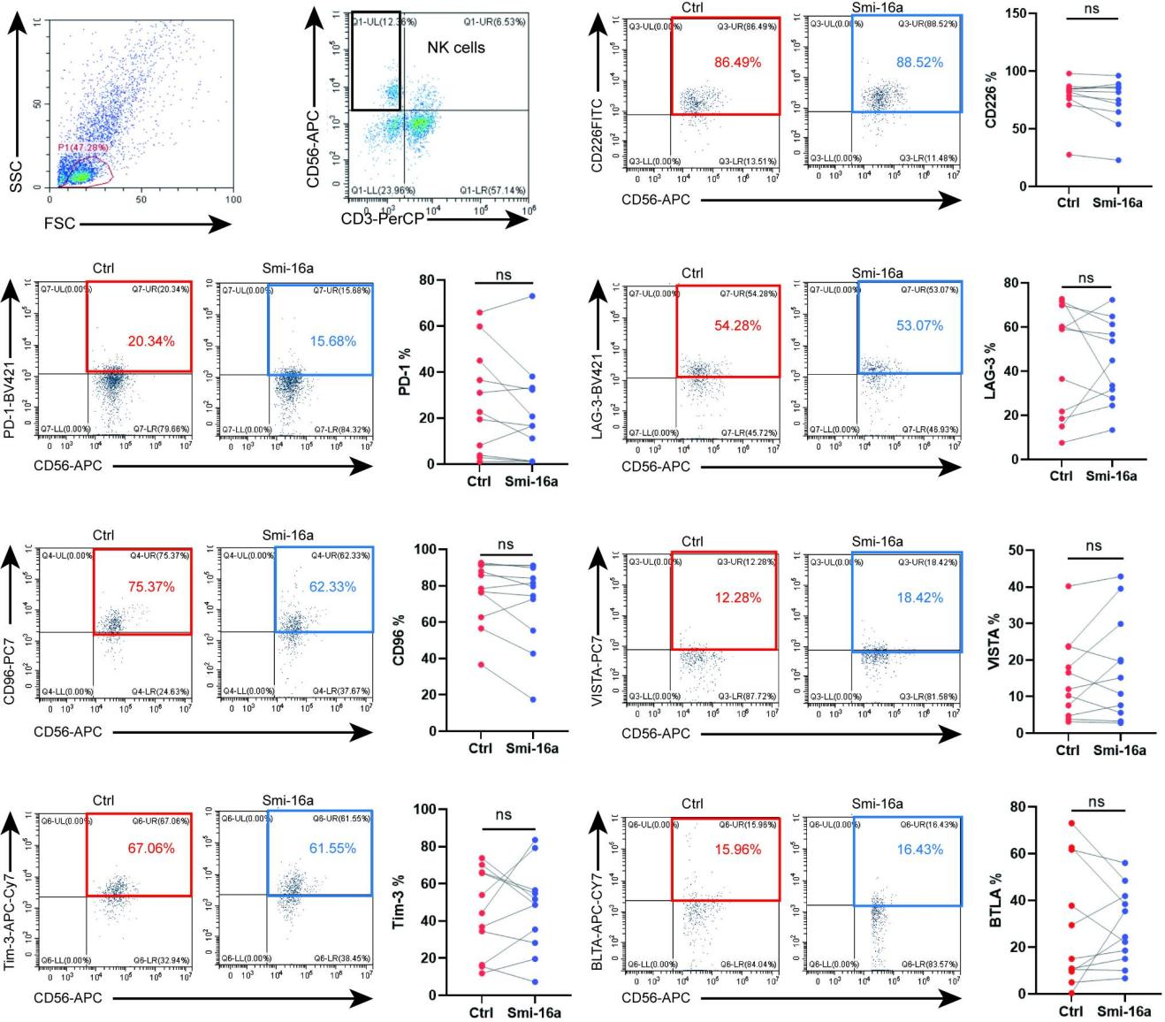
Supplement figure 3
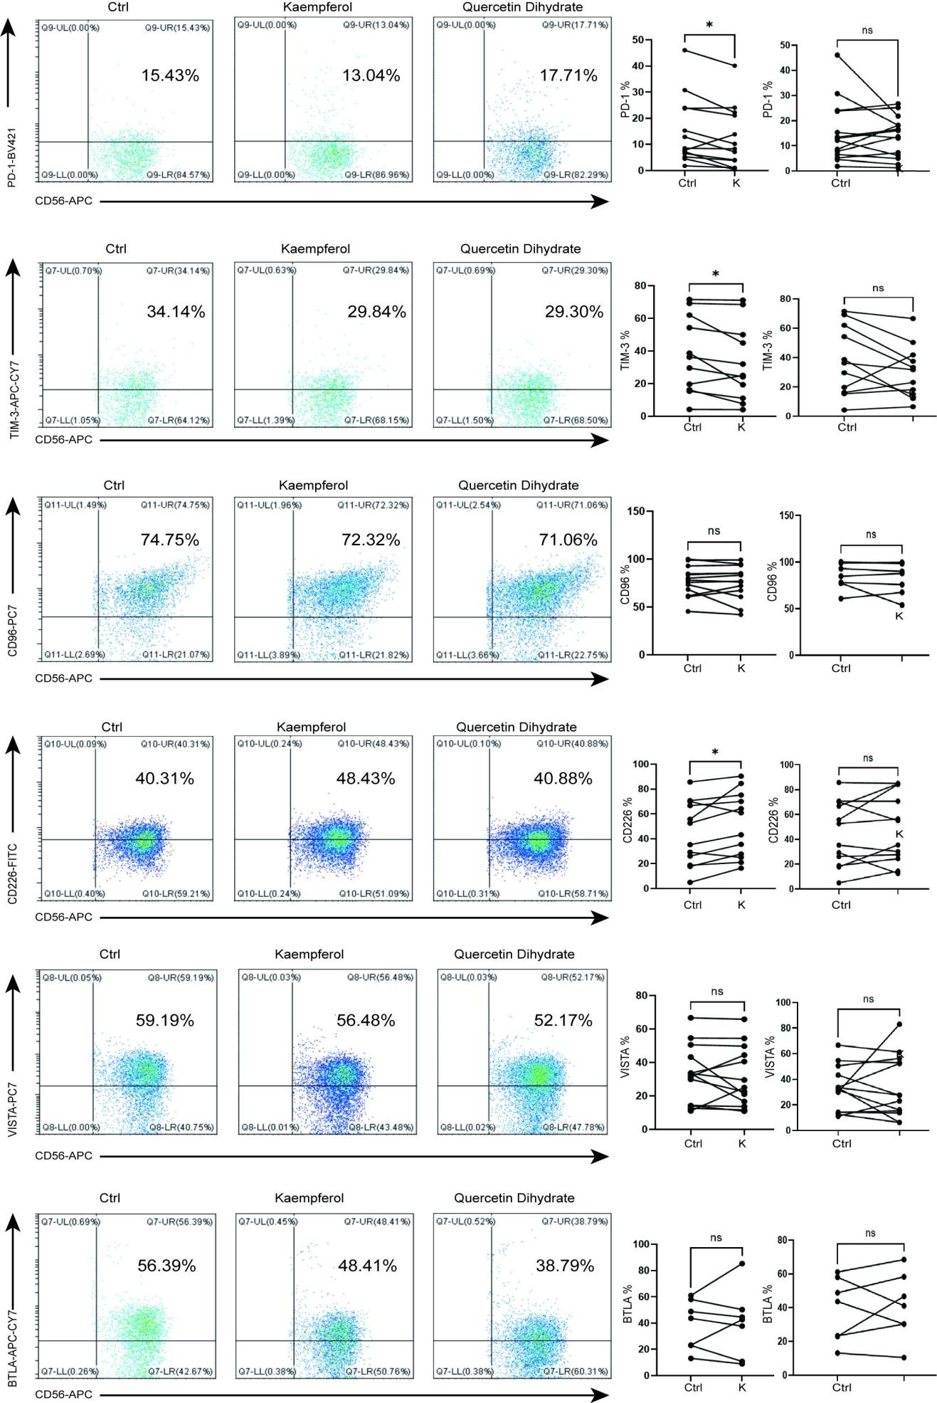
Supplement figure 4
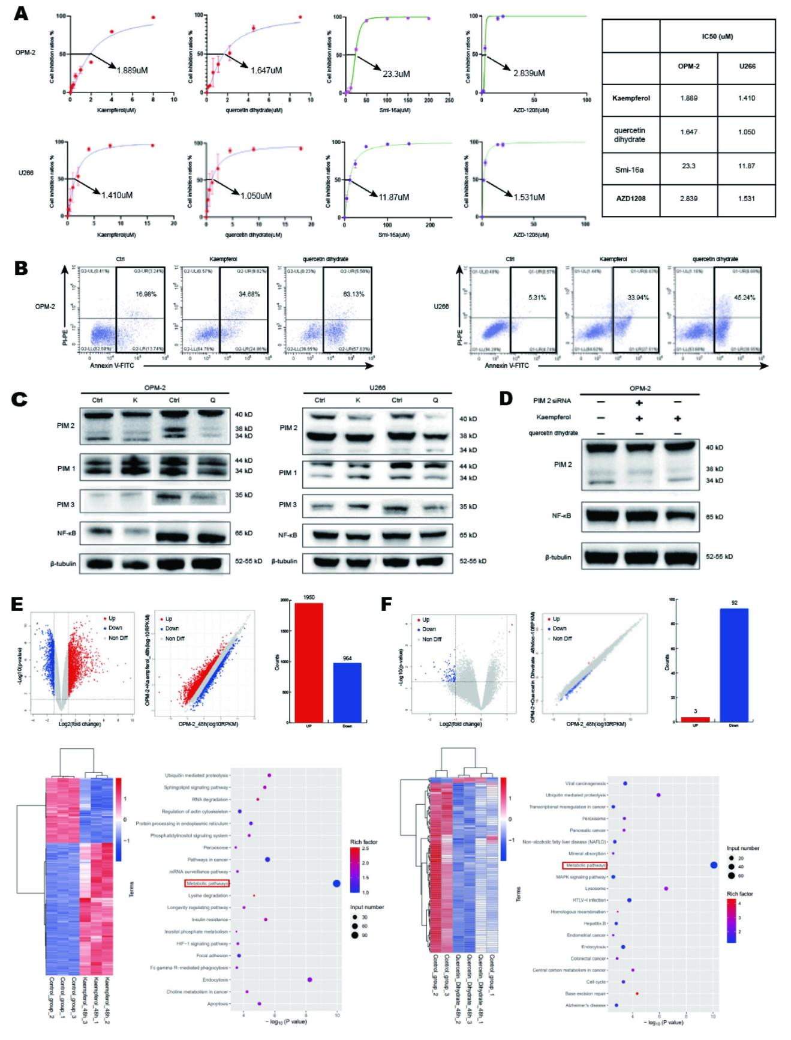

Supplemental figure legends
Supplement figure 1: Pim-2 kinase highly expressed in MM patients than healthy donors by using single-cell RNA sequencing.
Supplement figure 2 Changes in other immune checkpoints on NK cells besides TIGIT after addition of PIM2 kinase inhibitors Smi-16a.
Supplement figure 3 The expression of immune checkpoints on NK cells from MM patients with or without Kaempferol and Quercetin dihydrate.
Supplement figure 4 (A) The Cytotoxicity of kaempferol,Quercetin dihydrate, Smi-16a and AZD1208 on U266 and OPM-2 cells by CKK-8 assay. (B) Detection of apoptotic in U266 and OPM-2 cells after administration by flow cytometric assay. (n=3). (C) OPM-2 and U266 cells were treated with kaempferol and quercetin dihydrate at the IC50 concentration for 48 h, PIM1, PIM2, PIM3 and NK-κB expression was measured by Western blot (n=3). (D) The expression of PIM2 and NK-κB in PIM2 knockdown U266 cells with or without kaempferol was measured by Western blot. Kaempferol inhibited the expression of NF-KB depend on PIM2 kinase (n=3). (E) The transcript of OPM-2 cells treated with kaempferol at the IC50 concentration for 48 h. (F) The transcript of U266 cells treated with quercetin dihydrate at the IC50 concentration for 48 h. In all figures, K represents kaempferol and Q represents quercetin dihydrate. Results are shown as mean ± SD (n=3). * P < 0.05, ** P < 0.01, *** P < 0.001.
Supplement table1 The inhibition rate of 160 flavonoids to PIM2 kinase.

