Ethical argumentation report
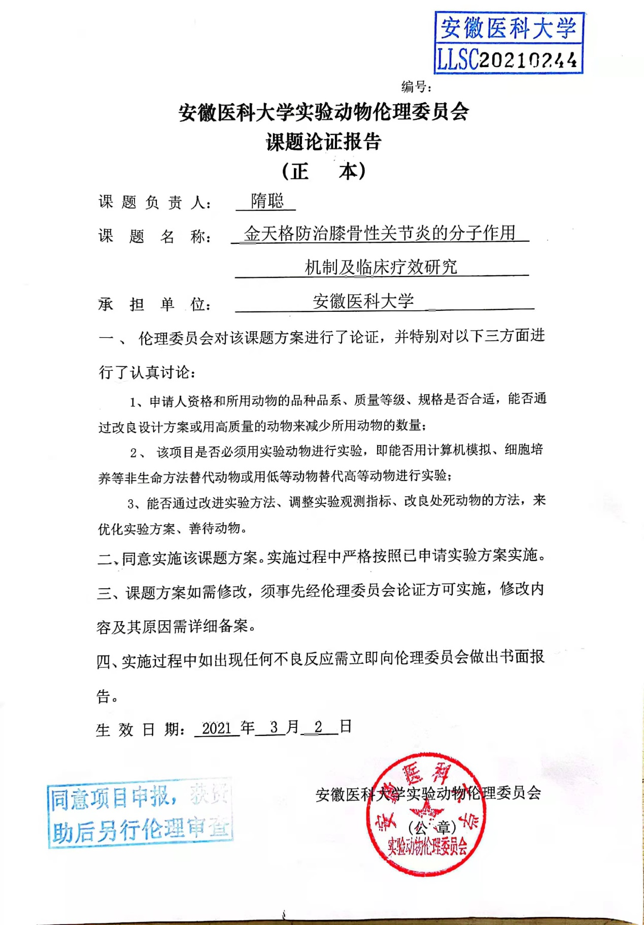

WB raw data graph

