Supporting materials：
Through-Polymer Via Technology-Enabled Flexible, Lightweight, and Integrated Device for Implantable Neural Probes

Cunkai Zhou^{1,2+}, Ye Tian^{2,3,+}, Gen Li^{2,3,+}, YiFei Ye², Lusha Gao², Jiazhi Li², Ziwei Liu², Haoyang Su^{3,4}, Yunxiao Lu^{1,2}, Meng Li^{3,4}, Zhitao Zhou^{3,4}, Xiaoling Wei^{3,4}, Lunming Qin¹*, Tiger H. Tao^{,2,3,4,5,6,7,8,9,10,}*, Liuyang Sun^{1,2,3,4}*

¹College of Electronics and Information Engineering, Shanghai University of Electric Power, Shanghai, China
²2020 X-Lab, Shanghai Institute of Microsystem and Information Technology, Chinese Academy of Sciences, Shanghai, China
³School of Graduate Study, University of Chinese Academy of Sciences, Beijing, China
⁴State Key Laboratory of Transducer Technology, Shanghai Institute of Microsystem and Information Technology, Chinese Academy of Sciences, Shanghai, China
⁵Center of Materials Science and Optoelectronics Engineering, University of Chinese Academy of Sciences, Beijing, China
⁶School of Physical Science and Technology, ShanghaiTech University, Shanghai, China
⁷Center for Excellence in Brain Science and Intelligence Technology, Chinese Academy of Sciences, Shanghai, China
⁸Neuroxess Co., Ltd. (Jiangxi), Nanchang, Jiangxi, China
⁹Guangdong Institute of Intelligence Science and Technology, Hengqin, Zhuhai, Guangdong, China
¹⁰Tianqiao and Chrissy Chen Institute for Translational Research, Shanghai, China

+These authors contributed equally.
*Corresponding author:
Email address: lunming.qin@shiep.edu.cn (Lunming Qin); tiger@mail.sim.ac.cn (Tiger H. Tao); liuyang.sun@mail.sim.ac.cn (Liuyang Sun).
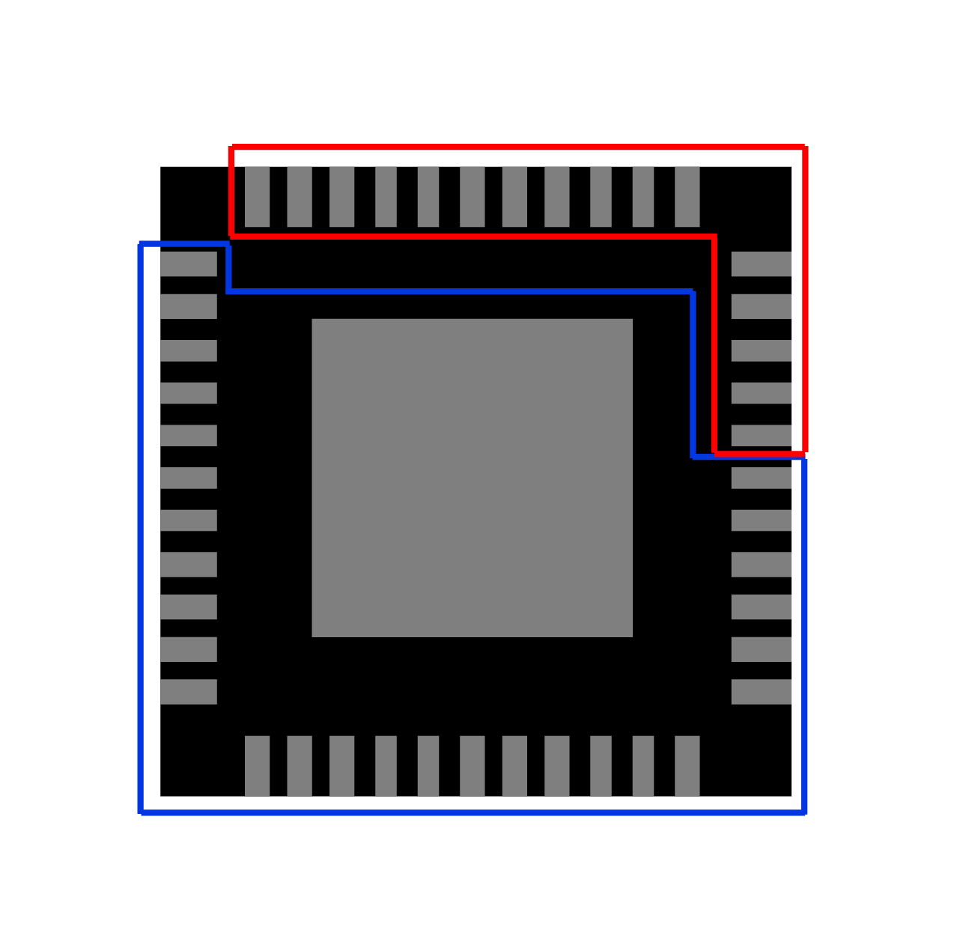
SFig 1. Intan chip bottom schematic, a total of 45 pins, red part 16 pins allocated for neural signal acquisition and blue part 29 pins dedicated to communicating with the host computer software.

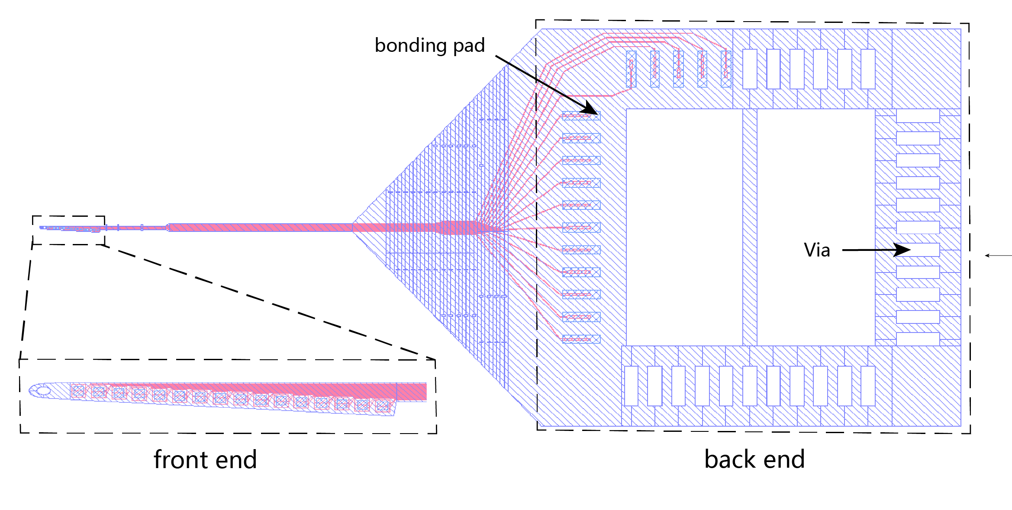
SFig 2. Overall schematic diagram of flexible probe

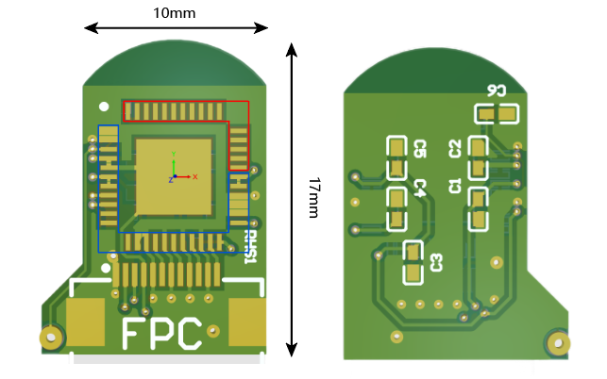
SFig 3. Schematic diagram of the PCB substrate

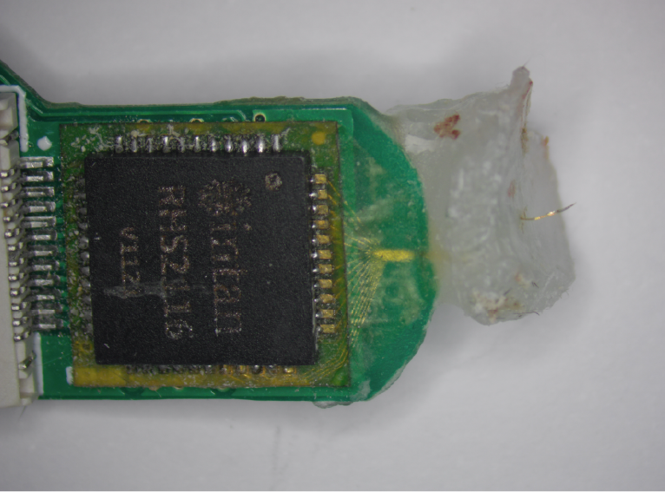
SFig 4. Schematic diagram of the complete device removal

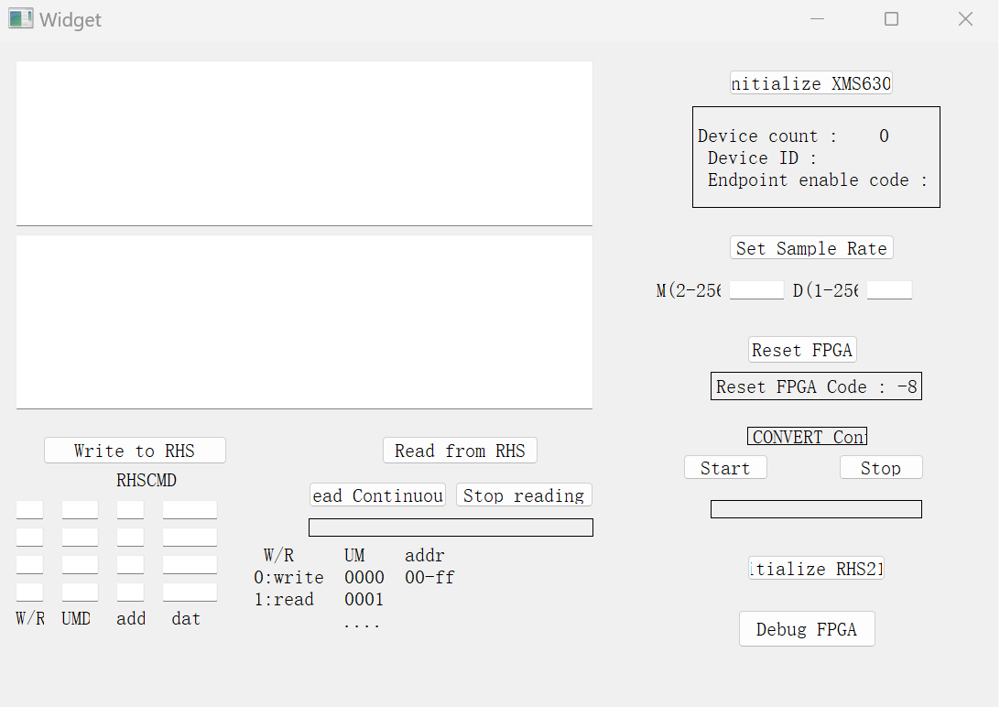
SFig 5. Host computer software operation interface

