Supplement information
Suuplementary tables and figures legends
Supplementary Table 1. List of 28 selected m7G modification-related genes.
Supplementary Table 2. Associations of demographics and clinical characteristics with OS of HBV-HCC patients.
Supplementary Table 3. Functional prediction of two identified significant SNPs.
Supplementary Figure 1. Correlations between rs12055336 and rs6580113 with LARP1 mRNA expression levels. For GTEx database, eQTL analysis of LARP1 rs12055336 in normal liver tissue (n=208, P=0.602) (A), and eQTL analysis of LARP1 rs6580113 in normal liver tissues (n=208, P=0.860) (B). For 1000 Genomes Project, correlation of rs12055336 with LARP1 mRNA expression in lymphoblastoid cells from CHB in a additivet model (n=76, P=0.0.274) (C); correlation of rs6580113 with LARP1 mRNA expression in lymphoblastoid cells from CHB in a additive model (n=76, P=0.107) (D).
Supplementary Figure 2. The locations of the two identified SNPs in LARP1.
Supplementary Figure 3. Mutation frequency of LARP1 in HCC tissues. Mutation frequency of LARP1 in hepatocellular carcinoma using the online database of the cBioPortal for Cancer Genomics.

Supplementary Table 1. List of 28 selected m7G modification-related genes
Name of gene-sets | Selected genes
GOMF_RNA_CAP_BINDING | AGO2, CYFIP1, CYFIP2, DCPS, EIF3D, EIF4A1, EIF4E, EIF4E1B, EIF4E2, EIF4E3, EIF4G3, GEMIN5, IFIT5, LARP1, LSM1, NCBP1, NCBP2, NCBP2L, NCBP3, SNUPN
GOMF_RNA_7_METHYLGUANOSINE_CAP_BINDING | AGO2, CYFIP1, CYFIP2, DCPS, EIF4E, EIF4E1B, EIF4E2, EIF4E3, GEMIN5, LARP1, NCBP1, NCBP2, NCBP3
GOBP_7_METHYLGUANOSINE_RNA_CAPPING | CMTR1, CMTR2, NCBP1, NCBP3, RAMAC, RNGTT, RNMT, TGS1
Removed Genes | 15 repeated genes and 3 genes without position were deleted
Previous systematic reviews^{1,2} | METTL1, WDR4, WBSCR22, TRMT112, RAB27A
Total | 28
Abbreviations: m7G, N7-methylguanosine.
Keyword: m7G
Organism: Homo sapiens
Website: http://www.gsea-msigdb.org/gsea/msigdb/search.js

Supplementary Table 2. Associations of demographics and clinical characteristics with OS of HBV-HCC patients
Characteristics | No. of patients | Death (%) | MST  (Month) | Univariate analysis |  | Multivariable analysis
 |  |  |  | HR (95% CI) | P | HR (95% CI) | P ª
Age (year)
≤ 47 | 434 | 233 (53.7) | 47.00 | 1.00 |  | 1.00
> 47 | 432 | 186 (43.1) | 82.60 | 0.72 (0.59-0.87) | <0.001 | 0.81 (0.66-0.99) | 0.036
Sex
Female | 106 | 42 (39.6) | 66.97 | 1.00 |  | 1.00
Male | 760 | 377 (49.6) | 71.98 | 1.25 (0.90-1.71) | 0.179 | 1.26 (0.90-1.76) | 0.176
Smoking status
No | 545 | 268 (49.2) | 62.00 | 1.00 |  | 1.00
Yes | 321 | 151 (47.0) | 60.00 | 0.96 (0.79-1.18) | 0.724 | 0.91 (0.71-1.17) | 0.475
Drinking status
No | 614 | 292 (47.6) | 66.00 | 1.00 |  | 1.00
Yes | 252 | 127 (59.4) | 54.00 | 1.07 (0.87-1.32) | 0.500 | 1.08 (0.84-1.41) | 0.541
AFP (ng/ml)
≤ 400 | 522 | 232 (44.4) | 70.30 | 1.00 |  | 1.00
> 400 | 344 | 187 (54.4) | 39.10 | 1.59 (1.31-1.93) | <0.001 | 1.29 (1.05-1.57) | 0.015
Cirrhosis status
No | 390 | 184 (47.2) | 61.90 | 1.00 |  | 1.00
Yes | 476 | 235 (49.4) | 61.50 | 1.00 (0.82-1.22) | 0.996 | 1.04 (0.85-1.41) | 0.702
Embolus
No | 636 | 260 (40.9) | 90.60 | 1.00 |  | 1.00
Yes | 230 | 159 (69.1) | 23.10 | 2.73 (2.32-3.34) | <0.001 | 1.74 (1.38-2.21) | <0.001
BCLC stage
0/A | 427 | 146 (34.2) | 99.60 | 1.00 |  | 1.00
B/C | 439 | 273 (62.2) | 30.10 | 2.73 (2.23-3.35) | <0.001 | 1.98 (1.56-2.52) | <0.001
ª adjusted for age, sex, smoking status, drinking status, AFP, cirrhosis status, embolus, and BCLC stage in Cox regression model.
Abbreviation: OS, overall survival; HBV-HCC, hepatitis B virus-related hepatocellular carcinoma; No. of patients, number of patients; MST, median survival time; HR, hazards ratio; CI, confidence interval; AFP, alpha fetoprotein; BCLC, Barcelona Clinic Liver Cancer.

Supplementary Table 3. Functional prediction of two identified significant SNPs
SNPs | Gene | Chr | RegulomeDB ª |  | HaploReg v4.2 ^{b}
SNPs | Gene | Chr | Rank | Score | Promoter histone marks | Enhancer histone marks | DNAse | Proteins bound | Motifs changed | Selected eQTL hits | dbSNP funcannot
rs12055336 | LARP1 | 5 | 1a | 0.940 | HRT | 11 tissues | - | RAD21 | 8 altered motifs | 7 hits | intronic
rs6580113 | LARP1 | 5 | 1b | 0.801 | HRT | 11 tissues | - | RAD21 | 6 altered motifs | 1 hit | intronic
Abbreviations: SNP, single nucleotide polymorphism; Chr, chromosome; DNAse, deoxyribonuclease; eQTL, expression quantitative trait loci; dbSNP funcannot, dbSNP function annotation.
ª https://regulomedb.org/regulome-search/
^{b} https://pubs.broadinstitute.org/mammals/haploreg/haploreg.php.

(A) |  | (B)
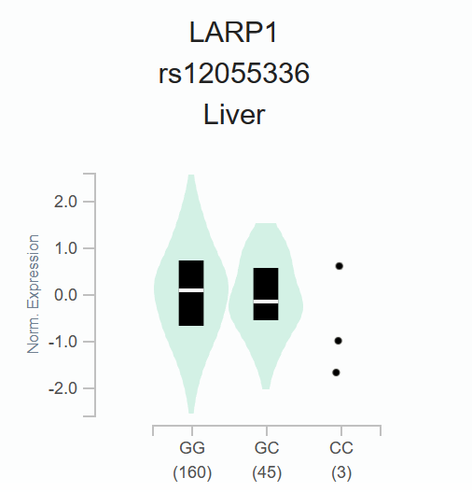  P=0.620, NES=0.034 |  | 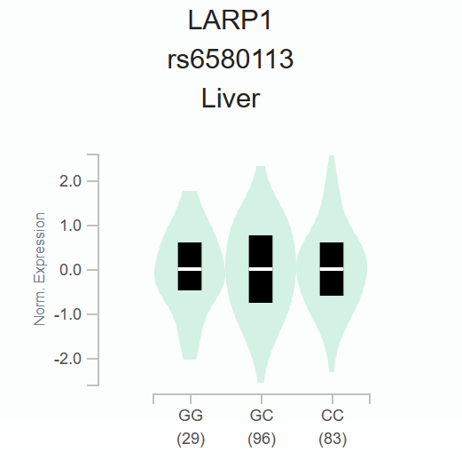  P=0.860, NES= - 0.0081
(C) |  | (D)
P=0.274 |  | P=0.107
Supplementary Figure 1. Correlations between rs12055336 and rs6580113 with LARP1 mRNA expression levels.
For GTEx database, eQTL analysis of LARP1 rs12055336 in normal liver tissue (n=208, P=0.602) (A), and eQTL analysis of LARP1 rs6580113 in normal liver tissues (n=208, P=0.860) (B).
For 1000 Genomes Project, correlation of rs12055336 with LARP1 mRNA expression in lymphoblastoid cells from CHB in a additivet model (n=76, P=0.0.274) (C); correlation of rs6580113 with LARP1 mRNA expression in lymphoblastoid cells from CHB in a additive model (n=76, P=0.107) (D).
Abbreviations: NES, normalized effect size; Norm, normalized; GTEx, Genotype-Tissue Expression project; eQTL, expression quantitative trait loci, CHB, Han Chinese in Beijing.
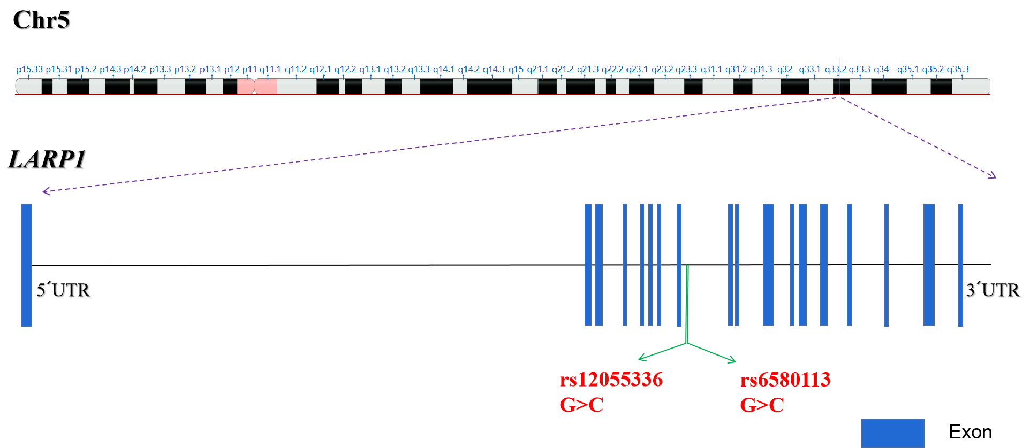
Supplementary Figure 2. The locations of the two identified SNPs in LARP1.

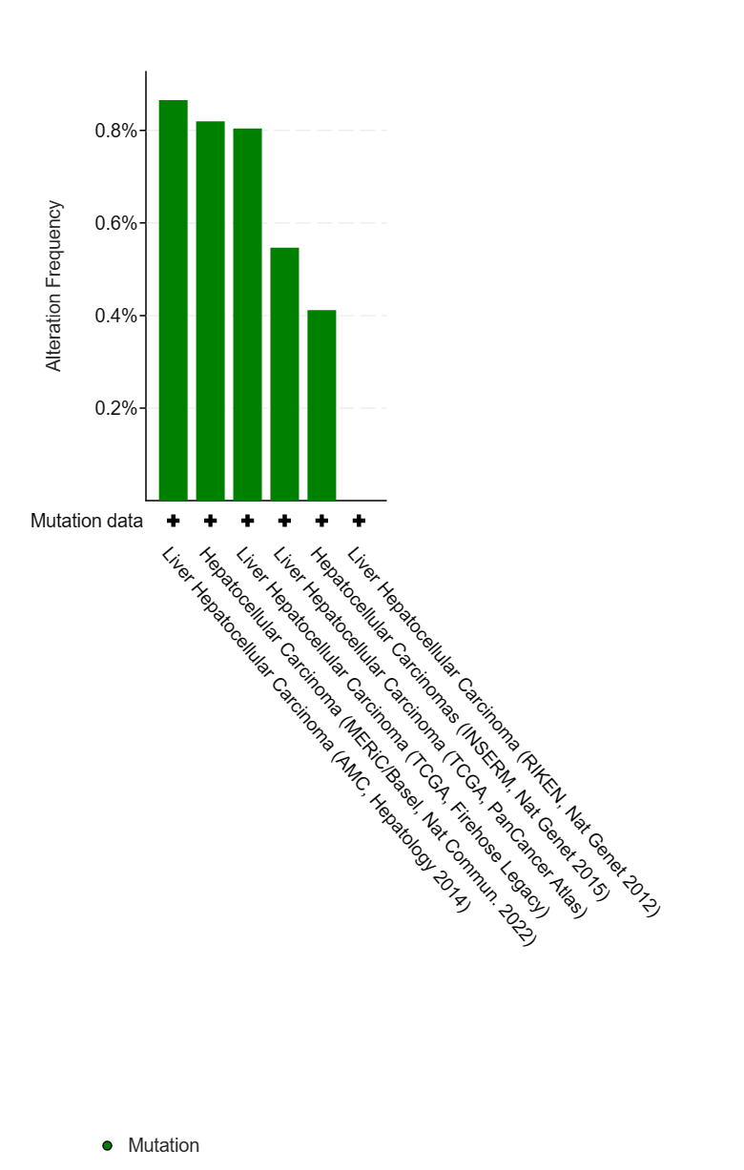
Supplementary Figure 3. Mutation frequency of LARP1 in HCC tissues.
Mutation frequency of LARP1 in hepatocellular carcinoma using the online database of the cBioPortal for Cancer Genomics.

References
[1] Luo Y, Yao Y, Wu P, et al. The potential role of N(7)-methylguanosine (m7G) in cancer. J Hematol Oncol 2022;15:63.
[2] Regmi P, He ZQ, Lia T, et al. N7-Methylguanosine Genes Related Prognostic Biomarker in Hepatocellular Carcinoma. Front Genet 2022;13:918983.

