Supplementary Information for
Climate change diverts atmospheric rivers toward densely populated Asia

Ju Liang^{1,2,3*}, Mat Collins³, Zhihua Pan^{1,2}, Jing Wang¹, Xuebiao Pan¹, Binxiang Huang¹, Buju Long^{1,2}, Qijin He¹, Wanlin Dong⁴

¹Department of Meteorology, College of Resources and Environmental Sciences, China Agriculture University, Beijing 100193, China
²China Meteorological Administration-China Agriculture University Joint Laboratory of Agriculture Addressing Climate Change (LACC/CMA-CAU), Beijing 100193, China
³Department of Mathematics and Statistics, University of Exeter, Exeter EX4 4QE, UK
⁴China Meteorological Administration, Beijing 100081, China

* Corresponding author at: Department of Meteorology, College of Resources and Environmental Sciences, China Agricultural University, Beijing 100193, China

FIGURES
Fig. S1. Histograms categorized by different variables averaged over the axes of ARs detected in LR-GCMs:
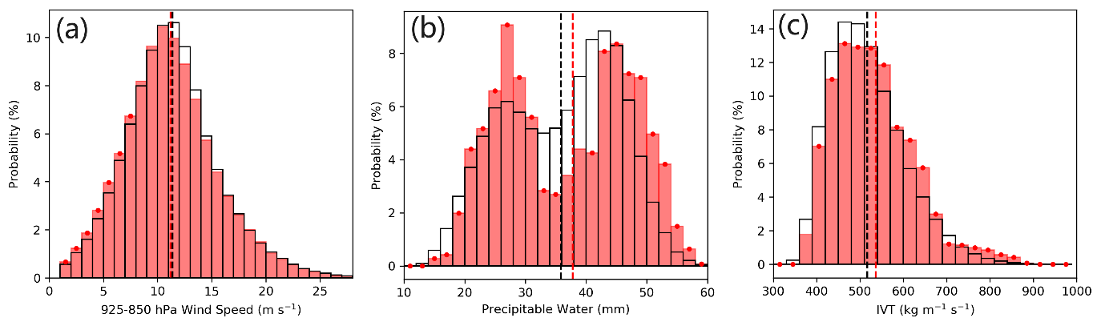
a, low-level (925-850 hPa) wind speeds. b, 1000-250 hPa precipitable water. c, IVT. Dashed lines show the mean values of samples. Red stippling indicates the future changes at a confidence level > 95%. Present-day simulations (1981-2010) are shown by black hollow bars and red bars show the future simulations (2021-2050) under the SSP5-8.5 scenarios. The confidence levels of statistical significance for the projected future changes are determined by the p-value (< 0.05) of a two-sided Student’s t-test.

Fig. S2. Present-day distributions of AR frequency:
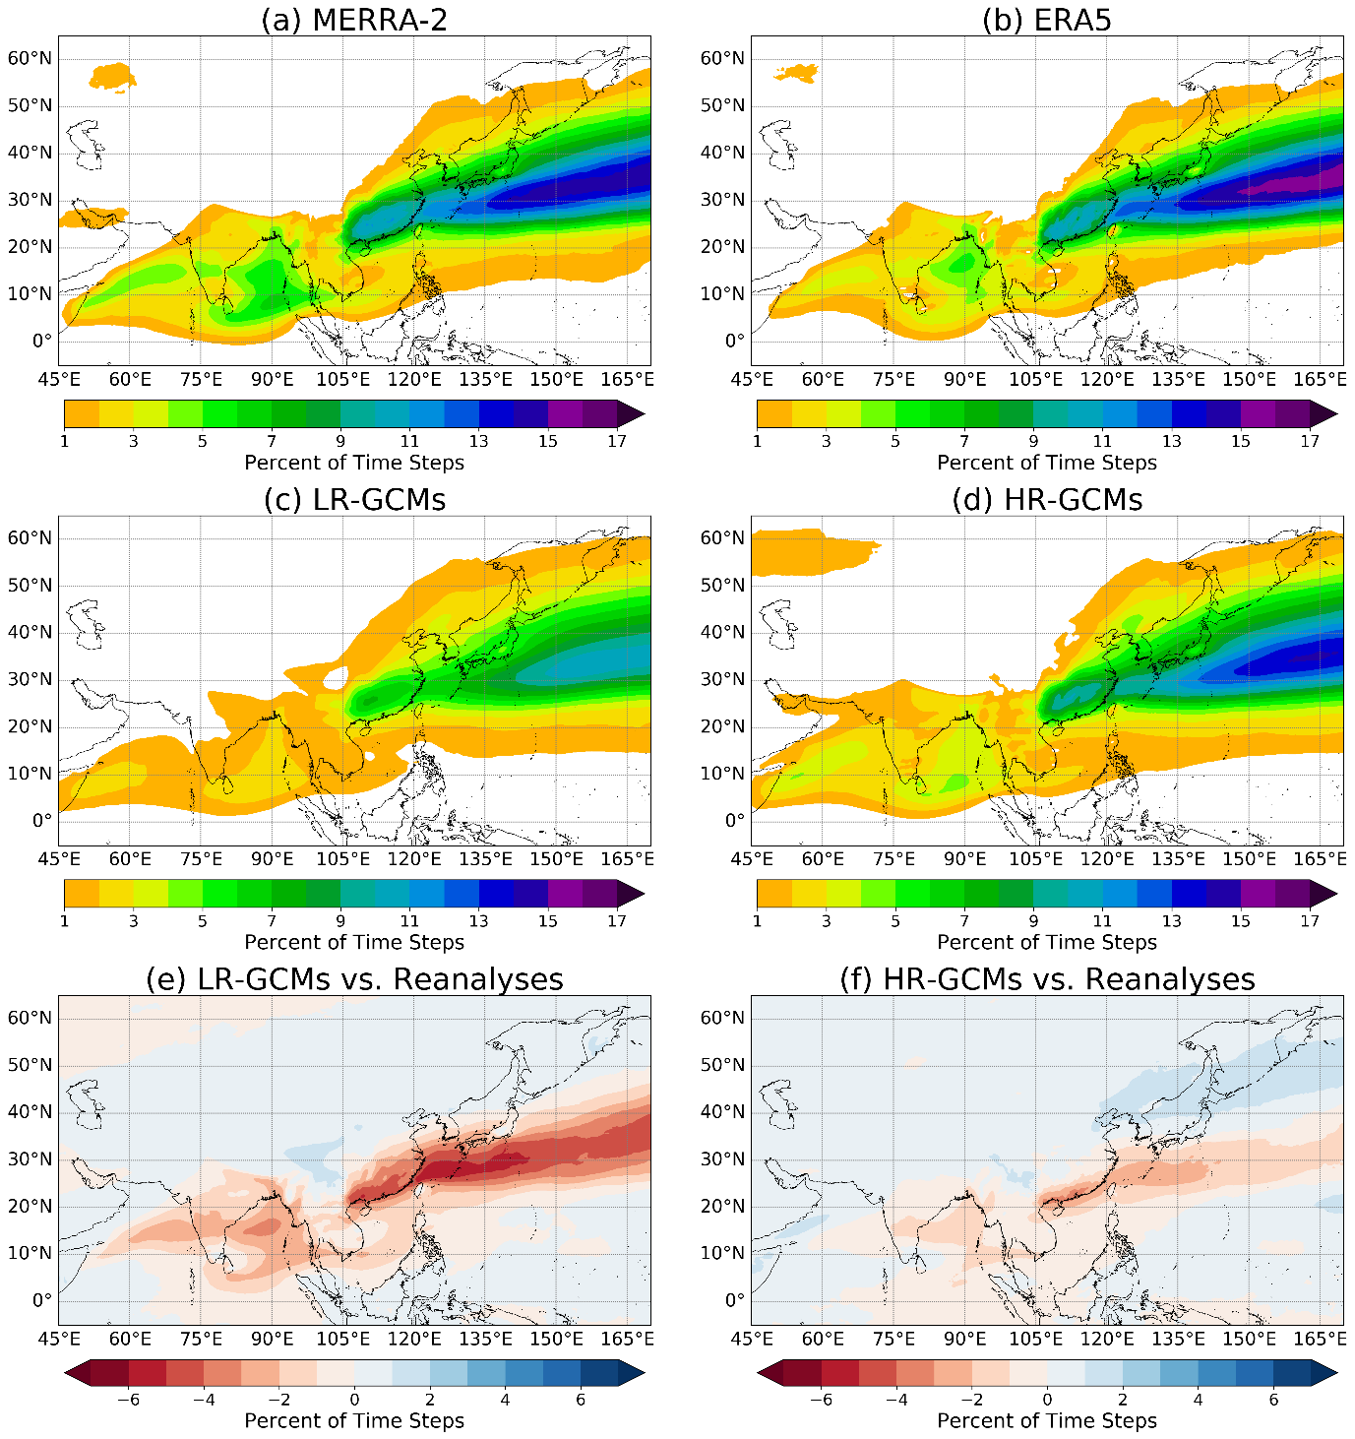
a, MERRA2. b, ERA5. c, The ensemble mean of the LR-GCMs. d. The ensemble mean of the HR-GCMs. e, the absolute biase for the ensemble mean of LR-GCMs with respect to the averaged field over both the reanalysis datasets. f. As e but for HR-GCMs.

Fig. S3. Projected changes in AR frequency diagnosed by the ARDT with different choices of IVT thresholding method.
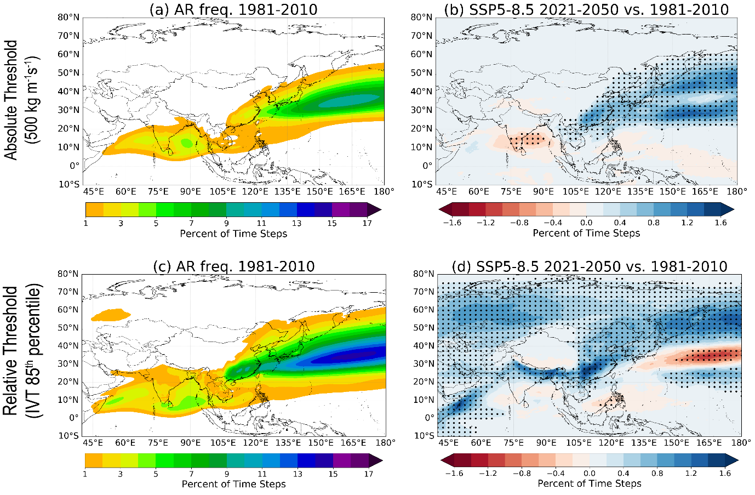
a-b, Results from the use of absolute IVT threshold (500 kgm⁻¹s⁻¹) for AR plume isolation for the present-day distribution (a) and the projected absolute changes (b). c-d, As (a, b) but for the use of relative IVT threshold (85th percentile of IVT). Black stippling indicates the future changes at a confidence level > 95%.

Fig. S4. Projected changes in the mean IVT when AR plumes occur and the associated changes in the low-level circulation during the AR-active seasons:
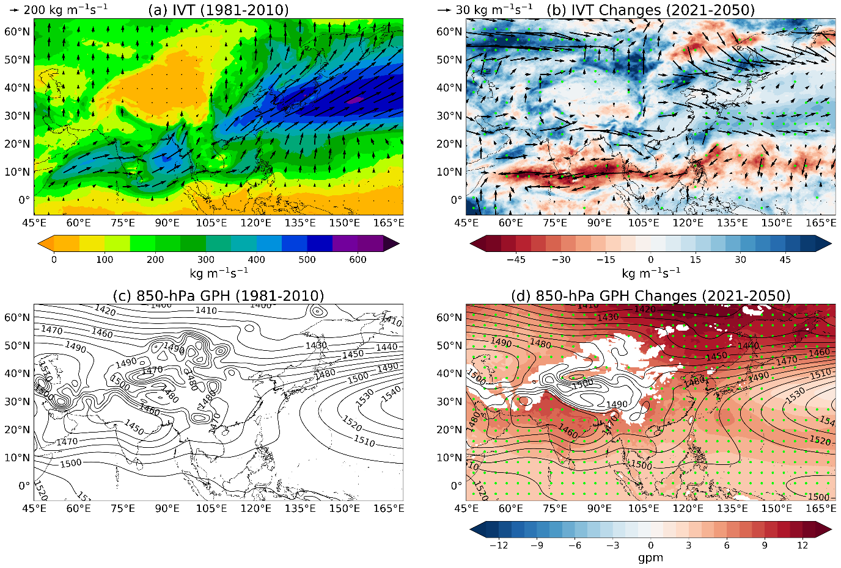
a, Present-day distribution of the mean IVT magnitude (shaded) and direction (vectors). b. Projected changes in IVT. c, Present-day distribution of geopotential height at 850 hPa averaged from May to September. d, Projected pattern of geopotential height at 850 hPa (black contours) and its changes (shaded) relative to present-day. Green stippling indicates the future changes at a confidence level > 95%.

Fig. S5. Present-day distributions of averaged annual accumulation of AR-associated precipitation:
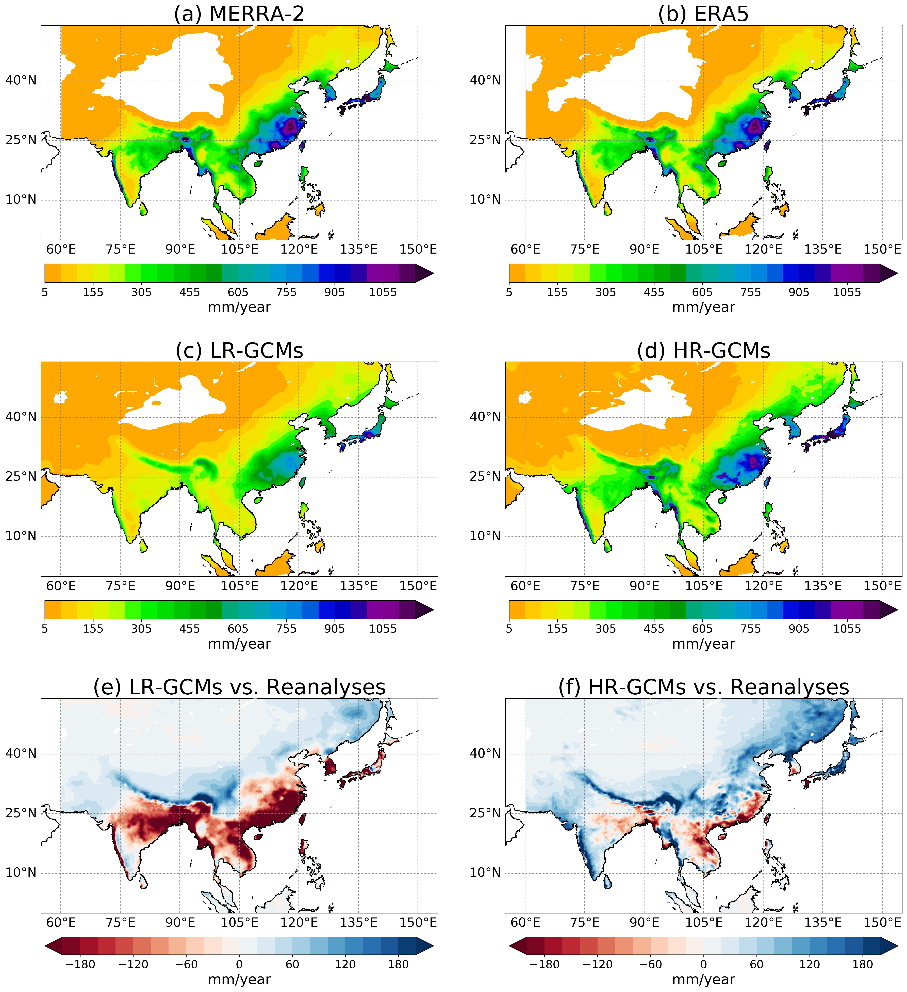
a, MERRA2+APHRODITE. b, ERA5+APHRODITE. c, The ensemble mean of the LR-GCMs. d. The ensemble mean of the HR-GCMs. e, the absolute biases for the ensemble mean of LR-GCMs with respect to the averaged field over both the reanalysis datasets. f. As e but for HR-GCMs.
Fig. S6. As Fig. S5 but for the averaged fractional contribution of AR-associated precipitation to the annual total precipitation.
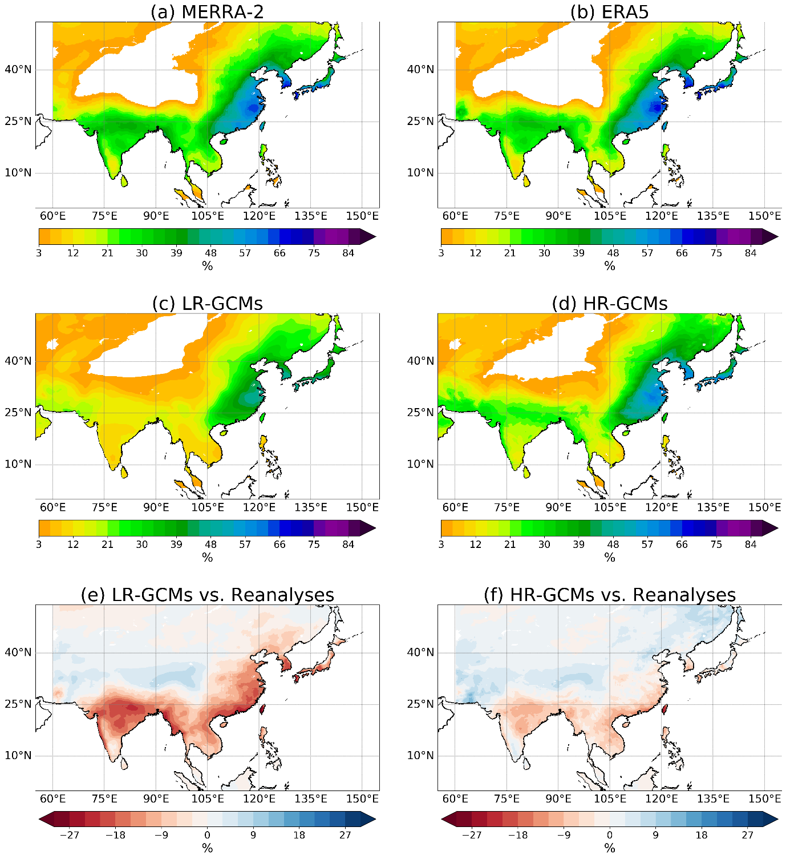

Fig. S7. As Fig. S5 but for the frequency of AR-associated extreme precipitation events.
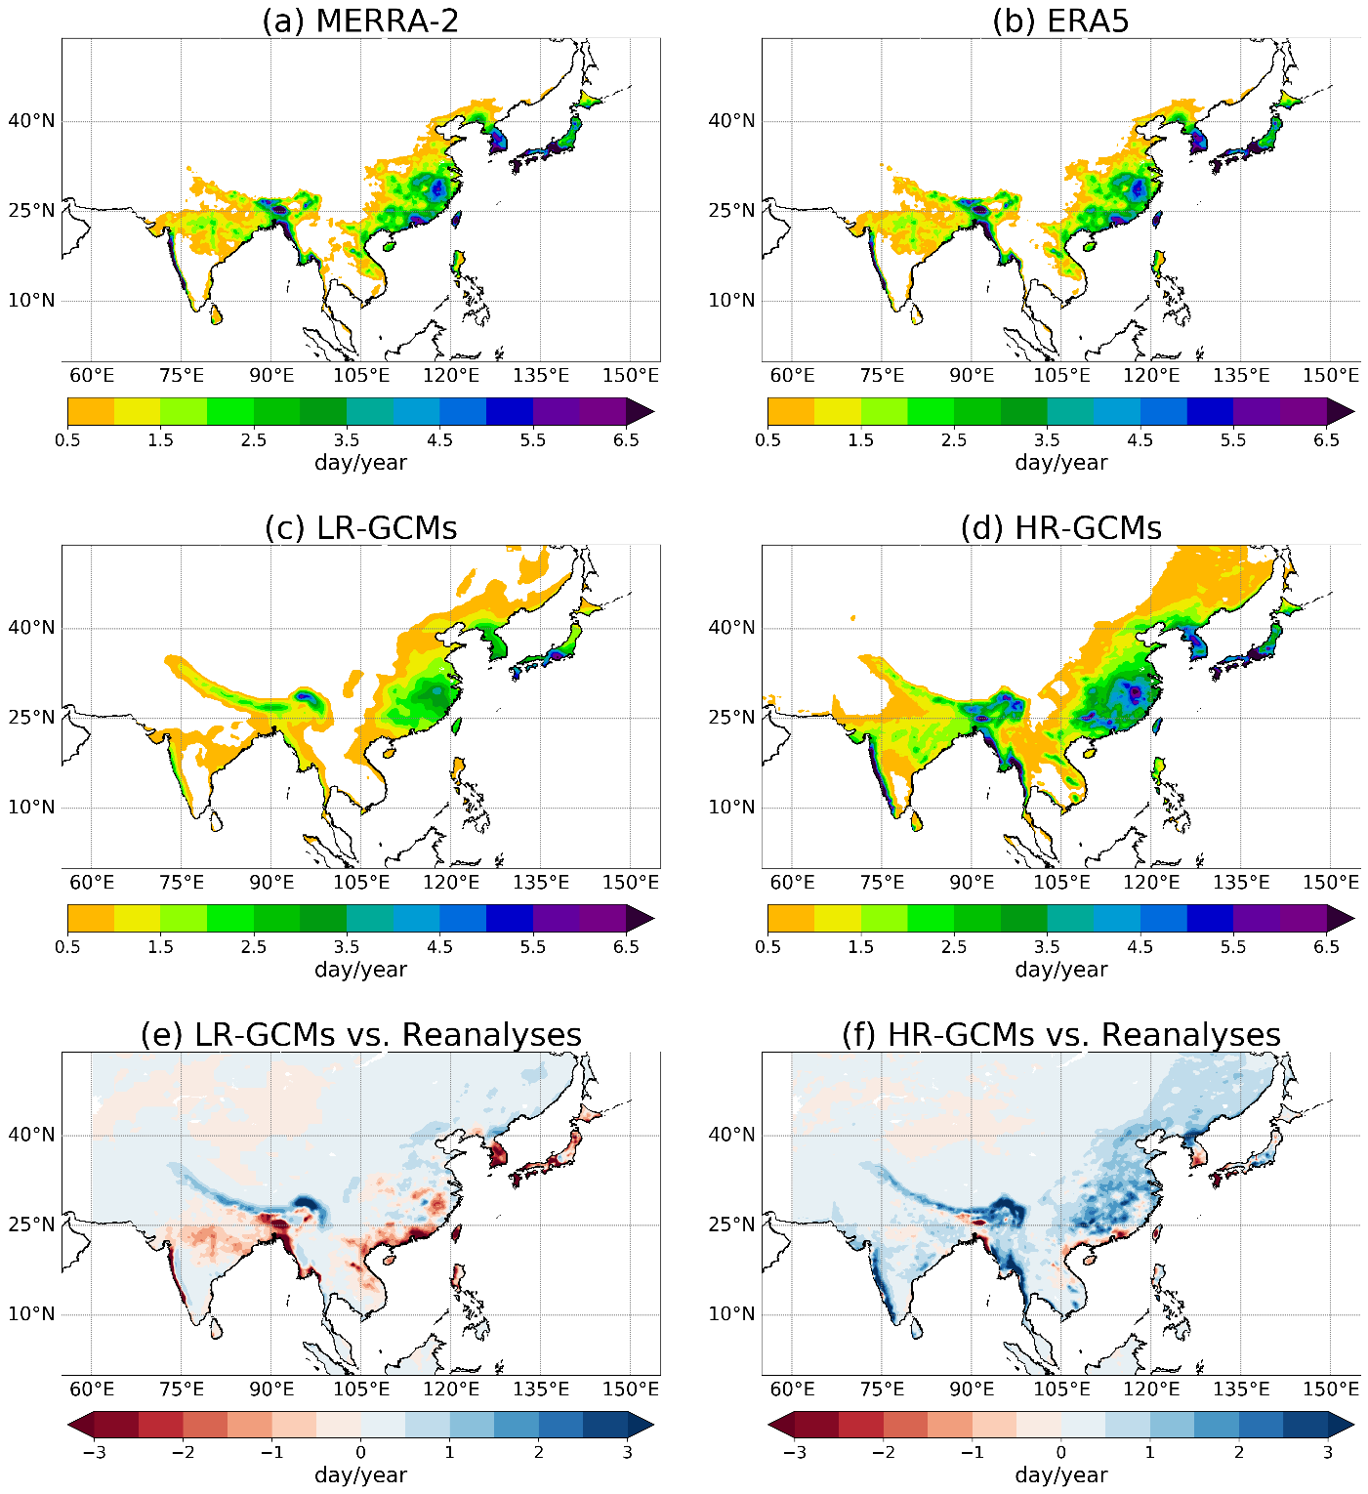

Fig. S8. As Fig. S5 but for the averaged fractional contribution of AR-associated extreme precipitation to the annual total frequency of extreme precipitation event.
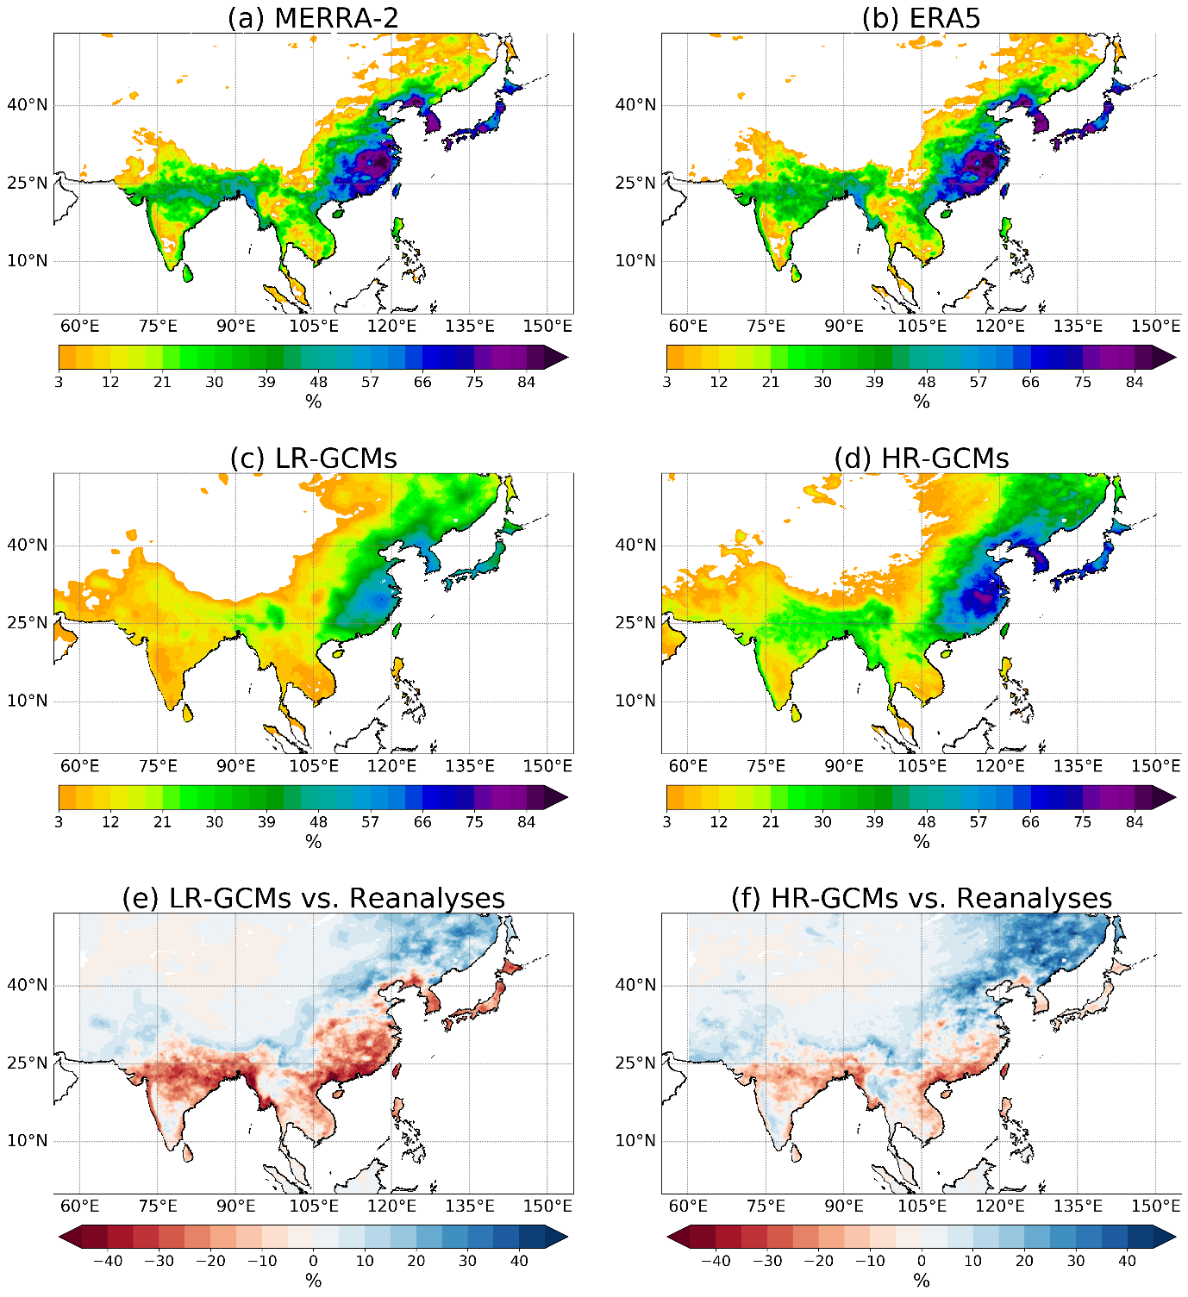

Fig. S9. Projected absolute changes in population exposures to AR impacts:
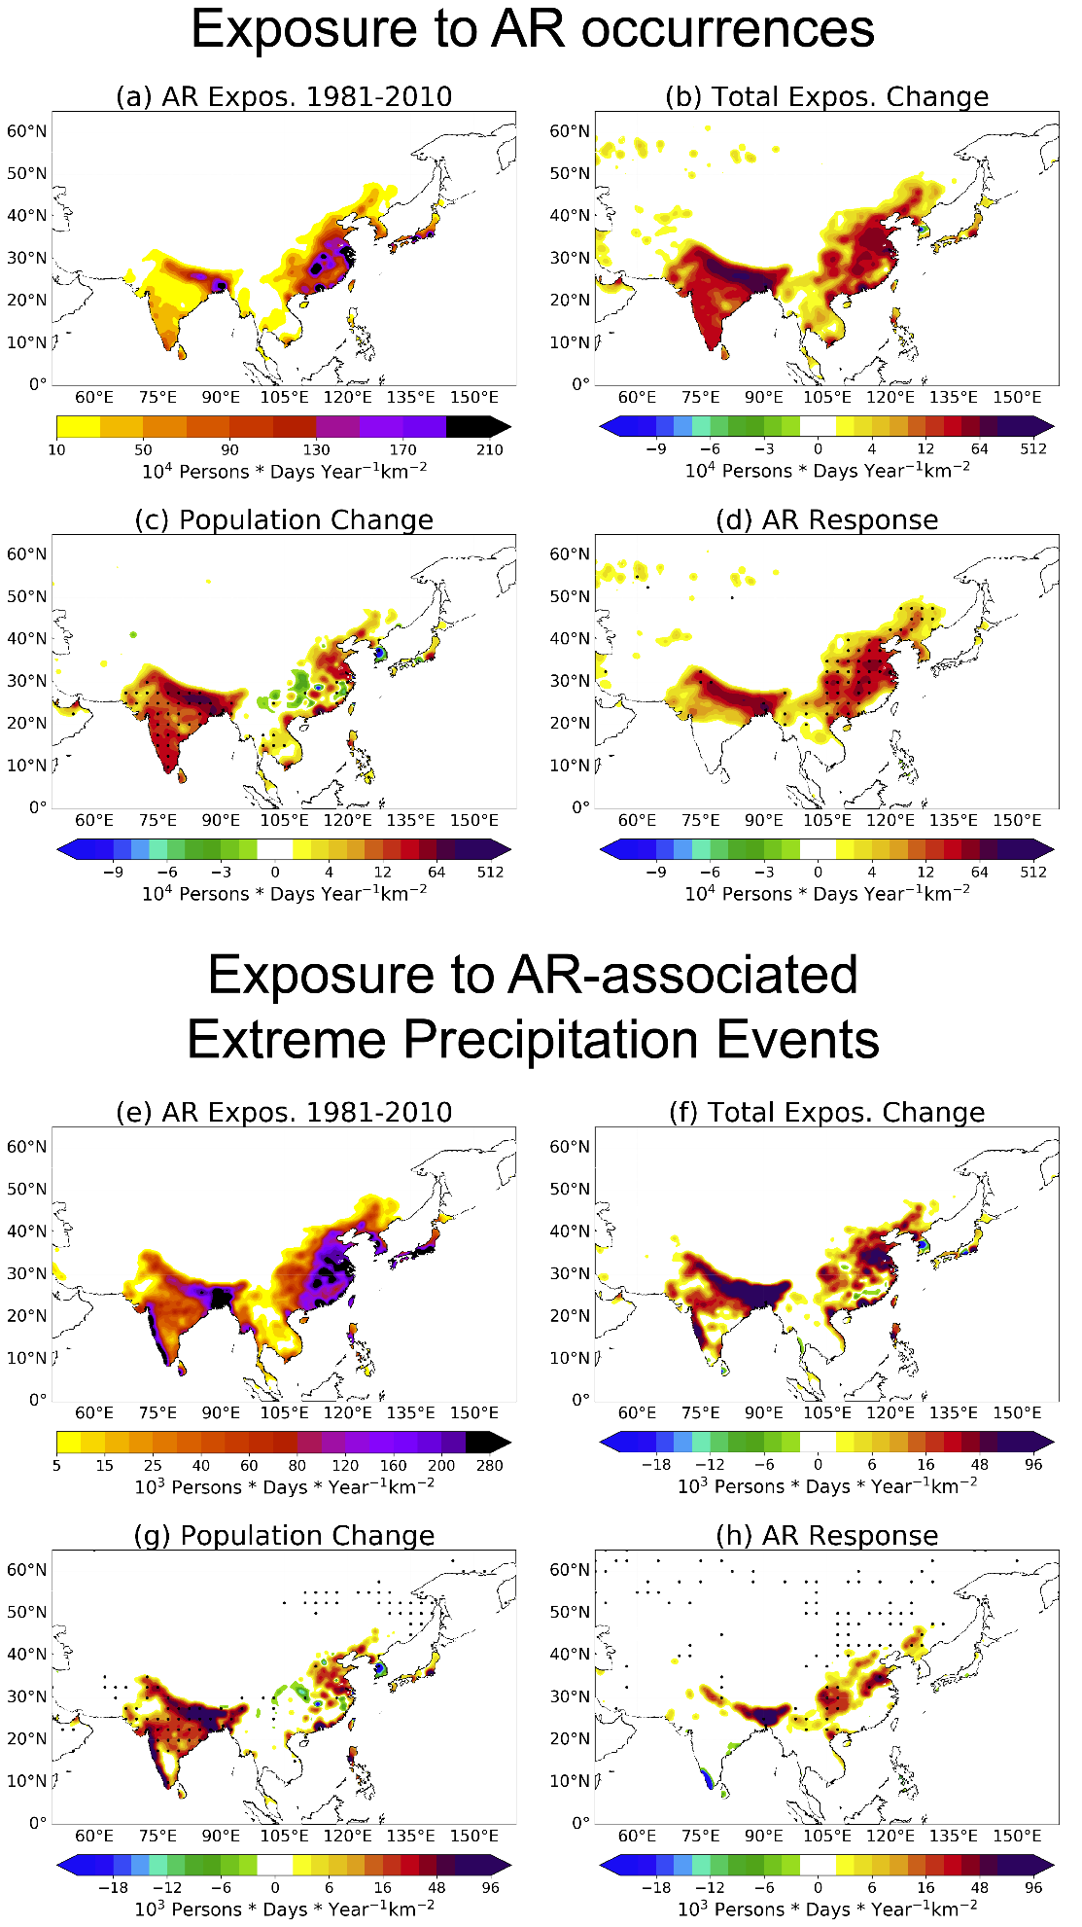
a, Population exposure to the local occurrences of ARs. b-d, Changes in exposure to ARs in total (b) and those due to population changes (c) and the responses of AR frequency (d). e-h, as (a-d) but for the exposure to the AR-associated extreme precipitation events. All the presented changes as shaded contours are at a confidence level > 95% (p-value < 0.05) and changes below the level are shown as zero. Stippling in (c) and (g) indicates changes that are dominated by population changes (i.e. the magnitude of exposure change by population change is greater than that by AR response). Stippling in (d) and (h) indicates changes that are dominated by changes in ARs.

Fig. S10. Mean population exposures to AR-associated extreme precipitation events within 150 km from the major cities over Asia.

Black bars, present-day exposure (1981-2010). Orange bars, future exposure (2021-2050) considering AR changes only (population fixed at the year 2000 values). Red bars, future exposure considering changes in both ARs and population.
Fig. S11. Flowchart for the ARIA-Asia procedures.
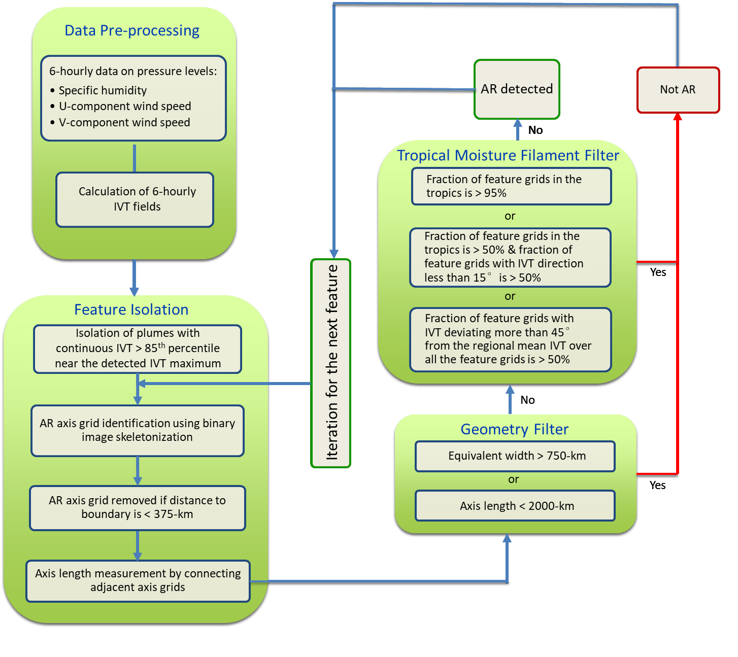

Supplementary Table 1. Summary of the used HighResMIP experiments for AR projection in Asia.
Developers | Model Name | Version | Horizontal Resolution (Longitude×Latitude) | Vertical Resolution (Number of Atmospheric Vertical Levels)
Meteorological Research Institute (Japan) | MRI-AGCM3-2 | LR-GCM | 0.563°×0.563° | 60
Meteorological Research Institute (Japan) | MRI-AGCM3-2 | HR-GCM | 0.188°×0.188° | 60
Max Planck Institute for Meteorology (Germany) | MPI-ESM-XR | LR-GCM | 0.5°×0.5° | 32
Max Planck Institute for Meteorology (Germany) | MPI-ESM-XR | HR-GCM | 0.234°×0.234° | 32
27 institutes in Europe | EC-Earth3P | LR-GCM | 0.703°×0.703° | 91
27 institutes in Europe | EC-Earth3P | HR-GCM | 0.352°×0.352° | 91
The UK Met Office Hadley Centre for Climate Change | HadGEM3-GC3.1 | LR-GCM | 1.875°×1.25° | 85
The UK Met Office Hadley Centre for Climate Change | HadGEM3-GC3.1 | HR-GCM | 0.35°×0.23° | 85
Euro‑Mediterranean Center on Climate Change (Italy) | CMCC-CM2 | LR-GCM | 1.25°×0.938° | 26
Euro‑Mediterranean Center on Climate Change (Italy) | CMCC-CM2 | HR-GCM | 0.313°×0.234° | 26
French National Centre for Meteorological Research | CNRM-CM6-1 | LR-GCM | 1.406°×1.406° | 91
French National Centre for Meteorological Research | CNRM-CM6-1 | HR-GCM | 0.5°×0.5° | 91

