Supplementary data
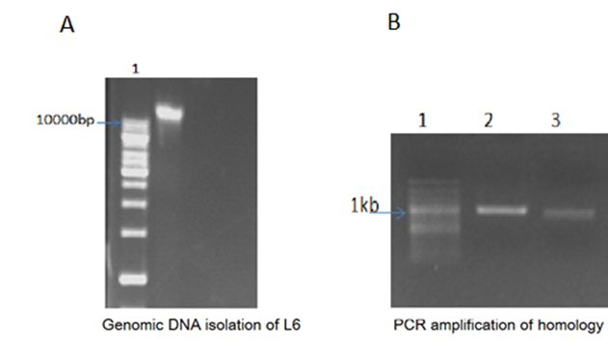
Figure S1: PCR amplification of Homology arms. A; Isolation of genomic DNA from L6 cells. Lane 1:1 Kb DNA ladder, Lane 2: L6 rat skeletal muscle cell genomic DNA. B:PCR amplification of homology arms. Lane 1: 100 bp DNA ladder, Lane 2: Epimerase Left arm, Lane 3: Epimerase Right arm
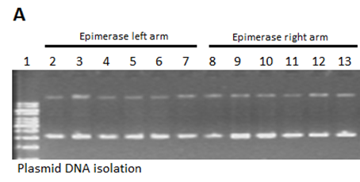
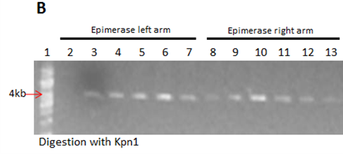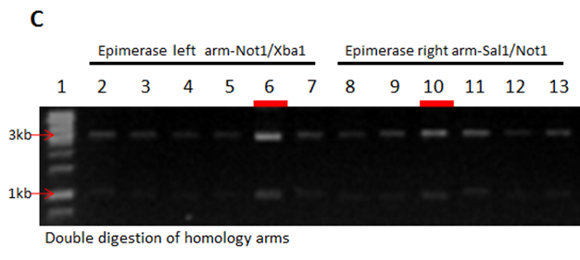
Figure S2: Cloning of homology arms in pJET1.2/blunt vector. Six clones were selected for each homology arms A; Plasmid DNA isolation for homology arms- Lane 1: 1Kb DNA ladder, Lane 2-7: Epimerase left arm. Lane 8-13: Epimerase right arm. B; Single digestion of homology arm clones with KpnI RE- Lane1: 1Kb DNA ladder, Lane 2-7: Epimerase left arm. Lane 8-13: Epimerase right arm. C; Double digestion of homology arms selected- lane 1: 1 Kb DNA ladder. Lane 2-7: Epimerase left arm with NotI/XbaI (clone 1-6). Lane 8-13: Epimerase right arm with SalI/NotI (clone 1-6).
- Epimerase Left arm

Score | Expect | Identitie | Gaps | Strand
340 bits(184) | 3e-96 | 243/271(90%) | 6/271(2%) | Plus/Plus
Query 18456 CCTGAGTCAGCACATTACAGAGACGC-ACACACCCATGCTTATTACAGCCAATTCACAAC 18514
|||||||| | |||||||||||||| ||| ||| | |||||||||||||||||||||
Sbjct 43 CCTGAGTCTTC-CATTACAGAGACGCCCCACCCCCCT--TTATTACAGCCAATTCACAAC 99

Query 18515 AGCCAAGTTACGGAGCCAGCCTAGCCTGGTGCTGGCCACTGGGGCGATCGCTGAAGGAAA 18574
||||||||||||||||| |||||||||||||||||||||||||||||||||||||||||
Sbjct 100 AGCCAAGTTACGGAGCCCCCCTAGCCTGGTGCTGGCCACTGGGGCGATCGCTGAAGGAAA 159

Query 18575 TGTGGTTATGTTGTGAGAGTTATGTTAAATAAAATCAGCCAGGTTTGGAGAGACAGACCG 18634
|||||||||||||||||| || |||||||| || ||||||||||||||||||||||
Sbjct 160 TGTGGTTATGTTGTGAGATTT-TGTTAAATTTT-TCCCCCAGGTTTGGAGAGACAGACCG 217

Query 18635 CCTGTTTGCTTTCTCATGTAGAACACAGATTTGAAGTAATATATAAGCATGCATATGTTA 18694
|||||||| |||||||||| ||||| |||||||| |||||||||||||||||||||||||
Sbjct 218 CCTGTTTGTTTTCTCATGTCGAACAAAGATTTGACGTAATATATAAGCATGCATATGTTA 277

Query 18695 TATGCACAGATATGAGAGTAGGCAGTGGACT 18725
||||| ||||||| | ||| || ||||||||
Sbjct 278 TATGCTCAGATATTATAGTCGGTAGTGGACT 308

- Epimerase right arm
Score | Expect | Identities | Gaps | Strand
206 bits(111) | 6e-56 | 134/144(93%) | 6/144(4%) | Plus/Plus
Query 20161 CCATTAGCGACCAGAGAACTAAGGTTTTTACTTCATAGTTCTTGCTTTCTGTCATCTCTT 20220
|||||||||| ||||||| ||||||||||||||| ||||||||||||||||||||||
Sbjct 36 CCATTAGCGA-CAGAGAA-TAAGGTTTTTACTTC-CCCTTCTTGCTTTCTGTCATCTCTT 92

Query 20221 TACCTCCAAGATTATCTATAAAATAGACATGCCTGATTGATTTTTAAATGTTTTTACATG 20280
|||||||||||||||||||||||||||||||||||||||||||| |||||||||| ||||
Sbjct 93 TACCTCCAAGATTATCTATAAAATAGACATGCCTGATTGATTTT-AAATGTTTTT-CATG 150

Query 20281 GAGTAGTTTTATTCCATTAAGTAT 20304
||||||||||| |||||||||||
Sbjct 151 GAGTAGTTTTAC-CCATTAAGTAT 173

Figure S3:Sanger sequencing of Homology arms aligned with GNE gene in Rattusnorvegicus. A; Epimerase left arm. B; Epimerase right arm.
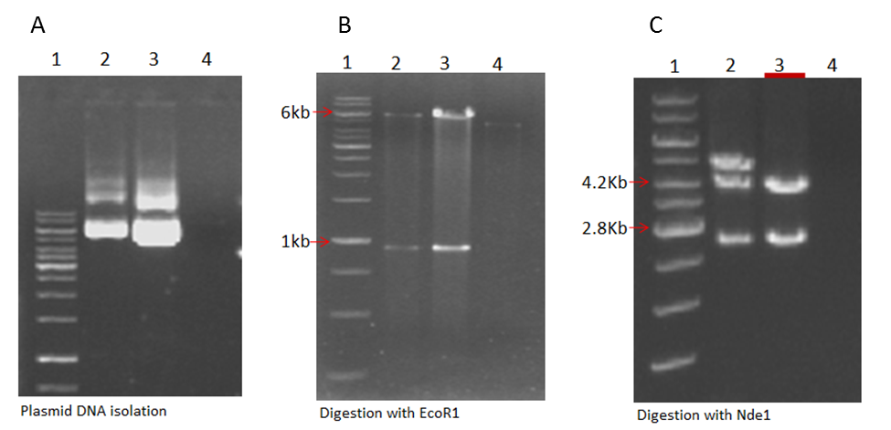
Figure S4: Confirmation of shuttle vector or GNE-EP-SEPT vector by restriction mapping. A; Plasmid DNA isolation of the three clones, 1 represents ladder, 2 represents clone 1, 3 represents clone 2 and 4 represents clone 3. B; Restriction digestion of three clones with EcoR1. 1, 2, 3, 4 represents 1Kb ladder, clone1, clone2, and clone3 respectively. C; Restriction digestion of epimerase shuttle vector with Nde1. 1, 2, 3, and 4 represents 1 Kb ladder, clone 1, clone 2 and clone 3 respectively.
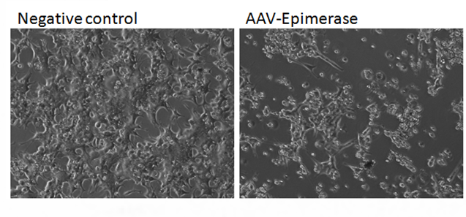
Figure S4:Generation of AAV viral stock. Negative control represents cells transfected with one of the shuttle vectors and either of RC or Helper. AAV-Epimerase represents AAV-293 cell after the formation of viral plaque with pAAV-GNE EP SEPT
Sequence similarity with SEPT
Alignment statistics for match #1
Score | Expect | Identities | Gaps | Strand
913 bits(494) | 0.0 | 498/500(99%) | 0/500(0%) | Plus/Minus
Query 899 TCCATAACTTCGTATAGCATACATTATACGAAGTTATGGAATTAATTCGCTGTCTGCGAG 958
||||||||||||||||||||||||||||||||||||||||||||||||||||||||||||
Sbjct 502 TCCATAACTTCGTATAGCATACATTATACGAAGTTATGGAATTAATTCGCTGTCTGCGAG 443

Query 959 GGCCAGCTGTTGGGGTGAGTACTCCCTCTCAAAAGCGGGCATGACTTCTGCGCTAAGATT 1018
||||||||||||||||||||||||||||||||||||||||||||||| ||||||||||||
Sbjct 442 GGCCAGCTGTTGGGGTGAGTACTCCCTCTCAAAAGCGGGCATGACTTTTGCGCTAAGATT 383

Query 1019 GTCAGTTTCCAAAAACGAGGAGGATTTGATATTCACCTGGCCCGCGGTGATGCCTTTGAG 1078
||||||||||||||||||||||||||||||||||||||||||||||||||||||||||||
Sbjct 382 GTCAGTTTCCAAAAACGAGGAGGATTTGATATTCACCTGGCCCGCGGTGATGCCTTTGAG 323

Query 1079 GGTGGCCGCGTCCATCTGGTCAGAAAAGACAATCTTTTTGTTGTCAAGCTTGAGGTGTGG 1138
||||||||||||||||||||||||||||||||||||||||||||||||||||||||||||
Sbjct 322 GGTGGCCGCGTCCATCTGGTCAGAAAAGACAATCTTTTTGTTGTCAAGCTTGAGGTGTGG 263

Query 1139 CAGGCTTGAGATCTGGCCATACACTTGAGTGACAATGACATCCACTTTGCCTTTCTCTCC 1198
||||||||||||||||||||||||||||||||||||||||||||||||||||||||||||
Sbjct 262 CAGGCTTGAGATCTGGCCATACACTTGAGTGACAATGACATCCACTTTGCCTTTCTCTCC 203

Query 1199 ACAGGTGTCCACTCCCAGGTCCAACTGCAGGTCGAGCGTCGAGAACGTTACTGGCCGAAG 1258
||||||||||||||||||||||||||||||||||||||||||||||||||||||||||||
Sbjct 202 ACAGGTGTCCACTCCCAGGTCCAACTGCAGGTCGAGCGTCGAGAACGTTACTGGCCGAAG 143

Query 1259 CCGCTTGGAATAAGGCCGGTGTGCGTTTGTCTATATGTTATTTTCCACCATATTGCCGTC 1318
||||||||||||||||||||||||||||||||||||||||||||||||||||||||||||
Sbjct 142 CCGCTTGGAATAAGGCCGGTGTGCGTTTGTCTATATGTTATTTTCCACCATATTGCCGTC 83

Query 1319 TTTTGGCAATGTGAGGGCCCGGAAACCTGGCCCTGTCTTCTTGACGAGCATTCCTAGGGG 1378
||||||||||||||||||||||||||||||||||||||||||||||||||||||||||||
Sbjct 82 TTTTGGCAATGTGAGGGCCCGGAAACCTGGCCCTGTCTTCTTGACGAGCATTCCTAGGGG 23

Query 1379 TCTTTCCCCTCTCGCCAAAG 1398
|||||||||| |||||||||
Sbjct 22 TCTTTCCCCTTTCGCCAAAG 3

Sequence similarity with Epimerase left the arm

Alignment statistics for match #2
Score | Expect | Identities | Gaps | Strand
494 bits(267) | 5e-143 | 375/425(88%) | 15/425(3%) | Plus/Minus
Query 480 TCCTGGTGCCCTGC-CttttattttatatatttattttttatttaaaaaaaaaaCCGGGG 538
||| || |||| || ||||| ||||| | | |||||||| |||||||||||||||||||
Sbjct 976 TCC-GGGGCCCCGCTCTTTT-TTTTAAAAAAATATTTTTT-TTTAAAAAAAAAACCGGGG 920

Query 539 -TTGGGGATTTAGCTCAGTG-GTAGAGCGCTTGTCTAGGAAGCACAAGGCCCTGGGTTCA 596
|||| |||| || || ||| || || | | | || |||||||||| ||||| |
Sbjct 919 GGGGGGGTTTTA-TTCCCTGTGTAAGGCCTTTTTTTTGAAACCACAAGGCCCCGGGTTTA 861

Query 597 GTCCCCAGCTC-CGaaaaaaagaaccaaaaaaaaaaaaaaaaaaaaaaaaaaaCCAAACA 655
||||| ||| ||||||||| |||| ||||||||||||||||||||||| ||||
Sbjct 860 TTCCCC-CCTCTCGAAAAAAA-AACC-----CAAAAAAAAAAAAAAAAAAAAACCCAACA 808

Query 656 ACTGTGTTTGGAAACTTTTTTCCCCCATTAAAGTGACAATTGTGGGGTTGGGGATTTGGC 715
||||||||||||||||||||| |||| |||||||||||||||||||||||||||||||||
Sbjct 807 ACTGTGTTTGGAAACTTTTTTTCCCCCTTAAAGTGACAATTGTGGGGTTGGGGATTTGGC 748

Query 716 TCAGTGGTAGAGCGCTTGCTTAGCAAGCGCAAGGCCCTGGGTTCAGTCCCCAGCTCCGaa 775
|||||||||||||||||||||||| ||||| |||||||||||||||| ||||||| ||||
Sbjct 747 TCAGTGGTAGAGCGCTTGCTTAGCCAGCGCCAGGCCCTGGGTTCAGTTCCCAGCTTCGAA 688

Query 776 aaaaataataggaaaaaaaaaaGTGACAATTGCTTCTTGAAAAGAAAATAGATGAGTGAT 835
||||||||| ||||||||||||||||||||||||||||||||||||||||||||||||||
Sbjct 687 AAAAATAATTGGAAAAAAAAAAGTGACAATTGCTTCTTGAAAAGAAAATAGATGAGTGAT 628

Query 836 AAAAAGGAAAAGATCTGACCATCATTAAAAGTCCAATTTCTTTCTGCCCCCCAAAAGAAA 895
||||||||||||||||||||||||||||||||||||||||||| ||||||||||||||||
Sbjct 627 AAAAAGGAAAAGATCTGACCATCATTAAAAGTCCAATTTCTTTTTGCCCCCCAAAAGAAA 568

Query 896 ATGTC 900
|||||
Sbjct 567 ATGTC 563

Figure S5: Blast result after sequencing of Clone 3 (SKM-GNE- SEPT). Clone 3 was sequenced and blasted with Left homology arm and SEPT sequences.
A; Sequencing result for 2.2Kb fragment
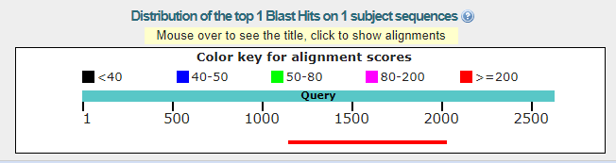
Score | Expect | Identities | Gaps | Strand
1605 bits(869) | 0.0 | 879/883(99%) | 3/883(0%) | Plus/Minus
Query 907 GCT-CCTGTTTAGAAACACATACCGCATGATTGAGCAGGACGACTTTGACATCAACACCA 965
||| ||||||||||||||||||||||||| ||||||||||||||||||||||||||||||
Sbjct 891 GCTCCCTGTTTAGAAACACATACCGCATGTTTGAGCAGGACGACTTTGACATCAACACCA 832

Query 966 GGCTACACACGATTGTTAGAGGGGAAGACGAAGCAGCCATGGTAGAGTCAGTGGGCCTAG 1025
||||||||||||||||||||||||||||||||||||||||||||||||||||||||||||
Sbjct 831 GGCTACACACGATTGTTAGAGGGGAAGACGAAGCAGCCATGGTAGAGTCAGTGGGCCTAG 772

Query 1026 CGCTAGTGAAGCTACCGGATGTCCTCAACCGCCTGAAGCCTGACATCATGATTGTTCACG 1085
||||||||||||||||||||||||||||||||||||||||||||||||||||||||||||
Sbjct 771 CGCTAGTGAAGCTACCGGATGTCCTCAACCGCCTGAAGCCTGACATCATGATTGTTCACG 712

Query 1086 GAGACCGATTTGACGCCCTCGCTCTGGCTACATCTGCTGCCCTGATGAACATCCGCATCC 1145
||||||||||||||||||||||||||||||||||||||||||||||||||||||||||||
Sbjct 711 GAGACCGATTTGACGCCCTCGCTCTGGCTACATCTGCTGCCCTGATGAACATCCGCATCC 652

Query 1146 TTCACATTGAAGGAGGAGAGGTCAGTGGGACTATTGATGACTCTATCAGACACGCCATAA 1205
||||||||||||||||||||||||||||||||||||||||||||||||||||||||||||
Sbjct 651 TTCACATTGAAGGAGGAGAGGTCAGTGGGACTATTGATGACTCTATCAGACACGCCATAA 592

Query 1206 CAAAACTGGCTCACTACCACGTGTGCTGCACCAGGAGTGCAGAGCAACACCTGATCTCCA 1265
||||||||||||||||||||||||||||||||||||||||||||||||||||||||||||
Sbjct 591 CAAAACTGGCTCACTACCACGTGTGCTGCACCAGGAGTGCAGAGCAACACCTGATCTCCA 532

Query 1266 TGTGTGAGGACCACGACCGCATCCTTTTGGCCGGCTGCCCTTCCTATGACAAACTGCTCT 1325
||||||||||||||||||||||||||||||||||||||||||||||||||||||||||||
Sbjct 531 TGTGTGAGGACCACGACCGCATCCTTTTGGCCGGCTGCCCTTCCTATGACAAACTGCTCT 472

Query 1326 CAGCCAAGAATAAAGACTATATGAGCATCATTCGGATGTGGCTAGGTATGTATGCCAAAC 1385
||||||||||||||||||||||||||||||||||||||||||||||||||||||||||||
Sbjct 471 CAGCCAAGAATAAAGACTATATGAGCATCATTCGGATGTGGCTAGGTATGTATGCCAAAC 412

Query 1386 TTTTTGGGCCAATGGTTGTTTTGCCACAAAGCATTGAGTGAATTTCAGTCTTTTTGGAAA 1445
||||||||||||||||||||||||||||||||||||||||||||||||||||||||||||
Sbjct 411 TTTTTGGGCCAATGGTTGTTTTGCCACAAAGCATTGAGTGAATTTCAGTCTTTTTGGAAA 352

Query 1446 CACATGGACACAATGTTCCATTAGCGACCAGAGAACTAAGGTTTTTACTTCATAGTTCTT 1505
||||||||||||||||||||||||||||||||||||||||||||||||||||||||||||
Sbjct 351 CACATGGACACAATGTTCCATTAGCGACCAGAGAACTAAGGTTTTTACTTCATAGTTCTT 292

Query 1506 GCTTTCTGTCATCTCTTTACCTCCAAGATTATCTATAAAATAGACATGCCTGATTGATTT 1565
||||||||||||||||||||||||||||||||||||||||||||||||||||||||||||
Sbjct 291 GCTTTCTGTCATCTCTTTACCTCCAAGATTATCTATAAAATAGACATGCCTGATTGATTT 232

Query 1566 TTAAATGTTTTTACATGGAGTAGTTTTATTCCATTAAGTATTTTAAATACTTTAGTGTAT 1625
||||||||||||||||||||||||||||||||||||||||||||||||||||||||||||
Sbjct 231 TTAAATGTTTTTACATGGAGTAGTTTTATTCCATTAAGTATTTTAAATACTTTAGTGTAT 172

Query 1626 TTATTAATTATATTTCATAATTCAGTGAATGGTATTCATCTGGAATACCATAAGGATAGT 1685
||||||||||||||||||||||||||||||||||||||||||||||||||||||||||||
Sbjct 171 TTATTAATTATATTTCATAATTCAGTGAATGGTATTCATCTGGAATACCATAAGGATAGT 112

Query 1686 TCTTTAACAGTTTTAATATATGTTGATAAATAAGCAAAAATATTTTTAAAAAATTAATTT 1745
||||||||||||||||||||||||||||||||||||||||||||||||||||||||||||
Sbjct 111 TCTTTAACAGTTTTAATATATGTTGATAAATAAGCAAAAATATTTTTAAAAAATTAATTT 52

Query 1746 CATTATTGTGTGCATTTACA-CTTGTGTATATATTTAAATCTT 1787
|||||||||||||||||||| |||||||||||||| |||||||
Sbjct 51 CATTATTGTGTGCATTTACAACTTGTGTATATATT-AAATCTT 10

B; Sequencing result of 1.8Kb
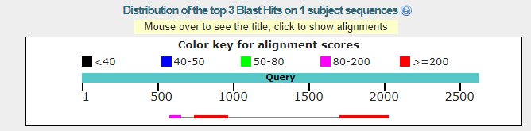

Sequence ID: Query_43127Length: 678Number of Matches: 3
Range 1: 9 to 331-
Score | Expect | Identities | Gaps | Strand
592 bits(320) | 1e-172 | 323/324(99%) | 1/324(0%) | Plus/Minus
Query 1463 CCATTAGCGACCAGAGAACTAAGGTTTTTACTTCATAGTTCTTGCTTTCTGTCATCTCTT 1522
||||||||||||||||||||||||||||||||||||||||||||||||||||||||||||
Sbjct 331 CCATTAGCGACCAGAGAACTAAGGTTTTTACTTCATAGTTCTTGCTTTCTGTCATCTCTT 272

Query 1523 TACCTCCAAGATTATCTATAAAATAGACATGCCTGATTGATTTTTAAATGTTTTTACATG 1582
||||||||||||||||||||||||||||||||||||||||||||||||||||||||||||
Sbjct 271 TACCTCCAAGATTATCTATAAAATAGACATGCCTGATTGATTTTTAAATGTTTTTACATG 212

Query 1583 GAGTAGTTTTATTCCATTAAGTATTTTAAATACTTTAGTGTATTTATTAATTATATTTCA 1642
||||||||||||||||||||||||||||||||||||||||||||||||||||||||||||
Sbjct 211 GAGTAGTTTTATTCCATTAAGTATTTTAAATACTTTAGTGTATTTATTAATTATATTTCA 152

Query 1643 TAATTCAGTGAATGGTATTCATCTGGAATACCATAAGGATAGTTCTTTAACAGTTTTAAT 1702
||||||||||||||||||||||||||||||||||||||||||||||||||||||||||||
Sbjct 151 TAATTCAGTGAATGGTATTCATCTGGAATACCATAAGGATAGTTCTTTAACAGTTTTAAT 92

Query 1703 ATATGTTGATAAATAAGCAAAAATATTTTTAAAAAATTAATTTCATTATTGTGTGCATTT 1762
||||||||||||||||||||||||||||||||||||||||||||||||||||||||||||
Sbjct 91 ATATGTTGATAAATAAGCAAAAATATTTTTAAAAAATTAATTTCATTATTGTGTGCATTT 32

Query 1763 ACACTTGTGTATATATTTAAATCT 1786
||||||||||||||||| ||||||
Sbjct 31 ACACTTGTGTATATATT-AAATCT 9

Range 2: 449 to 678
Score | Expect | Identities | Gaps | Strand
418 bits(226) | 2e-120 | 229/230(99%) | 1/230(0%) | Plus/Minus
Query 499 CAGTGGTAGAGCGCTTGCTTAGCAAGCGCAAGGCCCTGGGTTCAGTCCCCAGCTCCGaaa 558
||||||||||||||||||||||||||||||||||||||||||||||||||||||||||||
Sbjct 678 CAGTGGTAGAGCGCTTGCTTAGCAAGCGCAAGGCCCTGGGTTCAGTCCCCAGCTCCGAAA 619

Query 559 aaaataataggaaaaaaaaaaGTGACAA-TTGCTTCTTGAAAAGAAAATAGATGAGTGAT 617
|||||||||||||||||||||||||||| |||||||||||||||||||||||||||||||
Sbjct 618 AAAATAATAGGAAAAAAAAAAGTGACAAATTGCTTCTTGAAAAGAAAATAGATGAGTGAT 559

Query 618 AAAAAGGAAAAGATCTGACCATCATTAAAAGTCCAATTTCTTTCTGCCCCCCAAAAGAAA 677
||||||||||||||||||||||||||||||||||||||||||||||||||||||||||||
Sbjct 558 AAAAAGGAAAAGATCTGACCATCATTAAAAGTCCAATTTCTTTCTGCCCCCCAAAAGAAA 499

Query 678 ATGTCTCCCCCTAGTACTGTCTGGGCATGGGGTGGGGGGACAGCTGCGCT 727
||||||||||||||||||||||||||||||||||||||||||||||||||
Sbjct 498 ATGTCTCCCCCTAGTACTGTCTGGGCATGGGGTGGGGGGACAGCTGCGCT 449

Range 3: 598 to 678
Score | Expect | Identities | Gaps | Strand
100 bits(54) | 8e-25 | 73/82(89%) | 1/82(1%) | Plus/Minus
Query 335 CAGTGGTAGAGCGCTTGTCTAGGAAGCACAAGGCCCTGGGTTCAGTCCCCAGCTCCGaaa 394
||||||||||||||||| ||| |||| ||||||||||||||||||||||||||||||||
Sbjct 678 CAGTGGTAGAGCGCTTGCTTAGCAAGCGCAAGGCCCTGGGTTCAGTCCCCAGCTCCGAAA 619

Query 395 aaaagaaccaaaaaaaaaaaaa 416
|||| || | ||||||||||
Sbjct 618 AAAATAAT-AGGAAAAAAAAAA 598
Figure S6: Sequencing of SKM-GNEHz. A; Sequencing of 2.2 Kb fragment (wild type allele). B; Sequencing of 1.8 Kb fragment (Epimerase exon 3 Knockout allele).

