Supplementary Materials for

3D printable ultra-strong elastomers rivaling spider silk

Zizheng Fang^{1,2}, Hongfeng Mu¹, Zhuo Sun¹, Kaihang Zhang³, Anyang Zhang⁴, Ning Zheng¹, Qian Zhao¹, Xuxu Yang³, Jingjun Wu^{1,5}*, Tao Xie¹*
Correspondence to: jingjunwu@zju.edu.cn; taoxie@zju.edu.cn

Materials and Methods
Materials. Poly(tetrahydrofuran) (PTMG, M_{n}=1,000) was purchased from B&D and vacuum-dried at 100 °C before being used. Dimethylolbutanoic acid (DMBA), 4-hydroxybutyl acrylate, ditin butyl dilaurate (DBTDL), p-tolyl isocyanate, and Sudan III (photo-absorber) were bought from Aladdin. Tolylene-2,4-diisocyanate (TDI), 2-(tert-butylamino)ethyl methacrylate (TBEMA), bis(2,4,6-trimethylbenzoyl)-phenylphosphineoxide (Irgacure 819, photo-initiator), diethylene glycol, N-tert-butylethylamine, and hexanoic acid were acquired from TCI. All chemical reagents were used as received unless otherwise noted.
Preparation of DLP precursor. The synthesis includes three steps as follows. Firstly, PTMG and TDI at a molar ratio of 1:2 were added into a three-necked flask equipped with a mechanical stirrer and placed at 50 °C for 4 h after the addition of the catalyst DBTDL (0.1 wt% of PTMG). Subsequently, DMBA was added with a reaction time of 4 h. Finally, TBEMA was introduced and the product was obtained after reacting for another 4 hours, during which the solvent was involved to avoid the sharp increase of the viscosity. The molar ratio of DMBA and TBEMA was maintained at 1:1 to ensure equal molarity between the hindered urea bonds and the carboxylic acid group. The chemical structure of the product was characterized using ¹H NMR and FTIR analysis (Supplementary Figs. 2 and 3). DLP precursor-a and precursor-b were prepared with the same procedure except that the monomer TBEMA was replaced with 4-hydroxybutyl acrylate for precursor-a whereas the monomer DMBA was replaced with diethylene glycol for precursor-b.
Model compound experiments. Hindered urea compound n-(4-methylphenyl)-n-tert-butylethyl-urea was synthesized as follows (Supplementary Fig. 11). Specifically, N-tert-butylethylamine was added into a three-necked flask, followed by the dropwise addition of a stoichiometric amount of p-tolyl isocyanate in toluene. After reacting for 4 h at 50 °C, a yellow solid product was obtained after the removal of toluene. The structure was confirmed by ¹H NMR analysis (Supplementary Fig. 11). In the model compound experiment, a stoichiometric amount of n-(4-methylphenyl)-n-tert-butylethyl-urea and hexanoic acid were mixed and allowed to react at 90 °C. The conversion of hindered urea was calculated as the ratio between the change of the normalized intensity of peak b (3.43 ppm) and its initial value at time 0 (before the reaction). The conversion of amide was obtained as the ratio between the normalized intensity of peak a′ (1.58 ppm) and the total normalized intensity of peaks a (1.50 ppm) and a′. All the spectra were normalized using aromatic hydrogens (7.0~7.5 ppm) as the internal reference.
Digital light 3D printing. The printing precursor was prepared by mixing the DLP precursor with a solvent (ethylene glycol diacetate, 50%), followed by the addition of a photo-initiator (Irgacure 819, 3%) and a photo-absorber (Sudan III, 0.01%). The obtained mixture was stored in the dark before use. Printing was conducted using a bottom-up DLP 3D printer (DELL 1609WX, U. S. A., 10 mW cm⁻²) with an exposure time of 10 s. The printed objects were rinsed with ethylene glycol diacetate, which was removed by vacuum at 50 °C. They were subsequently post-cured in a UV chamber (IntelliRay 600 Flood UV, Uvitron International, 955 mW cm⁻², 265~700 nm, exposure for 120 s). After that, the printed objects were thermally post-cured at 90 °C.
Characterizations. The ¹H NMR spectra were collected using Avance III (Bruker). FTIR spectra were recorded using a Nicolet iS50 FTIR spectrometer (Thermo Fisher). Quadrupole time-of-flight (QTOF) mass spectrometry was performed with a Bruker Ultraflex mass spectrometer. Glass transition temperatures were tested using DSC Q200 (TA instruments) with a heating and cooling rate of 10 °C min⁻¹. Atomic force microscopy (AFM) was conducted under a tapping mode (cypher ES, Oxford instruments). Small-angle X-ray scattering (SAXS) and wide-angle X-ray diffraction (WAXD) experiments were carried out using a multilayer-focused Cu Ka X-ray source (XEUSS, XENOCS SA company, France, λ= 0.154 nm). Scattering data were recorded by a semiconductor detector (Pilatus 100K, DECTRIS, Switzerland). Each pattern was collected, background corrected, and normalized using the standard procedure. In the SAXS, the q_{max} corresponded to the position of the maximum intensity. The viscosity of the printing precursors was measured using a digital viscometer (NDJ-5S). The gelation kinetics in 3D printing were tested by measuring the gel fractions, with the samples extracted with toluene. A minimum of five specimens were tested for each sample.
Tensile test. The tensile tests were conducted on a testing machine (SUNS, CHINA) at a constant speed of 100 mm min⁻¹ without special notes. A minimum of five specimens were tested for each sample. The testing samples were cut into dumbbell shapes (20×2×0.4 mm³) before use. The true stress-strain curve was obtained by the modification of cross-sectional areas during stretching. Fracture tests were performed using a notched sample (gauge dimension: 20×5×0.4 mm³, notch: 1 mm). Tearing tests were carried out by clamping two arms of the notched sample (rectangle shape: 25×w mm, notch: 10 mm, thickness: 0.4 mm). The width (w) was set as 5 mm, 7.5 mm, and 10 mm, respectively. Puncture resistance tests were conducted using a needle with a tip radius of 0.5 mm and the sample thickness was set as 0.4 and 0.8 mm. The tensile toughness, fracture energy, and tearing energy were calculated according to previous works¹⁹⁻²¹.
SAXS simulations. The scattering profiles were fitted and analyzed on the software Igor pro. The Unified fit was constructed from q region 0.035-0.31 Å⁻¹. The Unified fitting was used to fit the multiple size scale systems following the equation:
$$I_{i}\left(q\right)=\sum_{i=1}^{n}{G_{i}exp\left(-\frac{q^{2}{R_{gi}}^{2}}{3}\right)+B_{i}exp\left(-\frac{q^{2}{R_{g(i+1)}}^{2}}{3}\right)}$$
where n is the number of levels (n=1). R_{gi} and P_{i} are the parameters from Guinier exponentials and Porod laws, and G_{i} and B_{i} are the prefactors. For correlated systems, the scattering intensity function can be expressed as：
$$I\left(q\right)= I_{i}\left(q\right)/(1+p×S\left(q,η\right))$$
where p is a packing factor p=8×v_{H}/v_{O}. v_{H} is the volume of the occupied phase (assumed hard spheres) and v_{O} is the volume in the nearest neighbor sphere. $S\left(q,η\right)$is the spherical amplitude function which reﬂects the organization of nearest-neighbor aggregates in a rough sphere around the aggregates:
$$S\left(q,η\right)=3\left(\frac{\sin\left(qη\right)-qηcos⁡(qη)}{{(qη)}^{3}}\right)$$
$η$(eta) is the distance between spherical aggregates.

The Debye-Bueche correlation length L of large-scale aggregates could only be roughly estimated from the decay in low q. The correlation length is a measure of the average spacing between regions of phase 1 and phase 2:
$$I\left(q\right)=C·\frac{L^{3}}{{(1+{\left(qL\right)}^{2})}^{2}}$$
where scale is
$$C=8π∅(1-∅)∆ρ^{2}$$
L is the correlation length.
Numerical simulations of puncture force on the 3D-printed balloon. The simulation was carried out using Abaqus 2020. For the model of the balloon being inflated and mechanical “torturing”, the Abaqus/Explicit solver was employed. The model was constructed using a 4-node bilinear axisymmetric quadrilateral, reduced integration, and hourglass control element (CAX4R). The material behavior of the balloon was captured with a 3-order Ogden hyperelastic model. The stick was set as a rigid body. Surface-to-surface contact type interaction was used in the model, with a penalty friction coefficient of 0.3.

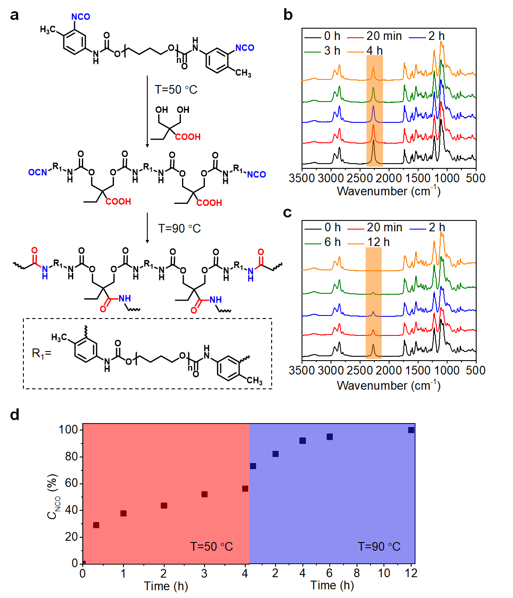
Supplementary Fig. 1 | The reactions between isocyanate and hydroxyl group and carboxylic acid group at different temperatures. a, Reaction schemes at 50 °C and 90 °C, respectively. b, FTIR spectra change of the isocyanate reacting with dimethylolbutanoic acid at 50 °C. c, FTIR spectra change when elevating the temperature to 90 °C. d, The calculated isocyanate conversions obtained from b and c using the C-O bands (1250 cm⁻¹) as the internal standard.
Discussion: Supplementary Fig. 1d shows that, at 50 °C, isocyanate reacts very rapidly initially but reaches a quasi-plateau conversion of around 60% for 4 hours. This plateau conversion is consistent with the molar ratio between hydroxyl groups (from dimethylolbutanoic acid) and the isocyanate group. When the temperature is raised to 90 °C, the remaining isocyanate continues to react and reaches full completion. The results indicate that the carboxylic acid group remains inert and unchanged during the synthesis at 50 °C. However, at 90 °C, the carboxylic acid group reacts with the excess isocyanate, resulting in the formation of amide bonds.
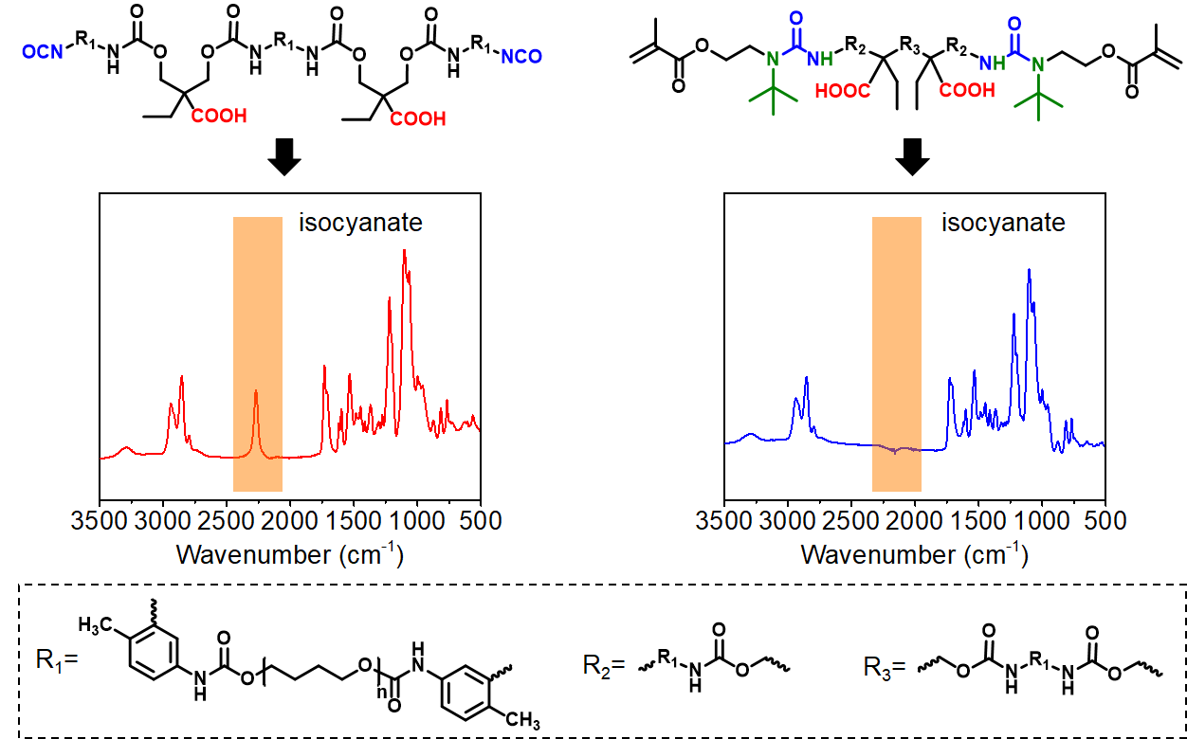
Supplementary Fig. 2 | FTIR spectra of DLP precursor. The highlighted isocyanate peak at 2280 cm⁻¹ was observed after the reaction with the dimethylolbutanoic acid (step ii in Fig. 1a). This peak disappeared after the reaction with 2-(tert-butylamino)ethyl methacrylate (step iii in Fig. 1a), suggesting the successful synthesis of target products.

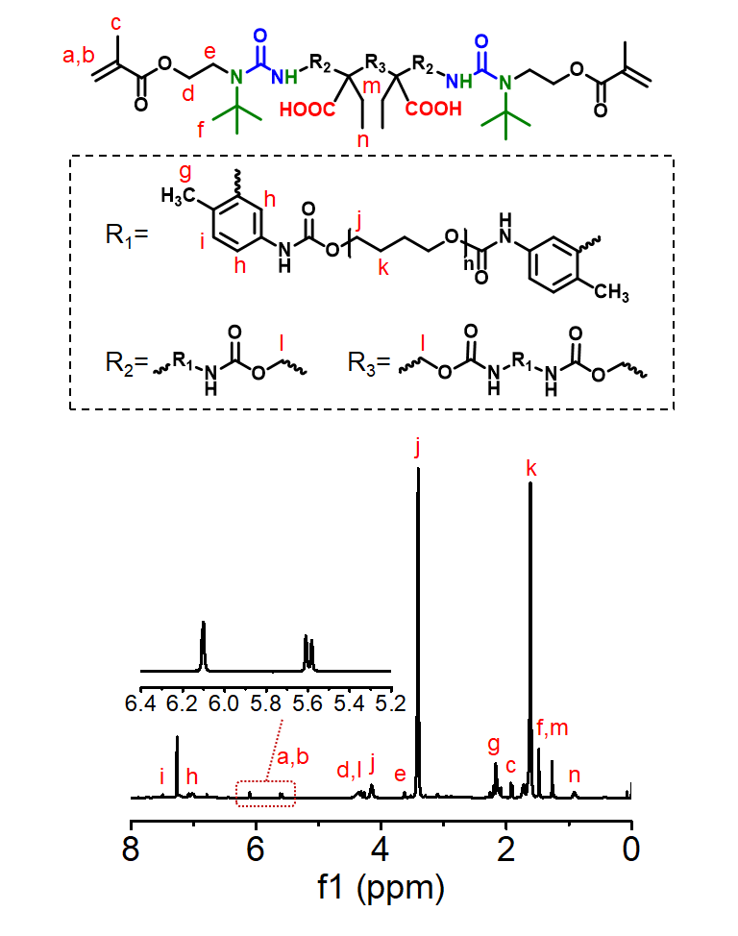
Supplementary Fig. 3 | ¹H NMR spectrum of the DLP precursor.
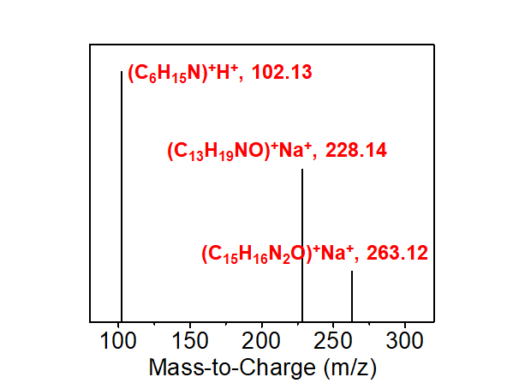
Supplementary Fig. 4 | Quadrupole time-of-flight (QTOF) mass spectroscopic analysis of the products of the model compound experiment in Fig. 1c with a reaction time of 6 h. The detected C₁₃H₁₉NO and C₁₅H₁₆N₂O correspond to the amide and urea products, respectively, which suggests the hindered urea is transformed into amide and urea.

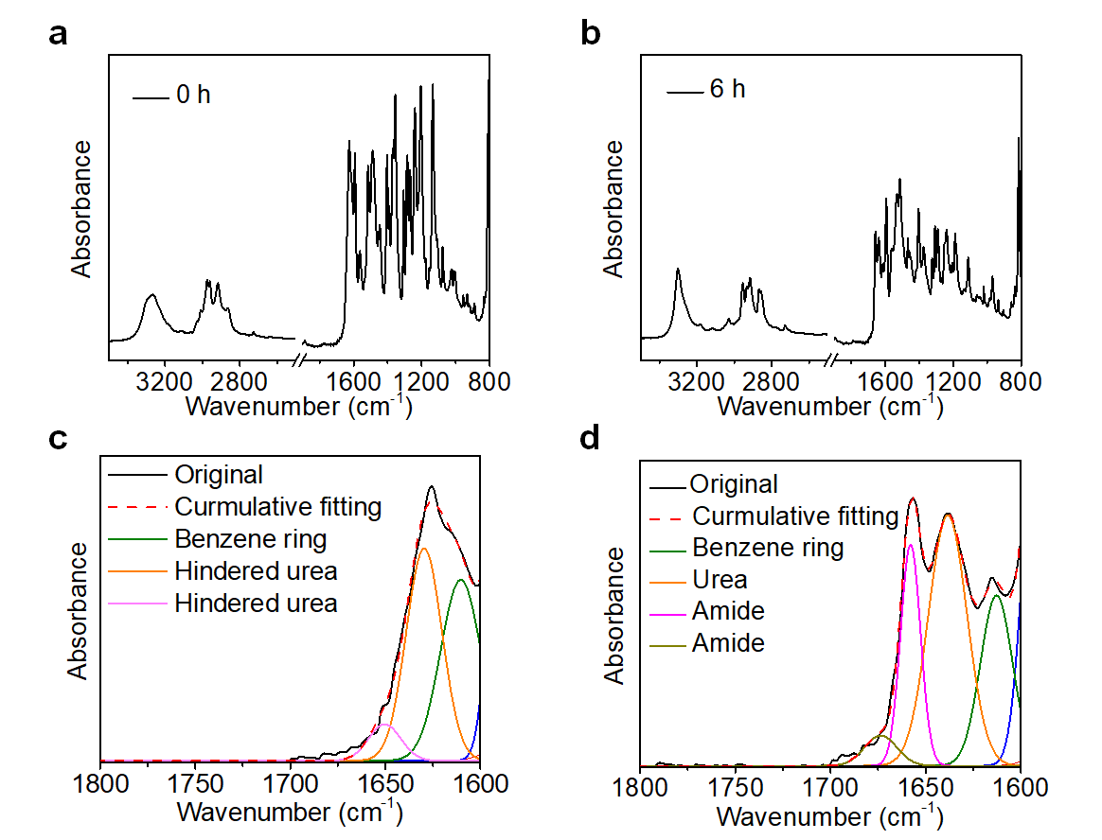
Supplementary Fig. 5 | FTIR spectra correspond to the model compound experiments in Fig. 1c. a, Full spectrum before reaction (reaction time of 0 h). b, Full spectrum with reaction time of 6 h. c, Deconvoluted spectrum of a. d, Deconvoluted spectrum of b. Direct comparison between c and d suggests that the hindered urea is converted into urea and amide after the reaction.
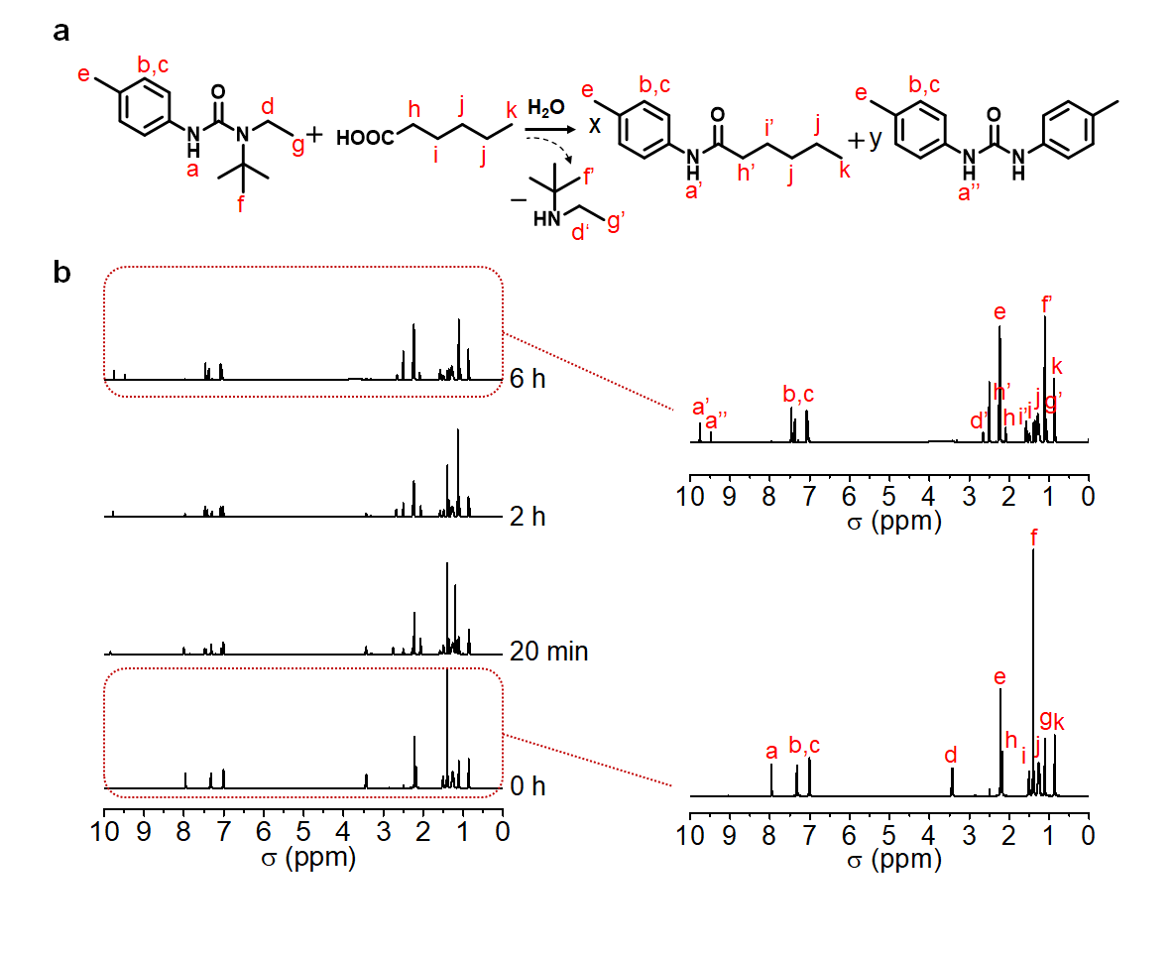
Supplementary Fig. 6 | Full spectra of the model compound experiments in Fig. 1d. a, Reaction scheme that converts hindered urea into amide/urea. b, The evolution of ¹H NMR spectrum as the model reaction occurs at 90 °C with the peak intensities normalized against the total aromatic hydrogens.

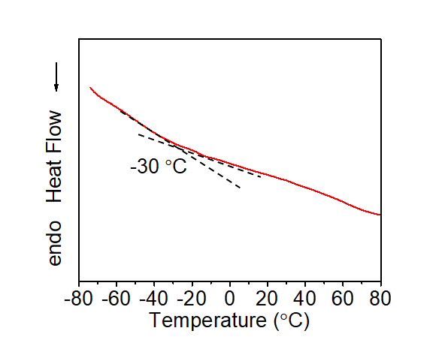
Supplementary Fig. 7 | Differential scanning calorimetry (DSC) curve of the photo-cured sample after thermal post-curing.
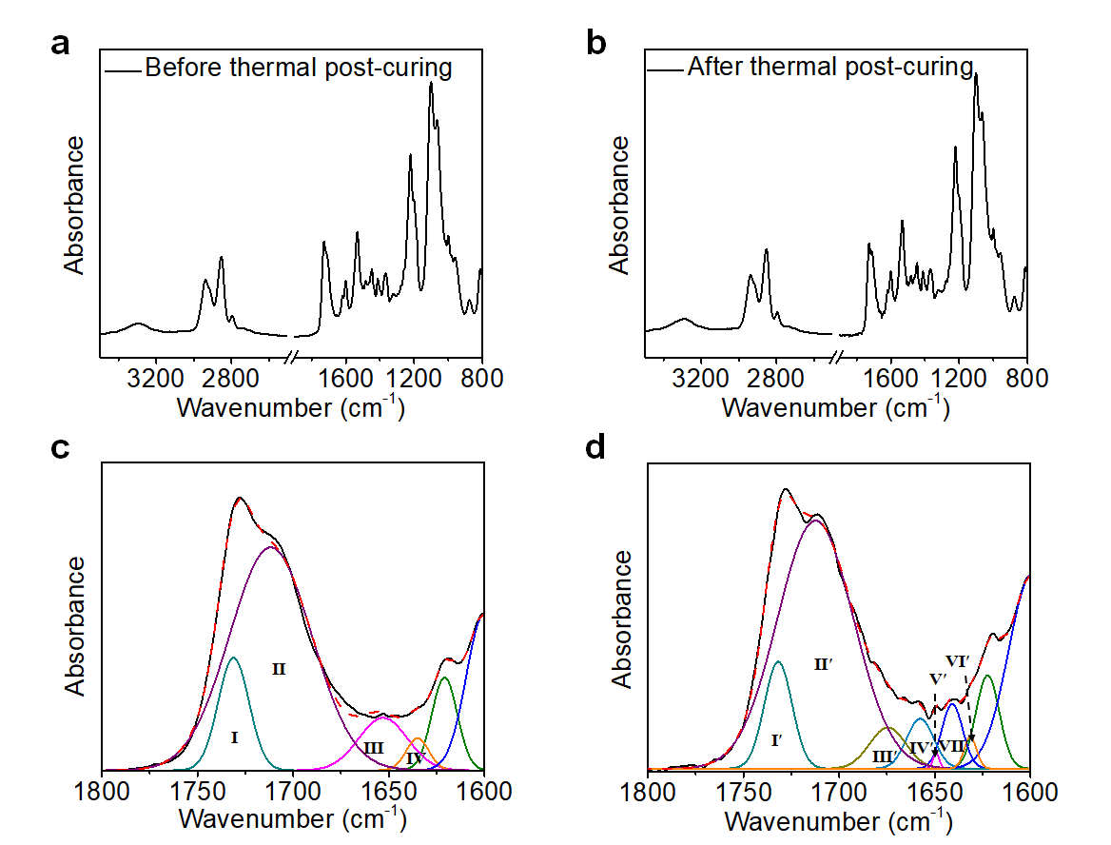
Supplementary Fig. 8 | The comparison of FTIR spectra of the photo-cured sample before and after thermal post-curing. a, Full spectrum before thermal post-curing. b, Full spectrum after thermal post-curing. c, Deconvoluted spectrum of a. d, Deconvoluted spectrum of b.
Note: The peak assignments in c and d are based on the model compound FTIR spectra in Supplementary Fig. 5. The results including the assignment of each peak and analysis of the peak intensity change can be found in Supplementary Table 3.

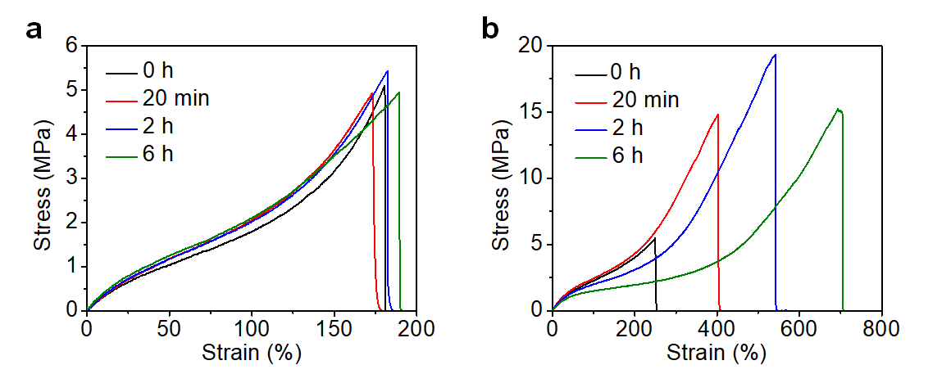
Supplementary Fig. 9 | Stress-strain curves of the photo-cured sample before and after thermal post-curing at 90 °C for different times. a, Network sample from DLP precursor-a. b, Network sample from DLP precursor-b.
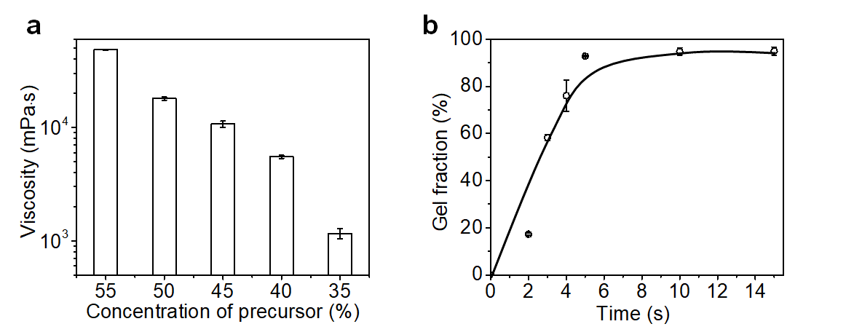
Supplementary Fig. 10 | The influence of the concentration of the DLP precursor on the viscosity and curing kinetics. a, The viscosity varies with the concentration of the DLP precursor. b, The gelation kinetics with a concentration of 50%.

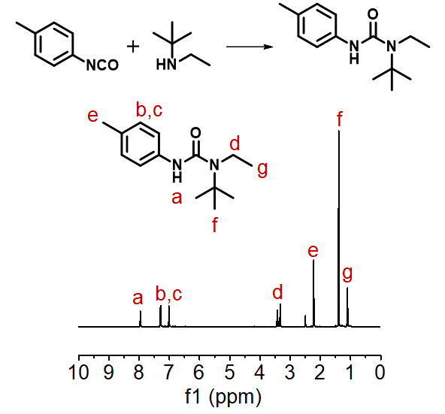
Supplementary Fig. 11 | ¹H NMR spectrum of the model compound hindered urea.

Supplementary Table 1 | The mechanical properties of DLP precursor after post-curing at 90 °C for different times.

 | Modulus  (MPa) | Tensile strength (MPa) | Breaking strain (%) | Toughness  (MJ m⁻³)
0 h | 3.8±0.1 | 10.1±1.3 | 372±32 | 15.0±2.5
20 min | 7.6±0.3 | 30.7±2.7 | 646±19 | 70.2±3.0
2 h | 18.2±1.5 | 53.8±1.6 | 830±29 | 177.9±9.0
6 h | 26.1±2.7 | 94.6±2.8 | 909±11 | 310.4±7.4

Supplementary Table 2 | Comparison of the tensile strength and toughness for various non-commercial and commercial 3D printed elastomers.

Type | Tensile strength  (MPa) | Estimated toughness (MJ/m³) | Reference
Non-commercial  3D printed elastomers | 25.9 | 142.3 | 8
Non-commercial  3D printed elastomers | 14.8 | 83.6 | 8
Non-commercial  3D printed elastomers | 1 | 1.4 | 9
Non-commercial  3D printed elastomers | 7.5 | 50 | 10
Non-commercial  3D printed elastomers | 0.3 | 0.16 | S1
Non-commercial  3D printed elastomers | 2.4 | 16 | S2
Non-commercial  3D printed elastomers | 0.7 | 0.5 | S3
Non-commercial  3D printed elastomers | 1.2 | 1.5 | S4
Non-commercial  3D printed elastomers | 1.6 | 6 | S5
Non-commercial  3D printed elastomers | 7.5 | 42 | S6
Non-commercial  3D printed elastomers | 3.4 | 4.5 | S7
Non-commercial  3D printed elastomers | 15.7 | 25 | S8
Non-commercial  3D printed elastomers | 14.1 | 15 | S9
Commercial  3D printed elastomers | 19 | 30 | S10
Commercial  3D printed elastomers | 15 | 20 | S11
Commercial  3D printed elastomers | 7 | 7 | S12
Commercial  3D printed elastomers | 9 | 5 | S13
Commercial  3D printed elastomers | 11 | 9 | S14
Commercial  3D printed elastomers | 8 | 4 | S15
Commercial  3D printed elastomers | 22.2 | 29 | S15
Commercial  3D printed elastomers | 21.6 | 60 | S15
Commercial  3D printed elastomers | 8.9 | 4.5 | S16
Commercial  3D printed elastomers | 3.2 | 2.6 | S17
Commercial  3D printed elastomers | 5 | 3 | S18
Commercial  3D printed elastomers | 21 | 8 | S19
Commercial  3D printed elastomers | 7.6 | 17.4 | S20
Commercial  3D printed elastomers | 14 | 17.9 | S21

Supplementary Table 3 | Summary of the deconvoluted peak position and the corresponding calculated area ratios of the C=O absorption band in the FTIR curves from Supplementary Fig. 8.

Assignment |  | Wavenumber (cm⁻¹) |  | Area (%)
 |  | Before thermal  post-curing | After thermal post-curing | Before thermal  post-curing | After thermal post-curing
Urethane | Free | Ⅰ (1731) | Ⅰ′ (1732) | 13.9 | 11.2
Urethane | H-bonded | Ⅱ (1712) | Ⅱ′ (1712) | 73.0 | 71.1
Amide | H-bonded (Disordered) |  | Ⅲ′ (1675) |  | 5.6
Amide | H-bonded (Ordered) |  | Ⅳ′ (1658) |  | 5.1
Hindered urea | Free | Ⅲ (1653) | Ⅴ′ (1649) | 10.2 | 0.4
Hindered urea | H-bonded | Ⅳ (1635) | Ⅵ′ (1632) | 2.9 | 1.5
Urea | H-bonded |  | Ⅶ′ (1641) |  | 5.1
Total degree of H-bonded |  |  |  | 75.9 | 88.4

Supplementary Table 4 | The results of multiplication on the signs in 2D infrared correlation synchronous and asynchronous spectra from Fig. 2i.

3250 | - | - | -
3270 | - | -
3328 | +
3435
 | 3435 | 3328 | 3270 | 3250

Supplementary References
- Wang, K. et al. 3D printing of viscoelastic suspensions via digital light synthesis for tough nanoparticle-elastomer composites. Adv. Mater. 32, 2001646 (2020).
- Zhao, T. et al. Superstretchable and processable silicone elastomers by digital light processing 3D printing. ACS Appl. Mater. Interfaces 11, 14391-14398 (2019).
- Bhattacharjee, N., Parra-Cabrera, C., Kim, Y. T., Kuo, A. P. & Folch, A. Desktop-stereolithography 3D-printing of a poly(dimethylsiloxane)-based material with Sylgard-184 properties. Adv. Mater. 30, 1800001 (2018).
- Thrasher, C. J., Schwartz, J. J. & Boydston, A. J. Modular elastomer photoresins for digital light processing additive manufacturing. ACS Appl. Mater. Interfaces 9, 39708-39716 (2017).
- Schaffner, M. et al. 3D printing of robotic soft actuators with programmable bioinspired architectures. Nat. Commun. 9, 878 (2018).
- Ren, C., Deng, Y. & Bao, J. Highly stretchable dual-cure photosensitive resin for digital light processing printing. J. Appl. Polym. Sci. 139, e52455 (2022).
- Li, X. et al. Self-healing polyurethane elastomers based on a disulfide bond by digital light processing 3D printing. ACS Macro Lett. 8, 1511-1516 (2019).
- Peng, S. et al. 3D printing mechanically robust and transparent polyurethane elastomers for stretchable electronic sensors. ACS Appl. Mater. Interfaces 12, 6479-6488 (2020).
- Ji, Z. et al. 3D printing of photocuring elastomers with excellent mechanical strength and resilience. Macromol. Rapid Commun. 40, 1800873 (2019).
- https://docs.carbon3d.com/files/technical-data-sheets/tds_carbon_epu-40.pdf?_ga=2.68815377.1087197162.1653643742-817933293.1653643742
- https://docs.carbon3d.com/files/technical-data-sheets/tds_carbon_epu-41.pdf?_ga=2.5443251.1087197162.1653643742-817933293.1653643742
- https://forward-am.com/material-portfolio/ultracur3d-photopolymers/flexible-elastomeric-line/ultracur3d-el-150/
- https://forward-am.com/material-portfolio/ultracur3d-photopolymers/flexible-elastomeric-line/ultracur3d-el-60/
- https://forward-am.com/material-portfolio/ultracur3d-photopolymers/flexible-elastomeric-line/ultracur3d-el-4000/
- https://www.luxcreo.cn/material/1?SelectID=MQ%3D%3D&elasticNavId=MA%3D%3D
- https://formlabs-media.formlabs.com/datasheets/2001418-TDS-ENUS-0.pdf
- https://formlabs-media.formlabs.com/datasheets/2001420-TDS-ENUS-0.pdf
- https://www.3dsystems.com/sites/default/files/2020-07/3d-systems-figure-4-RUBBER-65a-BLK-datasheet-usen-2020-06-30-web.pdf
- https://www.3dsystems.com/sites/default/files/2020-03/3d-systems-figure-4-RUBBER-BLK-10-datasheet-usen-2020-03-13-web.pdf
- https://envisiontec.com/wp-content/uploads/2022/01/ETR-70-Data-Sheet.pdf
- https://envisiontec.com/wp-content/uploads/2022/01/ETR-90-Data-Sheet.pdf

