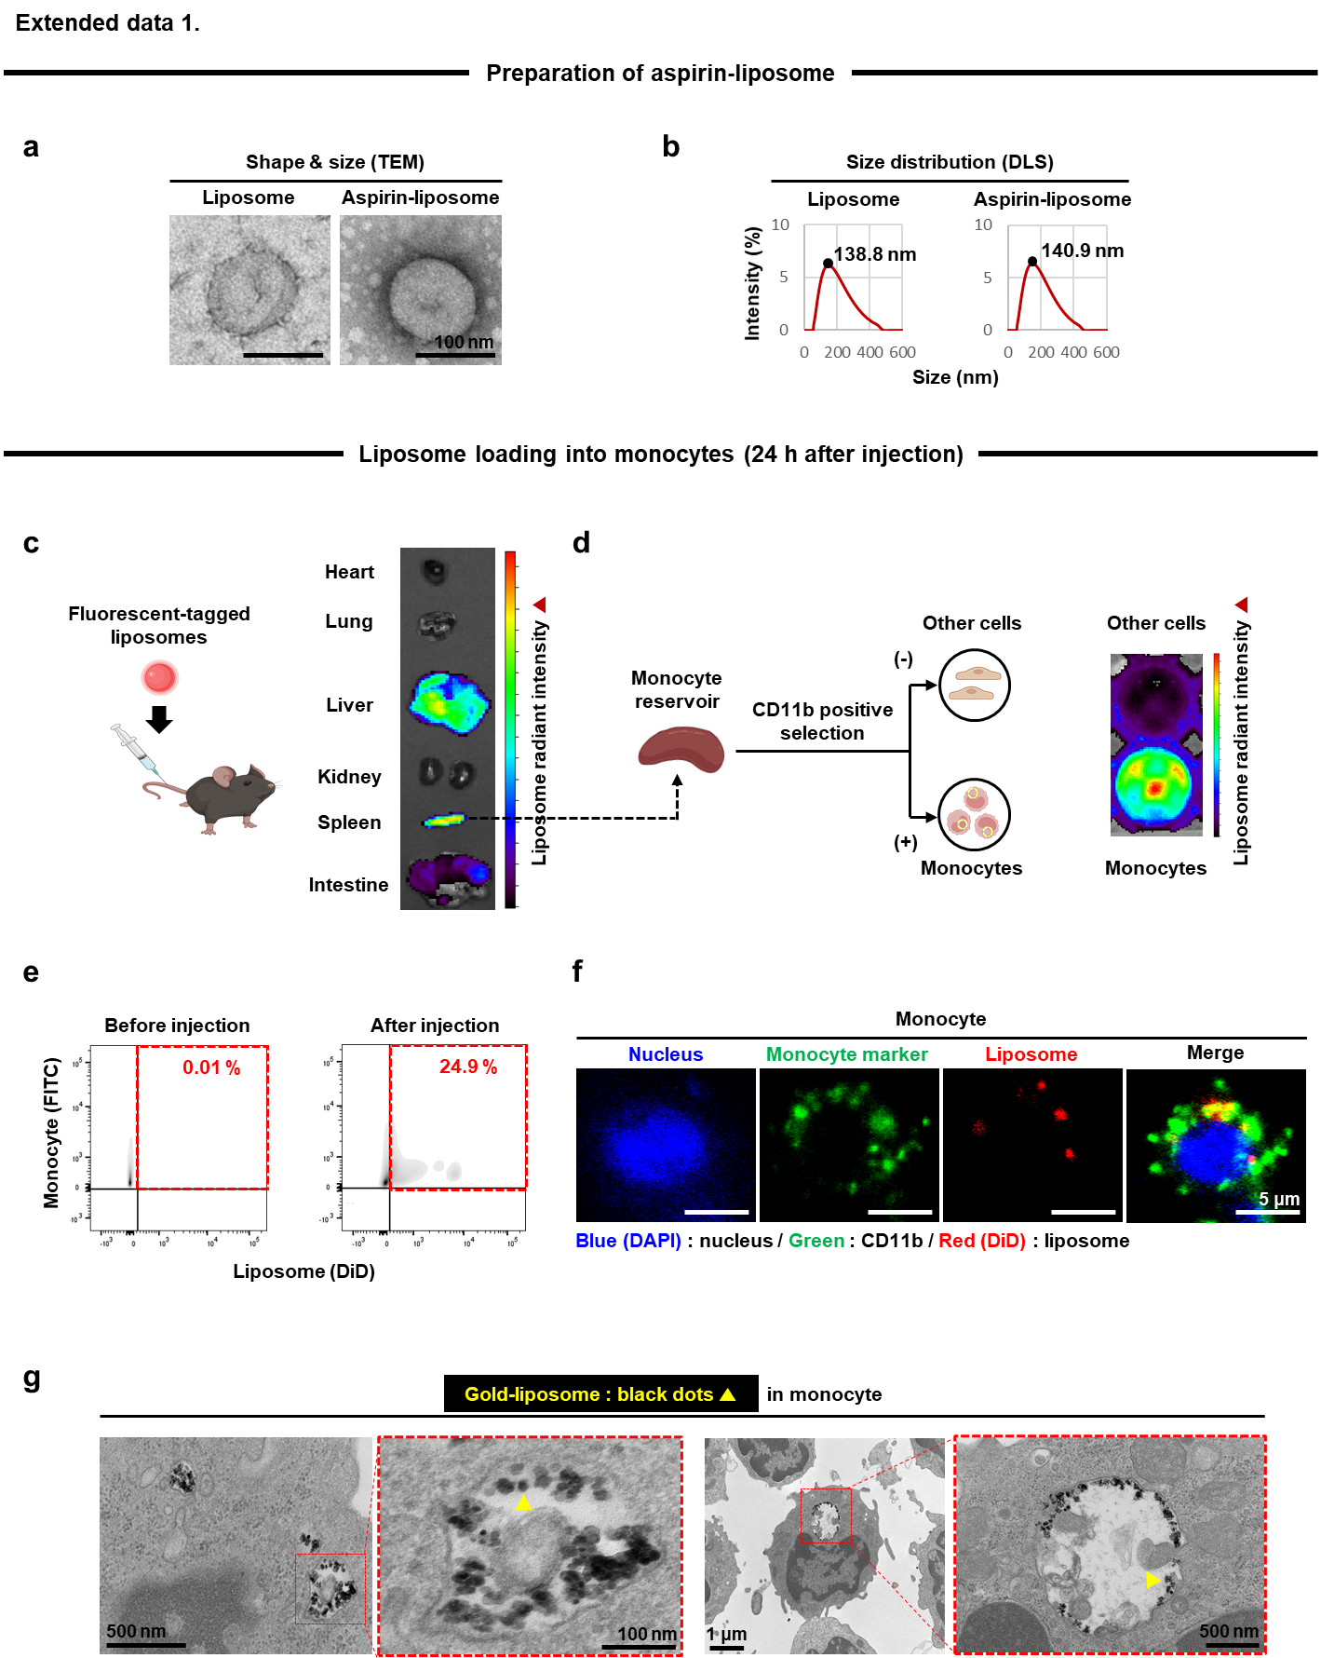
Extended data 1. Aspirin-liposome production with loading onto monocytes. a. liposomes (+/- aspirin) are produced through rapid injection and exhibit a circular shape in TEM with b. around 100 nm in diameter under DLS. c. When fluorescent-tagged liposomes are injected into each mouse through the tail vein, dominant distribution signals are detected in the liver and spleen in IVIS (radiant intensity: 1–18 × 10⁸). d. When cells are extracted from the spleen and separated to the CD11b-positive (monocytes) and negative groups, the CD11b⁺ monocytes exhibit the strong fluorescence intensity as an indication of liposomal uptake in contrast to the poor signal in other cells by IVIS (radiant intensity: 4-31 × 10⁶). e. When FACS is carried out post staining the monocytes with CD11b, 25 % of the population uptake liposomes within a day. f. As immunostaining evidence, the red (DiD) liposomes are shown up between the green CD11b of membrane and the blue nucleus inside the monocytes. g. The result is further confirmed as gold (10 nm)-tagged liposomes are presented in a circular liposome-like shape inside the monocytes under TEM imaging, thereby validating liposome loading into monocytes via tail vein injection. Transmission electron microscopy (TEM); dynamic light scattering (DLS); in vivo imaging system (IVIS); fluorescence-activated cell sorting (FACS).

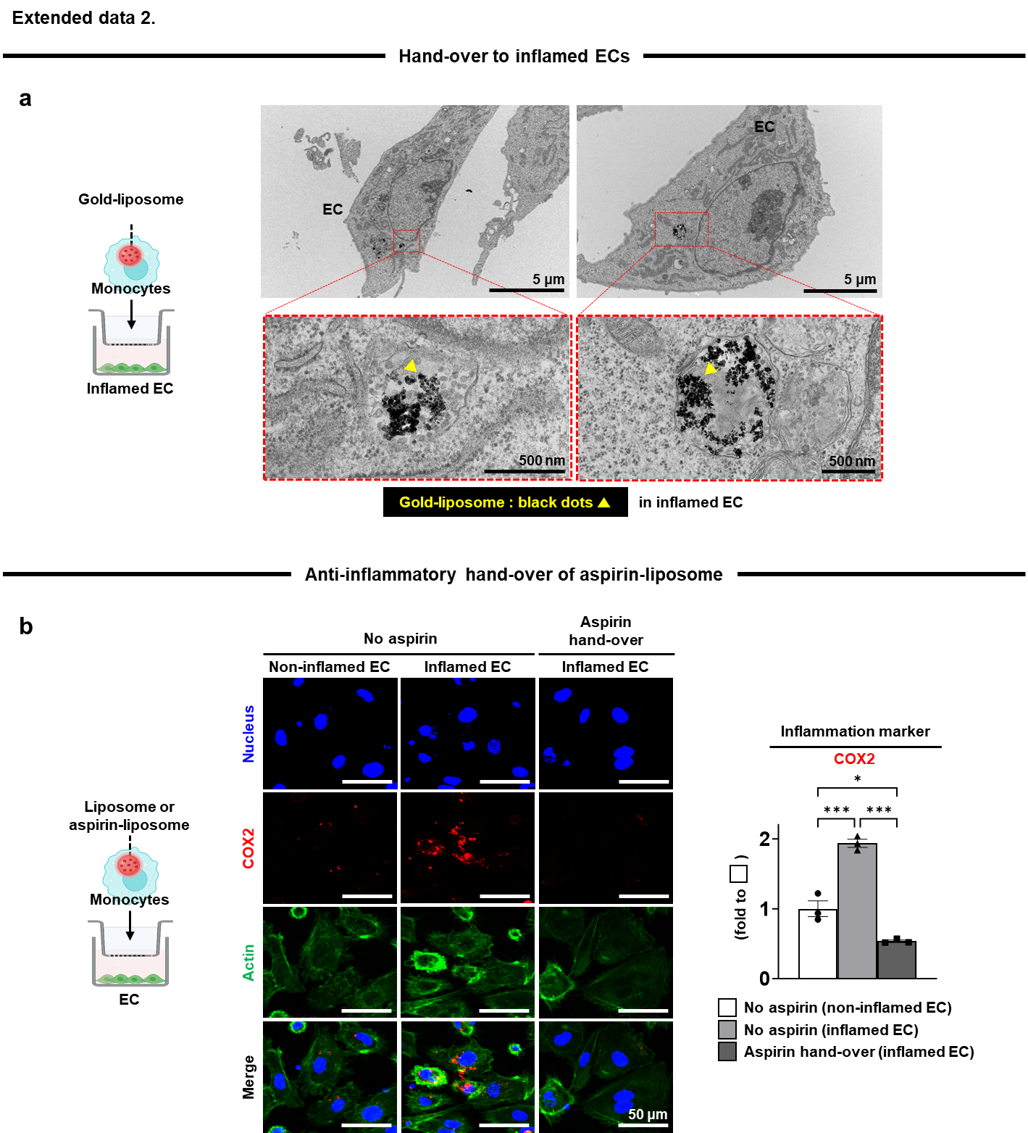
Extended data 2. Validation of hand-over from monocytes to inflamed ECs in co-culture. Liposomes (+/- aspirin) are loaded into monocytes, which are co-cultured with inflamed ECs post LPS treatment in trans-wells as shown in the illustration. a. Gold (10 nm) dots are seen in lining the circles inside the inflamed ECs under TEM imaging as evidence of hand-over of liposomes from monocytes to inflamed ECs. b. The intracellular expression of COX2 (red) in ECs (green actin and blue nucleus) significantly increases twice upon inflammatory induction in the absence of aspirin treatment, and the elevated expression is significantly reduced four times by the hand-over of aspirin-liposome from monocytes to inflamed ECs (N=3). Endothelial cell (EC); lipopolysaccharide (LPS); transmission electron microscopy (TEM); cyclooxygenase 2 (COX2). Data = mean ± SEM (N: dots on each graph). *p < 0.05 and ***p < 0.001 between lined groups.
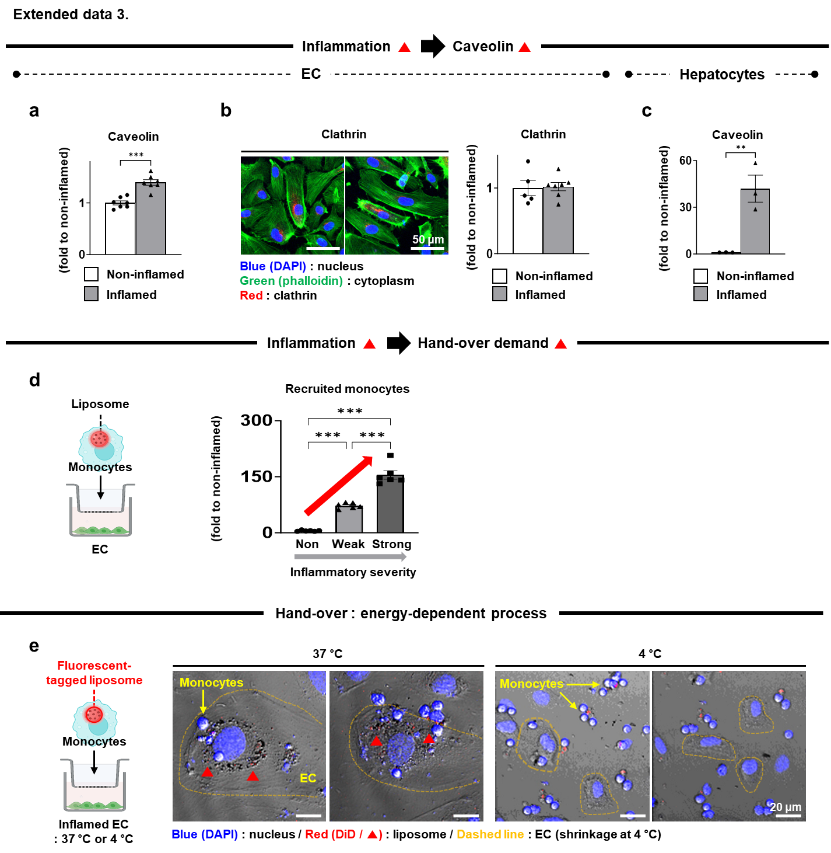
Extended data 3. Caveolin as a major mediator of hand-over via inflammation-induced expression and energy-dependent action. a. As a major mediator, the caveolin expression increases significantly in inflamed ECs compared to the non-inflamed condition in immunostaining with quantitative analysis (N=7). b. In contrast, the clathrin expression is not upregulated by inflammation (N=5-7). c. In the same setting, inflamed hepatocytes significantly increase caveolin expression compared to the non-inflamed control (N=3). d. Liposome-loaded monocytes are co-cultured with ECs in trans-wells. As the inflammation degree increases, more monocytes are recruited to inflamed ECs, indicating the inflammation degree-dependent elevation of hand-over demand (N=6). e. Fluorescent (DiD)-tagged liposomes are loaded into monocytes, which are co-cultured with inflamed ECs in trans-wells. When the culture temperature decreases from 37 to 4 ºC, the number of liposomes (red DiD) was reduced inside inflamed ECs. The result indicates the energy-dependent nature of hand-over process as the cellular energy decreases at 4 ºC. The energy-required action by caveolin mediates the hand-over process rather than the energy-independent passive diffusion. Endothelial cell (EC). Data = mean ± SEM (N: dots on each graph). **p < 0.01, and ***p < 0.001 between lined groups.

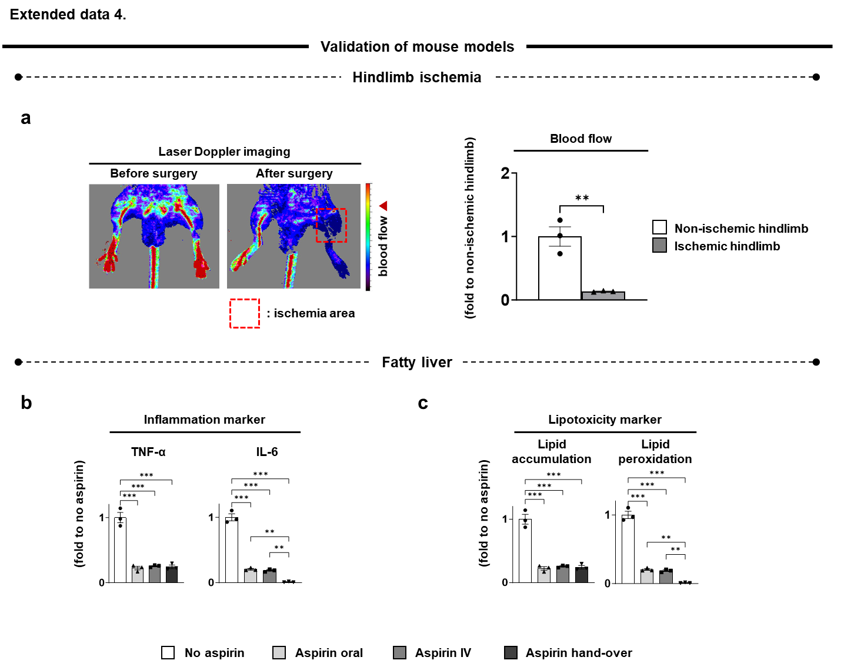
Extended data 4. Validation of mouse models with hindlimb ischemia and fatty liver. a. As the first model to induce vascular inflammation, each mouse undergoes ligation and dissection of femoral vein and artery to generate ischemic hindlimb (N=3). Laser Doppler imaging confirms the significant reduction of blood perfusion through the hindlimb as supported by the quantitative analysis. b. As the second model to induce liver inflammation, a fatty liver is generated in each mouse, followed by conducting the process according to each of the experimental groups. The immunostaining results with quantitative analysis (N=3) indicates that the TNF-α expression is reduced significantly by the aspirin injection groups compared to no aspirin as confirmed by the IL-6 expression in addition to c. the lipotoxicity marker (lipid accumulation and peroxidation). Of note, only the hand-over results in significant reductions of IL-6 expression and lipid peroxidation among the test groups, validating the therapeutic effect on the fatty liver. Tumor necrosis factor alpha (TNF-α); interleukin-6 (IL-6); intravenous (IV). Data = mean ± SEM (N: dots on each graph). **p < 0.01, and ***p < 0.001 between lined groups.

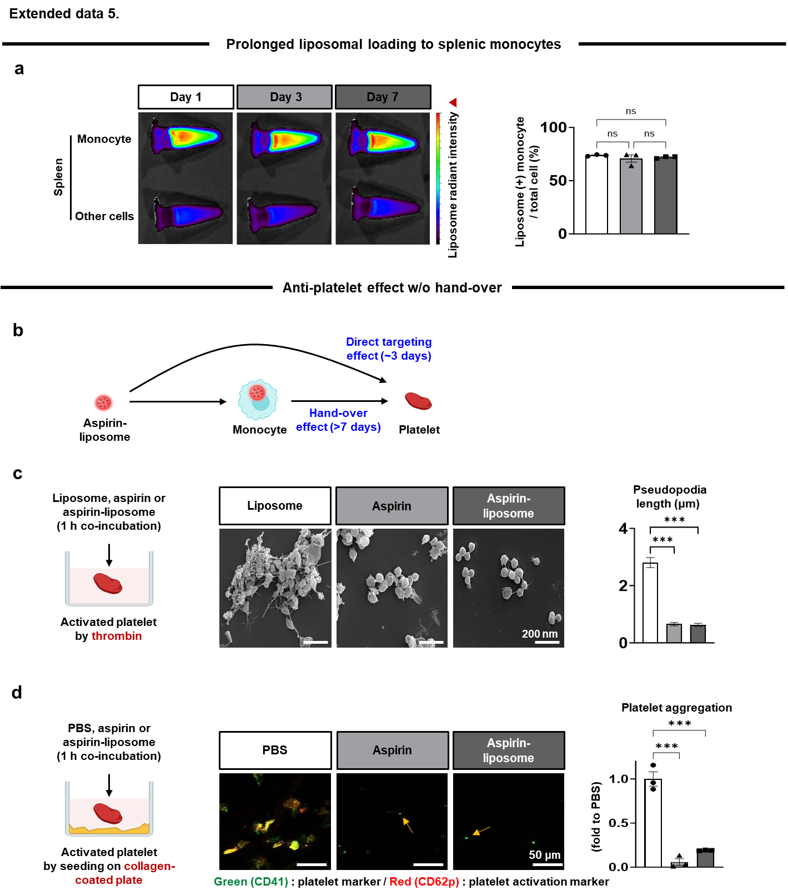
Extended data 5. Prolonged carrying of aspirin-liposome by monocytes with hand-over to platelets. a. Fluorescent-tagged liposomes are injected into a tail vein of each mouse, and cells are harvested from spleen as a major residence of monocytes, followed by selective sorting of monocytes (top tubes) from other cells (bottom tubes). When the fluorescence intensity of each tube is determined in IVIS (N=3, radiant intensity: 1–20 × 10⁶), the monocytes exhibit 75 % liposomes (+) signals out of the total cells, which is maintained for 7 days, indicating the prolonged loading of liposomes to splenic monocytes. b. Hence, the hand-over from monocytes to platelets is expected to last over 7 days. In contrast, aspirin-liposomes can target platelets through delivery by blood flow, which is expected to last merely up to 3 days as the body clearance of nanoparticles usually occur within the time frame. c. The direct targeting effect is determined using activated platelets upon thrombin treatment in vitro, followed by co-incubation with liposome, aspirin, or aspirin-liposome in comparison for 1 h. The SEM images indicate platelet activation is significantly reduced by aspirin regardless of liposome encapsulation compared to only liposome treatment. This result is confirmed by the quantitative image analysis of pseudopodia length as a marker of spreading platelet activation (N=82-103). d. Platelets are activated by culturing on collagen-coated plates as a model of basement exposure upon dysfunction of blood vessels, followed by incubation with PBS, aspirin, or aspirin-liposome in comparison for 1 h. The expression of activation marker (red CD62p) in platelets (green CD41) is significantly reduced from PBS to aspirin only and aspirin-liposomes as confirmed by the quantitative image analysis of platelet aggregation (N=3). In vivo imaging system (IVIS); scanning electron microscopy (SEM); phosphate-buffered saline (PBS). Data = mean ± SEM (N: dots on each graph). ***p < 0.001 between lined groups.

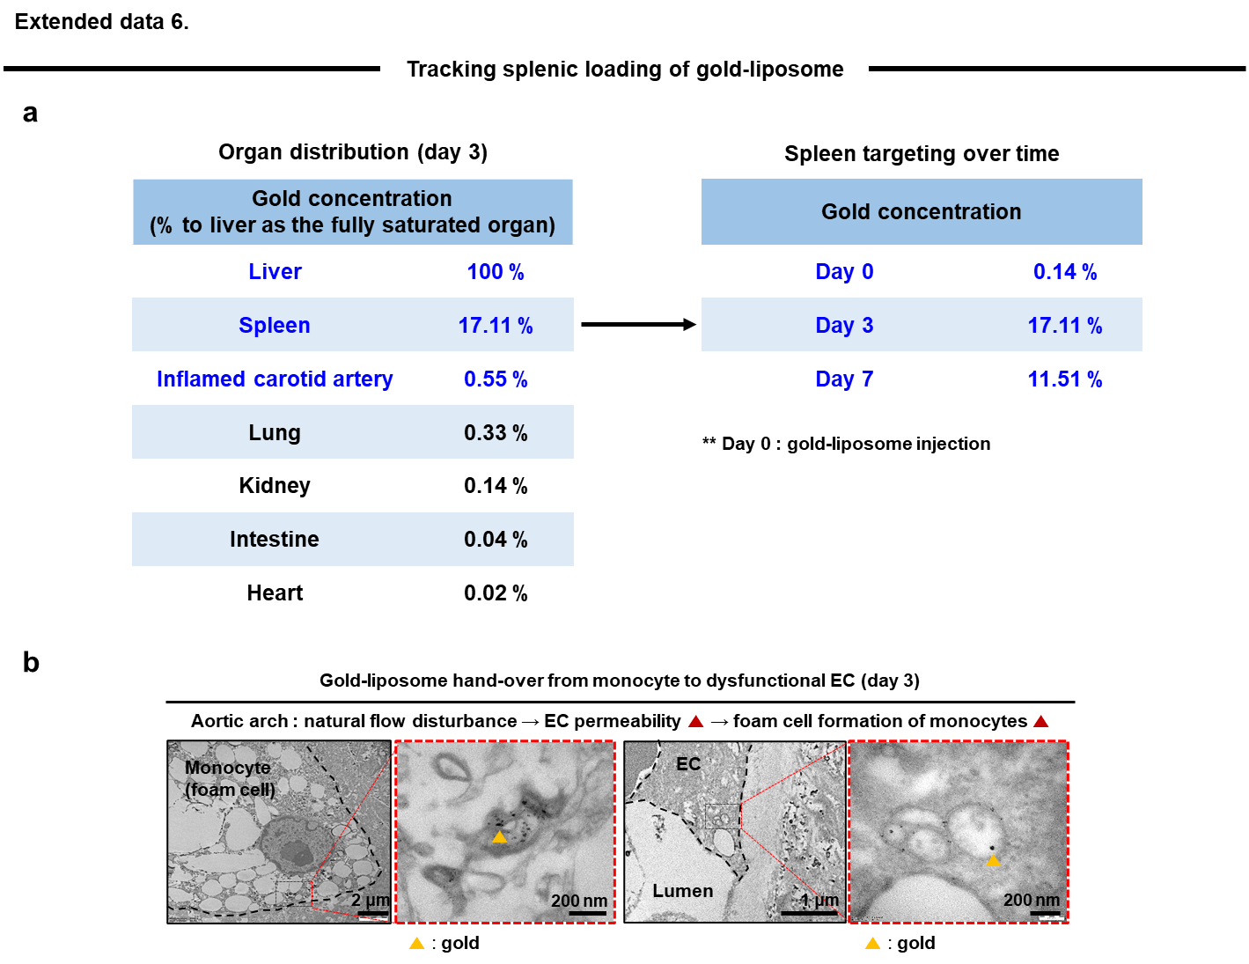
Extended data 6. Tracking hand-over during loading gold-liposome to splenic monocytes and hand-over to ECs. a. ApoE KO mice are subjected to partial carotid ligation at day 14 and western diet feeding, followed by injecting gold-liposomes at day 35. When the organ distribution of liposome is determined at day 3 post injection by tracking the gold concentration using ICP-MS, the dominant distributions to the liver and spleen are resulted. Compared to the liver as set to 100 %, the splenic distribution reaches 17.11 % as an indication of efficient liposomal targeting to spleen for 3 days compared to the other organs except the liver in the table. It is turned out that the spleen targeting of gold-liposomes increases from day 0 to 3 (17.11 %), which is maintained to 11.51 % at day 7. b. At day 3 post injection, the hand-over of gold-liposomes to dysfunctional ECs is visualized under TEM imaging. Aortic arch is naturally exposed to disturbed flow, and thus, ECs increase the permeability as an indication of dysfunction. Gold liposomes were found inside foam cells and ECs, indicating the efficient delivery of liposomes to dysfunctional ECs as a target cell type. ApoE gene knockout (apoE KO); inductively coupled plasma mass spectrometry (ICP-MS); transmission electron microscopy (TEM); endothelial cell (EC).
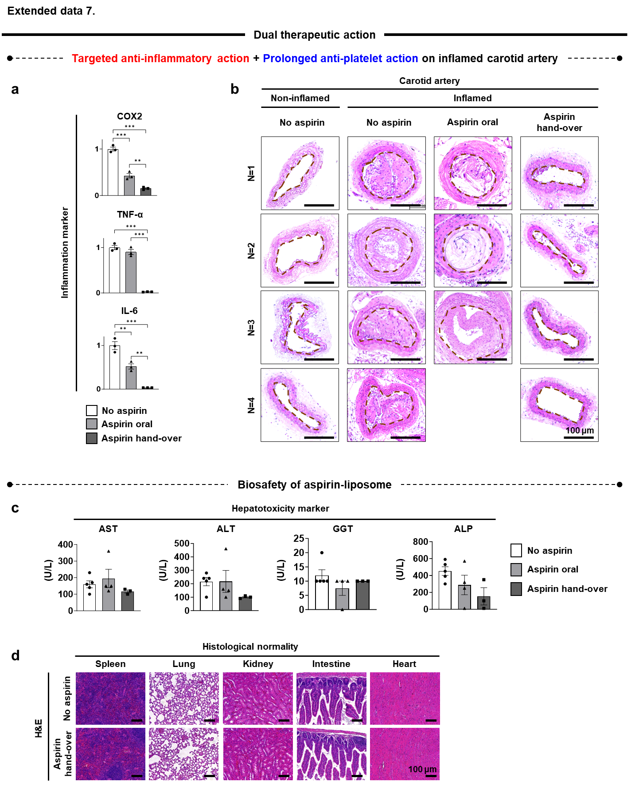
Extended data 7. Dual therapeutic action of aspirin-liposome on inflamed artery with bio-safety validation. a. The combination of targeted anti-inflammatory and prolonged anti-platelet actions is defined as the dual therapy. The therapeutic effect is determined on an inflamed carotery artery of each mouse post ligation surgery and western diet. The aspirin hand-over significantly reduces the expression of inflammation makers (COX2, TNF-α, and IL-6) in the target arteries compared to the other groups (N=3). Only the TNF-α expression is not significantly different between no aspirin and oral aspirin injection. b. As a supportive result, the aspirin hand-over exhibits the normal (non-inflammation and no aspirin)-like histological features of inflamed arteries. In contrast, no aspirin and aspirin oral result in nearly complete and partial stenotic features of inflamed arteries, respectively. c. Next, the biosafety profile of aspirin-liposome is examined in the liver where most dominant distribution is detected. The aspirin-liposome does not cause hepatotoxicity as evidenced by no significant elevation of markers (AST, ALT, GGT, and ALP) from blood samples. d. This result is supported by no visible finding of abnormal H&E features in spleen, lung, kidney, intestine, and heart. Intravenous (IV); cyclooxygenase 2 (COX2); tumor necrosis factor alpha (TNF-α); interleukin-6 (IL-6); aspartate aminotransferase (AST); alanine aminotransferase (ALT); gamma-glutamyl transferase (GGT); alkaline phosphatase (ALP); hematoxylin and eosin (H&E). Data = mean ± SEM (N: dots on each graph). **p < 0.01, and ***p < 0.001 between lined groups.

Supplementary Video 1
High-resolution movie on hand-over of aspirin-liposomes (red) from monocytes (blue) to ECs (green) by Lattice light-sheet 7 microscopy
