Supplementary file
PROTEINS | PDB ID | CITATIONS
AKT1 | 1UNQ | Jha et al., 2015;  Chandrasekaran&Bonchev et al., 2013;  Werner et al., 2021;  Dolgachevah et al., 2019;  Bohush et al., 2018;  Rui et al., 2020;  Nouri et al., 2020;  Elbaz et al., 2004;  Lin et al., 2020;  Tansey et al., 2022;  Castillo et al., 2015;  Mohammed et al., 2023; Halliday et al., 2017;  Ishan et al. 2022
ALPHA-SYN | 1XQ8
GSK3B | 1Q41
C-ABL | 2E2B
GBA | 1Y7V
DJ-1 | 6AFC
PARKIN | 7US1
LRRK2 | 3D6T
PI3K | 4G11
1L-6 | 1ALU
1L-2 | 1PW6
TNF-ALPHA | 2AZ5
IL-1B | 1ITB
CASPASE 1 | 3NS7
COMT | 3BWM
B-CATHENIN | 3SL9
CYP2D6 | 3QM4
A2 RECEPTOR | 3RFM
WNT | 4F0A
SIRTUIN 2 | 5D7Q
NMDA | 5YBF
GDNF | 7AB8
AChE | 5HF9
DR | 7X2F
HSP90 | 1BYQ
ERP57 | 2H8L
HSP70 | 1HJO
NEPRILYSIN | 6XVP
DJ-1 | 6AFG
BiP | 5F1X
JNK3 | 7S1N
JNK2 | 3NPC
IRE1 | 6W3A
PERK | 4X7O
HSP60 | 6MRD

Table 1 (SF1): PD implicated proteins with their respective PDB IDs and citation source.

Compound Name | Optimized Structure | Homo | Lumo
Quercetin | 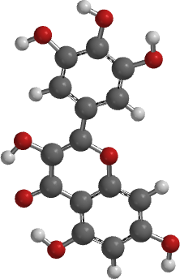 | 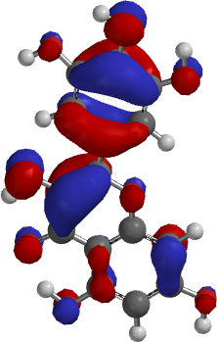 | 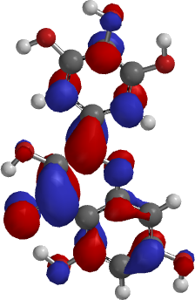
Catechin | 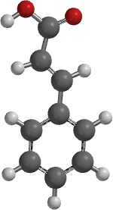 | 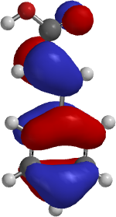 | 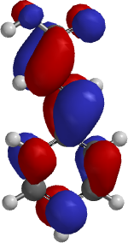
Ellagic acid | 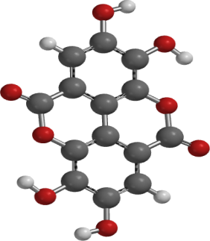 | 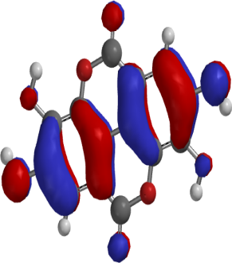 | 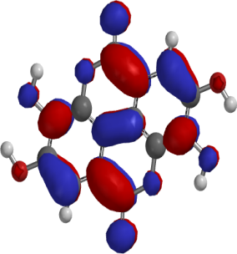
Epicatechin | 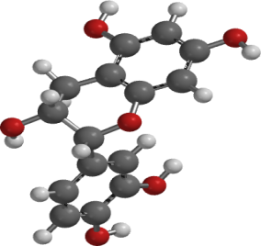 | 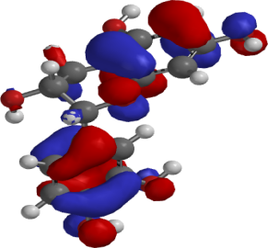 | 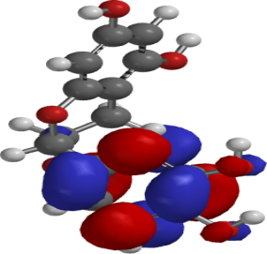
Doramapimod (3NPC unique ligand) | 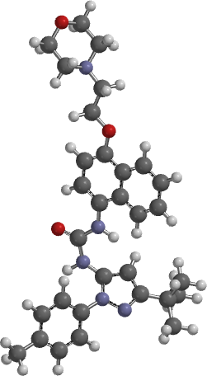 | 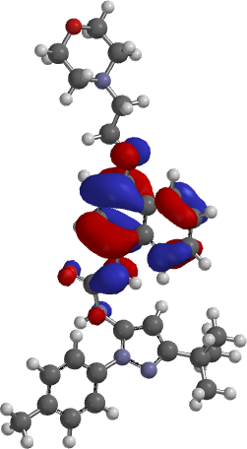 | 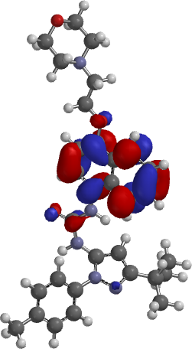
Nps-2143(7S1N unique ligand) | 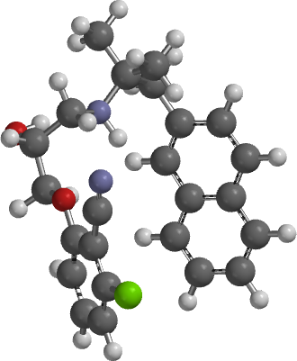 | 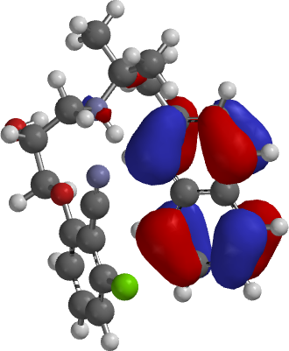 | 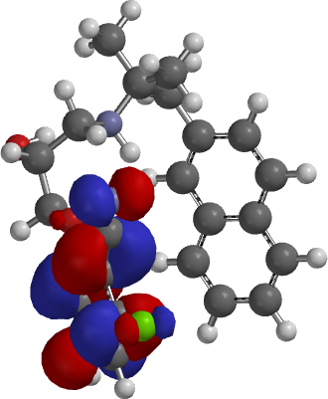
(6S)-2-chloro-5,6,7,8,9,10-hexahydrocyclohepta[b]indole-6-carboxamide (5D7Q unique ligand) | 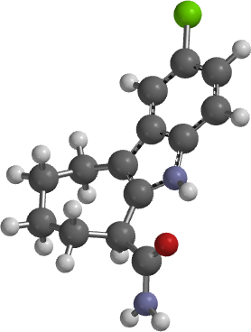 | 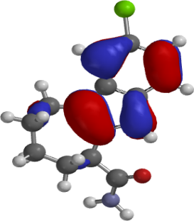 | 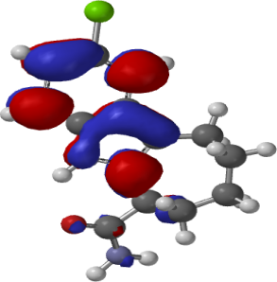
2-[4-(Morpholin-4-Yl)-6-Oxo-1,6-Dihydropyrimidin-2-Yl]-N-Phenylacetamide (4G11 unique ligand) | 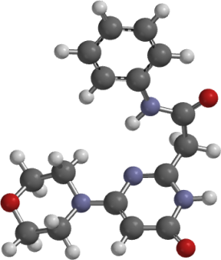 | 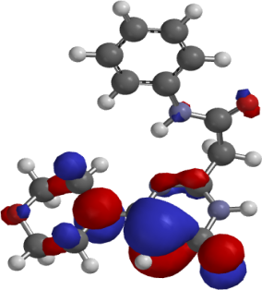 | 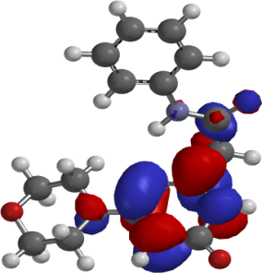
Dopamine (7X2F unique ligand) | 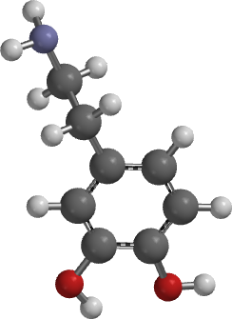 | 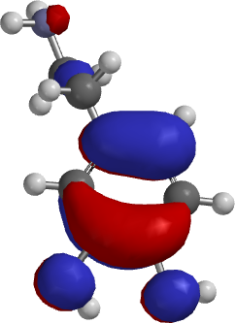 | 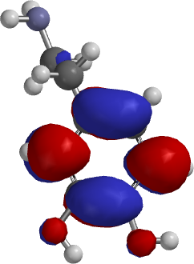
Caffeine (3RFM unique ligand) | 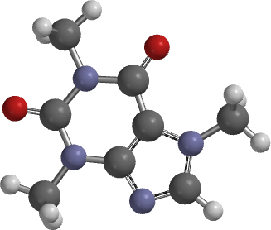 | 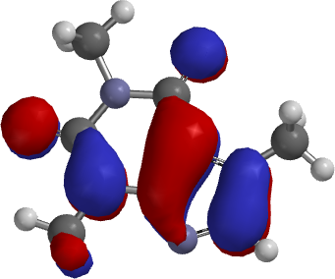 | 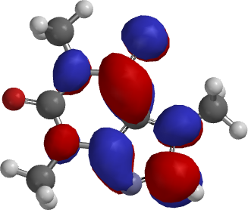
- adenosyl-L-methionine (3BWM unique ligand) | 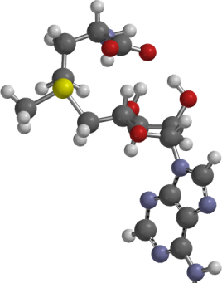 | 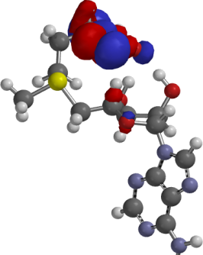 | 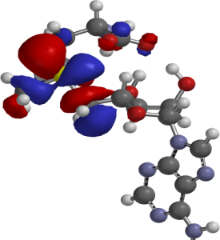
Indirubin(1Q41 unique ligand) | 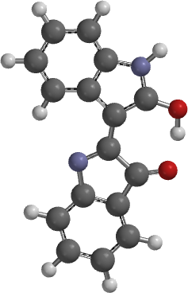 | 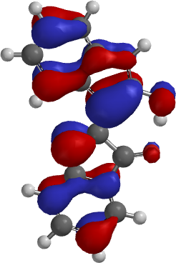 | 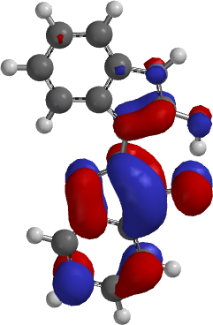
Figure 11: Optimized, Homo and Lumo structures of the density functional theory of the hit ligands and the co-ligands.

ORCID
Olanrewaju A. John 0000-0002-9540-4117
Arietarhire O. Leviticus 0000-0003-4069-0950
Soremekun E. Oladimeji 0000-0001-6086-7616
Olugbogi A. Ezekiel 0000-0003-1415-8856
Afolabi O. Toluwanimi 0000-0003-3603-3392
Adeleke O. Stephen 0000-0003-4667-1830
Alege E. Pelumi 0000-0002-6191-7977
Oyinloye O. Babatunde 0000-0001-6761-7580
Omotuyi I. Olaposi 0000-000-2547-3745X

