Supplementary Figures for

Automatic Identification of Kidney Cell Types in scRNA-seq and snRNA-seq Data Using Machine Learning Algorithms

Authors: ​​Adam Tisch¹, Siddharth Madapoosi¹ , Stephen Blough¹, Jan Rosa¹, Sean Eddy¹, Laura Mariani¹, Abhijit Naik¹, Christine Limonte², Philip Mccown¹, Rajasree Menon¹, Blue B. Lake³, Opeyemi Olabisi⁴, Sylvia E. Rosas⁵, Chirag R. Parikh⁶, Matthias Kretzler¹, Ahmed Mahfouz⁷, Fadhl Alakwaa¹

Affiliations:
1 Department of Internal Medicine, Division of Nephrology, University of Michigan, Ann Arbor, MI, USA
2 Division of Nephrology, University of Washington, Seattle, WA, USA
3 Department of Bioengineering, University of California, San Diego, La Jolla, CA, USA
4 Division of Nephrology, Department of Medicine, Duke University School of Medicine, Durham, NC, USA
5 Kidney and Hypertension Unit, Joslin Diabetes Center and Harvard Medical School, Boston, MA, USA
6 Johns Hopkins School of Medicine, Baltimore, MD, USA
7 Department of Human Genetics, Leiden University Medical Center, Leiden, The Netherlands & Delft Bioinformatics Lab, Delft University of Technology, Delft, The Netherlands

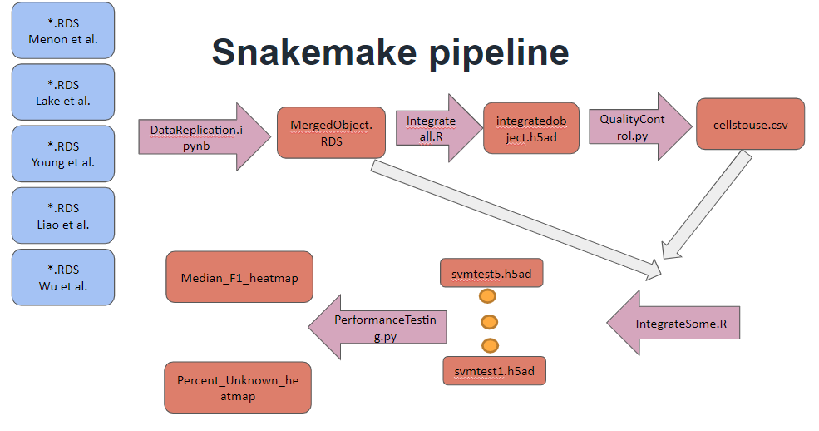

Figure S1: Snakemake pipeline of our study.

(A)
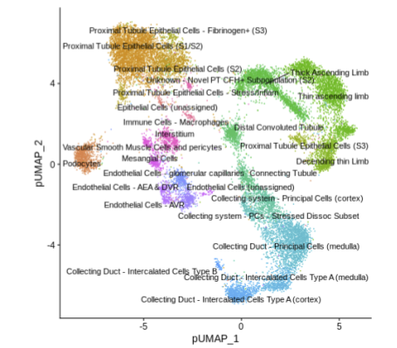

(B)
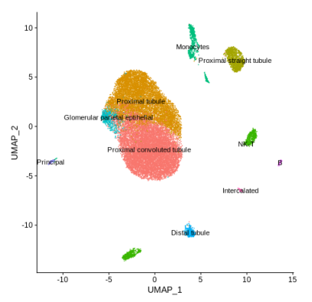
(C)
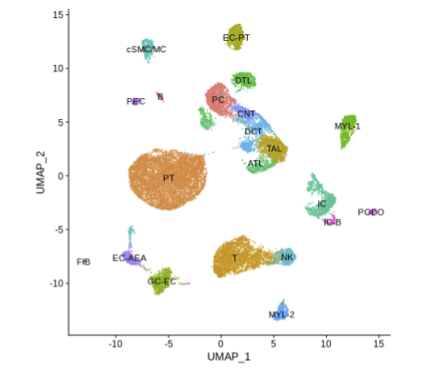
(D)
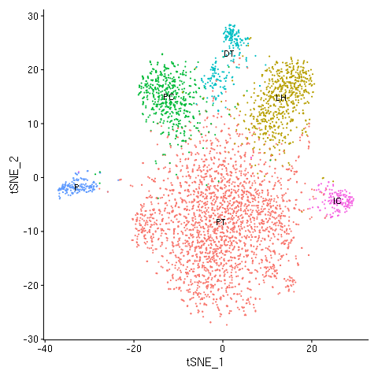
(E)
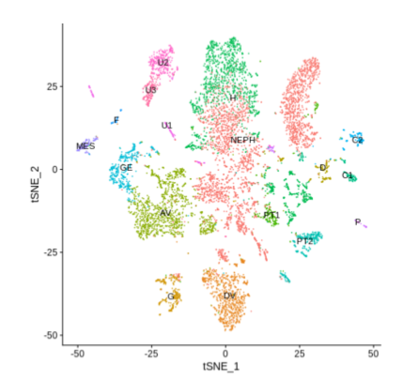
Figure S2: Uniform manifold approximation and projection for dimension reduction (UMAP) and t-distributed stochastic neighbor embedding (t-SNE) visualizations of each dataset generated using the code provided by authors in their publication or sent to us directly for (A) Lake et al., (B) Liao et al., (C) Menon et al., (D) Wu et al., (E) Young et al.
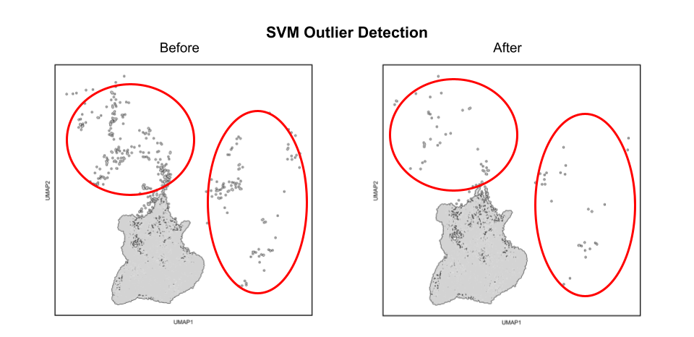

Figure S3: Schematic of SVM outlier detection with 4,257 cells removed from further analysis due to poor alignment with their original annotated cell type. UMAP of cells within the “Proximal Tubule” pooled cell type before (left) and after (right) SVM outlier detection. Cells circled in red are poorly aligned with the remaining cells of their pooled cell type, a trend observed with all other pooled cell types.
(a)
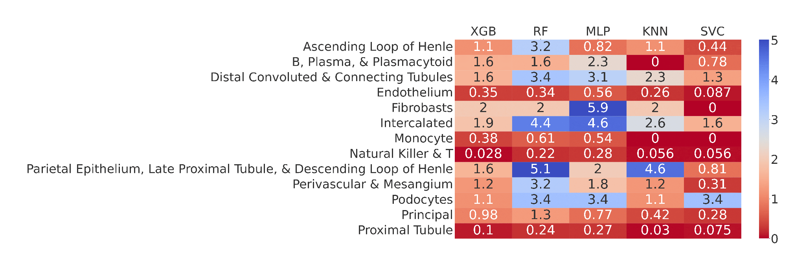

(b)
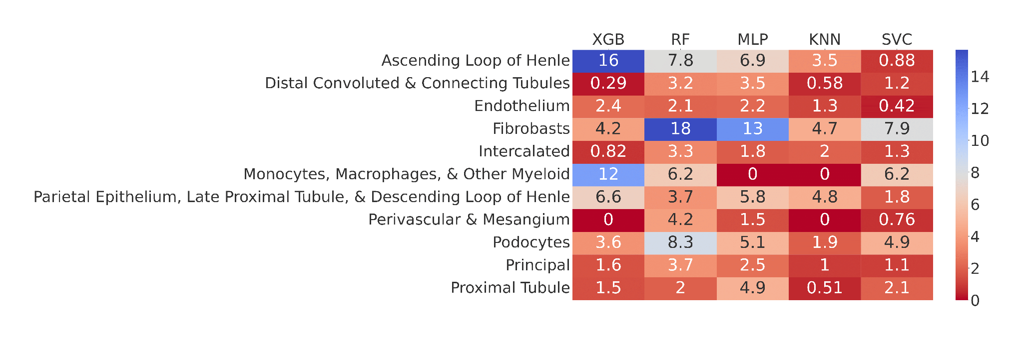
(c)
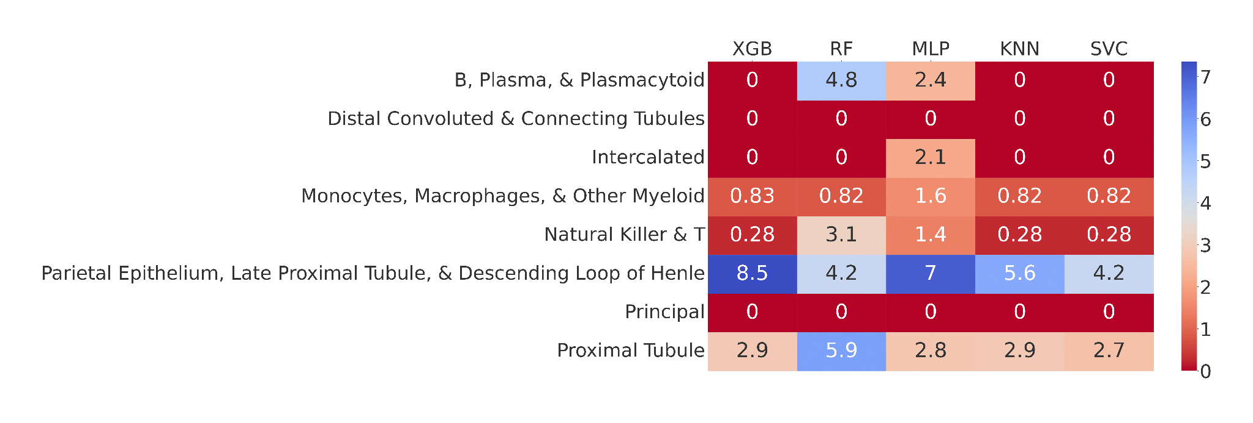
(d)
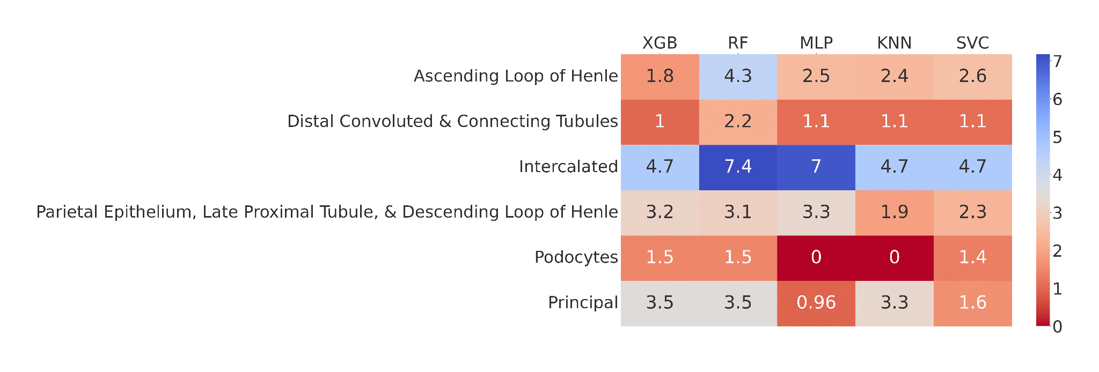
Figure S4. Heatmap of each classifier’s rejection rate on (a) Menon et al., (b) Lake et al., (c) Liao et al. and (d) Wu et al with respect to each cell type.

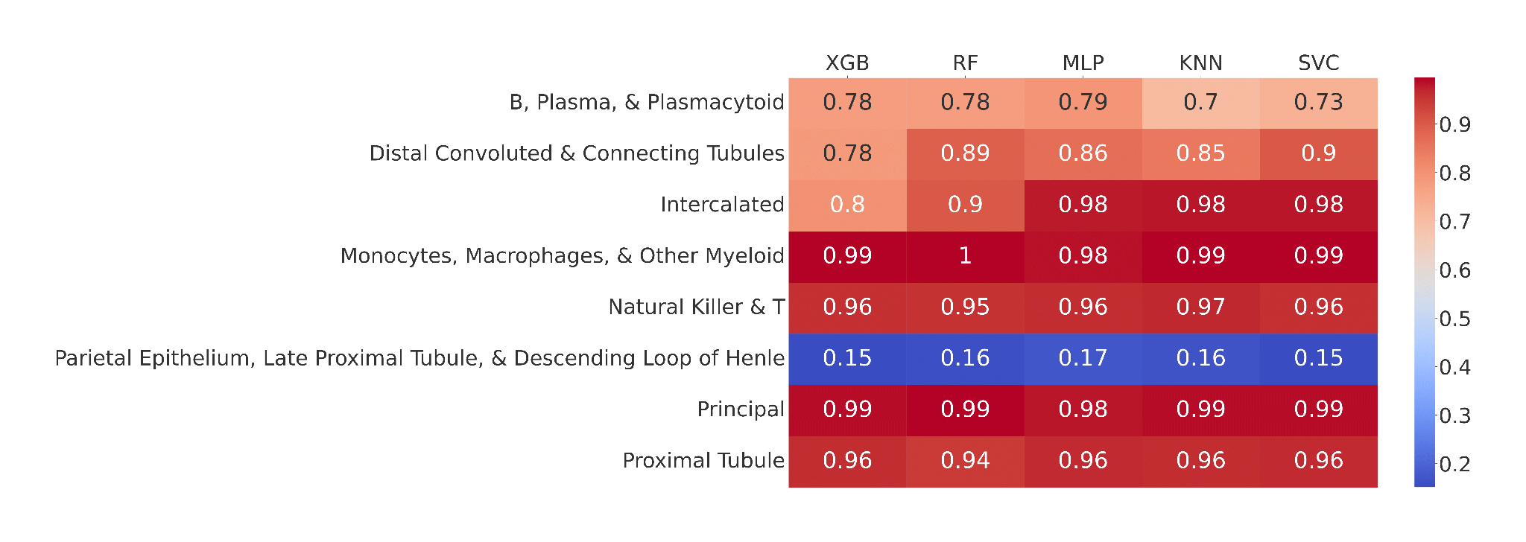

Figure S5. Heatmap of each classifier’s F1 score on Liao et al. with respect to each cell type.
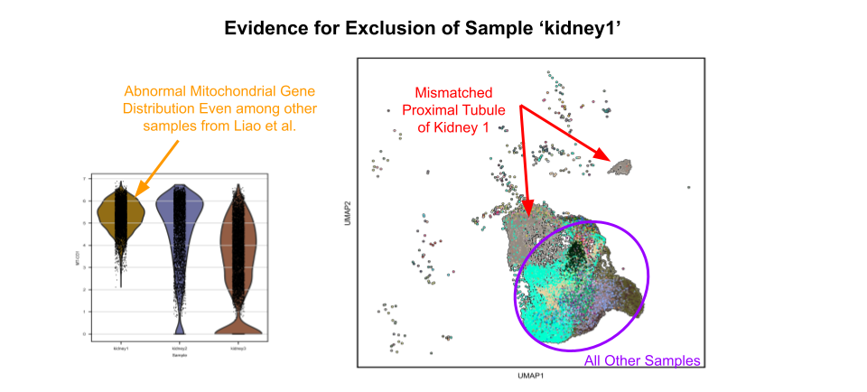

Figure S6: Evidence for exclusion of sample “kidney1” from Liao et al. Violin plot of the expression of a mitochondrial gene in each of the three samples from Liao et al showing a uniform abnormally high distribution of kidney1 (left). UMAP of cells in the “Proximal Tubule” pooled cell type, colored by sample of origin showing that while most samples align with one another, cells from sample kidney1 appear distinct from the group and have poor alignment with the other cells in the same cell type (right).

