Enhanced protocatechuic acid production using metabolically engineered Corynebacterium glutamicum

Jiwoon Chung^{1,2}, Woo-Shik Shin¹, Chulhwan Park^{2,}* and Jaehoon Cho^{1,}*
* Corresponding authors:
Chulhwan Park, PhD
Department of Chemical Engineering
Kwangwoon University
20, Gwangun-ro, Nowon-gu, Seoul, 01897, Republic of Korea
Tel: +82-2-940-5173
E-mail address: chpark@kw.ac.kr

Jaehoon CHO, PhD
Green and Sustainable Materials R&D Department
Korea Institute of Industrial Technology (KITECH)
89, Yangdaegiro-gil, Ipjang-myeon, Seobuk-gu, Cheonan, 31056, Republic of Korea
Tel: +82-41-589-8341
E-mail address: cjh0107@kitech.re.kr

Supporting Information

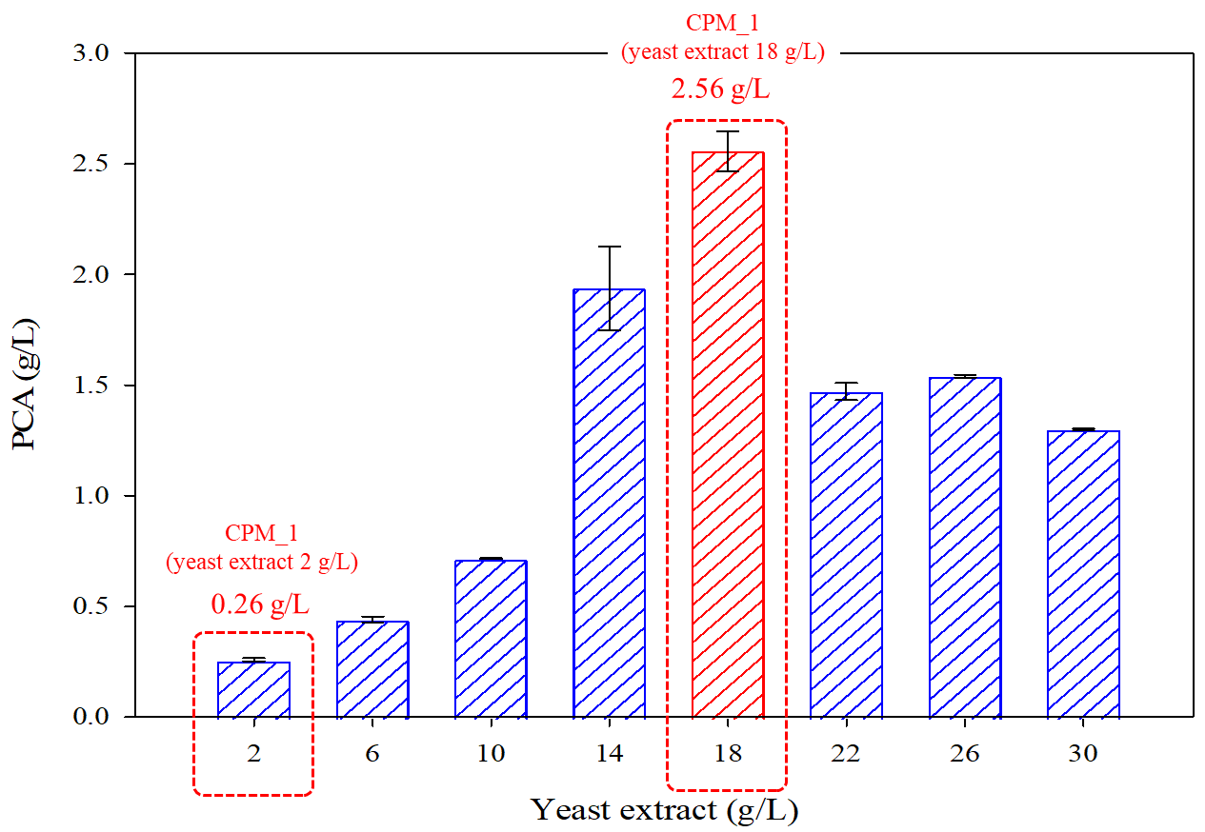
Fig. S1. Effect of yeast extract on PCA production during fermentation in flask cultures. Fermentation was conducted for 72 h in batch culture by C. glutamicum AK103 with CPM_1.

Table S1. Coding and assigned concentration (g/L) of variables of different levels for two-level factorial design. Code levels represent a change in concentration of each factor: -1, reduced concentration; +1, elevated concentration; 0, center point.
Factor | Variable | -1 | 0 | 1
A | Glucose | 35 | 50 | 65
B | Urea | 2 | 5 | 8
C | (NH₄) ₂SO₄ | 2 | 5 | 8
D | Yeast extract | 14 | 18 | 22
E | KH₂PO₄ | 0 | 0.5 | 1
F | MgSO₄⋅7H₂O₄ | 0 | 0.5 | 1

Table S2. Experimental matrix for the fractional factorial design. A, glucose; B, urea; C, (NH₄)₂SO₄; D, yeast extract; E, KH₂PO₄; F, MgSO₄⋅7H₂O.
Run | A: Glucose | B: Urea | C: (NH₄)₂SO₄ | D: Yeast extract | E: KH₂PO₄ | F: MgSO₄⋅7H₂O | Response PCA g/L
1 | 65 | 8 | 8 | 22 | 0 | 0 | 2.66
2 | 65 | 2 | 8 | 22 | 1 | 1 | 3.83
3 | 65 | 2 | 2 | 14 | 0 | 1 | 5.63
4 | 65 | 2 | 2 | 14 | 1 | 0 | 0.98
5 | 65 | 8 | 2 | 22 | 1 | 0 | 2.78
6 | 35 | 8 | 2 | 22 | 0 | 0 | 2.02
7 | 65 | 8 | 8 | 14 | 1 | 0 | 1.10
8 | 35 | 2 | 8 | 14 | 0 | 1 | 4.12
9 | 65 | 2 | 8 | 14 | 0 | 0 | 5.43
10 | 35 | 8 | 2 | 14 | 1 | 0 | 0.93
11 | 65 | 8 | 2 | 14 | 1 | 1 | 1.99
12 | 65 | 8 | 2 | 14 | 0 | 0 | 2.40
13 | 65 | 2 | 2 | 22 | 1 | 1 | 4.62
14 | 35 | 8 | 8 | 22 | 1 | 0 | 1.54
15 | 35 | 2 | 2 | 22 | 1 | 1 | 3.68
16 | 65 | 2 | 2 | 22 | 0 | 0 | 4.26
17 | 65 | 2 | 8 | 22 | 0 | 0 | 4.75
18 | 65 | 2 | 8 | 22 | 1 | 0 | 4.57
19 | 65 | 2 | 8 | 14 | 1 | 1 | 6.80
20 | 35 | 8 | 2 | 22 | 1 | 0 | 2.13
21 | 35 | 8 | 2 | 14 | 0 | 1 | 2.34
22 | 65 | 8 | 8 | 14 | 0 | 1 | 1.96
23 | 35 | 2 | 2 | 14 | 1 | 1 | 5.12
24 | 35 | 8 | 8 | 22 | 0 | 1 | 2.02
25 | 65 | 8 | 2 | 22 | 0 | 1 | 0.45
26 | 35 | 2 | 2 | 22 | 0 | 1 | 3.47
27 | 65 | 8 | 8 | 22 | 1 | 1 | 2.03
28 | 35 | 8 | 8 | 14 | 1 | 1 | 2.19
29 | 35 | 8 | 8 | 14 | 0 | 0 | 0.47
30 | 35 | 2 | 8 | 22 | 0 | 0 | 3.89
31 | 35 | 2 | 2 | 14 | 0 | 0 | 4.42
32 | 35 | 2 | 8 | 14 | 1 | 0 | 4.94

Table S3. Experiment based on the center point of FFD to perform ascent method (SAM). Parameters for the SAM experiment (r value, slope value, new step, and new step Ⅱ) were calculated based on the factorial design.
 |  | Glucose |  | Urea |  | (NH₄)₂SO₄ |  | Yeast extract |  | KH₂PO₄ |  | MgSO₄⋅7H₂O
Center point |  | 50 |  | 5 |  | 5 |  | 18 |  | 0.5 |  | 0.5
Origin step |  | 15 |  | 3 |  | 3 |  | 4 |  | 0.5 |  | 0.5
Main effect |  | 0.23 |  | -1.36 |  | 0.096 |  | -0.13 |  | 0.03 |  | 0.16
Coefficient |  | 0.115 |  | -0.68 |  | 0.048 |  | -0.065 |  | 0.015 |  | 0.08
r Value |  | 1.6109004
Slope value |  | 0.2649783 |  | -1.588465 |  | 0.674188 |  | -1.005234 |  | 0.2968705 |  | 1.6109004
New step |  | 3.974674 |  | -4.765395 |  | 2.0225639 |  | -4.020936 |  | 0.1484352 |  | 0.8054502
New step II |  | 0.7949348 |  | -0.953079 |  | 0.4045128 |  | -0.804187 |  | 0.029687 |  | 0.16109
Steps | Glucose |  | Urea |  | (NH₄)₂SO₄ |  | Yeast extract |  | KH₂PO₄ |  | MgSO₄⋅7H₂O |  | PCA (g/L)
Center point | 50 |  | 5 |  | 5 |  | 18 |  | 0.5 |  | 0.5
1 | 50.794 |  | 4.05 |  | 5.4 |  | 17.2 |  | 0.52 |  | 0.66 |  | 1.95
2 | 51.588 |  | 3.1 |  | 5.8 |  | 16.4 |  | 0.54 |  | 0.82 |  | 2.55
3 | 52.382 |  | 2.15 |  | 6.2 |  | 15.6 |  | 0.56 |  | 0.98 |  | 3.01
4 | 53.176 |  | 1.2 |  | 6.6 |  | 14.8 |  | 0.58 |  | 1.14 |  | 3.31
5 | 53.97 |  | 0.25 |  | 7 |  | 14 |  | 0.6 |  | 1.3 |  | 3.1
6 | 54.764 |  | 0 |  | 7.4 |  | 13.2 |  | 0.62 |  | 1.46 |  | 1.75

Table S4. Experimental matrix of the central composite design (CCD) and PCA production for each experiment. Factor A, urea; Factor B, yeast extract; Factor C, MgSO₄⋅7H₂O.
Run | Factor A: UREA | Factor B: Yeast extract | Factor C: MgSO₄⋅ 7H₂O | Response 1: PCA g/L
1 | 1.2 | 11.43 | 1.14 | 3.79
2 | 0.8 | 16.8 | 1.44 | 4.15
3 | 1.2 | 14.8 | 1.14 | 4.64
4 | 0.8 | 12.8 | 1.44 | 3.25
5 | 1.2 | 14.8 | 1.14 | 4.58
6 | 1.87 | 14.8 | 1.14 | 4.73
7 | 1.2 | 14.8 | 1.14 | 4.39
8 | 1.6 | 16.8 | 0.84 | 5.20
9 | 1.6 | 12.8 | 0.84 | 5.56
10 | 1.6 | 12.8 | 1.44 | 5.58
11 | 0.8 | 12.8 | 0.84 | 3.47
12 | 1.2 | 14.8 | 1.64 | 4.77
13 | 1.6 | 16.8 | 1.44 | 5.38
14 | 0.8 | 16.8 | 0.84 | 4.11
15 | 1.2 | 18.16 | 1.14 | 5.38
16 | 0.52 | 14.8 | 1.14 | 3.24
17 | 1.2 | 14.8 | 0.63 | 4.39

a
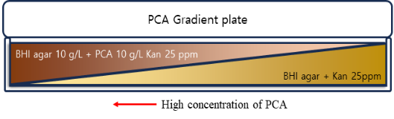
b
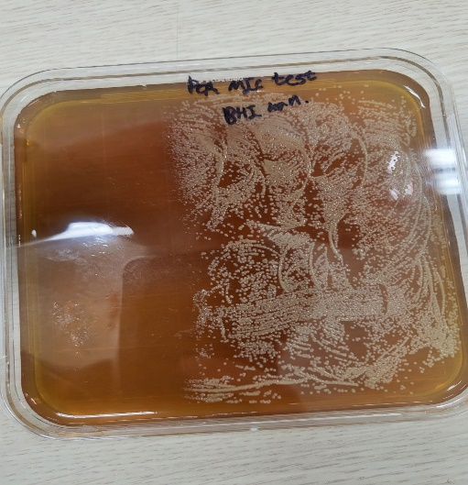
Fig. S2. PCA gradient agar plate. (a) Schematic diagram of a PCA gradient agar plate. (b) Photograph of growing strain colonies. To create a concentration gradient, square plant culture dishes were used because of their convenience and larger surface area for the solid agar culture. The cultured cells were then spread onto the gradient plate using the 100 μL spreading method and incubated for 48–72 h.

a
b
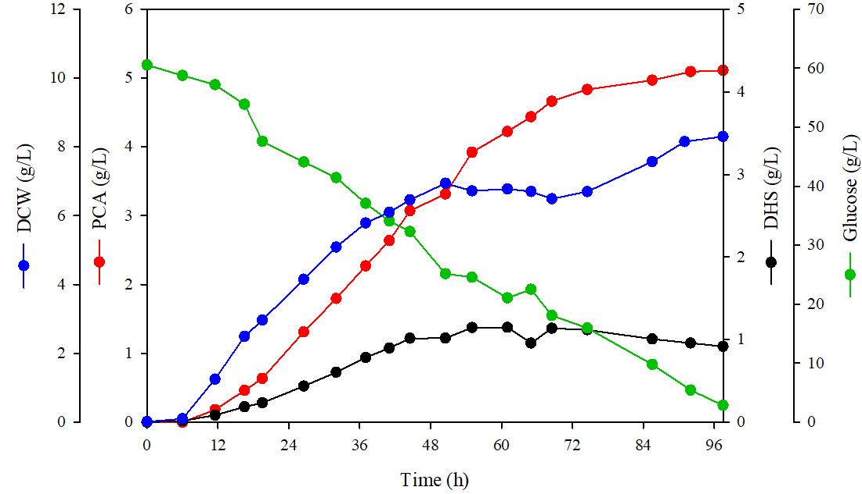
Fig. S3. Effect of substrate supply methods on PCA production during fermentation in a 5 L fermenter. (a) Fermentation was conducted for 97.5 h in fed-batch culture by C. glutamicum AK103 with CPM_2 (46 h feeding start; pulse-feeding of 100 g/L yeast extract). (b) Fermentation was conducted for 97.5 h in fed-batch culture by C. glutamicum AK104 with CPM_2 (46 h feeding start; pulse-feeding of 8× CPM_2).

a b
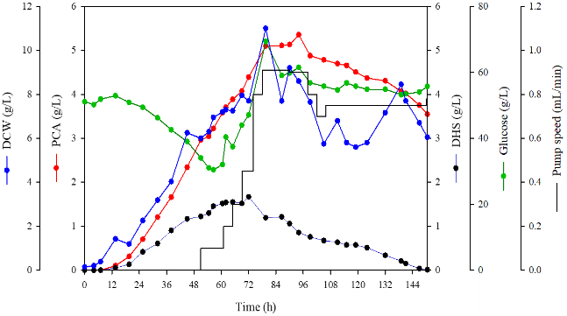
c d
Fig. S4. Time-course profiles of cell growth, sugar consumption, pump speed, and metabolite production in continuous cultures. (a) Fermentation was conducted for 150.5 h in continuous culture with CPM_2 (51 h pump start; production medium: CPM_2; feeding: 8× CPM_2 medium (51~96 h); 1× CPM_2 medium (96 h~)). The 5 L fermentation was performed under the operating conditions. (b) Fermentation was conducted for 150.5 h in continuous culture with CPM_2 (51 h pump start; production medium: CPM_2; feeding: 8× CPM_2 medium (51~80 h); 2× CPM_2 medium (80 h~)). (c) Fermentation was conducted for 172 h in continuous culture by C. glutamicum AK104 with CPM_2 (65 h pump start; production medium: CPM_2; feeding: 1× CPM_2 medium). (d) Fermentation was conducted for 191 h in continuous culture by C. glutamicum AK104 with CPM_2 (65 h pump start; production medium: CPM_2; feeding: 4× CPM_2 medium).

