Supplementary information

Supplementary Figure 1. AstC-DN1 is not involved in vitellogenesis progression during reproductive maturation.
a Number of stage 8–11 and 12–14 follicles per virgin female of the indicated genotypes at the indicated hours after eclosion (HAE) (n = 8–10 for each genotype). One-way ANOVA followed by Tukey's test for multiple comparisons (a and b); **p < 0.005; *p < 0.05; ns (non-significance), p > 0.05.
b Above, experimental protocol. Number of stage 8–11 and 12–14 follicles per virgin female of the indicated genotypes at the indicated HAE (n = 16-20 for each genotype).

Supplementary Figure 2. AstC-mTh neurons and their Ca²⁺ activity during reproductive maturation
a Negative images of the brain (above) and VNC (bottom) from 4-day-old virgin females of the indicated genotypes stained with anti-AstC (black). Arrows indicate the SEZ and VNC regions in which AstC-RNAi driven by AstC-D-split-Gal4 led to an attenuation of anti-AstC labeling. Note that anti-AstC labeling in the SEZ and AstC-mTh neuron somas is lost simultaneously in the presence of AstC-RNAi. Scale bars, 50 μm.
b Negative images of the brain (above) and VNC (bottom) from 4-day-old virgin females carrying AstC-D-split-Gal4, Otd^{Flp}, UAS>stop>UAS-GFP stained with anti-GFP. Scale bars, 50 μm.
c Negative images of TRIC labelling (anti-GFP) of pairs of AstC-mTh neurons in the brain (above) and VNC (bottom) of 4-day-old virgin females, indicating intracellular Ca²⁺ transients, TRIC driven by AstC-D-split-Gal4 labeled one of two AstC-mTh neurons. Arrowheads (red) indicate AstC-mTh neuron somas. Scale bars, 50 μm.
d The GFP intensity in AstC-mTh neurons of TRIC females show Ca²⁺ activity in virgin females at the indicated hours after eclosion (HAE). One-way ANOVA followed by Tukey's test for multiple comparisons; ns (non-significance), p > 0.05.

Supplementary S3 Activation of AstC-D-split-Gal4 neurons reduces JH-III biosynthesis.
Above, experimental protocol for thermal activation followed by JH-III analysis. Bottom, JH-III levels from whole-body extracts from w¹¹¹⁸ S8 stage pupae (2 days before eclosion, day -2), w¹¹¹⁸ adult females (1 day after eclosion, day 1), and AstC-D-split-Gal4, UAS-dTrpA1 adult females (day 1). Each circle indicates the average JH-III level from 10 females. One-way ANOVA followed by Tukey's test for multiple comparisons. *p < 0.05; **p < 0.005; ns (non-significance), p > 0.05.

Supplementary Figure 4. AstC-mTh neurons do not innervate the CA.
a Negative image of the brain-CA complex of 4-day-old virgin females of the indicated genotype stained with anti-GFP (Black). The black arrows indicate the CA. a’ represents a higher magnification image of a. Scale bars, 50 μm.

Supplementary Figure 5. AstC-mTh neurons have a limited influence on insulin signaling.
a Above, experimental protocol. Bottom, relative fluorescence intensity of anti-Dilp2 staining of the brain insulin-producing cells from virgin females of the indicated genotype, maintained for 3 days post-eclosion at 30°C. Each circle indicates a relative fluorescence intensity measurement from all the IPC somas of a single brain. The relative fluorescence intensity was calculated by setting the average of the control group (genotype 1, +>dTrpa1) to 100%. One-way ANOVA followed by Tukey's test for multiple comparisons (a, b); **p < 0.005; ns (non-significance) p > 0.05.
b Wing size in pixels as measured for the indicated genotypes. 1 pixel is close to 2.5 μm.

Supplementary Figure 6. Mating-induced vitellogenesis in Drosophila melanogaster.
The number of vitellogenic follicles of stage 8–14 and oviposited eggs (OVI) from w¹¹¹⁸ virgin females (black bars) or females mated with wild-type Canton-S (CS) males (white bars) or SP-less males (SP⁰/Δ130) (gray bar in g), at the indicated hours after mating. Virgin females were age-matched. Each bar represents n = 6–10. Unpaired t-tests (a-f, h); One-way ANOVA followed by Tukey's test for multiple comparisons (g); ***p < 0.001; **p < 0.005; *p < 0.05; no labeling, p > 0.05.

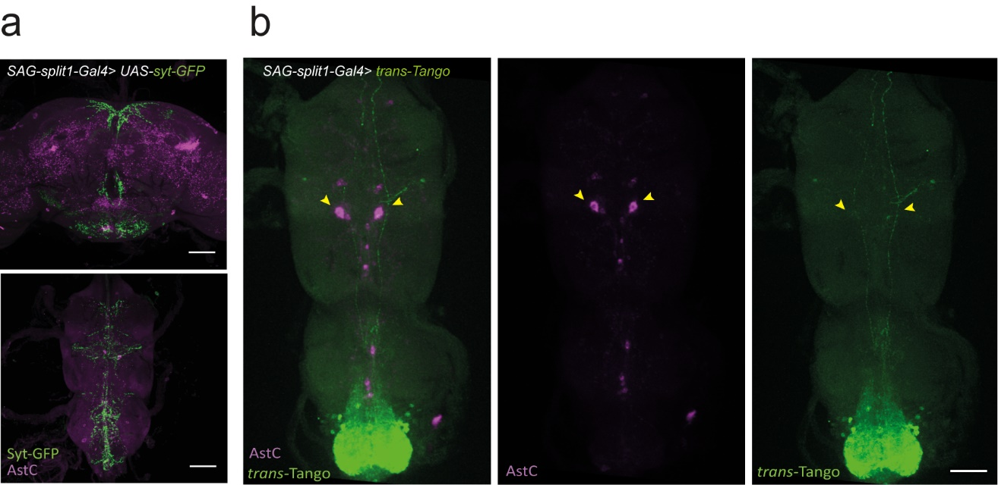
Supplementary Figure 7. Anatomical interaction between SAG neurons and AstC-mTh neurons.
a Confocal Z-projection images of the brain (above) and VNC (bottom) of 4-day-old virgin females carrying SAG-split1-Gal4 and UAS-syt-GFP stained with anti-GFP. Scale bars, 50 μm.
b Confocal Z-projection images of the VNC of 4-day-old virgin females carrying SAG-split1-Gal4 and trans-Tango stained with anti-AstC (magenta) and anti-HA (trans-Tango, green). The trans-Tango signal (green) does not colocalize with AstC-mTh neurons (arrows). Scale bar, 50 μm.

