Additional file 1. SPIRIT figure of the phases of the trial and data collection time points.

STUDY PERIOD

Enrolment
Allocation
Intervention (Post-allocation)
Efficacy

TIMEPOINT ENROLMENT:

Pre- randomization

t0

Randomization t0

1st visit (Baseline)

t0

1st cycle of intervention

Week 1-8

2nd visit
Week 9

Rest

Week 10-14

2nd cycle of intervention

Week 15-23

3rd visit

Week 24

Follow-up
+3 months without intervention

4th visit

Week 37

Eligibility screen X

Informed consent X

ALLOCATION

EA
Small Fibers DPN
X

Sessions 1 to 16

---

Sessions 17 to 32

---

Sham EA
Sessions 1 to 16

---
Sessions 17 to 32

---

Sessions
Axonal DPN
EA 1 to 16

---
Sessions 17 to 32

---

Sham EA
Sessions 1 to 16

---
Sessions 17 to 32

---

ASSESSMENTS:

Demographics X

Anthropometry X X X X

MNSI questionnaire X X X X

MDNS
questionnaire X

X X X

DN-4 questionnaire X X X X

NRS questionnaire X X X X

SF-36 questionnaire X X X X

Nerve Conduction
Velocity Study X

X X X

Biochemical profile X

Inflammation X X X X

Oxidative Stress X X X X

Genetic expression X X X X

Treatment adherence

X X X X

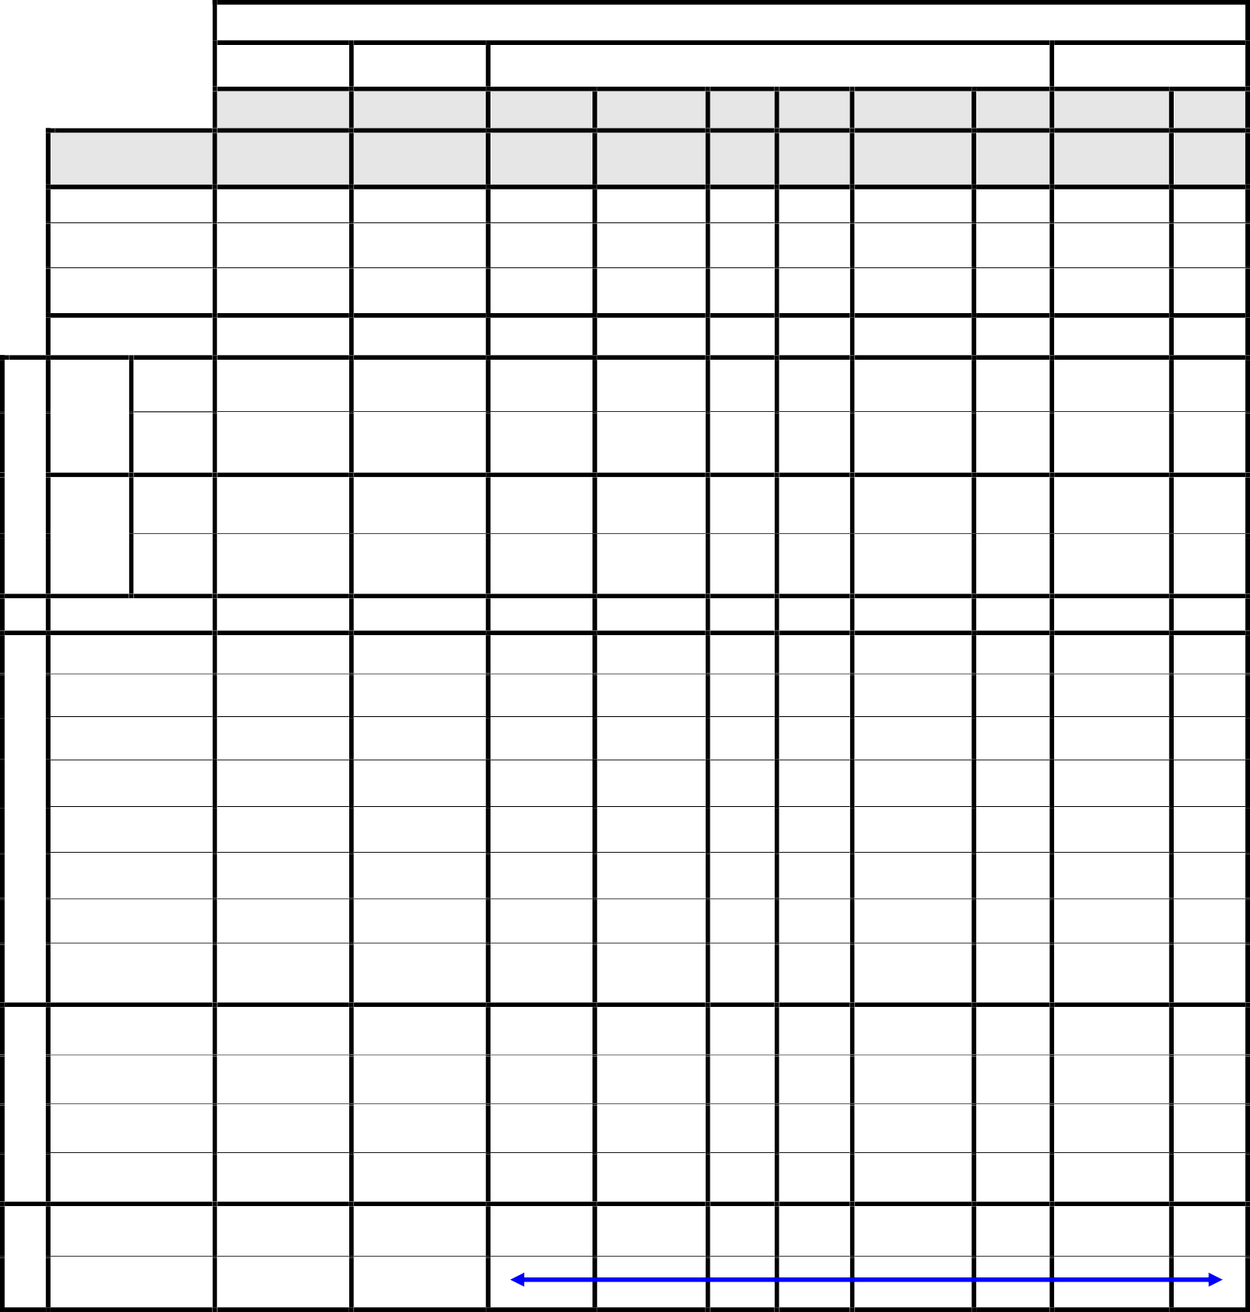
BIOCHEMICAL & MOLECULAR
SECURITY
CLINICAL AND ELECTROPHYSIOLOGICAL
INTERVENTIONS
Adverse effects

t0 = Time zero. DPN = Diabetic Polyneuropathy. EA= Electroacupuncture.

