Supplementary Table 1 Primer sets used for qPCR.

Gene | Forward primer (5´-3´) | Reverse primer (5´-3´)
Igf1r | TGCTGACCTCTGTTACCTCTCCAC | GTCTTCTCACACATCGGCTTCTCC
β-actin | TCAAGATCATTGCTCCTCCTGA | CTCGTCATACTCCTGCTTGCTG

Supplementary Table 2 Antibodies and reagents used in this study.
List of primary antibodies
Antibody | Source | Catalog Number
IGF-1R | Abcam | ab263903
pIGF-1R | Abcam | ab39398
AKT | Cell signaling | #9272
pAKT | Cell signaling | #4060
S6 | Cell signaling | #2217
pS6 | Cell signaling | #2211
GM-CSF | Santa Cruz Biotechnology | sc-32753
IGF-1 | Abcam | ab9572
GAPDH | Fdbio science | FD0063

List of reagents
Name | Source
Cell Counting Kit-8 | Fdbio science,FD3788
NVP-AEW541 | MedChem Express
Rapamycin | Alexis Biochemicals
IGF-1 neutralizing antibody | Millipore (05-172)
TRAP stain kit | Wako
Human GM-CSF ELISA kit | Proteintech, KE00003
Human IGF-1 ELISA kit | Abcam, ab100545
Human IGF-2 ELISA kit | R&D Systems, Bio-Techne, DG200
Mouse IGF-1 ELISA kit | Abcam, ab100695
Mouse IGF-2 ELISA kit | Abcam, ab100696
PrimeScript RT reagent kit | TaKaRa
SYBR Premix ExTaq | TaKaRa
H&E stain kit | Solarbio
GTVisionTM Ⅲ Detection System | Gene Tech
RNAprep Pure FFPE Kit | TIANGEN
Recombinant human IGF-1 protein | Abcam, ab270062
D-luciferin postassium salt | Beyotime,ST196

Supplementary Table 3 The expression of up-regulated genes located in the Plasma membrane were screened.
Location | Plasma membrane | Location | Plasma membrane & Endoplasmic reticulum
 | NRCAM |  | RGMA
 | IGF-1R |  | SPCS1
 | SMIM36 | Location | Cytosol
 | IVL |  | UBE2D2
 | EREG |  | NRK
 | PRKD1 |  | SPRR2F
Location | Nucleus |  | KRTAP10-2
 | NEUROG2 |  | KRT34
 | LBX1 |  | PDCL
 | MAFA |  | FBXW9
 | POU6F2 |  | S100A7A
 | NKX2-2 |  | WDR81
Location | Extracellular | Location | Endoplasmic reticulum
 | GAL |  | RCN1
 | DLK1 | Location | Golgi apparatus
 | ARTN |  | HS3ST2
 | PLAT | Location | Unknown
 | GPRC5B |  | ERVV-1
 | CLPSL1 |  | CCDC166
Location | Cytoskeleton
 | LGALSL

Supplementary Table 4 Gene sets used for GSEA.

Bone mineralization gene list
NUM | SYMBOL | NUM | SYMBOL | NUM | SYMBOL
1 | PHOSPHO1 | 13 | COL1A2 | 25 | BGLAP
2 | LOX | 14 | LEP | 26 | FGR
3 | ASPN | 15 | PKDCC | 27 | PRICKLE1
4 | ZBTB40 | 16 | RSPO2 | 28 | SLC24A3
5 | BMP2 | 17 | SOX9 | 29 | FGFR2
6 | ERCC2 | 18 | FGFR3 | 30 | GPC3
7 | ANKH | 19 | TUFT1 | 31 | FBXL15
8 | LTBP3 | 20 | EIF2AK3 | 32 | IFT80
9 | PTHLH | 21 | PTN | 33 | ALOX15
10 | KLF10 | 22 | PTH1R | 34 | PTH
11 | SNX10 | 23 | HIF1A
12 | IBSP | 24 | COMP

Bone morphogenesis gene list
NUM | SYMBOL | NUM | SYMBOL | NUM | SYMBOL
1 | GHR | 15 | IFITM5 | 29 | LTF
2 | GLI3 | 16 | NPPC | 30 | CITED2
3 | ATF2 | 17 | CER1 | 31 | OSR2
4 | FGF4 | 18 | ATG9A | 32 | SERPINH1
5 | HOXA11 | 19 | ACP5 | 33 | NEUROG1
6 | RIPPLY2 | 20 | AXIN2 | 34 | IHH
7 | MSX2 | 21 | TMEM119 | 35 | HAS2
8 | RARG | 22 | TMEM107 | 36 | ANXA6
9 | EXT1 | 23 | FOXN3 | 37 | STC1
10 | SMPD3 | 24 | MATN1 | 38 | FGFR2
11 | LRP5 | 25 | TSKU | 39 | CDX1
12 | SFRP4 | 26 | MMP13 | 40 | ALPL
13 | MEGF8 | 27 | FOXC1 | 41 | PEX7
14 | FGF18 | 28 | SOX9

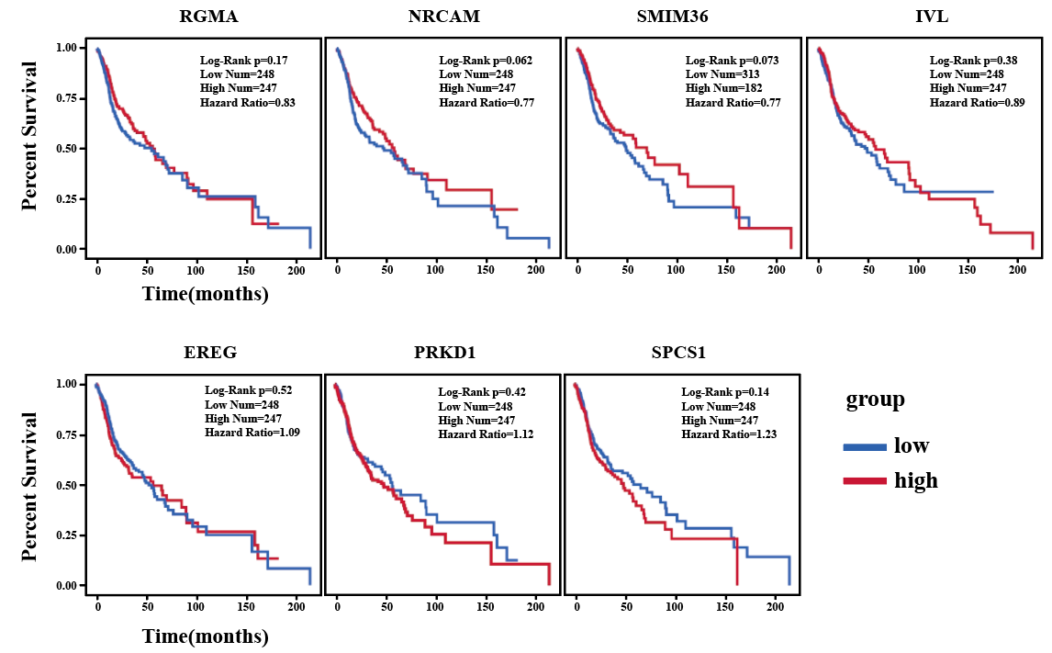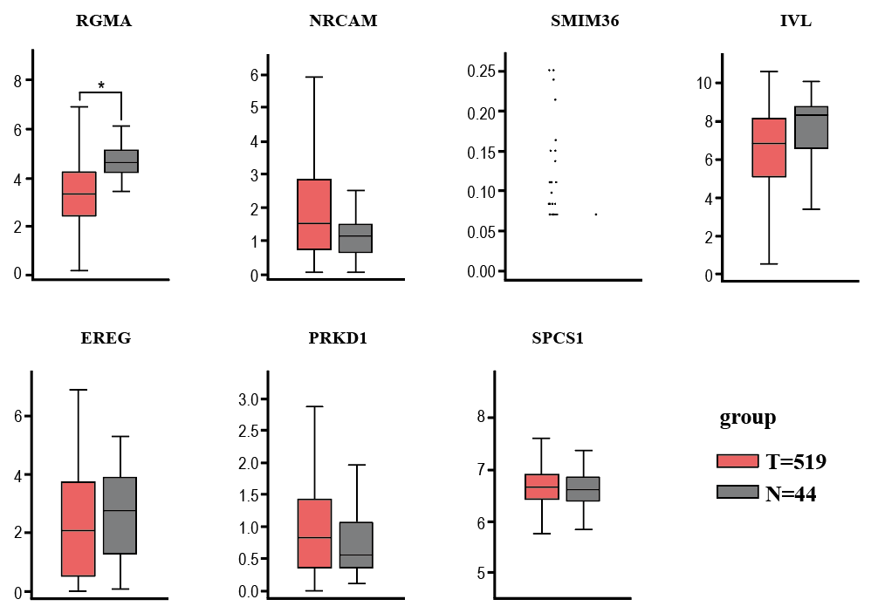
b
a

Supplementary Figure 1 There was no significant difference in survival analysis and in the expression of normal versus tumor tissues of the candidate genes. (a)Survival analysis of candidate genes. (b)Expression of candidate genes in tumor tissues versus normal tissues. (“*” represents P < 0.05.)

