Supplementary Figure
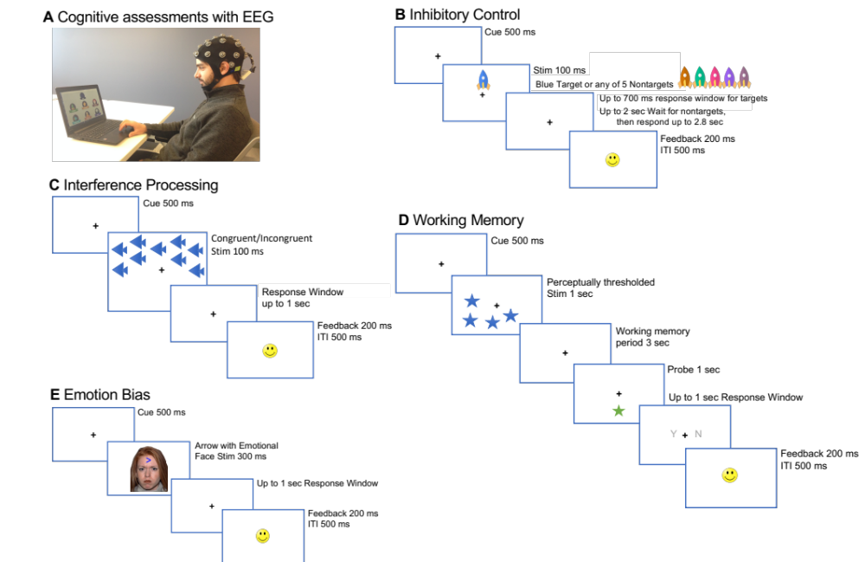

Supplementary Figure 1. Task design for each of the exteroceptive cognitive tasks performed at the same session as the interoceptive task. (A) Setup for cognitive assessments with EEG. Task design shown with temporal sequence for (B) the inhibitory control task, (C) interference processing (Flanker) task, (D) working memory (visuo-spatial delayed match to sample task with perceptually thresholded stimuli), and (D) emotion bias task (presenting neutral, happy, sad or angry faces on equivalent number of trials).
Supplementary Table
Network | Regions of Interest | ROI index in DK Atlas
FPN | caudalmiddlefrontal L | 5
FPN | caudalmiddlefrontal R | 6
FPN | rostralmiddlefrontal L | 55
FPN | rostralmiddlefrontal R | 56
FPN | superiorparietal L | 59
FPN | superiorparietal R | 60
CON | caudalanteriorcingulate L | 3
CON | caudalanteriorcingulate R | 4
CON | insula L | 19
CON | insula R | 20
CON | parsopercularis L | 37
CON | parsopercularis R | 38
CON | parsorbitalis L | 39
CON | parsorbitalis R | 40
CON | parstriangularis L | 41
CON | parstriangularis R | 42
CON | superiorfrontal L | 57
CON | superiorfrontal R | 58
CON | transversetemporal L | 67
CON | transversetemporal R | 68
aDMN | frontalpole L | 11
aDMN | frontalpole R | 12
aDMN | lateralorbitofrontal L | 25
aDMN | lateralorbitofrontal R | 26
aDMN | medialorbitofrontal L | 29
aDMN | medialorbitofrontal R | 30
aDMN | rostralanteriorcingulate L | 53
aDMN | rostralanteriorcingulate R | 54
pDMN | inferiorparietal L | 15
pDMN | inferiorparietal R | 16
pDMN | isthmuscingulate L | 21
pDMN | isthmuscingulate R | 22
pDMN | precuneus L | 51
pDMN | precuneus R | 52
mtDMN | entorhinal L | 9
mtDMN | entorhinal R | 10
mtDMN | inferiortemporal L | 17
mtDMN | inferiortemporal R | 18
mtDMN | middletemporal L | 31
mtDMN | middletemporal R | 32
mtDMN | parahippocampal L | 35
mtDMN | parahippocampal R | 36
mtDMN | superiortemporal L | 61
mtDMN | superiortemporal R | 62
mtDMN | temporalpole L | 65
mtDMN | temporalpole R | 66

Supplementary Table 1. Regions of Interest (ROIs) grouped within five cognitive brain networks are enumerated for the fronto-parietal network (FPN), cingulo-opercular network (CON) and the anterior, posterior and medial temporal default mode network (DMN). Corresponding indices of ROIs within the Desikan-Killiany (DK) atlas are also shown. L: left, R: right.

