Appendix 05. Figure 2. Distribution of number of completed pulmonary rehabilitation visits (of 16) for participants in the Libre post TB intervention at SES Policlínico in Lima, Peru, beginning in March 2022 (N=40).
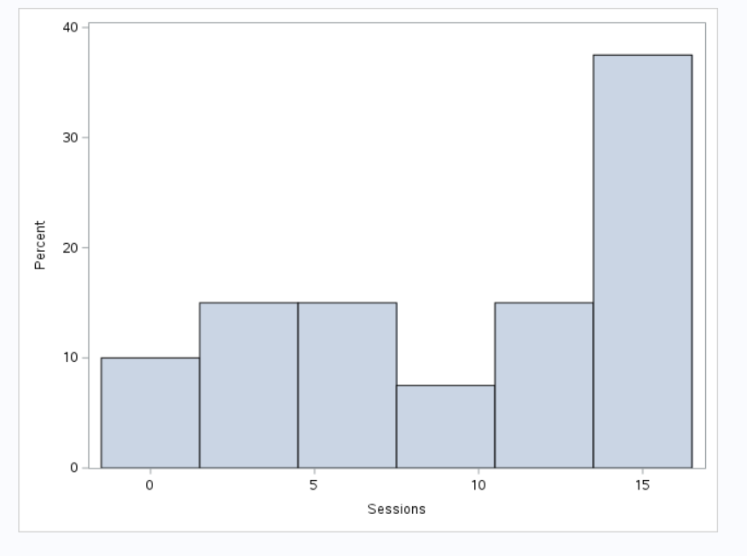
% completing pulmonary rehabilitation sessions
Number of pulmonary rehabilitation sessions completed

