Photocatalytic Study
In the full factorial design, all possible combinations of the factors and their settings are simultaneously considered. Assume that there is k investigating variables and each variable could be set to m distinctive levels. So, the number of possible combinations of the factors and their settings is m^{k}. In chemical systems, three levels of the factor setting is common because such designs allow the determination of all main effects and all interaction effects with small number of experiment.
In full factorial method, the relation between factors and response is theoretically modeled which causes the reproducibility in the phenomenon under study to be able to experiment with it and to elucidate the results. Response surface methodology (RSM) is a mathematical and statistical method, which analyzes experimental design by applying an empirical model [33]. The adequacy of the applied model is checked using analysis of variance (ANOVA) and least squares techniques which need some replicate experiments [33]. In these analyses the differences between group means with the variability within the groups around the corresponding mean values are compared and produce F-distribution ratio. This ratio is called an F-value that is varied from 1 to larger values. Values far from 1, exceeding from the tabulated F-value, provide evidence against the null hypothesis, indicating the significance of the regression parts of the fitted models. Equivalently, the null hypothesis is rejected when p-value is less than a significant level. In order to obtain the significant and reliable model at the 95% confidence level, the p-values for the fitted model and its corresponding terms should be smaller than 0.05. The p-value of the present regression was smaller than 0.05, showing that the model was significant at a high confidence level (95%) [33]. A further assessment of the fitted model can be carried out using the lack-of-fit test. Via this statistical test, the residual part is sub-divided into pure error and lack-of-fit. In other words, it distinguishes the random error from the systematic one, causing the lack of fit of the model with specific order. Therefore, at the 95% confidence level, the p-values for the lack-of-fits should be greater than 0.05, which is not significant.

Experimental design for achieving optimal conditions in MG degradation process
The photocatalytic activity of the synthesized Sr₂Nb₂O₇ samples was investigated for the degradation of MG in the presence of H₂O₂ (30%, w/w) under visible light irradiation. To prepare 100 ppm MG dye solution, 25 mg of MG powder was dissolved in 250 mL of deionized water. The pH value of the obtained solution was 4. In a typical photocatalytic experiment, certain amount (g) of the as-synthesized Sr₂Nb₂O₇ (S₁) photocatalyt was added to 70 mL of the prepared MG aqueous solution and sonicated for 10 min in a dark room to establish an adsorption/desorption equilibrium between MG molecules and the surface of the photocatalyst. Afterwards, certain volume (mL) of H₂O₂ was added into the mixture solution, followed by further magnetic stirring under solar light condition. When the designed time (min) was elapsed, the solution was drawn out and the photocatalyst was separated by centrifugation in order to measure the absorption spectra of MG and calculate the MG concentration using UV-Vis spectrophotometry. The mixture was kept at a constant stirring of 300 rpm at the temperature of the experiment. Besides, the photocatalytic performance of the other synthesized nanomaterials (S₂ – S₄) was studied at the optimized condition to investigate the size of the obtained materials on the degradation yield. The photodegradation yield (%) of MG was calculated by the following formula:
$$\left(\frac{{\text{A}}_{\text{0}}\text{-}{\text{A}}_{\text{t}}}{{\text{A}}_{\text{0}}}\right)×100$$
where, A₀ and A_{t} represent the initial absorbance of MG at 612 nm and the absorbance at time t, respectively.
The optimal conditions were obtained by design expert software for S₁. The volume and concentration of the as prepared MG solution were 80 mL and 50 ppm, respectively, for obtaining the optimum conditions. It was found that the optimum conditions were 0.61 mL H₂O₂, 40 mg catalyst, and 60 min time.

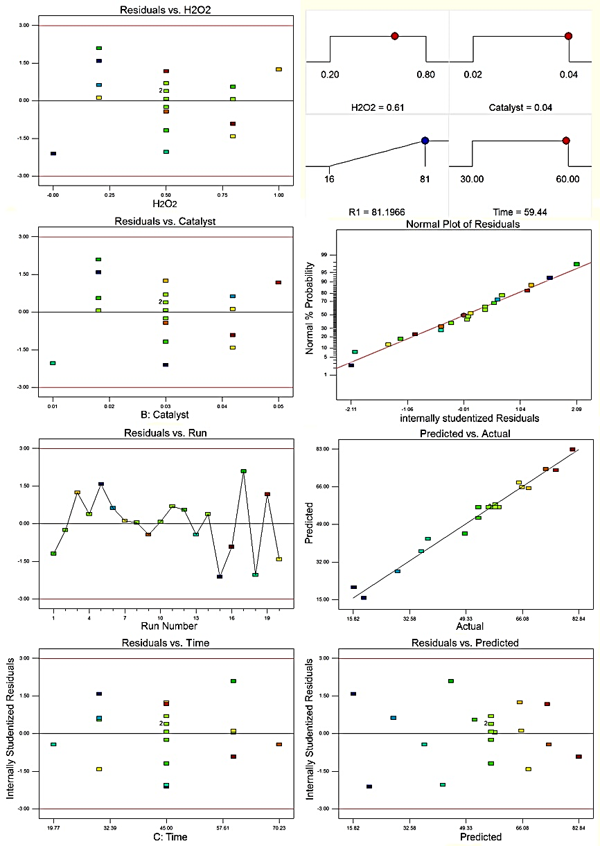
Figure S₁. (a) The experimental data versus the predicted data of normalized removal of dye and (b) the normalized residual plot.
To illustrate the effects in the above model, the three–dimensional (3D) response surfaces plot of the response (using equation (1) when the amount of time was fixed at optimal level and the other two were allowed to vary) is shown in figure S₂. To investigate the interactive effects of the three influential factors on the proposed process, the response surface methodology (RSM) was used. Figure S₂ represents the 3D and 2D plots related to the interaction of AC, AB and BC. The semi-curvatures of these plots indicate the interaction between the variables. In other words, as stirring time, H₂O₂ and catalyst amount increase, dyes removal percentage improves. This means that, the mass transfer of dye molecules enhances on the surface of the catalyst and the dye adsorption process on the catalyst reaches equilibrium state quickly. Also, by increasing the catalyst amount, further surface area of adsorbent is available for dyes molecules leads to enhance the dyes removal percentage.
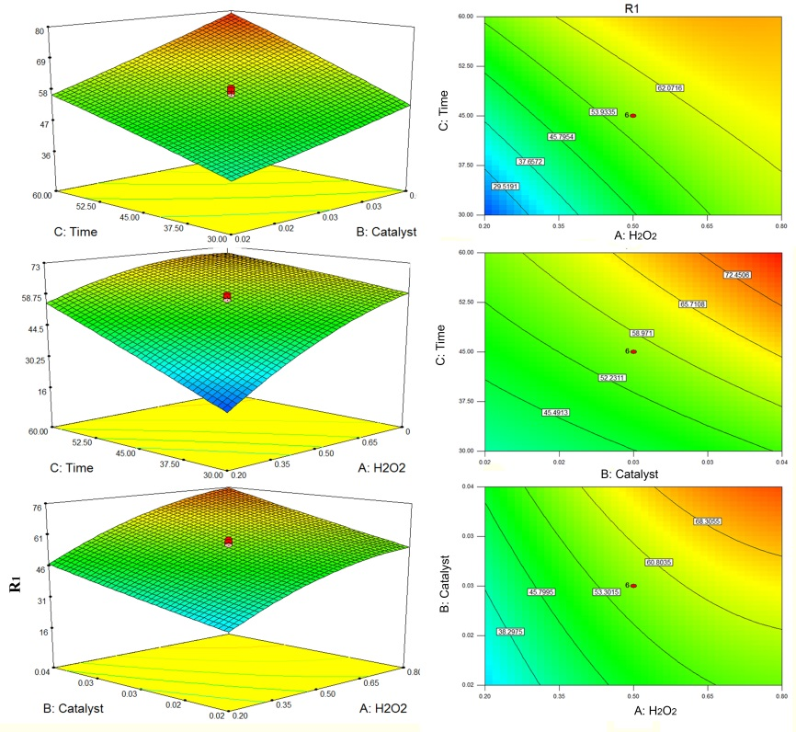
Figure S₂. 3D surface plot of removal of MG dye.

Proposed mechanism for photocatalytic degradation
The mechanism of converting light energy to chemical energy in the photocatalysis by Sr₂Nb₂O₇ composite (SrNbO-C) could be similar to previously reported and extensively studied mechanism; in a way that electrons (e⁻) and holes (h⁺) could be excited under visible irradiation to the conduction band and the valence band edge, respectively. These photo-excited e⁻ and h⁺ then can transfer to the surface of the photocatalyst, where they react with oxidants and reductants, respectively, or recombine in the absence of e⁻ and h⁺ traps. The recombination of e⁻ and h⁺ could be greatly minimized in the presence of H₂O₂, which traps the e⁻ and h⁺ to form •OH and •O₂⁻ species [34]. The excited e⁻ reacts with H₂O₂ to form HO• and OH⁻ groups. The formed OH⁻ group reacts with h⁺ and forms HO• group. Besides, H₂O₂ can trap the photoexcited species in another way. It reacts with h⁺ and forms HO₂• radical and H⁺. The produced HO₂• is decomposed to •O₂⁻ and H⁺. H₂O as the solvent of the photodegradation reaction can react with h⁺ to form HO• and H⁺ species. The produced H⁺ ion reacts with the dissolved O₂ and 2e⁻ and forms the initial H₂O₂. The dissolved O₂ can also react with e⁻ to form •O₂⁻. The so-formed •OH or •O₂⁻ species are used for the decomposition of organic contamination molecules such as MG to intermediates or mineralized products through oxidation reactions [35-37].
$$SrNbO-C+hν →h^{+} \left(SrNbO-C\right)+ e^{-} \left(SrNbO-C\right) \left(1\right)$$
$$H_{2}O_{2}+ e^{-} \left(SrNbO-C\right)→{HO}^{•}+ {OH}^{-} (2)$$
$${OH}^{-}+ h^{+} \left(SrNbO-C\right)→{HO}^{•} (3)$$
$$H_{2}O_{2}+ h^{+} \left(SrNbO-C\right)→{HO}_{2}^{•}+ H^{+} (4)$$
$${HO}_{2}^{•}→ {•O}_{2}^{-}+ H^{+} (5)$$
$$H_{2}O+ h^{+} \left(SrNbO-C\right)→{HO}^{•} + H^{+}(6)$$
$$2H^{+}+ O_{2}+2e^{-} → H_{2}O_{2} (7)$$
$$O_{2}+ e^{-} \left(SrNbO-C\right)→{•O}_{2}^{-} (8)$$
$$MG+ {OH}^{•}+ {•O}_{2}^{-} →degradation product (9)$$
The maximum removal efficiency (81 %) was obtained at 0.61 mL of H₂O₂ volume, and it slightly decreased above the volume. It is because the produced highly reactive hydroxyl radical (eq. 11) reacts with excess amount of H₂O₂ and produces hydroperoxyl radical (HO₂•) (eq.12) which is less reactive and ultimately inhibits the degradation with producing O₂ and H₂O in (eq.14). The reaction mechanism is explained below [38, 39]:
$$H_{2}O_{2}+ e^{-} \left(SrNbO-C\right)→{HO}^{•}+ {OH}^{-} (10)$$
$${OH}^{-}+ h^{+} \left(SrNbO-C\right)→{HO}^{•} (11)$$
$$H_{2}O_{2}+ {HO}^{•} → {HO}_{2}^{•}+ H_{2}O (12)$$
$$H_{2}O_{2}+ {{HO}_{2}}^{•} → {HO}^{•}+ O_{2}+H_{2}O (13)$$
$${HO}^{•}+ {{HO}_{2}}^{•} → O_{2}+H_{2}O (14)$$
Finding kinetic order for the photocatalytic reaction
Finding the reaction kinetic of the present photocatalytic process is important part to investigate the influence of the parameters on the reaction rate. Langmuir–Hinshelwood (L–H) kinetic model is used to find the kinetic order of most catalytic processes using heterogeneous catalysts (Eq. (8)).
r₀=-(dC₀)/dt=(kKC₀)/(1+kC₀ ) (8)
In which k, K_{app}, R²and r₀are the adsorption coefficient of the reaction, the apparent rate constant of the reaction, correlation coefficient and the initial rate of the reaction respectively.
The K_{app} and R² of the Biginelli reaction were studied by first-order kinetic model (Eq. (9).
ln[C₀]/[C] =K_{app}t (9)
Where C is ethyl acetoacetate concentration in the reaction mixture at time t; C₀ is the initial ethyl acetoacetate concentration; and k is the first-order rate constant.
The graph in figure S₄ shows the catalytic behavior of S₁. The data indicates that the linear dependence of the graph at the time intervals among 0 to 90 min follows a first-order kinetic model for the two samples. The slope of the line represents the apparent rate constant (K_{app}). The amount of K_{app} and R² values are 0.0411 min⁻¹ and 0.954 for S₁.

Figure S₄. Plot of ln (C₀/C) versus reaction time for the photodegradation of MG..

To show the merit of the present work, we have compared Sr₂Nb₂O₇ nanocatalyst results with some of the previously reported catalysts for the degradation of MG (Table S₁). It is clear that Sr₂Nb₂O₇ showed greater activity than some other heterogeneous catalysts. Besides, the high yields of photodegradation were achieved in this work by the application of solar light condition.

Table S₁. Comparison study of the photocatalytic ability of the synthesized Sr₂Nb₂O₇ with other catalysts [40].
Catalyst | Condition | Yield (%)
Sr₂Nb₂O₇ (Present Work) | H₂O₂, 40 mg catalyst, 60 min, visible ligth, 80 mL of 50 ppm MG | 81
Sr₂As₂O₇ | H₂O₂, 20 mg catalyst, 33 min, solar ligth, 70 mL of 100 ppm MG | 97
MoS₂/TiO₂ | 40 min, sunlight irradiation, 0.1 g catalyst, 10 ppm MG | 97
PbCrO₄ | 365 ppm MG, 0.1 g catalyst, 4 h, pH=7.5, visible light, 60 min | 90
Ni_{1-x}Co_{x}Fe₂O₄ | Sunlight, 50 mL of 25 ppm catalyst, 1 µM MG, H₂O₂, 15 h | 100
Carbon/TiO₂ | 25 ppm MG, 30 min, pH=8 | 82-100
Mg-doped TiO₂ | Vis light, pH=9, 100 ppm MG | 89
La/N co-doped TiO₂ (Ni) | 50 W tungsten halogen lamp, 500 mL of 30 ppm MG, 240 min | 100
Cd(OH)₂-NW-AC | 0.06 g catalyst, 50 mL of 15 ppm MG, 35 min | 90
ZnO-NP-AC | 50 mL of 15 ppm MG, 0.015 g catalyst, 35min, pH=7 | 95
Fe₃O₄@Mel | 0.3 g catalyst, pH=6.3, 100 mL of 8 ppm MG, 20 min | 9mg_{MG}/g_{cat}
FeSO₄ -7H₂O | 10 mM Fe²⁺, 40 °C, 25.5 mM H₂O₂, 10 ppm MG | 94
ZnO | 4h time, 60 ppm MG, pH=7.5, solar radiation | 98
Prosopis cineraria | 100 mL of 500 ppm MG, 0.4 g PCSD, 3 h | 80
polyoxometalates | 0.1 g catalyst, 200 mL of 0.02 mM of MG, 160 min | 65
S-Me/MA | 6 mL of 1000 ppm MG, 50 °C, 24 h, 0.06 g catalyst, pH=10 | 98
Aspergillus flavus | pH=5.8, 150 ppm MG, 8 day | 100

