Supplementary information:
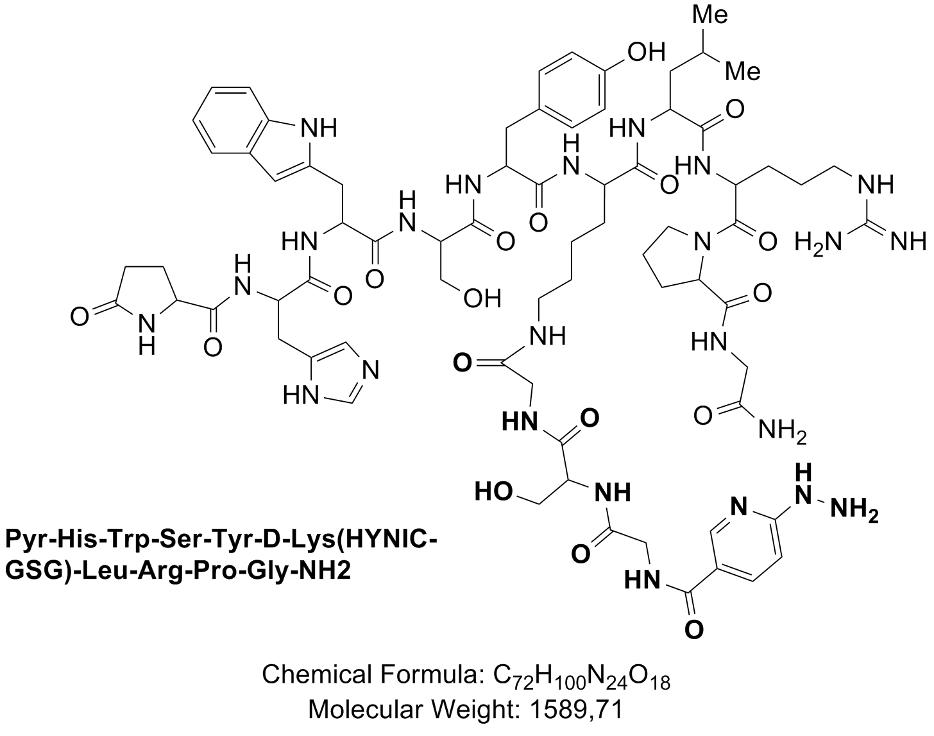

Figure S1: Decapeptide analog HYNIC-GSG-LHRH(D-Lys6) as provided by SIQUIMIA S.A (Uruguay); C₇₂H₁₀₀N₂₄O_{18;} 1589.71 g/mol.
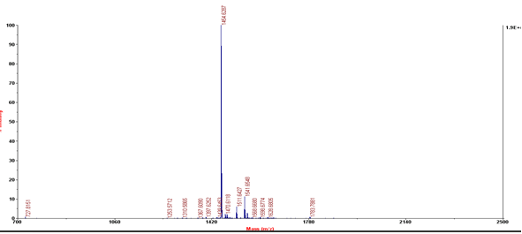
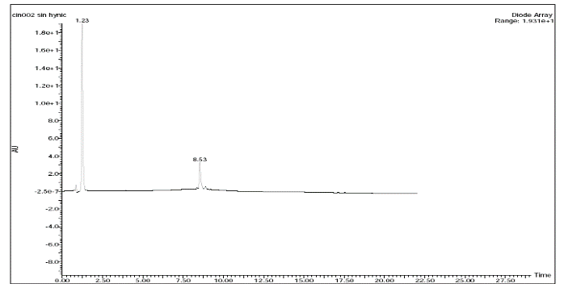

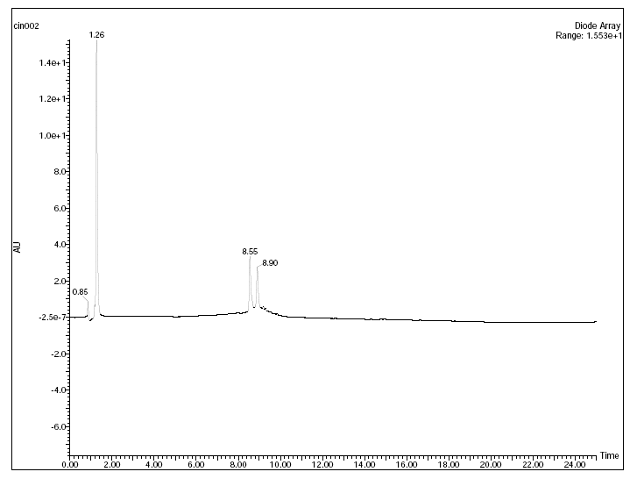
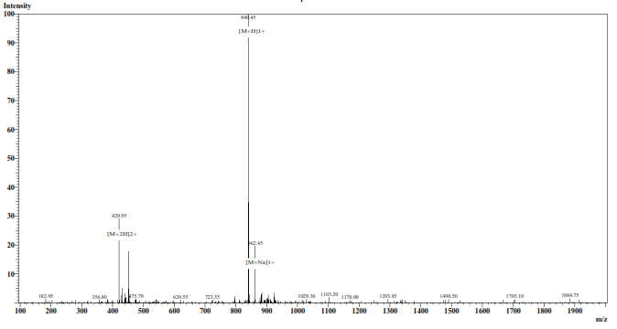

Figure S2: Mass spectrometry (left) and HPLC-UV chromatogram (right) of LHRH(D-Lys6); 1454.6 g/mol (top) and HYNIC-GSG-LHRH(D-Lys6), 1589.71 g/mol, (bottom), provided by SIQUIMIA.S.A.

Table S1: Biodistribution outcomes conducted in normal Balb/c female mice; reported as percentage injected dose per gram (%ID/g, top) and percentage injected dose (%ID, bottom) (mean ± SD, n=4).
%ID/g | 1 h p. i | 3 h p. i | 6 h p. i
Blood | 0.3 ± 0.1 | 0.03 ± 0.02 | 0.18±0.01
Liver | 0.82 ± 0.02 | 0.95 ± 0.03 | 1.15± 0.01
Heart | 1.1± 0.6 | 0.83 ± 0.02 | 0.92± 0.01
Lungs | 1.9 ± 0.1 | 1.58 ± 0.03 | 1.86± 0.03
Spleen | 0.97 ± 0.04 | 0.78 ±0.06 | 1.36± 0.02
Kidneys | 38.4 ± 3.5 | 59.3 ± 2.3 | 30.53± 0.04
Thyroid | 1.14 ± 0.08 | 0.96 ±0.02 | 0.94± 0.01
Muscle | 0.07 ± 0.03 | 0.06 ± 0.04 | 0.07± 0.01
Bone | 0.08 ± 0.05 | 0.01 ±0.01 | 0.01±0.01
Stomach | 1.4 ± 0.1 | 1.55 ± 0.04 | 1.3± 0.2
%ID
Urine+Bladder | 47.3 ± 0.5 | 48.3 ± 0.1 | 48.0±1.7
GIT | 1.6 ± 0.6 | 2.7 ± 0.2 | 4.8± 1.6

Table S2: Biodistribution Outcomes conducted on Balb/c female mice, harboring unblocked and blocked 4T1 tumors, reported as percentage injected dose per gram (%ID/g, top) and percentage injected dose (%ID, bottom) (mean ± SD, n=4). Statistical annotations are as follows: **** for P≤0.0001, *** for P≤0.001, ** for P≤0.01, * for P≤0.05, and not annotated for P>0.05 (not significant), utilizing Student's t-test for analysis

%ID/g | 1 h p. i | 3 h p. i | 3 h p.i block | 6 h p. i
Blood | 1.6 ± 1.1 | 0.73 ± 0.01 | 0.4 ± 0.2 | 0.7±0.1
Liver | 3.2 ± 1,1 | 1.8± 0.7 | 2.3± 1.3 | 2.0± 0.7
Heart | 2.5 ± 1.1 | 2.5± 1.4 | 1.7± 0.7 | 2.4± 0.6
Lungs | 4.1 ± 0.5 | 1.5± 1.0 | 1.0± 0.7 | 2.8± 0.3
Spleen | 2.3 ± 1.2 | 1.4± 0.4 | 1.4± 0.3 | 1.8± 0.4
Kidneys | 72.8 ± 15.8 | 55.1±8.6 | 33.4±12.3**** | 57.5± 5.4
Thyroid | 2.5± 0.6 | 3.6±2.1 | 2.3±0.5 | 2.2± 0.3
Muscle | 0.12 ± 0.03 | 0.16±0.07 | 0.18±0.07 | 0.18± 0.03
Bone | 0.22± 0.09 | 0.2±0.2 | 0.3±0.1 | 0.3± 0.1
Stomach | 4.1 ± 0.3 | 2.5±1.0 | 1.10±0.02 | 4.1± 1.3
Tumor | 5.8 ± 0.5 | 3.7±0.4 | 1.7±0.9 * | 3.1± 0.6
Tumor/Muslce | 30.5 ± 11.1 | 14.5 ± 6.6 | 7.8 ± 1.5 | 13.7 ± 1.4
Tumor/Blood | 2.8± 1.5 | 5.5 ± 3.5 | 6.9 ± 2.6 | 4.7 ± 1.1
Tumor/Liver | 1,4 ± 0.1 | 3.0 ± 1.9 | 0.7±0.2 | 1.8 ± 0.8

%ID | 1 hs p.i | 3 hs p.i | 3 hs p.i block | 6 hs p.i
Urine+Bladder | 10.4 ± 1.3 | 54.1 ± 14.2 | 39.1 ± 22.3 | 51.9±9.5
GIT | 3.7 ± 0.6 | 4.7± 0.5 | 6.8± 5.1 | 4.0± 0.5

