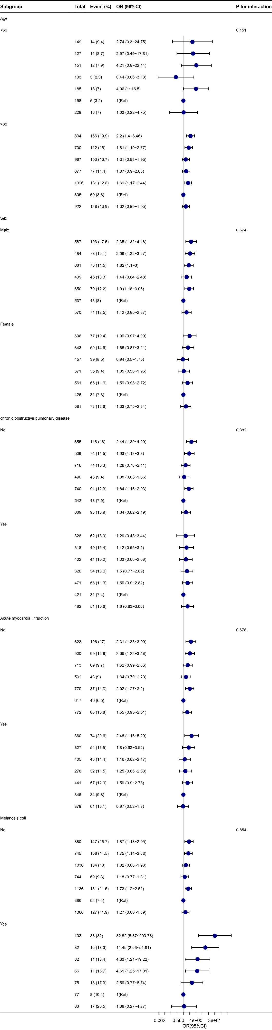

Supplement Figure. Stratified analyses of the association between Blood calcium with In-hospital mortality rate.
Note: The p value for interaction represents the likelihood of interaction between the Blood calcium with Intrahospital mortality rate.
Abbreviations: OR, odd ratio; CI, confidence interval.

