Graph 1 Comparison of INSL3, INSL7, RXFP1, Testosterone, MDA levels in testicular tissue of male offspring between the groups (mean±SD).
b)
a)

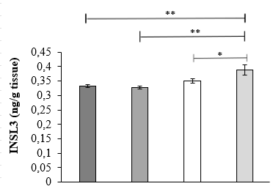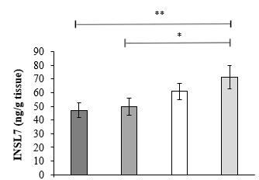
d)
c)

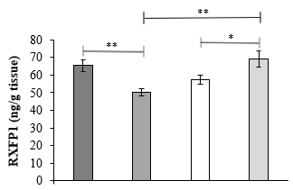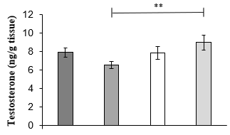

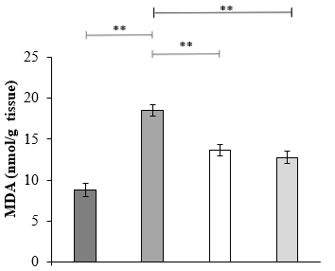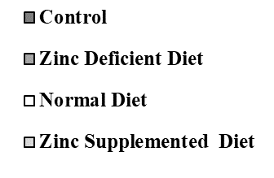
e)

(*p<0.05, **p<0.01) The differences between the groups are statistically important.

Graph 2 Comparison of INSL3, INSL7, MDA levels in liver tissue of male offspring between groups (mean±SD)
b)
a)
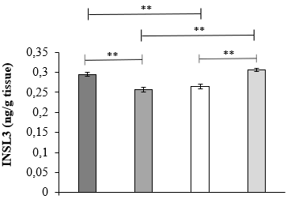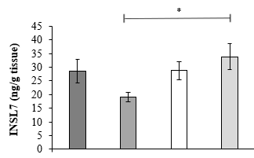
c)

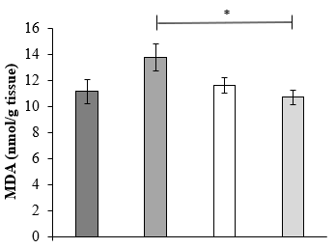

(*p<0.05, **p<0.01) The differences between the groups are statistically important.

