Supplementary Information S1. MS spectrum [M H⁺] of selected actinomycetes extract based on LC-MS/MS analysis

MS spectrum [M H⁺] of Putative compound detected from APM-7 strain.
Compound 4 (7-deoxyechinosporin)
Compound 3 (Unknown)
Compound 2 (Enteromycin)
Compound 1 (Rancinamycin)

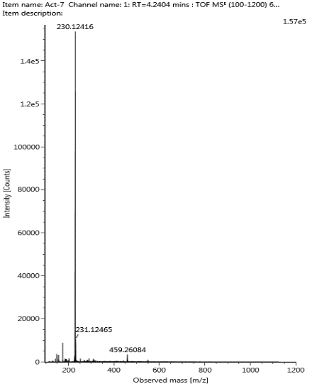
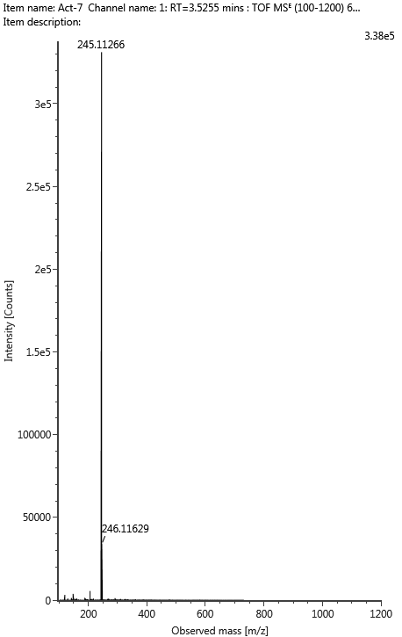
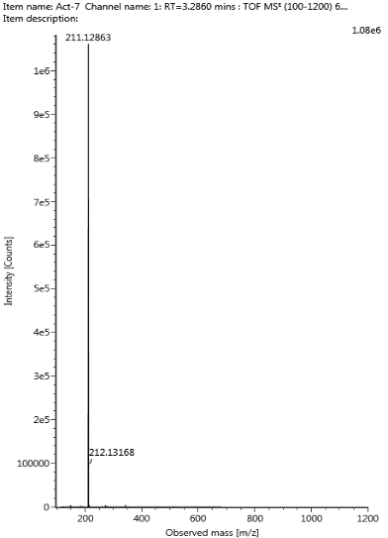
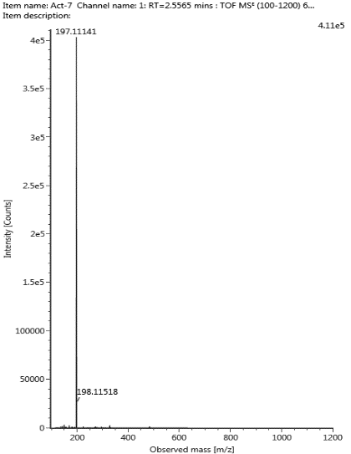

Compound 6 (Bromoisorumbrin)
Compound 7 (Maremycin)
Compound 5 (Unknown)
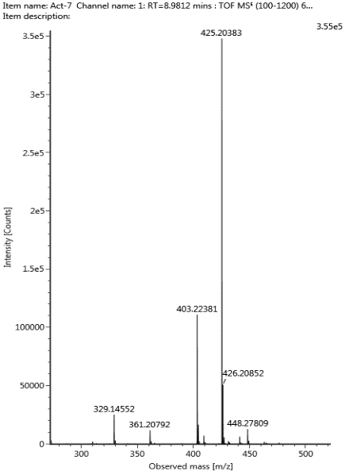
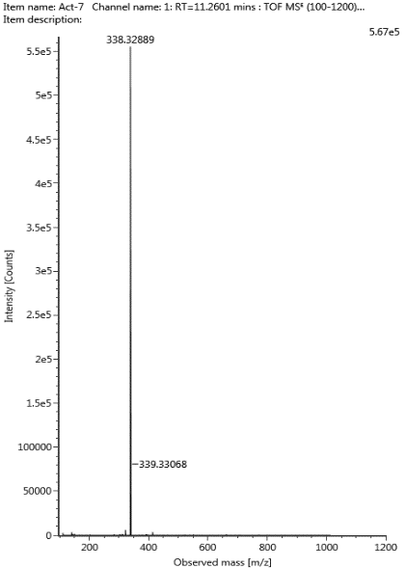
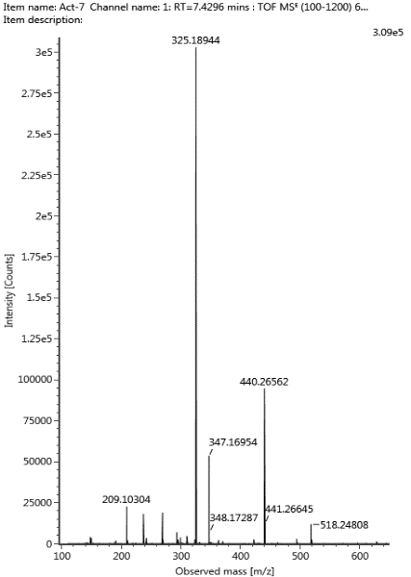

MS spectrum [M H⁺] of Putative compound detected from APM-11 strain.
Compound 4 (Unknown)
Compound 3 (Unknown)
Compound 2 (Enteromycin)
Compound 1 (Rancinamycin)

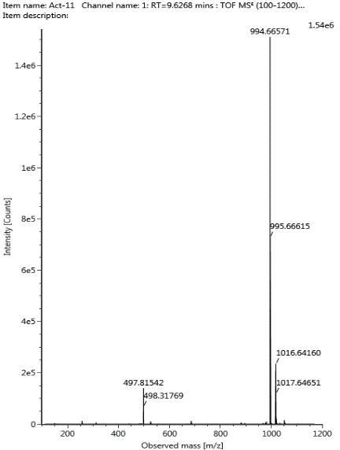
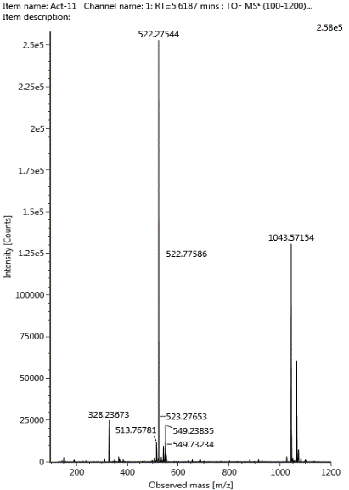
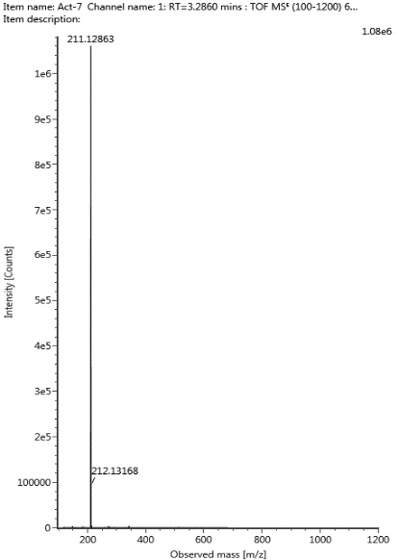
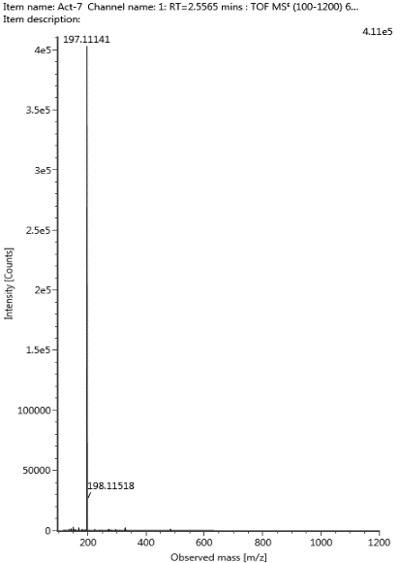

Compound 7 (Thiazohalostatin)
Compound 6 (Unknown)
Compound 5 (Ashimide B)
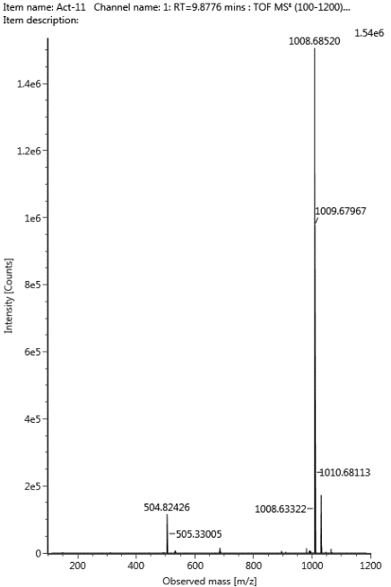
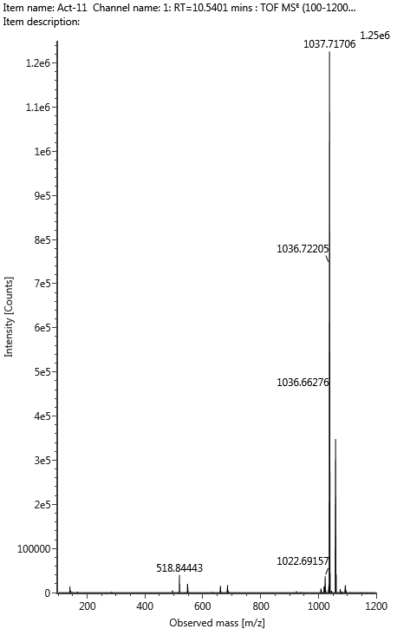
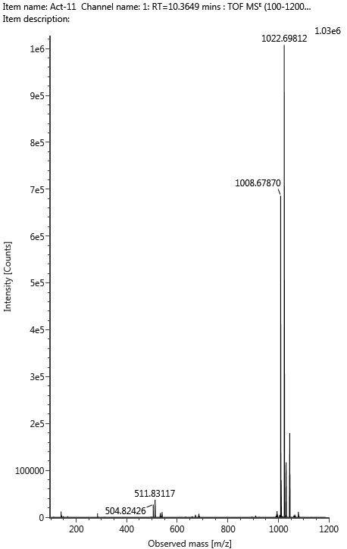

MS spectrum [M H⁺] of Putative compound detected from APM-21 strain.
Compound 4 (Paramagnetoquinone C)
Compound 3 (Unknown)
Compound 2 (Enteromycin)
Compound 1 (Rancinamycin)
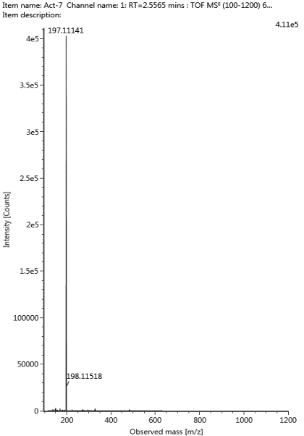
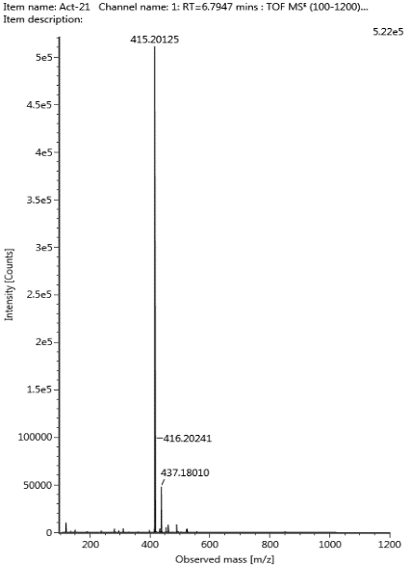
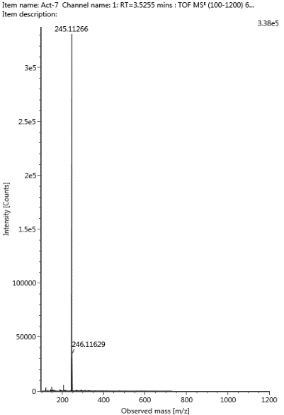
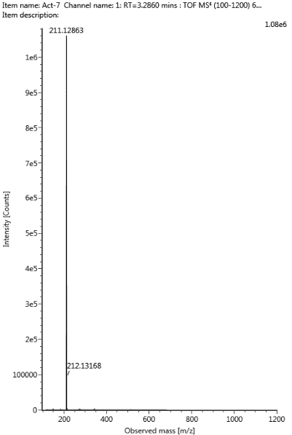

Compound 5 (Bromoisorumbrin)
Compound 6 (Caerulomycin I)
Compound 7 (Maremycin)
