SUPPLEMENTARY MATERIAL (SM)
1. Materials and methods
1.1. Reagents
1.2. Instruments
2. General Synthesis Method of the Compounds
2.1. General Method for the synthesis of the ligands, [NH₄Ln]
2.2. General Method for the synthesis of [Ni(Ln)₂]
3. Hirshfeld Surface (HS) Analysis
4. Calculation details
4.1. DFT calculations
4.2. Molecular Docking Calculations (MD)
5. In vitro cytotoxic activity studies
6. Chemical parameters and HOMO and LUMO
7. Structural Data
Tables
Table SM1. Selected IR data (cm⁻¹) assignment of vibrational bands for the compounds.
Table SM2. ¹H NMR data of [NH₄Ln] (D₂O) and [Ni(Ln)₂] (CDCl₃) (δ in ppm, J in Hz, s: singlet, d: doublet, dd: doublet of doublets, t: triplet, and m: multiplet).
Table SM3. ¹³C NMR data of [NH₄Ln] (D₂O) and [Ni(Ln)₂] (CDCl₃) (δ in ppm, J in Hz).
Table SM4. The intermolecular C—H···X (X= O, S) interactions (Å and °) for [Ni(L1)₂], [Ni(L2)₂], [Ni(L4)₂] and [Ni(L5)₂].
Table SM5. Binding interactions of the complexes [Ni(L1)₂], [Ni(L2)₂], [Ni(L4)₂] and [Ni(L5)₂] with colon cancer antigen proteins, PDB ID: 2HQ6 and liver cancer protein, PDB ID: 3WZE.
8. The Spectra of The Compounds
8.1. Figs SM 1-10. MS spectra of the compounds.
8.2. Figs SM 11-20. ¹H-NMR spectra of the compounds.
8.3. Figs SM 21-30. ¹³C-NMR spectra of the compounds.
8.4. Figs SM 31-40. ³¹P-NMR spectra of the compounds.
8.5. Figs SM 41-44. The resolved 2D fingerprint plots depicting the contributions to the overall Hirshfeld surface area in the compounds.

1. Materials and methods
1.1. Reagents
Ethyl alcohol, n-pentyl alcohol; 2-pentyl alcohol; 4-tert-butyl-benzyl alcohol; 2-propyl alcohol; 2-butyl alcohol; benzene, 1,2-dimethoxybenzene, P₄S₁₀ and NiCl₂.6H₂O were supplied from Sigma-Aldrich.
1.2. Instruments
The LC/MS system was supplied by Waters with a C-18 HPLC column and a Waters Micromass ZQ connected to an ESI ionizer. Melting point determinations were done on a Gallenkamp apparatus with a glass capillary. ¹H (500 MHz), ¹³C (¹H decoupled; 125 MHz) and ³¹P NMR (¹H decoupled; 202.4 MHz) spectra were done on a Bruker FT spectrometer at 298 K. ¹H and ¹³C NMR chemical shifts (δ) are represented in ppm and referenced to the internal signal of TMS. 85% H₃PO₄ was used as the external standard for ³¹P NMR. D₂O solvent was preferred as the solvent for the ligands, [NH₄Ln], and CDCl₃ for their Ni(II) complexes. IR spectra were measured on a Perkin Elmer Spectrum 400 FTIR device (200-4000 cm⁻¹) with wavenumbers (cm⁻¹). Elemental analyses were done on a LECO CHNS-932 C instrument.
2. General Synthesis Method of the Compounds
2.1. General Method for the synthesis of the ligands, [NH₄Ln]
To 4.30 mmol (2.00 g) of the SAVA 1 reagent was carefully added to 8.60 mmol an alcohol (0.76 g for n-pentyl alcohol; 0.76 g for 2-pentyl alcohol; 1,41 g for 4-tert-but-benzyl alcohol; 0.52 g for 2-propyl alcohol; 0.64 g for 2-butyl alcohol) under an inert atmosphere. The mixture was heated (~50-60°C) until dissolved, then allowed to cool. The oily-viscous crude acid (HLn) was taken into benzene solvent, filtered and cooled to 0°C. Ammonia gas was passed in this solution to obtained ammonium salt, [NH₄Ln]. The precipitated white amorphous salt was washed with anhydrous benzene and dried in a vacuum desiccator.
The analytical data for dithiophosphonate ligands were as follows:
Ammonium O-n-pentyl (3,4-dimethoxyphenyl)dithiophosphonate, [NH₄L1]: Yield: 2.20 g (75%). White. m.p. 149-150⁰C. LC/MS: m/z 319.80 ([M-NH₄]⁻, 100%). Anal. Calcd. for: C₁₃H₂₄NO₃PS₂ (337.44 g.mol⁻¹): C, 46.27; H, 7.17; N, 4.15; S, 19.00; found: C, 46.33; H, 7.22; N, 4.20; S, 19.05 %.
Ammonium O-2-pentyl (3,4-dimethoxyphenyl)dithiophosphonate, [NH₄L2]: Yield: 1.93 g (62%). White. m.p. 151-153⁰C. LC/MS: m/z 319.82 ([M-NH₄]⁻, 100%). Anal. Calcd. for: C₁₃H₂₄NO₃PS₂ (337.44 g.mol⁻¹): C, 46.27; H, 7.17; N, 4.15; S, 19.00; found: C, 46.24; H, 7.15; N, 4.11; S, 18.97 %.
Ammonium O-4-tert-but-benzyl (3,4-dimethoxyphenyl)dithiophosphonate, [NH₄L3]: Yield: 2.78 g (78%). White. m.p. 174-175 ⁰C. LC/MS: m/z 395.95 ([M-NH₄]⁺, 100%). Anal. Calcd. for: C₁₉H₂₈NO₃PS₂ (413.53 g.mol⁻¹): C, 55.18; H, 6.82; N, 3.39; S, 15.51; found: C, 55.21; H, 6.84; N, 3.43; S, 15.57 %.
Ammonium O-2-propyl (3,4-dimethoxyphenyl)dithiophosphonate, [NH₄L4]: Yield: 1.87 g (65%). White. m.p. 203-204°C. LC/MS: m/z 291.74 ([M-NH₄]⁻, 100%). Anal. Calcd.for: C₁₁H₂₀NO₃PS₂ (309.39 g.mol⁻¹): C, 42.70; H, 6.52; N, 4.53; S, 20.73; found: C, 42.74; H, 6.67; N, 4.58; S, 20.80 %.
Ammonium O-2-butyl (3,4-dimethoxyphenyl)dithiophosphonate, [NH₄L5]: Yield: 2.17 g (72 %). White. m.p. 197-198°C, decomposition. LC/MS: m/z 305.78 ([M-NH₄]⁻, 100%). Anal. Calcd.for: C₁₂H₂₂NO₃PS₂ (323.41 g.mol⁻¹): C, 44.56; H, 6.86; N, 4.33; S, 19.83; found: C, 44.50; H, 6.79; N, 4.27; S, 19.77 %.
2.2. General Method for the synthesis of [Ni(Ln)₂]
An ethanolic solution of NiCl₂.6H₂O (2.1 mmol; 0.5 g) was added to ammonium salt (4.21 mmol; 1.42 g for [NH₄L1] and [NH₄L2]; 1.74 g for [NH₄L3]; 1.30 g for [NH₄L4]; 1.36 g for [NH₄L5]) in ethyl alcohol by stirring and heated to the boiling temperature of the solution. After cooling, the precipitated solid was crystallized from ethanol.
The analytical data for dithiophosphonato Ni(II) complexes were as follows:
Trans bis-[O-n-pentyl-(3,4-dimethoxyphenyl)dithiophosphonato]nickel(II), [Ni(L1)₂]; Yield: 1.36 g (93%). Violet. m.p. 96-97 ⁰C. m/z 140.24 ([(C₆H₃-(OCH₃)₂+2H]⁺, 100%), 698.09 ([M-H]⁺, 28%). Anal. Calcd. for: C₂₆H₄₀NiO₆P₂S₄ (697.49 g.mol⁻¹): C, 44.77; H, 5.78; S, 18.39; found: C, 44.74; H, 5.73; S, 18.36 %.
Trans bis-[O-2-pentyl-(3,4-dimethoxyphenyl)dithiophosphonato]nickel(II), [Ni(L2)₂]; Yield: 1.15 g (78%). Violet. m.p. 120-121 ⁰C. LC/MS: m/z 720.16 ([M+Na]⁺, 100%), 720.16 ([M]⁺, 72%). Anal. Calcd. for: C₂₆H₄₀NiO₆P₂S₄ (697.49 g.mol⁻¹): C, 44.77; H, 5.78; S, 18.39; found: C, 44.80; H, 5.80; S, 18.45 %.
Trans bis-[O-4-tert-but-benzyl-(3,4-dimethoxyphenyl)dithiophosphonato]nickel(II), [Ni(L3)₂]; Yield: 1.27 g (71%). Violet. m.p. 128-130 ⁰C. LC/MS: m/z 140.16 ([(C₆H₃-(OCH₃)₂+2H]⁺, 100%), 850.33 ([M-H]⁺, 12%). Anal. Calcd. for: C₃₈H₄₈NiO₆P₂S₄ (849.69 g.mol⁻¹): C, 53.71; H, 5.69; S, 15.10; found: C, 53.71; H, 5.74; S, 15.15 %.
Trans-bis-[O-2-propyl-(3,4-dimethoxyphenyl)dithiophosphonato]nickel(II), [Ni(L1)₂]:Yield: 1.16 g (86%). Violet. m.p.159-161°C. LC/MS: m/z 642.01 ([M+H]⁺, 100%). Anal. Calcd.for: C₂₂H₃₂NiO₆P₂S₄ (641.3%9 g.mol⁻¹): C, 41.20; H, 5.03; S, 20.00; found: C, 41.27; H, 5.10; S, 20.07 %.
Trans-bis-[O-2-butyl-(3,4-dimethoxyphenyl)dithiophosphonato]nickel(II), [Ni(L2)₂]: Yield: 0.98 g (70%). Violet. m.p.150-151°C. LC/MS: m/z 692.09 ([M+Na]⁺, 100%), 692.09 ([M]⁺, 100%). Anal. Calcd.for: C₂₃H₃₆NiO₆P₂S₄ (669.44 g.mol⁻¹): C, 43.06; H, 5.42; S, 19.16; found: C, 43.14; H, 5.50; S, 19.23 %.
3. Hirshfeld Surface (HS) Analysis
Hirshfeld surfaces [1] incorporating two-dimensional (2D) fingerprint plots [2] using Crystal Explorer [3] was used in order to get a better insight into the intermolecular interactions in the solid state of [Ni(L1)₂]. The normalized contact distance (dnorm) surface, which expressed in terms of distances to the surface from the nuclei inside and outside the Hirshfeld surface (di, and de, respectively) and the vdW radii of the atoms, defined as Eq. 1 gives identification of the regions of particular importance to intermolecular interactions [4, 5]. The 2D fingerprint plots, which were derived from the combination of di, and de, were used for quantifying the intermolecular contacts in the crystal.
$d_{norm}=\frac{d_{i}-r_{i}^{vdw}}{r_{i}^{vdw}}+\frac{d_{e}- r_{e}^{vdw}}{r_{e}^{vdw}}$ Equation (1)
4. Calculation details
4.1. DFT calculations
The Gaussian 09 software package and the Gauss-view visualization programs were used for DFT calculation of the [Ni(L1)₂] and [Ni(L2)₂] complexes [6, 7]. The experimental data of the nickel complexes were used to optimization in Gaussian 09. The complexes were optimized at B3LYP/LANL2DZ [8-10] to estimate the total energies, frontier orbitals and MEPs. The optimized structures were used for the molecular docking studies.
4.2. Molecular Docking Calculations (MD)
MD studies of [Ni(L1)₂] and [Ni(L2)₂] were performed with colon cancer antigen proteins, PDF ID: 2HQ6 and liver cancer protein, PDB ID: 3WZE. AutoDock-Vina software was used for MD calculation [11]. Molecular structures of PDB ID: 2HQ6 and PDB ID: 3WZE were taken on Protein Data Bank (PDB). Discover Studio Visualizer 4.0 software (DSV4) was computed to remove all residues [12]. The polar hydrogens and partial charges were inserted to form applicable protonation states and to show torsions and rotatable bonds by AutoDockTools (ADT) [13]. ADT was used for creating docking data entry files. The grid size values are 30×30×30 Å. The Root Mean Square Deviation (RMSD) between the docked pose and known confirmation of crystal structures were considered to assess the quality of docking results. If the RMSD value is lower than 2 Å, MD results are agreeable [14]. In addition to this, the lowest free-bond energy (ΔG) is very important for MD executions [15]. The RMSD values and calculated bonding energies for MD studies of [Ni(L1)₂] and [Ni(L2)₂] with 2HQ6 and 3WZE are given in Table 2. The docking poses and interactions statues were depicted by DSV4 [12].
5. In vitro cytotoxic activity studies
Human colon cancer cell line (DLD-1) (ATCC® CCL-221TM) and human liver hepatocellular carcinoma cell line (HepG2) (ATCC® HB-8065TM) were purchased from American Type Culture Collection (ATCC, USA).
The cytotoxic activity studies were performed considering the literature procedure[16]. The DLD-1 and HepG2 cells were seeded into sterile 96-well plates at a density of 5 x 10³ cells/well. Cells were exposed to six different concentrations of synthesized ligands and their nickel complexes for 48 h. After the incubation period was completed, 5 mg/mL of MTT stock solution was added to each well, and the plates were re-incubated for 2 h. Absorbance measurements were made at 560 nm using the Promega plate reader device. IC₅₀ values were calculated using GraphPad Prism software 5.
6. Chemical parameters and HOMO and LUMO
HOMOs and LUMOs are very significant for chemical reactivity and are related with electron affinity and ionization potential. The energy band gaps, ΔΕ_{Gap} = (E_{LUMO} – E_{HOMO}), between HOMOs and LUMOs of [Ni(L1)₂] and [Ni(L2)₂] were predicted with the B3LYP/LANL2DZ/6-31+G(d,p) level of the DFT in the ground state. Then as regards to Koopmans theorem [17], the chemical parameters such as ionization potential (IP), electron affinity (EA), chemical hardness (η), absolute electronegativity (χ) and absolute softness (σ) were calculated for the investigated two Ni(II) complexes.

7. TABLES
Table SM1.
Selected IR data (cm⁻¹) assignment of vibrational bands for the compounds.
Table SM2.
¹H NMR data of [NH₄Ln] (D₂O) and [Ni(Ln)₂] (CDCl₃) (δ in ppm, J in Hz, s: singlet, d: doublet, dd: doublet of doublets, t: triplet, and m: multiplet).
[NH₄L1] | [NH₄L2] | [NH₄L3] | [NH₄L4] | [NH₄L5] |  | [Ni(L1)₂] | [Ni(L2)₂] | [Ni(L3)₂] | [Ni(L4)₂] | [Ni(L5)₂]
7.6 (d, 1H)  ³J_{PH}= 14.6 | 7.7 (d, 1H)  ³J_{PH}= 14.7 | 7.6 (d, 1H)  ³J_{PH}= 14.8 | 7.4 (d, 1H)  ³J_{PH}= 14.0 | 7.5 (d, 1H)  ³J_{PH}= 14.7 | C₂-H | 7.5 (d, 2H)  ³J_{PH}= 15.1 | 7.6 (d, 2H)  ³J_{PH}= 14.7 | 7.6 (d, 2H)  ³J_{PH}= 15.1 | 7.4 (d, 2H)  ³J_{PH}= 13.8 | 7.6 (d, 2H)  ³J_{PH}= 15.3
7.1 (dd, 1H)  ⁴J_{PH}= 3.7  ³J_{HH}= 8.3 | 7.1 (dd, 1H)  ⁴J_{PH}= 3.7  ³J_{HH}= 8.3 | 6.8 (dd, 1H)  ⁴J_{PH}= 3.7  ³J_{HH}= 8.5 | 7.1 (dd, 1H)  ⁴J_{PH}= 3.7  ³J_{HH}= 8.2 | 6.9 (dd, 1H)  ⁴J_{PH}= 3.8  ³J_{HH}= 8.1 | C₅-H | 7.0 (dd, 2H)  ⁴J_{PH}= 3.9  ³J_{HH}= 8.1 | 7.0 (dd, 2H)  ⁴J_{PH}= 3.8  ³J_{HH}= 8.0 | 7.0 (dd, 2H)  ⁴J_{PH}= 3.6  ³J_{HH}= 7.9 | 7.1 (dd, 2H)  ⁴J_{PH}= 3.7  ³J_{HH}= 8.2 | 7.0 (dd, 2H)  ⁴J_{PH}= 4.2 ³J_{HH}= 8.4
7.7 (dd,1H);  ³J_{PH}= 14.2  ³J_{HH}= 8.3 | 7.7 (dd, 1H)  ³J_{PH}= 14.3  ³J_{HH}= 8.3 | 7.7 (dd, 1H)  ³J_{PH}= 14.1  ³J_{HH}=8.3 | 7.5 (dd, 1H)  ³J_{PH}= 13.3  ³J_{HH}= 8.3 | 7.5 (dd, 1H)  ³J_{PH}= 14.2 ³J_{HH}= 8.3 | C₆-H | 7.7 (dd, 2H)  ³J_{PH}= 14.3  ³J_{HH}= 8.2 | 7.7 (dd, 2H)  ³J_{PH}= 13.7  ³J_{HH}= 8.6 | 7.7 (dd, 2H)  ³J_{PH}= 14.3  ³J_{HH}=8.3 | 7.5 (dd, 2H);  ³J_{PH}= 14.9  ³J_{HH}= 8.0 | 7.7 (dd, 2H)  ³J_{PH}= 14.8 ³J_{HH}= 8.3
3.9 (s, 3H) | 3.9 (s, 3H) | 3.7 (s, 3H) | 3.9 (s, 3H) | 3.8 (s, 3H) | C₇-H | 4.0 (s, 6H) | 4.0 (s, 6H) | 4.0 (s, 6H) | 3.9 (s, 6H) | 4.0 (s, 6H)
3.9 (s, 3H) | 3.9 (s, 3H) | 3.7 (s, 3H) | 3.9 (s, 3H) | 3.7 (s, 3H) | C₈-H | 3.9 (s, 6H) | 4.0 (s, 6H) | 4.0 (s, 6H) | 3.9 (s, 6H) | 3.9 (s, 6H)
3.8 (dd, 2H)  ³J_{PH}= 15.2  ³J_{HH}= 6.6 | 4.5 (dd, 1H)  ³J_{PH}= 14.1  ³J_{HH}= 6.3 | 4.8 (s, 2H) | 4.5 (m, H) | 4.3 (m, H) | C₉-H | 4.3 (dd, 4H)  ³J_{PH}= 15.4  ³J_{HH}= 6.7 | 5.1 (m, 2H) | 5.4 (d, 2H)  ³J_{PH}= 8.7 | 4.5 (m, 2H) | 5.0 (m, 2H)
1.6 (m, 2H) | 1.5 (m, 2H) | - | 1.2 (dd, 6H)  ⁴J_{PH}= 6.2 ³J_{HH}= 11.6 | 1.4 (m, 2H) | C₁₀-H | 1.8 (m, 4H) | 1.7 (m, 4H) | - | 1.2 (dd, 12H)  ⁴J_{PH}= 6.2 ³J_{HH}= 11.6 | 1.7 (m, 4H)
1.2 (m, 4H) | 1.3 (m, 2H) | 7.1 (d, 2H)  ³J_{HH}= 8.5  (Arom-C₁₁-H) | - | 0.7 (t, 3H)  J_{HH}= 7.5 | C₁₁-H | 1.4 (s, 8H) | 1.5 (s, 4H) | 7.4 (m, 8H)  (Arom-C_{11,12}-H) | - | 1.0 (t, 6H)  ³J_{HH}= 7.4
 | 1.2 (d, 3H)  ³J_{HH}= 6.3 | 7.0 (d, 2H)  ³J_{HH}= 8.4  (Arom-C₁₂-H) | - | 1.0 (dd, 3H)  ³J_{PH}= 2.4 ; ³J_{HH}= 6.3 | C₁₂-H | - | 1.5 (s, 6H) | - | - | 1.4 (d, 6H)  ³J_{HH}= 6.2
0.8 (t, 3H)  ³J_{HH}= 7.1 | 0.8 (t, 3H)  ³J_{HH}= 7.4 | - |  |  | C₁₃-H | 0.9 (t, 6H)  ³J_{HH}= 6.6 | - (t, 6H)  ³J_{HH}= 7.2 | - | - | -
- | - | 0.9 (s, 9H) |  |  | C_{15,15’,15’’}H | - | - | 1.4 (s, 18H) | - | -

Table SM3.
¹³C NMR data of [NH₄Ln] (D₂O) and [Ni(Ln)₂] (CDCl₃) (δ in ppm, J in Hz).
[NH₄L1] | [NH₄L2] | [NH₄L3] | [NH₄L4] | [NH₄L5] |  | [Ni(L1)₂] | [Ni(L2)₂] | [Ni(L3)₂] | [Ni(L4)₂] | [Ni(L5)₂]
136.7  J_{PC}= 111.3 | 137.6  J_{PC}= 113.0 | 136.7  J_{PC}= 111.2 | 134.2  J_{PC}= 145.1 | 134.7  J_{PC}= 113.7 | C₁ | 128.9  J_{PC}= 115.5 | 129.2  J_{PC}= 117.0 | 128.4  J_{PC}= 114.9 | 129.0  J_{PC}= 116.6 | 129.2  J_{PC}= 117.0
115.5  ²J_{PC}= 14.9 | 115.7  ²J_{PC}= 14.8 | 115.7  ²J_{PC}= 14.9 | 116.1  ²J_{PC}= 13.8 | 112.7  ²J_{PC}= 14.9 | C₂ | 111.9  ²J_{PC}= 16.2 | 111.9  ²J_{PC}= 16.5 | 111.9  ²J_{PC}= 17.0 | 111.9  ²J_{PC}= 16.3 | 111.9  ²J_{PC}= 16.2
150.2  ³J_{PC}= 17.3 | 150.0  ³J_{PC}= 17.3 | 150.0  ³J_{PC}= 17.3 | 150.4  ³J_{PC}= 17.6 | 147.2  ³J_{PC}= 17.3 | C₃ | 148.8  ³J_{PC}= 18.3 | 148.8  ³J_{PC}= 18.8 | 148.8  ³J_{PC}= 19.0 | 148.8  ³J_{PC}= 18.6 | 148.8  ³J_{PC}= 18.6
153.1  ⁴J_{PC}= 3.0 | 153.0  ⁴J_{PC}= 3.0 | 152.9  ⁴J_{PC}= 2.9 | 153.2  ⁴J_{PC}= 3.2 | 150.1  ⁴J_{PC}= 3.0 | C₄ | 152.7 | 152.4 | 152.7 | 152.5 | 152.5
113.7  ³J_{PC}= 17.1 | 113.5  ³J_{PC}= 17.1 | 113.2  ³J_{PC}= 16.9 | 114.0  ³J_{PC}= 16.9 | 110.7  ³J_{PC}= 17.1 | C₅ | 110.7  ³J_{PC}= 18.5 | 110.6  ³J_{PC}= 18.6 | 110.6  ³J_{PC}= 18.9 | 110.6  ³J_{PC}= 18.5 | 110.6  ³J_{PC}= 18.6
126.5  ²J_{PC}= 12.6 | 126.6  ²J_{PC}= 12.7 | 126.5  ²J_{PC}= 12.3 | 126.9  ²J_{PC}= 11.2 | 123.6  ²J_{PC}= 12.6 | C₆ | 123.6  ²J_{PC}= 13.6 | 123.5  ²J_{PC}= 13.4 | 123.8  ²J_{PC}= 13.9 | 123.6  ²J_{PC}= 13.4 | 123.6  ²J_{PC}= 13.3
58.6 | 58.6 | 58.4 | 58.6 | 55.7 | C₇ | 56.1 | 56.1 | 56.2 | 56.1 | 56.1
58.5 | 58.5 | 58.3 | 58.6 | 55.6 | C₈ | 56.1 | 56.1 | 56.1 | 56.1 | 56.1
68.4  ²J_{PC}= 7.7 | 77.0  ²J_{PC}= 8.0 | 69.4  ²J_{PC}= 7.0 | 73.1  ²J_{PC}= 6.6 | 75.5  ²J_{PC}= 7.9 | C₉ | 66.6  ²J_{PC}= 6.2 | 75.6  ²J_{PC}= 6.4 | 67.7  ²J_{PC}= 4.7 | 72.3  ²J_{PC}= 5.8 | 30.5  ²J_{PC}= 4.7
32.1  ³J_{PC}= 8.1 | 42.1  ³J_{PC}= 4.8 | 137.0  ³J_{PC}= 8.9 | 26.2  ³J_{PC}= 5.8 | 30.0  ³J_{PC}= 10.6 | C₁₀ | 29.8  ³J_{PC}= 7.4 | 39.8  ³J_{PC}= 4.8 | 132.7  ³J_{PC}= 8.8 | 24.3  ³J_{PC}= 3.6 | 30.3  ³J_{PC}= 5.4
30.2 | 23.9  ⁴J_{PC}= 3.0 | 130.6 | - | 20.4  ⁴J_{PC}= 3.0 | C₁₁ | 27.8 | 22.4 | 128.1 | - | 21.8
24.4 | 20.8 | 127.5 | - | 8.9  ³J_{PC}= 2.8 | C₁₂ | 22.2 | 18.6 | 125.5 | - | 9.6
16.1 | 16.1 | 152.8 |  |  | C₁₃ | 13.9 | 14.1 | 151.6
- | - | 36.5 |  |  | C₁₄ | - | - | 34.6
- | - | 33.6 |  |  | C₁₅ | - | - | 31.3

Table SM4.
The intermolecular C—H···X (X= O, S) interactions (Å and °) for [Ni(L1)₂], [Ni(L2)₂], [Ni(L4)₂] and [Ni(L5)₂].
D—H···A | Symmetry | d(H···A) | d(D···A) | D—H···A
[Ni(L1)₂]
C17—H17C···O3 | 3/2-x,1-y,-1/2+z | 2.617 | 3.559 | 166.72
C17—H17B···O3 | 1-x,-1/2+y,3/2-z | 2.593 | 3.229 | 123.86
C1A—H1AA···O5 | 1/2+x,1/2-y,1-z | 2.565 | 3.518 | 166.73
C7—H7A···S4 | 1+x,y,z | 2.897 | 3.845 | 161.85
C2A—H2AB···S1 | 1+x,y,z | 2.964 | 3.892 | 160.87
[Ni(L2)₂]
C15—H15A···O2 | -x, 1-y, -z | 2.546 | 3.408 | 149.46
C17—H17B···O5 | 1-x, 1-y, 2-z | 2.60 | 3.551 | 170.11
C16—H16A···O3 | 1+x, y, 1+z | 2.65 | 3.523 | 151.92
C15—H15B···S4 | 1-x, 1-y, 1-z | 2.65 | 3.598 | 169.92
[Ni(L4)₂]
C14—H14A···O2 | -x, -y, -z | 2.504 | 3.442 | 165.11
C14—H14A···O3 | -x, -y, -z | 2.602 | 3.308 | 130.61
C16—H16C···O4 | 1-x, 2-y, 2-z | 2.381 | 3.334 | 172.11
C16—H16C···O5 | 1-x, 2-y, 2-z | 2.679 | 3.352 | 127.49
C17—H17C···S1 | 1-x, 2-y, 1-z | 2.848 | 3.729 | 152.96
[Ni(L5)₂]
C14—H14B···O2 | 1-x, 1-y, 2-z | 2.437 | 3.389 | 171.36
C14—H14B···O3 | 1-x, 1-y, 2-z | 2.647 | 3.333 | 128.73
C16—H16A···O5 | 2-x, 1-y, -z | 2.557 | 3.286 | 132.85
C16—H16A···O6 | 2-x, 1-y, -z | 2.596 | 3.527 | 163.56
C16—H16B···O3 | 1-x, 1-y, 1-z | 2.632 | 3.565 | 164.01
C3—H3···S2 | 1-x, 2-y, 1-z | 2.906 | 3.695 | 143.41

Table SM5.
Binding interactions of the complexes [Ni(L1)₂] and [Ni(L2)₂] with colon cancer antigen proteins, PDB ID: 2HQ6 and liver cancer protein, PDB ID: 3WZE.
Compound (UNK0)- 2HQ6 and 3WZE | Name | Distance (Å) | Bonding types (Category)
[Ni(L1)₂] - 2HQ6 | UNK0:S2 - A:ASN103:O | 3.532 | Hydrogen Bond (HB)
[Ni(L1)₂] - 2HQ6 | UNK0:S3 - A:ASN103:O | 3.351 | Hydrogen Bond (HB)
[Ni(L1)₂] - 2HQ6 | A:ARG56:NH1 - UNK0:S2 | 3.574 | Hydrogen Bond (HB)
[Ni(L1)₂] - 2HQ6 | UNK0:C - A:ASP152:O | 3.651 | Carbon Hydrogen Bond (HB)
[Ni(L1)₂] - 2HQ6 | A:ALA102 - UNK0:C | 4.102 | Alkyl (HFB)
[Ni(L1)₂] - 2HQ6 | UNK0:C - A:ILE62 | 4.540 | Alkyl (HFB)
[Ni(L1)₂] - 2HQ6 | UNK0:C - A:LEU123 | 4.886 | Alkyl (HFB)
[Ni(L1)₂] - 2HQ6 | UNK0 - A:ARG56 | 5.493 | Pi-Alkyl (HFB)
[Ni(L1)₂] - 2HQ6 | A:HIS127 - UNK0:C | 4.277 | Pi-Alkyl (HFB)
[Ni(L1)₂] - 2HQ6 | UNK0 - A:LYS126 | 5.301 | Pi-Alkyl (HFB)
[Ni(L1)₂] - 3WZE | UNK0:S2 - A:ASP1046:OD2 | 3.635 | Hydrogen Bond (HB)
[Ni(L1)₂] - 3WZE | UNK0:S3 - A:ASP1046:OD2 | 3.559 | Hydrogen Bond (HB)
[Ni(L1)₂] - 3WZE | UNK0:S2 - A:HIS1026:O | 3.082 | Hydrogen Bond (HB)
[Ni(L1)₂] - 3WZE | UNK0:C - A:TYR1059:OH | 3.410 | Carbon Hydrogen Bond (HB)
[Ni(L1)₂] - 3WZE | UNK0:C - A:ASP1028:OD2 | 3.245 | Carbon Hydrogen Bond (HB)
[Ni(L1)₂] - 3WZE | UNK0:C - A:LEU889 | 4.807 | Alkyl (Hydrophobic)
[Ni(L1)₂] - 3WZE | UNK0:C - A:ILE892 | 5.243 | Alkyl (Hydrophobic)
[Ni(L1)₂] - 3WZE | UNK0:C - A:PRO1068 | 4.246 | Alkyl (Hydrophobic)
[Ni(L1)₂] - 3WZE | A:ILE888:CD1 - UNK0 | 3.918 | Pi-Alkyl (HFB)
[Ni(L1)₂] - 3WZE | UNK0 - A:ILE1053 | 5.346 | Pi-Alkyl (HFB)
[Ni(L1)₂] - 3WZE | A:CYS1024:SG - UNK0 | 5.076 | Pi-Sulfur (Other)
[Ni(L1)₂] - 3WZE | A:ARG1027:NH1 - UNK0 | 3.567 | Pi-Cation (HFB)
[Ni(L2)₂] - 2HQ6 | A:ARG56:NH1 -UNK0:S1 | 3.748 | Hydrogen Bond (H)
[Ni(L2)₂] - 2HQ6 | A:GLN64:NE2 - UNK0:S1 | 3.558 | Hydrogen Bond (H)
[Ni(L2)₂] - 2HQ6 | A:ARG56:NH1 -UNK0:S4 | 3.210 | Hydrogen Bond (H)
[Ni(L2)₂] - 2HQ6 | UNK0:C - A:ASP152:O | 3.483 | Carbon Hydrogen Bond
[Ni(L2)₂] - 2HQ6 | UNK0:C - A:HIS55:O | 3.611 | Carbon Hydrogen Bond
[Ni(L2)₂] - 2HQ6 | A:ALA104 - UNK0:C | 3.982 | Alkyl (HFB)
[Ni(L2)₂] - 2HQ6 | A:ALA102 - UNK0:C | 3.690 | Alkyl (HFB)
[Ni(L2)₂] - 2HQ6 | UNK0:C - A:ILE62 | 4.681 | Alkyl (HFB)
[Ni(L2)₂] - 2HQ6 | UNK0:C - A:LEU123 | 4.823 | Alkyl (HFB)
[Ni(L2)₂] - 2HQ6 | UNK0:C - A:LEU123 | 4.762 | Alkyl (HFB)
[Ni(L2)₂] - 2HQ6 | A:PHE61 - UNK0:C | 4.939 | Pi-Alkyl (HFB)
[Ni(L2)₂] - 2HQ6 | UNK0 - A:ARG56 | 5.383 | Pi-Alkyl (HFB)
[Ni(L2)₂] - 2HQ6 | A:HIS127 - UNK0:C | 4.097 | Pi-Alkyl (HFB)
[Ni(L2)₂] - 2HQ6 | UNK0:C - A:PHE114 | 3.990 | Pi-Sigma (HFB)
[Ni(L2)₂] - 2HQ6 | UNK0:S - A:HIS127 | 5.072 | Pi-Sulfur (Other)
[Ni(L2)₂] - 2HQ6 | A:HIS127 - UNK0 | 5.313 | Pi-Pi T-shaped (HFB)
[Ni(L2)₂] - 3WZE | UNK0:S3 - A:HIS1026:O | 3.169 | Hydrogen Bond (H)
[Ni(L2)₂] - 3WZE | UNK0:S3- A:ASP1046:OD2 | 3.447 | Hydrogen Bond (H)
[Ni(L2)₂] - 3WZE | UNK0:S2 - A:ASP1046:OD2 | 3.694 | Hydrogen Bond (H)
[Ni(L2)₂] - 3WZE | UNK0:C - A:ASP1028:OD2 | 3.255 | Carbon Hydrogen Bond
[Ni(L2)₂] - 3WZE | UNK0:C - A:TYR1059:OH | 3.491 | Carbon Hydrogen Bond
[Ni(L2)₂] - 3WZE | UNK0:C - A:ARG1027 | 4.867 | Alkyl (HFB)
[Ni(L2)₂] - 3WZE | UNK0 - A:ILE1053 | 5.341 | Pi-Alkyl (HFB)
[Ni(L2)₂] - 3WZE | UNK0 - A:LEU1049 | 5.330 | Pi-Alkyl (HFB)
[Ni(L2)₂] - 3WZE | A:ILE888:CD1 - UNK0 | 3.755 | Pi-Sigma (HFB)
[Ni(L2)₂] - 3WZE | UNK0:C - A:HIS1026 | 3.959 | Pi-Sigma (HFB)
[Ni(L2)₂] - 3WZE | A:CYS1024:SG - UNK0 | 5.170 | Pi-Sulfur (Other)
[Ni(L2)₂] - 3WZE | A:ARG1027:NH1 - UNK0 | 3.649 | Pi-Cation (HFB)
[Ni(L4)₂] - 2HQ6 | A:ALA104 - UNK0:C | 3.471 | Alkyl (HFB)
[Ni(L4)₂] - 2HQ6 | A:ALA102 - UNK0:C | 3.644 | Alkyl (HFB)
[Ni(L4)₂] - 2HQ6 | UNK0:C - A:LEU123 | 4.880 | Alkyl (HFB)
[Ni(L4)₂] - 2HQ6 | UNK0 - A:ARG56 | 4.911 | Pi-Alkyl (HFB)
[Ni(L4)₂] - 2HQ6 | A:PHE61 - UNK0:C | 5.287 | Pi-Alkyl (HFB)
[Ni(L4)₂] - 2HQ6 | A:PHE61 - UNK0:C | 5.147 | Pi-Alkyl (HFB)
[Ni(L4)₂] - 2HQ6 | UNK0 - A:LYS126 | 5.363 | Pi-Alkyl (HFB)
[Ni(L4)₂] - 2HQ6 | A:ARG56:NH1 - UNK0 | 3.939 | Pi-Cation (HFB)
[Ni(L4)₂] - 2HQ6 | A:HIS127 - UNK0 | 4.929 | Pi-Pi T-shaped (HFB)
[Ni(L4)₂] - 3WZE | UNK0:C - A:LEU889 | 4.822 | Alkyl (HFB)
[Ni(L4)₂] - 3WZE | UNK0:C - A:ILE888 | 4.128 | Alkyl (HFB)
[Ni(L4)₂] - 3WZE | UNK0 - A:ILE888 | 5.496 | Alkyl (HFB)
[Ni(L4)₂] - 3WZE | A:ARG1027 - UNK0 | 4.985 | Alkyl (HFB)
[Ni(L4)₂] - 3WZE | UNK0:C - A:ARG1027 | 4.300 | Alkyl (HFB)
[Ni(L4)₂] - 3WZE | UNK0:C - A:ARG1066:O | 3.321 | Alkyl (HFB)
[Ni(L4)₂] - 3WZE | A:TYR1082 - UNK0:C | 4.280 | Pi-Alkyl (HFB)
[Ni(L4)₂] - 3WZE | A:TYR1082 - :UNK0:C | 4.810 | Pi-Alkyl (HFB)
[Ni(L4)₂] - 3WZE | UNK0:C - A:HIS816 | 3.941 | Pi-Sigma (HFB)
[Ni(L4)₂] - 3WZE | A:ILE888:CD1 - UNK0 | 3.656 | Pi-Sigma (HFB)
[Ni(L4)₂] - 3WZE | A:CYS1024:SG - :UNK0 | 5.510 | Pi-Sulfur (Other)
[Ni(L4)₂] - 3WZE | A:ARG1027:NH1 - UNK0 | 3.586 | Pi-Cation (HFB)
[Ni(L5)₂] - 2HQ6 | A:GLN64:NE2 - UNK0:S | 3.647 | Hydrogen Bond (H)
[Ni(L5)₂] - 2HQ6 | UNK0:C - A:ASP152:O | 3.612 | Carbon Hydrogen Bond
[Ni(L5)₂] - 2HQ6 | UNK0:C - A:HIS55:O | 3.515 | Carbon Hydrogen Bond
[Ni(L5)₂] - 2HQ6 | A:ALA104 - UNK0:C | 3.688 | Alkyl (HFB)
[Ni(L5)₂] - 2HQ6 | A:ALA104 - UNK0:C | 3.983 | Alkyl (HFB)
[Ni(L5)₂] - 2HQ6 | UNK0:C - A:ILE62 | 4.966 | Alkyl (HFB)
[Ni(L5)₂] - 2HQ6 | UNK0 - A:ARG56 | 5.310 | Pi-Alkyl (HFB)
[Ni(L5)₂] - 2HQ6 | UNK0 - A:LYS126 | 5.304 | Pi-Alkyl (HFB)
[Ni(L5)₂] - 2HQ6 | A:HIS127 - UNK0:C | 4.664 | Pi-Alkyl (HFB)
[Ni(L5)₂] - 2HQ6 | UNK0:C - A:LEU123 | 4.136 | Pi-Alkyl (HFB)
[Ni(L5)₂] - 2HQ6 | A:PHE61 - UNK0:C | 4.887 | Pi-Alkyl (HFB)
[Ni(L5)₂] - 2HQ6 | UNK0:C - A:ILE62 | 4.966 | Pi-Alkyl (HFB)
[Ni(L5)₂] - 2HQ6 | A:PHE61 - UNK0:C | 4.806 | Pi-Alkyl (HFB)
[Ni(L5)₂] - 2HQ6 | UNK0:S - A:HIS127 | 4.934 | Pi-Sulfur (Other)
[Ni(L5)₂] - 2HQ6 | A:HIS127 - UNK0 | 4.964 | Pi-Pi T-shaped (HFB)
[Ni(L5)₂] - 3WZE | UNK0:C - A:TYR1059:OH | 3.504 | Carbon Hydrogen Bond
[Ni(L5)₂] - 3WZE | UNK0:C - A:ASP1028:OD2 | 3.220 | Carbon Hydrogen Bond
[Ni(L5)₂] - 3WZE | UNK0:C - A:ASP1046:OD2 | 3.791 | Carbon Hydrogen Bond
[Ni(L5)₂] - 3WZE | UNK0:C - A:GLU815:O | 3.393 | Carbon Hydrogen Bond
[Ni(L5)₂] - 3WZE | UNK0:C - A:ARG1027 | 4.186 | Alkyl (HFB)
[Ni(L5)₂] - 3WZE | A:HIS1026 - UNK0:C | 4.137 | Pi-Alkyl (HFB)
[Ni(L5)₂] - 3WZE | A:TYR1082 - UNK0:C | 4.655 | Pi-Alkyl (HFB)
[Ni(L5)₂] - 3WZE | UNK0 - A:ILE1053 | 5.303 | Pi-Alkyl (HFB)
[Ni(L5)₂] - 3WZE | UNK0 - A:LEU1049 | 5.346 | Pi-Alkyl (HFB)
[Ni(L5)₂] - 3WZE | A:ILE888:CD1 - UNK0 | 3.823 | Pi-Sigma (HFB)
[Ni(L5)₂] - 3WZE | A:CYS1024:SG - UNK0 | 5.145 | Pi-Sulfur (Other)
[Ni(L5)₂] - 3WZE | A:ARG1027:NH1 - UNK0 | 3.616 | Pi-Cation (HFB)
(H: Hydrogen; HB: Hydrogen Bond; Carbon Hydrogen Bond: CHB; HFB: Hydrophobic)

The Spectra of The Compounds
Fig SM1. MS spectrum of [NH₄L1].
Fig SM2. MS spectrum of [NH₄L2].
Fig SM3. MS spectrum of [NH₄L3].
Fig SM4. MS spectrum of [NH₄L4].
Fig SM5. MS spectrum of [NH₄L5].
Fig SM6. MS spectrum of [Ni(L1)₂].
Fig SM7. MS spectrum of [Ni(L2)₂].
Fig SM8. MS spectrum of [Ni(L3)₂].
Fig SM9. MS spectrum of [Ni(L4)₂].
Fig SM10. MS spectrum of [Ni(L5)₂].
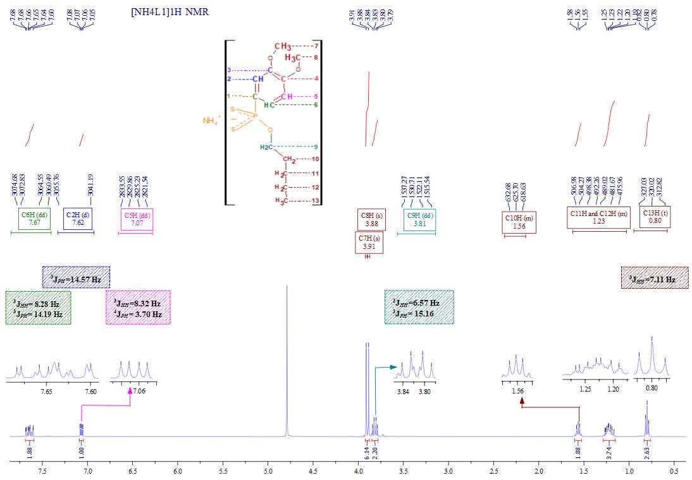
Fig SM11. ¹H NMR spectrum of [NH₄L1].
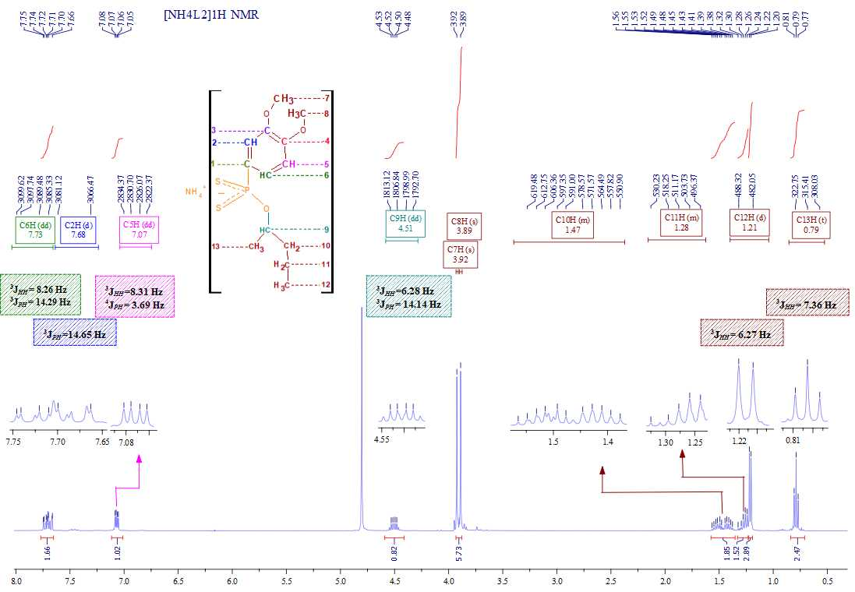
Fig SM12. ¹H NMR spectrum of [NH₄L2].
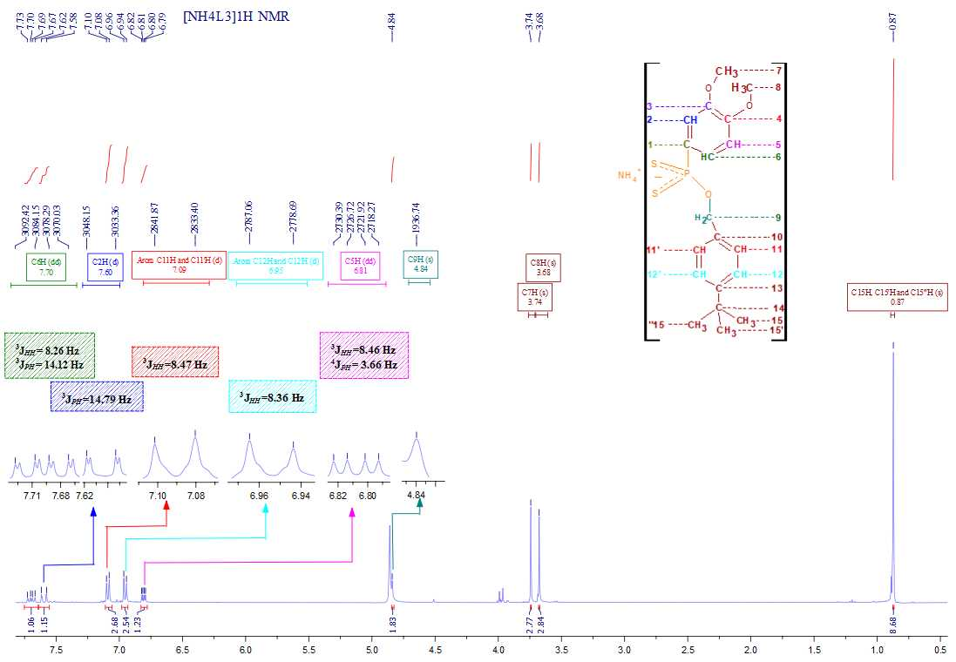
Fig SM13. ¹H NMR spectrum of [NH₄L3].
Fig SM14. ¹H NMR spectrum of [NH₄L4].
Fig SM15. ¹H NMR spectrum of [NH₄L5].
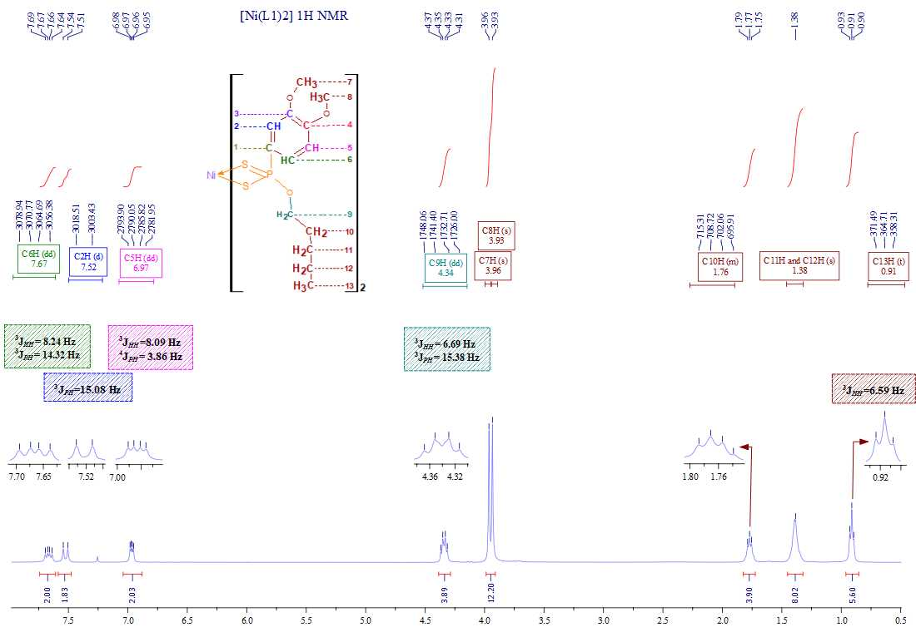
Fig SM16. ¹H NMR spectrum of [Ni(L1)₂].
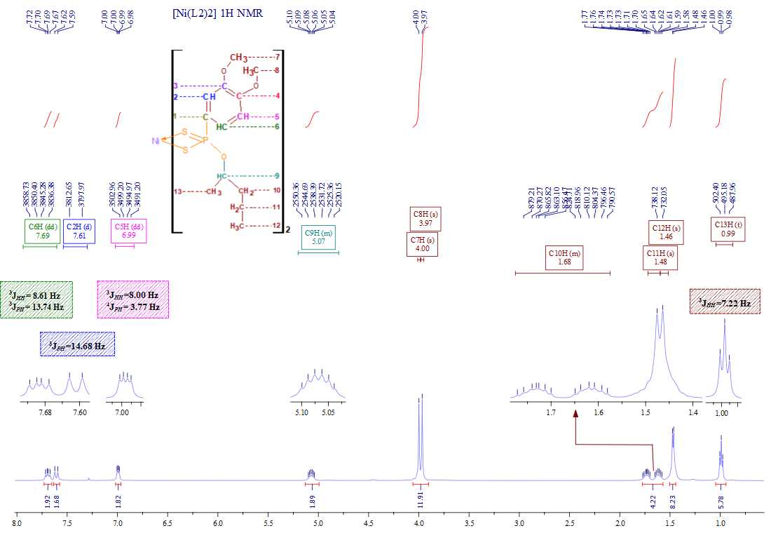
Fig SM17. ¹H NMR spectrum of [Ni(L2)₂].
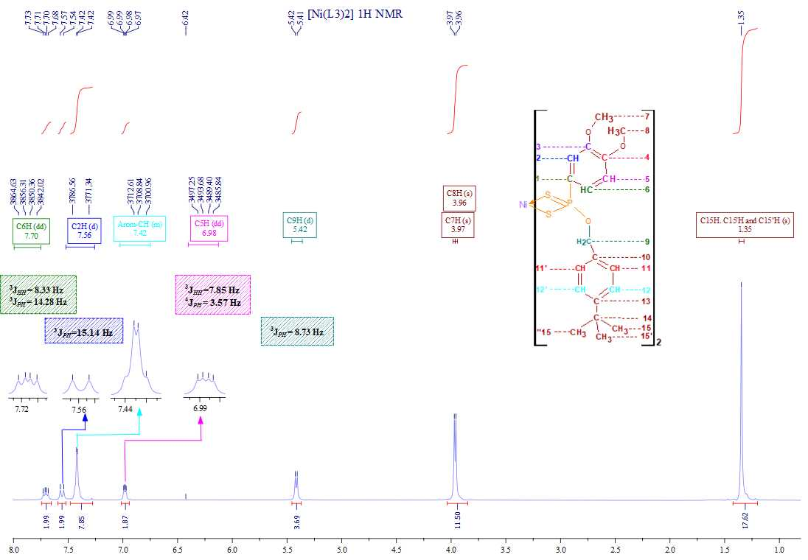
Fig SM18. ¹H NMR spectrum of [Ni(L3)₂].
Fig SM19. ¹H NMR spectrum of [Ni(L4)₂].
Fig SM20. ¹H NMR spectrum of [Ni(L5)₂].
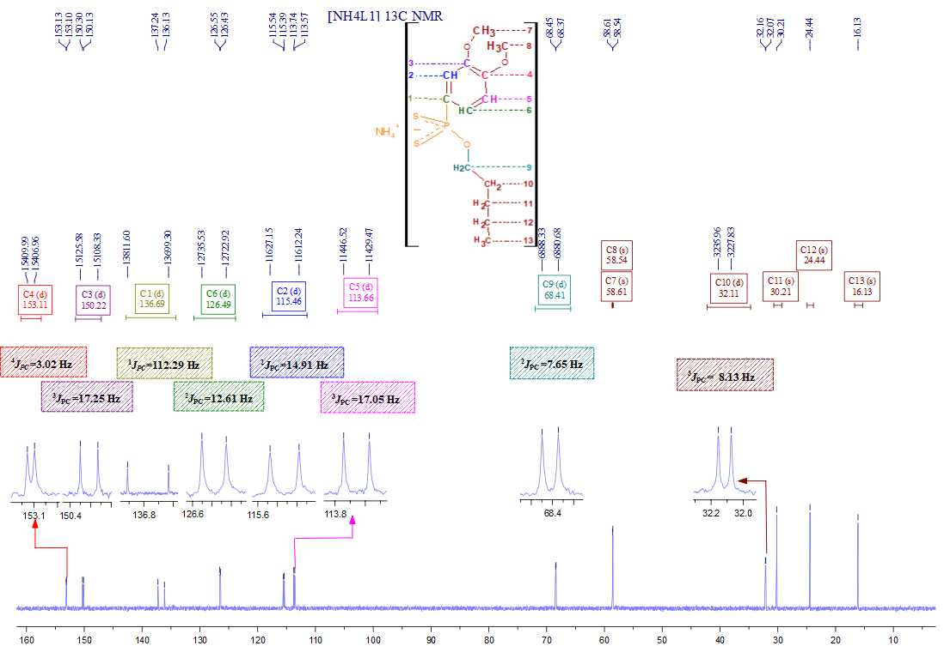
Fig SM21. ¹³C NMR spectrum of [NH₄L1].
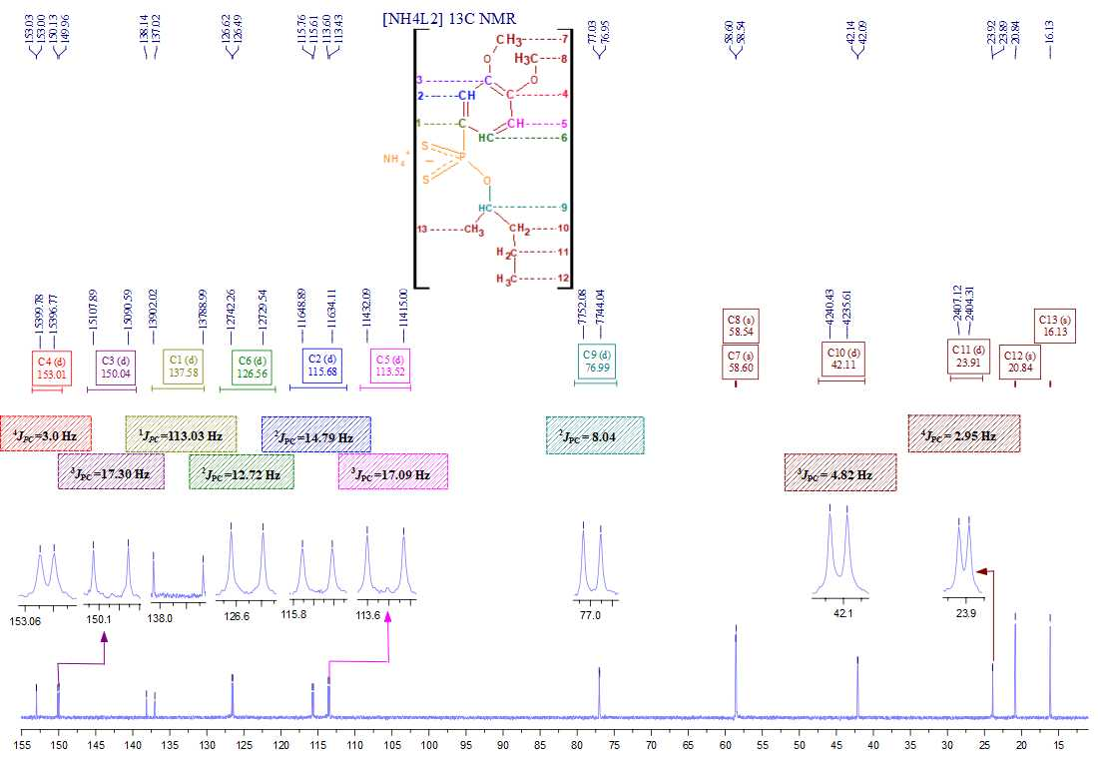
Fig SM22. ¹³C NMR spectrum of [NH₄L2].
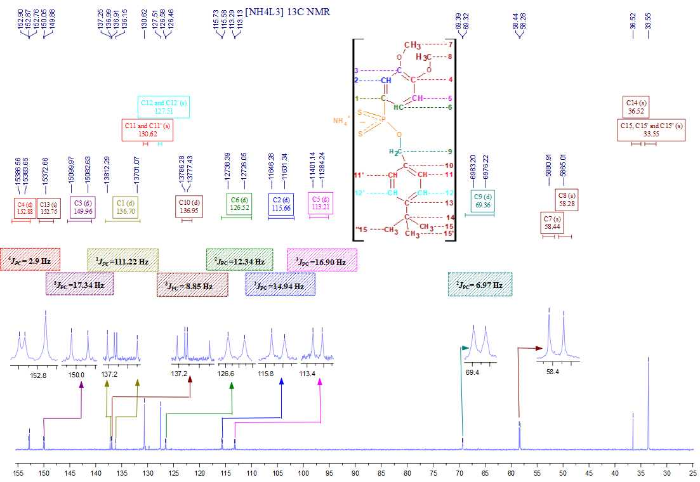
Fig SM23. ¹³C NMR spectrum of [NH₄L3].
Fig SM24. ¹³C NMR spectrum of [NH₄L4].
Fig SM25. ¹³C NMR spectrum of [NH₄L5].
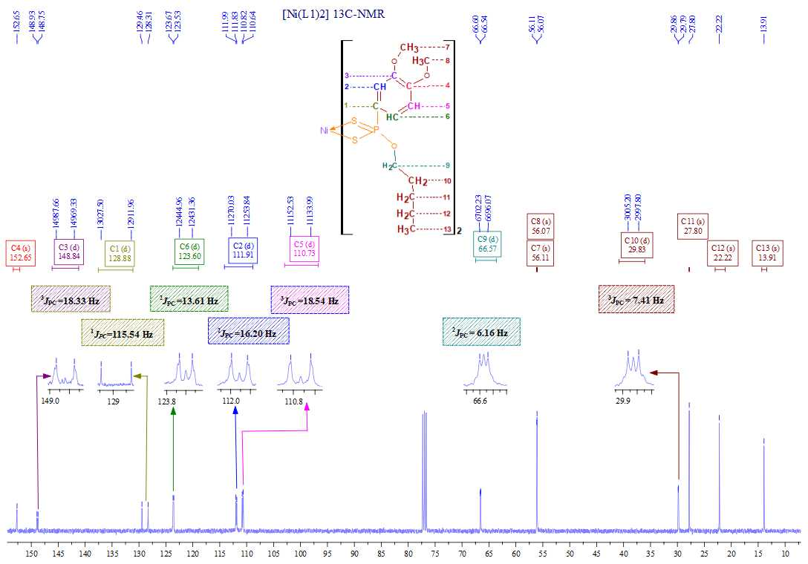
Fig SM26. ¹³C NMR spectrum of [Ni(L1)₂].
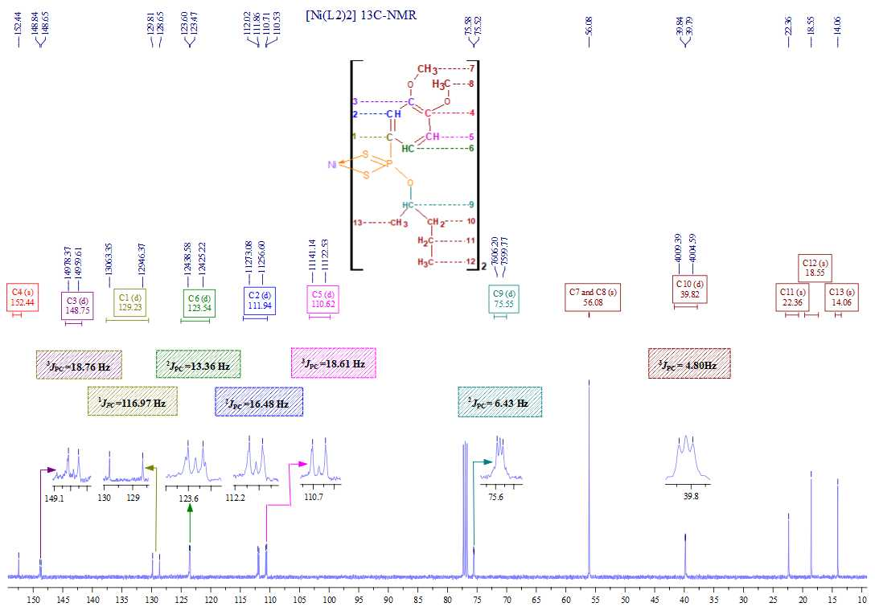
Fig SM27. ¹³C NMR spectrum of [Ni(L2)₂].
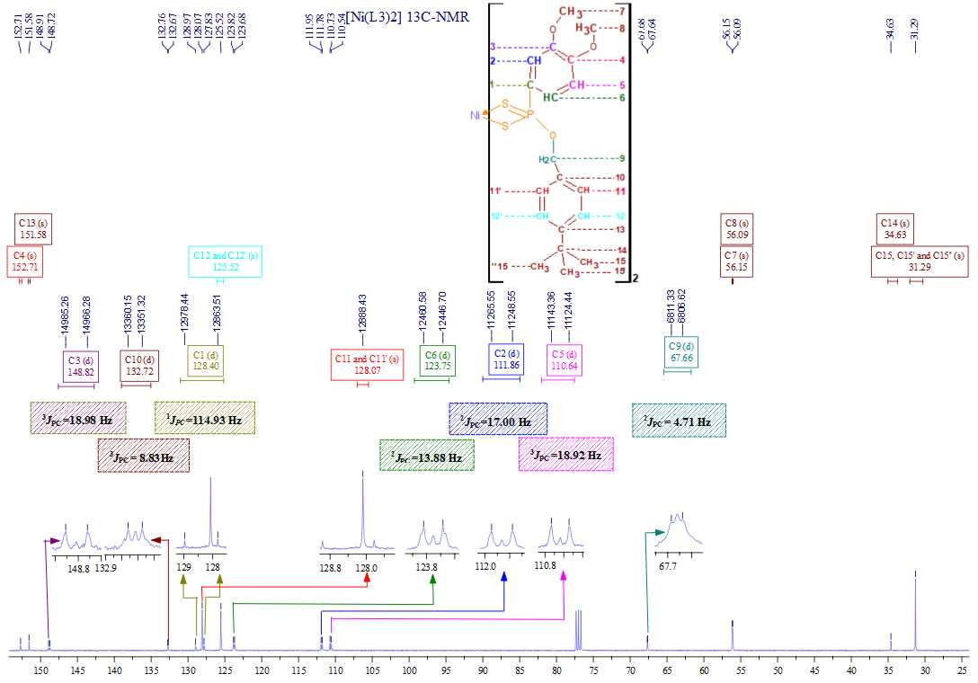
Fig SM28. ¹³C NMR spectrum of [Ni(L3)₂].

Fig SM29. ¹³C NMR spectrum of [Ni(L4)₂].

Fig SM30. ¹³C NMR spectrum of [Ni(L5)₂].
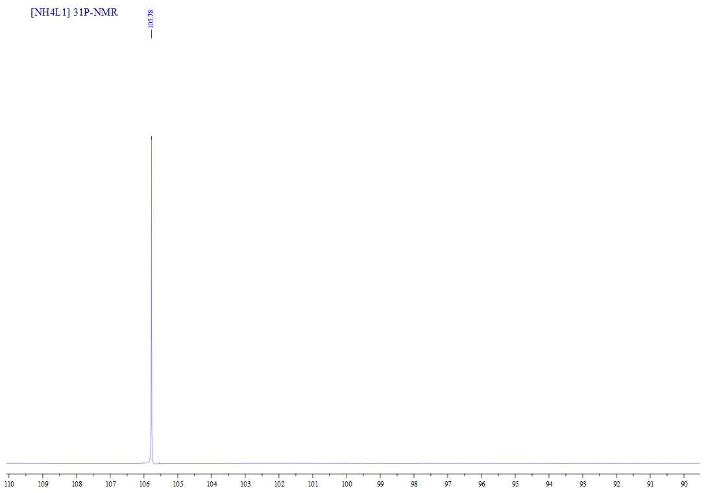
Fig SM31. ³¹P NMR spectrum of [NH₄L1].
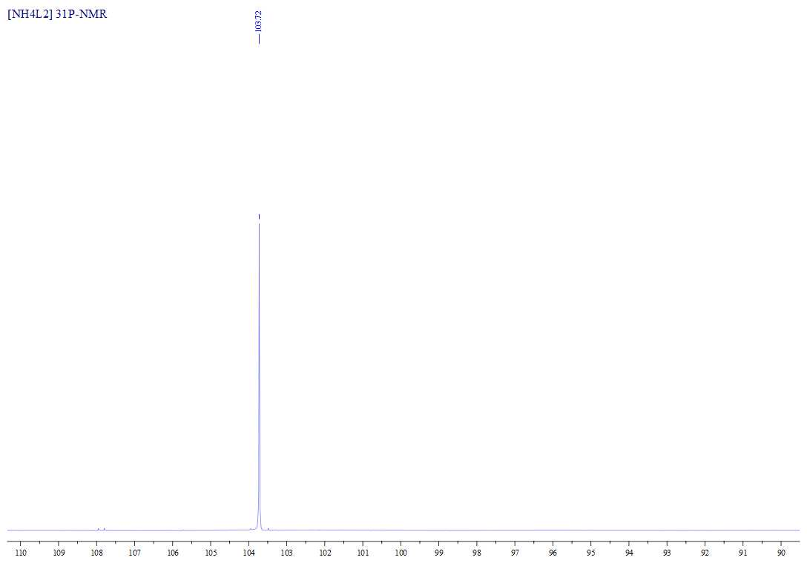
Fig SM32. ³¹P NMR spectrum of [NH₄L2].
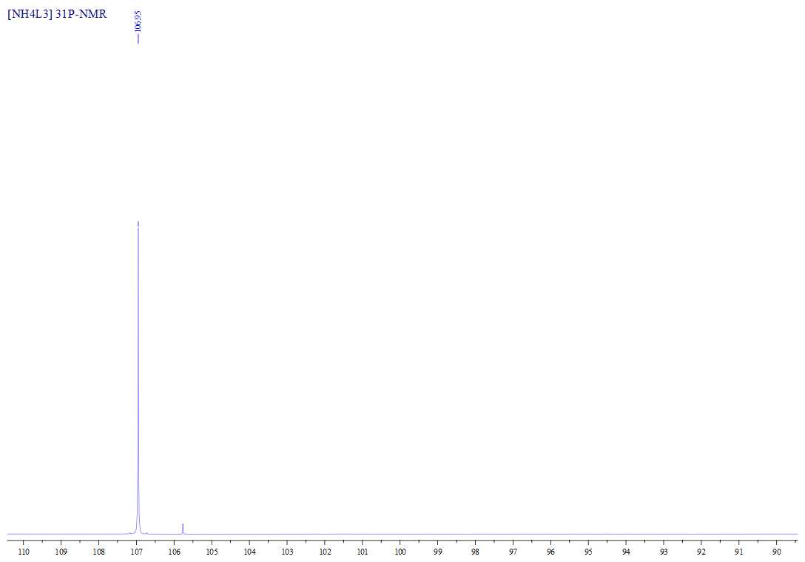
Fig SM33. ³¹P NMR spectrum of [NH₄L3].
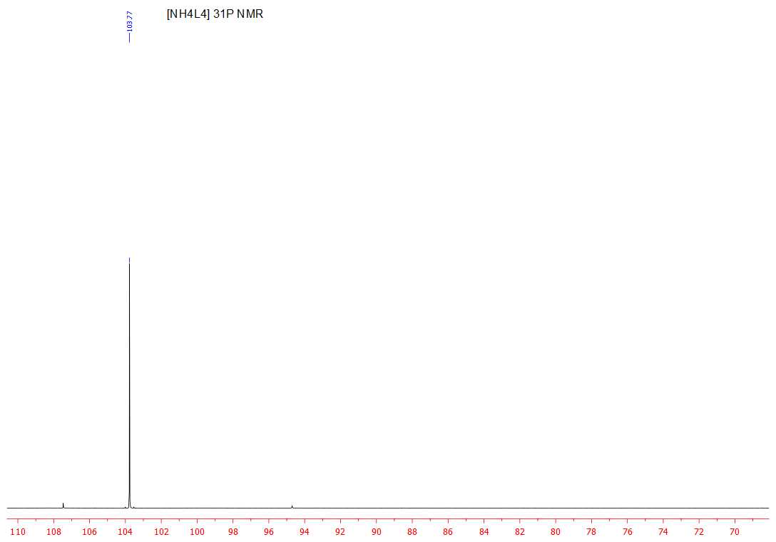
Fig SM34. ³¹P NMR spectrum of [NH₄L4].
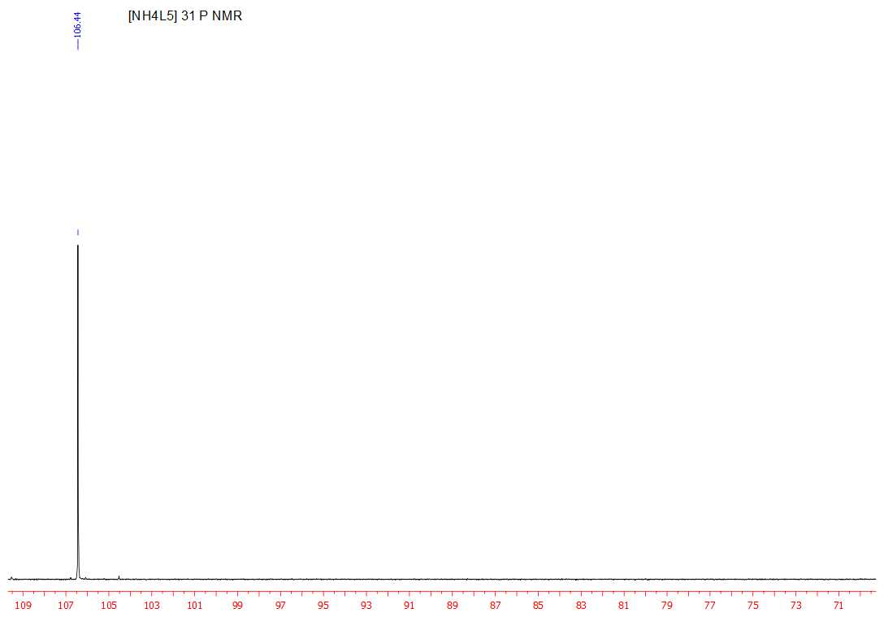
Fig SM35. ³¹P NMR spectrum of [NH₄L5].
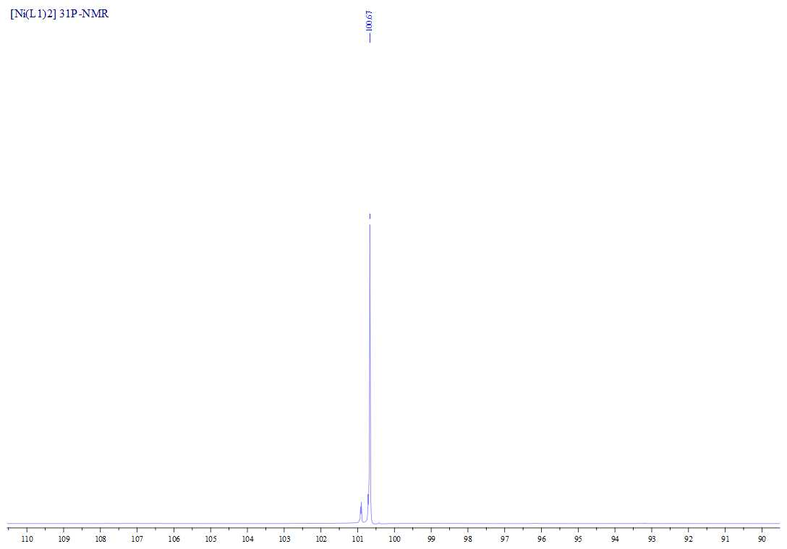
Fig SM36. ³¹P NMR spectrum of [Ni(L1)₂].
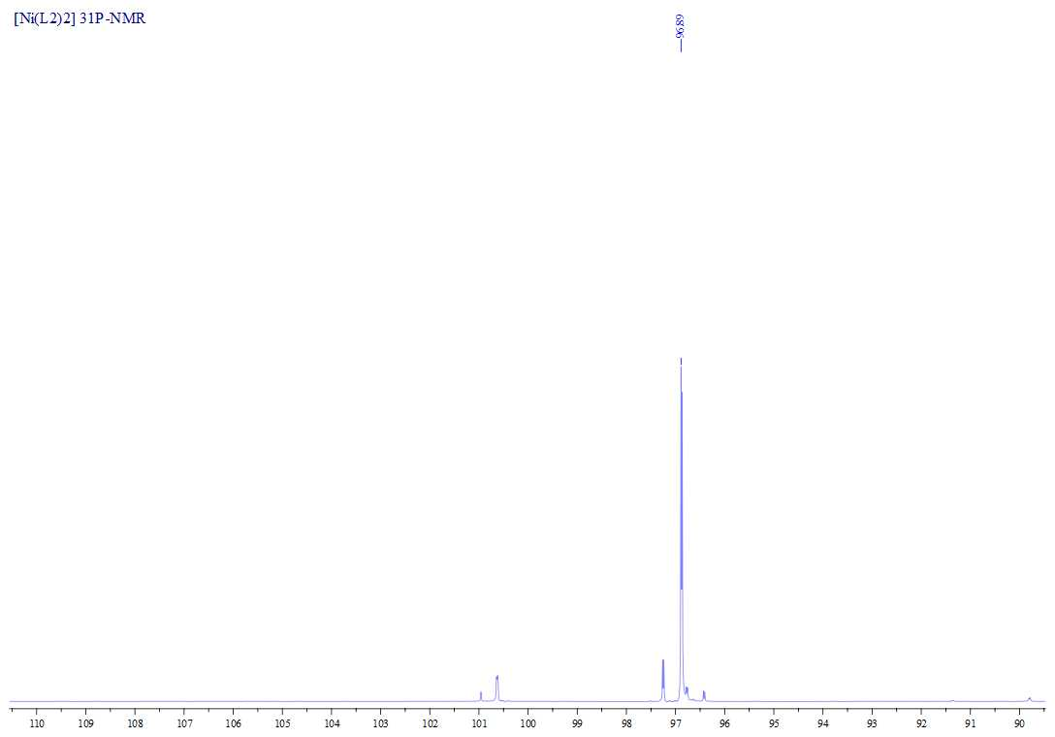
Fig SM37. ³¹P NMR spectrum of [Ni(L2)₂].
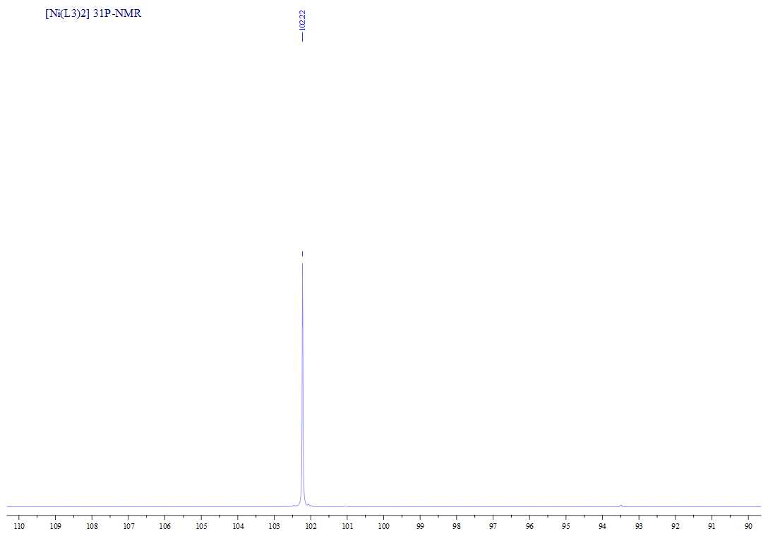
Fig SM38. ³¹P NMR spectrum of [Ni(L3)₂].
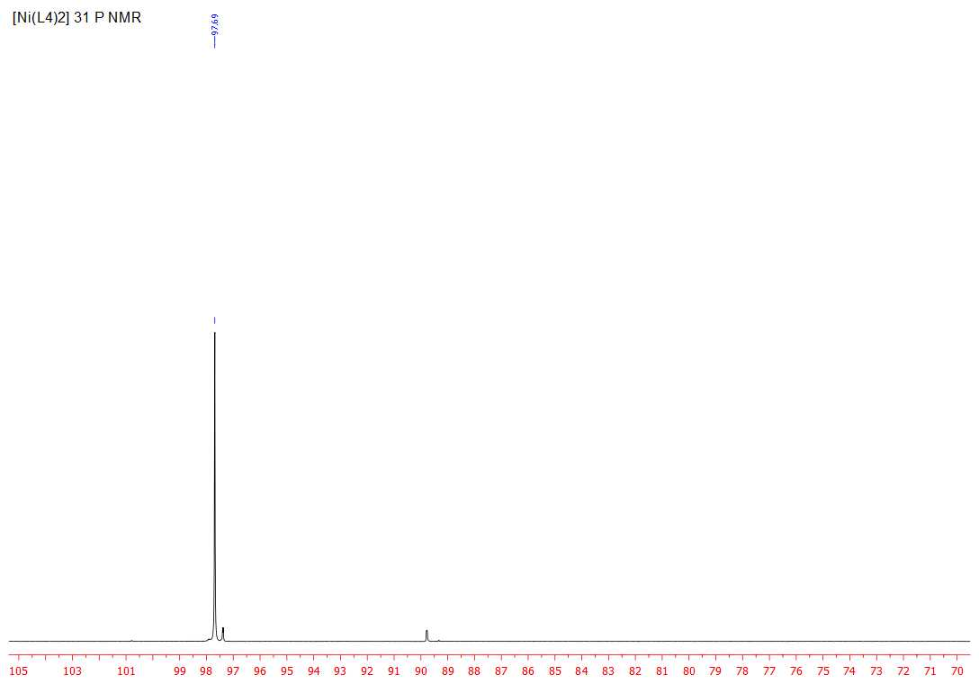
Fig SM39. ³¹P NMR spectrum of [Ni(L4)₂].
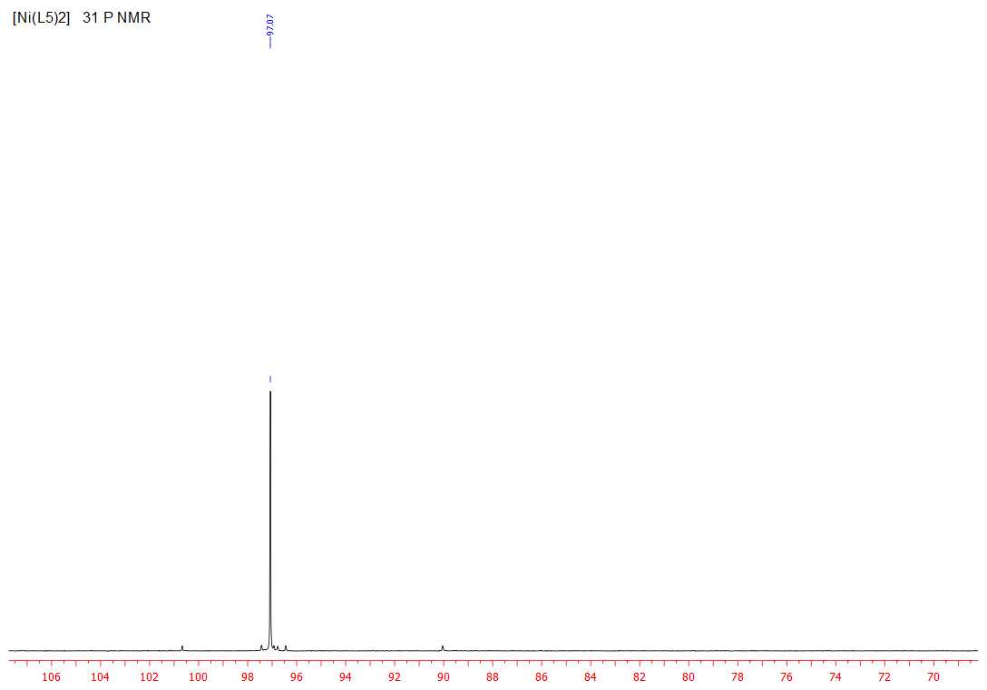
Fig SM40. ³¹P NMR spectrum of [Ni(L5)₂].

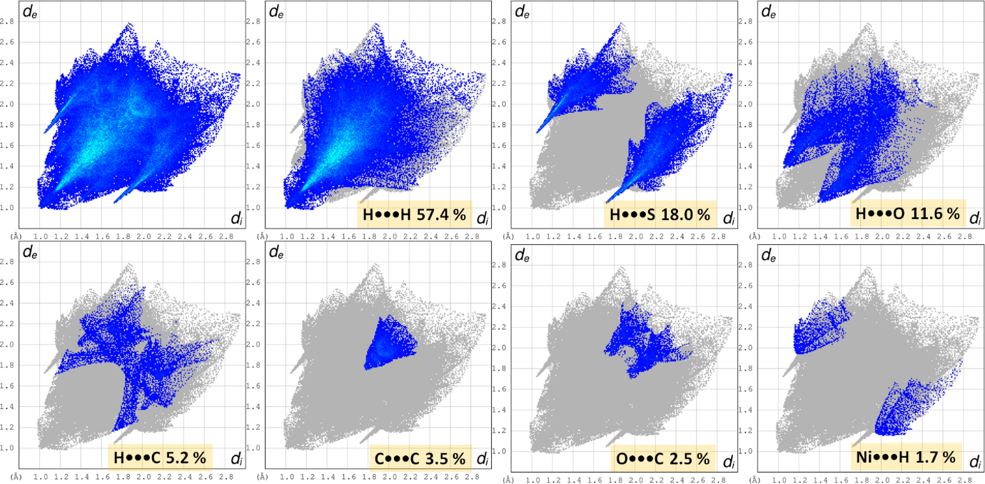
Fig. SM 41. The resolved 2D fingerprint plots showing the contributions to the overall Hirshfeld surface area in [Ni(L1)₂].
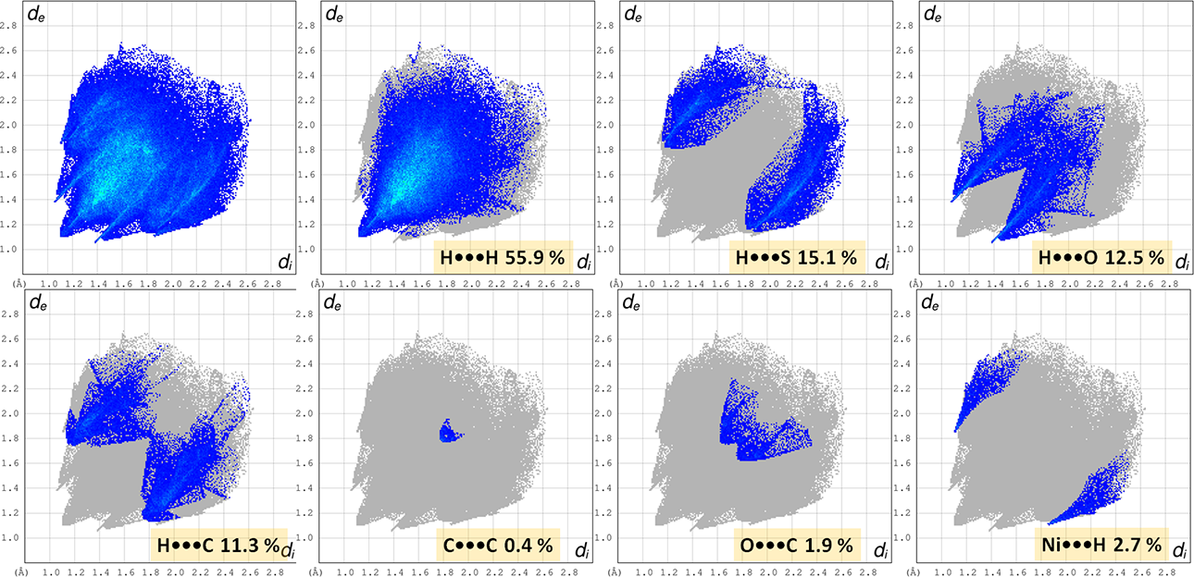
Fig. SM42. The resolved 2D fingerprint plots depicting the contributions to the overall Hirshfeld surface area in [Ni(L2)₂].

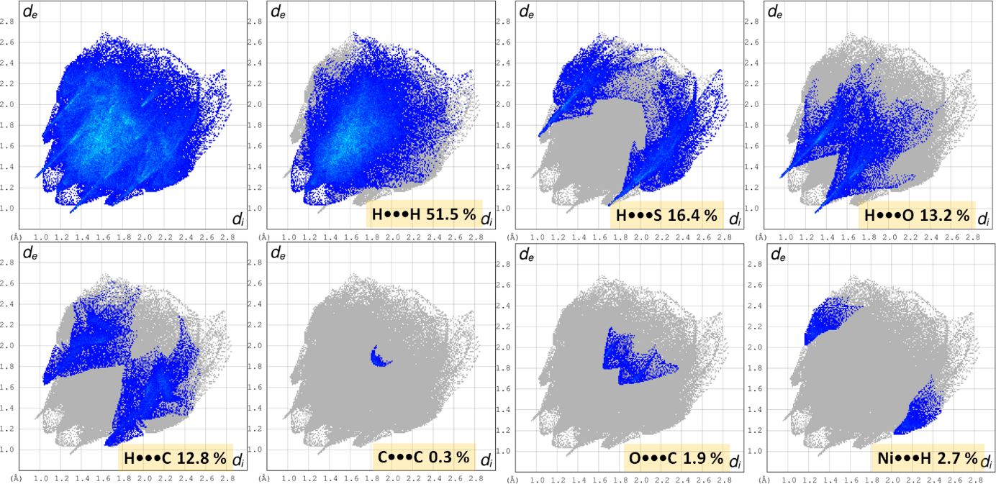
Fig. SM43. The resolved 2D fingerprint plots depicting the contributions to the overall Hirshfeld surface area in [Ni(L4)₂].
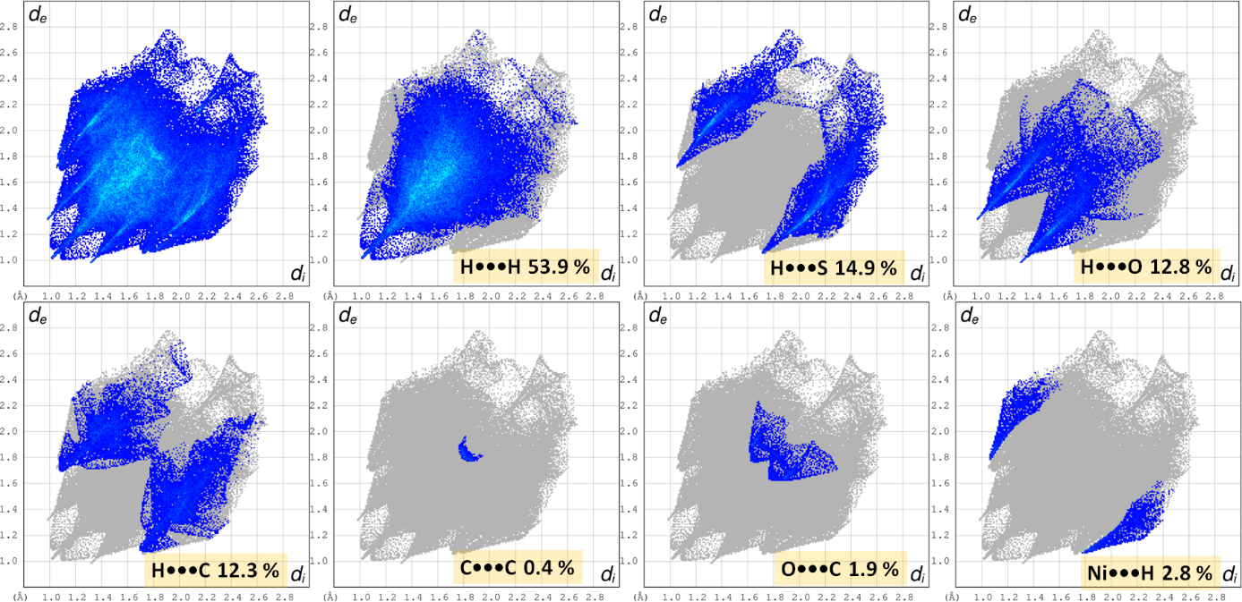
Fig. SM44. The resolved 2D fingerprint plots depicting the contributions to the overall Hirshfeld surface area in [Ni(L5)₂].

REFERENCES
- M.A. Spackman, D. Jayatilaka, Hirshfeld surface analysis, CrystEngComm. 2009, 11, 19-32. https://doi.org/10.1039/B818330A .
- M.A. Spackman, J. J. McKinnon, Fingerprinting intermolecular interactions in molecular crystals, CrystEngComm. 2002, 4, 378-392, https://doi.org/10.1039/B203191B .
- M.J.Turner, J.J.McKinnon, S.K.Wolff, D.J.Grimwood, P.R.Spackman, D.Jayatilaka, M.A.Spackman, CrystalExplorer17, University of Western Australia, 2017.
- J.J. McKinnon, M.A. Spackman, A.S. Mitchell, Novel tools for visualizing and exploring intermol­ecular interactions in molecular crystals, Acta Cryst. Section B60 (2004) 627-668. https://doi.org/10.1107/S0108768104020300 .
- J.J. McKinnon, D. Jayatilaka, M.A. Spackman, Towards quantitative analysis of intermolecular interactions with Hirshfeld surfaces, Chem. Commun. 2007, 37, 3814-3816, https://doi.org/10.1039/B704980C .
- M.J. Frisch, G.W.Trucks, H.B.Schlegel, G.E.Scuseria, M.A.Robb, J.R.Cheeseman, G.Scalmani, V.Barone, B.Mennucci, G.A.Petersson, H.Nakatsuji, M.Caricato, X. Li, H.P. Hratchian, A.F.Izmaylov, J.Bloino, G.Zheng, J.L.Sonnenberg, M.Hada, M.Ehara, K.Toyota, R.Fukuda, J.Hasegawa, M.Ishida, T.Nakajima, Y.Honda, O.Kitao, H.Nakai, T.Vreven, J.A.Montgomery, Jr JEP. F.Ogliaro, M.Bearpark, J.J.Heyd, E.Brothers, K.N.Kudin, V.N.Staroverov, R.Kobayashi, J.Normand, K.Raghavachari, A.Rendell, J.C.Burant, S.S.Iyengar, J.Tomasi, M.Cossi, N.Rega, J.M.Millam, M.Klene, J.E.Knox, J.B.Cross, V.Bakken, C.Adamo, J.Jaramillo, R.Gomperts, R.E.Stratmann, O.Yazyev, A.J.Austin, R.Cammi, C.Pomelli, J.W.Ochterski, R.L.Martin, K.Morokuma, V.G.Zakrzewski, G.A.Voth, P.Salvador, J.J.Dannenberg, S.Dapprich, A.D.Daniels, Ö.Farkas, J.B.Foresman, J.V. Ortiz, J.Cioslowski, D.J.Fox (2009) Gaussian 09. Revision A.02. Gaussian. Inc: Wallingford CT.
- R.Dennington, T.Keith, J.Millam, (2009) GaussView. Version 5. Semichem. Inc.. Shawnee Mission. KS.
- T. H. Dunning Jr. and P. J. Hay, in Modern Theoretical Chemistry, Ed. H. F. Schaefer III, Plenum, New York, 3 (1977) 1-28.
- A.D. Becke, Density‐functional thermochemistry. IV. A new dynamical correlation functional and implications for exact‐exchange mixing, J. Chem. Phys. 104 3 (1996) 1040–1046, http://dx.doi.org/10.1063/1.470829 .
- J.-P.Blaudeau, M.P.McGrath, L.A.Curtiss and L.Radom, Extension of Gaussian-2 (G2) theory to molecules containing third-row atoms K and Ca, J. Chem. Phys. 107 13 (1997) 5016, http://dx.doi.org/10.1063/1.474865 .
- O. Trott. A. J. Olson. AutoDock Vina: improving the speed and accuracy of docking with a new scoring function. efficient optimization and multithreading, J.Comput.Chem. 31 2 (2010) 455-461, https://doi.org/10.1002/jcc.21334 .
- Discovery Studio Visualizer Software. V16.1.015350 (2015). Dassault Systemes Biovia Corp. http://www.accelrys.com.
- M.F.Sanner. Python: A Programming Language for Software Integration and Development. J. Mol. Graphics Mod. 17 (1999) 57-61.
- B.Kramer, M.Rarey, T.Lengauer, Evaluation of the FLEXX incremental construction algorithm for protein–ligand docking, Proteins, 37 2 (1999) 228–241, https://doi.org/10.1002/(SICI)1097-0134(19991101)37:2<228::AID-PROT8>3.0.CO;2-8 .
- A.B.Gurung, M.A.Ali, A.Bhattacharjee, M.A.Farah, F. Al-Hemaid, F.M.Abou-Tarboush, K.M.Al-Anazi, F.S.M.Al-Anazi, J.Lee, Molecular docking of the anticancer bioactive compound proceraside with macromolecules involved in the cell cycle and DNA replication, Genet. Mol. Res. 15 2 (2016) 15027829, https://doi.org/10.4238/gmr.15027829 .
- S. Akkoç, Derivatives of 1-(2-(Piperidin-1-yl)ethyl)-1H-benzo[d]imidazole: Synthesis, Characterization, Determining of Electronic Properties and Cytotoxicity Studies, ChemistrySelect, 4 17 (2019) 4938-4943, https://doi.org/10.1002/slct.201900353
- T. Koopmans, Über die Zuordnung von Wellenfunktionen und Eigenwerten zu den Einzelnen Elektronen Eines Atoms, Physica, 1 (1934) 104-113. https://doi.org/10.1016/s0031-8914(34)90011-2 .

