Supplemental Figure

Supplemental Figure 1. Forest plot of the comparison: remdesivir-treated group vs. control group: in-hospital mortality analyzed by the original data.
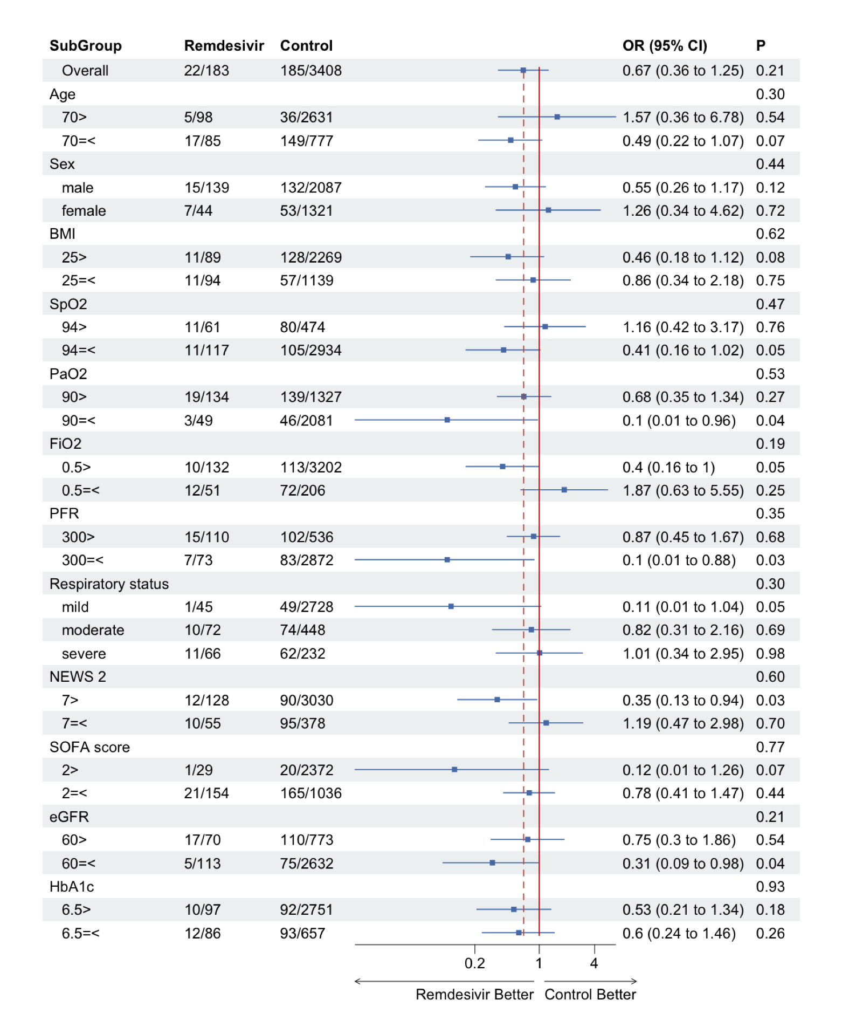

In the subgroup analysis of respiratory status, p values for the interaction between mild and moderate/severe cases are shown.
OR, odds ratio; CI, confidence interval; BMI, body mass index; SpO2, saturation of percutaneous oxygen; PaO2, partial pressure of oxygen in arterial blood; FiO2, fraction of inspiratory oxygen; PFR, partial pressure of oxygen in arterial blood/fraction of inspiratory oxygen ratio; NEWS2, National Early Warning Score 2; SOFA, Sequential Organ Failure Assessment; eGFR, estimated glomerular filtration rate; HbA1c, hemoglobin A1c.

Supplemental Tables

Supplemental Table 1. All patient characteristics before and after adjusting for propensity score overlap weighting

 | Study participants |  |  | OW-adjusted participants
Characteristics | Controls  (n = 3,408) | Remdesivir recipients  (n = 183) | SMD | Controls  (n = 97.7) | Remdesivir recipients  (n = 97.7) | SMD
Age, yr | 51 (34-68) | 69 (55-77) | 0.79 | 67 (76-55) | 67 (54-77) | 0.00
Sex, male, n (%) | 2087 (61.2%) | 139 (75.9%) | 0.32 | 74.6 (76.4%) | 74.6 (76.4%) | 0.00
BMI | 23 (21-26) | 25 (22-28) | 0.40 | 24(27-22) | 25 (22-28) | 0.00
Brinkman index | 0 (0-60) | 0 (0-245) | 0.23 | 0 (0-274) | 0 (0-274) | 0.00
<Comorbidity>
Hypertension, n (%) | 312 (9.1%) | 28 (15.3%) | 0.18 | 14.4 (14.8%) | 14.4 (14.8%) | 0.00
Cardiac infarction, n (%) | 13 (0.3%) | 2 (1.0%) | 0.08 | 0.9 (1.0%) | 0.9 (1.0%) | 0.00
Heart failure, n (%) | 56 (1.6%) | 3 (1.6%) | 0.00 | 1.6 (1.6%) | 1.6 (1.6%) | 0.00
Cancer, n (%) | 80 (2.3%) | 4 (2.1%) | 0.01 | 2.4 (2.4%) | 2.4 (2.4%) | 0.00
Diabetes, n (%) | 390 (11.4%) | 60 (32.7%) | 0.53 | 27.3 (28.0%) | 27.3 (28.0%) | 0.00
Asthma, n (%) | 126 (3.6%) | 10 (5.4%) | 0.08 | 5.1 (5.2%) | 5.1 (5.2%) | 0.00
COPD, n (%) | 37 (1.0%) | 5 (2.7%) | 0.12 | 3.5 (3.5%) | 3.5 (3.5%) | 0.00
<Clinical signs and status>
Glasgow Coma Scale | 15 (15-15) | 15 (15-15) | 0.20 | 15 (15-15) | 15 (15-15) | 0.00
Body temperature, Celsius | 36.9 (36.5-37.6) | 37.2 (36.5-38.0) | 0.16 | 37.2 (36.6-38.0) | 37.2 (36.6-38.0) | 0.00
Systolic blood pressure, mmHg | 125 (113-139) | 129 (118-142) | 0.18 | 130 (117-146) | 131 (118-144) | 0.00
Respiratory rate, times/min | 18 (16-20) | 21 (18-25) | 0.71 | 20 (18-25) | 21 (18-24) | 0.00
Pulse rate, bpm | 84 (75-96) | 89 (73-100) | 0.14 | 87 (75-98) | 90 (73-100) | 0.00
PaO2, mmHg | 91 (78-105) | 73 (65-91) | 0.37 | 76 (65-91) | 75 (66-91) | 0.00
FiO2 | 0.21 (0.21-0.21) | 0.36 (0.22-0.52) | 0.84 | 0.36 (0.21-0.45) | 0.32 (0.21-0.45) | 0.00
PaO2/FiO2 ratio | 433 (342-500) | 230 (145-323) | 1.29 | 237 (162-352) | 257 (155-338) | 0.00
Charlson comorbidity index | 0 (0-0) | 0 (0-1) | 0.12 | 0 (0-1) | 0 (0-1) | 0.00
SOFA score | 1 (0-2) | 2 (2-4) | 0.80 | 2 (2-4) | 2 (2-4) | 0.00
Respiration | 0 (0-1) | 2 (1-3) | 1.33 | 2 (1-3) | 2 (1-2) | 0.00
Coagulation | 0 (0-0) | 0 (0-0) | 0.08 | 0 (0-0) | 0 (0-1) | 0.00
Liver | 0 (0-0) | 0 (0-0) | 0.08 | 0 (0-0) | 0 (0-0) | 0.00
Cardiovascular | 0 (0-0) | 0 (0-0) | 0.12 | 0 (0-0) | 0 (0-0) | 0.00
CNS | 0 (0-0) | 0 (0-0) | 0.22 | 0 (0-0) | 0 (0-0) | 0.00
Renal | 0 (0-0) | 0 (0-0) | 0.01 | 0 (0-0) | 0 (0-0) | 0.00
NEWS2 | 2 (0-4) | 5 (3-7) | 0.92 | 5 (3-7) | 5 (3-7) | 0.00
<Laboratory Findings>
White blood cell count, ×10⁹/μL | 5.1 (4.0-6.7) | 6.4 (4.9-8.3) | 0.45 | 6.3 (4.7-8.6) | 6.1 (4.8-8.5) | 0.00
Platelet count, ×10⁴/L | 20 (16-25) | 20 (15-26) | 0.33 | 19(15-25) | 20 (15-25) | 0.00
Bilirubin, mg/dL | 0.5 (0.4-0.7) | 0.6 (0.4-0.7) | 0.04 | 0.6 (0.5-0.8) | 0.6 (0.4-0.8) | 0.00
Alanine amino transferase, U/L | 24 (15-41) | 34 (20-58) | 0.23 | 32 (20-55) | 34 (21-58) | 0.00
Aspartate amino transferase, U/L | 27 (20-43) | 44 (29-65) | 0.35 | 41 (30-60) | 43 (28-62) | 0.00
Creatinine, mg/dL | 0.79 (0.64-0.95) | 0.84 (0.66-1.04) | 0.07 | 0.82 (0.67-1.03) | 0.83(0.67-1.03) | 0.00
Blood urea nitrogen, mg/dL | 13 (10-17) | 16 (12-23) | 0.27 | 15 (12-23) | 16 (12-24) | 0.00
eGFR, ml/min per 1.73 m2 | 76 (62-91) | 67 (52-87) | 0.22 | 70 (54-86) | 70 (53-87) | 0.00
Lactate dehydrogenase, U/L | 225 (180-314) | 371 (298-446) | 0.83 | 363 (269-460) | 367 (288-468) | 0.00
C-reactive protein, mg/dL | 1.4(0.2-5.8) | 8.5(4.8-13.2) | 0.85 | 7.6(3.7-14.8) | 7.99(4.9-12.9) | 0.00
Procalcitonin, ng/mL | 0.06 (0.04-0.16) | 0.14 (0.08-0.27) | 0.00 | 0.14 (0.07-0.31) | 0.14(0.08-0.28) | 0.00
Blood glucose level, mg/dL | 107 (95-127) | 137 (107-185) | 0.60 | 131 (111-170) | 135 (106-179) | 0.00
Sodium, mmol/L | 139 (137-141) | 137 (135-139) | 0.48 | 137 (134-140) | 137 (135-140) | 0.00
Potassium, mmol/L | 4.0 (3.8-4.3) | 3.9 (3.6-4.3) | 0.25 | 3.9 (3.6-4.3) | 3.9 (3.6-4.3) | 0.00
PT-INR | 1.0 (0.9-1.0) | 1.0 (0.9-1.1) | 0.29 | 1.0 (1.0-1.1) | 1.0 (0.9-1.1) | 0.00
APTT, sec | 31 (29-34) | 33 (30-36) | 0.26 | 32 (29-36) | 33 (30-36) | 0.00
D-dimer, μg/ml | 0.9 (0.6-1.6) | 1.3 (0.8-2.5) | 0.08 | 1.5 (0.9-3.2) | 1.3 (0.9-2.7) | 0.00
Fibrinogen, mg/dL | 426 (338-528) | 564 (470-647) | 0.78 | 546 (465-638) | 559 (474-639) | 0.00
HbA1c, % | 5.8 (5.5-6.3) | 6.3 (5.9-7.3) | 0.61 | 6.3 (6.0-7.2) | 6.3 (5.9-7.3) | 0.00
<Treatments>
Favipiravir, n (%) | 1026 (30.1%) | 41 (22.4%) | 0.17 | 33.4 (34.2%) | 33.4 (34.2%) | 0.00
Steroids, n (%) | 408 (11.9%) | 126 (68.8%) | 1.42 | 53.6 (54.9%) | 53.6 (54.9%) | 0.00
Vasopressors, n (%) | 198 (5.8%) | 51 (27.8%) | 0.61 | 25.0 (25.6%) | 25.0 (25.6%) | 0.00
Heparin, n (%) | 765 (22.4%) | 148 (80.8%) | 1.44 | 70.4 (72.1%) | 70.4 (72.1%) | 0.00
Ventilator use on admission, n (%) | 232 (6.8%) | 66 (36.0%) | 0.32 | 30.3 (31.0%) | 30.3 (31.0%) | 0.00

Data are expressed as percentages or medians and interquartile ranges.
OW, overlap weighting; SMD, standardized mean difference; BMI, body mass index; COPD, chronic obstructive pulmonary disease; FiO2, fraction of inspiratory oxygen; PaO2, partial pressure of oxygen in arterial blood; SOFA, Sequential Organ Failure Assessment; CNS, central nervous system; NEWS2, The National Early Warning Score 2; eGFR, estimated glomerular filtration rate; PT-INR, prothrombin time and international normalized ratio; APTT, activated partial thromboplastin time; HbA1c, hemoglobin A1c.

Supplemental Table 2. The baseline patient characteristics of the remdesivir treatment and control groups.

 | Study participants
Characteristics | Controls  (n = 3,408) | Remdesivir recipients  (n = 183) | SMD
Age, yr | 51 (34-68) | 69 (55-77) | 0.79
Sex, male, n (%) | 2087 (61.2%) | 139 (75.9%) | 0.32
Race, n (%) |  |  | 0.21
Asian | 3220 (94.4%) | 179 (97.8%) | NA
Caucasian | 120 (3.5%) | 4 (2.1%) | NA
BMI | 23 (21-26) | 25 (22-28) | 0.40
Brinkman index | 0 (0-60) | 0 (0-245) | 0.23
<Comorbidity>
Hypertension, n (%) | 312 (9.1%) | 28 (15.3%) | 0.18
Hyperlipemia, n (%) | 158 (4.6%) | 18 (9.8%) | 0.20
Arrhythmia, n (%) | 64 (1.8%) | 8 (4.3%) | 0.14
Cardiac infarction, n (%) | 13 (0.3%) | 2 (1.0%) | 0.08
Heart failure, n (%) | 56 (1.6%) | 3 (1.6%) | 0.00
Chronic Kidney Disease | 102 (2.9%) | 5 (2.7%) | 0.01
Diabetes, n (%) | 390 (11.4%) | 60 (32.7%) | 0.53
Asthma, n (%) | 126 (3.6%) | 10 (5.4%) | 0.08
COPD, n (%) | 37 (1.0%) | 5 (2.7%) | 0.12
Cancer, n (%) | 80 (2.3%) | 4 (2.1%) | 0.01
<Clinical signs and status>
Glasgow Coma Scale | 15 (15-15) | 15 (15-15) | 0.20
Body temperature, Celsius | 36.9 (36.5-37.6) | 37.2 (36.5-38.0) | 0.16
Systolic blood pressure,  mmHg | 125 (113-139) | 129 (118-142) | 0.18
Diastolic blood pressure,  mmHg | 78 (70-88) | 77 (69-87) | 0.02
Respiratory rate, times/min | 18 (16-20) | 21 (18-25) | 0.71
Pulse rate, bpm | 84 (75-96) | 89 (73-100) | 0.14
SpO2, % | 97 (96-98) | 95 (93-97) | 0.63
PaO2, mmHg | 91 (78-105) | 73 (65-91) | 0.37
FiO2 | 0.21 (0.21-0.21) | 0.36 (0.21-0.52) | 0.84
PaO2/FiO2 ratio | 433 (342-500) | 231 (145-323) | 1.29
Ground glass opacity | 2240 (65.7%) | 182 (99.4%) | 0.99
Charlson comorbidity index | 0 (0-0) | 0 (0-1) | 0.12
SOFA score | 1 (0-2) | 2 (2-4) | 0.80
Respiration | 0 (0-1) | 2 (1-3) | 1.33
Coagulation | 0 (0-0) | 0 (0-0) | 0.08
Liver | 0 (0-0) | 0 (0-0) | 0.08
Cardiovascular | 0 (0-0) | 0 (0-0) | 0.12
Central Nervous System | 0 (0-0) | 0 (0-0) | 0.22
Renal | 0 (0-0) | 0 (0-0) | 0.01
NEWS2 | 2 (0-4) | 5 (3-7) | 0.92
Respiratory Severity |  |  | 1.34
mild | 2728 (80.0%) | 45 (24.5%) | NA
moderate | 448 (13.1%) | 72 (39.3%) | NA
severe | 232 (6.8%) | 66 (36.0%) | NA
<Laboratory Findings>
White blood cell count, ×10⁹/μL | 5.1 (4.0-6.7) | 6.4 (4.9-8.3) | 0.45
Platelet count, ×10⁴/L | 20 (16-25) | 20 (15-26) | 0.33
Bilirubin, mg/dL | 0.5 (0.4-0.7) | 0.6 (0.4-0.7) | 0.04
Alanine amino transferase, U/L | 24 (15-41) | 34 (20-58) | 0.23
Aspartate amino transferase, U/L | 27 (20-43) | 44 (29-65) | 0.35
Albumin, g/dL | 3.9 (3.3-4.3) | 3.2 (2.7-3.6) | 0.83
Creatinine, mg/dL | 0.79 (0.64-0.95) | 0.84 (0.66-1.04) | 0.07
Blood urea nitrogen, mg/dL | 13 (10-17) | 16 (12-23) | 0.27
eGFR, ml/min per 1.73 m2 | 76 (62-91) | 67 (52-87) | 0.22
Lactate dehydrogenase, U/L | 225 (180-314) | 371 (298-446) | 0.83
Creatinine kinase, U/L | 76 (51-122) | 81 (51-170) | 0.09
C-reactive protein, mg/dL | 1.4 (0.2-5.8) | 8.5 (4.8-13.2) | 0.85
Procalcitonin, ng/mL | 0.06 (0.04-0.16) | 0.14 (0.08-0.27) | 0.00
Blood glucose level, mg/dL | 107 (95-127) | 137 (107-185) | 0.60
Sodium, mmol/L | 139 (137-141) | 137 (135-139) | 0.48
Potassium, mmol/L | 4.0 (3.8-4.3) | 3.9 (3.6-4.3) | 0.25
PT-INR | 1.0 (0.9-1.0) | 1.0 (0.9-1.1) | 0.29
APTT, sec | 31 (29-34) | 33 (30-36) | 0.26
D-dimer, μg/ml | 0.9 (0.6-1.6) | 1.3 (0.8-2.5) | 0.08
Fibrinogen, mg/dL | 426 (338-528) | 564 (470-647) | 0.78
HbA1c, % | 5.8 (5.5-6.3) | 6.3 (5.9-7.3) | 0.61
<Treatments>
Days from symptom onset  to Remdesivir | NA | 8 (5-10) | NA
Favipiravir, n (%) | 1026 (30.1%) | 41 (22.4%) | 0.17
Tocilizumab, n (%) | 45 (1.3%) | 26 (14.2%) | 0.49
Steroids, n (%) | 408 (11.9%) | 126 (68.8%) | 1.42
Vasopressors, n (%) | 198 (5.8%) | 51 (27.8%) | 0.61
Heparin, n (%) | 765 (22.4%) | 148 (80.8%) | 1.44
Oxygen flow volume  on admission, L/min | 0 (0-0) | 3 (0-6) | 0.97
ICU stay, n (%) | 615 (18.0%) | 99 (54.0%) | 0.81
Ventilator use on admission, n (%) | 232 (6.8%) | 66 (36.0%) | 0.76
Ventilator use  during hospitalization, n (%) | 341 (10.0%) | 83 (45.3%) | 0.86
ECMO use  during hospitalization, n (%) | 61 (1.7%) | 5 (2.7%) | 0.06
<Outcome>
Length of hospital stay, days | 10 (7-17) | 12 (9-18) | 0.05
death | 185 (5.4%) | 22 (12.0%) | 0.23

Data are expressed as percentages or medians and interquartile ranges.
SMD, standardized mean difference; BMI, body mass index; COPD, chronic obstructive pulmonary disease; SpO2, saturation of percutaneous oxygen; FiO2, fraction of inspiratory oxygen; PaO2, partial pressure of oxygen in arterial blood; SOFA, Sequential Organ Failure Assessment; NEWS2, The National Early Warning Score 2; eGFR, estimated glomerular filtration rate; PT-INR, prothrombin time and international normalized ratio; APTT, activated partial thromboplastin time; HbA1c, hemoglobin A1c; ICU, intensive care unit; ECMO, extracorporeal membrane oxygenation.

Supplemental Table 3. The variables used in the imputation model and the number of missing values for each.

Variables used | Number of missing values  (Missing values ratio)
Age, n (%) | 0 (0%)
Sex, male, n (%) | 0 (0%)
Race, n (%) | 0 (0%)
BMI, n (%) | 522 (14.1%)
Brinkman index, n (%) | 0 (0%)
<Comorbidity>
Hypertension, n (%) | 0 (0%)
Hyperlipemia, n (%) | 0 (0%)
Arrhythmia, n (%) | 0 (0%)
Angina pectoris, n (%) | 0 (0%)
Cardiac infarction, n (%) | 0 (0%)
Heart failure, n (%) | 0 (0%)
Chronic Kidney Disease, n (%) | 0 (0%)
Diabetes, n (%) | 0 (0%)
Asthma, n (%) | 0 (0%)
COPD, n (%) | 0 (0%)
Cancer, n (%) | 0 (0%)
Pregnancy, n (%) | 0 (0%)
<Clinical signs and status>
Glasgow Coma Scale, n (%) | 18 (0.5%)
Body temperature, n (%) | 10 (0.3%)
Systolic blood pressure,  mmHg, n (%) | 93 (2.5%)
Diastolic blood pressure,  mmHg, n (%) | 93 (2.5%)
Respiratory rate, n (%) | 642 (17.4%)
Pulse rate, n (%) | 107 (2.9%)
SpO2, n (%) | 5 (0.1%)
PaO2, n (%) | 0 (0%)
FiO2, n (%) | 3 (0.1%)
PaO2/FiO2 ratio, n (%) | 0 (0%)
PaO2/FiO2 ratio on admission, n (%) | 3 (0.1%)
Ground glass opacity, n (%) | 0 (0%)
Charlson comorbidity index, n (%) | 0 (0%)
SOFA score, n (%) | 219 (5.9%)
Respiration, n (%) | 3 (0.1%)
Coagulation, n (%) | 3 (0.1%)
Liver, n (%) | 121 (3.3%)
Cardiovascular, n (%) | 37 (1.0%)
Central Nervous System, n (%) | 18 (0.5%)
Renal, n (%) | 2 (0.1%)
NEWS2, n (%) | 0 (0%)
Respiratory Severity, n (%) | 0 (0%)
<Laboratory Findings>
White blood cell count, n (%) | 0 (0%)
Platelet count, n (%) | 5 (0.1%)
Bilirubin, n (%) | 125 (3.4%)
Alanine amino transferase, n (%) | 24 (0.6%)
Aspartate amino transferase, n (%) | 23 (0.6%)
Albumin, n (%) | 146 (3.9%)
Creatinine, n (%) | 3 (0.1%)
Blood urea nitrogen, n (%) | 33 (0.8%)
eGFR, n (%) | 3 (0.1%)
Lactate dehydrogenase, n (%) | 126 (3.4%)
Creatinine kinase, n (%) | 312 (8.4%)
C-reactive protein, n (%) | 92 (2.5%)
Procalcitonin, n (%) | 1,727 (46.7%)
Blood glucose level, n (%) | 600 (16.2%)
Sodium, n (%) | 59 (1.6%)
Potassium, n (%) | 46 (1.2%)
PT-INR, n (%) | 516 (14.0%)
APTT, n (%) | 843 (22.8)
D-dimer, n (%) | 987 (26.7%)
Fibrinogen, n (%) | 1373 (37.1%)
Ferritin, n (%) | 1265 (34.2%)
HbA1c, n (%) | 1216 (32.9%)
<Treatments>
Remdesivir, n (%) | 0 (0%)
Favipiravir, n (%) | 0 (0%)
Tocilizumab, n (%) | 0 (0%)
Steroids, n (%) | 0 (0%)
Vasopressors, n (%) | 0 (0%)
Heparin, n (%) | 0 (0%)
Oxygen flow volume  on admission, n (%) | 135 (3.7%)
ICU stay, n (%) | 0 (0%)
Ventilator use on admission, n (%) | 0 (0%)
Ventilator use  during hospitalization, n (%) | 0 (0%)
ECMO ues  during hospitalization, n (%) | 0 (0%)
<Outcome>
Length of hospital stay, n (%) | 0 (0%)
death, n (%) | 0 (0%)
status at discharge, n (%) | 0 (0%)

Data are expressed as percentages.
BMI, body mass index; COPD, chronic obstructive pulmonary disease; SpO2, saturation of percutaneous oxygen; FiO2, fraction of inspiratory oxygen; PaO2, partial pressure of oxygen in arterial blood; SOFA, Sequential Organ Failure Assessment; NEWS2, The National Early Warning Score 2; eGFR, estimated glomerular filtration rate; PT-INR, prothrombin time and international normalized ratio; APTT, activated partial thromboplastin time; HbA1c, hemoglobin A1c; ICU, intensive care unit; ECMO, extracorporeal membrane oxygenation.

