Supplemental Online Content
KH Lee, EH Lee, K Lee, et al. The Relation between Cigarette Smoking and Development of Sepsis: A 10-year Follow-up Study of Four Million Adults from the National Health Screening Program

Supplementary Table 1. List of diagnosis codes used to extract patients with sepsis
Supplementary Table 2. Self-report questionnaires from the biennial health screening program by the Korean National Health Insurance Service
Supplementary Table 3. List of diagnosis codes and criteria to identify chronic medical illnesses
Supplementary Table 4. Impact of smoking status and amount on incidence of sepsis
Supplementary Table 5. Impact of smoking status and duration on incidence of sepsis
Supplementary Table 6. Impact of total cumulative smoking amount regardless of smoking status on health examination on incidence of sepsis
Supplementary Table 7. Impact of smoking status or amount on incidence of sepsis according to various characteristics

Supplementary Fig. 1. Impact of total smoking amount on incidence of sepsis by baseline characteristics
Supplementary Fig. 2. Impact of total smoking amount on incidence of sepsis by lifestyle behaviors
Supplementary Fig. 3. Impact of total smoking amount on incidence of sepsis by medical comorbidities

Supplementary Table 1. List of diagnosis codes used to extract patients with sepsis
ICD-10 code | Diagnosis
A02.1 | Salmonella sepsis
A20.7 | Septicemic plague
A22.7 | Anthrax sepsis
A26.7 | Erysipelothrix sepsis
A32.7 | Listerial sepsis
A40 | Streptococcal sepsis
A40.0 | Sepsis due to Streptococcus, group A
A40.1 | Sepsis due to Streptococcus, group B
A40.2 | Sepsis due to Streptococcus, group D and enterococcus
A40.3 | Sepsis due to Streptococcus pneumoniae (Pneumococcal sepsis)
A40.8 | Other Streptococcal sepsis
A40.9 | Streptococcal sepsis, unspecified
A41 | Other sepsis
A41.0 | Sepsis due to Staphylococcus aureus
A41.1 | Sepsis due to other specified Staphylococcus  (Sepsis due to coagulase-negative Staphylococcus)
A41.2 | Sepsis due to unspecified Staphylococcus
A41.3 | Sepsis due to Haemophilus influenzae
A41.4 | Sepsis due to anaerobes
A41.5 | Sepsis due to other Gram-negative organisms  (Gram-negative sepsis NOS)
A41.8 | Other specified sepsis
A41.9 | Sepsis, unspecified (Septicemia)
A42.7 | Actinomycotic sepsis
B37.7 | Candidal sepsis
R57.2 | Septic shock
R65 | Systemic Inflammatory Response Syndrome
R65.0 | Systemic Inflammatory Response Syndrome of infectious origin without organ failure
R65.1 | Systemic Inflammatory Response Syndrome of infectious origin with organ failure (Severe sepsis)
No patients were defined by ICD-10 codes A20.7 and A22.7.
Abbreviations: ICD-10, International Classification of Diseases and Related Health Problems, 10th Revision; NOS, not otherwise specified.

Supplementary Table 2. Self-report questionnaires from the biennial health screening program by the Korean National Health Insurance Service
Physical activities
Please read the following items and mark '√' on the response that corresponds to your activity status during the past week.
1. How many days in the past week did you engage in intense activities that made you breathe much harder than usual for more than 20 minutes? (e.g., running, aerobics, fast cycling, hiking, etc.)
0 | 1 | 2 |  | 3 | 4 | 5 |  | 6 | 7
2. How many days in the past week did you engage in moderate activities that made you breathe slightly harder than usual for more than 30 minutes? (e.g., brisk walking, playing tennis, cycling at a regular pace, mopping, etc.) Exclude activities related to the response in 1.
0 | 1 | 2 |  | 3 | 4 | 5 |  | 6 | 7
3. How many days in the past week did you walk for at least 30 minutes, combining walks of at least 10 minutes each time? (e.g., walking during commuting or leisure time) Exclude physical activities related to the responses in 1 and 2.
0 | 1 | 2 |  | 3 | 4 | 5 |  | 6 | 7
Smoking habits
Please read the following items and provide information that corresponds to your current condition.
1. Have you smoked a total of 5 packs (100 cigarettes) or more in your lifetime?
(1) No |  |  | (2) Yes, but I quit.  → Go to questionnaire 2 |  |  |  | (3) Yes, I am smoking.  → Go to questionnaire 3
2. If you are an ex-smoker,
How many years did you smoke? | Total ______ years
How many cigarettes per day? | ______ cigarettes

3. If you are a current smoker,
How many years have you been smoking? | Total ______ years
How many cigarettes per day? | ______ cigarettes

Drinking habits
Please read the following items and provide information that corresponds to your current condition.
1. On average, how many days a week do you drink alcohol?
0 | 1 | 2 |  | 3 | 4 | 5 |  | 6 | 7
2. How much do you usually drink per day (regardless of the type of alcohol)?
______ glasses

Supplementary Table 3. List of diagnosis codes and criteria to identify chronic medical illnesses
ICD-10 code | ICD-10 Code | Diagnostic criteria
DM | E10 - Type 1 DM | Fasting glucose ≥ 126 mg/dL
DM | E11 - Type 2 DM | Fasting glucose ≥ 126 mg/dL
DM | E11 - Malnutrition-related DM | Fasting glucose ≥ 126 mg/dL
DM | E13 - Other specified DM | Fasting glucose ≥ 126 mg/dL
DM | E14 - Unspecified DM | Fasting glucose ≥ 126 mg/dL
Hypertension | I10 - Essential (primary) hypertension | Systolic BP ≥ 140 mmHg or diastolic BP ≥ 90 mmHg
Hypertension | I11 - Hypertensive heart disease | Systolic BP ≥ 140 mmHg or diastolic BP ≥ 90 mmHg
Hypertension | I12 - Hypertensive renal disease | Systolic BP ≥ 140 mmHg or diastolic BP ≥ 90 mmHg
Hypertension | I13 - Hypertensive heart and renal disease | Systolic BP ≥ 140 mmHg or diastolic BP ≥ 90 mmHg
Hypertension | I15 - Secondary hypertension | Systolic BP ≥ 140 mmHg or diastolic BP ≥ 90 mmHg
Dyslipidemia | E78.0 - Pure hypercholesterolaemia | Fasting total cholesterol ≥ 240 mg/dL
Dyslipidemia | E78.1 - Pure hyperglyceridaemia | Fasting total cholesterol ≥ 240 mg/dL
Dyslipidemia | E78.2 - Mixed hyperlipidaemia | Fasting total cholesterol ≥ 240 mg/dL
Dyslipidemia | E78.4 - Other hyperlipidaemia | Fasting total cholesterol ≥ 240 mg/dL
Dyslipidemia | E78.5 - Hyperlipidaemia, unspecified | Fasting total cholesterol ≥ 240 mg/dL
CKD | N18.3 - Chronic kidney disease, stage 3, GFR (30-59 mL/min) | Estimated GFR < 60 mL/min/1.73m², as calculated by the Modification of Diet in Renal Disease equation
CKD | N18.4 - Chronic kidney disease, stage 4, GFR (15-29 mL/min)
CKD | N18.5 - Chronic kidney disease, stage 5, End stage kidney disease
CKD | N18.9 - Chronic kidney disease, unspecified
Abbreviations: BP, blood pressure; CKD, chronic kidney disease; DM, diabetes mellitus; GFR, glomerular filtration rate; ICD-10, International Classification of Diseases and Related Health Problems, 10th Revision.

Supplementary Table 4. Impact of smoking status and amount on incidence of sepsis
Smoking status | Subjects | Sepsis | Duration (years) | IRª | HR (95% CI)
 |  |  |  |  | Model 1 | Model 2 | Model 3
None | 2,342,841 | 51,407 | 23,688,509.1 | 2.17 | 1 (Refence) | 1 (Refence) | 1 (Refence)
Former smoking &  < 10 packs | 77,248 | 1,482 | 778,123.0 | 1.90 | 0.882 (0.837, 0.929) | 0.952 (0.903, 1.003) | 0.980 (0.930, 1.033)
Former smoking &  < 20 packs | 214,398 | 3,908 | 2,162,983.1 | 1.81 | 0.836 (0.809, 0.864) | 0.901 (0.870, 0.932) | 0.927 (0.895, 0.960)
Former smoking &  ≥ 20 packs | 248,204 | 6,857 | 2,467,891.4 | 2.78 | 1.291 (1.258, 1.324) | 1.071 (1.041, 1.101) | 1.067 (1.038, 1.098)
Active smoking &  < 10 packs | 109,277 | 2,465 | 1,087,617.4 | 2.27 | 1.054 (1.012, 1.098) | 1.382 (1.326, 1.440) | 1.396 (1.339, 1.455)
Active smoking &  < 20 packs | 425,980 | 6,646 | 4,296,484.9 | 1.55 | 0.718 (0.698, 0.736) | 1.364 (1.326, 1.402) | 1.363 (1.325, 1.402)
Active smoking &  ≥ 20 packs | 464,010 | 9,296 | 4,646,300.1 | 2.00 | 0.929 (0.911, 0.951) | 1.498 (1.461, 1.537) | 1.448 (1.411, 1.486)
p value |  |  |  |  | < 0.001 | < 0.001 | < 0.001
Model 1: Non-adjusted, Model 2: Adjusted with age and sex, Model 3: Adjusted with age, sex, income status of the lowest quartile, five categories of body-mass index, regular exercise, alcohol consumption, diabetes mellitus, hypertension, and dyslipidemia, chronic kidney disease. ª Per 1,000 person-years.
Aberrations: CI, confidence interval; HR, hazard ratio; IR, incidence rate.
Supplementary Table 5. Impact of smoking status and duration on incidence of sepsis
Smoking status | Subjects | Sepsis | Duration (Years) | IRª | HR (95% CI)
 |  |  |  |  | Model 1 | Model 2 | Model 3
None | 2,342,841 | 51,407 | 23,688,509.1 | 2.17 | 1 (Refence) | 1 (Refence) | 1 (Refence)
Former smoking &  < 10 years | 125,089 | 1,258 | 1,275,870.3 | 0.99 | 0.455 (0.431, 0.481) | 0.892 (0.842, 0.944) | 0.916 (0.865, 0.969)
Former smoking &  < 20 years | 190,279 | 2,431 | 1,934,917.5 | 1.26 | 0.580 (0.557, 0.604) | 0.858 (0.822, 0.895) | 0.879 (0.844, 0.919)
Former smoking &  ≥ 20 years | 224,482 | 8,558 | 2,198,209.7 | 3.89 | 1.813 (1.772, 1.855) | 1.058 (1.031, 1.086) | 1.065 (1.038, 1.093)
Active smoking &  < 10 years | 143,306 | 972 | 1,464,704.3 | 0.66 | 0.307 (0.288, 0.327) | 1.492 (1.396, 1.589) | 1.473 (1.380, 1.571)
Active smoking &  < 20 years | 372,622 | 2,548 | 3,807,177.2 | 0.67 | 0.310 (0.298, 0.323) | 1.442 (1.382, 1.505) | 1.421 (1.361, 1.483)
Active smoking &  ≥ 20 years | 483,339 | 14,887 | 4,758,520.8 | 3.13 | 1.458 (1.432, 1.485) | 1.419 (1.389, 1.451) | 1.399 (1.368, 1.430)
p value |  |  |  |  | < 0.001 | < 0.001 | < 0.001
Model 1: Non-adjusted, Model 2: Adjusted with age and sex, Model 3: Adjusted with age, sex, income status of the lowest quartile, five categories of body-mass index, regular exercise, alcohol consumption, diabetes mellitus, hypertension, and dyslipidemia, chronic kidney disease. ª Per 1,000 person-years.
Aberrations: CI, confidence interval; HR, hazard ratio; IR, incidence rate.
Supplementary Table 6. Impact of total cumulative smoking amount regardless of smoking status on health examination on incidence of sepsis
Pack-years | Subjects | Sepsis | Duration (Years) | IRª | HR (95% CI)
 |  |  |  |  | Model 1 | Model 2 | Model 3
None | 2,342,841 | 51,407 | 23,688,509.1 | 2.17 | 1 (Refence) | 1 (Refence) | 1 (Refence)
< 10 | 586,872 | 6,054 | 5,975,584.3 | 1.01 | 0.468 (0.456, 0.481) | 1.078 (1.048, 1.110) | 1.096 (1.065, 1.128)
< 20 | 447,018 | 7,142 | 4,511,994.8 | 1.58 | 0.733 (0.716, 0.752) | 1.148 (1.117, 1.181) | 1.159 (1.127, 1.191)
< 30 | 256,226 | 6,111 | 2,552,874.4 | 2.39 | 1.113 (1.083, 1.142) | 1.199 (1.164, 1.234) | 1.193 (1.158, 1.228)
≥ 30 | 249,001 | 11,347 | 2,398,946.3 | 4.73 | 2.218 (2.173, 2.263) | 1.383 (1.351, 1.416) | 1.344 (1.312, 1.376)
p value |  |  |  |  | <0.001 | <0.001 | <0.001
Model 1: Non-adjusted, Model 2: Adjusted with age and sex, Model 3: Adjusted with age, sex, income status of the lowest quartile, five categories of body-mass index, regular exercise, alcohol consumption, diabetes mellitus, hypertension, dyslipidemia, and chronic kidney disease. ª Per 1,000 person-years.
Aberrations: CI, confidence interval; HR, hazard ratio; IR, incidence rate.

Supplementary Table 7. Impact of smoking status or amount on incidence of sepsis according to various characteristics
Subgroup |  | Smoking status | Subject | Sepsis | IRª | HR (95% CI)
 |  |  |  |  |  | Model 1 | Model 2 | Model 3
Sex | Male | None | 651,422 | 15,958 | 2.45 | 1 (Ref.) | 1 (Ref.) | 1 (Ref.)
Sex | Male | Former | 512,098 | 11,777 | 2.30 | 0.937 (0.915, 0.960) | 0.966 (0.944, 0.990) | 0.980 (0.956, 1.003)
Sex | Male | Active | 940,116 | 16,924 | 1.79 | 0.734 (0.718, 0.750) | 1.384 (1.354, 1.415) | 1.363 (1.333, 1.394)
Sex | Female | None | 1,691,419 | 35,449 | 2.06 | 1 (Ref.) | 1 (Ref.) | 1 (Ref.)
Sex | Female | Former | 27,752 | 470 | 1.68 | 0.818 (0.747, 0.896) | 1.275 (1.164, 1.396) | 1.263 (1.153, 1.384)
Sex | Female | Active | 59,151 | 1,483 | 2.50 | 1.220 (1.158, 1.285) | 1.654 (1.571, 1.743) | 1.644 (1.561, 1.732)
Sex | p for interaction |  |  |  |  | <.0001 | <.0001 | <.0001
Age group,  years | < 40 | None | 617,934 | 2,056 | 0.32 | 1 (Ref.) | 1 (Ref.) | 1(Ref.)
Age group,  years | < 40 | Former | 134,512 | 460 | 0.33 | 1.027 (0.929, 1.137) | 0.745 (0.673, 0.825) | 0.790 (0.714, 0.875)
Age group,  years | < 40 | Active | 447,881 | 1,811 | 0.39 | 1.221 (1.146, 1.300) | 0.962 (0.903, 1.026) | 0.983 (0.922, 1.048)
Age group,  years | 40-64 | None | 1,354,507 | 18,286 | 1.32 | 1 (Ref.) | 1 (Ref.) | 1 (Ref.)
Age group,  years | 40-64 | Former | 332,068 | 5,013 | 1.49 | 1.132 (1.097,1.168) | 0.968 (0.936, 1.001) | 0.959 (0.927, 0.992)
Age group,  years | 40-64 | Active | 486,748 | 9,573 | 1.96 | 1.498 (1.462,1.536) | 1.504 (1.464, 1.546) | 1.448 (1.408, 1.489)
Age group,  years | ≥ 65 | None | 370,400 | 31,065 | 8.97 | 1 (Ref.) | 1 (Ref.) | 1(Ref.)
Age group,  years | ≥ 65 | Former | 73,270 | 6,774 | 10.37 | 1.181 (1.150, 1.212) | 1.062 (1.032, 1.093) | 1.083 (1.052,1.115)
Age group,  years | ≥ 65 | Active | 64,638 | 7,023 | 12.82 | 1.492 (1.454,1.531) | 1.438 (1.398, 1.479) | 1.446 (1.406,1.488)
Age group,  years | p for interaction |  |  |  |  | <.0001 | <.0001 | <.0001
Lowest quartile of household income | No | None | 1,929,180 | 42,564 | 2.18 | 1 (Ref.) | 1 (Ref.) | 1 (Ref.)
Lowest quartile of household income | No | Former | 481,084 | 10,348 | 2.14 | 0.988 (0.967,1.009) | 0.986 (0.962, 1.010) | 1.002 (0.976, 1.025)
Lowest quartile of household income | No | Active | 870,168 | 14,953 | 1.71 | 0.789 (0.774,0.804) | 1.408 (1.377, 1.439) | 1.392 (1.361, 1.424)
Lowest quartile of household income | Yes | None | 413,661 | 8,843 | 2.12 | 1 (Ref.) | 1 (Ref.) | 1 (Ref.)
Lowest quartile of household income | Yes | Former | 58,766 | 1,899 | 3.28 | 1.561 (1.486, 1.641) | 1.033 (0.981, 1.087) | 1.039 (0.987, 1.094)
Lowest quartile of household income | Yes | Active | 129,099 | 3,454 | 2.71 | 1.294 (1.244, 1.346) | 1.502 (1.442, 1.565) | 1.472 (1.413, 1.534)
Lowest quartile of household income | p for interaction |  |  |  |  | <.0001 | 0.008 | 0.0296
BMI (kg/m²) | < 25 | None | 1,638,787 | 31,728 | 1.91 | 1 (Ref.) | 1 (Ref.) | 1 (Ref.)
BMI (kg/m²) | < 25 | Former | 326,036 | 7,771 | 2.39 | 1.255 (1.224, 1.286) | 1.031(1.003, 1.060) | 1.047 (1.018, 1.076)
BMI (kg/m²) | < 25 | Active | 651,489 | 13,148 | 2.02 | 1.063 (1.041, 1.085) | 1.501(1.466, 1.536) | 1.470 (1.435, 1.505)
BMI (kg/m²) | ≥ 25 | None | 704,054 | 19,679 | 2.77 | 1 (Ref.) | 1 (Ref.) | 1 (Ref.)
BMI (kg/m²) | ≥ 25 | Former | 213,814 | 4,476 | 2.08 | 0.755 (0.731, 0.780) | 0.929 (0.898, 0.962) | 0.940 (0.907, 0.973)
BMI (kg/m²) | ≥ 25 | Active | 347,778 | 5,259 | 1.50 | 0.545 (0.528, 0.562) | 1.284 (1.242, 1.327) | 1.276 (1.235, 1.319)
BMI (kg/m²) | p for interaction |  |  |  |  | <.0001 | <.0001 | <.0001
Regular exercise | No | None | 1,945,468 | 43,176 | 2.20 | 1 (Ref.) | 1 (Ref.) | 1 (Ref.)
Regular exercise | No | Former | 403,253 | 8,996 | 2.23 | 1.020 (0.997, 1.044) | 0.988 (0.963, 1.014) | 0.997(0.972, 1.024)
Regular exercise | No | Active | 836,915 | 15,166 | 1.81 | 0.828 (0.813, 0.843) | 1.402 (1.371, 1.433) | 1.393(1.362, 1.425)
Regular exercise | Yes | None | 397,373 | 8,231 | 2.04 | 1 (Ref.) | 1 (Ref.) | 1 (Ref.)
Regular exercise | Yes | Former | 136,597 | 3,251 | 2.37 | 1.169 (1.123, 1.218) | 1.041 (0.998, 1.085) | 1.036 (0.994,1.081)
Regular exercise | Yes | Current | 162,352 | 3,241 | 1.99 | 0.984 (0.945, 1.025) | 1.494 (1.433, 1.558) | 1.470 (1.409,1.533)
Regular exercise | p for interaction |  |  |  |  | <.0001 | 0.0064 | 0.0381
Drinking | Non | None | 1,619,562 | 41,578 | 2.55 | 1 (Ref.) | 1 (Ref.) | 1 (Ref.)
Drinking | Non | Former | 161,378 | 5,654 | 3.57 | 1.419 (1.380, 1.459) | 1.113 (1.079, 1.148) | 1.106 (1.073, 1.141)
Drinking | Non | Active | 232,746 | 6,501 | 2.82 | 1.121 (1.092, 1.151) | 1.452 (1.411, 1.495) | 1.432 (1.391, 1.474)
Drinking | Mild to  moderate | None | 666,651 | 8,346 | 1.23 | 1 (Ref.) | 1 (Ref.) | 1 (Ref.)
Drinking | Mild to  moderate | Former | 306,828 | 5,081 | 1.64 | 1.337 (1.292,1.385) | 0.922 (0.890,0.955) | 0.914 (0.882, 0.947)
Drinking | Mild to  moderate | Active | 588,302 | 8,351 | 1.40 | 1.152 (1.117,1.187) | 1.411 (1.368, 1.456) | 1.358 (1.316, 1.401)
Drinking | Heavy | None | 56,628 | 1,483 | 2.61 | 1 (Ref.) | 1 (Ref.) | 1 (Ref.)
Drinking | Heavy | Former | 71,644 | 1,512 | 2.10 | 0.803 (0.748,0.863) | 0.910 (0.847, 0.978) | 0.908 (0.845, 0.975)
Drinking | Heavy | Active | 178,219 | 3,555 | 1.99 | 0.767 (0.722,0.815) | 1.383 (1.302, 1.470) | 1.345 (1.266, 1.429)
Drinking | p for interaction |  |  |  |  | <.0001 | <.0001 | <.0001
DM | No | None | 2,154,376 | 39,386 | 1.80 | 1 (Ref.) | 1 (Ref.) | 1 (Ref.)
DM | No | Former | 479,552 | 9,162 | 1.90 | 1.059 (1.035, 1.083) | 1.004 (0.978, 1.030) | 1.023 (0.997, 1.050)
DM | No | Active | 912,579 | 14,315 | 1.56 | 0.870 (0.854, 0.887) | 1.440 (1.408, 1.473) | 1.418 (1.386, 1.451)
DM | Yes | None | 188,465 | 12,021 | 6.63 | 1 (Ref.) | 1 (Ref.) | 1 (Ref.)
DM | Yes | Former | 60,298 | 3,085 | 5.33 | 0.809 (0.777,0.841) | 0.933 (0.895, 0.972) | 0.958 (0.919, 0.998)
DM | Yes | Active | 86,688 | 4,092 | 4.93 | 0.751 (0.724,0.778) | 1.362 (1.312, 1.413) | 1.371 (1.321, 1.423)
DM | p for interaction |  |  |  |  | <.0001 | 0.0009 | 0.0101
HTN | No | None | 1,741,233 | 23,615 | 1.33 | 1 (Ref.) | 1 (Ref.) | 1 (Ref.)
HTN | No | Former | 370,721 | 5,543 | 1.48 | 1.115 (1.083, 1.148) | 0.978 (0.948, 1.009) | 0.997 (0.966, 1.029)
HTN | No | Active | 783,618 | 10,410 | 1.31 | 0.994 (0.971, 1.017) | 1.412 (1.376, 1.449) | 1.371 (1.335, 1.407)
HTN | Yes | None | 601,608 | 27,792 | 4.70 | 1 (Ref.) | 1 (Ref.) | 1 (Ref.)
HTN | Yes | Former | 169,129 | 6,704 | 4.05 | 0.870 (0.847, 0.893) | 0.999 (0.970, 1.028) | 1.014 (0.985, 1.044)
HTN | Yes | Active | 215,649 | 7,997 | 3.81 | 0.821 (0.800, 0.841) | 1.480 (1.441, 1.522) | 1.451 (1.412, 1.492)
HTN | p for interaction |  |  |  |  | <.0001 | 0.0218 | 0.0042
Dyslipidemia | No | None | 1,920,601 | 36,294 | 1.86 | 1 (Ref.) | 1 (Ref.) | 1 (Ref.)
Dyslipidemia | No | Former | 436,988 | 9,128 | 2.08 | 1.121 (1.096, 1.147) | 0.986 (0.961, 1.011) | 1.007 (0.981, 1.033)
Dyslipidemia | No | Active | 851,595 | 14,555 | 1.70 | 0.918 (0.901, 0.936) | 1.424 (1.393, 1.456) | 1.406 (1.375, 1.439)
Dyslipidemia | Yes | None | 422,240 | 15,113 | 3.57 | 1 (Ref.) | 1(Ref.) | 1(Ref.)
Dyslipidemia | Yes | Former | 102,862 | 3,119 | 3.05 | 0.860 (0.827, 0.894) | 1.001 (0.960, 1.041) | 1.004 (0.964, 1.046)
Dyslipidemia | Yes | Active | 147,672 | 3,852 | 2.62 | 0.741 (0.715, 0.768) | 1.432 (1.379, 1.486) | 1.409 (1.357, 1.463)
Dyslipidemia | p for interaction |  |  |  |  | <.0001 | 0.8212 | 0.9879
CKD | No | None | 2,164,555 | 41,946 | 1.91 | 1 (Ref.) | 1 (Ref.) | 1 (Ref.)
CKD | No | Former | 498,896 | 10,330 | 2.06 | 1.085 (1.062, 1.108) | 0.983 (0.960, 1.008) | 1.001 (0.976, 1.026)
CKD | No | Active | 949,595 | 16,553 | 1.73 | 0.915 (0.899, 0.932) | 1.440 (1.410, 1.471) | 1.416 (1.385, 1.447)
CKD | Yes | None | 178,286 | 9,461 | 5.46 | 1 (Ref.) | 1 (Ref.) | 1 (Ref.)
CKD | Yes | Former | 40,954 | 1,917 | 4.85 | 0.890 (0.848, 0.935) | 1.017 (0.966, 1.070) | 1.039 (0.988, 1.093)
CKD | Yes | Active | 49,672 | 1,854 | 3.82 | 0.699 (0.665, 0.735) | 1.331 (1.265, 1.401) | 1.341 (1.274, 1.411)
CKD | p for interaction |  |  |  |  | <.0001 | 0.0031 | 0.0282
Model 1: Non-adjusted, Model 2: Adjusted with age and sex, Model 3: Adjusted with age, sex, income status of the lowest quartile, five categories of body-mass index, regular exercise, alcohol consumption, diabetes mellitus, hypertension, dyslipidemia, and chronic kidney disease. ª Per 1,000 person-years.
Aberrations: CKD, chronic kidney disease; CI, confidence interval; DM, diabetes mellitus; HR, hazard ratio; HTN, hypertension; IR, incidence rate; Ref, reference.

Supplementary Fig. 1. Impact of total smoking amount on incidence of sepsis by baseline characteristics
(A) Sex
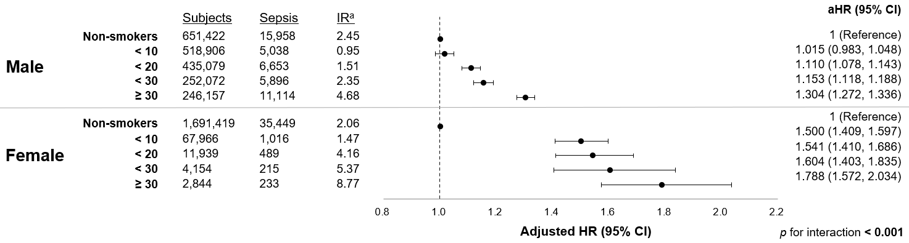

(B) Age group
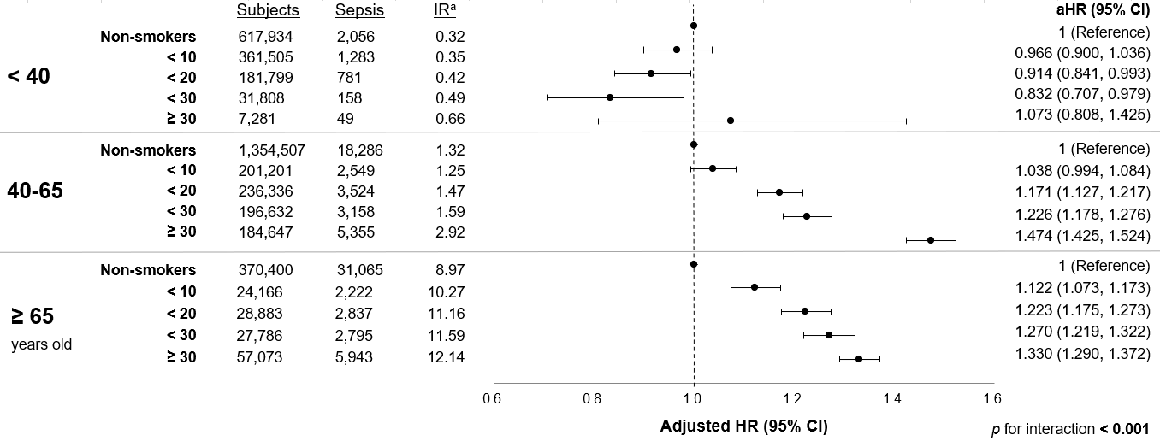

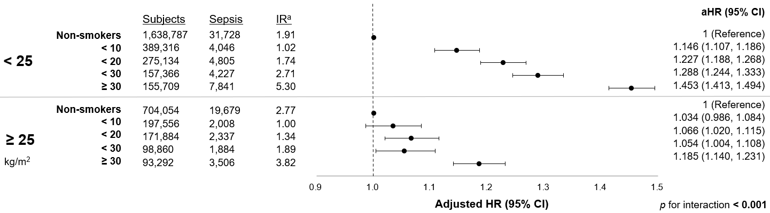
(C) BMI
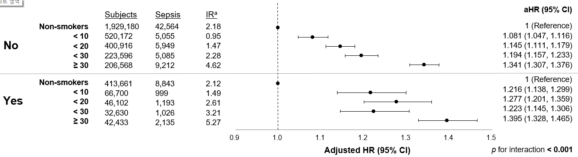
(D) Lowest income status
Supplementary Fig. 2. Impact of total smoking amount on incidence of sepsis by lifestyle behaviors
(A) Regular exercise
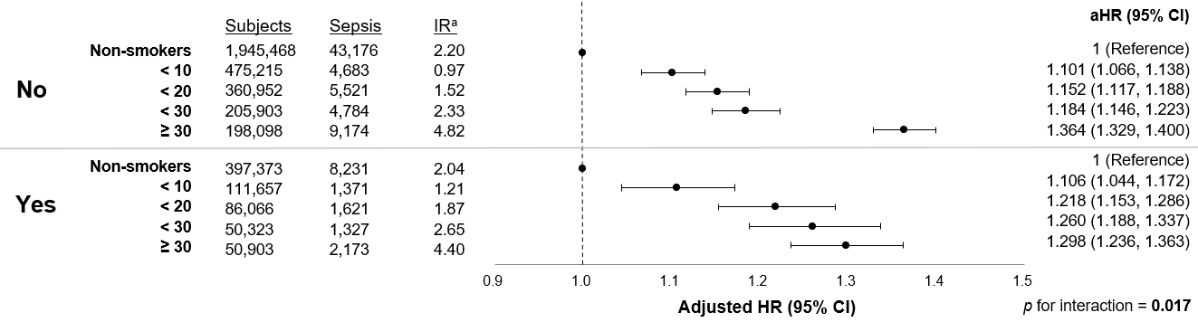

(B) Drinking
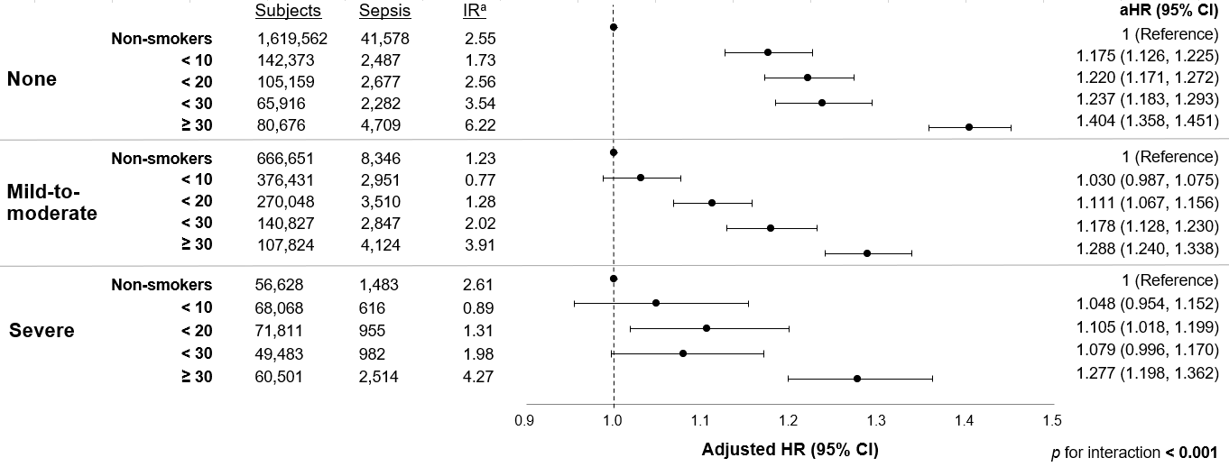

Supplementary Fig. 3. Impact of total smoking amount on incidence of sepsis by medical comorbidities
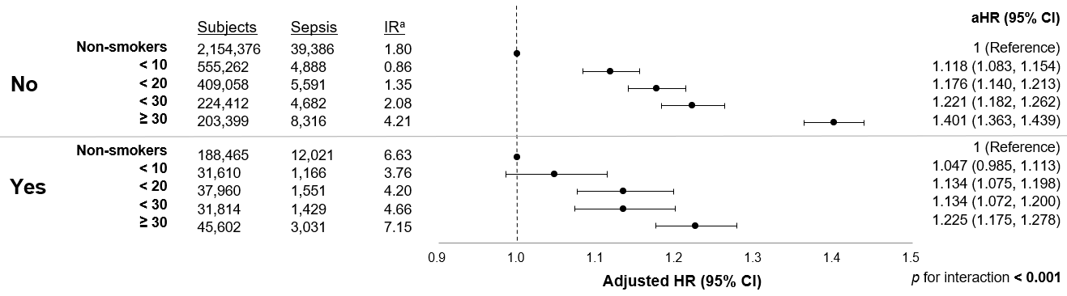
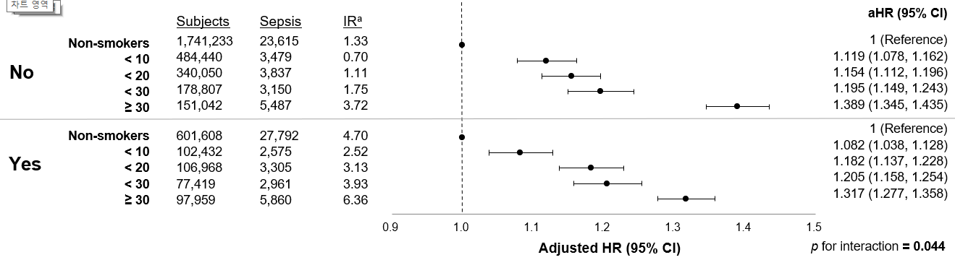
(A) Diabetes mellitus
(B) Hypertension
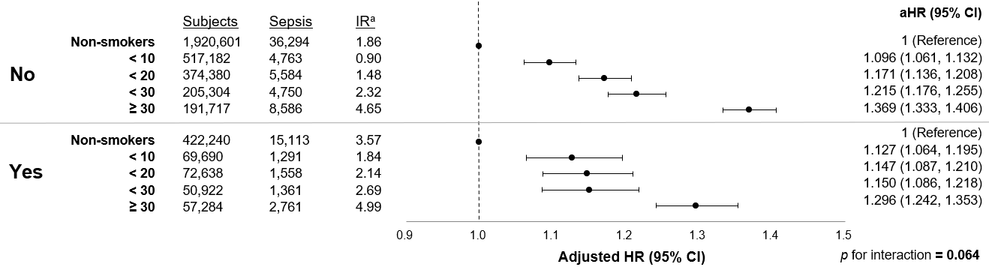
(C) Dyslipidemia
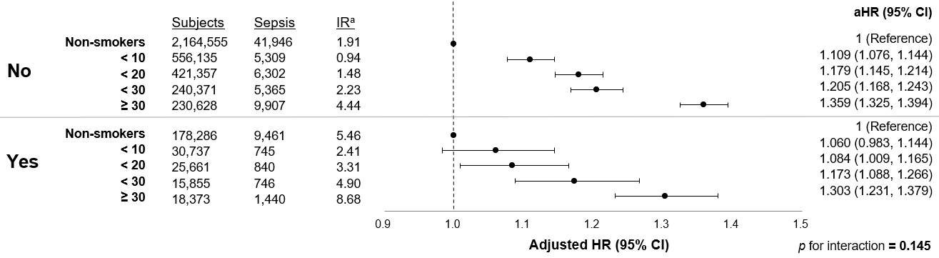
(D) Chronic kidney disease

