Supplementary Information

A Solvent-free Processed Low-temperature Tolerant Adhesive

Xiaoming Xie^{1,2†}, Runhan Li^{1†}, Xiaoman Yao¹, Jiaqi Zhang³, Zilin Zhang², Taoping Huang¹, Yulian Jiang², Yifa Chen¹*, Shun-li Li¹, Ya-Qian Lan¹*

1 School of Chemistry, South China Normal University, Guangzhou, 510006, P. R. China.
2 Department of Chemistry, Xinzhou Normal University, Xinzhou, Shanxi, 034000, China.
3. College of Physics and Optoelectronics, Taiyuan University of Technology, Taiyuan, 030024, China.
*Correspondence and requests for materials should be addressed to Y. C (email: chyf927821@163.com) and Y. -Q. L. (email: yqlan@m.scnu.edu.cn).
Homepage: http://www.yqlangroup.com/*
- Supplementary Notes
Note 1: Materials.
Note 2: Characterization.
Note 3: Experimental Procedures.
Note 4: Computational Methods.
- Supplementary Figures
Figure 1. The preparation of SSFP and PSFP adhesives.
Figure 2. FT-IR spectra of SSFP adhesive, SiW₁₂, and PEG.
Figure 3. PXRD pattern of the physical mixture of PEG and SiW₁₂.
Figure 4. Total XPS spectra of SSFP adhesive, SiW₁₂ and PEG. a) SSFP adhesive. b) SiW₁₂. c) PEG.
Figure 5. XPS spectra of SSFP, PEG and SiW₁₂. a) XPS spectra of the C 1s of SSFP and PEG. b) XPS spectra of the W 4f of SSFP and SiW₁₂.
Figure 6. ¹³C NMR spectra of SSFP and PEG.
Figure 7. SEM images of SSFP adhesive and contrast samples. a) SiW₁₂. b) PEG. c) PEG after heating at 90 °C for 2 h. d) SSFP adhesive.
Figure 8. Adhesion behaviors of the SSFP adhesive for adhering various substrates. a) SS. b) Ceramic. c) Rubber. d) Carnelian. e) Glass. f) Wood.
Figure 9. Comparison of the adhesion strengths with the reported POMs based adhesive. a) The total graph. b) The enlarge graph.
Figure 10. Adhesion strengths of SSFP adhesive on SS substrates during eight warming-cooling treating processes.
Figure 11. The distribution images of SSFP adhesive on SS substrates after detachment (the SSFP adhesive dispersed within the dashed line).
Figure 12. FT-IR spectra of the SSFP adhesives with different mass ratios (PEG : SiW₁₂ = 2 : 5, 2 : 4, and 2 : 3).
Figure 13. ¹H NMR spectra of SSFP adhesives with different mass ratios (PEG : SiW₁₂ = 2 : 5, 2 : 4, and 2 : 3).
Figure 14. PXRD patterns of SSFP adhesives with different mass ratios (PEG : SiW₁₂ = 2 : 5, 2 : 4, and 2 : 3).
Figure 15. TGA curves of SSFP adhesives with different mass ratios (PEG : SiW₁₂ = 2 : 5, 2 : 4, and 2 : 3).
Figure 16. Adhesion strengths of SSFP and PSFP adhesives with different mass ratios (PEG : POMs = 2 : 5, 2 : 4, and 2 : 3).
Figure 17. The digital photographs of SSAP adhesive.
Figure 18. Adhesion strengths of the SSAP and SSFP adhesives on SS substrates.
Figure 19. Characterization of the PSFP adhesive. a) ¹³C NMR spectra of PSFP and PEG. b) ¹H NMR spectra of PSFP adhesives with different mass ratios (PEG : PW₁₂ = 2 : 5, 2 : 4, and 2 : 3) and PEG. c) FT-IR spectra of PSFP adhesive, PW₁₂, and PEG. d) FT-IR spectra of PSFP adhesives with different mass ratios (PEG : PW₁₂ = 2 : 5, 2 : 4, and 2 : 3). e) PXRD patterns of PSFP adhesive, physical mixture of PEG and PW₁₂, PW₁₂, and PEG. f) PXRD patterns of PSFP adhesives with different mass ratios (PEG : PW₁₂ = 2 : 5, 2 : 4, and 2 : 3).
Figure 20. SEM images and elemental mapping of the samples. a) PW₁₂. b) PSFP adhesive. c) The corresponding elemental mapping.
Figure 21. TGA curves of the samples. a) PEG. b) PW₁₂. c-e) PSFP adhesives with different mass ratios (PEG : PW₁₂ = 2 : 5, 2 : 4, and 2 : 3). (f) DSC spectra of PSFP adhesive (2 : 5), PW₁₂, and PEG.
Figure 22. Digital photographs of the samples. a) Mixture of PEG and Na₃PW₁₂O₄₀. b) Mixture of PEG and Na₃PW₁₂O₄₀ after heating at 90 °C for 2 h.
Figure 23. PXRD patterns of the samples. a) PEG. b) Na₃PW₁₂O₄₀. c) Physical mixture of PEG and Na₃PW₁₂O₄₀. d) Mixture of PEG and Na₃PW₁₂O₄₀ after heating at 90 °C for 2 h.
Figure 24. SEM images of the mixture for Na₃PW₁₂O₄₀ and PEG after heating, and the corresponding elemental mapping.
Figure 25. Digital photographs of the samples after heating at 90 °C for 2 h. a) Adhesive based on PCL and SiW₁₂. b) Mixture of PE and SiW₁₂. c) Mixture of PVDF and SiW₁₂.
Figure 26. Adhesion strengths of different polymers based adhesives on SS substrates. a) PCL. b) PEG (Mn, ~10000).
Figure 27. Digital photographs of the PEG analogues based adhesives. a) PEG. b) PEGME. c) PEGdME (Mn, ~2000).
Figure 28. Adhesion strengths of different polymers based adhesives on SS substrates. a) PEG. b) PEGME. c) PEGdME (Mn, ~2000).
Figure 29. Characterization of the different polymers based adhesives. a) Viscosity as a function of shear rate. b) Shear stress as a function of shear rate.
Figure 30. Photographs of the SSFP adhesive after immersion in organic solvents (N-hex) for 14 days.
Figure 31. Adhesion behavior of the SSFP adhesive in organic solvent. a) Stainless steel mould. b) Initial adhesion state. c) Lifted state (the adhesion area is 1.77 cm², and the volume of ethyl acetate is 500 mL).
Figure 32. Adhesion behavior of the solvent-free adhesives (EVA and SSFP). a) Photographs of the solvent-free adhesives soaking in mesitylene. b) Adhesion strength of the solvent-free adhesive adhered on SS substrates after soaking for 7 days.
Figure 333. Shear viscosity of the samples as a function of temperature. a) The SSFP adhesive. b) PEG.
Figure 34. DSC spectra of SSFP adhesive, SiW₁₂, and PEG.
Figure 35. TGA curves of SSFP adhesive, SiW₁₂ and PEG. a) SSFP adhesive. b) SiW₁₂. c) PEG.
Figure 36. Photographs of the SSFP adhesive adhered in glass slices after treatment. a) 25 °C. b) -196 °C.
Figure 37. Photographs of the PEG adhered in glass slices at different temperature. a) 60 °C. b) 25 °C. c) -196 °C.
Figure 38. Photographs of the EVA adhered in glass slices after treatment. a) 25 °C. b) -196 °C.
Figure 39. Adhesion strengths of SSFP adhesive on SS substrates at various temperatures.
Figure 40. Adhesion performance of SSFP adhesive in liquid nitrogen (-196 °C). a) Adhesion strength of SSFP adhesive frozen for different times. b) The photograph of SSFP adhesive on SS after soaking in liquid nitrogen (-196 °C) for 60 days.
Figure 41. Adhesion tests of the commercial hot melt glue EVA in liquid nitrogen. a) Initial adhesion state. b) Immersed state. c-d) Frost-cracked state.
Figure 42. Temperature-dependent FT-IR spectra of SSFP adhesive at different temperature conditions. a) W=O_{d}. b) W–O_{b}–W. c) W–O_{c}–W. d) C–O–C.
Figure 43. The ratio of formative hydrogen bonds between PEG and SiW₁₂ at 25 and -196 °C for the final 2 ns of the simulation.
Figure 44. Snapshots of the aggregation behavior of PEG and SiW₁₂ at 55 °C (the cubic boundaries are marked with black lines).
Figure 45. The interaction energy of PEG and SiW₁₂ during cross-linking process at 25 and 55 °C.
Figure 46. The ratio of formative hydrogen bonds between PEG and SiW₁₂ at 25 and 55 °C for the final 2 ns of the simulation.
Figure 47. Snapshots of the aggregation behavior of PEG and PW₁₂ at 25 °C (the cubic boundaries are marked with black lines).
Figure 48. The interaction energy of PEG and POMs (SiW₁₂ and PW₁₂) during cross-linking process at 25 °C.
Figure 49. The ratio of formative hydrogen bonds between PEG and POMs (SiW₁₂ and PW₁₂) at 25 °C for the final 2 ns of the simulation.
- Supplementary Table
Table 1. Performance comparison of the reported POMs based adhesives, and the test method is the same in the all references (lap joint).

Supplementary Notes
Supplementary Note 1: Materials.
All solvents and reagents obtained from commercial sources were used without further purification. PEG (Mn, ~2000 and ~10000 Da), PEGME (Mn, ~2000 Da), and PEGdME (Mn, ~2000 Da) were bought from Aladdin Industrial Corporation. PCL (Mn, ~10000 Da), PE (Mn, ~400000 Da), and PVDF (Mn, ~180000 Da) were purchased from Macklin Biochemical Technology Co., Ltd. (Shanghai). SiW₁₂, PW₁₂, Na₃PW₁₂O₄₀, mesitylene, isopropyl ether, ethyl acetate, octanoic acid, petroleum ether, n-hexane, dioxane, and 1,4-dibromobutane were obtained from Shanghai Titan Scientific Co., Ltd. The EVA was bought from the Taobao store.

Supplementary Note 2: Characterization.
Powder X-ray diffraction (PXRD) patterns were recorded on a Rigaku SmartLab diffractometer (Rigaku SmartLab, Japan) with Cu Kαradiation at 45 kV, 200 mA. Morphological and structural characterizations were performed by a field-emission scanning electron microscope (SEM, Hitachi SU-8010) system and energy-dispersive spectral (EDS) analysis instrument. X-ray photoelectron spectroscopy (XPS) measurements were conducted by a Thermo Fisher Scientific Escalab 250 Xi. Fourier transform infrared spectrometry (FT-IR) spectra were tested using a Bruker Optics Tensor 27 in the range of 4000-600 cm⁻¹ with KBr pellets. Solid-state ¹³C CP/MAS NMR was performed on a Bruker Avance NEO 400 WB spectrometer. ¹H NMR and ¹³C NMR spectra were collected on a Bruker AVANCE 500 MHz spectrometer. ³²Si NMR spectra were collected on a Bruker AVANCE 500 MHz spectrometer (10 s for relaxation time, 3000 scans). Thermogravimetric analysis (TGA) was tested on a TGA5500 using a heating rate of 10 ºC min⁻¹ from 30 to 800 ºC in nitrogen atmosphere. Differential Scanning Calorimeter (DSC) measurements were performed by a TAQ200 with a heating rate of 10 ºC min⁻¹ from -60 to 60 ºC in nitrogen atmosphere. All lap shear tests were tested by a universal testing machine at a strain rate of 10 mm min⁻¹ at ambient temperature. The cycling test used cycles of lap shearing and interfacial adhesion. Rheological studies were collected on a Rotary rheometer (Austria Anton Paar, MCR302). Degree of crosslinking were performed on low field NMR analyzer (MesoMR23/12-060H-I).

Supplementary Note 3: Experimental Procedures.
Syntheses of the SSFP adhesive with different mass ratio (2 : 3, 2 : 4 and 2 : 5).
The POMs based solvent-free polymer adhesives were prepared using a simple method. PEG (200 mg) and SiW₁₂ (300, 400 and 500 mg) were mixed evenly in glass bottles, then the mixture was heated at 90 °C for 2 h. The SiW₁₂ based solvent-free polymer (SSFP) adhesive was obtained after cooling to room temperature. The SSFP adhesive can also be prepared on a kilogram scale through increasing raw materials in equal proportions. As a contrast, PW₁₂ based solvent-free polymer (PSFP) adhesives were obtained by replacing SiW₁₂ with PW₁₂ under the same preparation method. In addition, The POMs based solvent-assisited polymer adhesives (SSAP and PSAP) were prepared by adding 4 mL of water into the mixture of POMs and PEG, then standing for 2 h. (PEG : POMs = 2 : 5).

Supplementary Note 4: Computational Details.
Density functional theory (DFT) calculations
Firstly, PEG fragments with five polymerization degrees are selected as the PEG computational model. The interaction energy calculations between the POMs and PEGs are performed by DFT simulation with Gaussian 09 program¹ at the B3LYP-D3² functional. The 6-31 +G** basis set is used for H atom involved in the POMs.The LanL2DZ basis sets³ are used for the W atoms, and 6-31G* basis sets are employed for the other main-group atoms. The independent gradient model based on Hirshfeld (IMGH) partition is performed using Multiwfn⁴. Images of the 3D structures are prepared with VMD visualization program⁵.
Interaction energies have been evaluated with the following formula:
E_{Int} = E_{POM-nPEG} − (E_{POM} + n*E_{PEG})
Where, E_{POM} is the energy of the POM structure alone, E_{PEG} is the energy of the PEG polymer (n = 1, 2, 3), and E_{POM-nPEG} is the total energy of POM-nPEG complexes.

Molecule dynamics (MD) simulations
The structures of MD simulation is consist of 5 H₄SiW₁₂O₄₀ or H₃PW₁₂O₄₀, and 25 PEG fragments (mass ratio of POM : PEG = 1 : 5). The models for POM and PEG can be obtained at ground-state geometric structures of DFT calculations, and the RESP charge⁶ of POMs and PEGs are obtained with Multiwfn at same theoretical level. The mix molecules are placed in a 4 × 4 × 4 nm³ simulation box, respectively.
The GROMACS 2018.8 simulation package⁶⁻⁸ is employed for the MD simulations, and OPLS force field⁹ and UFF force field¹⁰ can also be used in GROMACS system. The cutoff distance for short-range nonbonded interactions is set to be 12 Å. The V-rescale temperature coupling method¹¹ is used to maintain three temperature levels at 78.15, 298.15 and 328.15 K, respectively. The three-dimensional periodic boundary conditions (PBC) have been applied for all of the MD simulations. The NVT Ensemble is applied with running over 2 ns in steps of 2 fs. After simulation run, the interaction energy and hydrogen bond percentage between POMs and PEGs are analyzed. Snapshots and videos of the aggregation behavior of are prepared with VMD visualization program.

Supplementary Figures
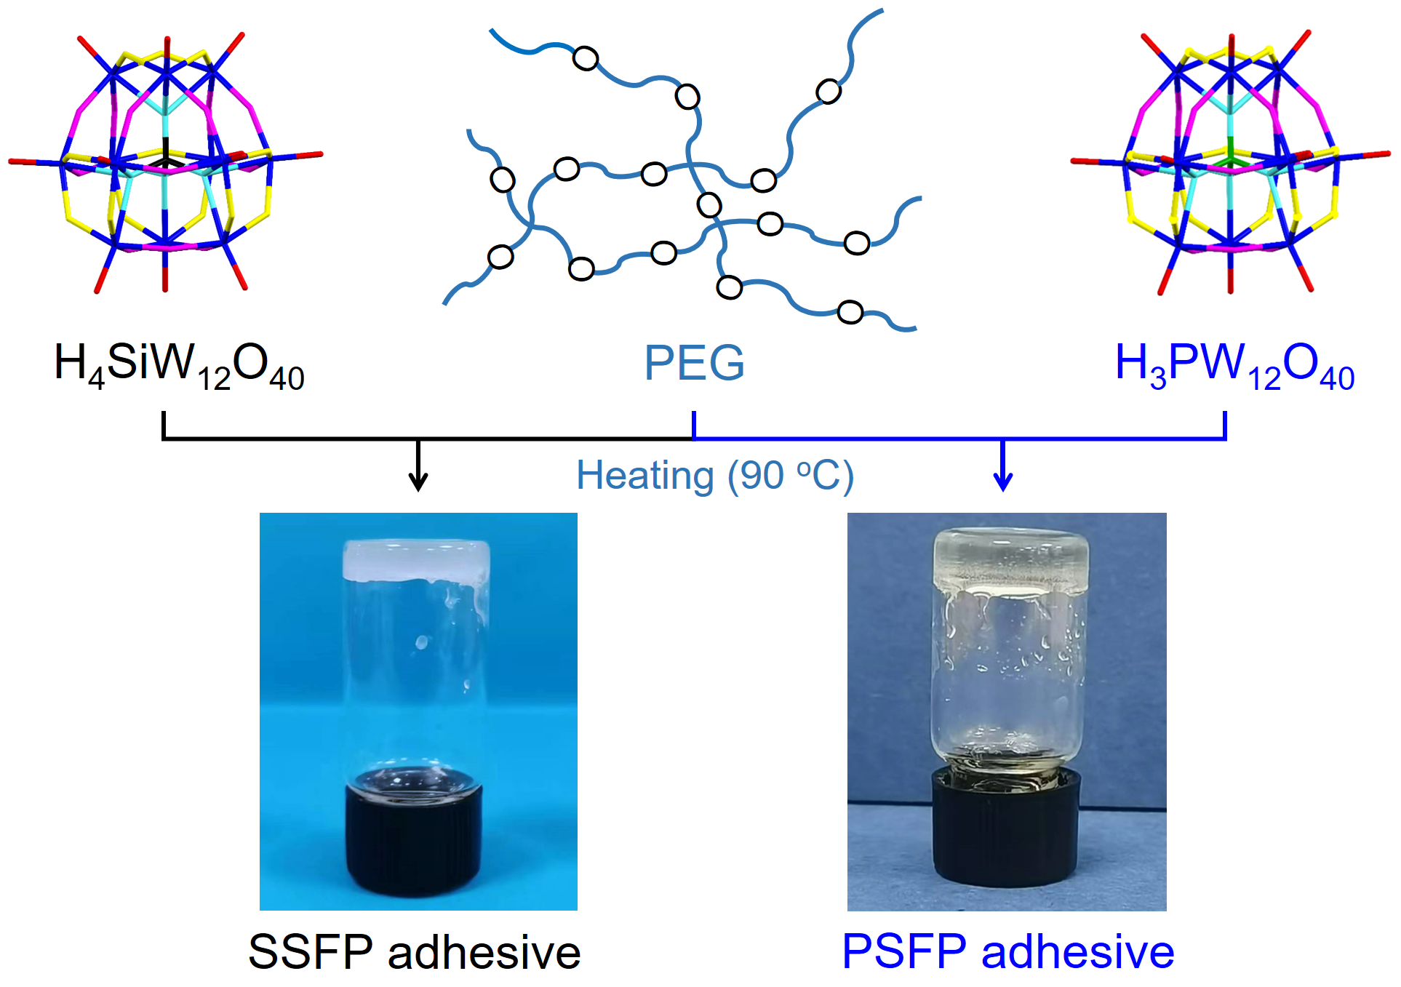
Supplementary Figure 1. The preparation of SSFP and PSFP adhesives.

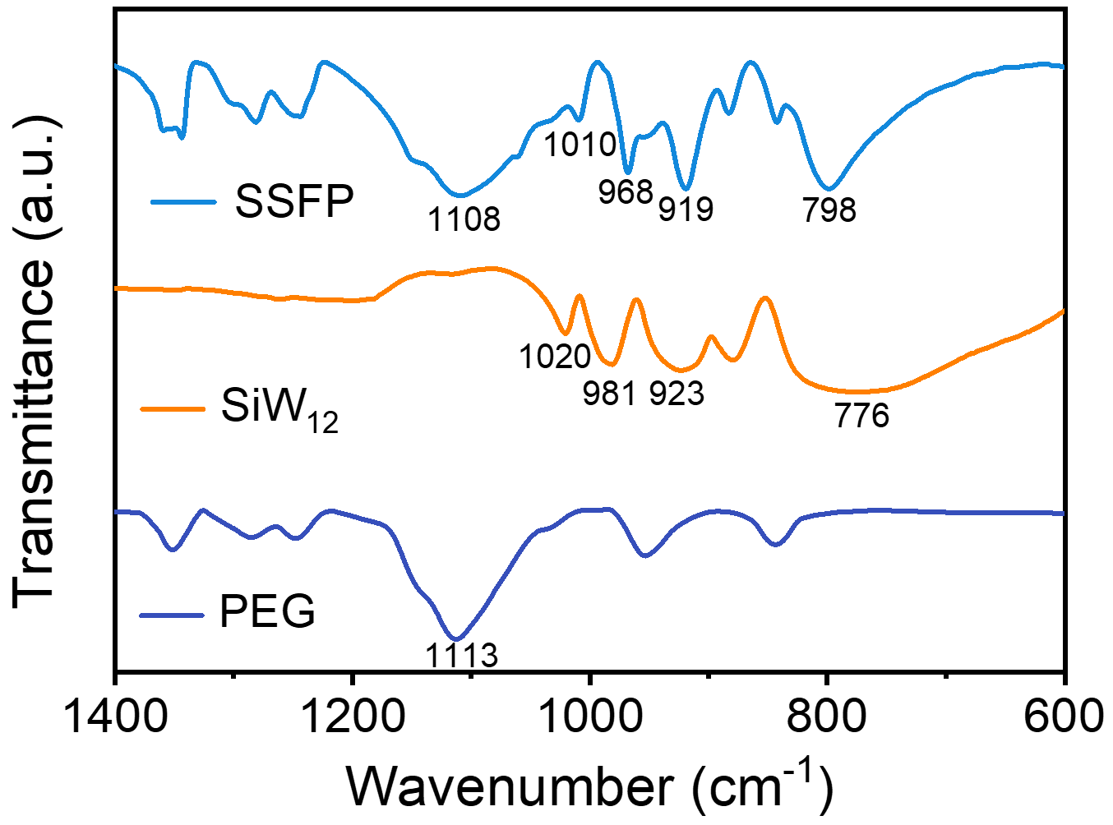
Supplementary Figure 2. FT-IR spectra of SSFP adhesive, SiW₁₂, and PEG.

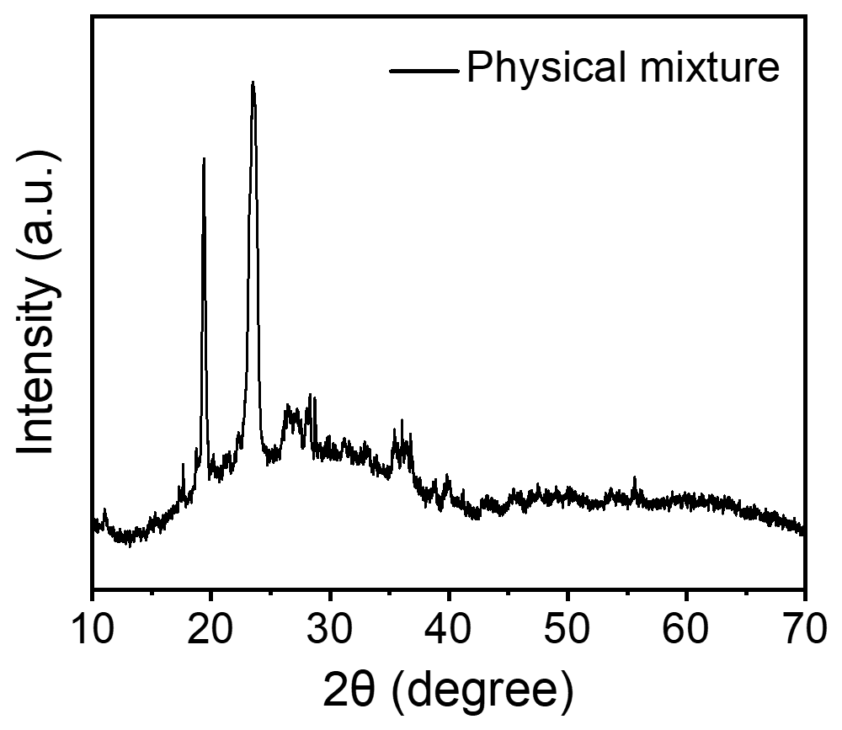
Supplementary Figure 3. PXRD pattern of the physical mixture of PEG and SiW₁₂.

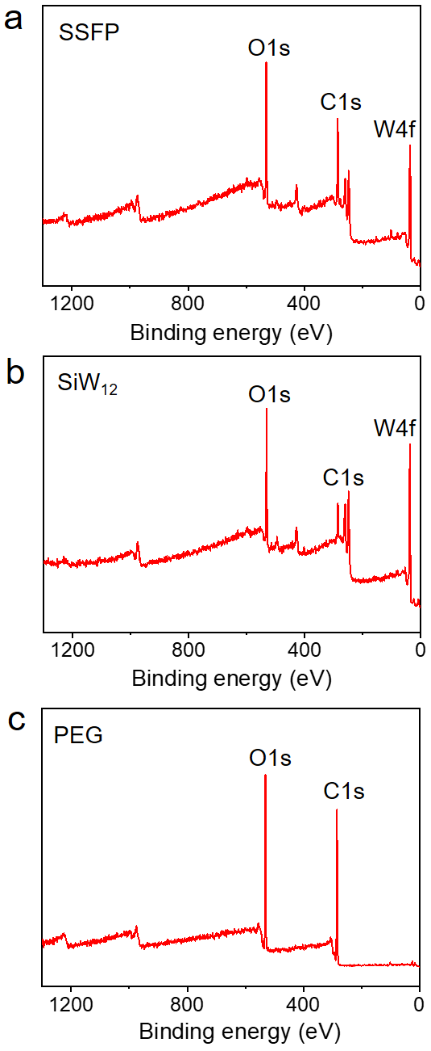
Supplementary Figure 4. Total XPS spectra of SSFP adhesive, SiW₁₂ and PEG. a) SSFP adhesive. b) SiW₁₂. c) PEG.
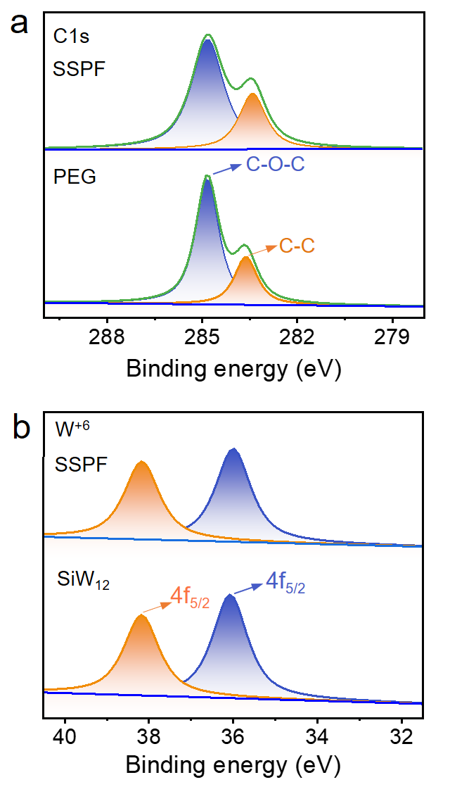
Supplementary Figure 5. XPS spectra of SSFP, PEG and SiW₁₂. a) XPS spectra of the C 1s of SSFP and PEG. b) XPS spectra of the W 4f of SSFP and SiW₁₂.

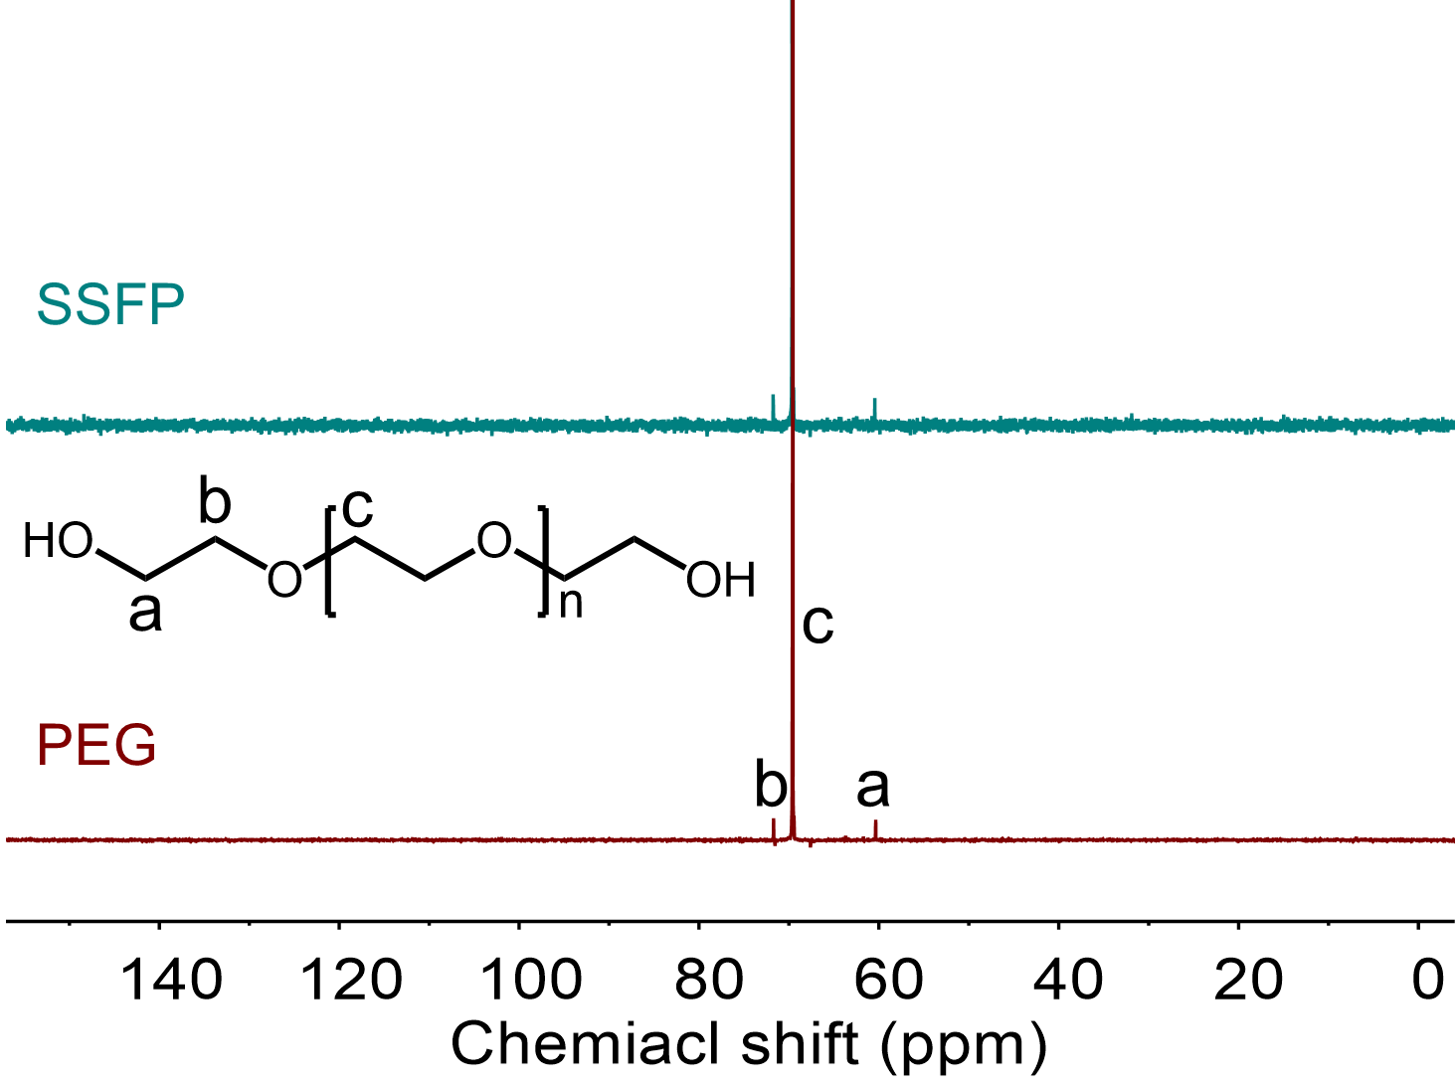
Supplementary Figure 6. ¹³C NMR spectra of SSFP and PEG.

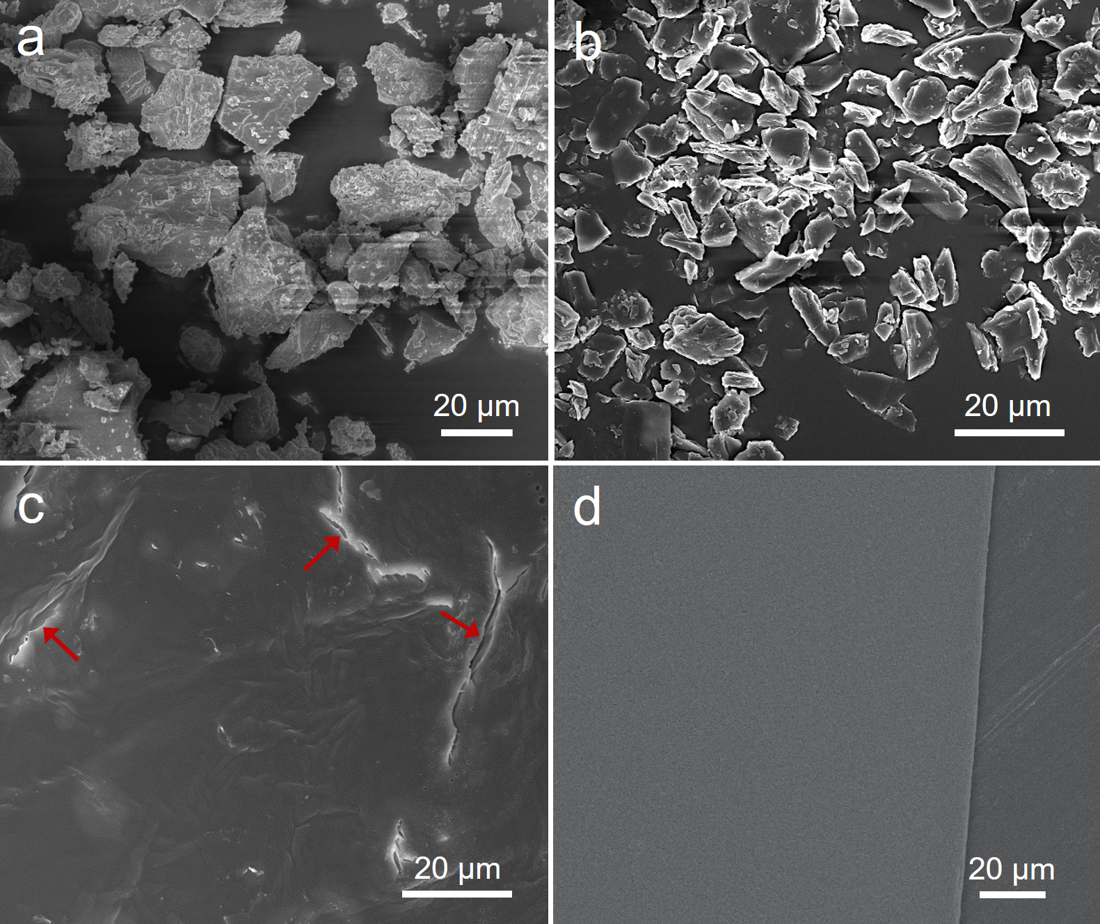
Supplementary Figure 7. SEM images of SSFP adhesive and contrast samples. a) SiW₁₂. b) PEG. c) PEG after heating at 90 °C for 2 h. d) SSFP adhesive.
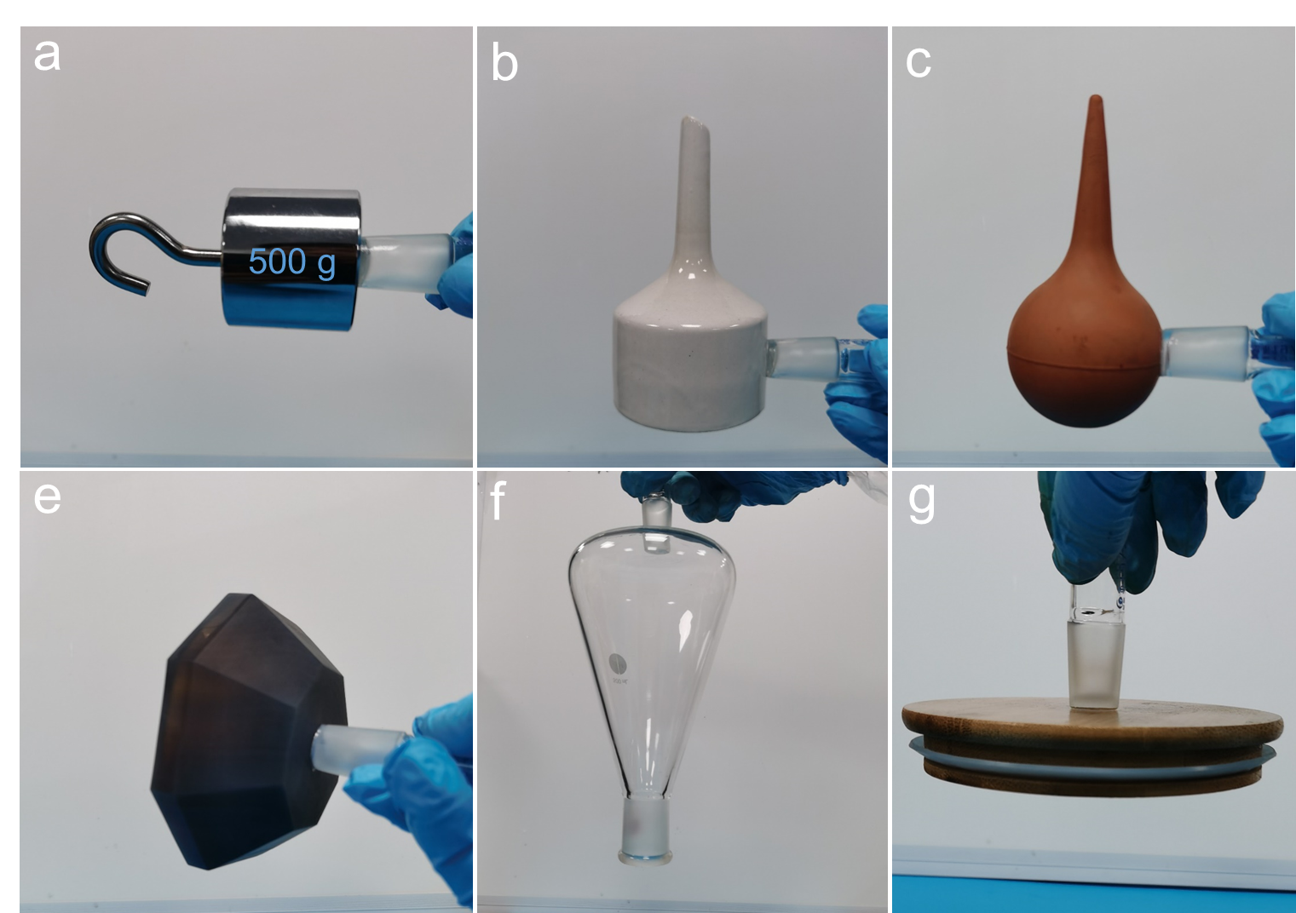
Supplementary Figure 8. Adhesion behaviors of the SSFP adhesive for adhering various substrates. a) SS. b) Ceramic. c) Rubber. d) Carnelian. e) Glass. f) Wood.
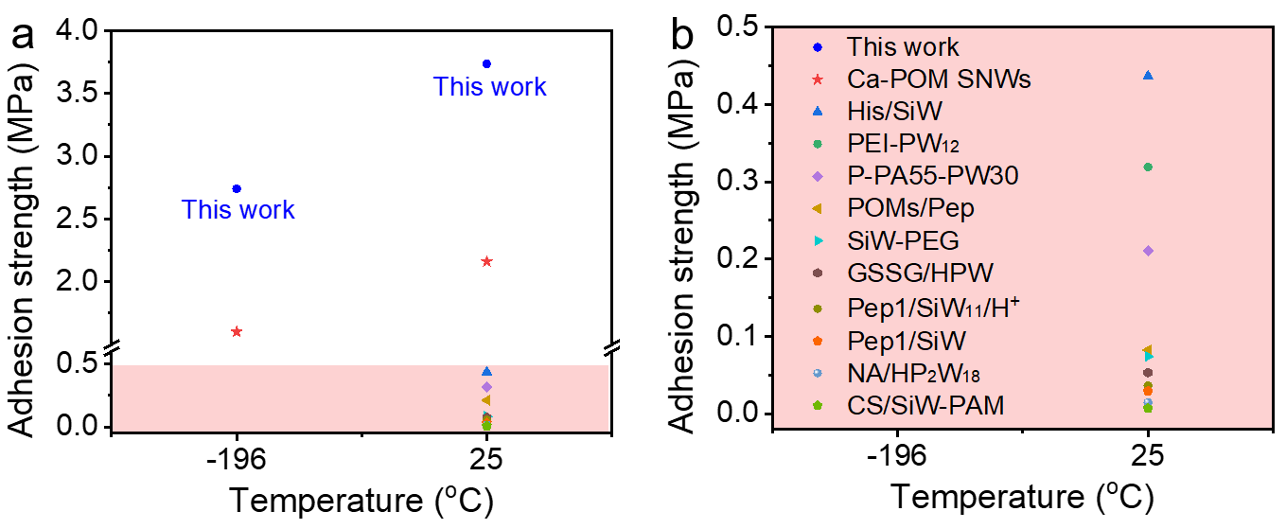
Supplementary Figure 9. Comparison of adhesion strengths with the reported POMs based adhesive¹²⁻²². a) The total graph. b) The enlarge graph.
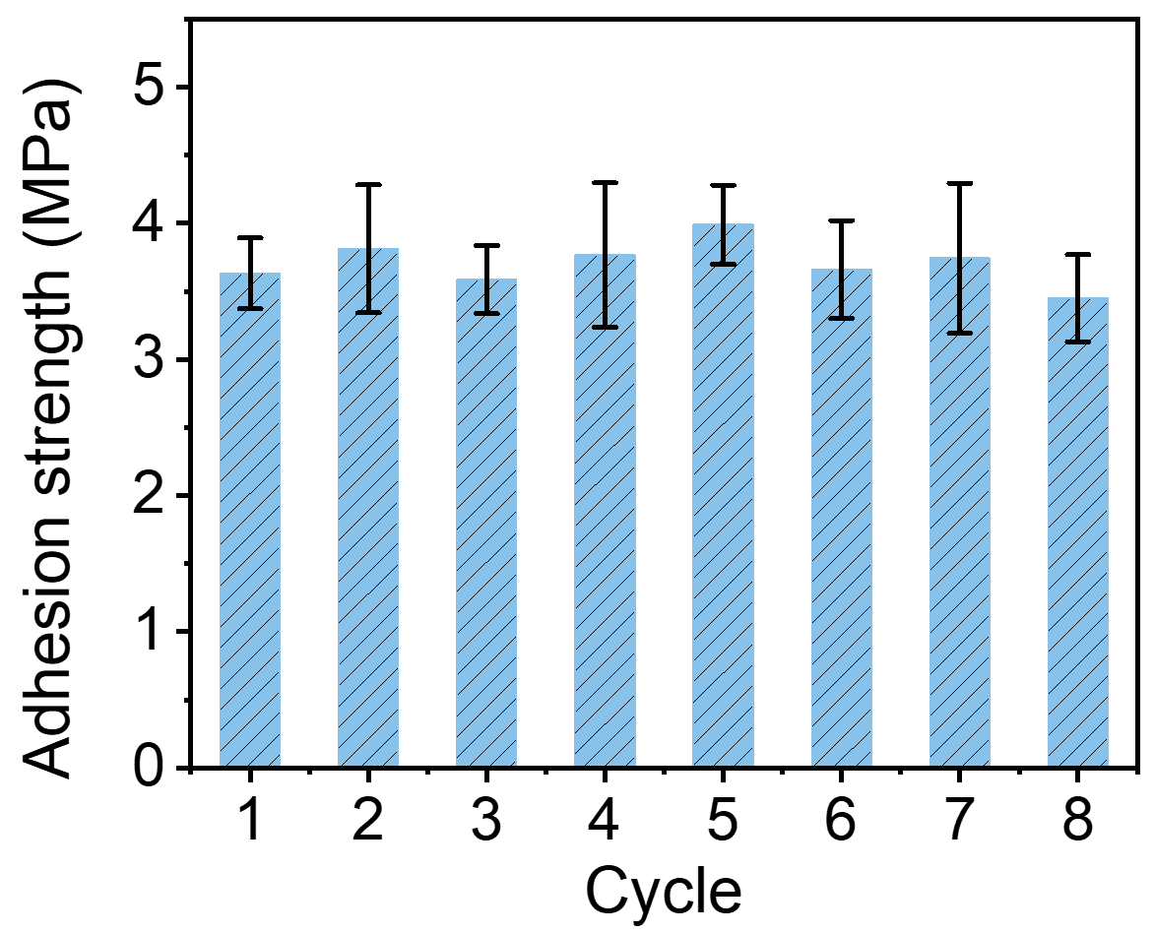
Supplementary Figure 10. Adhesion strengths of SSFP adhesive on SS substrates during eight warming-cooling treating processes.
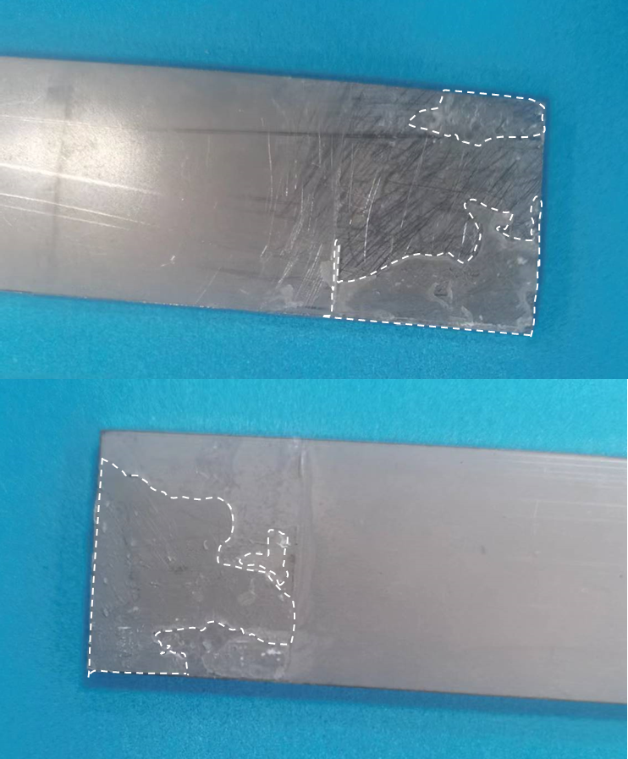
Supplementary Figure 11. The distribution images of SSFP adhesive on SS substrates after detachment (the SSFP adhesive dispersed within the dashed line).
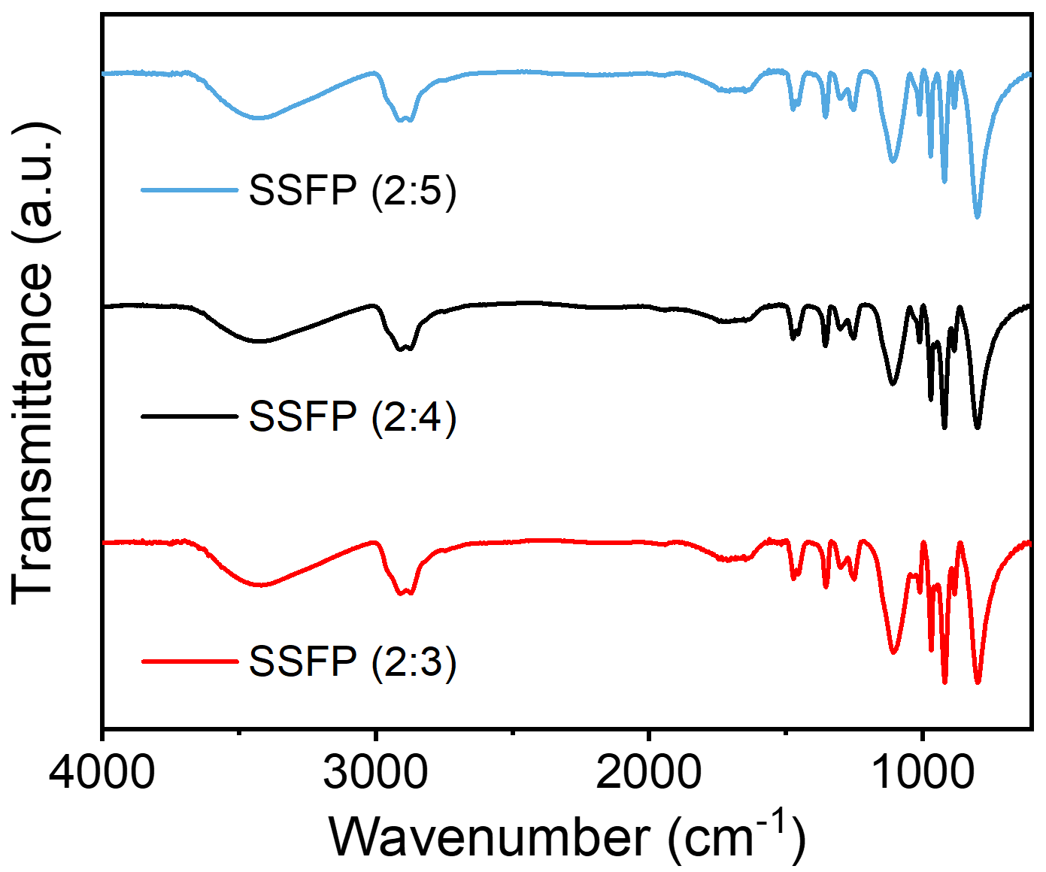
Supplementary Figure 12. FT-IR spectra of the SSFP adhesives with different mass ratios (PEG : SiW₁₂ = 2 : 5, 2 : 4, and 2 : 3).

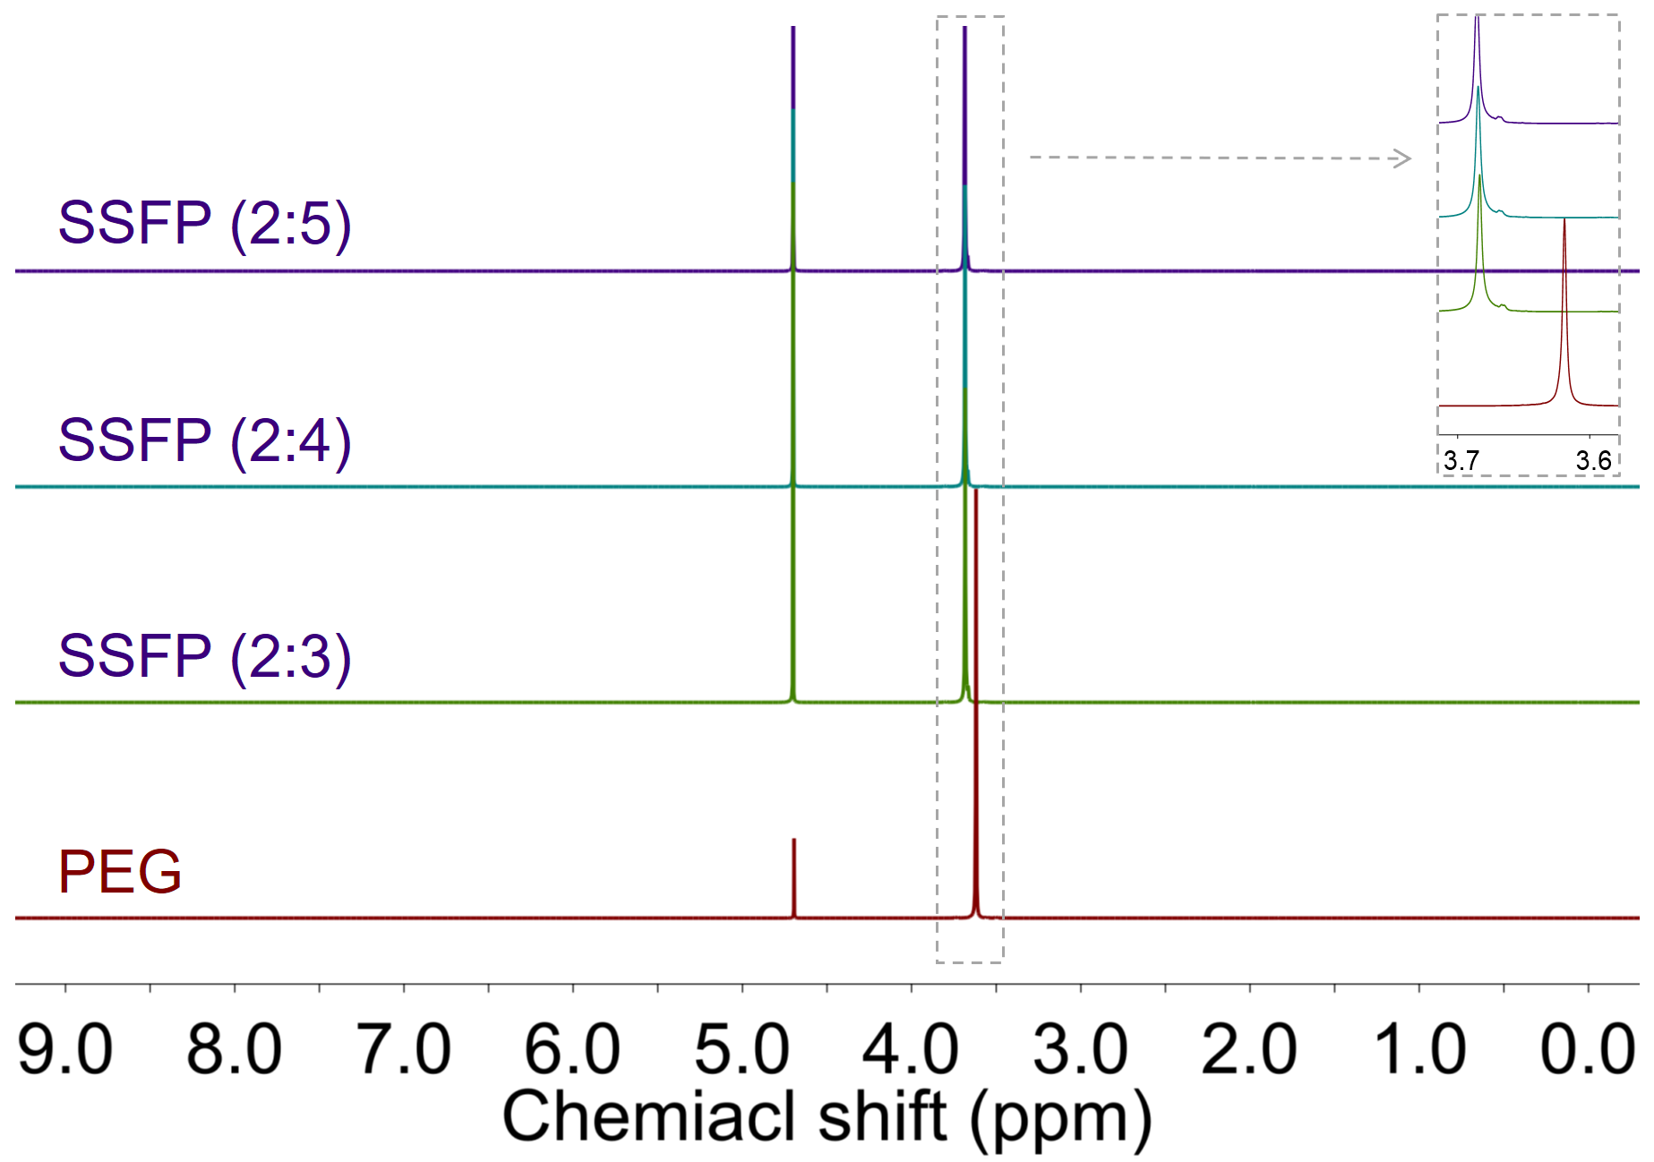
Supplementary Figure 13. ¹H NMR spectra of SSFP adhesives with different mass ratios (PEG : SiW₁₂ = 2 : 5, 2 : 4, and 2 : 3).

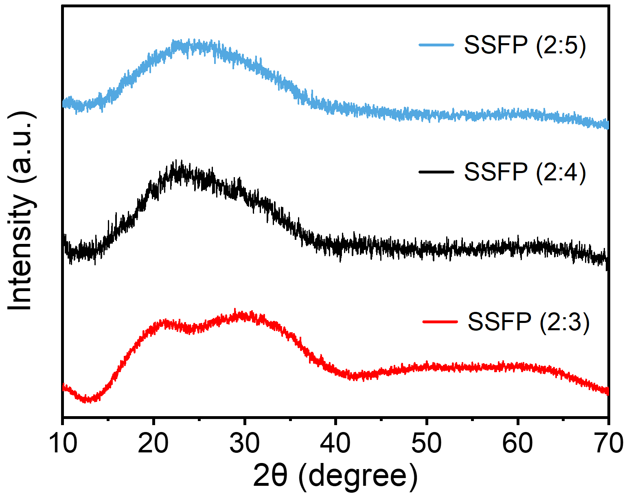
Supplementary Figure 14. PXRD patterns of SSFP adhesives with different mass ratios (PEG : SiW₁₂ = 2 : 5, 2 : 4, and 2 : 3).

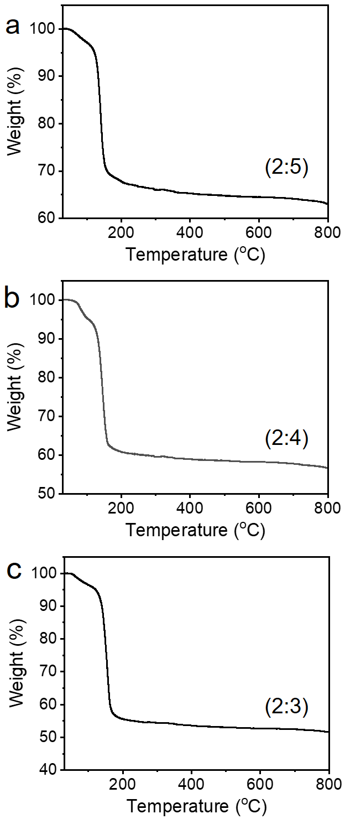
Supplementary Figure 15. TGA curves of SSFP adhesives with different mass ratios (PEG : SiW₁₂ = 2 : 5, 2 : 4, and 2 : 3).

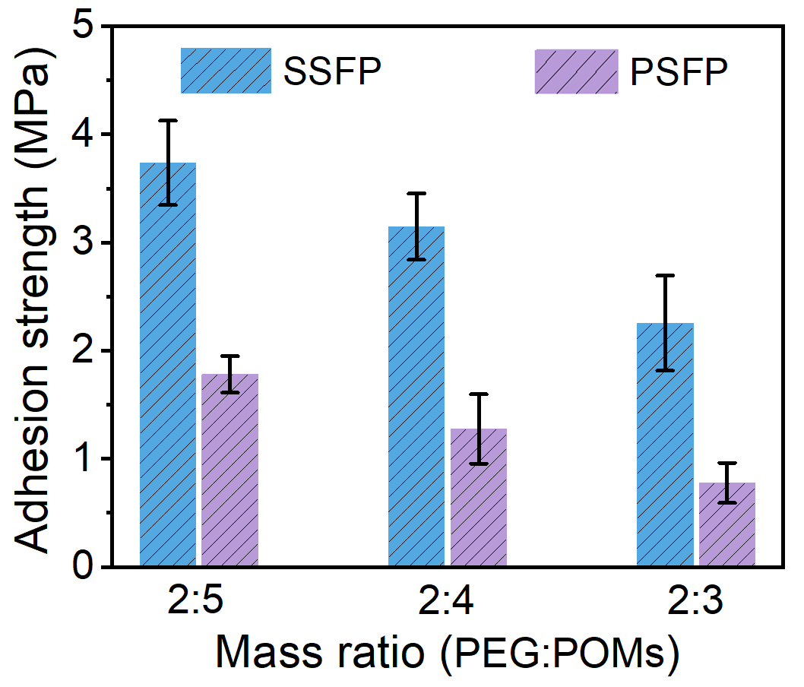
Supplementary Figure 16. Adhesion strengths of SSFP and PSFP adhesives with different mass ratios (PEG : POMs = 2 : 5, 2 : 4, and 2 : 3).
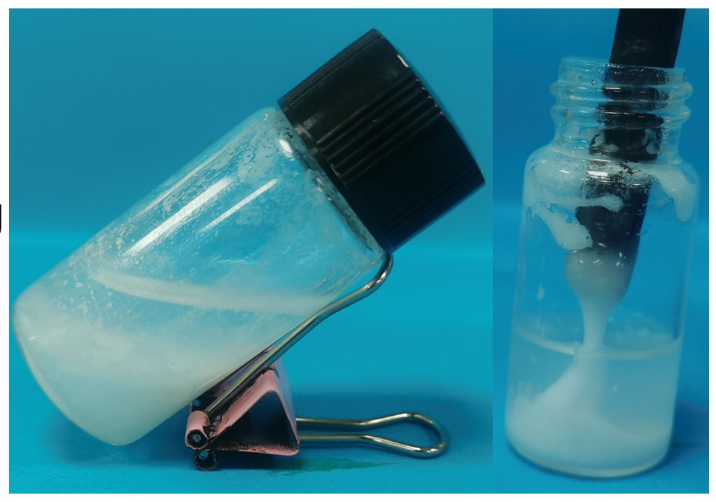
Supplementary Figure 17. The digital photographs of SSAP adhesive.

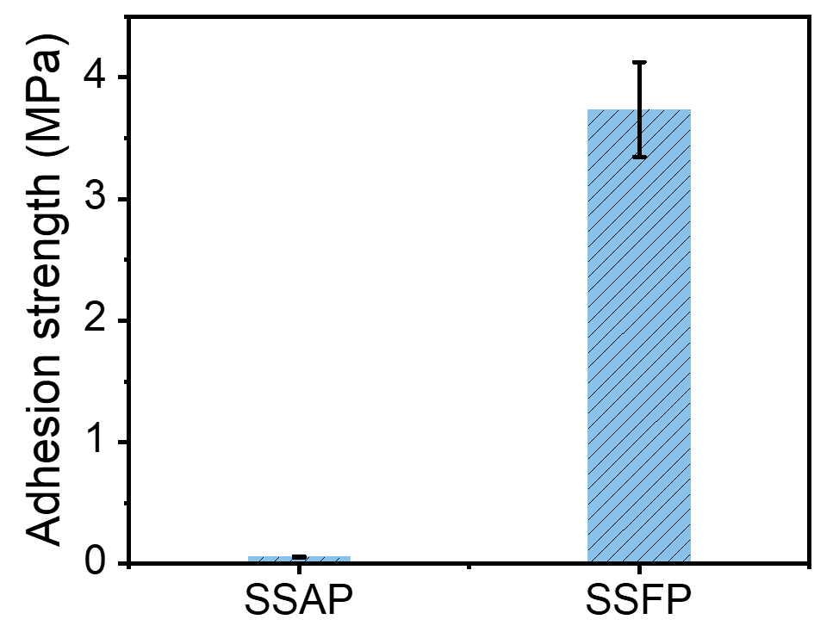
Supplementary Figure 18. Adhesion strengths of the SSAP and SSFP adhesives on SS substrates.
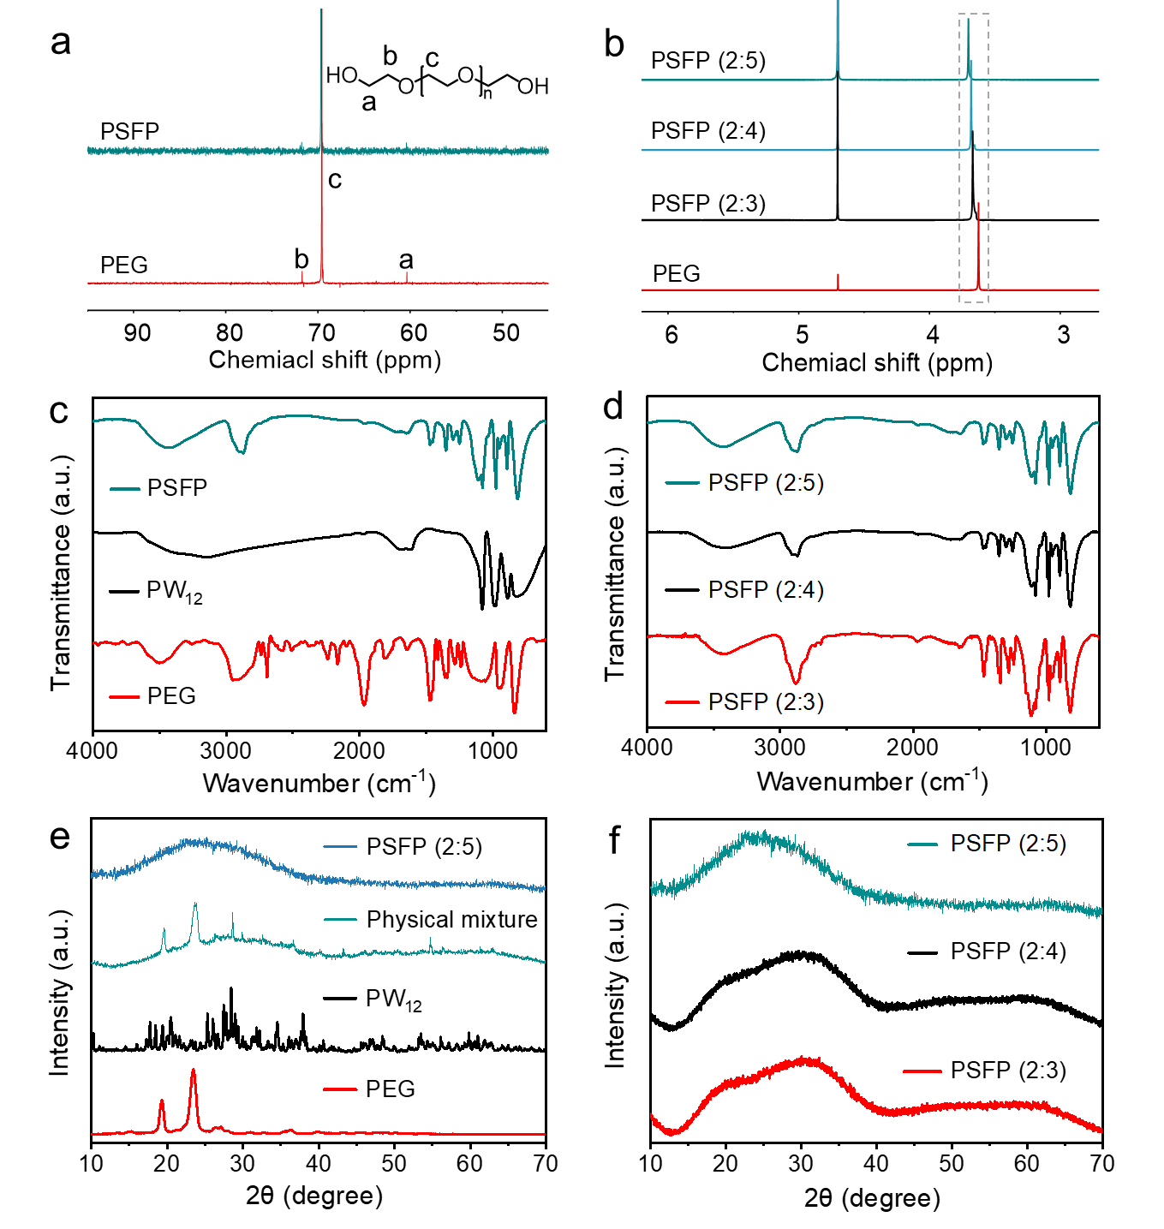
Supplementary Figure 19. Characterization of the PSFP adhesive. a) ¹³C NMR spectra of PSFP and PEG. b) ¹H NMR spectra of PSFP adhesives with different mass ratios (PEG : PW₁₂ = 2 : 5, 2 : 4, and 2 : 3) and PEG. c) FT-IR spectra of PSFP adhesive, PW₁₂, and PEG. d) FT-IR spectra of PSFP adhesives with different mass ratios (PEG : PW₁₂ = 2 : 5, 2 : 4, and 2 : 3). e) PXRD patterns of PSFP adhesive, physical mixture of PEG and PW₁₂, PW₁₂, and PEG. f) PXRD patterns of PSFP adhesives with different mass ratios (PEG : PW₁₂ = 2 : 5, 2 : 4, and 2 : 3).

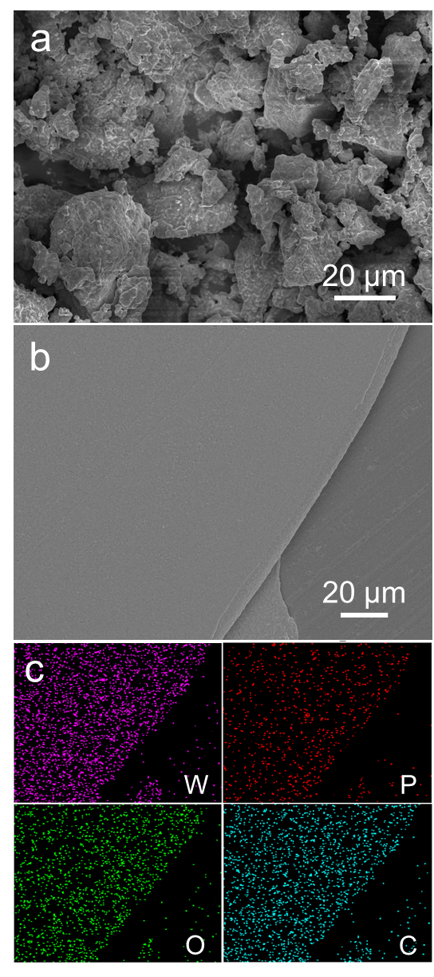
Supplementary Figure 20. SEM images and elemental mapping of the samples. a) PW₁₂. b) PSFP adhesive. c) The corresponding elemental mapping.

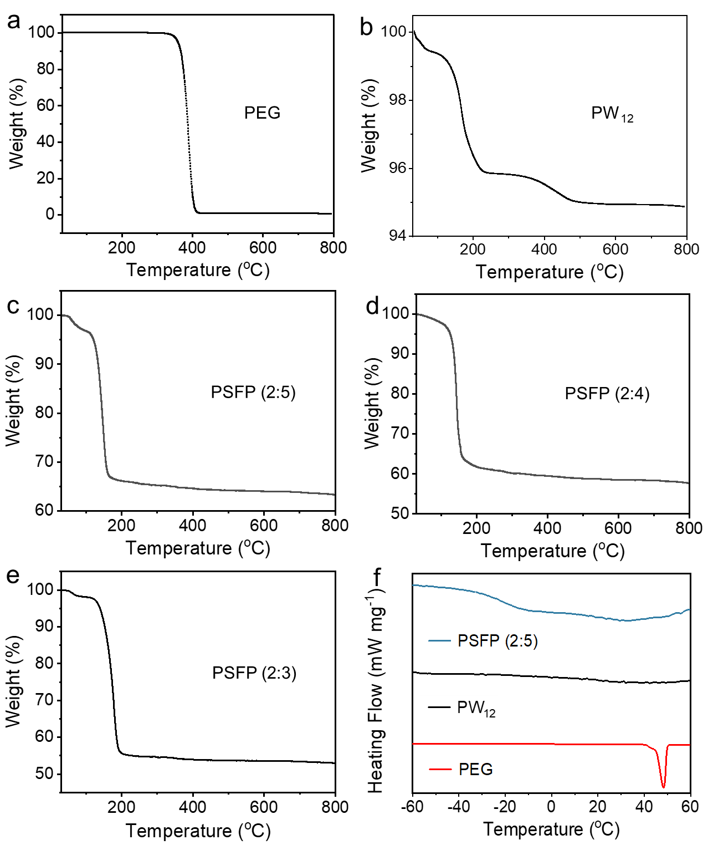
Supplementary Figure 21. TGA curves of the samples. a) PEG. b) PW₁₂. c-e) PSFP adhesives with different mass ratios (PEG : PW₁₂ = 2 : 5, 2 : 4, and 2 : 3). f) DSC spectra of PSFP adhesive (2 : 5), PW₁₂, and PEG.

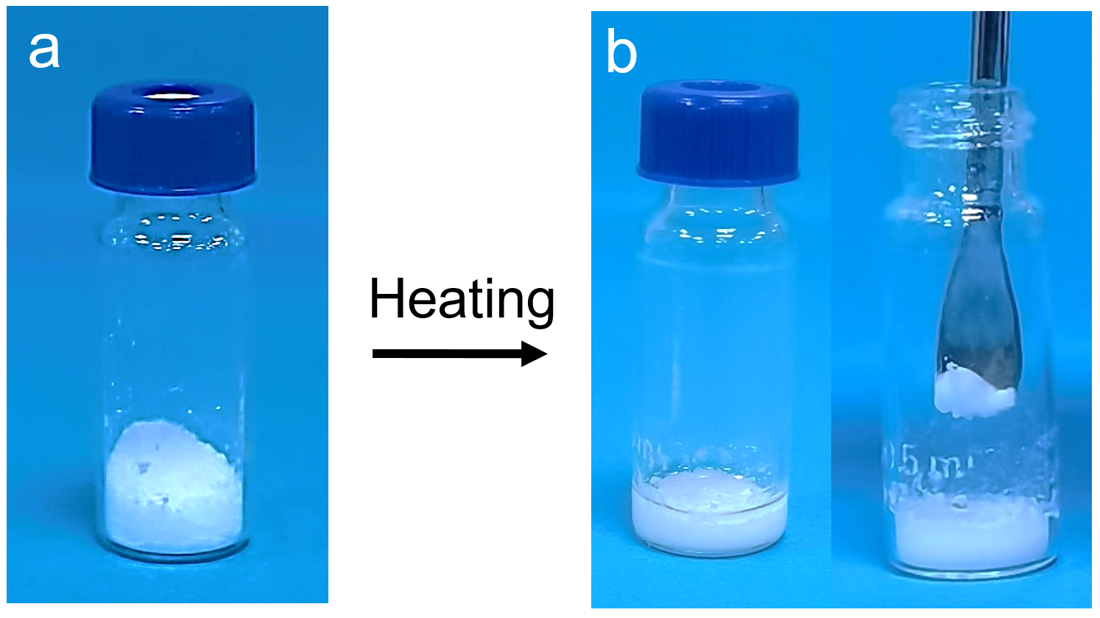
Supplementary Figure 22. Digital photographs of the samples. a) Mixture of PEG and Na₃PW₁₂O₄₀, b) Mixture of PEG and Na₃PW₁₂O₄₀ after heating at 90 °C for 2 h.

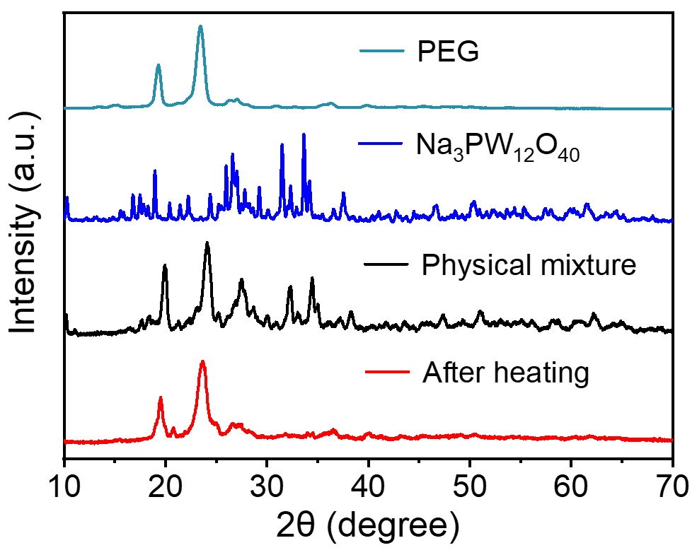
Supplementary Figure 23. PXRD patterns of the samples. a) PEG. b) Na₃PW₁₂O₄₀. c) Physical mixture of PEG and Na₃PW₁₂O₄₀. d) Mixture of PEG and Na₃PW₁₂O₄₀ after heating at 90 °C for 2 h.

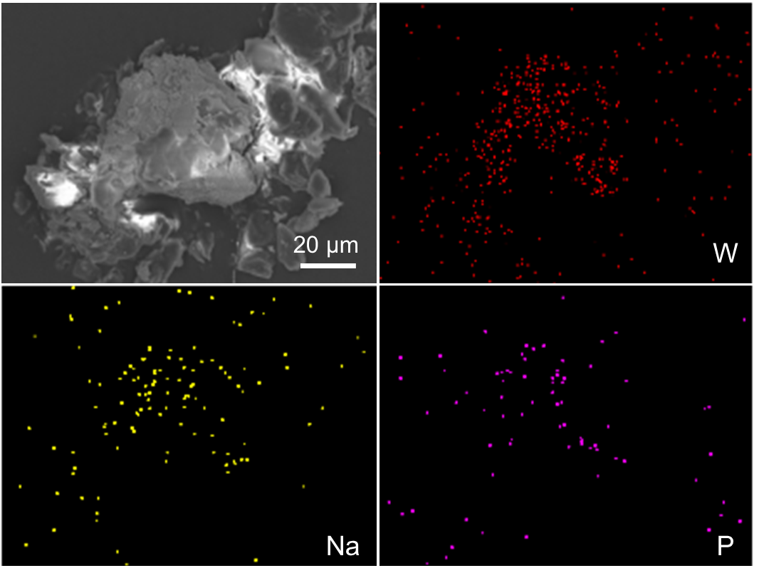
Supplementary Figure 24. SEM images of the mixture for Na₃PW₁₂O₄₀ and PEG after heating, and the corresponding elemental mapping.

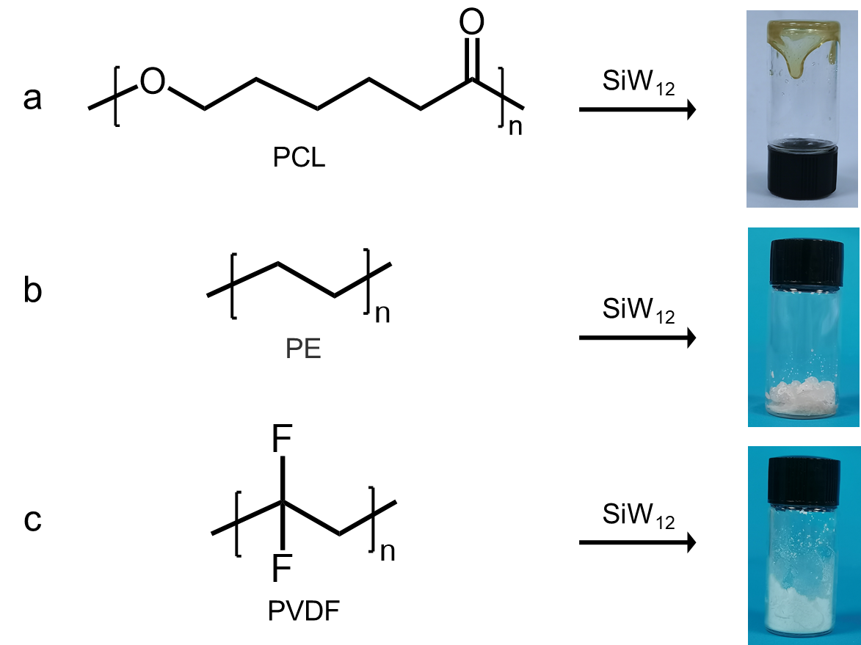
Supplementary Figure 25. Digital photographs of the samples after heating at 90 °C for 2 h. a) Adhesive based on PCL and SiW₁₂. b) Mixture of PE and SiW₁₂. c) Mixture of PVDF and SiW₁₂.

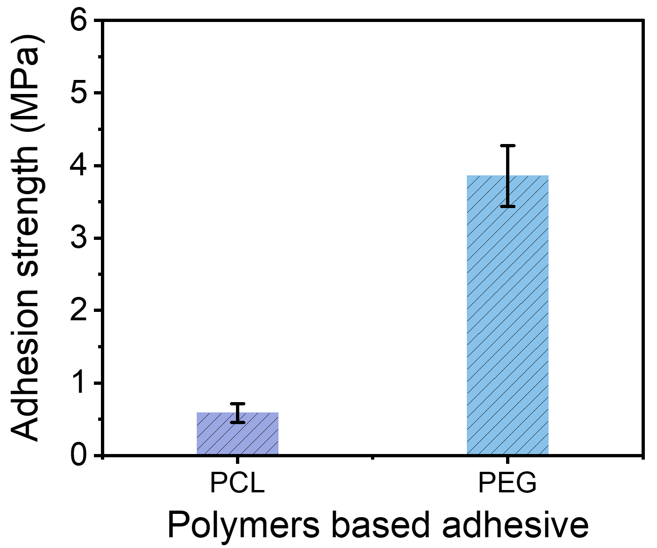
Supplementary Figure 26. Adhesion strengths of different polymers based adhesives on SS substrates. a) PCL. b) PEG (Mn, ~10000).
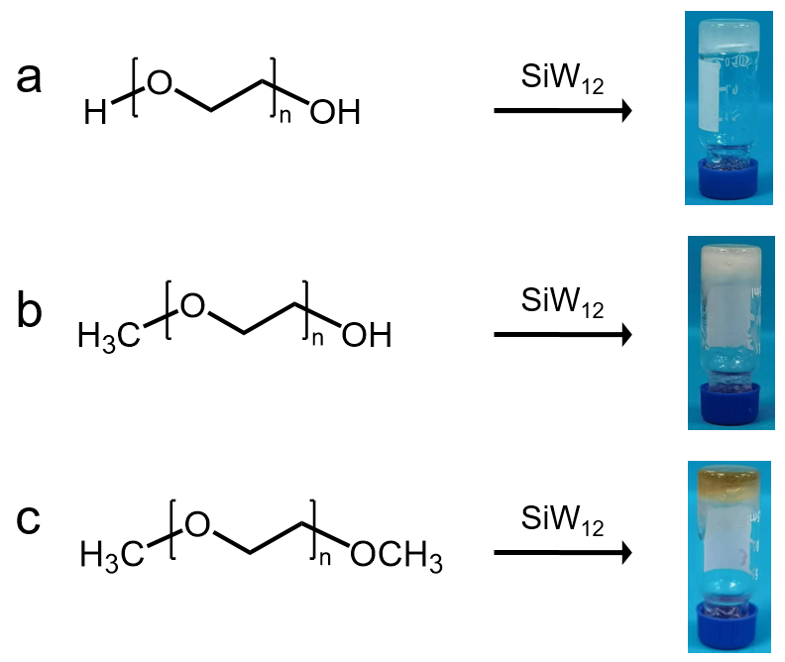
Supplementary Figure 27. Digital photographs of the PEG analogues based adhesives. a) PEG. b) PEGME. c) PEGdME (Mn, ~2000).

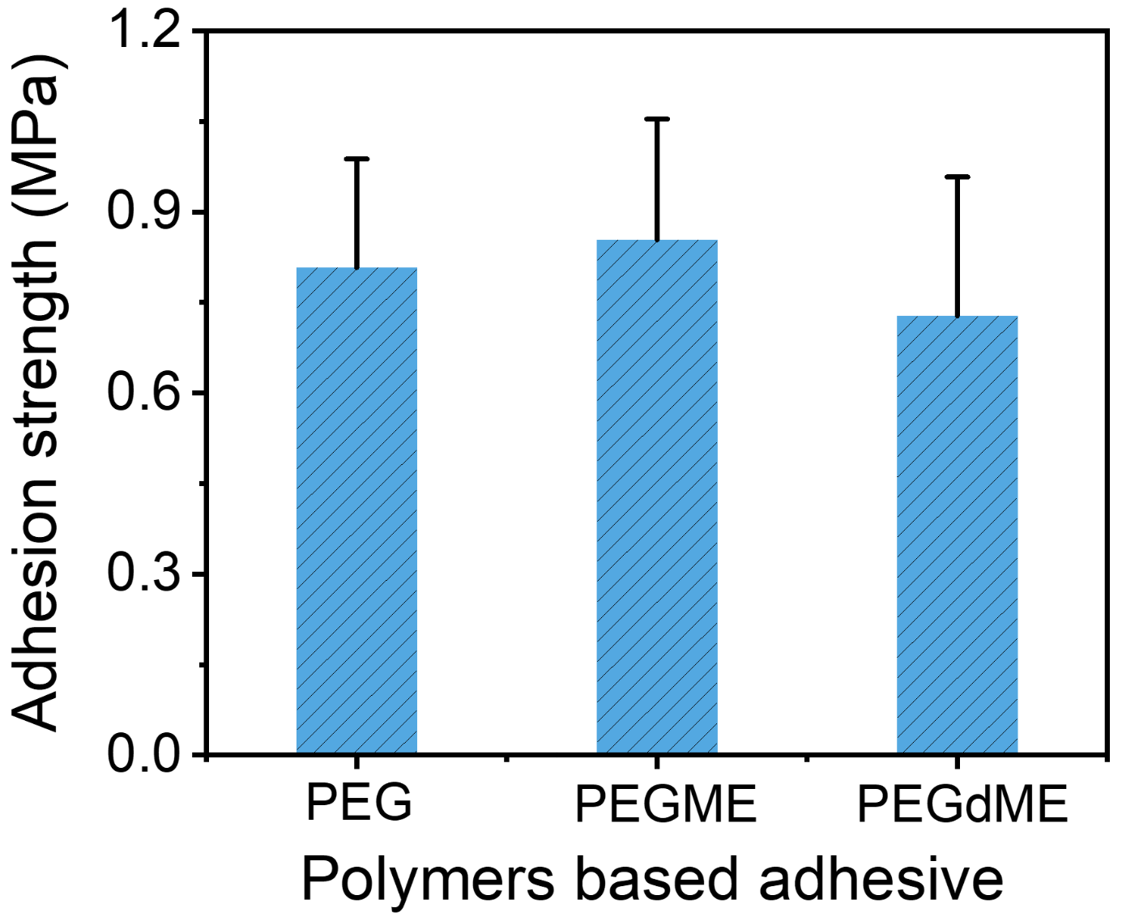
Supplementary Figure 28. Adhesion strengths of different polymers based adhesives on SS substrates. a) PEG. b) PEGME. c) PEGdME (Mn, ~2000).

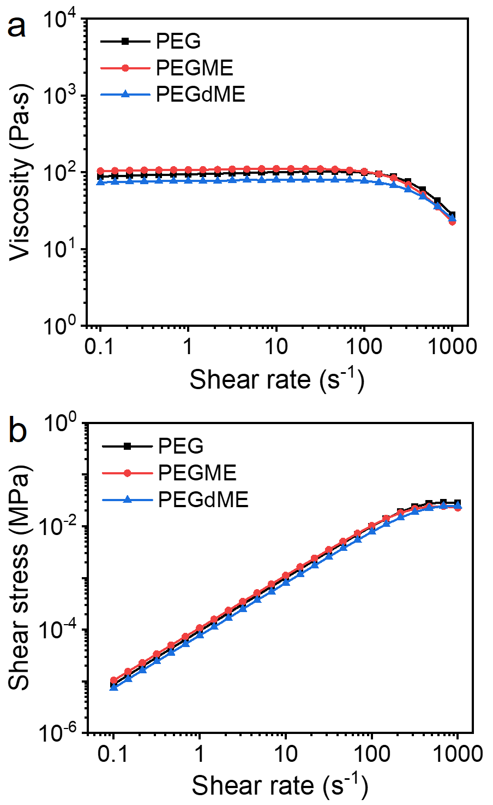
Supplementary Figure 29. Characterization of the different polymers based adhesives. a) Viscosity as a function of shear rate. b) Shear stress as a function of shear rate.
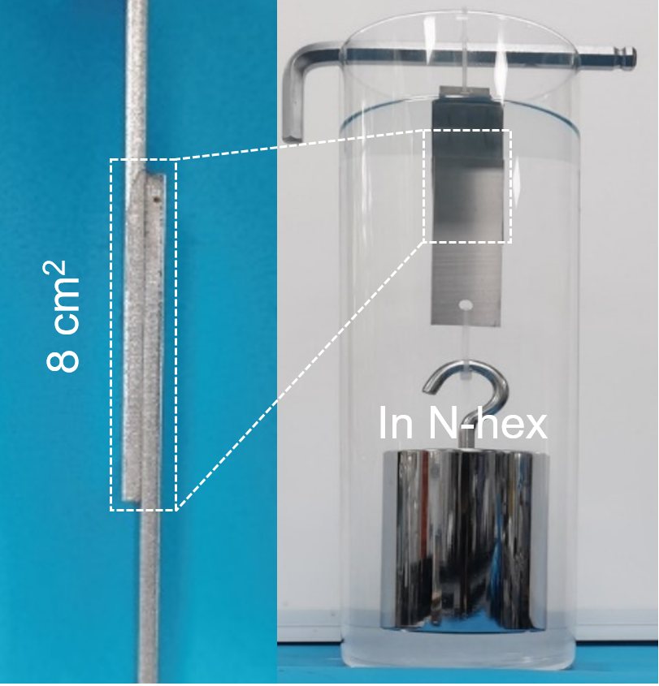
Supplementary Figure 30. Photographs of the SSFP adhesive after immersion in organic solvents (N-hex) for 14 days.

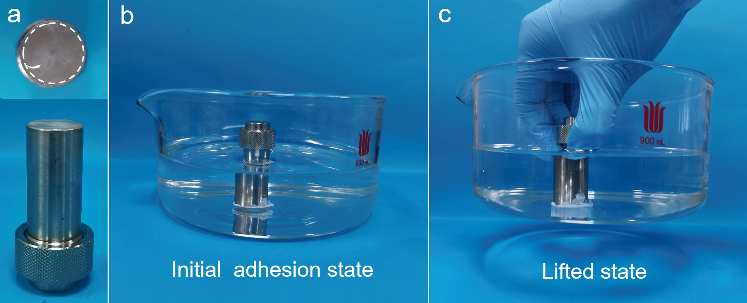
Supplementary Figure 31. Adhesion behavior of the SSFP adhesive in organic solvent. a) Stainless steel mould. b) Initial adhesion state. c) Lifted state (the adhesion area is 1.77 cm², and the volume of EA is 500 mL).

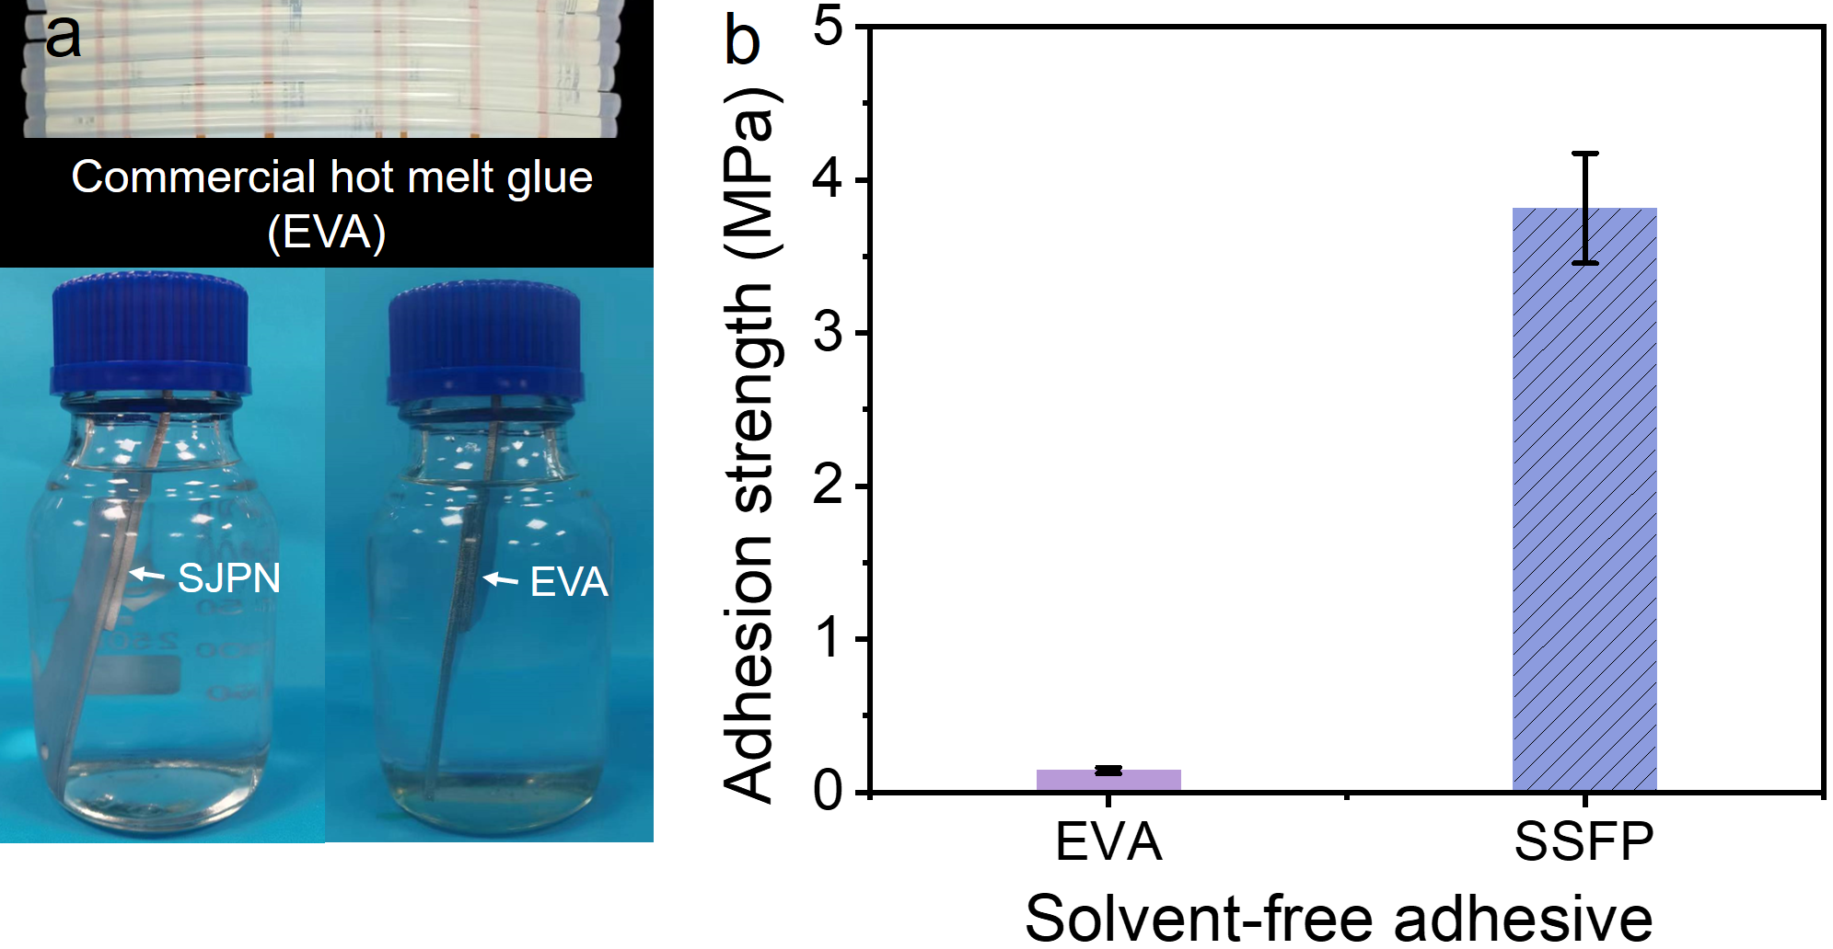
Supplementary Figure 32. Adhesion behavior of the solvent-free adhesives (EVA and SSFP). a) Photographs of the solvent-free adhesives soaking in mesitylene. b) Adhesion strength of the solvent-free adhesive adhered on SS substrates after soaking for 7 days.

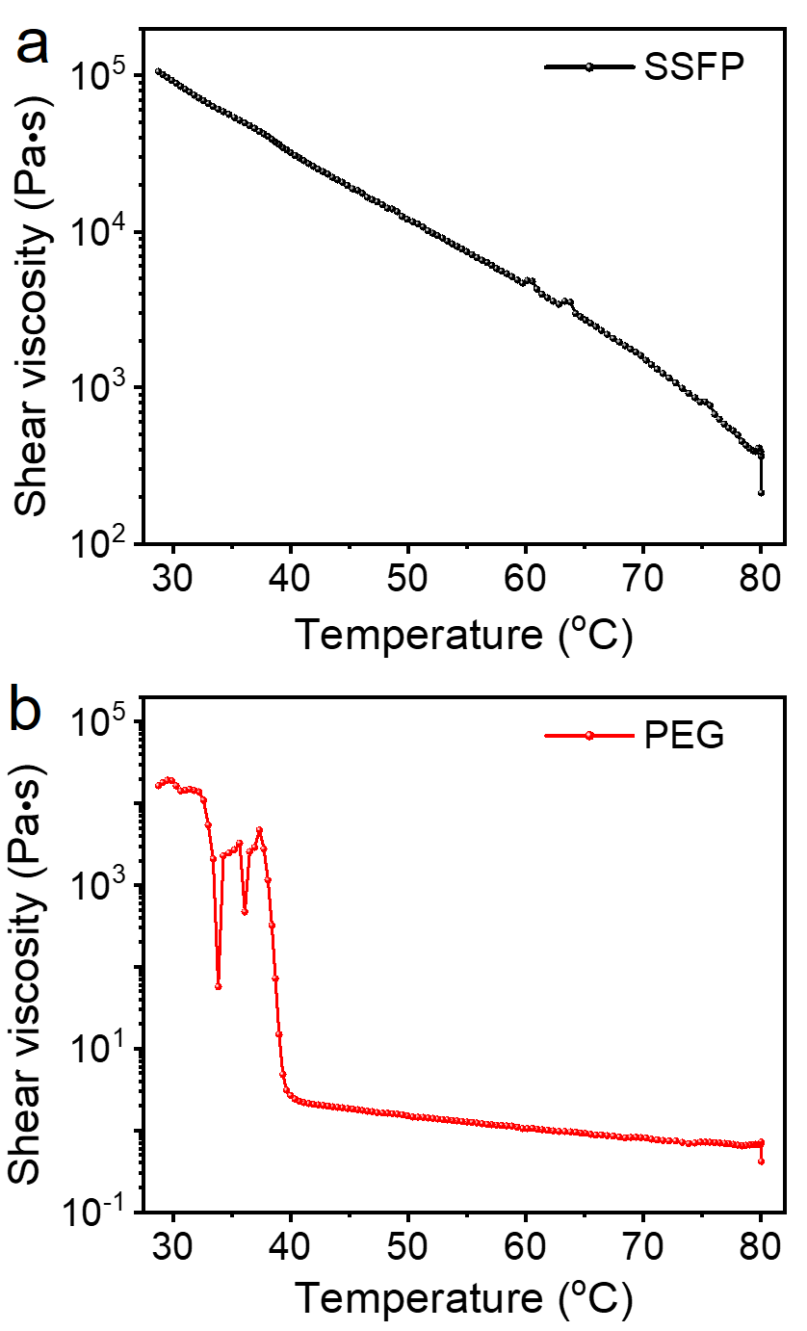
Supplementary Figure 33. Shear viscosity of the samples as a function of temperature. a) The SSFP adhesive. b) PEG.

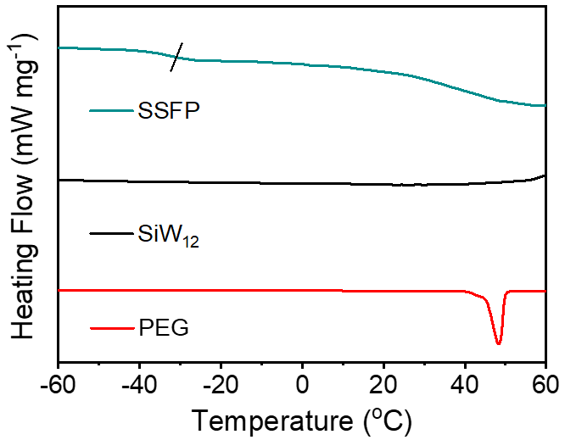
Supplementary Figure 34. DSC spectra of SSFP adhesive, SiW₁₂, and PEG.
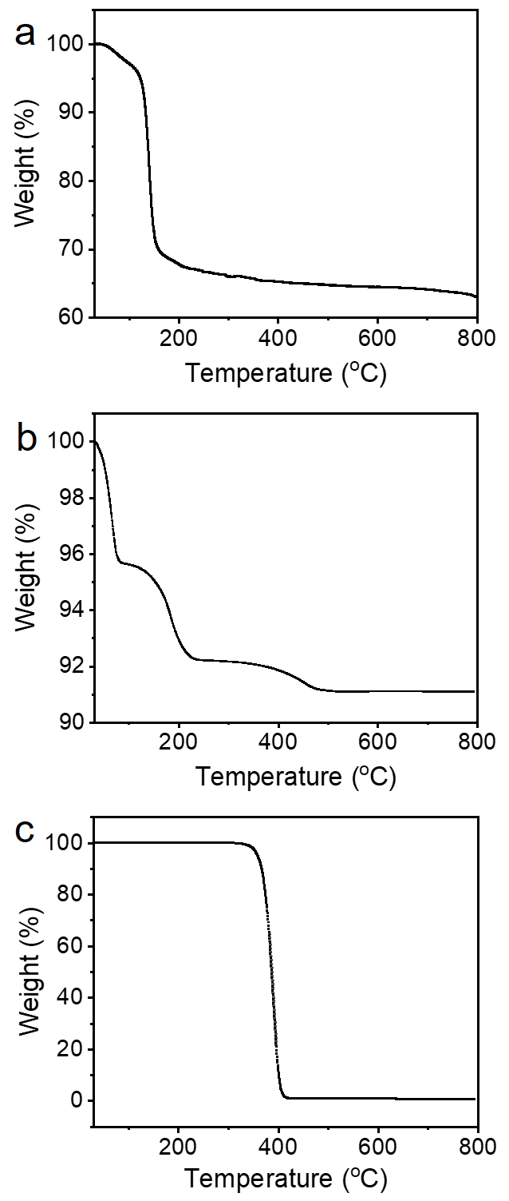
Supplementary Figure 35. TGA curves of SSFP adhesive, SiW₁₂ and PEG. a) SSFP adhesive. b) SiW₁₂. c) PEG.

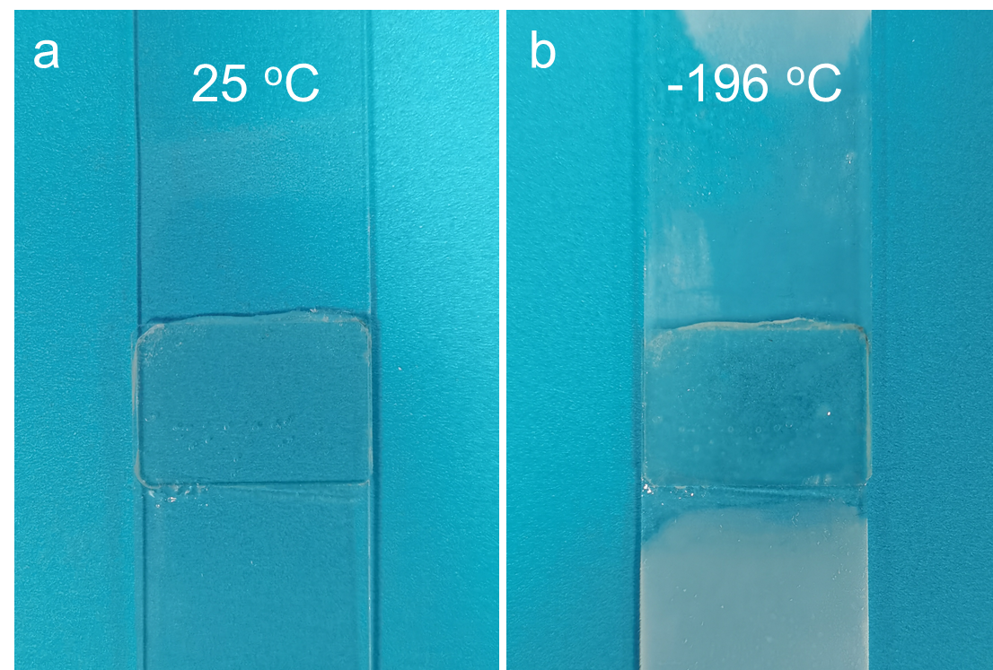
Supplementary Figure 36. Photographs of the SSFP adhesive adhered in glass slices after treatment. a) 25 °C. b) -196 °C.

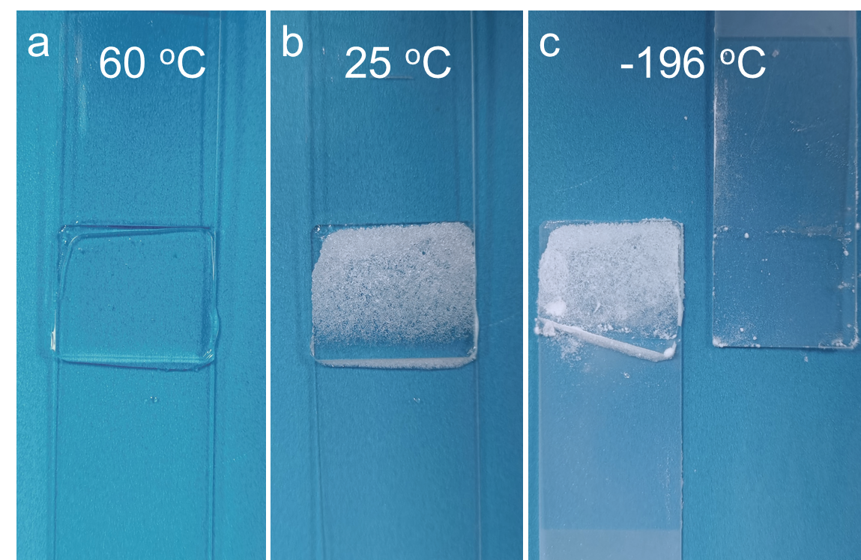
Supplementary Figure 37. Photographs of the PEG adhered in glass slices at different temperature. a) 60 °C. b) 25 °C. c) -196 °C.

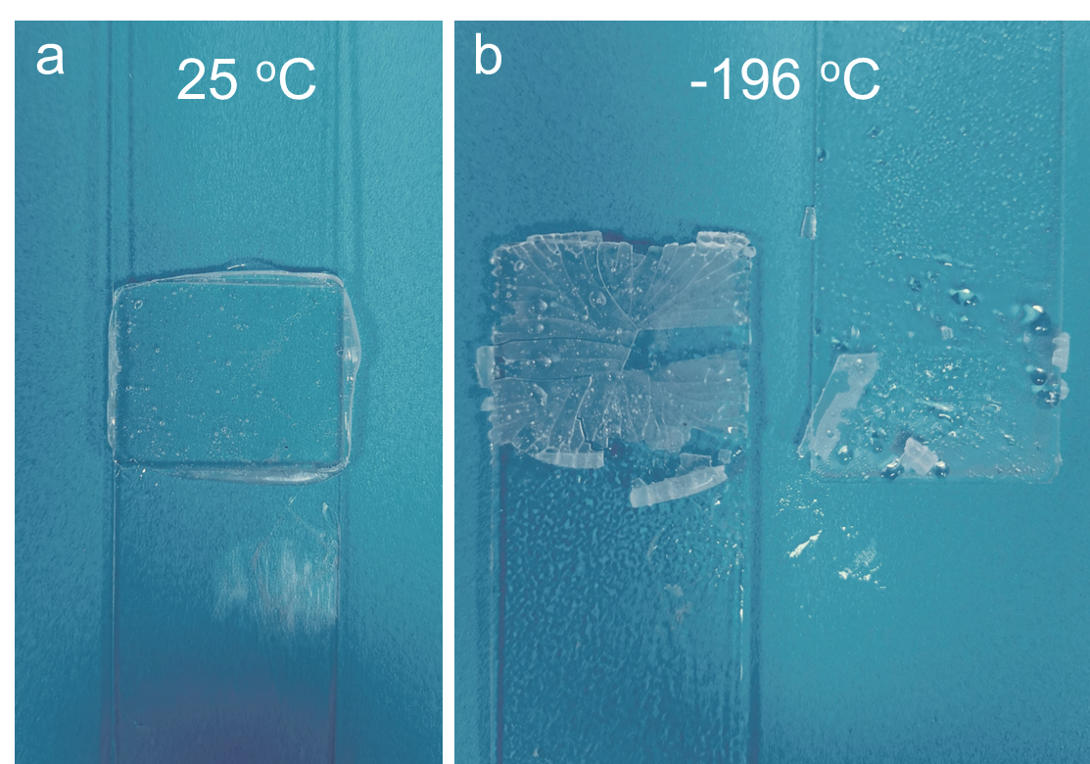
Supplementary Figure 38. Photographs of the EVA adhered in glass slices after treatment. a) 25 °C. b) -196 °C.

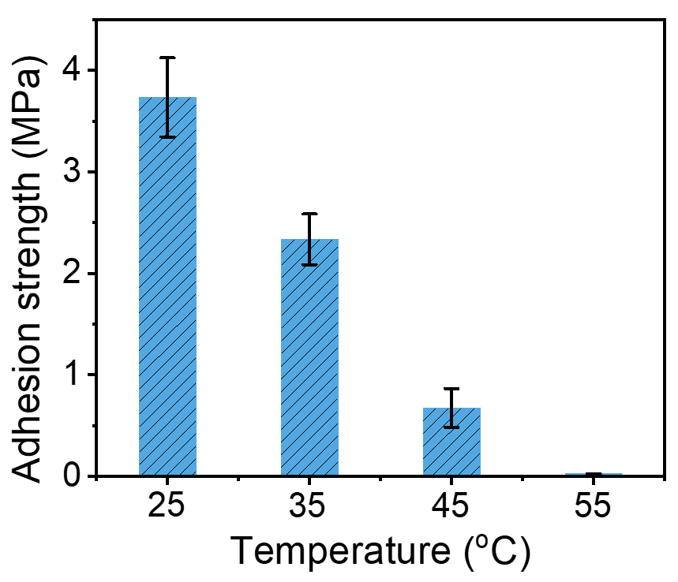
Supplementary Figure 39. Adhesion strengths of SSFP adhesive on SS substrates at various temperatures.

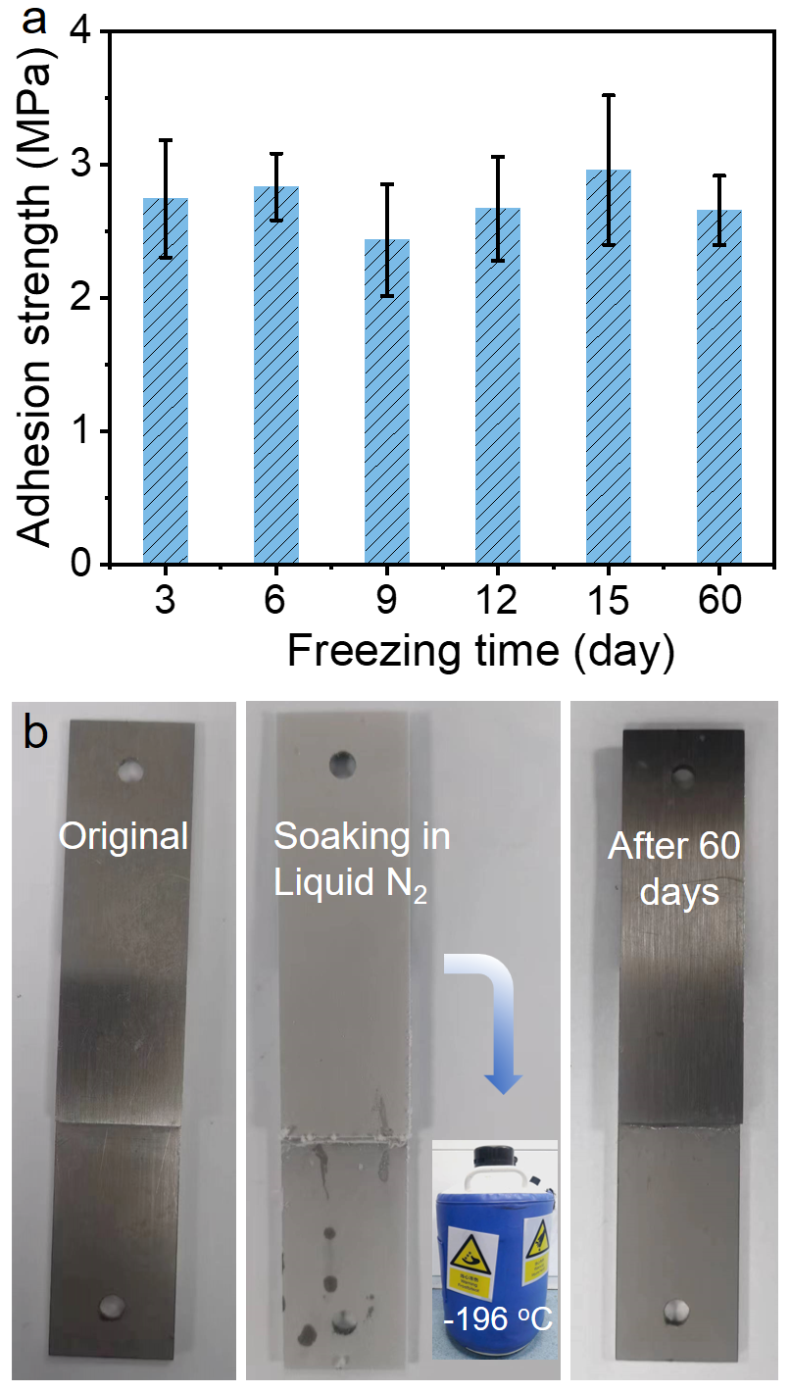
Supplementary Figure 40. Adhesion performance of SSFP adhesive in liquid nitrogen (-196 °C). a) Adhesion strength of SSFP adhesive frozen for different times. b) The photograph of SSFP adhesive on SS after soaking in liquid nitrogen (-196 °C) for 60 days.

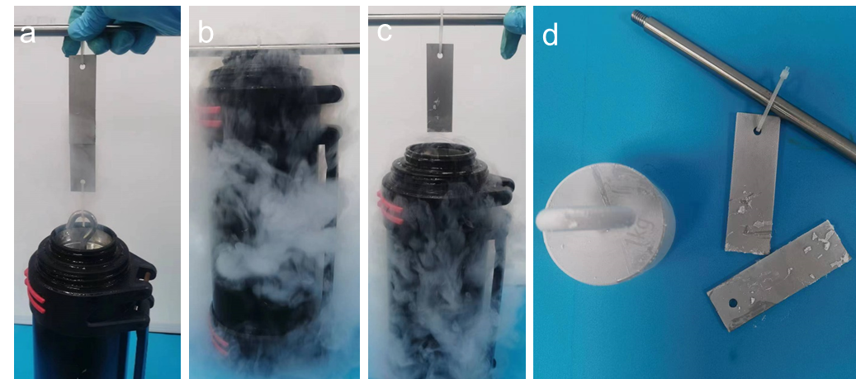
Supplementary Figure 41. Adhesion tests of the commercial hot melt glue EVA in liquid nitrogen. a) Initial adhesion state. b) Immersed state. c-d) Frost-cracked state.

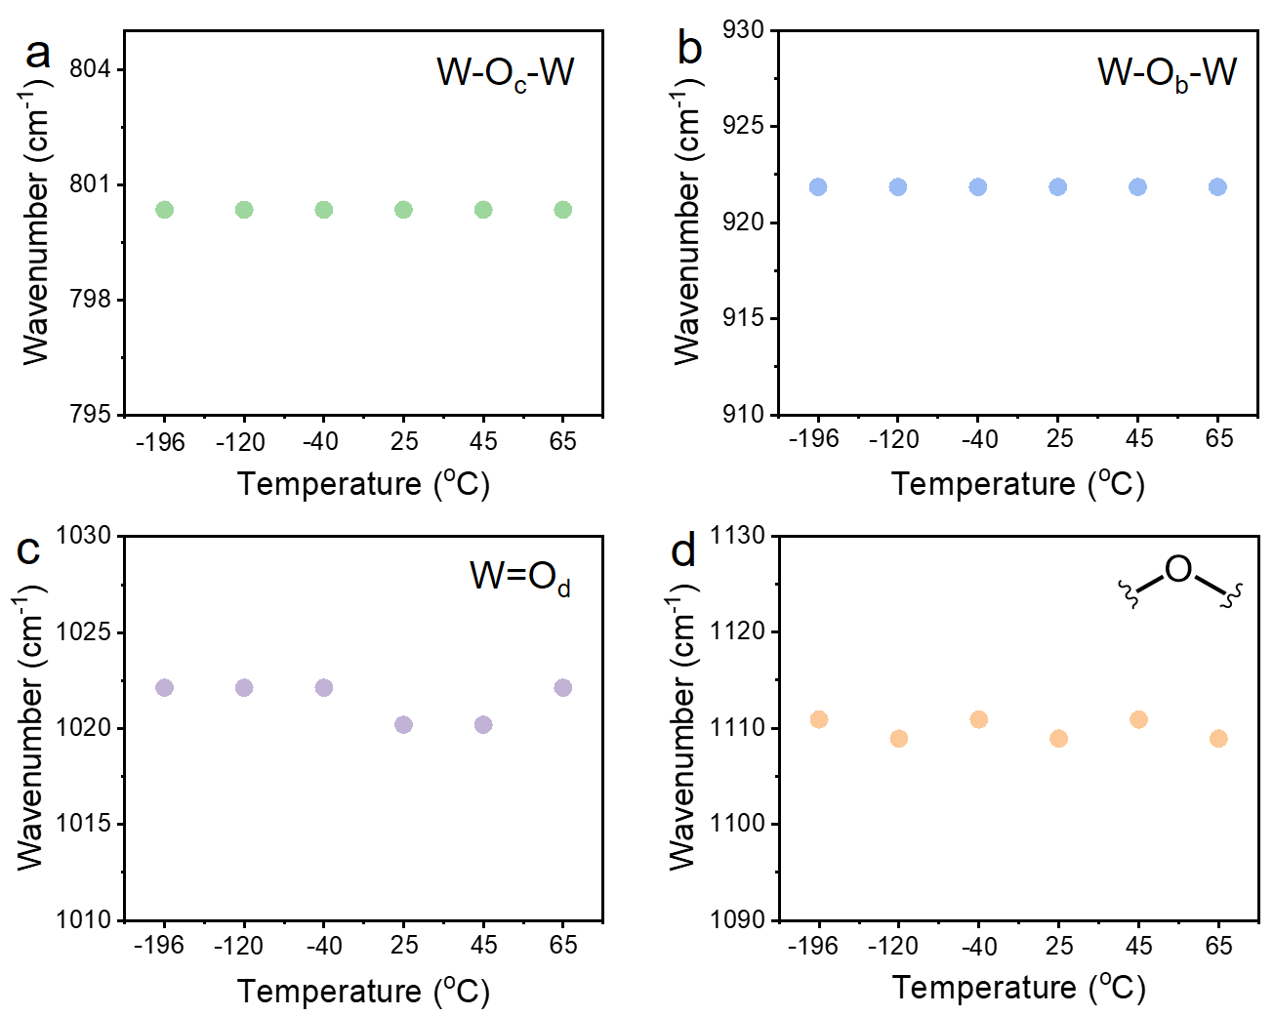
Supplementary Figure 42. Temperature-dependent FT-IR spectra of SSFP adhesive at different temperature conditions. a) W–O_{c}–W. b) W–O_{b}–W. c) W=O_{d}. d) C–O–C.

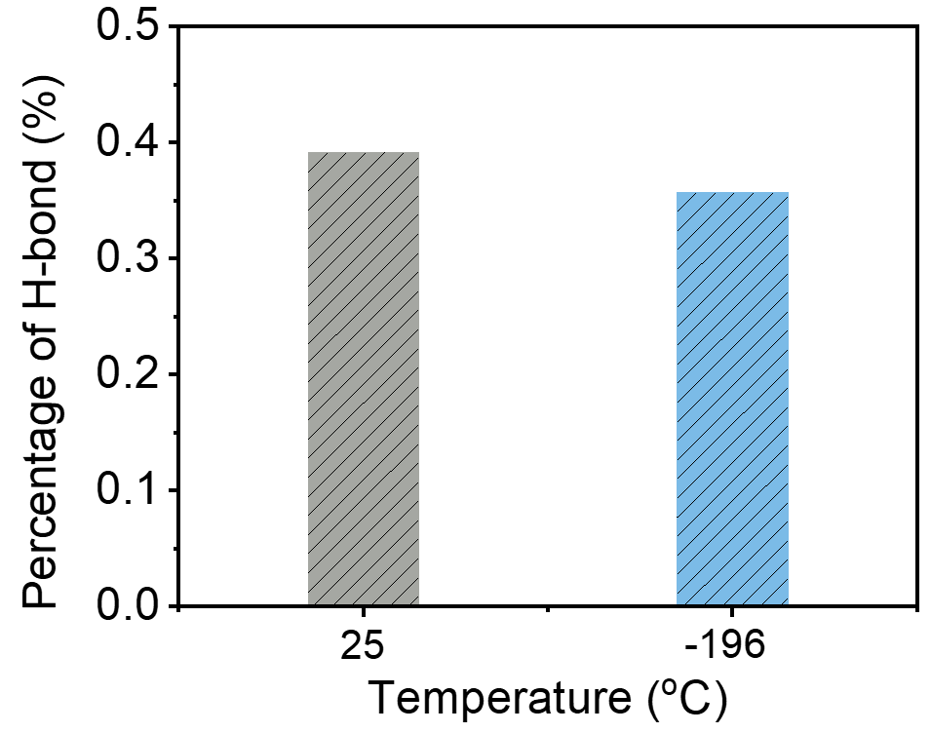
Supplementary Figure 43. The ratio of formative hydrogen bonds between PEG and SiW₁₂ at 25 and -196 °C for the final 2 ns of the simulation.

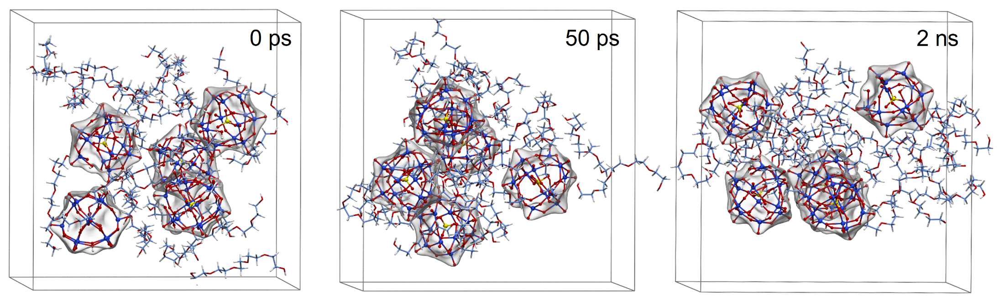
Supplementary Figure 44. Snapshots of the aggregation behavior of PEG and SiW₁₂ at 55 °C (the cubic boundaries are marked with black lines).

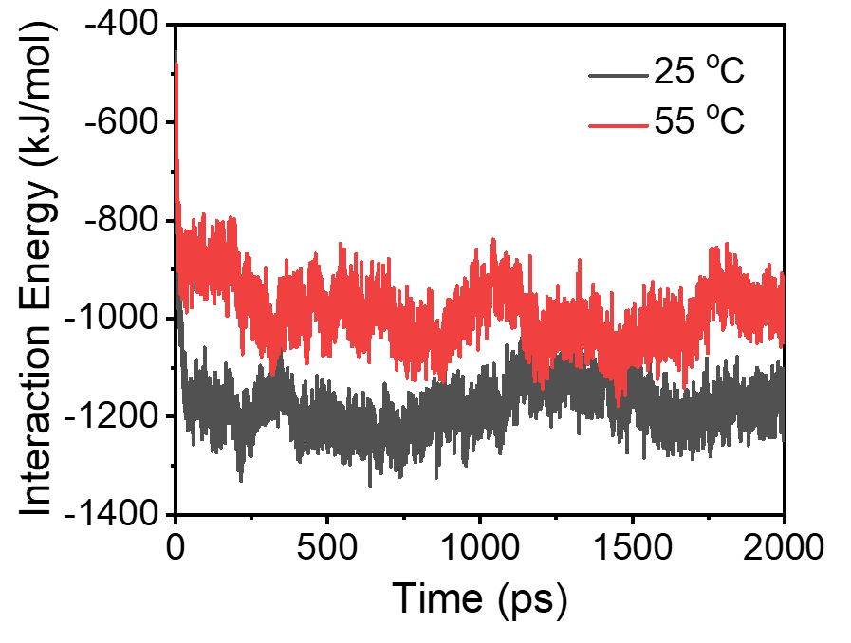
Supplementary Figure 45. The interaction energy of PEG and SiW₁₂ during cross-linking process at 25 and 55 °C.

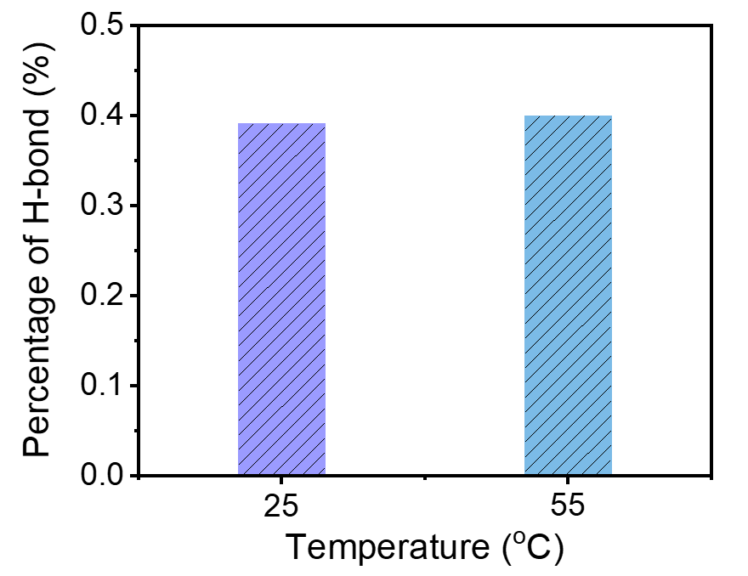
Supplementary Figure 46. The ratio of formative hydrogen bonds between PEG and SiW₁₂ at 25 and 55 °C for the final 2 ns of the simulation.

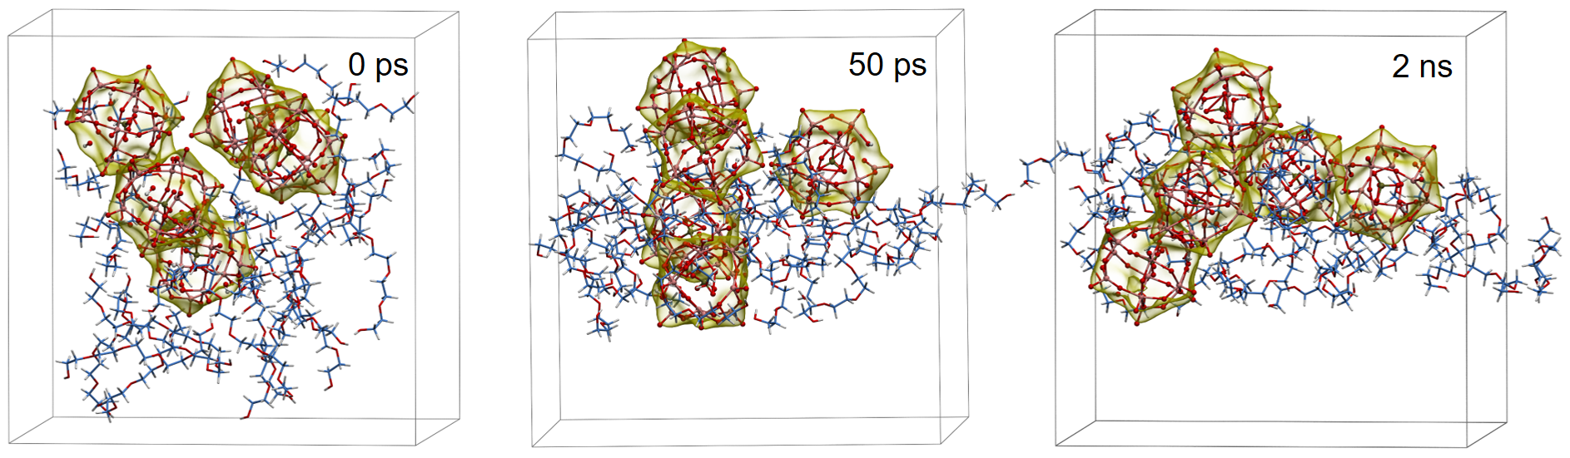
Supplementary Figure 47. Snapshots of the aggregation behavior of PEG and PW₁₂ at 25 °C (the cubic boundaries are marked with black lines).

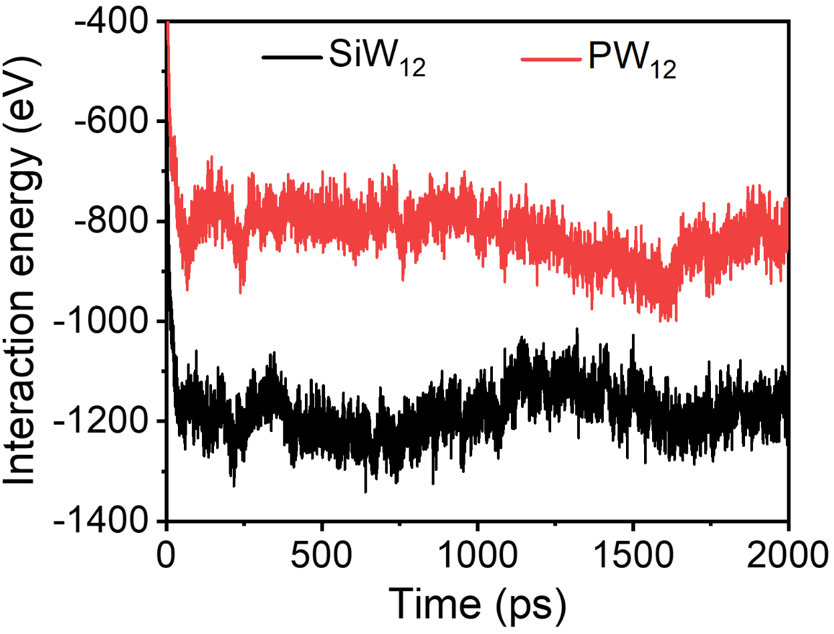
Supplementary Figure 48. The interaction energy of PEG and POMs (SiW₁₂ and PW₁₂) during cross-linking process at 25 °C.

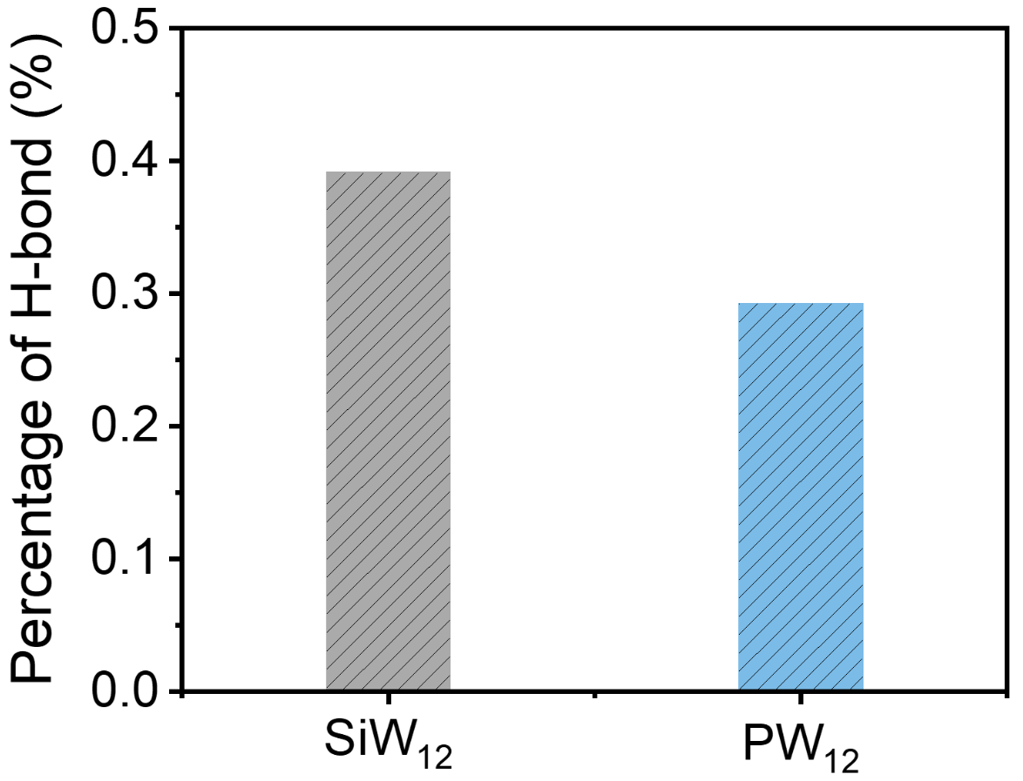
Supplementary Figure 49. The ratio of formative hydrogen bonds between PEG and POMs (SiW₁₂ and PW₁₂) at 25 °C for the final 2 ns of the simulation.

Video S1. The SSFP adhesive performing rapid adhesion in organic solvent (ethyl acetate).

Video S2. The SSFP adhesive preventing an emergency leakage for organic solvent (N-hex).

Video S3. The SSFP adhesive performing low-temperature resistance (liquid nitrogen, -196 ℃).

Video S4. The MD of the SSFP adhesive based on PEG and SiW₁₂ at 25 ℃.

Video S5. The MD of the SSFP adhesive based on PEG and SiW₁₂ at 55 ℃.

Video S6. The MD of the SSFP adhesive based on PEG and SiW₁₂ at -196 ℃.

Supplementary Table
Supplementary Table 1. Performance comparison of the reported POMs based adhesives, and the test method is the same in the all references (lap joint).
Sample | POM | Cross-linked compound | Type | Temperature (ºC) | Substrate | Adhesion strength (kPa) | Ref.
SSFP | SiW₁₂ | PEG (10 kDa) | Solvent-free | -196  RT | SS | 2741.0  3736.0 | This work
POMs/Pep | BW₁₂/  PMo₁₁V | Ac-KKNSQCC-NH₂/GHK | Solvent-assisted (H₂O) | RT | Ti | 82.5 | 12
SiW-PEG | SiW₁₂ | PEG (20 kDa) | Solvent-assisted (H₂O) | RT | SS | 74.2 | 13
Pep1/SiW₁₁/H⁺  Pep1/SiW₁₁/M^{n+} | SiW₁₁ | GHK/H⁺  GHK/Co²⁺ | Solvent-assisted (H₂O) | RT | Ti | 36.5  21.1 | 14
P-PA55-PW30 | PW₁₂ | Polyacrylate (100 kDa)/H₃PO₄ | Solvent-assisted (CH₃COCH₃) | RT | Glass | 211.0 | 15
PEI-PW₁₂ | PW₁₂ | PEI (1.8 kDa) | Solvent-assisted (H₂O) | RT | Wood | 319.0 | 16
Ca-POM SNWs | PW₁₂ | Oleylamine/Ca²⁺ | Solvent-assisted (H₂O) | -196  100 | SS | 2160.0  ~ 1700.0 | 17
Pep1/SiW | SiW₁₂ | Ac-EEMQRRAD-NH₂ | Solvent-assisted (H₂O) | RT | PEEK | 29.6 | 18
GSSG/HPW | PW₁₂ | GSSH | Solvent-assisted (H₂O) | RT | Ti | 53.3 | 19
NA/HP₂W₁₈ | P₂W₁₈ | 3-(2-naphthyl)-l-alanine | Solvent-assisted (H₂O) | RT | PEEK | 14.7 | 20
His/SiW | SiW₁₂ | Histidine | Solvent-assisted (H₂O) | RT | Wood | 436.7 | 21
CS/SiW-PAM | SiW₁₂ | Polyacrylamide/  Chitosan (3 kDa) | Solvent-assisted (H₂O) | RT | PP | 7.0 | 22

References¹⁻¹¹
1. Frisch, M. J. et al. Gaussian 09, Revision D.01, Gaussian Inc., Wallingford CT. (2019).
2. Grimme, S., Antony, J., Ehrlich, S. & Krieg, H. A consistent and accurate ab initio parametrization of density functional dispersion correction (DFT-D) for the 94 elements H-Pu. J. Chem. Phys. 132, 154104 (2010).
3. Marenich, A. V., Cramer, C. J. & Truhlar, D. G. Universal solvation model based on solute electron density and on a continuum model of the solvent defined by the bulk dielectric constant and atomic surface tensions. J. Phys. Chem. B 113, 6378-6396 (2009).
4. Lu, T. & Chen, F. Multiwfn: A multifunctional wavefunction analyzer. J. Comput. Chem. 33, 580-592 (2012).
5. Humphrey, W., Dalke, A. & Schulten K. VMD: Visual molecular dynamics. J. Mol. Graph. 14, 33-38 (1996).
6. Berendsen, H. J. C., van der Spoel, D. & van Drunen, R. GROMACS: A message-passing parallel molecular dynamics implementation. Comp. Phys. Comm. 91, 43-56 (1995).
7. van der Spoel, D. et al. GROMACS: fast, flexible and free. J. Comp. Chem. 26, 1701-1718 (2005.)
8. Hess, B., Kutzner, C., van der Spoel, D. & Lindahl, E. GROMACS 4: algorithms for highly efficient, load-balanced, and scalable molecular simulation. J. Chem. Theory Comput. 4, 435-447 (2008).
9. Jorgensen, W. L., Madura, J. D. & Swenson, C. J. Optimized intermolecular potential functions for liquid hydrocarbons. J. Am. Chem. Soc. 106, 6638-6646 (1984).
10. Rappé, A. K., Casewit, C. J., Colwell, K. S., Goddard III, W. A. & Skiff, W. M. UFF, a full periodic table force field for molecular mechanics and molecular dynamics simulations. J. Am. Chem. Soc. 114, 10024-10035 (1992).
11. Berendsen, H. J. C., Postma, J. P. M., Vangunsteren, W. F., Dinola, A. & Haak, J. R. J. Chem. Phys. 81, 3684-3690 (1984).
12. Liu, X., Ma, Z., Nie, J., Fang, J. & Li, W. Exploiting redox-complementary peptide/polyoxometalate coacervates for spontaneously curing into antimicrobial adhesives. Biomacromolecules 23, 1009-1019 (2022).
13. Peng, Q. et al. Adhesive coacervates driven by hydrogen-bonding interaction. Small 16, e2004132 (2020).
14. Li, X. et al. Coassembly of short peptide and polyoxometalate into complex coacervate adapted for pH and metal ion-triggered underwater adhesion. Langmuir 35, 4995-5003 (2019).
15. Guo, H. et al. Multifunctional enhancement of proton-conductive, stretchable, and adhesive performance in hybrid polymer electrolytes by polyoxometalate nanoclusters. ACS Appl. Mater. Interfaces 13, 30039-30050 (2021).
16. Cui, Y. et al. A universal and reversible wet adhesive via straightforward aqueous self-assembly of polyethylenimine and polyoxometalate. ACS Appl. Mater. Interfaces 13, 47155-47162 (2021).
17. Zhang, S., Shi, W., Yu, B. & Wang, X. Versatile inorganic subnanometer nanowire adhesive. J. Am. Chem. Soc. 144, 16389-16394 (2022).
18. Xu, J. et al. Supramolecular copolymerization of short peptides and polyoxometalates: toward the fabrication of underwater adhesives. Biomacromolecules 18, 3524-3530 (2017).
19. Liu, X. et al. Heteropoly acid-driven assembly of glutathione into redox-responsive underwater adhesive. Chem. Commun. 56, 11034-11037 (2020).
20. Li, X. et al. Bringing heteropolyacid‐based underwater adhesive as printable cathode coating for self‐powered electrochromic aqueous batteries. Adv. Funct. Mater. 28, (2018).
21. Xu, J. et al. Wet and functional adhesives from one-step aqueous self-assembly of natural amino acids and polyoxometalates. Angew. Chem. Int. Ed. 56, 8731-8735 (2017).
22. Wei, X. et al. Adhesive, conductive, self-healing, and antibacterial hydrogel based on chitosan–polyoxometalate complexes for wearable strain sensor. ACS Appl. Polym. Mater. 2, 2541-2549 (2020).

