Supplemental material

Table 2: Average of morphological of five oat genotypes.
 | Genotypes
 | UFRGS 127013-1 |  |  | URS 21 |  |  | URS ALTIVA |  |  | UFRGS 146155-1 |  |  | URS TAURA
TCL (cm) | 82,8 | ± | 1,31 | 84,0 | ± | 1,4 | 88,7 | ± | 1,11 | 68,9 | ± | 1,18 | 66,8 | ± | 1,07
LFI (mm) | 59,7 | ± | 4,44 | 64,5 | ± | 5,28 | 63,8 | ± | 5,01 | 41,7 | ± | 4,01 | 39,0 | ± | 3,84
LSI (mm) | 125,6 | ± | 4,94 | 118,9 | ± | 5,57 | 123,2 | ± | 3,43 | 104,5 | ± | 5,02 | 101,5 | ± | 4,78
DFI (mm) | 4,0 | ± | 0,11 | 4,3 | ± | 0,12 | 4,3 | ± | 0,09 | 4,7 | ± | 0,11 | 4,5 | ± | 0,13
DSI (mm) | 4,3 | ± | 0,12 | 4,8 | ± | 0,11 | 4,9 | ± | 0,10 | 5,4 | ± | 0,10 | 5,5 | ± | 0,14
TFI (mm) | 0,8 | ± | 0,04 | 0,8 | ± | 0,04 | 0,9 | ± | 0,04 | 1,3 | ± | 0,05 | 1,1 | ± | 0,05
TSI (mm) | 0,6 | ± | 0,04 | 0,7 | ± | 0,03 | 0,7 | ± | 0,03 | 0,9 | ± | 0,04 | 0,8 | ± | 0,04
TCL: Total culm length; LFI: Length of first internode; LSI: Length of second internode; DFI: Diameter of first internode; DSI: Diameter of second internode; TFI: Thickness of first internode; TSI: Thickness of second internode;

Fig. 4 Percentage of lignina in dry matter (%) for five oat genotypes, in two seasons of crop, in 2018. Orange color represent the first season (Environmet 5) and de green color represent the second season (Environment 8). Averages followed by the same letter do not differ by Duncan's test between genotypes within the same environment. p = 0.05.

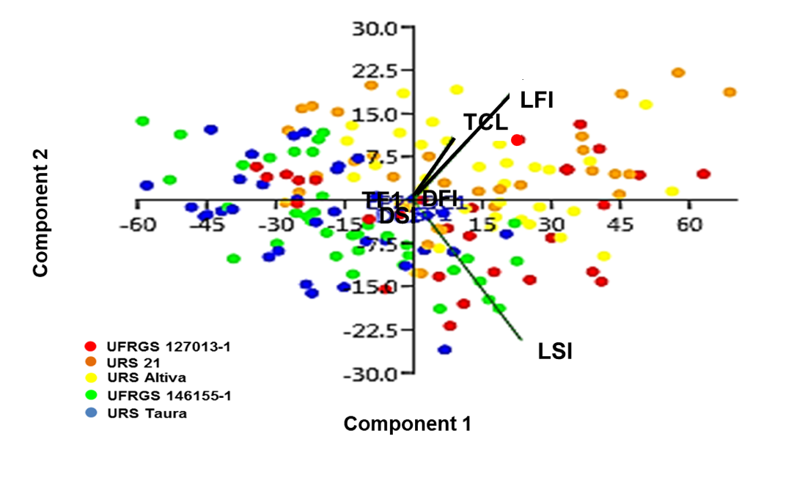
Fig. 5 Principal component analysis (PCA) in five oat genotypes in nine environments for: Total culm length (TCL); Length of first internode (LFI); Length of second internode (LSI); Diameter of first internode (DFI); Diameter of second internode (DSI); Thickness of first internode (TFI); Thickness of second internode (TSI) .
TABELA 3. Principal component analysis (PCA) in five oat genotypes in nine environments for culm components.
PC | Caracter | % variance
1 | TCL | 83.3
2 | LFI | 10.112
3 | LSI | 6.515
4 | DFI | 0.065538
5 | DSI | 0.004578
6 | TFI | 0.002577
7 | TSI | 0.000354
PC: Principal component; TCL: Total culm length; LFI: Length of first internode; LSI: Length of second internode; DFI: Diameter of first internode; DSI: Diameter of second internode; TFI: Thickness of first internode; TSI: Thickness of second internode;

Table 4. Correlation of morphological culm characters in five oat genotypes in nine environments.
 | RE | TCL | LFI | LSI | DFI | DSI
TCL | -0,6*
LFI | -0,48* | 0,71*
LSI | -0,45* | 0,63* | 0,79*
DFI | 0,43* | -0,18 | 0,16
DSI | 0,7* | -0,41* | - | -0,17
TFI | 0,59 | -0,63 | -0,53 |  | 0,5
TSI | 0,49 | -0,56 | - | -0,39 |  | 0,55
RE: resistance scale; TCL: Total culm length; LFI: Length of first internode; LSI: Length of second internode; DFI: Diameter of first internode; DSI: Diameter of second internode; TFI: Thickness of first internode; TSI: Thickness of second internode;

TABLE 5. Multiple linear regression of culm characters in five oat genotypes in nine environments.
 | R² | Nível de sig
TCL+LFI+LSI+DFI+DSI+TFI+TSI | 0,67 | **
TCL+DFI+DSI | 0,65 | **
DFI+DSI | 0,59 | **
DFI+TFI | 0,51 | **
DFI+TFI+LFI | 0,51 | **
TCL+DFI+TFI | 0,49 | **
TCL+DFI | 0,47 | **
TCL+TFI+TSI | 0,47 | **
TCL+TFI | 0,44 | **
LFI+TFI | 0,39 | **
TCL+LFI+LSI | 0,38 | **
DFI+TFI | 0,38 | **
TFI+TSI | 0,38 | **
TCL | 0,37 | **
TCL+TFI | 0,37 | **
TFI | 0,35 | **
LFI+LSI | 0,24 | **
LFI | 0,23 | **
DFI | 0,19 | **
DSI | 0,50 | **
TCL: Total culm length; LFI: Length of first internode; LSI: Length of second internode; DFI: Diameter of first internode; DSI: Diameter of second internode; TFI: Thickness of first internode; TSI: Thickness of second internode;

TABLE 6. Average of number of cell layers in subdermal parenchyma (SP), sclerenchyma ring (SR), cortical parenchyma (CP), medular parenchyma (MP), vascular bundles (VB) and number of total cell layers (TCL), in five oat genotypes in two crop seasons, 2018.
Genotype | Season | SP |  | SR |  | CP |  | MP |  | VB |  | TCL
UFRGS 127013-1 | 1 | 1,0 | b | 6,0 | a | 5,6 | b | 6,6 | a | 52,0 | b | 18,2 | b
UFRGS 127013-1 | 2 | 1,2 | b | 5,8 | a | 4,4 | b | 8,6 | a | 54,4 | b | 18,8 | b
URS 21 | 1 | 2,2 | a | 5,2 | a | 5,6 | b | 6,0 | a | 55,2 | ab | 19,0 | ab
URS 21 | 2 | 2,6 | a | 4,4 | b | 5,6 | a | 6,4 | b | 50,8 | bc | 19,0 | b
URS Altiva | 1 | 2,2 | a | 5,4 | a | 6,2 | ab | 7,0 | a | 51,8 | b | 20,8 | a
URS Altiva | 2 | 2,6 | a | 4,4 | b | 6,0 | a | 6,0 | b | 59,0 | a | 19,0 | b
UFRGS 146155-1 | 1 | 2,6 | a | 5,6 | a | 6,8 | a | 6,0 | a | 58,6 | a | 21,0 | a
UFRGS 146155-1 | 2 | 2,6 | a | 4,4 | b | 5,4 | a | 6,8 | b | 50,4 | bc | 19,2 | b
URS Taura | 1 | 2,0 | a | 5,8 | a | 6,6 | ab | 6,2 | a | 51,6 | b | 19,2 | ab
URS Taura | 2 | 2,2 | a | 5,0 | b | 5,6 | a | 8,6 | a | 48,0 | c | 21,2 | a
Season 1 (Environment 5); Season 2 (Environment 8); Number of vascular bundles include small and large vascular bundles; Averages followed by the same letter do not differ by Duncan's test between genotypes within the same environment. p = 0.05.

cd
bcd
abc
ab
abc
cd
d
ab
a
Fig. 6 Grain yield (kg ha ⁻¹) in nine environments. Averages followed by the same letter do not differ by Duncan's test between genotypes within the same environment. p = 0.05.

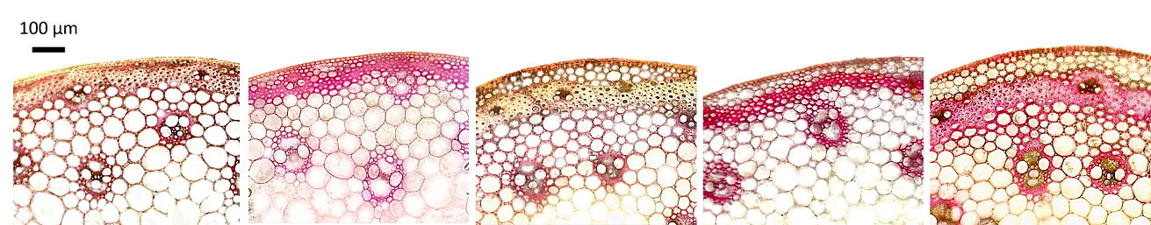
EA
D
C
B
A
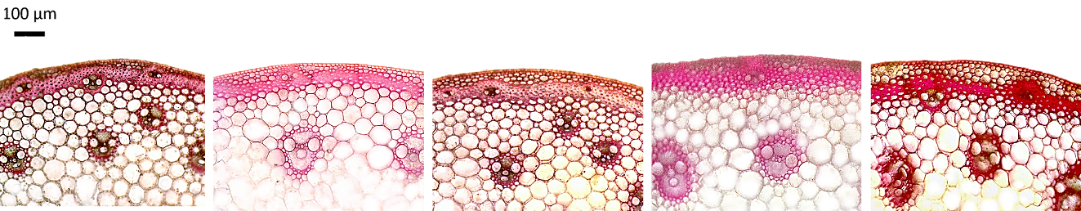
JA
I
F
G
H
Fig. 7 Cross-sections of the first expanded internode, reacted with phloroglucinol + HCl, showing anatomical characteristics and deposition of lignin (reddish color) in different oat genotype tissues, under optical microscopy with 10X magnification (100 µm scale); A: UFRGS 127013-1; B: URS Altiva; C: URS 21; D: UFRGS 146155-1; E: URS Taura on the first crop season (Environment 5); F: UFRGS 127013-1; G: URS Altiva; H: URS 21; I: UFRGS 146155-1; J: URS Taura on the second crop season (Environment 8).

B
C
D
EA
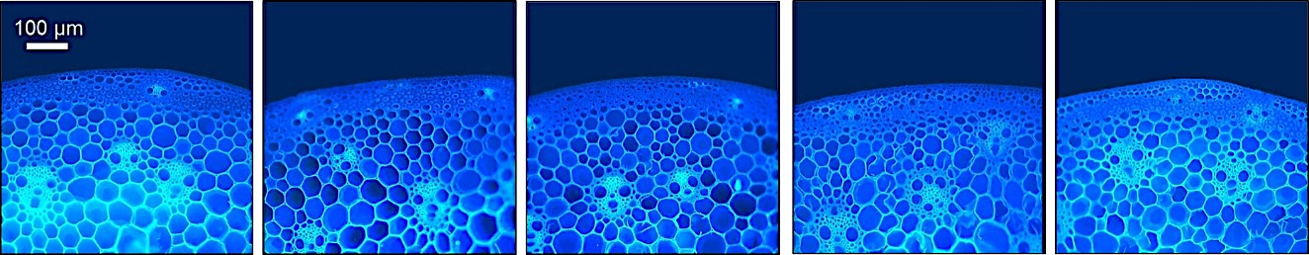
A
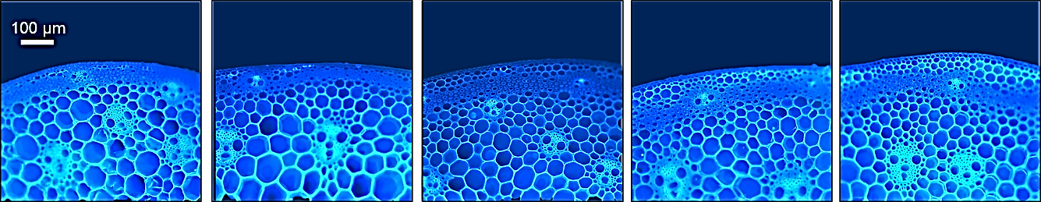
I
H
G
F
JA
Fig. 8 Cross-sections of the first expanded internode, reacted with calcofluor showing anatomical characteristics and cellulose deposition on the cell wall of various tissues of oat genotypes, under optical microscopy at 10X magnification (100 µm scale). A: UFRGS 127013-1; B: URS Altiva; C: URS 21; D: UFRGS 146155-1; E: URS Taura on the first crop season (Environment 5); F: UFRGS 127013-1; G: URS Altiva; H: URS 21; I: UFRGS 146155-1; J: URS Taura on the second crop season (Environment 8).

