Supplementary Material

Table S1: Patient characteristics.
No. | age | sex | DBS settings | Medication | MDS-UPDRS
 |  |  |  |  | OFF | ON
1 | 65 | F | 2.5mA bilat/130Hz/91µs (Libra) | L-dopa, Ent, Rop | 28 | 11
2 | 71 | M | 3.0V bilat/130Hz/ 90µs (Activa) | L-dopa, Rop | 45 | 25
3 | 68 | F | 3.2V bilat/130Hz/90µs (Activa) | L-dopa, Ent, Rop | 34 | 17
4 | 58 | M | 1.1mA bilat/130Hz/143µs (Libra) | L-dopa, Rop | 40 | 26
5 | 52 | M | 3.3V bilat/130Hz/90µs (Activa) | L-dopa, Rot | 42 | 14
6 | 55 | M | 1.5V bilat/130Hz/60µs (Activa) | L-dopa, Pra | 46 | 29
7 | 64 | F | 2.4V bilat/130Hz/90µs (Activa) | L-dopa, Ent | 50 | 17
8 | 61 | F | 2.4V bilat/130Hz/90µs (Activa) | L-dopa, Ent, Rop | 35 | 15
9 | 39 | M | 3.9mA(bip)/3.0mA(bip)/130Hz/78µs (Libra) | L-dopa, Ent, Rop | 48 | 13
10 | 60 | M | 1.9V bilat/130Hz/90µs (Activa) | L-dopa, Ent | 31 | 18
11 | 65 | F | 3.2mA bilat (bip)/130Hz/65µs (Libra) | L-dopa, Rop | 44 | 31
12 | 53 | M | 2.2 V bilat/130Hz/90µs (Activa) | L-dopa, Ent, Rop | 48 | 28
13 | 58 | M | 3.3V/4.3V/130Hz/90µs (Activa) | L-dopa, Rop, Rot, Bipe | 53 | 37
14 | 55 | F | 1.4mA/1.8mA/130Hz/91µs (Libra) | L-dopa, Ent, Pra | 55 | 31
15 | 65 | F | 1.6V/1.4V/130Hz/90µs (Activa) | L-dopa, Pra | 36 | 17
16 | 56 | M | 2.1V/2.1V(bip)/130Hz/90µs (Activa) | L-dopa, Ent | 30 | 17
17 | 58 | M | 1.2V/2.5V/130Hz/90µs (Activa) | L-dopa, Ent, Rop | 49 | 26
18 | 63 | M | 2.1V bilat/90µs/130Hz (Activa) | L-dopa, Ent, Rop, Sel | 24 | 15
19 | 66 | M | 2.5V bilat/90µs/130Hz (Activa) | L-dopa, Ent, Rop | 50 | 24
20 | 73 | M | 2.5V/ 3.0V /90µs/130Hz (Activa) | L-dopa, Ent | 30 | 11
21 | 59 | M | 2.6V bilat/90µs/130Hz (Activa) | L-dopa | 40 | 21
22 | 56 | M | 3.0V bilat/60µs/130Hz (Activa) | L-dopa, Ent | 36 | 21
23 | 64 | M | 2.2V/90µs/130Hz (Activa) | L-dopa, Rop | 38 | 14
24 | 66 | M | 2.8V/90µs/130Hz (Activa) | L-dopa, Pra | 36 | 25
25 | 54 | M | 3.6V/60µs/130Hz (Activa) | L-dopa, Ent, Rop | 36 | 17
26 | 65 | M | 1.4V/90µs/130Hz (Activa) | L-dopa, Pra | 44 | 24
27 | 68 | F | 2.2mA/91µs/130Hz (Libra) | L-dopa, Ent, Ama | 29 | 9
28 | 66 | M | 2.9V and 2.7V/90µs/130Hz (Activa) | L-dopa, Ent | 36 | 21
29 | 54 | M | 3.2V/90µs/130Hz (Activa) | L-dopa, Ent, Rop, Ama | 58 | 24
30 | 68 | F | 0.5 and 1.7V/90µs/130Hz (Activa) | L-dopa, Rop | 42 | 23
31 | 64 | M | 2.6V/90µs/130Hz (Activa) | L-dopa, Ent, Rop | 64 | 33
32 | 58 | M | 1.0V/90µs/180Hz (Activa) | L-dopa, Ent, Pra | 26 | 17
33 | 69 | M | 3.3V/90µs/130Hz (Activa) | 0 | 39 | 30
34 | 66 | M | 1.5V/4.0V bip/90µs/140Hz (Activa) | L-dopa, Tol, Rot, Ama | 41 | 27
35 | 68 | F | 1.4mA bilat/60µs/130Hz (Percept) | L-dopa, Ent, Rop | 48 | 37
36 | 65 | F | 1.7 V bilat/90µs/130Hz (Activa PC) | L-dopa, Ent, Pra | 35 | 12
37 | 51 | M | 2.5mA (left STN) and 3.5mA (right STN)/90µs/110Hz (Percept) | L-dopa | 50 | 9
38 | 66 | M | 1.6V bilat/90µs/130 Hz (Activa PC) | L-dopa, Rot | 30 | 8
39 | 58 | F | 2.3mA bilat/90µs/130 Hz (Infinity) | L-dopa | 38 | 15
40 | 49 | M | 3.7 mA (left) and 2.8mA (right)/60µs/130Hz (Percept) | L-dopa, Ent | 60 | 28
41 | 64 | M | 1.5 mA/90µs/130 Hz (Infinity) | L-dopa, Ent, Pra | 28 | 15
42 | 65 | F | 1.6mA (left) and 1.3 mA (right)/90µs/130Hz (Percept) | L-dopa | 53 | 24
43 | 58 | F | 1.1mA bilat/90µs/130 Hz (Percept) | 0 | 0 | 0

Table S2: Characteristics of patient group. Average values ± standard deviations. *Three subjects were forced right-handed.

age | 61.07 ± 6.76 | Digit span | 45.14 ± 9.19
sex | 14 females, 29 males | Stroop interference | 47.60 ± 10.60
Right-handed / left-handed | 43 / 0* | Word list 1 | 46.07 ± 12.33
MDS-UPDRS_{OFF} | 40.12 ± 11.50 | Word list 2 | 53.62 ± 7.56
MDS-UPDRS_{ON} | 20.37 ± 8.21 | Mattis total score | 140.64 ± 3.61

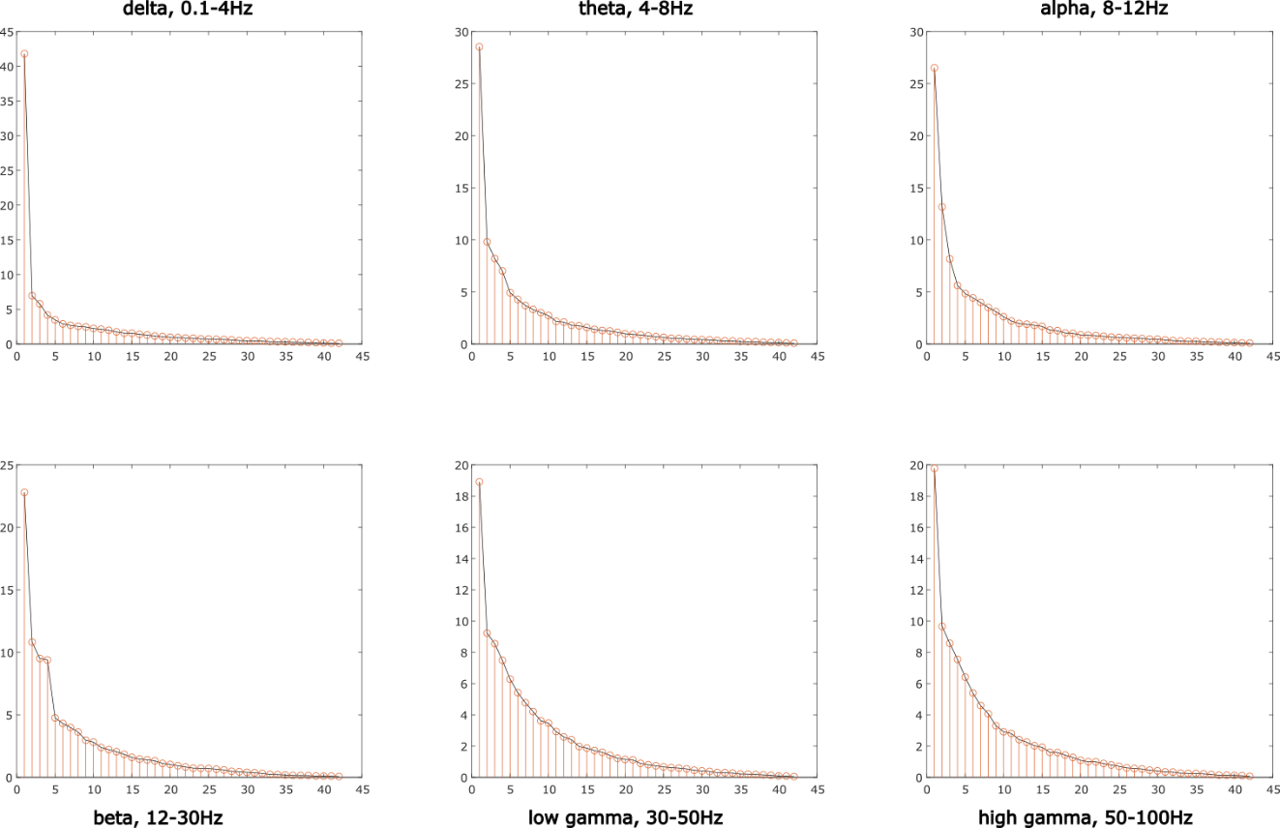Figure S1: Functions of explained variance by individual PCA components of DBS OFF motor subnetwork connectivity. By an elbow criterion, the first three components were used to define DBS OFF connectivity patterns CP_{motor}s of motor subnetwork.

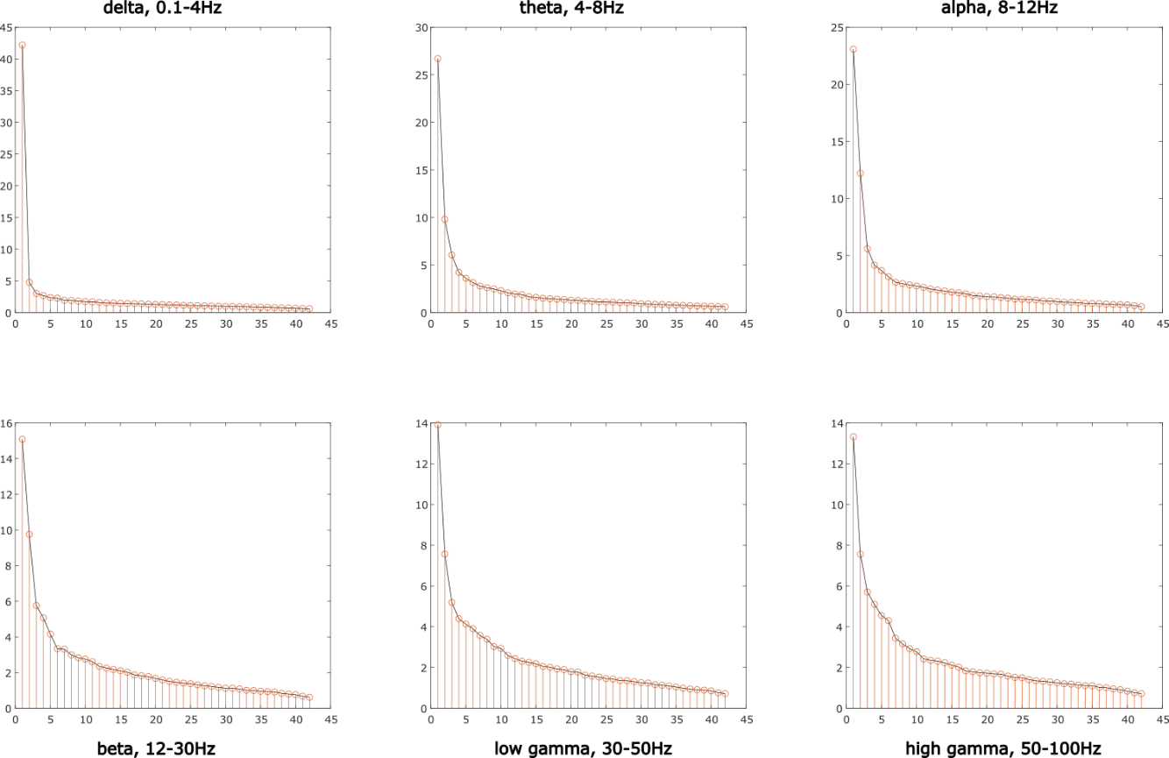Figure S2: Functions of explained variance by individual PCA components of DBS OFF whole-brain connectivity. By an elbow criterion, the first five components were used to define DBS OFF connectivity patterns CP_{OFF}s.

The DBS OFF connectivity profile of optimal responders – classification analysis, details
The nested leave-one-out cross-validation design was adapted. In the outer loop, one subject was removed as a test subject, the rest went into the inner loop. There, another one subject was eliminated. On the remaining validation dataset, a sweep across different levels of response threshold for identifying optimal responders was undertaken. For each response threshold level, a subset of subjects was identified as possibly-optimal, and the average difference in DBS ON and DBS OFF connectivity was computed for this subset. The values of connectivity differences outside four standard deviations from the average value in each frequency band were used to define a characteristic connectivity profile of these possibly-optimal responders. This process is depicted in the scheme in Figure S1.
The identified profile was used as an input to the linear support vector machine (SVM) classification to classify optimal and suboptimal responders. The procedure includes the following steps. Subjects identified as possibly-optimal were observed as positives (optimal responders) and the rest as negatives (suboptimal responders). Their individual connectivity profiles were taken to train a linear SVM classifier. The classifier was then evaluated on the test subject. Bringing the classification results across all folds together, correctly classified possibly-optimal responders were marked as true positives (TP) and correctly classified suboptimal subjects as true negatives (TN). The possibly-optimal responders classified incorrectly as suboptimal were marked as false negatives (FN), and suboptimal responders classified incorrectly as optimal were saved as false positives (FP). From these, the positive predictive value (PPV) was evaluated as PPV=TP/(TP+FP), negative predictive value (NPV) as NPV=TN/(FN+TN), sensitivity=TP/(TP+FN), and specificity=TN/(FP+TN).
The PPV, NPV, sensitivity, and specificity were used to evaluate the strength of the connectivity profile to predict optimal responders. When the response threshold is low, and a group of optimal responders contains all or almost all subjects (THR>-14), high sensitivity and high positive predictive values are obtained. However, the specificity and negative predictive values are low because suboptimal responders were included in the connectivity profile computation. At the other end of the spectrum, when only subjects with the best movement improvement after DBS were used in the analysis, it resulted in high specificity and negative predictive values, and very low sensitivity and positive predictive values. However, when the connectivity from a broader scale of subjects is included in connectivity profile computation, the percentage of correctly classified true optimal responders increases while keeping the positive predictive value relatively high.
In this way, a classifier was constructed for each response threshold of possibly-optimal responders.
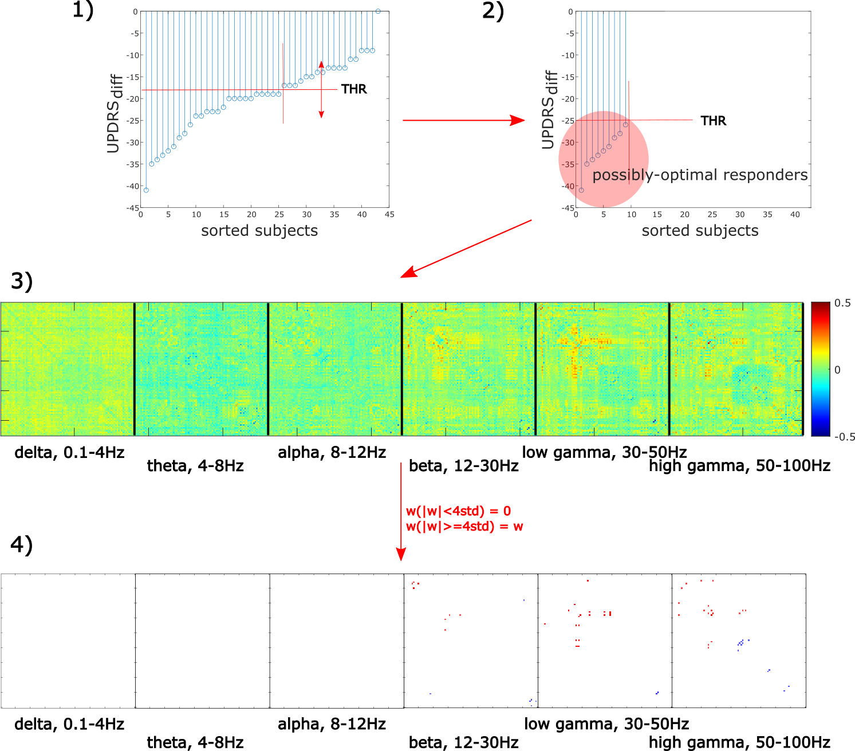
Figure S3: Scheme for extraction of connectivity profile from optimal responders. 1) UPDRS_{diff} = UPDRS_{ON} – UPDRS_{OFF} computed for each subject and sorted. Sweep across response thresholds identifying possibly-optimal responders (UPDRS_{diff} from -9 (poor improvement of motor symptoms after DBS) to -41 (the best-measured improvement)). 2) Set a response threshold for possibly-optimal responders. 3) For them, compute subject-wise DBS ON – DBS OFF connectivity difference in each frequency band separately, compute the average across subjects. 4) Use only extreme values of connectivity difference to specify the connectivity profile influenced the most by DBS (values outside four standard deviations from the average value in the matrix). Obtain the profile for each frequency band. Repeat the process from step 2) with different response threshold.

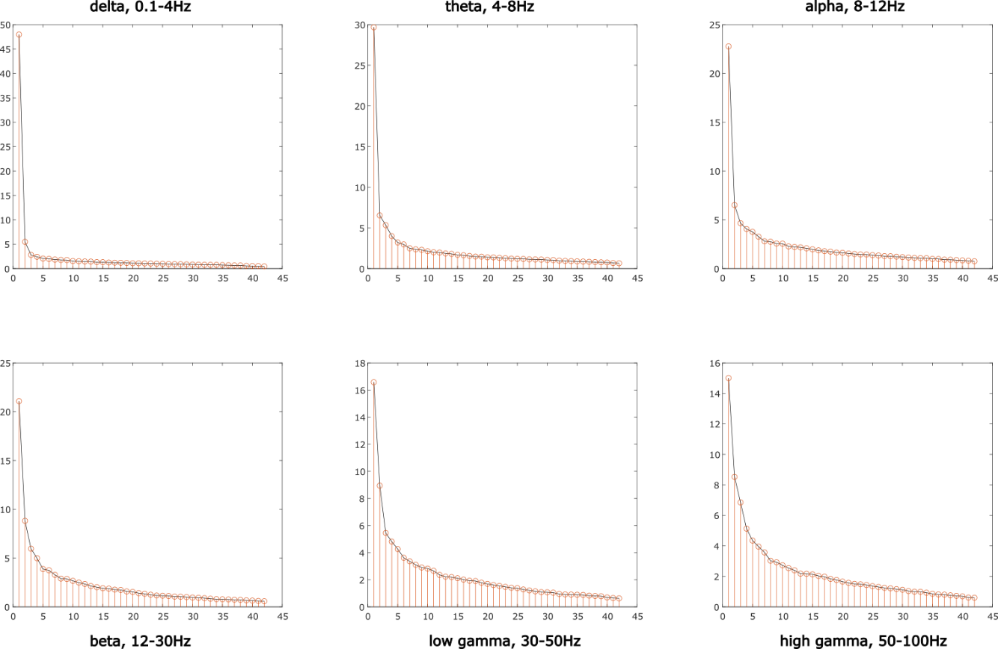Figure S4: Functions of explained variance by individual PCA components of DBS ON whole-brain connectivity. By an elbow criterion, the first five components were used to define DBS ON connectivity patterns CP_{ON}s.

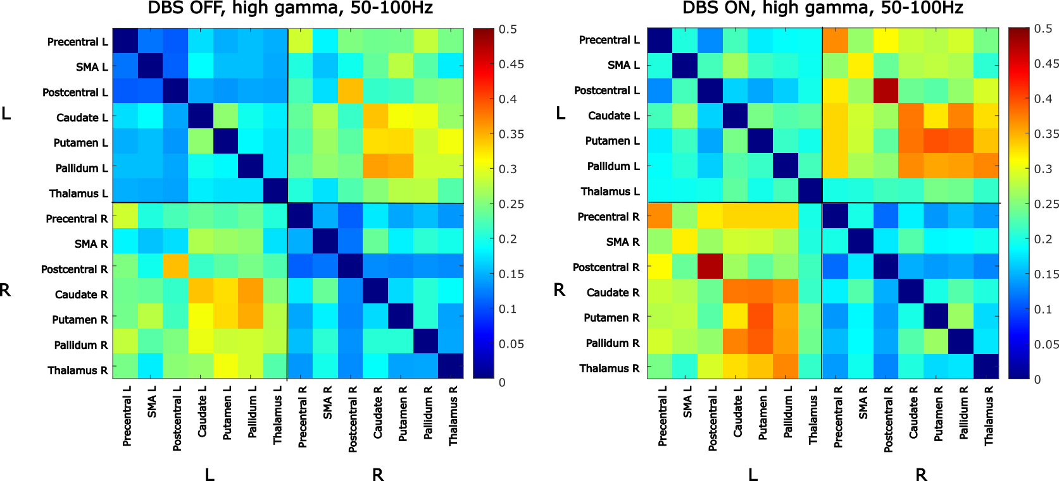Figure S5: The average connectivity within motor subnetwork in DBS OFF and DBS ON states, high gamma band, 50-100Hz. ROIs are sorted by hemispheres; the upper left quarter shows connections within the left hemisphere, the lower right quarter connections within the right hemisphere, and the upper right and the lower left quarters show inter-hemispheric connections.
a)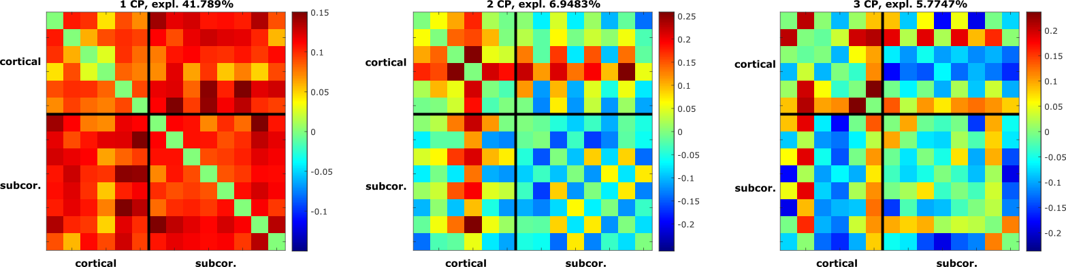b)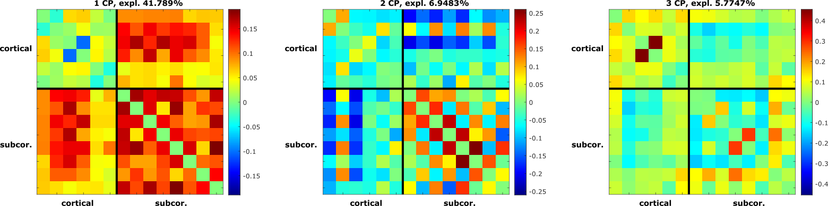c)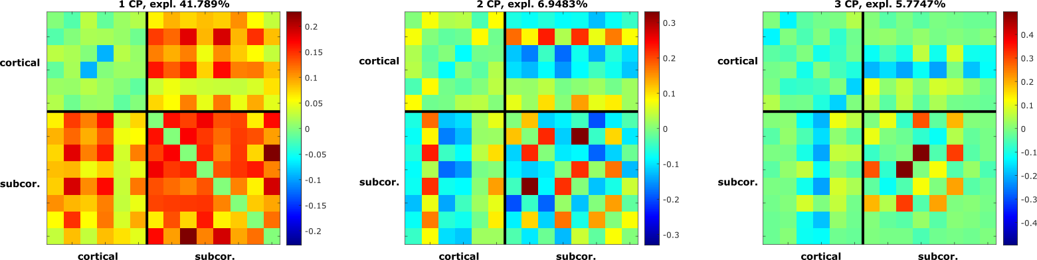d)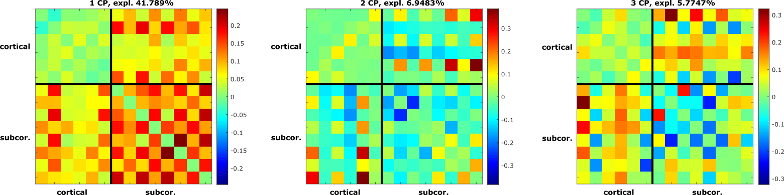e)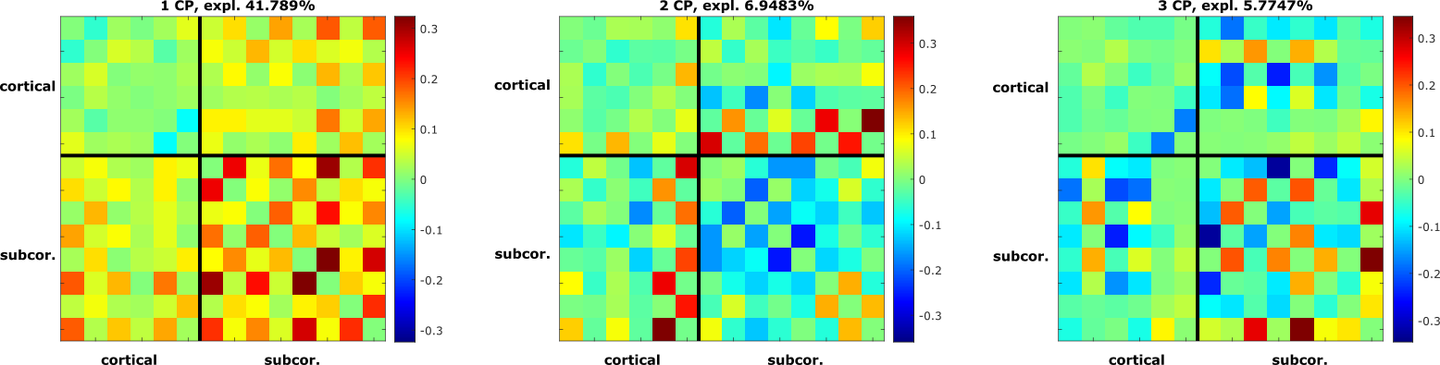f)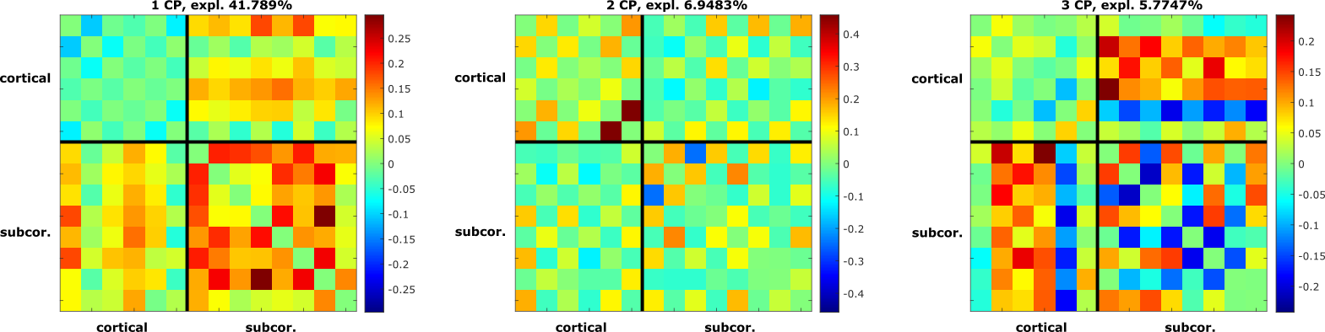Figure S6: Motor subnetwork DBS OFF a) delta, b) theta, c) alpha, d) beta, e) low gamma, f) high gamma connectivity patterns (CP_{motor}s). ROIs are sorted by hemispheres; the upper left quarter shows connections within the left hemisphere, the lower right quarter connections within the right hemisphere, and the upper right and the lower left quarters show inter-hemispheric connections. Color-coded values correspond to PCA loadings: red: higher connectivity, blue: lower connectivity.

Table S3: P-values of correlations between motor subnetwork DBS OFF connectivity profiles CPs and movement improvement caused by DBS measured by UPDRS_{diff}. Bold: significant results reported in the Results section of the full paper.
 | 1st CP_{motor} | 2nd CP_{motor} | 3rd CP_{motor}
delta | p = 0.018 | p = 0.50 | p = 0.29
theta | p = 0.40 | p = 0.89 | p = 0.04
alpha | p = 0.96 | p = 0.30 | p = 0.020
beta | p = 0.57 | p = 0.86 | p = 0.86
low gamma | p = 0.75 | p = 0.32 | p = 0.09
high gamma | p = 0.009 | p = 0.35 | p = 0.47

a)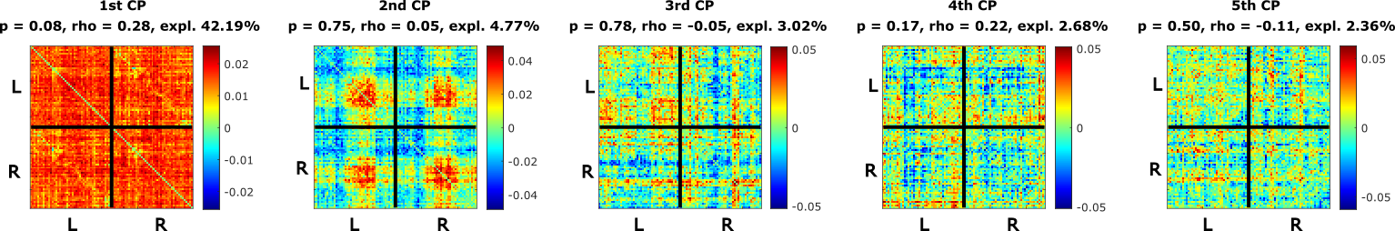b)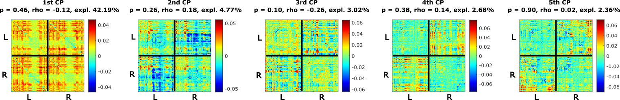c)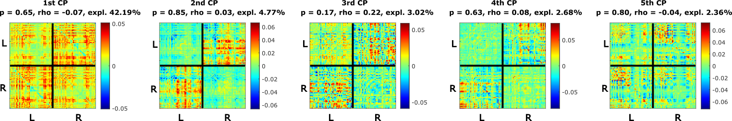d)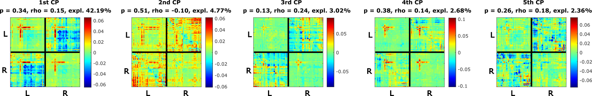e)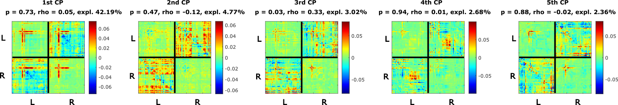f)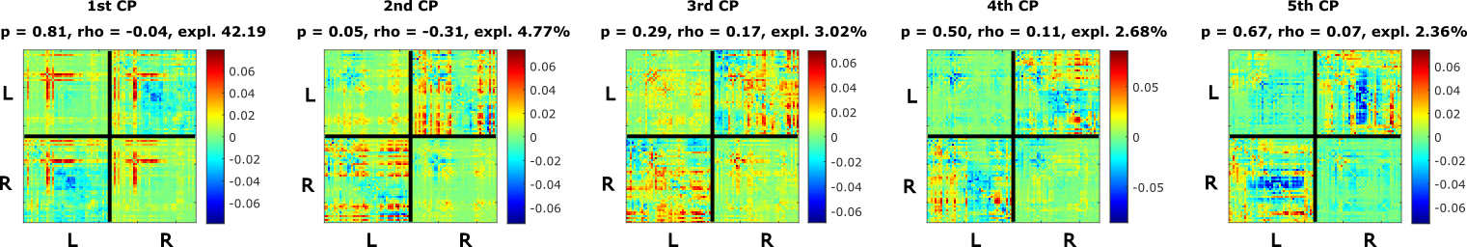Figure S7: DBS OFF a) delta, b) theta, c) alpha, d) beta, e) low gamma, f) high gamma connectivity patterns (CP_{OFF}s). ROIs are sorted by hemispheres; the upper left quarter shows connections within the left hemisphere, the lower right quarter connections within the right hemisphere, and the upper right and the lower left quarters show inter-hemispheric connections. Color-coded values correspond to PCA loadings: red: higher connectivity, blue: lower connectivity.

Table S4: P-values of correlations between DBS OFF connectivity profiles CPs and movement improvement caused by DBS measured by UPDRS_{diff}. Bold: significant results reported in the Results section of the full paper.
 | 1st CP_{OFF} | 2nd CP_{OFF} | 3rd CP_{OFF} | 4th CP_{OFF} | 5th CP_{OFF}
delta | p = 0.08 | p = 0.75 | p = 0.78 | p = 0.17 | p = 0.50
theta | p = 0.47 | p = 0.26 | p = 0.10 | p = 0.38 | p = 0.90
alpha | p = 0.65 | p = 0.85 | p = 0.17 | p = 0.63 | p = 0.80
beta | p = 0.34 | p = 0.51 | p = 0.13 | p = 0.38 | p = 0.26
low gamma | p = 0.73 | p = 0.47 | p = 0.03 | p = 0.94 | p = 0.88
high gamma | p = 0.81 | p = 0.05 | p = 0.29 | p = 0.50 | p = 0.67

a)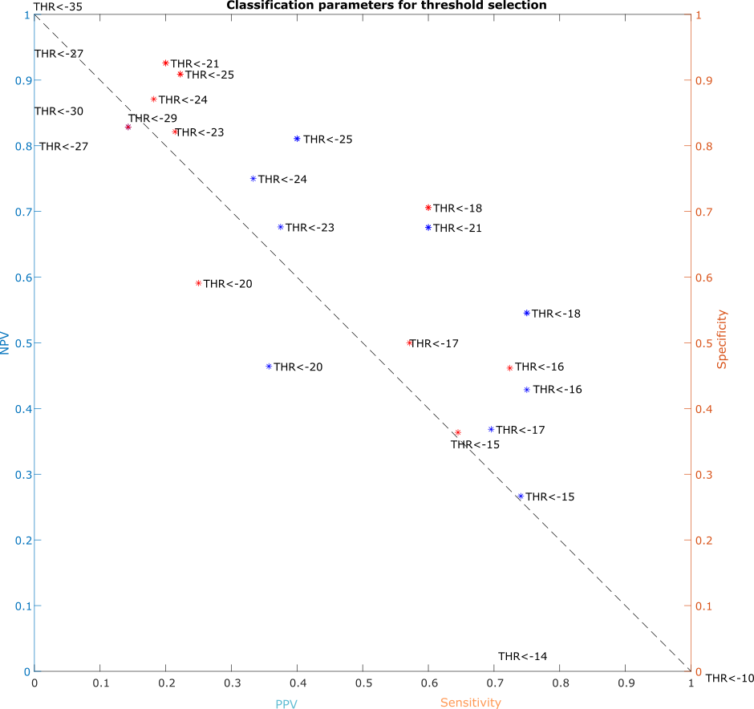
b)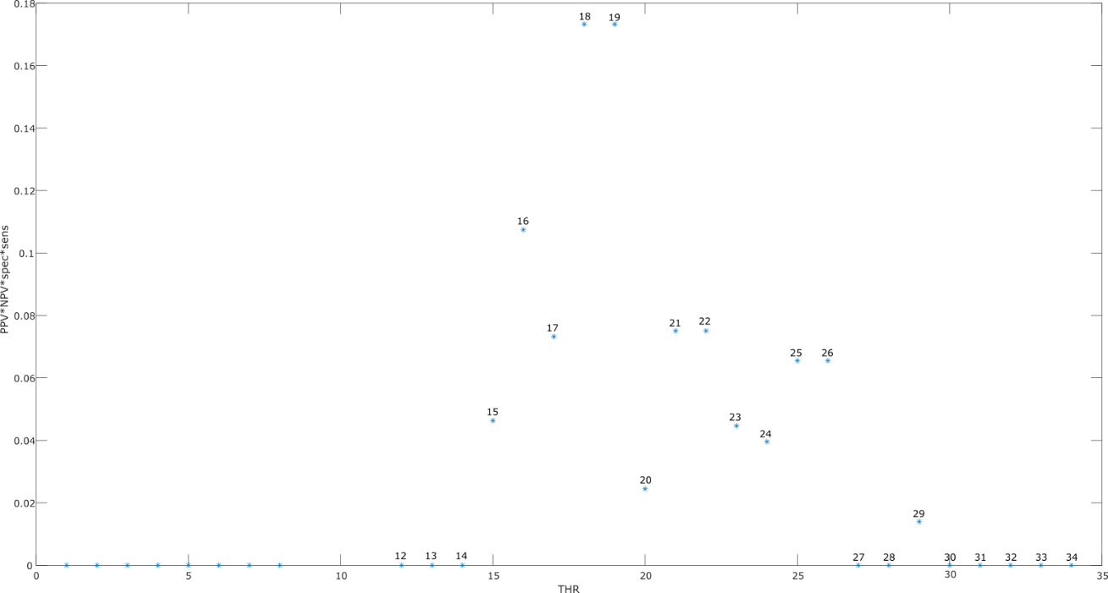
Figure S8: a) The relations between positive predictive values (PPV) and negative predictive values (NPV), sensitivity, and specificity for diverse response thresholds for the 1st fold of the cross-validation outer loop. Blue points: relation between NPV and PPV, red points: relation between specificity and sensitivity. b) Multiplication between PPV, NPV, spec, and sensitivity for diverse response thresholds. The highest y-value implies the best ratio of all four measures.
Table S5: Results of one repetition of the cross-validation. The PPV, NPV, specificity (Spec), and sensitivity (Sens) of each fold of outer loop for the best response threshold (THR) identified by the inner loop.
fold | THR | PPV | NPV | Spec | Sens | fold | THR | PPV | NPV | Spec | Sens
1 | 17 | 0.89 | 0.55 | 0.86 | 0.63 | 22 | 18 | 0.79 | 0.55 | 0.75 | 0.60
2 | 18 | 0.82 | 0.68 | 0.76 | 0.75 | 23 | 23 | 0.80 | 0.75 | 0.96 | 0.31
3 | 18 | 0.74 | 0.50 | 0.69 | 0.56 | 24 | 18 | 0.76 | 0.55 | 0.69 | 0.64
4 | 16 | 0.82 | 0.54 | 0.58 | 0.79 | 25 | 18 | 0.81 | 0.56 | 0.82 | 0.54
5 | 17 | 0.78 | 0.50 | 0.64 | 0.67 | 26 | 18 | 0.75 | 0.52 | 0.76 | 0.50
6 | 18 | 0.76 | 0.55 | 0.69 | 0.64 | 27 | 18 | 0.74 | 0.55 | 0.71 | 0.58
7 | 16 | 0.76 | 0.40 | 0.62 | 0.57 | 28 | 16 | 0.79 | 0.50 | 0.50 | 0.79
8 | 18 | 0.72 | 0.48 | 0.69 | 0.52 | 29 | 18 | 0.79 | 0.59 | 0.76 | 0.63
9 | 18 | 0.76 | 0.55 | 0.69 | 0.64 | 30 | 16 | 0.77 | 0.47 | 0.54 | 0.71
10 | 18 | 0.76 | 0.54 | 0.76 | 0.54 | 31 | 16 | 0.78 | 0.50 | 0.54 | 0.75
11 | 18 | 0.67 | 0.48 | 0.65 | 0.50 | 32 | 16 | 0.81 | 0.60 | 0.50 | 0.86
12 | 18 | 0.71 | 0.50 | 0.71 | 0.50 | 33 | 18 | 0.75 | 0.52 | 0.69 | 0.60
13 | 18 | 0.83 | 0.67 | 0.75 | 0.76 | 34 | 16 | 0.86 | 0.62 | 0.67 | 0.83
14 | 18 | 0.79 | 0.52 | 0.82 | 0.46 | 35 | 18 | 0.77 | 0.58 | 0.69 | 0.68
15 | 17 | 0.92 | 0.45 | 0.93 | 0.41 | 36 | 21 | 0.75 | 0.76 | 0.93 | 0.43
16 | 18 | 0.75 | 0.52 | 0.69 | 0.60 | 37 | 18 | 0.80 | 0.62 | 0.76 | 0.67
17 | 23 | 0.67 | 0.74 | 0.93 | 0.31 | 38 | 20 | 0.62 | 0.61 | 0.77 | 0.42
18 | 18 | 0.76 | 0.55 | 0.69 | 0.64 | 39 | 17 | 0.74 | 0.44 | 0.57 | 0.63
19 | 24 | 0.75 | 0.81 | 0.97 | 0.30 | 40 | 16 | 0.77 | 0.47 | 0.54 | 0.71
20 | 18 | 0.81 | 0.56 | 0.82 | 0.54 | 41 | 16 | 0.82 | 0.54 | 0.58 | 0.79
21 | 17 | 0.74 | 0.41 | 0.64 | 0.52 | 42 | 18 | 0.75 | 0.57 | 0.71 | 0.63

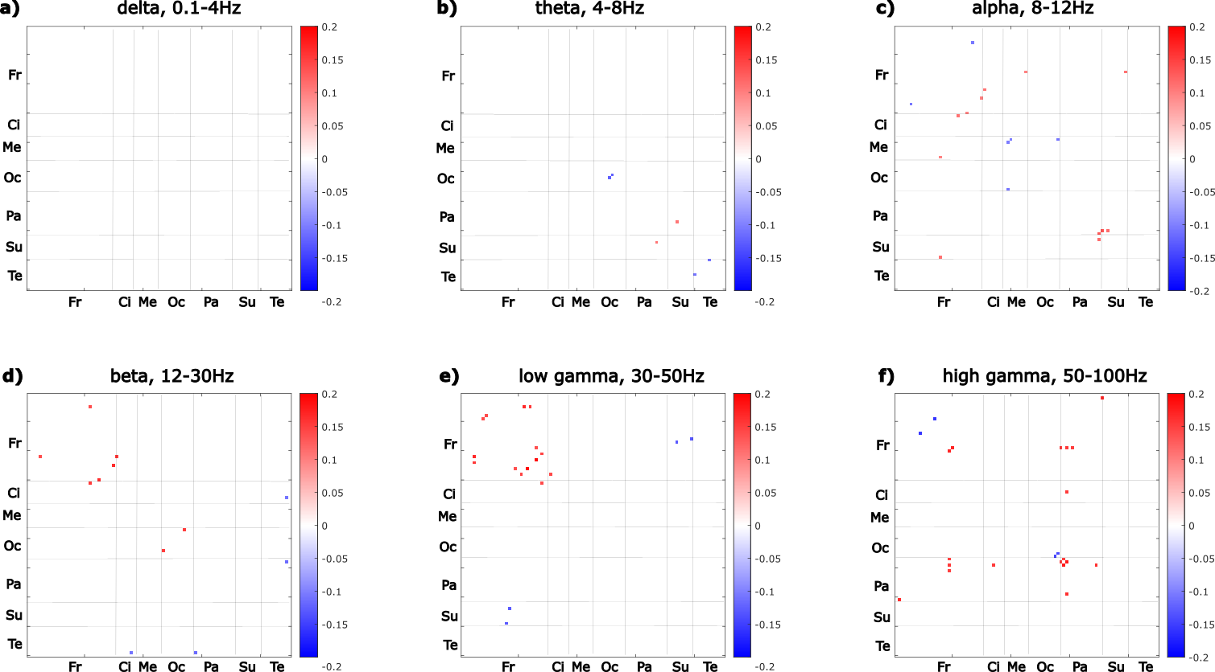Figure S9: Matrix representation of the connectivity profile discriminating optimal and suboptimal responders the best. Red: increase in ON, blue: decrease in ON. Fr: Frontal, Ci: Cingulum, Me: Mesiotemporal, Oc: Occipital, Pa: Parietal, Su: Subcortical, Te: Temporal regions.

Table S6: Full names of ROIs involved in the connectivity profile discriminating response to DBS. ROIs are sorted, first reported are those involved in increased connections in DBS ON, second those involved in connections decreased in DBS ON compared to DBS OFF.
delta |  | theta |  | alpha
 |  | PCUN.L | Precuneus L | ORBinf.R | Frontal Inf Orb R
 |  | PUT.R | Putamen R | OLF.R | Olfactory R
 |  |  |  | ORBsupmed.L | Frontal Med Orb L
 |  | MOG.L | Occipital Mid L | INS.R | Insula R
 |  | MOG.R | Occipital Mid R | ACG.L | Cingulum Ant L
 |  | HES.R | Heschl R | CUN.L | Cuneus L
 |  | MTG.L | Temporal Mid L | PCL.R | Paracentral Lobule R
 |  |  |  | CAU.L | Caudate L
 |  |  |  | PUT.L | Putamen L
 |  |  |  | HES.L | Heschl L
 |  |  |  | ORBsup.R | Frontal Sup Orb R
 |  |  |  | REC.L | Rectus L
 |  |  |  | PHG.L | ParaHippocampal L
 |  |  |  | PHG.R | ParaHippocampal R
 |  |  |  | FFG.R | Fusiform R
beta |  | low gamma |  | high gamma
ORBsup.L | Frontal Sup Orb L | ORBsup.L | Frontal Sup Orb L | PreCG.R | Precentral R
OLF.R | Olfactory R | MFG.R | Frontal Mid R | SMA.L | Supp Motor Area L
ORBsupmed.L | Frontal Med Orb L | ORBmid.L | Frontal Mid Orb L | SMA.R | Supp Motor Area R
INS.R | Insula R | SMA.L | Supp Motor Area L | DCG.R | Cingulum Mid R
ACG.L | Cingulum Ant L | OLF.L | Olfactory L | PoCG.L | Postcentral L
LING.L | Lingual L | OLF.R | Olfactory R | PoCG.R | Postcentral R
IOG.R | Occipital Inf R | SFGmed.L | Frontal Sup Medial L | SPG.L | Parietal Sup L
 |  | SFGmed.R | Frontal Sup Medial R | IPL.L | Parietal Inf L
PCG.R | Cingulum Post R | ORBsupmed.R | Frontal Med Orb R | PCL.L | Paracentral Lobule L
PoCG.R | Postcentral R | REC.R | Rectus R | CAU.L | Caudate L
ITG.L | Temporal Inf L | ACG.L | Cingulum Ant L
 |  |  |  | ORBmid.L | Frontal Mid Orb L
 |  | ORBinf.R | Frontal Inf Orb R | IFGtriang.R | Frontal Inf Tri R
 |  | ROL.L | Rolandic Oper L | FFG.L | Fusiform L
 |  | PUT.R | Putamen R | FFG.R | Fusiform R
 |  | HES.L | Heschl L

a)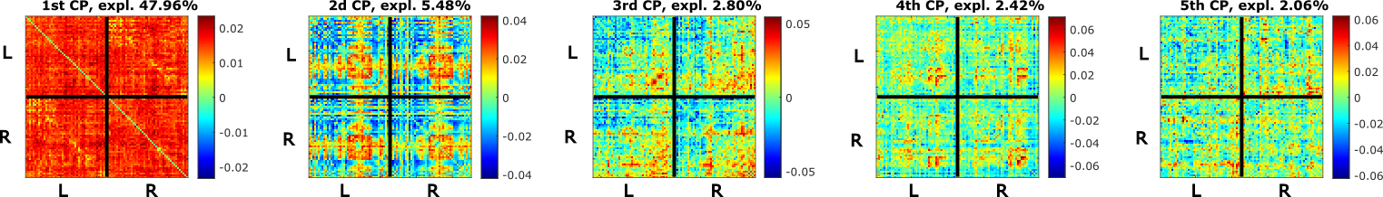b)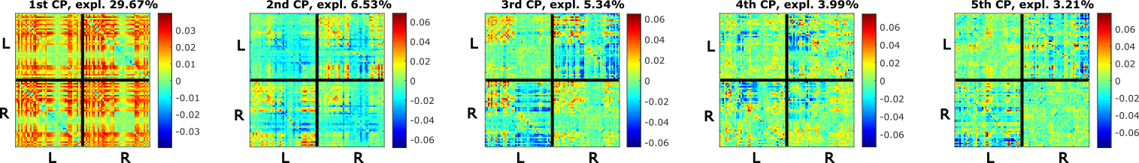c)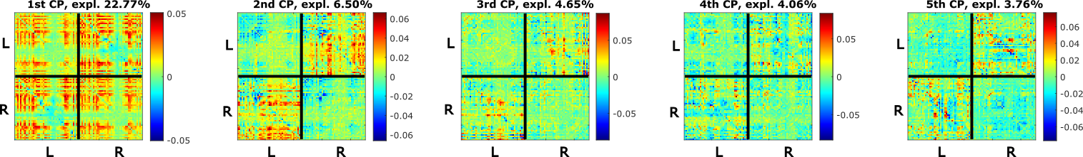d)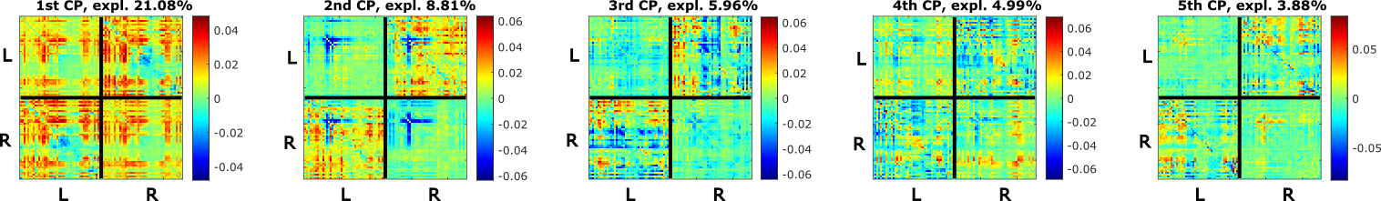e)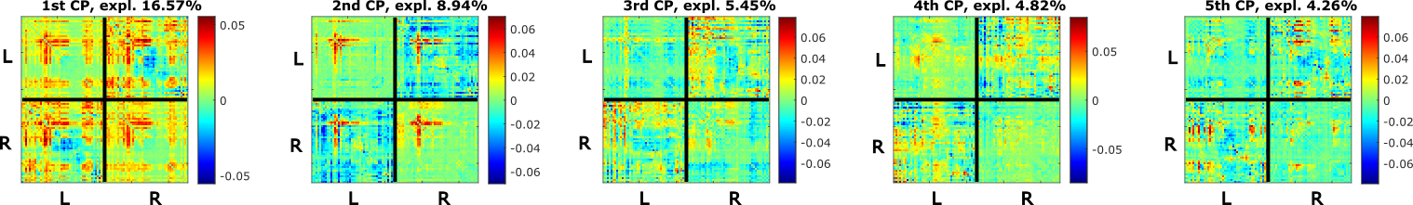f)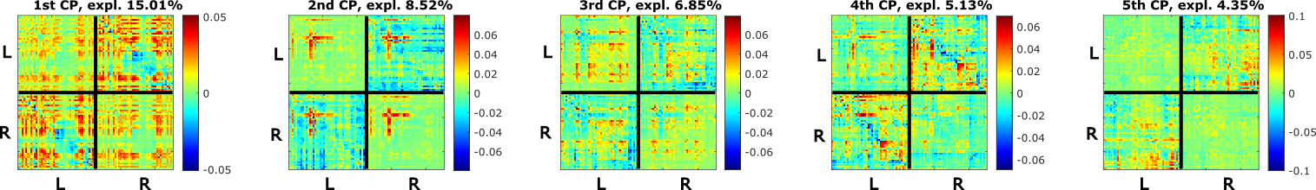Figure S10: DBS ON a) delta, b) theta, c) alpha, d) beta, e) low gamma, f) high gamma connectivity patterns (CP_{ON}s). ROIs are sorted by hemispheres; the upper left quarter shows connections within the left hemisphere, the lower right quarter connections within the right hemisphere, and the upper right and the lower left quarters show inter-hemispheric connections. Color-coded values correspond to PCA loadings: red: higher connectivity, blue: lower connectivity.

Table S7: P-values of correlations between DBS ON connectivity profiles CPs and cognitive scores. Bold: significant results reported in the Results section of the full paper. DS: Digit span, WL1: Word list 1, WL2: Word list 2, SI: Stroop interference, MT: Mattis total score.
DS | 1st CP_{ON} | 2nd CP_{ON} | 3rd CP_{ON} | 4th CP_{ON} | 5th CP_{ON}
delta | p = 0.27 | p = 0.58 | p = 0.67 | p = 0.55 | p = 0.41
theta | p = 0.65 | p = 0.68 | p = 0.41 | p = 0.99 | p = 0.25
alpha | p = 0.91 | p = 0.92 | p = 0.07 | p = 0.25 | p = 0.82
beta | p = 0.40 | p = 0.87 | p = 0.14 | p = 0.79 | p = 0.20
low gamma | p = 0.48 | p = 0.78 | p = 0.82 | p = 0.56 | p = 0.13
high gamma | p = 0.91 | p = 0.65 | p = 0.08 | p = 0.55 | p = 0.57
WL1 | 1st CP_{ON} | 2nd CP_{ON} | 3rd CP_{ON} | 4th CP_{ON} | 5th CP_{ON}
delta | p = 0.50 | p = 0.54 | p = 0.86 | p = 0.46 | p = 0.85
theta | p = 0.22 | p = 0.82 | p = 0.24 | p = 0.52 | p = 0.75
alpha | p = 0.13 | p = 0.68 | p = 0.70 | p = 0.45 | p = 0.77
beta | p = 0.42 | p = 0.79 | p = 0.94 | p = 0.28 | p = 0.74
low gamma | p = 0.78 | p = 0.79 | p = 0.39 | p = 0.12 | p = 0.72
high gamma | p = 0.79 | p = 0.46 | p = 0.97 | p = 0.28 | p = 0.63
WL2 | 1st CP_{ON} | 2nd CP_{ON} | 3rd CP_{ON} | 4th CP_{ON} | 5th CP_{ON}
delta | p = 0.92 | p = 0.29 | p = 0.71 | p = 0.95 | p = 0.06
theta | p = 0.61 | p = 0.24 | p = 0.95 | p = 0.25 | p = 0.53
alpha | p = 0.10 | p = 0.07 | p = 0.53 | p = 0.98 | p = 0.07
beta | p = 0.85 | p = 0.62 | p = 0.30 | p = 0.98 | p = 0.63
low gamma | p = 0.76 | p = 0.88 | p = 0.43 | p = 0.03 | p = 0.73
high gamma | p = 0.90 | p = 0.29 | p = 0.21 | p = 0.41 | p = 0.14
SI | 1st CP_{ON} | 2nd CP_{ON} | 3rd CP_{ON} | 4th CP_{ON} | 5th CP_{ON}
delta | p = 0.24 | p = 0.12 | p = 0.36 | p = 0.56 | p = 0.40
theta | p = 0.65 | p = 0.28 | p = 0.66 | p = 0.30 | p = 0.31
alpha | p = 0.73 | p = 0.73 | p = 0.02 | p = 0.06 | p = 0.19
beta | p = 0.47 | p = 0.81 | p = 0.004 | p = 0.36 | p = 0.63
low gamma | p = 0.69 | p = 0.75 | p = 0.014 | p = 0.98 | p = 0.13
high gamma | p = 0.05 | p = 0.46 | p = 0.003 | p = 0.004 | p = 0.97
MT | 1st CP_{ON} | 2nd CP_{ON} | 3rd CP_{ON} | 4th CP_{ON} | 5th CP_{ON}
delta | p = 0.52 | p = 0.68 | p = 0.96 | p = 0.37 | p = 0.14
theta | p = 0.50 | p = 0.51 | p = 0.55 | p = 0.06 | p = 0.17
alpha | p = 0.13 | p = 0.36 | p = 0.59 | p = 0.82 | p = 0.39
beta | p = 0.76 | p = 1.00 | p = 0.09 | p = 0.56 | p = 0.11
low gamma | p = 0.59 | p = 0.77 | p = 0.09 | p = 0.77 | p = 0.08
high gamma | p = 0.50 | p = 0.76 | p = 0.46 | p = 0.96 | p = 0.84

The effect of DBS on the connectivity in the best and the worst responders
The best and the worst responders were defined based on the change of MDS-UPDRS. The response thresholds for the best and the worst responders to DBS were derived by visual inspection to capture the most differentiating connectivity features. The response threshold of UPDRS_{diff} < -25 (leading to 9 best responders) was estimated for the best responders and the response threshold for the worst responders to DBS was estimated as UPDRS_{diff} > -18 (leading to 17 worst responders). They are plotted in Supplementary figure S11. The intra-subject differences between DBS ON and DBS OFF connectivity were computed and compared between the best and the worst responders using Wilcoxon rank sum test, p<0.01. The result is visualized in Supplementary figure S12. An increased connectivity pattern of the ROIs 21 to 45 in beta and low gamma bands was observed in the best responders in DBS ON compared to DBS OFF. In the worst responders, there are significant decreases within the same pattern. In the theta and alpha frequencies, pronounced patterns of decreased connectivity in optimal responders were detected.
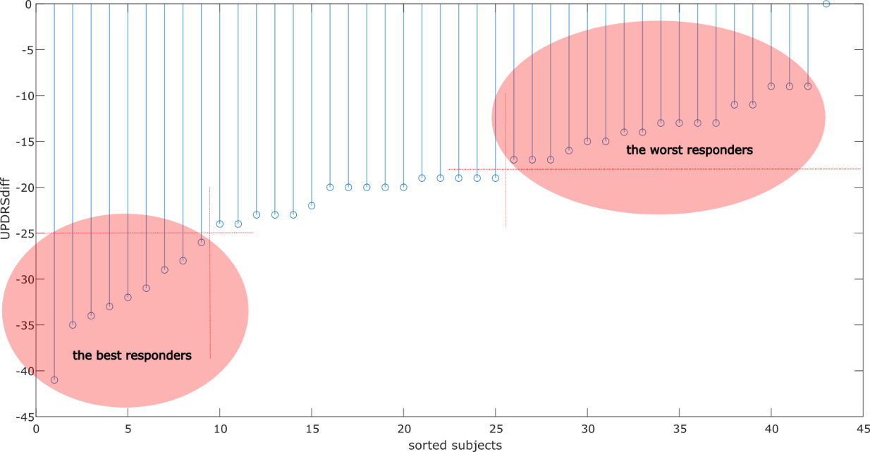
Figure S11: Identification of the best and the worst responders.

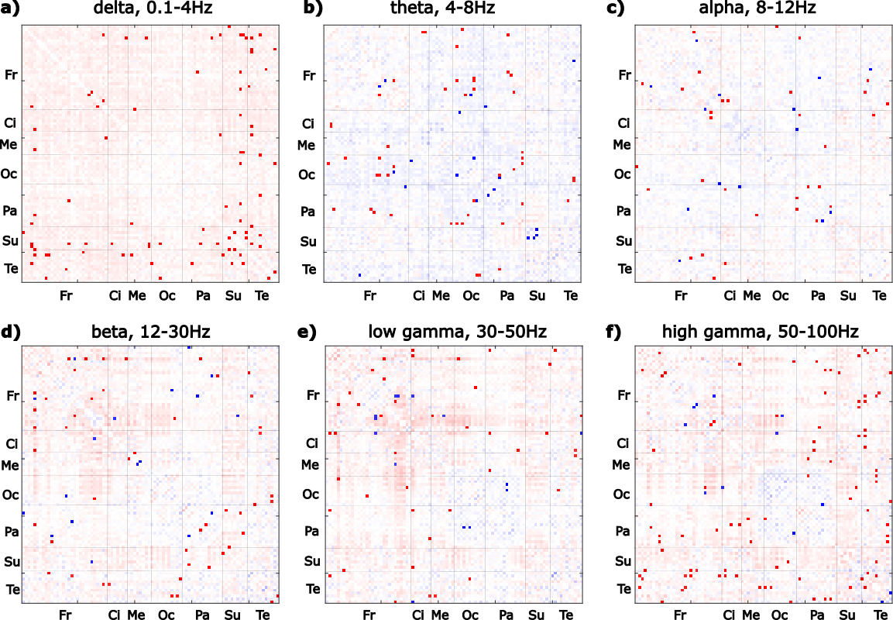Figure S12: The edgewise connectivity differences between the best and the worst responders for each frequency band (p<0.01). Solid red: higher difference between DBS ON and OFF condition in the best responders compared to the worst responders. Solid blue: lower difference between DBS ON and OFF condition in the best responders compared to the worst responders. Background: the average difference between ON and OFF conditions in the best responders; hues of red: higher connectivity in DBS ON compared to OFF, shades of blue: lower connectivity in DBS ON compared to OFF. Fr: Frontal, Ci: Cingulum, Me: Mesiotemporal, Oc: Occipital, Pa: Parietal, Su: Subcortical, Te: Temporal regions.

