List of Figures

Figure A

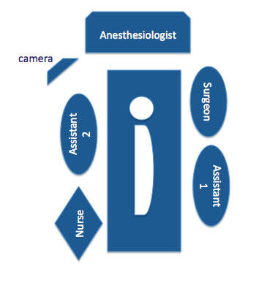
Fig. A Patient’s placement and operative room set up.

Figure B
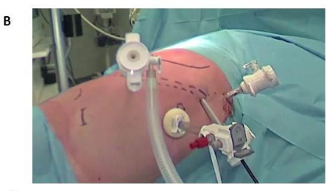

Fig. B Laparoscopic Ports placement.

Figure C

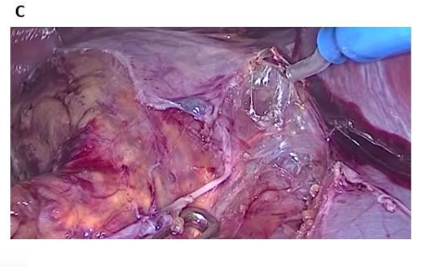
Fig. C. Laparoscopic dissection of the adrenal gland.

Figure D

Figure D: comparison between neuroblastome with pre-operative positive IDRF and with pre-operative negative IDRF in term of conversion rate, recurrences and death.

