ONLINE RESOURCE

Final results on effectiveness and safety of Ibrutinib in patients with chronic lymphocytic leukemia from the non-interventional FIRE study.

Caroline DARTIGEAS^{1a}, Anne QUINQUENEL², Loïc YSEBAERT³, Marie-Sarah DILHUYDY⁴, Bruno ANGLARET⁵, Borhane SLAMA⁶, Katell LE DU⁷, Stéphanie TARDY⁸, Emmanuelle TCHERNONOG⁹, Hubert ORFEUVRE¹⁰, Laurent VOILLAT¹¹, Stéphanie GUIDEZ¹² Jean-Valère MALFUSON¹³, Sandrine DUPUIS¹⁴, Marine DESLANDES¹⁴, Pierre FEUGIER¹⁵, Véronique LEBLOND¹⁶, on behalf of the FIRE Investigators Group

¹ CHRU Hôpitaux de Tours, Tours, France
² CHU de Reims, Reims, France
³ IUCT Oncopôle, CHU de Toulouse, Toulouse, France
⁴ Hôpital Haut-Lévêque, Bordeaux, France
⁵ CH de Valence, Valence, France
⁶ CH Henri Duffaut, Avignon, France
⁷ Hôpital Privé du Confluent, Nantes, France
⁸ CH Annecy Genevois, Annecy, France
⁹ CHU de Montpellier, Montpellier, France
¹⁰ CH de Bourg-en-Bresse, Bourg-en-Bresse, France
¹¹ CH William Morey, Chalon-sur-Saone, France
¹² CHU de Poitiers, Poitiers, France
¹³ HIA Percy, Clamart, France
¹⁴ Janssen France, Issy-les-Moulineaux, France
¹⁵ Hôpitaux de Brabois, CHU de Nancy, Nancy, France
¹⁶ AP-HP Hôpital de la Pitié-Salpêtrière, Paris La Sorbonne

Online Resource 1. Overall design of the study.
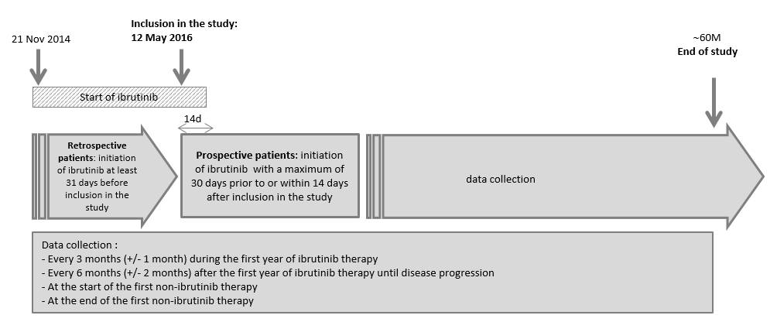

Online Resource 2. Definitions of the primary and secondary endpoints.
Endpoints | Definitions
PFS | The time from ibrutinib initiation to progression or death from any cause of death
OS | The time from ibrutinib initiation to the date of death from any cause of death
DOR | The time from response to ibrutinib to progression or death resulting from progression
Time to best response | The time form ibrutinib initiation to the best objective response (complete response, partial response, partial response with lymphocytosis)
Time to first response | The time from ibrutinib initiation to the first objective response (complete response, partial response, partial response with lymphocytosis)
Time to next treatment | The time from ibrutinib initiation to the start of non-ibrutinib subsequent therapy or death from any cause

Online Resource 3. Duration of response for CLL patients by type of inclusion (Effectiveness population, N=388).
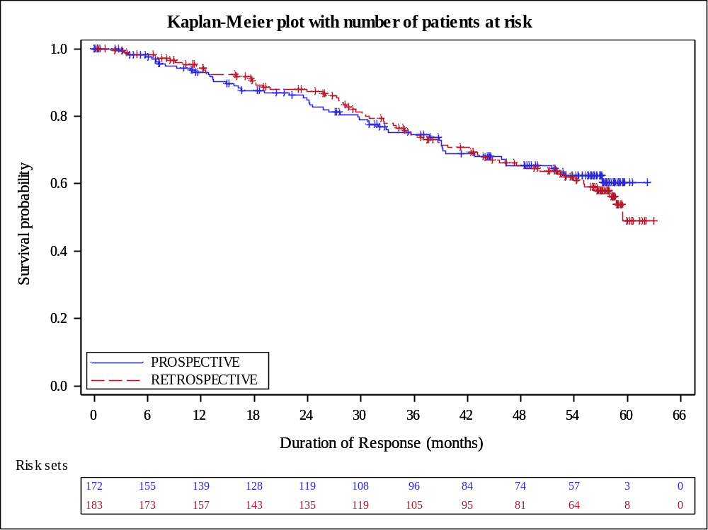

Online Resource 4. Time to first response for CLL patients by type of inclusion (Effectiveness population, N=388).
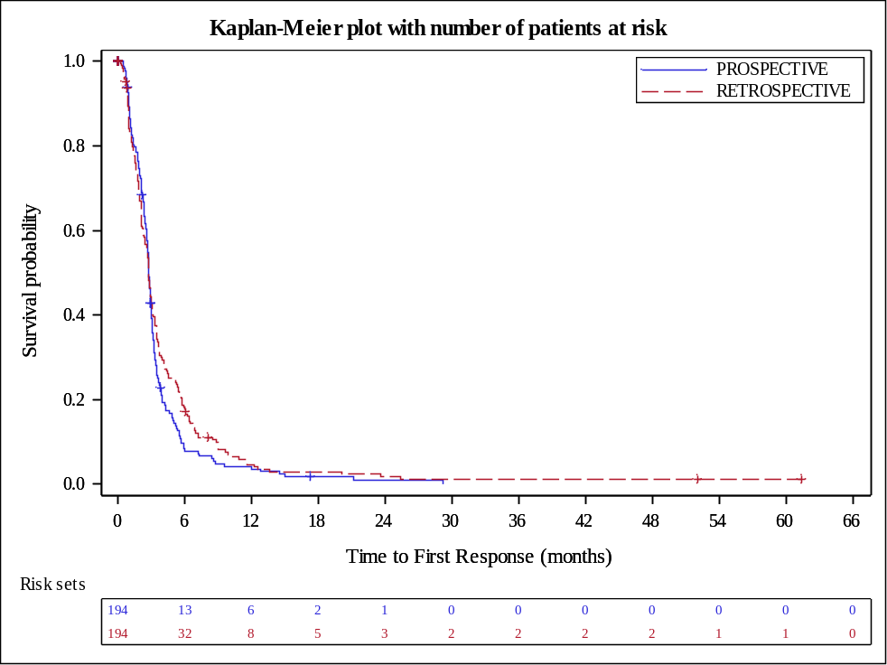

Online Resource 5. Time to best response for CLL patients by type of inclusion (Effectiveness population, N=388).
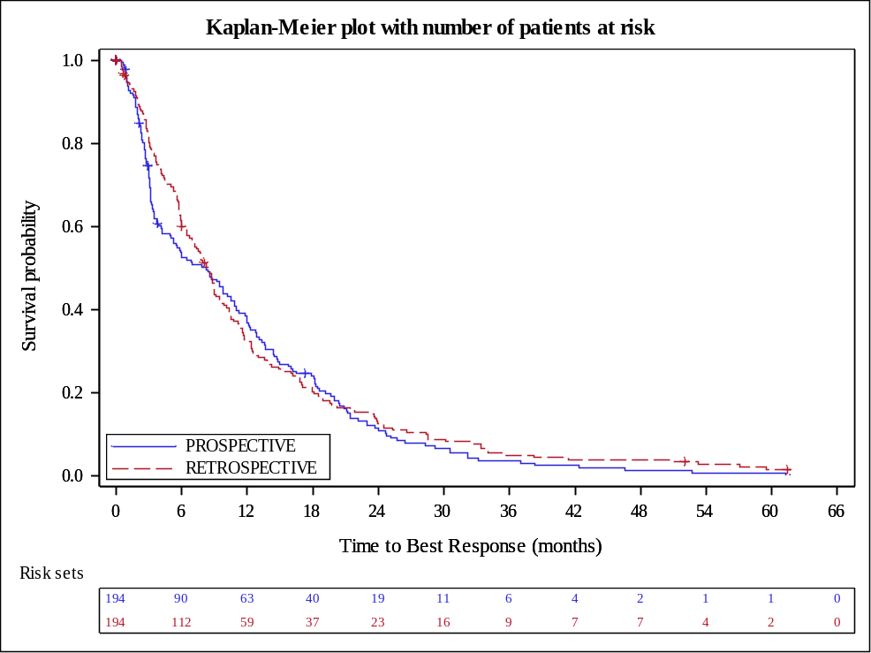

Online Resource 6. Comparison of the results between RESONATE and FIRE Studies
 |  | RESONATEª  (N=195) | FIRE
 |  | RESONATEª  (N=195) | Retro (N=194) | Pro (N=194)
Study population
Patients CLL/SLL |  | R/R CLL (L2+) | L1 (del17p) and L2+
Follow-up, months | Median (range) | 65.3 (0.3−71.6) | 59.24 (3.7-72.0) | 58.53 (0.1-68.7)
Patients’ characteristics
Sex | Male, N (%) | 129 (66.2) | 122 (62.9) | 136 (70.1)
Age, years | Median (range) | 67 (30-86) | 72 (43-91) | 71 (39-93)
ECOG PS | 0 | 79 (40.5) | 79 (53.0) | 76 (48.4)
 | 1 | 116 (59.5) | 56 (37.6) | 63 (40.1)
 | 2 | - | 11 (7.4) | 15 (9.6)
 | 3 | - | 3 (2.0) | 3 (1.9)
Duration of ibrutinib, months | Median (range) | 41.0 (0.2‐71.1) | 39.2 (0.7-66.5) | 34.5 (0.0-63.5)
Permanent discontinuation
Permanent discontinuation | N (%) | 152 (77.9)^{b} | 119 (61.3) | 127 (65.5)
Reasons for permanent discontinuation (N, %) | N (%) | 152 | 115 | 119
Reasons for permanent discontinuation (N, %) | Disease progression | 72 (47.4) | 38 (33.0) | 39 (32.8)
 | Adverse event | 32 (21.1) | 50 (43.5) | 50 (42.0)
 | Death | 13 (6.7) | 6 (5.2) | 12 (10.1)
 | Patient withdrawal / preference | 15 (8.6) | 2 (1.7) | 4 (3.4)
 | Investigator decision | 20 (13.2) | 4 (3.5) | 1 (0.8)
 | Other | - | 15 (13.0) | 13 (10.9)
Effectiveness outcomes
Median PFS (95% CI) |  | 44.1 (38.5-56.2) | 53.06 (44.5-60.5) | 52.93 (40.3-60.6)
Median OS (95% CI) |  | 67.7 (61.0-NR) | NR | NR
Overall Response Rate |  | 91% | 96.8% | 96.6%
Abbreviations: CI, Confidence Interval; CLL, Chronic Lymphocytic Leukaemia; ECOG PS, Eastern Cooperative Oncology Group Performance Status; NR, Not Reached; PRO, Prospective; Retro, Retrospective; SLL, Small Lymphocytic Lymphoma.

ª Reference [8].

^{b} 43 patients who discontinued treatment because of Sponsor’s decision have been excluded: they were still on ibrutinib at the end of the study but had to stop treatment because of study closure.

