Fluorescent Carbon Dots: Aggregation-Induced Emission Enhancement, Application as probe for CN⁻ and Cr₂O₇⁻², sensing strips and bio-imaging agent

Madhuri Bhatt^{a,b}, Shreya Bhatt^{a,b}, Gaurav Vyas^{a,b}, Ishan Ravalª, Anshu Kumar^{a,b}, Parimal Paul^{a,b}*

ª Analytical and Environmental Science Division & Centralized Instrument Facility, CSIR-Central Salt and Marine Chemicals Research Institute, G. B. Marg, Bhavnagar 364002, India.
^{b} Academy of Scientific and Innovative Research (AcSIR), Ghaziabad- 201002, India.

Table of the content
Fig. No. | Figure caption | Page No.
Fig. S1 | Fluorescence spectra of the crude Trp-CD excited at 380 nm in water. | 2
Fig. S2 | Fluorescence spectra of Trp-CD in the pH range 3 to 10 in water-ethanol. | 3
Fig. S3 | Fluorescence spectral change of Trp-CD in presence of TBA-OH and CN⁻. | 4
Fig. S4 | UV-Vis absorption spectra of Trp-CD with different concentration of CN⁻. | 5
Fig. S5 | Decay profile of the emission life-time of Trp-CD upon addition of CN⁻. | 6
Fig. S6 | Trp-CD coating on different solid material (A) waste wooden strips, (B) agarose based gel, (C) coating on filter paper. | 7
Fig. S7 | Agar-agar based film prepared from Trp-CD (A) under day light (B) under UV light. | 8

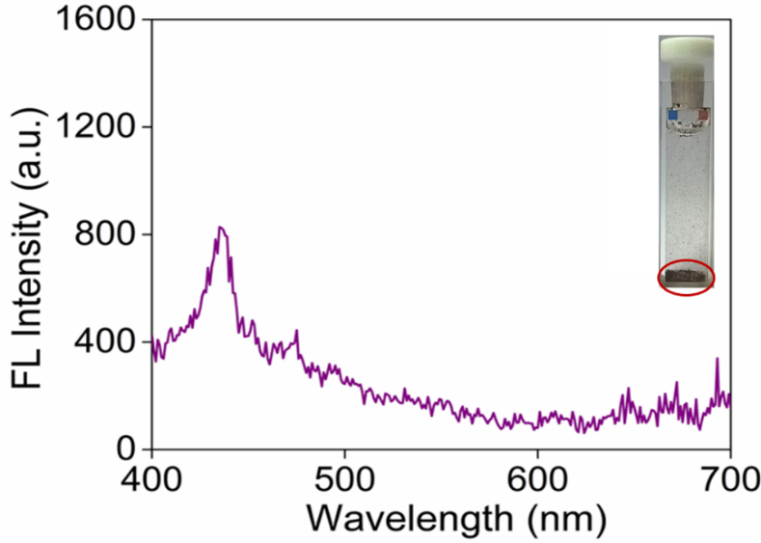

Fig. S1 Fluorescence spectra of the crude Trp-CD excited at 380 nm in water.

Fig. S2 Fluorescence spectra of Trp-CD in the pH range 3 to 10 in water-ethanol.

Fig. S3 Fluorescence spectral change of Trp-CD in presence of TBA-OH and CN⁻.

Fig. S4 UV-Vis absorption spectra of Trp-CD with different concentration of CN⁻.

Fig. S5 Decay profile of the emission life-time of Trp-CD upon addition of CN⁻.

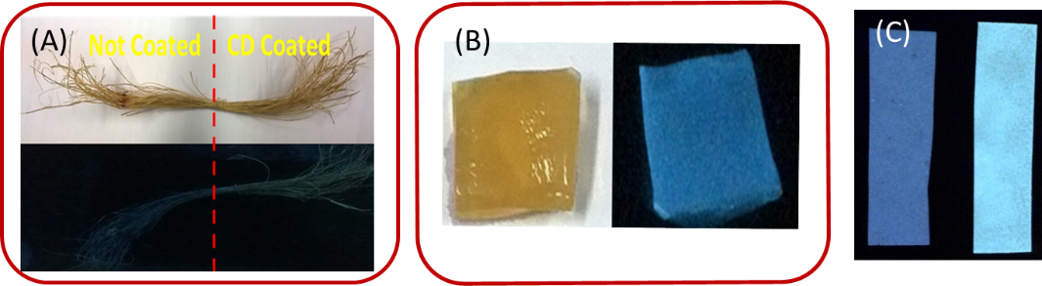

Fig. S6 Trp-CD coating on different solid material (A) waste wooden strips, (B) agarose based gel, (C) coating on filter paper.

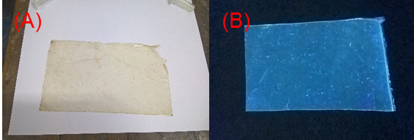

Fig. S7 Agar-agar based film prepared from Trp-CD (A) under day light and (B) under UV light.

