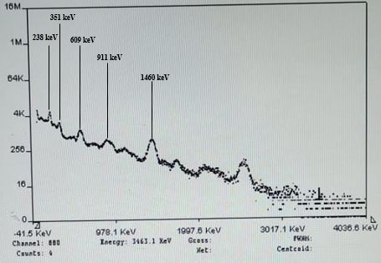
Figure S1 Spectrum taken for S7.
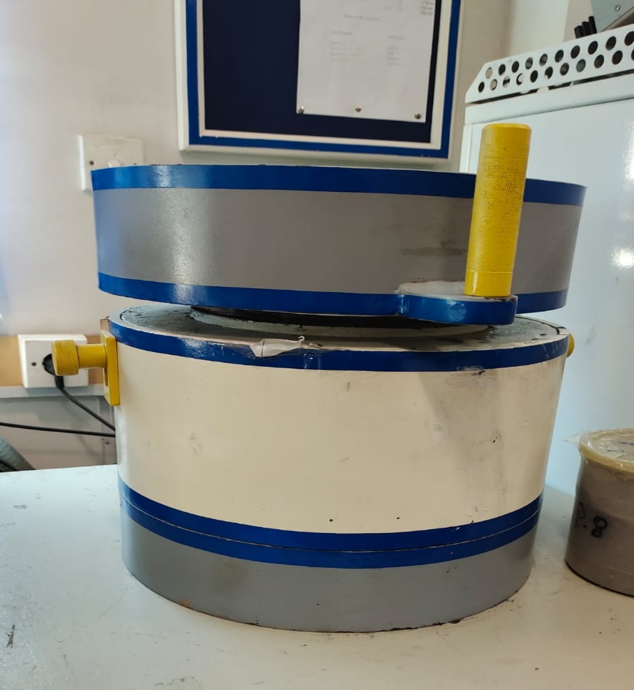
Figure S2 External view of 3*3 NaI(Tl) detector used for analysis.
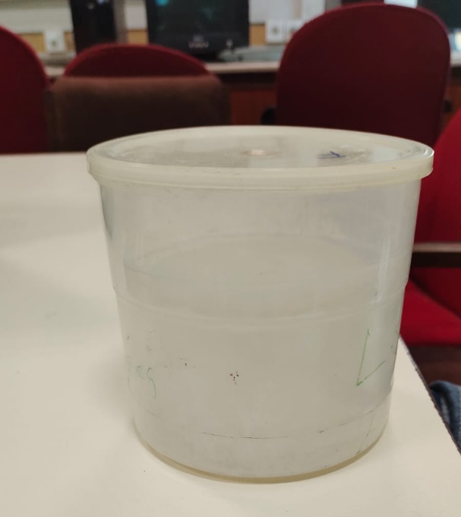
Figure S3 Marnelli beaker used for storing the water samples & analysis.
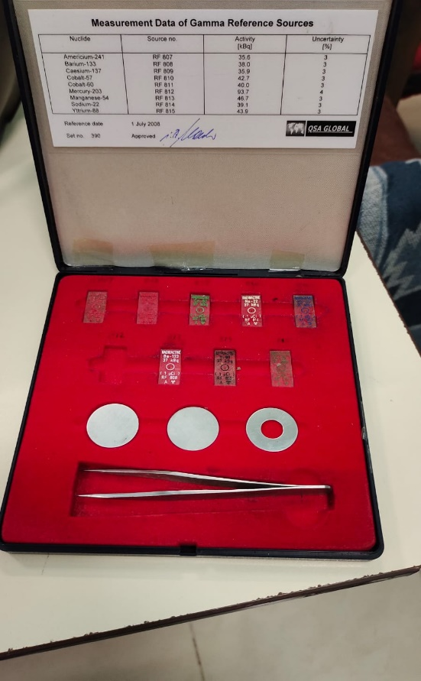
Figure S4 Standard gamma sources used for calibration.

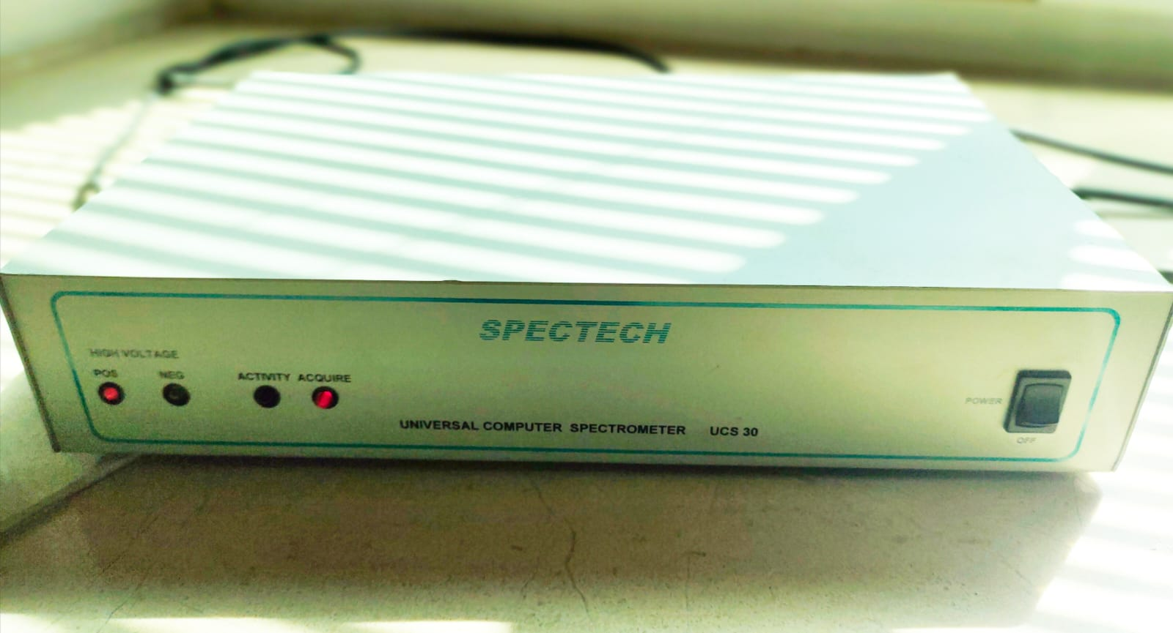
Figure S5 SPECTECH MCA used to acquire the spectrum via NAI(Tl)

Table S1 ICP-OES elemental data.
Elements | S1 | S2 | S3 | S4 | S5 | S6 | S7 | S8 | S9 | S10 | S11 | S12 | S13 | S14 | S15
Al | 40650 | 62899 | 60270 | 64463 | 62236 | 38526 | 51240 | 24434 | 46586 | 32695 | 30451 | 32394 | 7635 | 40617 | 61273
As | 4.44 | 5.01 | 5.31 | 5.74 | 6.14 | 5.05 | 6.5 | 0 | 7.28 | 2.27 | 2.32 | 0 | 8.93 | 0 | 8.68
Ba | 127 | 152 | 229 | 227 | 214 | 159 | 179 | 73.65 | 190 | 131 | 125 | 120 | 74.42 | 147 | 205
Ca | 76708 | 27265 | 43110 | 55194 | 22497 | 37802 | 23963 | 19012 | 18659 | 52964 | 83566 | 121177 | 25510 | 82797 | 26203
Co | 7.52 | 10.54 | 9.67 | 10.89 | 13.77 | 10.2 | 10.3 | 7.05 | 10.85 | 7.06 | 8.07 | 6 | 9.99 | 8.44 | 10.64
Cr | 87.93 | 75.74 | 79.29 | 93.1 | 107 | 85.84 | 87.93 | 66.35 | 98.72 | 54.97 | 73.67 | 59.86 | 91.28 | 69.05 | 78.65
Cu | 3.46 | 3.36 | 7.57 | 0 | 0 | 18.78 | 18.48 | 9.91 | 21.16 | 15.53 | 51.15 | 21.82 | 32.51 | 31.99 | 17.82
Fe | 26007 | 37116 | 32727 | 35001 | 38864 | 27420 | 30577 | 17842 | 28301 | 19077 | 20020 | 18958 | 21771 | 23678 | 31008
K | 10137 | 13667 | 16424 | 18053 | 16402 | 15844 | 15789 | 8506 | 14480 | 10603 | 10420 | 8378 | 12179 | 10792 | 20860
Li | 18.33 | 19.78 | 24.12 | 28 | 27.98 | 22.13 | 24.59 | 14.26 | 24.88 | 14.03 | 12.55 | 14.48 | 8.26 | 13.59 | 28.2
Mg | 8982 | 12819 | 10908 | 12897 | 10422 | 6997 | 9289 | 5089 | 8983 | 5993 | 4519 | 7145 | 2121 | 8580 | 8163
Mn | 461 | 649 | 613 | 645 | 781 | 360 | 513 | 246 | 587 | 470 | 490 | 385 | 571 | 580 | 447
Na | 4932 | 14162 | 6283 | 8868 | 5393 | 2918 | 4026 | 853 | 4473 | 5311 | 6524 | 7685 | 5921 | 10778 | 3496
Ni | 27.5 | 28.21 | 29.76 | 34.84 | 42.91 | 32.91 | 31.14 | 25.98 | 34.99 | 19.03 | 19.7 | 14.88 | 25.12 | 18.81 | 27.5
P | 987 | 721 | 842 | 555 | 1091 | 537 | 518 | 333 | 1023 | 1168 | 622 | 995 | 1673 | 1354 | 508
Pb | 45.5 | 9.89 | 27.23 | 20.12 | 38.84 | 5.87 | 5.21 | 8.48 | 23.32 | 12.17 | 93.49 | 64.56 | 140.66 | 47.6 | 8.42
S | 490 | 128 | 284 | 155 | 198 | 55 | 96.38 | 25.89 | 365 | 321 | 262 | 621 | 352 | 473 | 67.08
Sr | 330 | 158 | 178 | 243 | 108 | 78.19 | 95.26 | 35.89 | 89.15 | 153 | 364 | 521 | 203 | 393 | 64
Ti | 2423 | 3965 | 2966 | 3400 | 4170 | 2800 | 2973 | 2163 | 3328 | 2374 | 2501 | 2008 | 3197 | 3020 | 3325
V | 67.84 | 121 | 85.9 | 110 | 103 | 97.93 | 99.09 | 58.31 | 97.55 | 64.89 | 80.89 | 71.94 | 95.91 | 93.91 | 99.95
Zn | 226 | 92.26 | 151 | 115 | 141 | 82.24 | 80.32 | 43.42 | 136 | 120 | 98.52 | 154 | 188 | 130 | 87.12
Zr | 134 | 106 | 107 | 113 | 189 | 75.47 | 94.31 | 124 | 172 | 102 | 78.71 | 81.52 | 56.78 | 98.05 | 138

