Online-only Supplementary Material
Title: Death, Inequality, and the Pandemic in the Nation’s Capital

Appendix A. Total population estimates in Washington DC by year and racial breakdown
Year | Total population  (% Margin of Error) | % Black  (% Margin of Error) | % White  (% Margin of Error) | % Hispanic  (% Margin of Error)
2015 | 672,228 (± 0.1) | 46.5% (± 0.3) | 36.0 % (± 0.1) | 10.6% (± 0.8)
2016 | 681,170 (± 0.1) | 46.4% (± 0.3) | 36.3% (± 0.1) | 10.9% (± 0.7)
2017 | 693,972 (± 0.1) | 45.3% (± 0.4) | 36.5% (± 0.2) | 11.0% (± 0.8)
2018 | 702,455 (± 0.3) | 44.4% (± 0.4) | 36.9% (± 0.1) | 11.3% (± 0.7)
2019 | 705,749 (± 0.1) | 44.1% (± 0.4) | 37.3% (± 0.1) | 11.3% (± 0.7)
2020 | 712,816 (± 0.1) | 44.1% (± 0.4)* | 37.3% (± 0.1)* | 11.3% (± 0.7)*
2021 | 670,050 (± 0.1) | 42.7% (±0.4) | 36.4% (±0.3) | 11.5% (±1.0)
Source: US Census Bureau (1)
*Note: Because the experimental data tables released by the Census for 2020(2) did not have a breakdown by race, we used the same race composition as 2020.
Margin of Error for Total population and Hispanic population estimates are calculated by aggregating the standard errors of the subgroups.
Standard Error = Margin of Error (90% confidence level)/1.645
Where Margin of Error = max (upper bound - estimate, estimate - lower bound)
$SE\left(\hat{X_{1}}+ \hat{X_{2}}+…\right)$≈ $\sqrt{{\left[SE\left(\hat{X_{1}}\right)\right]}^{2}+{\left[SE\left(\hat{X_{2}}\right)\right]}^{2}+… }$
Where $SE\left(\hat{X_{1}}\right), SE\left(\hat{X_{2}}\right)$etc. are standard errors of sample estimates and $SE\left(\hat{X_{1}}+ \hat{X_{2}}+…\right)$ is the approximate standard error of the sum of these sample estimates.

Appendix B. COVID-19 Prevalence Rate (%) by Age, Sex, and Race in DC, 2020-2021
Sex | Male |  |  | Female
Age | Non-Hispanic White | Hispanic | Non-Hispanic Black | Non-Hispanic White | Hispanic | Non-Hispanic Black
0-17 | 4.7% | 16.1% | 23.5% | 4.9% | 16.8% | 24.4%
18-49 | 11.8% | 19.0% | 15.2% | 12.2% | 21.2% | 22.7%
50-65 | 6% | 11.7% | 20.8% | 3.7% | 11.8% | 22.3%
65+ | 5.5% | 6.2% | 17.9% | 3.5% | 5.2% | 17.5%
Source: CDC case counts (3) and ACS 1-year population estimates (1)

Appendix C. Relative Risk of COVID Deaths by race in DC
Sex | Male |  |  | Female
Year | Non-Hispanic White | Hispanic | Non-Hispanic Black | Non-Hispanic White | Hispanic | Non-Hispanic Black
2020 | 1.12 | 1.71 | 1.15 | 1.09 | 1.35 | 1.14
2021 | 1.09 | 1.16 | 1.1 | 1.04 | 1.13 | 1.1
Source: Author’s calculations
Relative Risk calculation:
Numerator: number of people dying from COVID-19
Denominator number of people who died from causes other than COVID-19

Appendix D. Total population estimates by race and ward

Ward | Population | % Black | % White | % Hispanic | Median Income
1 | 85,289 | 25.4% | 46.9% | 17.6% | $110,457
2 | 77,923 | 7.9% | 66.1% | 12.9% | $114,649
3 | 84,651 | 8.1% | 70.4% | 9.6% | $129,681
4 | 90,300 | 48.4% | 23.6% | 22.5% | $96,245
5 | 92,094 | 61.3% | 22.5% | 10.4% | $77,367
6 | 101,882 | 27.7% | 56.3% | 7.8% | $117,752
7 | 84,271 | 90.2% | 2.7% | 4.0% | $48,474
8 | 85,564 | 86.0% | 5.9% | 4.1% | $37,963
Source: Office of Planning, Open Data DC (4)
Note: Data at the ward level is not available after 2018. Median Income is in 2020 inflation-adjusted dollars.
Note: The three racial groups account for approximately 93% of the population. The remainder represents the following groups as described by the ACS: Asians, American Indian and Alaska Native, Native Hawaiian and Other Pacific Islanders, and Some Other Race.

Appendix E: Between 2020-2021 and the previous five years (2015-2019), excess deaths show that residents 45 and older are most affected
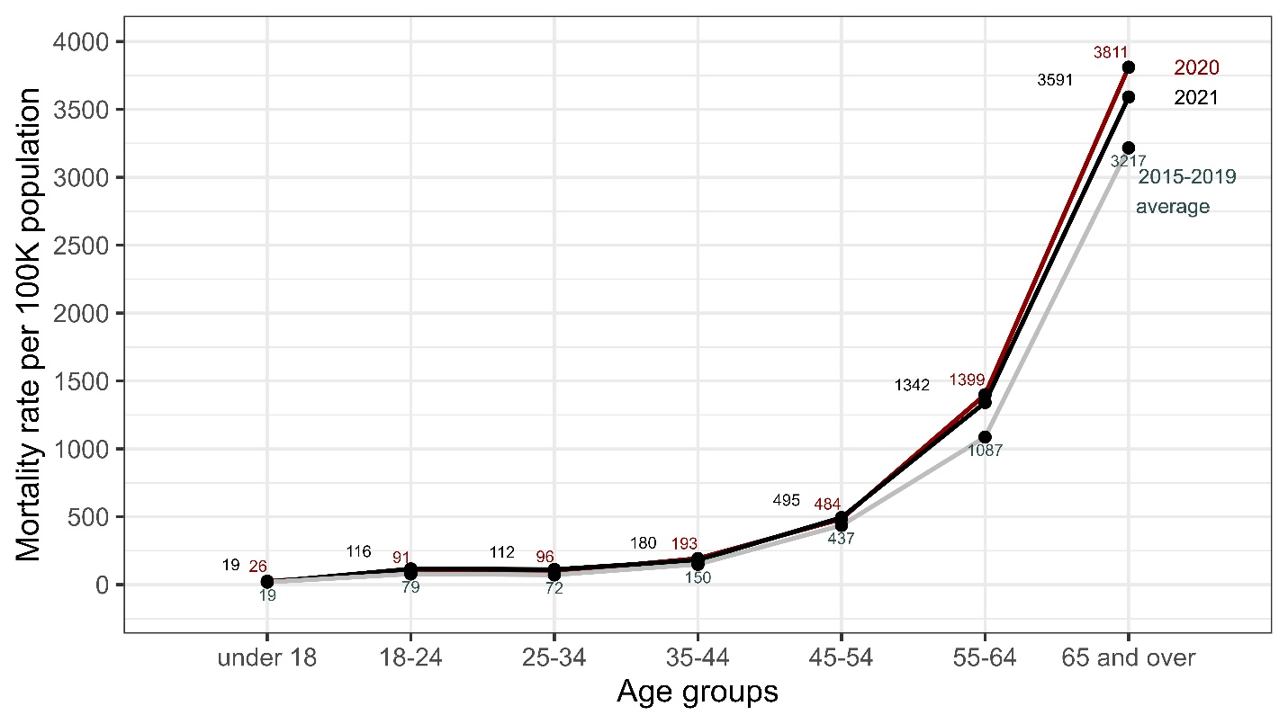

Appendix F: Increases in mortality rate in 2020 were greater for DC wards with more ethnic minorities and lower-income residents
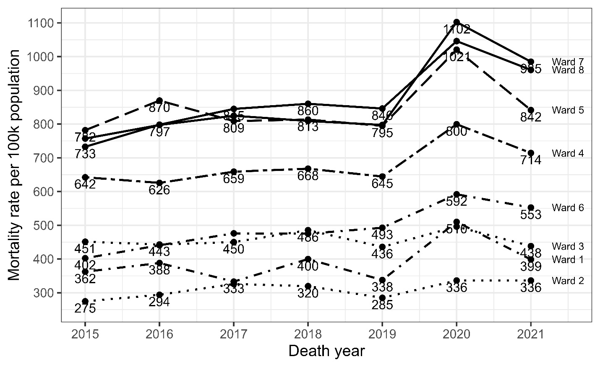

Appendix G: Cause-specific mortality rates by race and sex in 2021, compared to the 2015-2019 period
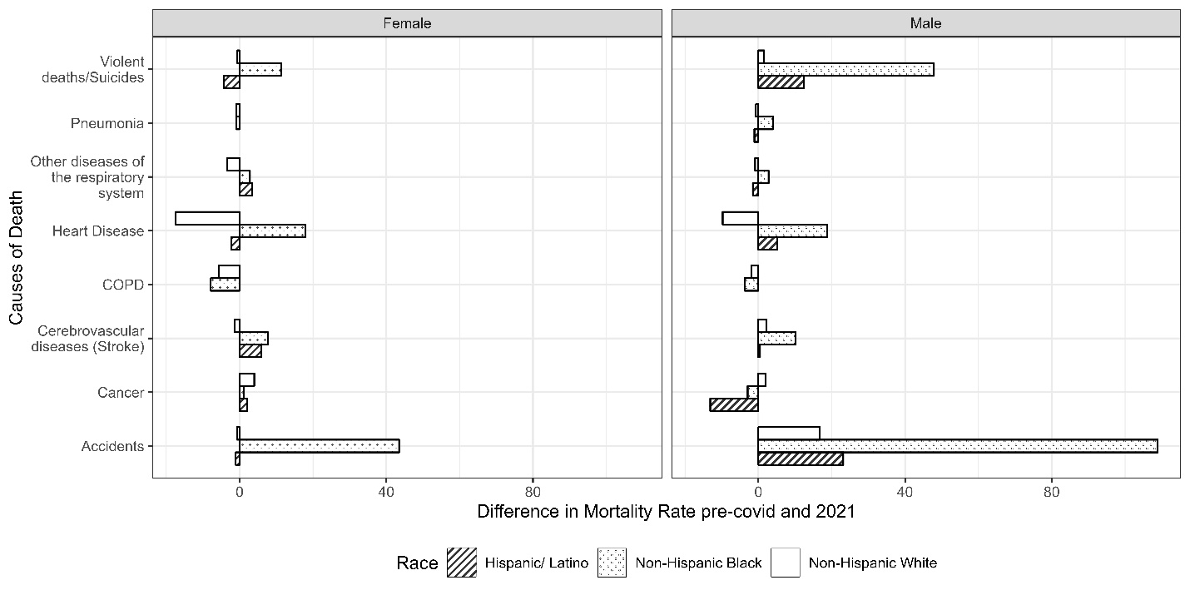

Appendix H: Differences in Life expectancy in the US between 2019 and 2020: DC lost nearly twice as many years of life expectancy between 2019 and 2020 compared to the US as a whole
US |  | Life Expectancy at birth |  | Years of Life Lost due to Covid-19
Race | Sex | Without Covid-19 (2019) | With Covid-19 (2020) | Years of Life Lost due to Covid-19
Hispanic | Female | 84.4 | 81.3 | 3.1
Hispanic | Male | 79.1 | 74.6 | 4.5
Non-Hispanic Black | Female | 78.1 | 75.4 | 2.7
Non-Hispanic Black | Male | 71.3 | 67.8 | 3.5
Non-Hispanic White | Female | 81.3 | 80.1 | 1.2
Non-Hispanic White | Male | 76.3 | 74.8 | 1.6
All National* |  | 78.8 | 77.3 | 1.5
DC |  | 78.0 | 75.3 | 2.7
*Source: National Center for Health Statistics (5)
** Center on Society and Health; National Center for Health Statistics (6, 7)

Appendix I. DC Department of Vital Statistics versus CDC mortality counts
Year | DC Department of Vital Statistics mortality | CDC Mortality (as of 05-01-2023)
2015 | 3965 | 4871
2016 | 4148 | 5037
2017 | 4262 | 4965
2018 | 4286 | 5008
2019 | 4115 | 4927
2020 | 5283 | 6198
2021 | 4784 | 5833
Sources: DC Department of Vital Statistics (8) and CDC WONDER (9)
Notes: 2020 values are still provisory for the CDC. The CDC numbers include DC residents who die in other states which translated into higher death numbers

References
1. US Census Bureau, ACS 1-Year Estimates Detailed Tables, B02001: RACE. Census.gov (November 5, 2022).
2. US Census Bureau, 2020 ACS 1-Year Experimental Data Tables. Census.gov (2021) (August 15, 2022).
3. CDC, COVID-19 Case Surveillance Public Use Data with Geography | Data | Centers for Disease Control and Prevention (2021) (September 14, 2022).
4. Office of Planning, Open Data DC, ACS Demographic Characteristics DC Ward. DC.gov (August 15, 2022).
5. E. Arias, J. Xu,, Division of Vital Statistics, United States Life Tables, 2019. 59 (2022).
6. Center on Society and Health, Washington, D.C. Life Expectancy Methodology and Data Table.
7. National Center for Health Statistics, District of Columbia (2023) (April 27, 2023).
8. CDC, NVSS (2022) (August 15, 2022).
9. CDC WONDER, Mortality Data on CDC WONDER (May 1, 2023).

