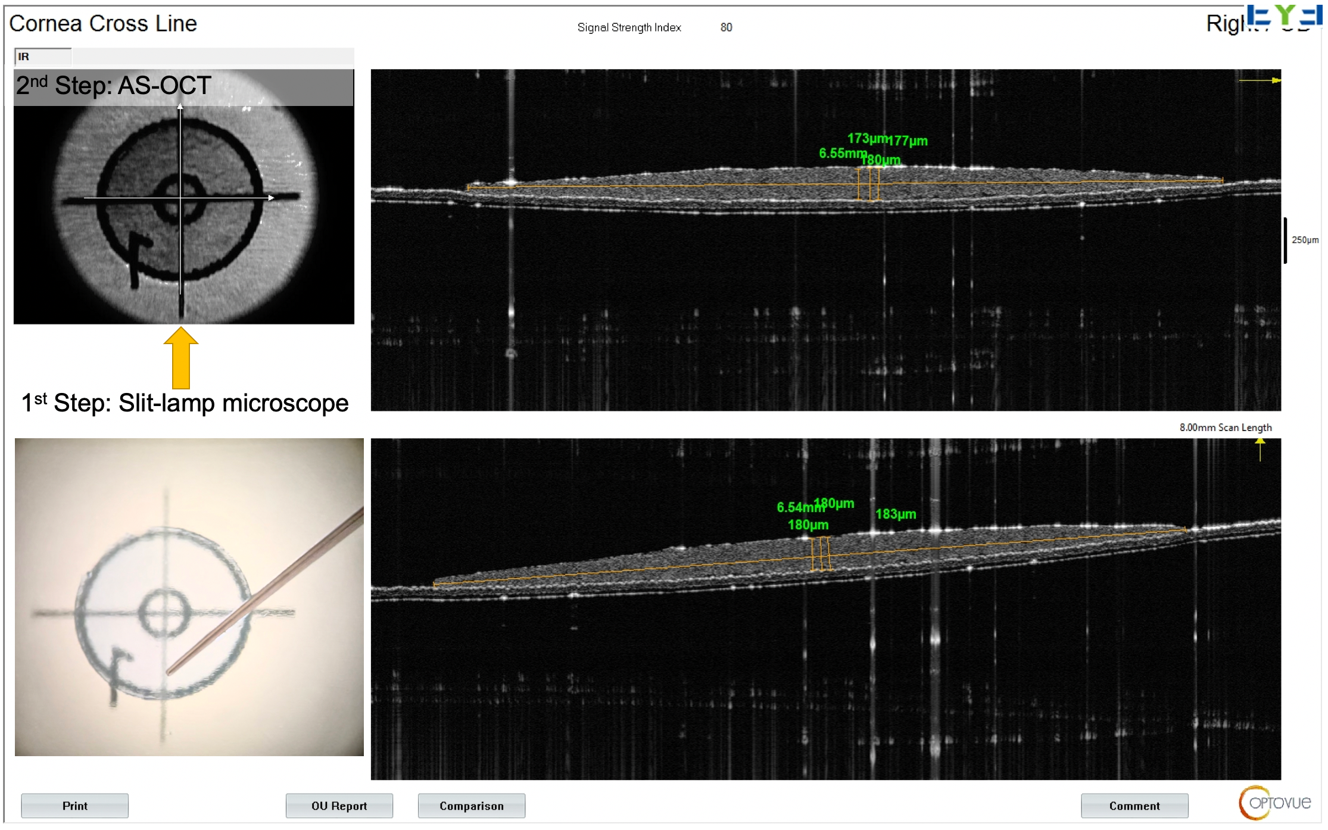
Supplementary Figure. The arc length measurement of the ex vivo lenticular diameter can be divided into two steps: 1st step is to determine the center of the transparent and circle lenticule under the observation of the microscope; 2nd step is to align the scanning center to the center of lenticule under the infrared reflection of AS-OCT, then the arc length of the lenticular diameter would be measured horizontally and vertically, and finally take the mean.
Supplementary Table 1. Measurement of the chord length and arc length of the lenticular diameter in ex vivo, and compare the result with POZ
No. | POZ in chord length of diameter (mm) | Lenticule measured arc length of diameter (mm) | Preoperative corneal curvature radius (mm) | Lenticule chord length adjusted by curvature (mm) | Change of lenticule chord length (mm)
1 | 6.5 | 6.62 | 7.71 | 6.42 | -0.08
2 | 6.5 | 6.68 | 7.73 | 6.47 | -0.03
3 | 6.5 | 6.59 | 8.23 | 6.42 | -0.08
4 | 6.5 | 6.62 | 8.16 | 6.44 | -0.06
5 | 6.5 | 6.57 | 7.64 | 6.37 | -0.13
6 | 6.5 | 6.60 | 7.64 | 6.40 | -0.10
7 | 6.5 | 6.71 | 7.79 | 6.50 | 0.00
8 | 6.5 | 6.69 | 7.82 | 6.49 | -0.01
9 | 6.5 | 6.75 | 7.48 | 6.52 | 0.02
10 | 6.5 | 6.60 | 7.65 | 6.40 | -0.10
11 | 6.5 | 6.60 | 7.73 | 6.40 | -0.10
12 | 6.5 | 6.63 | 7.91 | 6.44 | -0.06
13 | 6.5 | 6.61 | 7.82 | 6.42 | -0.08
14 | 6.5 | 6.69 | 7.94 | 6.50 | 0.00
15 | 6.5 | 6.49 | 7.67 | 6.30 | -0.20
16 | 6.5 | 6.70 | 7.68 | 6.49 | -0.01
Mean | 6.5 | 6.63 | 7.79 | 6.44 | -0.06
SD | 0 | 0.06 | 0.20 | 0.06 | 0.06

Supplementary Table 2. Literature Review of Optical Zone Change after LIKE and HLASIK
 | Current study |  |  | Reinstein (2017)[9] |  |  |  | Roesler (2018)[4] |  |  |  | Liu (2022)[16]
 | LIKE | HLASIK |  | SMILE | HLASIK1 | HLASIK2 |  | ≤+3 | ＞+3 | total |  | LIKE
Treatment SEQ (D) | +6.09±0.91  (+4.5~+7.5) | +3.53±1.11  (+1.75~+5.13) |  | +5.61±0.96  (+3.2~+6.5) | +4.83±0.80  (+3.13~+6.3) | +5.54±0.95  (+3.13~+7.0) |  | +3.55±1.28 |  |  |  | N
Planned OPZ (mm) | 6.47±0.09  (6.2~6.5) | 6.56±0.14  (6.5~7) |  | 6.37  (6.3~6.7) | 6.5 | 7 |  | 6.75±0.90 | 6.48±0.94 | 6.59±0.92 |  | 6.5
EOZ (mm) | 5.2±0.28  (4.72~5.69) | 4.61±0.20  (4.37~4.97) |  | 5.03±0.30  (4.4~6) | 4.53±0.25  (4.2~5.4) | 4.96±0.25  (4.5~5.7) |  | 4.89±0.85 | 4.23±0.84 | 4.49±0.89 |  | 5.33±0.28
EOZ/FOZ (%) | 80% | 70% |  | 79% | 70% | 71% |  | 72% | 65% | 68% |  | 82%
SEQ = spherical equivalent; D = diopters; mm = millimeter; POZ = programmed optical zone; EOZ = effective optical zone

Supplementary Table 3. Change in Mean Corneal Aberrations after LIKE and HLASIK.
 | Preoperative |  |  |  | Postoperative |  |  |  | Change
 | LIKE | HLASIK | P |  | LIKE | HLASIK | P |  | LIKE | HLASIK | P
HOAs | 0.404 | 0.410 | 0.56 |  | 0.788 | 0.791 | 1.00 |  | 0.385 | 0.380 | 0.86
SA (Z⁰₄) | 0.205 | 0.246 | 0.02* |  | 0.080 | 0.107 | 0.90 |  | -0.126 | -0.140 | 0.65
coma | 0.267 | 0.247 | 0.71 |  | 0.601 | 0.541 | 0.55 |  | 0.334 | 0.294 | 0.69
trefoil | 0.121 | 0.104 | 0.47 |  | 0.228 | 0.170 | 0.22 |  | 0.108 | 0.066 | 0.46
Z¹₃ | -0.011 | -0.002 | 0.92 |  | -0.132 | -0.035 | 0.33 |  | -0.122 | -0.033 | 0.65
Z⁻¹₃ | -0.041 | -0.083 | 0.41 |  | 0.437 | 0.354 | 0.63 |  | 0.478 | 0.437 | 0.99
Z³₃ | -0.003 | 0.000 | 0.64 |  | 0.001 | 0.037 | 0.47 |  | 0.004 | 0.037 | 0.68
Z⁻³₃ | -0.016 | 0.028 | 0.24 |  | -0.091 | 0.052 | 0.00* |  | -0.075 | 0.023 | 0.04*
Z¹₅ | -0.004 | 0.015 | 0.02* |  | 0.002 | -0.018 | 0.55 |  | 0.006 | -0.033 | 0.33
Z⁻¹₅ | -0.005 | -0.011 | 0.90 |  | -0.051 | -0.112 | 0.04* |  | -0.046 | -0.102 | 0.11
Z³₅ | 0.003 | -0.001 | 0.47 |  | -0.006 | -0.021 | 0.52 |  | -0.009 | -0.021 | 0.82
Z⁻³₅ | -0.001 | -0.003 | 0.69 |  | 0.017 | 0.041 | 0.15 |  | 0.018 | 0.044 | 0.13
A * indicates statistical significance. HOAs = high-order aberration; SA = spherical aberration

